Problem Solving and Decision Making

Contents
Table of Figures 2
Introduction 3
About Sainsbury’s 3
Defining complex problem 4
Analyse identified problem 5
Problem Solving Tools and Techniques 6
Decision-making techniques to evaluate solutions 12
Plan for solution implementation 15
Communication plan for stakeholders 16
Monitoring and review techniques for solution implementation 18
Conclusion 19
References 20

Table of Figures
Figure 1: Affinity Diagram for Sainsbury's 7
Figure 2: Fishbone Diagram for Sainsbury's 8
Figure 3: Decision Tree for Sainsbury's Problem Solution 13

Introduction
Organisations have been facing problems related to a myriad of aspects of which the customer related issues and product and service quality are significant. Understanding the needs and interests of the customers has been of prime priority for Sainsbury’s in achieving the goal of becoming the trusted retailer. However, Sainsbury’s services and products have been receiving criticisms and dissatisfied customers. Even with a simple pricing strategy with price satisfaction offered to the customers, Sainsbury’s product quality and customer services have been full of problems that seek immediate address(Mirror, 2017). This paper would identify the different problems of Sainsbury’s and suggest suitable solutions based on problem-solving and decision-making techniques.

About Sainsbury’s
Sainsbury’s Supermarkets is the third largest supermarket of UK with a 16.3% share. The company is listed in the London Stock Exchange and is a part of the FTSE 100 Index (The Guardian, 2010). Sainsbury was established in 1869 by John James and Mary Ann Sainsbury as a small dairy store in their Drury Lane home. The Company has a wide range of subsidiaries and is one of the biggest names in food retailing run by CEO Michael Andrew Coupe, CFO Kevin O’Byrne and John Rogers. The company also specializes in providing high quality food choices with a value for money and excellent customer service. At present Sainsbury constitutes of 440 stores in the UK with 23,000 products and 40% of the products carrying the brand identity. At present Sainsbury also comprises of 116,400 employees, including frontline and internal employees (Bloomberg, 2019).
However the business of Sainsbury is not limited to only food retail but also consist of general merchandise, homewares, online groceries, clothing, toys, electrical and technology products. At the same time, Sainsbury operated 883 Argos stores, 317 collection points, with 208 convenience stores (Bloomberg, 2019). The company also extends its services to development of real estate properties as well as, financial services, personal, home, care, pet and life insurances. On the other hand, Sainsbury believes in sustainable development to tackle climate change as well as inequality. As Sainsbury is one of the largest retailers of the nation, there are various issues and factors that affect its business performance.

Defining complex problem
One of the first complex and technical problems faced by Sainsbury’s was due to its website glitch. In 2017, the supermarket’s website suffered a serious setback that prevented the customers from processing their Christmas orders and there was a series of complaints made by the customers on the social media about the issue. The online shoppers were planning to dodge the store crowd but were left fuming when Sainsbury’s website suffered a glitch which left their order incomplete (Mirror, 2017). This was coupled with a serious technical glitch on the company’s mobile application as the shoppers failed to get through the checkout progress. The social media networking sites such as Facebook and Twitter were swamped with the complaints of angry customers. Although Sainsbury’s made social apology to the customers and advised them to use another device or browser, the problem persisted.
Correspondingly, the supermarket has also been facing problems due to its product quality and has been prosecuted on several occasion regarding food safety and quality. Sainsbury’s was found to be selling food products past its use-by date. This has triggered a serious problem for Sainsbury’s product quality standards which has highly dissatisfied the customers. Sainsbury’s customers had also complained about the rotten and mouldy turkeys which have disrupted and ruined their Christmas yet again in 2018. Families of the customers have been left disgusted during their Christmas dinner tables due to the rancid smells which have forced them to ditch the turkey and be forced to go hungry (Christodoulou, 2018).
A series of complaints were made by the customers with picture evidence against Sainsbury’s while the company had apologised that their product could not meet the usual high standards and had promised to conduct probe against the problem. However, the company had ascertained that the customers who are dissatisfied with the product quality are entitled to refunds but the problem persists as there is no promise of improving the product quality. It was also found that the staffs of Sainsbury’s were not trained accurately to execute their duties involved with the product quality and food safety. There has been a decline in the sale of the products of Sainsbury’s which is followed by the rapid growth of Aldi. In 2019, Sainsbury’s suffered a drop in sales by 1.2% in the month of April. The collapse of the Asda and Sainsbury’s collapse have also attributed to the decline in the share price of Sainsbury’s to the lowest and the company has expected to reveal a decline in its annual profits and sales due to the increased competition from Aldi and Lidl (Butler, 2019).

Analyse identified problem
It has been identified, that Sainsbury has been affected by various issues and problems that has significantly affected the business. As observed the most critical issue are regarding poor product quality, low customer satisfaction and resultant declining sales. As Sainsbury is a product and service oriented company, it is evident that poor quality in both the factors will have imprint on the overall sales. As most of the retailers and shoppers are technology friendly, the most explicit experience is provided to the customers by streamlining the services offline and online. Thus, the technical glitches suffered by Sainsbury did not only disrupt the customers shopping experience but also resulted in failed orders and people seeking other options. This event took place during Christmas and people addressed their complaints in social media pages affecting the brand image of Sainsbury resulting in declining sales (Grierson, 2011).
Moreover the failure of the online delivery services meant that Sainsbury is yet to introduce a failsafe IT system that will ensure that such issues will not occur further in future. While the customers were provided a full refund for their items, this also raised issues about data security and privacy for the online customers. Another essential area of concern is the quality of the food provided to the customers. Issues like those with mouldy turkey during Christmas and tasteless items were few of the concerns of the people. An online survey revealed while Sainsbury is performing sufficiently in both in-store and online shopping experiences, 63% and 69% respectively, customers provided a very low score in the aspect of value for money (Munbodh, 2019). This overall experiences of the customers enabled German supermarkets like Aldi and Lidl outperforming Sainsbury resulting in decline in sales. As these companies have a proper and efficient online platforms of business, it is understood that companies like Sainsbury needs to develop their online expertise to provide seamless experience. Similarly the loss of market share and low sales rate can be attributed to the severe competition faced by the Company against rivals. It is further observed by Kostyra, et al. (2016) that online customer reviews is a major source of information for the customers and can have significant impact on the purchase decisions, as the customers consider and compare the brand, price as well as technical attributes. Therefore, it can be said, that Sainsbury suffered a loss due to the assimilated effect of various situations and conditions that had resulted in the loss of faith and trust among the customers.

Problem Solving Tools and Techniques
There are four distinct problems that have been identified for Sainsbury’s that requires an immediate solution. In this regards, the first problem is related to the poor product quality due to the rotten and mouldy turkey sold in Christmas and lack of trained staff to monitor food safety, dissatisfaction of customers due to the website and mobile application glitch, absence of customer grievance cell to resolve customer complaints and decline in the sales due to extreme competition, product quality issues and technical glitch. Based on the affinity diagram, a brainstorming session was carried out to group the problems and ascertain the different major problems faced by Sainsbury are which is presented below(Widjaja and Takahashi, 2016):

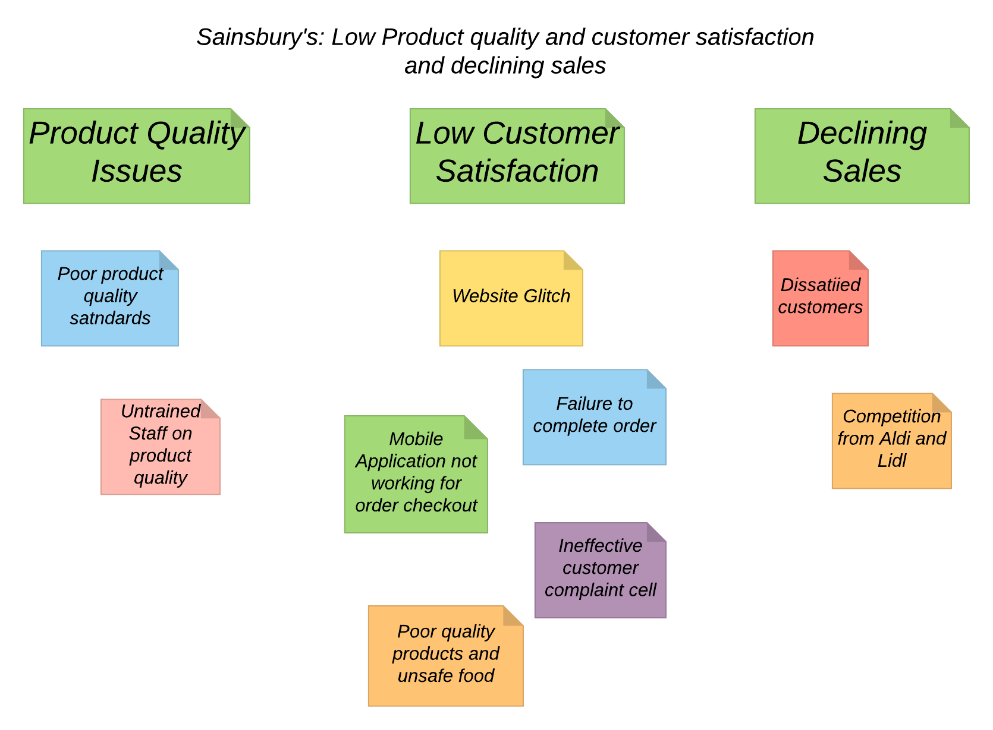
Figure 1: Affinity Diagram for Sainsbury's
Source: Self
In this regards, the possible causes of the problems are required to be analysed to understand the type of solutions that could be suggested. The fishbone diagram is a significant problem-solving tool that helps to sort out the possible causes into various branches that are out from the original problem (Coccia, 2018). Considering these problems faced by Sainsbury’s, the fishbone diagram is presented below:
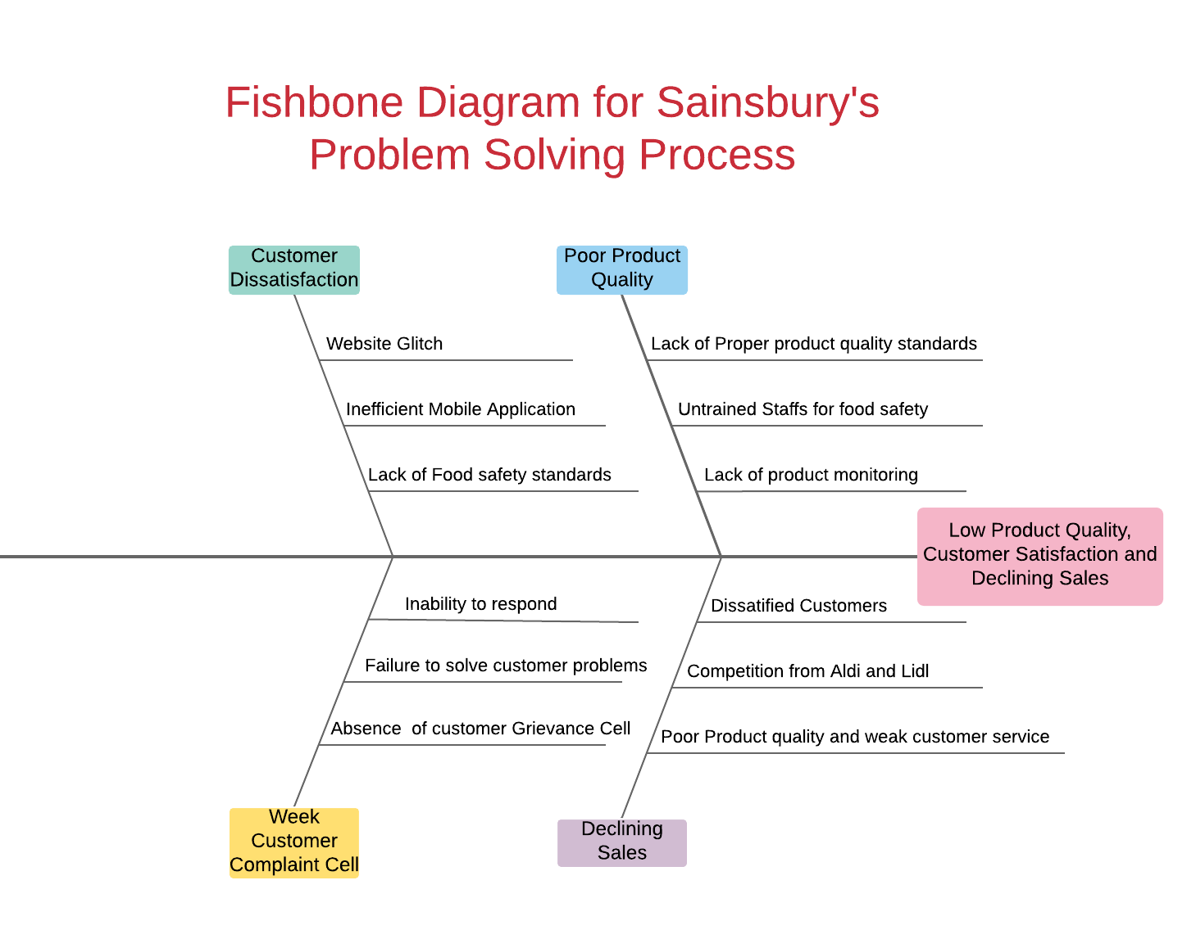
Figure 2: Fishbone Diagram for Sainsbury's
Source: Self
It must be noted that the affinity diagram develops from a brainstorming session could identify only three possible problems; however, the fishbone diagram has revealed four problems with their potential causes. For the product quality problem, Sainsbury’s have failed to maintain high-quality standards while selling Turkey which is coupled with the lack of product monitoring process and inefficient staff that did not carry out the duty of ensuring food safety(Jones, 2018). On the other hand, the dissatisfaction of the customers has been due to the poor product safety standards, website glitch and ineffective mobile application that failed the customers to make their order for Christmas. The problem of declining sales is multidimensional which is due to the competition from Aldi and Lidl, dissatisfied customers for the reasons stated above and poor product and customer services. This is substantiated by the lack of customer grievance cells of Sainsbury’s which has forced the customers to share their fuming remarks and comments on the social media(Mirror, 2017). However, poor responsiveness and inability to solve customer problems are also significant in this case.
SWOT analysis of Sainsbury’s would assist in the formation of the solution as presented below:
Strengths  - Differentiated food proposition  - High quality of products and services  - Diversified business with a strong market share | Weaknesses  - Poor food safety standards  - Untrained staffs  - Absence of grievance cell  - Technical glitch
Opportunities  - Staff training for improved customer service  - Technological innovation on product quality | Threats  - Competition from Aldi and Lidl  - Declining sales and profits

Strengths- Sainsbury’s sell differentiated food products and promises to sell products of high-quality standards. On the other hand, with strong market share and diversified business opportunities, Sainsbury’s have been able to experience growth in the business(Sainsbury's, 2016).
Weaknesses- Sainsbury’s have been criticised of poor product quality and technical glitch which have dissatisfied the customers and prevented them from ordering and purchasing food. It was found that the Sainsbury’s staffs were inexperienced in maintaining food safety while there was no grievance cell for the customers to resolve their complaints and queries(Munbodh, 2019).
Opportunities- With opportunities for staff training, the problems related to product quality, customer service and website and mobile application glitch could be solved. On the other hand, the technological innovation on product quality could help to satisfy the needs of the customers.
Threats- Sainsbury’s receives a threat from its competitors Aldi and Lidl after its sudden growth while the low customer satisfaction and poor product quality have also contributed to the decline in the sales of the company by 1.2% in the first quarter of 2019(Butler, 2019).
A PESTLE Analysis would further support the problem-solving approach which is presented in the case of Sainsbury’s below:
Political | Brexit would have significant implication on the retail business like Sainsbury’s due to loss of staffs and decline in business(Butler, 2019).
Economic | There is a prediction of a steep decline in Great Britain Pound after Brexit hit the UK which would lower the income of Sainsbury’s and also increase the import cost(Telegraph , 2019).
Social | Sustainable business practices with the rising demand in organic food have garnered support from Sainsbury’s customers
Technological | Data-driven analytics and digital technology have improved the business practices of Sainsbury’s(Vizard, 2015).
Legal | The regulatory approvals from the UK government have in some cases delayed the business decisions and business growth of Sainsbury’s.
Environmental | Sainsbury’s has abided by the environmental laws and reduced waste, carbon emission and developed a strategic sustainability plan(Smithers, 2011).

Therefore, from this analysis, some potential solutions for Sainsbury’s could be suggestedto solve the problems. The potential solutions are presented below:
Potential Solutions | Description | Problem Addressed
Staff Training | A dual training programme should be undertaken focusing on quality systems and technical skills. Sainsbury’s can develop quality systems training to review its product quality and food safety standards. Technical skills enhancement training should also be provided to the technical staffs of Sainsbury’s(Ganesh and Indravei, 2015) | - Improve product quality  - Review food safety standards  - Debugging technical glitch on website and mobile application  - Customer Satisfaction
Technology on product quality | Radio-frequency identification (RFID) technology could be used for product traceability by tracking and tracing the product throughout the supply chain of Sainsbury’s to support the food safety efforts (Chen et al., 2008) | - Improve product quality  - Ensuring food safety  - Customer Satisfaction  - Increase sales
Incorporating Grievance Cell for customers | Sainsbury’s should implement a customer grievance cell to record and docket all the customer complaints and queries and work towards resolving them | - Customer satisfaction

Decision-making techniques to evaluate solutions
Based on the evaluation and the problem-solving techniques applied in the previous sections, three solutions were suggested for Sainsbury’s problems. These solutions tend to solve more than one problems but the effectiveness of each of the problems is subject to further evaluation. The decision tree is considered to be a decision support tool that helps in modelling the decisions and solutions to problems and their possible consequences(Tofan, 2014). The tree-like model is displayed in the form of an algorithm that contains conditional control statements.
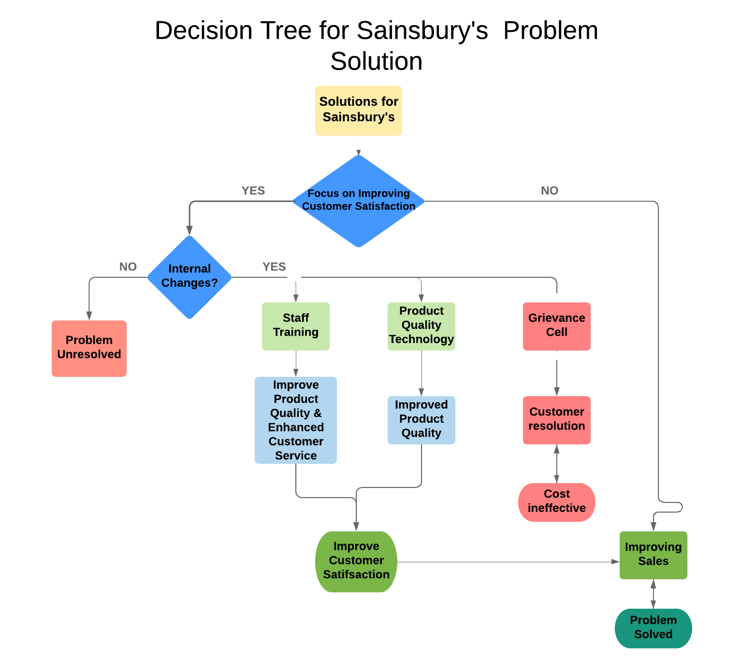
Figure 3: Decision Tree for Sainsbury's Problem Solution
Source: Self
Considering the decision tree represented above, the prime focus of Sainsbury’s must be on improving customer satisfaction which could only be done by the internal changes or driving sales. With no internal change initiated the problem would remain unresolved. On the other hand, there are three internal changes identified as solutions to address the problems of Sainsbury’s which are the staff training, product quality technology and grievance cell.
In the case of the grievance cell setup, Sainsbury’s would be able to resolve the complaints and queries of the customers and improve their satisfaction level. However, setting up a grievance cell would mean that Sainsbury’s have to start a new department which would incur a substantial cost. For instance, Sainsbury’s would have to purchase more of systems, hire and appoint customer service representative to record and docket the customer complaints and queries, establish a link with the respective departments and then monitor the departmental performance including providing training and development for a completely new department. While the grievance cell solution is cost-ineffective, it is also time-consuming for Sainsbury’s(Kotangale et al., 2018). However, the opportunity cost of setting up the grievance cell could be used as a source to purchase a product quality technology.
In this regards, the onetime cost of purchasing the product quality technology such as Radio-frequency Identification (RFID) technology for conducting product traceability function could be incurred by Sainsbury’s. It must be noted that the main concern and reason for customer dissatisfaction is due to the low product quality and hence installation of the RFID technology is considered to be a justified and suitable solution for Sainsbury’s. The RFID technology uses the low power radio waves to exchange information between the tags and readers. In this case, Sainsbury’s could use passive tags to tracks pallets, bins and returnable transport items containing ingredients or products as the products are in the supply chain. It would support the food safety efforts abiding by the Food Safety Modernisation Act (FSMA) and by collecting, accessing and utilising necessary data to track and trace the products(O’Boyle, 2016). Given this, Sainsbury’s would be able to improve its product quality and monitoring process which would improve customer satisfaction and increase sales. On the other hand, dual staff training could be initiated by Sainsbury’s to train the staffs to acquire knowledge and practical application about product quality and food safety standards. This would help the staffs to be effective enough to monitor the product quality and food safety by preventing the selling of products that had passed its use date. Consequently, a technical skills training programme could also be initiated by Sainsbury’s to improve the technical knowledge to solve technical problems related to website crash and glitch in the mobile application to improve the ordering and purchasing process for the online customers of Sainsbury’s(Ganesh and Indravei, 2015).

Plan for solution implementation
The solutions outlined for Sainsbury needs to be implemented across every branch and store to harmonise the activities and attain complete integration of the services. Therefore a solution implementation plan is formulated.
Introduction- The implementation plan seeks to provide adequate product and quality training to the staff, while also enabling technological assessment of product quality and enabling a grievance cell to ensure that the customers are provided with the best experience.
Solution | Personnel involved | Resources | Strategy | Timeline
Staff Training | - Managers/Leaders  - Outsourced trainers | Courses and teachers resourced from institutes and organisations. | The staff training will be conducted in the form of workshops and courses according to the area of concern and expertise needed(Ekanayake and Ekanayake, 2014). | October 2019
Technology on product quality | - IT staff  - Suppliers | Partnership with IT firms and technological suppliers | The RFID technology will be integrated with the help of IT firms to track food quality and inventory. | September 2019
Incorporating Grievance Cell for customers | - Customer care manager  - Frontline staff | Customer information, records and dockets of the complaints registered. | New employees are to be trained and hired for the position to provide 24 hour customer service | August 2019

Security and privacy- The training and education would be provided following the UK Health and Safety at Work Regulation Act 1974 and the risks associated with the implementation of solution will be adequately identified and managed under the law(HSE, 2019). The data privacy and security of Sainsbury and its employees will also be maintained while the solutions are implemented. Hence security software will be installed for each project website and portals.
Acceptance Criteria- The effectiveness or success of the implementation would be analysed at the end of the implementation by observing the increase in sales, motivation and understanding of the staff and clients.
Monitoring Performances- Key performance indicators or KPIs of the project would be analysed and the employee or product quality will be assessed by simulation programmes.
Project Approval- Consent and approval will be obtained from the management before executing the actions.

Communication plan for stakeholders
The stakeholders are vital parts of an organisation who are involved with the planning, implementation and monitoring of solutions to address organisational problems. According to Edward Freeman stakeholders are individuals or group of people who are influences the business of an organisation and at the same time gets affected by the organisation(David, Sanoubane and Jones, 2017). The stakeholders can be further segregated into external and internal stakeholders, where the external stakeholders are the customers, suppliers and government organisations, whereas the internal stakeholders are the employees and managers of the organisation. When implementing the solution it is necessary to involve the internal stakeholders and inform the external stakeholders about the Companies activities. Effective communication ensures that the stakeholders are properly informed about the need for the project implementation in developing the efficiency of the organisation. Therefore effective communication motivates the stakeholders to perform in a unified manner, whereas the lack of communication leads to absence of collaboration and interest in the implementation process, thereby affecting the outcome (Butt, Naaranoja and Savolainen, 2016).Thus a communication plan is needed to be formed to outline the tasks.
Stakeholder | Interest  (1,2,3) | Influence  (1,2,3) | Stakeholder  goals | Contribution | Ways to communicate | Additional comments
Managers | 1 | 1 | To monitor and manage the changes and implementation plan | - Daily update of budget  - Delegate tasks  - Mitigate issues | Information sent through email, phone calls, seminars, weekly/monthly meetings, periodicals and documents
Employees | 1 | 1 | To undertake training and development to improve the services | - Participate in training  - Monitor the tasks | Companywide updates sent through emails, weekly/monthly meetings
Suppliers | 2 | 2 | To provide new equipment, and better quality products | - Monitor the supplies and the budget  - Maintain quality | Information sent through Monthly meetings, emails, advertisements, publications to the press
Customers/Government | 1 | 2 | To ensure Sainsbury maintains its quality and sales growth | - Monitor the activities of the Company | Information sent through publication to the press, other promotional activities

Monitoring and review techniques for solution implementation
The monitoring and reviewing of the solution implementation process is essential to understand the effectiveness of the implementation process in delivering the desired outcome. While the most significant result of the process is to identify the growth of sales and customer satisfaction attained after the implementation process. Track progress can be obtained by collecting the data and advices from the experts. For staff training and grievance cell implementation the performance of the staffs and the level of knowledge gained by the employees over a specific period of time can be assessed(Hanaysha, 2016). Formal assessment as well as practical applications can be used as effective tools to understand the progress of the process. Measureable business improvement in the form of high return on investment, significant number of complaints lodged and addressed as well as organisational profits are the most essential parameters to review the success of the training programme(Chen et al., 2015). The monitoring can also be done by Managers by observing the level of productivity, behaviours, and confidence showcased by the employees during different situations.
On the other hand, for monitoring and reviewing the RFID technology implementation in tracking product quality requires a strict method of evaluation. The efficiency of integrating the technology can be monitored and reviewed by the IT department of Sainsbury. The technicians can build algorithms to review the performance of the technology in identifying and maintaining the product quality. Hence this will requires assessing the date of manufacture or resourcing, packaging, delivery as well as shelf life of the products(Shin and Eksioglu, 2015). Further informal evaluation or review of the technology could be conducted by assessing the customer complaints or feedback received on the product quality. An assessment of the cost incurred in installing the technology against the return on investment will enable in understanding the cost effectiveness of the technology in attaining the implementation goal.

Conclusion
Sainsbury is one of the most well-known retail brands of the UK providing unique customer services to the people. While there company has existence in both online and traditional stores, there have been few issues that has ailed the company in the past few years resulting in loss of significant shares and profit. It has been observed, that there have been few technical glitches in the form of website crash, complaints on poor product quality as well as fall in sales that has affected the company growth. These issues have deeply affected the company image and reputation and as a result it has been outperformed by foreign retail organisations. As observed through the fish tail model, low product quality, lack of employee knowledge, customer dissatisfaction and declining sales have affected the organisation. Based on a SWOT and PESTEL analysis few solutions are outlined to mitigate these issues. The solutions of providing adequate training to the staff, introduce a RFID product quality technology and employ a grievance cell to address the issues are outlined in a plan and a communication plan for the stakeholders is also designed. It is therefore observed, that the various stakeholders have a significant role in planning, implementing and monitoring the implementation process and attain the organisational success. Thus various monitoring and reviewing techniques like employee assessment, return on investment are outlined.

References
Bloomberg (2019) Company Overview of J Sainsbury plc, 16 July, [Online], Available: https://www.bloomberg.com/research/stocks/private/snapshot.asp?privcapId=409932 [16 July 2019].
Butler, S. (2019) No-deal Brexit would mean shortages and price rises, say retailers, [Online], Available: https://www.theguardian.com/business/2019/jan/28/no-deal-brexit-price-rises-retailers-sainsburys-asda-ms-coop [16 July 2019].
Butler, S. (2019) Sainsbury's sales slide as Aldi continues rapid growth, [Online], Available: https://www.theguardian.com/business/2019/apr/30/sainsburys-sales-slide-as-aldi-continues-rapid-growth [16 July 2019].
Butt, A., Naaranoja, M. and Savolainen, J. (2016) 'Project change stakeholder communication', International Journal of Project Management, vol. 34, no. 8, November, pp. 1579-1595.
Chen, K.-S., Chang, T.-C., Wang, K.-J. and Huang, C.-T. (2015) 'Developing control charts in monitoring service quality based on the number of customer complaints', Total Quality Management & Business Excellence, vol. 26, no. 5-6, pp. 675-689.
Chen, R.-S., Chen, C.-C., Yeh, K.C., Chen, Y.-C. and Kuo, d.C.-W. (2008) 'Using RFID Technology in Food Produce Traceability', WSEAS TRANSACTIONS on, vol. 5, no. 11, pp. 1551-1560.
Christodoulou, H. (2018) Tesco, Morrisons, Aldi and Sainsbury’s customers complain of ‘rotten and mouldy’ turkeys as families say Christmas is ‘ruined’, [Online], Available: https://www.thesun.co.uk/news/8059042/christmas-tesco-morrisons-sainsburys-rotten-turkeys-customer-complaints/ [16 July 2019].
Coccia, M. (2018) 'The Fishbone Diagram to Identify, Systematize and Analyze the Sources of General Purpose Technologies', Journal of Social and Administrative Sciences, vol. 4, no. 4, pp. 291-303.
David, V., Sanoubane, D. and Jones, M.C. (2017) 'chapter 5: Identifying and Examining Key Stakeholders/Decision Makers', in Jones, M.C. and Rothwell, W.J. (ed.) Evaluating Organization Development, 1st edition, New York : Productivity Press.
Ekanayake, S.Y. and Ekanayake, S.Y. (2014) 'Integrating mobile phones into teaching and learning: A case study of teacher training through professional development workshops', British Journal of Educational Technology, vol. 46, no. 1, January, pp. 173-189.
Ganesh, M. and Indravei, R. (2015) 'Importance and Effectiveness of Training and Development', Mediterranean Journal of Social Sciences, vol. 1, pp. 334-338.
Grierson, J. (2011) Technical glitch hits Sainsbury's deliveries, 22 December, [Online], Available: https://www.independent.co.uk/news/business/news/technical-glitch-hits-sainsburys-deliveries-6280525.html [16 July 2019].
Hanaysha, J. (2016) 'Examining the Effects of Employee Empowerment, Teamwork, and Employee Training on Organizational Commitment', Procedia - Social and Behavioral Sciences, vol. 229, August, pp. 298-306.
HSE (2019) Health and Safety at Work etc Act 1974 , [Online], Available: http://www.hse.gov.uk/legislation/hswa.htm [16 July 2019].
Jones, S. (2018) Christmas DISGUST as cooks find supermarket turkeys to be ROTTEN, [Online], Available: https://www.dailystar.co.uk/news/latest-news/750047/christmas-turkey-rotten-off-aldi-morrisons-sainsburys-tesco [16 July 2019].
Kostyra, D., Reiner, J., Natter, M. and Klapper, D. (2016) 'Decomposing the effects of online customer reviews on brand, price, and product attributes', International Journal of Research in Marketing, vol. 33, no. 1, March, pp. 11-26.
Kotangale, A., More, S., Sakharkar, P., Deshkar, D. and Banabakode, P.D. (2018) 'Grievance Cell and Complaints Tracking System for Citizens', International Research Journal of Engineering and Technology, vol. 5, no. 4, pp. 597-599.
Mirror (2017) Sainsbury's customers FURIOUS after website 'glitch' means they can't complete Christmas shopping orders, [Online], Available: https://www.mirror.co.uk/tech/sainsburys-customers-furious-after-website-11737852 [16 July 2019].
Munbodh, E. (2019) Asda, Sainsbury's Tesco AND Morrisons voted worst supermarkets by customers, [Online], Available: https://www.mirror.co.uk/money/asda-sainsburys-tesco-morrisons-voted-14033366 [16 July 2019].
Munbodh, E. (2019) Asda, Sainsbury's Tesco AND Morrisons voted worst supermarkets by customers, 22 February, [Online], Available: https://www.mirror.co.uk/money/asda-sainsburys-tesco-morrisons-voted-14033366 [16 July 2019].
O’Boyle, T. (2016) RFID: A Taste of Traceability, [Online], Available: https://www.foodqualityandsafety.com/article/rfid-taste-traceability/ [16 July 2019].
Sainsbury's (2016) Further enhance our differentiated food proposition, Sainsbury's.
Shin, S. and Eksioglu, B. (2015) 'An empirical study of RFID productivity in the U.S. retail supply chain', International Journal of Production Economics, vol. 163, May, pp. 89-96.
Smithers, R. (2011) Sainsbury's launches sustainability plan, [Online], Available: https://www.theguardian.com/environment/2011/oct/12/food-food-and-drink [16 July 2018].
Telegraph (2019) What will happen to the pound after Brexit?, [Online], Available: https://www.telegraph.co.uk/financial-services/currency-exchange/international-money-transfers/pound-forecast-post-brexit/ [16 July 2019].
The Guardian (2010) Company profile for Sainsbury's, 15 December, [Online], Available: https://www.theguardian.com/sustainable-business/companies-list-s-t1 [16 July 2019].
Tofan, C.A. (2014) 'Optimization Techniques of Decision Making - Decision Tree', Advances in Social Sciences Research Journal, vol. 1, no. 5, pp. 142-148.
Vizard, S. (2015) Why customer data will be a key component of Sainsbury’s turnaround, [Online] [16 July 2019].
Widjaja, W. and Takahashi, M. (2016) 'Distributed interface for group affinity-diagram brainstorming', Concurrent Engineering, vol. 24, no. 4Widjaja, pp. 344-358.

