3-Jaw Gripper
Design manufacturing
ACMA5002

University of Wales Trinity Saint David
School of Engineering
William Jake Taylor
1909829
04/06/2021

Contents

- Introduction.................................................................................................................. 2

- Concept Design Apraisal……………………………………………………………………………………………3

  - Design Specifacation…………………………………………………………………………………………………4

- Manufacturing Process Proposal……………………………………………………………………………….5
  - Why Stainless Steel Casting?........................................................................................5
  - Stainless steel casting……………………………………………………………………………………………….6
  - Surface Grinder………………………………………………………………………………………………………..7

- Design and Development Work Undertaken …………………………………………………………….8
  - Changes Made …………………………………………………………………………………………………………8
  - DFMEA……………………………………………………………………………………………………………………..9
- Manufacturing Process Design…………………………………………………………………………………9

- Conclusion………………………………………………………………………………………………………………10

1.0 Introduction
The task at hand is to understand, review and improve a 3-Jaw Gripper that meets all customer needs with the adaptability to be able to pick up a wide range of products needed by the end user. The function of the 3-Jaw Cripper is to “Pick and Place”, to be able to pick up a product and move the product to a new location or to put in to a position to be assembled.
These grippers are pretty much similar to a turning machine chuck fitted on a robot, they are also known as self-centering. The 3 ''fingers'' are closing toward a central axis to squeeze the part at the very center of this axis. Most of these grippers are actuated by hydraulic or pneumatic energy. They can usually carry a large payload, but are not very flexible at all and you have to change fingers or jaws for each different application (Bélanger-Barrette, 2015)
Flexibility: ++
Repeatability: +++++
Price: +++
A Concept design has already beenm designed by the manufacturer with asimple concept to achive the custromer requirments. Reviewing the design is required as there could possibly be better ideas to give the product a better function , aesthetics and over all cost to make the product for effective to the cumpany. A manufacturing process are to be concidered to be able to produce the part at a low cost but with a quaility to meet all the end users needs, the process is required to produce between 1000-2000 units per week to meet customer demands. But at the same time, the production process needs to have a low tolorance with a repeatability and reproducability capability.
The gripping force of the product will be determined by how much air is supplyed to the motor by the end user,as it will depend on what the end user is picking up as the weight of the part will determin the required gripping force. although, a minimum requirement of air will be required and displayed on the product as it will standardise the marketing of the product.
The force of a gripper is influenced by the air pressure, if you increase the air pressure by 20% then you have increased the force on the griper by 20% (up to the gripper maximum air pressure rating). This also gives you the ability to reduce the gripper force by using an air regulator. (Omega , 2021)

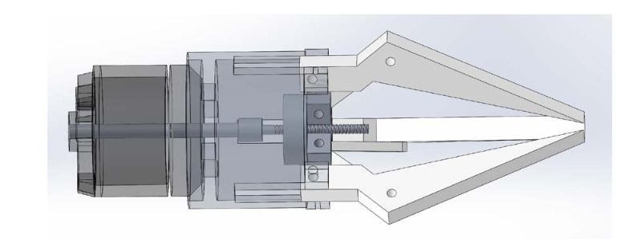
2.0 Concept Design Appraisal
The expected customer are going to be manufacturing companys that needs process that requires picking up products and reloacting them or orientating them ready for the next process, a example would be a company that makes bearings, this is a good example because bearings are small intregate products that are light enough to reposition or orientate in a good mannor.
The customer needs a product that is easy to use, cost effective, and universal to all different shapes, sizes and weights of products to be picked up. The product needs to repeat and reproduce its actions accordingly inline with the specific customer needs. Concidering this is just a concept design, the design could reach all aspect of customer needs by give it little tweeks. A good example would be to make the tips of the jaws have a radious instead of a flat point as this will help the jaw pick up more spherical products cause the product to before more adaptable to the design.
When it comes to Aesthetics, the product needs to have a good apperance to become eye catching to the consumer. The customer is going to wantr a product that looks heavy duty, industrial, mayble a bit of shine or colour. This concept design is very bland, basic and abit boring when it comes to the looks of the product, it would be high recommended to adda bit of colour to the Cylinder and Motor to give any onlooker a eye catching colour to look at,talioring the colours together could give the product a interesting name depending on what colours are chosen, a example of this would be to colour the motor Blue and the Cylinder red to give the product ‘The Spider Claw’. Could potentially give the jaws a machined or chromium look too them as shiney well looked after product do tend to become more eye catching.
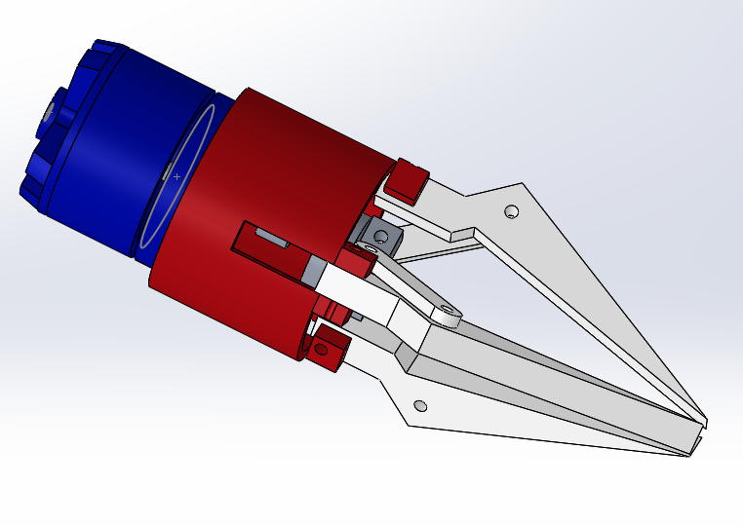

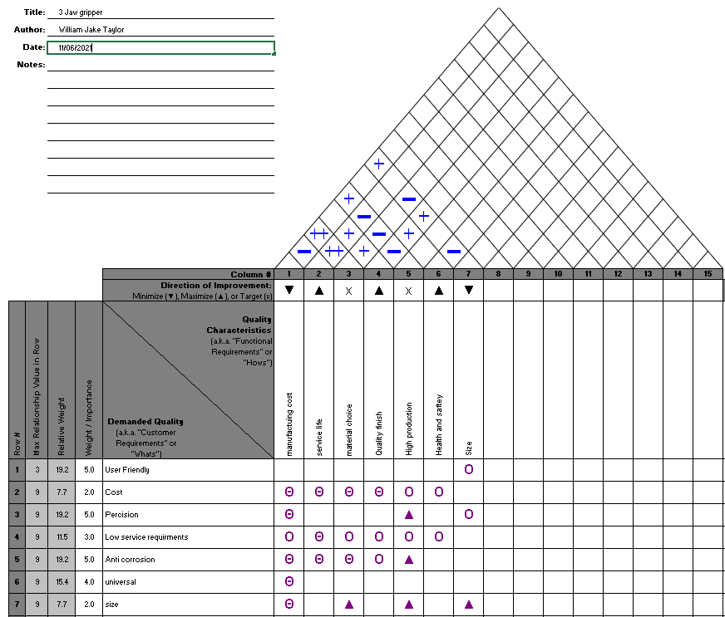A Quality function Deployment was conducted so a design specification can be created, a ‘House of Quality’ sheet needs to be conducted to establish what is the best route of process to go down in order to meet all customer needs and requirements, the Findings shown by the ‘House of Quality’ show that the process requires a high volume of production, good quality finish with a low cost, the 3 claw gripper need to have a good service life, a good size and be safe to use.
Considering the imformation gathered and extracted from the ‘House of Quality’, a Design specifacation was created to outline what are the over all requirements to produce , sell and meet the customer requirments. The specifacation overs the Target market, Funtions, Materials, Overall Size,Manufacturing proxesses, Product life span, Aesthetic appearanceand Quality assurance. Theses are the catagorys that give a overview for the product, its future and where to improve.

2.1 Design specification
Target Market: The target market will be consumers that are in the market for a 3 Claw Gripper, a customer that requires a gripper to relocate or orientate ojbects for their process
Functions: The Gripper will be simple, effective and modern looking. It will give reliable results and consistent accuracy, easy to use by all and have the ability to be universal across all products.
Materials: Materials required are the motor, cylinder, claws, drive plate, shaft, worm and join. Majoyrity of these sub assemblys will need to be bought in from external supplyers to reduce cost. The Claws are going made from stainless steel.
Overall Size:the Gripper will be manufacutred in one standard size but have the capability to funtion as if it is bigger.
Manufacturing processes:The claws will be casted to give tight tolorences, high production and high overal quality.
Product life span:Manufaturing to a high standard with frequent TPM to ensure ever product has the highest life span.
Aesthetic appearance: the claws will have a machined finished look to give it a pleasing look and the motor and cylinder will be painted to give as more eye catching look.
Quality assurance: dimensionally the product will be tested on a CCM machine and testing in a lab for mechanical properties to ensure the diamentions are within tolorance, mechanical properties will show how well it has been casted.
3.0 Manufacturing Process Proposal
3.1 Why Stainless Steel Casting?
The casting process is a highly productive and efficent process which meets the customer demand of 1000-2000 units per week, this process has the capability to have high accuracy, low machine work after cast and the tooling is relatively affordable compared to other casting processes. The cappability to have complex and intergate shapes and sizes with close tolernces that meet ISO 8062 CT5-CT6 level, the surface finish provides a smooth and bright finish crated a more aethetic look to the product, The output from the cast has high machineability.
With all things concidered, this manufacturing process to create the grippers will be the most cost effective and reliable process to meet all of the customer demands.
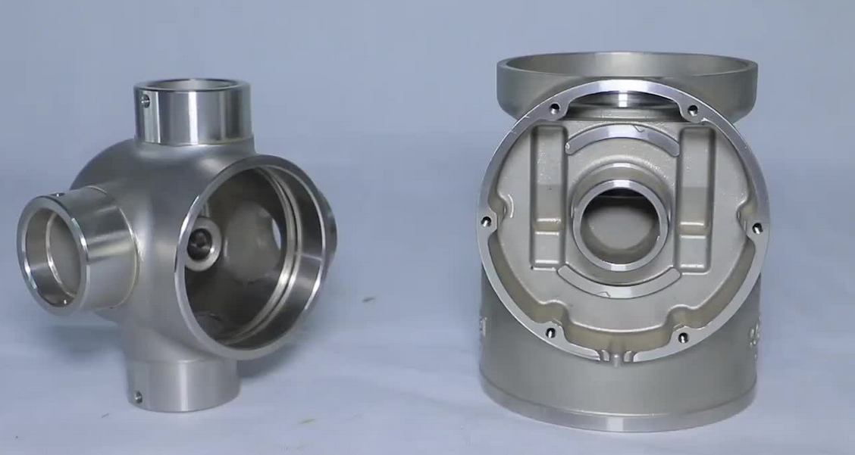

3.2 Stainless steel casting
Stainless steel has its characteristics of rust resistance, corrosion resistance and shining appearance, therefore, it is always preferred as the forming material of various metal products. Stainless steel casting, as its name implies, is the casting process of stainless steel alloys. Investment casting or lost wax casting, is the most precise casting method to manufacture stainless steel products, especially those irregular or complex structures, so stainless steel investment casting is almost equal to stainless steel precision casting. The whole casting stainless steel process contains several steps: mold making, wax model making, tree assembly, dipping and dewaxing, pouring, etc. (Stainless Steel Casting, 2021)
Stainless steel casting process has been chosen to manufacture the gripper jaws because, 304 stainless steel can be used , this is good because it is suited to loads of different product like:
- Medical
- food industry
- chemical industry
- mechanical equipment
- pipe industry
- automotive industry
- and more
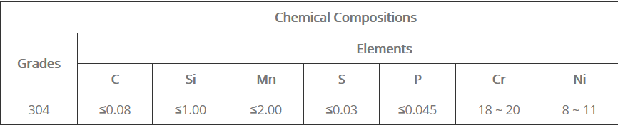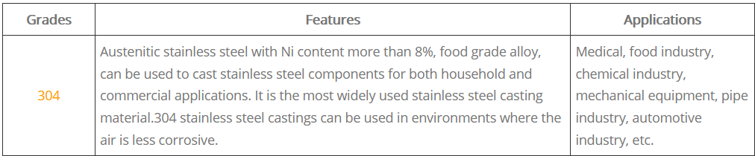
This opens up a wide range of potential customers and many different industrys. This material suports the design specifacation because it has a high proiorty to be universal to many different companys as the presure of the grips would be highly different compared to picking up a food product that requires a delecate grip to avoid crushing the product, than picking up pipe line products that require a stronger grip to withstand the weight of the product.

3.3 Surface Grinder
To achive the best finish to the jaws , a surface grinder will be used to give the product a aesthetically pleaseing shine to the jaws. This process will be performed and managed by a human operator as this will be more cost effective than buying a automated process. The LAY of the finish will be in a Vertical pattern all the way down the jaw.
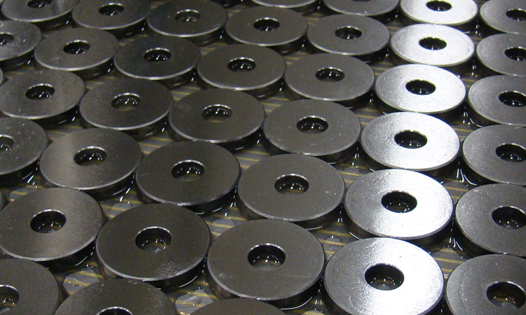

4.0 Design and Development Work Undertaken
4.1 Changes made
Although , it is belived that the basic concept is a well built , functioning 3 jaw gripper, some changes have been made to make the product more univeral to the customer. As the compasny is only fanufacturing the Jaws only these will be changed.
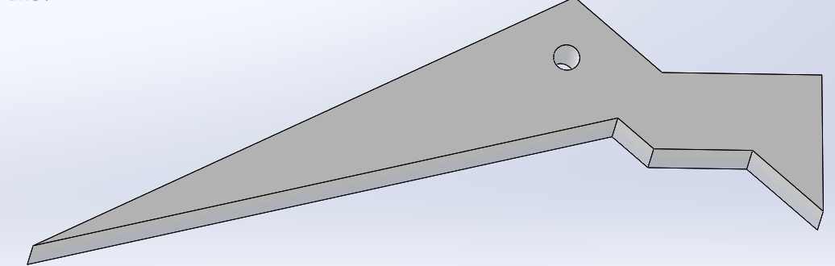
Grip face to be rounded inwards.
The face of the gripping area to be rounded at a very small radius to have the capability to pick up rounder obejects easier and more effectivly, From the tip end, up 10mm would have a ribbed face to increase the grip of the jaw. Both of these changes will be created in the casting process, the cylinder and motor will be bought in with the colour blue and red to give the product ‘The Spider claw’ for more aethetics and eye catching requriments.
These changes will provide the jaw with the capability to be more universal no matter what products its dealing with. Creating a product more univeral will ultimately will have better feedback and repitation to potentially bring in new customers.
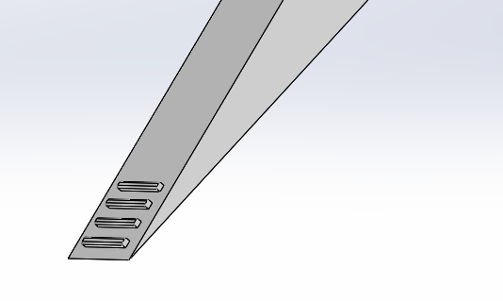

4.2 DFMEA
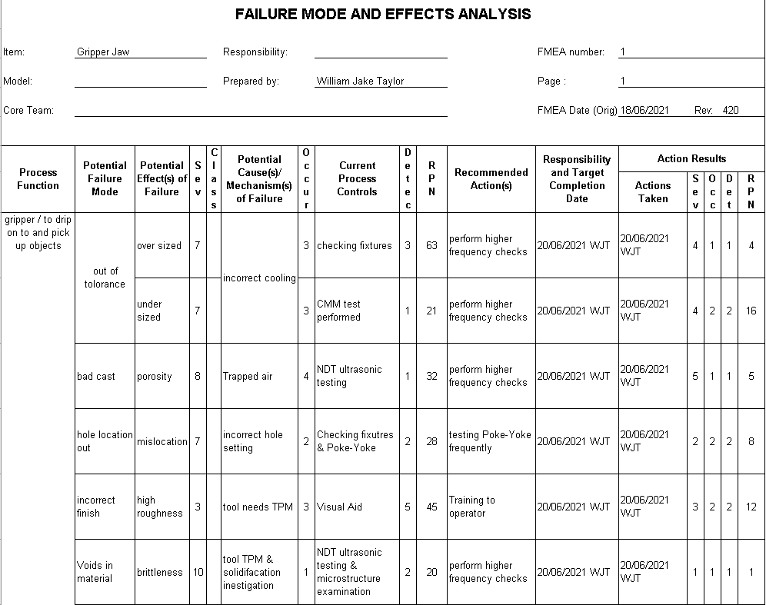

DFMEA was created to identify the potential defects and problems that can occure during the life cycle of the gripper Jaw, The casting process has high tolorances with good surface finish but, not all manufacturing processes are perfect. In this DFMEA, a number of problems were assessed, the parts being out of tolorance , bad casting, Hole out of location, Incorrect surface finish, Voids in the material.
Out of tolerance has been ranked as 7 for serveraty as this failure would cause high disatifaction to the customer as if the jaws have incresed in thickness, then they would not be able to retract in to the cylinder causing the grips not to grip anything, the potential causes of this can be related to the cooling of the material, if the material is not cooled enough, the material can shrink in size. To reduce the risk of these being sent to the custer, a Chekcing fixture has been put inplace as a quick over view check on the product. A CMM machine will be used to check these products on a less frequent check compared to the checking fixture. These to quality check will give the product a high detection to reduce failures going out the door. The recommended action is to increase the checks to a more frequent period to ensure that the process has good reproductability and reproducability.
Porosity has been ranked 8 as porosity can cause many material failures like brittleness , cracks and fatige. Hole misslocation has been ranked a 7 as this would cause the parts to be assembled wrong and therefor work incorrectly. Porosity can be detected by using a C scan ultrasonic tester, this NDT process works by sending a signal through the material , reflecting the signal off the back wall to recive it back in to the prob, if Porosity is in the way of the back wall, the signal will reflect off the Porosity giving a smaller thcikness reading.The usual failure to have porosity is trapped air within the tool with no where to go, so to pervent this, the dia tools will have TPM performed on a frequent basis to ensure all air vents leading in side the tool are all clean and open for the air to escape.
Hole miss location has been ranked 7 because it can cause misslocation to the assebly. If misslocatred, the jaw would not be able to open and close subsequently causeing the gripper not to function correctly and not pick any products up. This defect can be picked up buy using checking fixtures to give a good diamentional over view to the part, plus a Poke-Yoke can be installed to the proceses to detect the presence of the hole in the correct location. Frequent dummy tests will be performed on the Poke-Yoke to ensure that its functioning as intended.
Incorrect finish has been ranked 3 as this isnt defective but dose not meet the customers epectations, the expecations of the customer is to recive a shiney well finished product that is aesthetically pleaseing. Even though the aperance can be changed with the surface grinder, the process will take longer as it will need to grind off more surfance than intended, more energy and time will be consumed. To battle this , frequent TPMs will be performed on the tool to ensure there is no residual material left on the walls of the dia.
Voids has been ranked 10 as this a devastating defect that can occur, voids create weaknesses in the material make the jaws incredability brittle, over time the voids can generate micro cracks over time by fatigue to eventually fail. The tool reqires a TPM and a investigation needs to take place to find out what is causing the voids. This defect will be detected by NDT ultrasonic testing and microscopic examination and to ensure the products are safe, frequent checks will be performed on a daily basis.

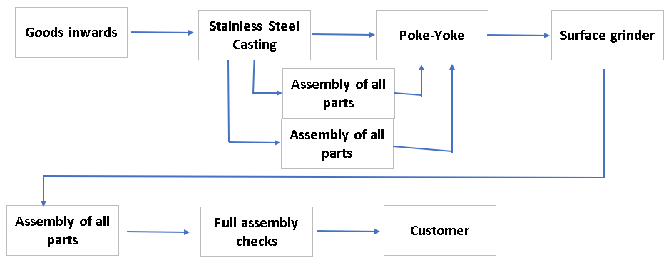
5.0 Manufacturing Process Design

Process Flow sheet was created to illistrate what the process will be when in full effect, From the DFMEA hourly checks are to be performed in line with the severity of the potential failures that can occure, along with CMM checks to ensure the diamentions of the jaws are up to standard. This process would be good for the company because the quality check being performed provide reassurance that the products being manufactured are safe, up to customer standard and reliable that the products output, is fully functioning.
6.0 Conclusion
In this report, a overview of what process would be would be suggested to be able to produce, manufacture and market the ‘Spider Claw’. If there was no constraints in any of the process, the entirety of the gripper would be manufactured in house, but concidering producing assebleing each and every part would require a lot of machines , high enviromental impact , much higher cost and the company would be very dependant on every machine operating, if one machine goes down then all operations after would be on stop, resulting in paying out wages. It is believed that the material selection is the best option as this material can be used in medical and food industries rather than normal steel because of its corrosion.

References
Bélanger-Barrette, M., 2015. Why Use a Robot Gripper with 3 Fingers?. [Online]
Available at: https://blog.robotiq.com/why-use-a-robot-gripper-with-3-fingers
[Accessed 05 May 2016].
Omega , 2021. pneumatic gripper. [Online]
Available at: https://www.omega.co.uk/prodinfo/grippers.html
Stainless Steel Casting, 2021. Stainless Steel Casting. [Online]
Available at: https://stainlesssteelcasting.net/stainless-steel-casting/

