Tia Willock (2514120)
12.11.25
L4 - Introduction to Web and Database Concepts
HTML & CSS Web Development

- Table of Contents:

Abstract
This report outlines the design, development, and evaluation of a gaming blog created to share knowledge and personal experiences about the evolution of gaming consoles. The site combines factual information with personal insights to engage gaming enthusiasts and those interested in gaming culture. It covers consoles such as the Leapster LMax, Nintendo 2DS and 3DS, PlayStation 2, and PlayStation 4, while exploring the cultural impact of newer releases and the transition from 2D to 3D gaming.
The development process included HTML and CSS validation to ensure compliance with web standards, resulting in error-free code. Evaluation focused on usability, accessibility, and SEO. Usability was assessed using ISO 9241-11 principles, highlighting clear navigation and consistent design, with recommendations for improved interactivity and content standardisation. Accessibility was reviewed against WCAG 2.1 guidelines using tools such as WAVE and colour contrast checkers, confirming strong contrast and keyboard operability, with minor improvements suggested for alt text and ARIA roles. SEO analysis identified effective use of meta tags and responsive design but recommended enhanced semantic structure and keyword optimisation.
A comparative analysis of PlayStation and Nintendo websites examined usability, accessibility, mobile responsiveness, and SEO. PlayStation demonstrated superior SEO and accessibility, while Nintendo excelled in mobile responsiveness and franchise organisation. Overall, PlayStation was considered the better option for a consistent user experience across platforms.

Introduction

My website was created to share knowledge and personal experiences about the history and evolution of gaming consoles. The goal was to make the blog both informative and enjoyable, combining both researched facts with personal perspectives showing how these consoles shaped gaming culture.

It explores how gaming shaped my life growing up. It provides background on consoles like the Leapster LMax, Nintendo 2DS and 3DS, PlayStation 2, and PlayStation 4, while examining the cultural impact of newer releases. It also looks at the shift from 2D to 3D gaming and how this change influenced game design. Alongside this, the site highlights some of my favourite games and series from each console, sharing interesting facts and personal insights to give readers both technical details and a personal perspective.

My website combines factual content with personal experiences to engage gaming enthusiasts and those interested in learning more about consoles and games. This choice is supported by research showing that gamers often participate in online communities and consume related content, such as blogs and reviews, to stay informed and connected [1]. Blogs also play an important role in gaming culture, with studies linking blog engagement to increased gameplay and purchasing behaviour [2].

Implementation

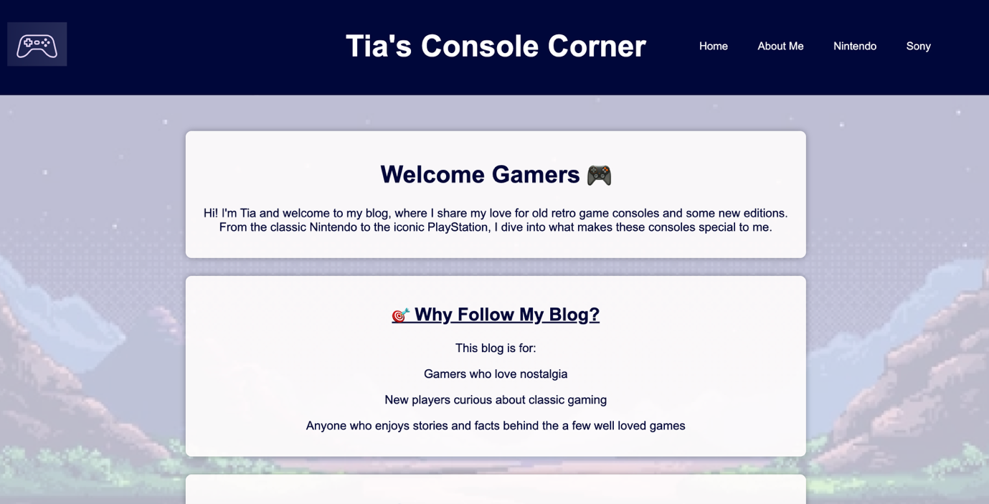
The Homepage
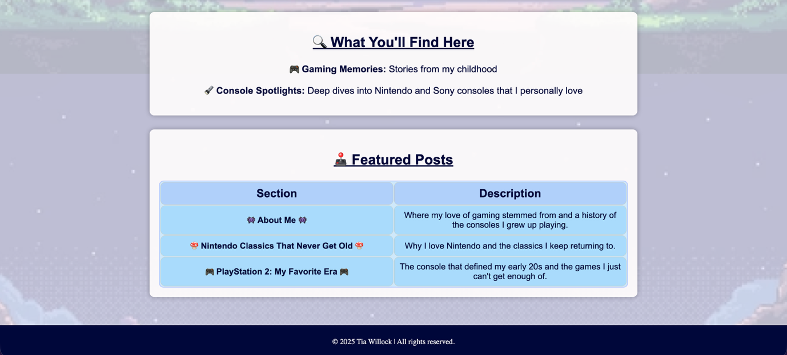

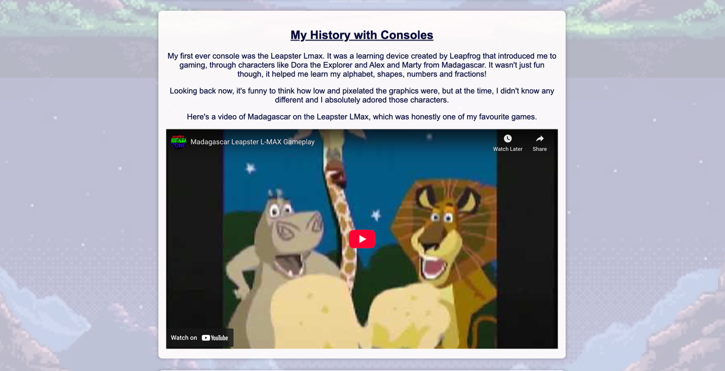
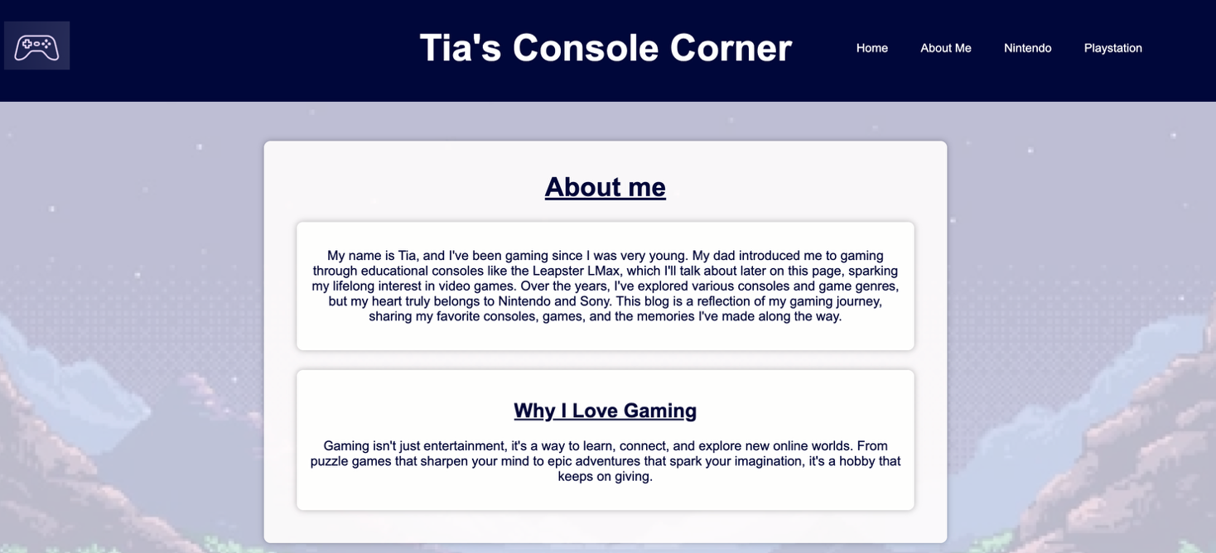
About me Page

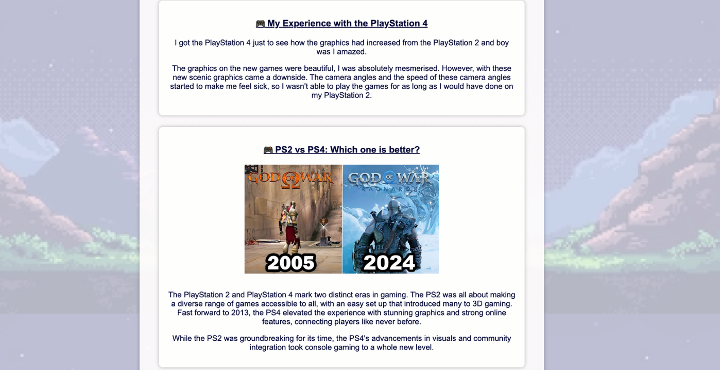
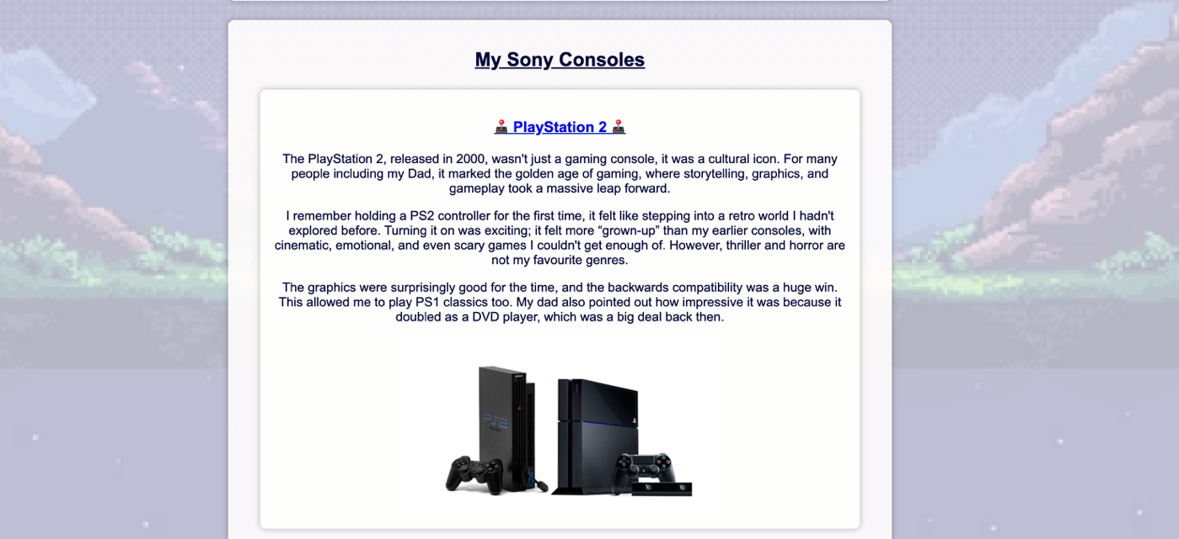
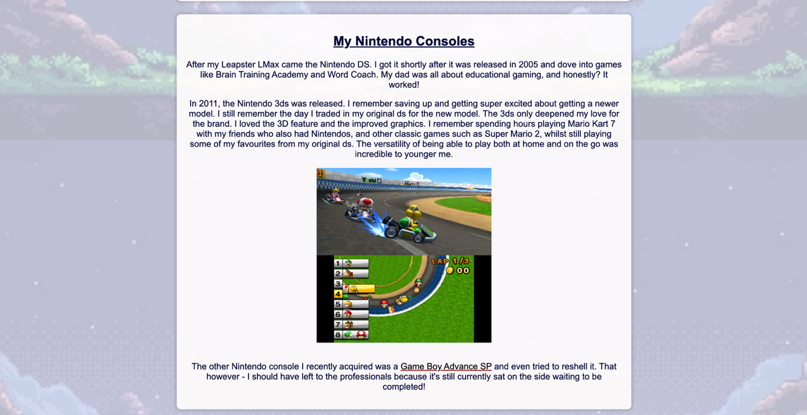
Nintendo Page
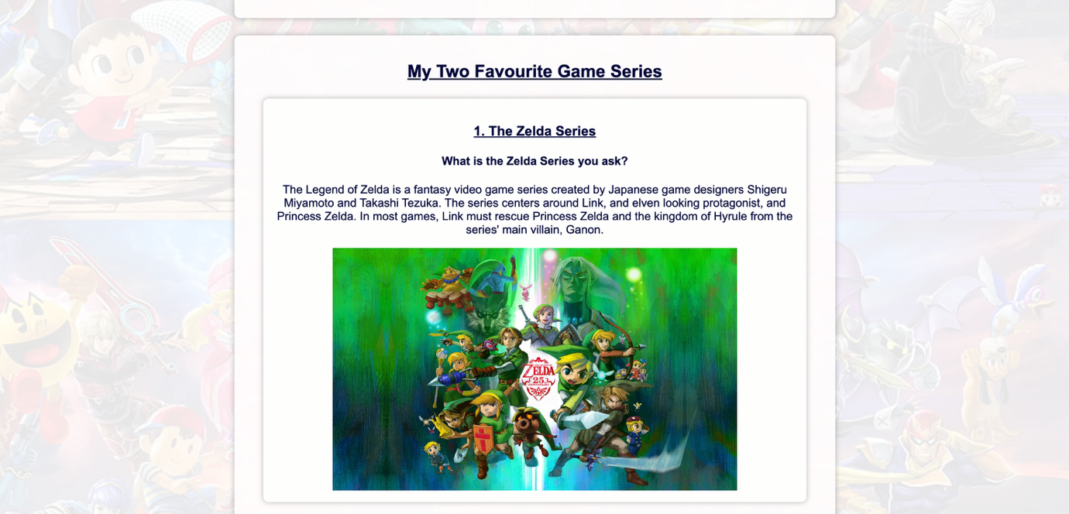
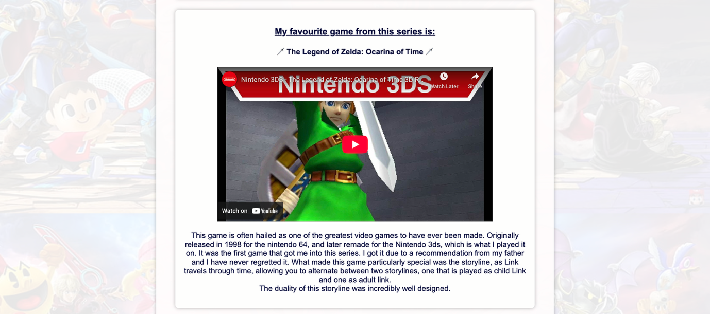
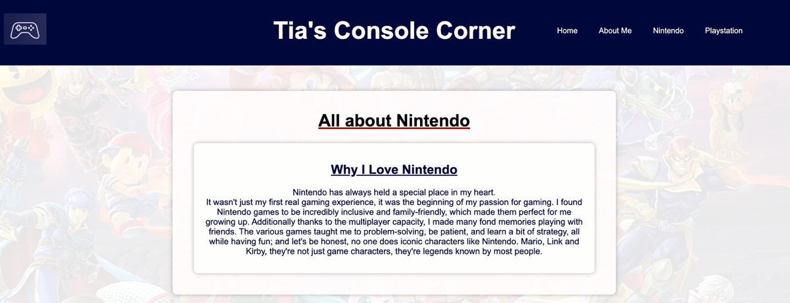

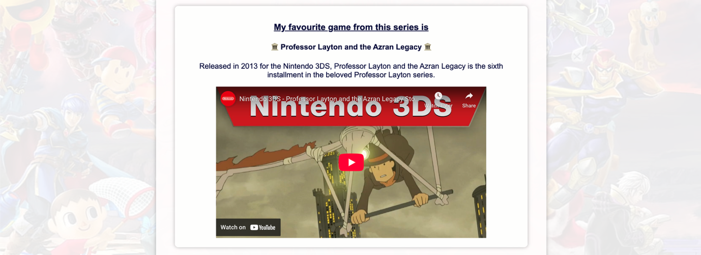
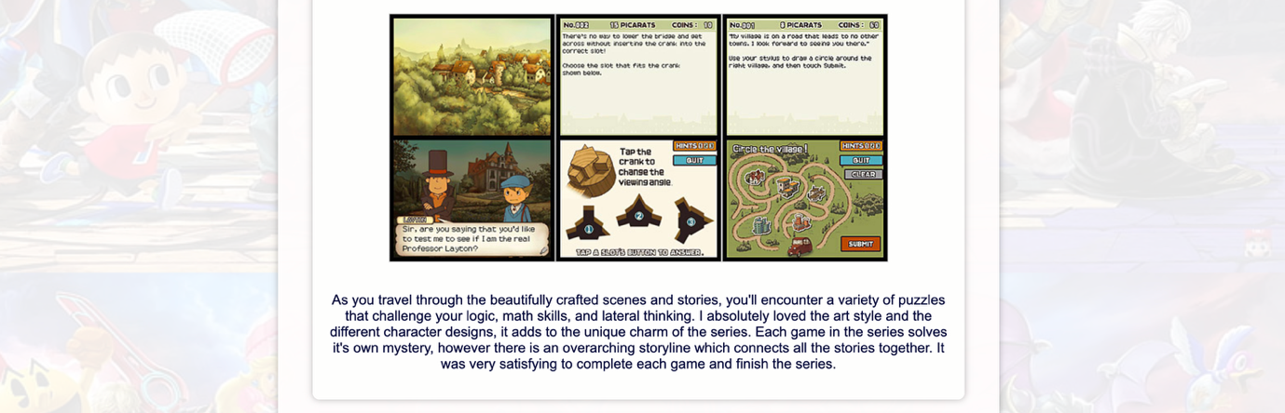
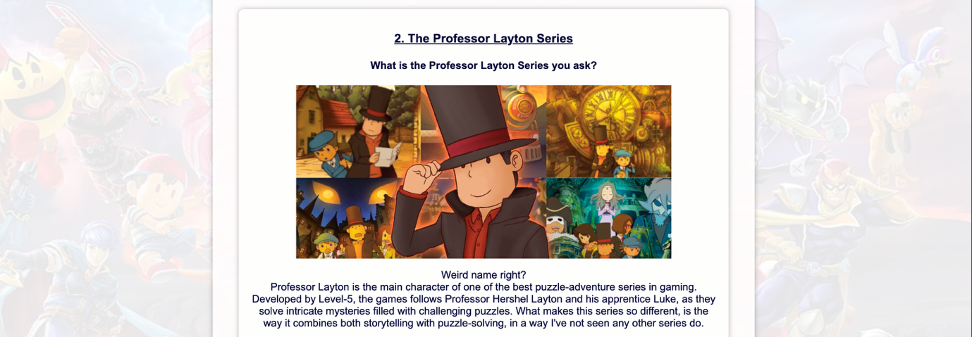
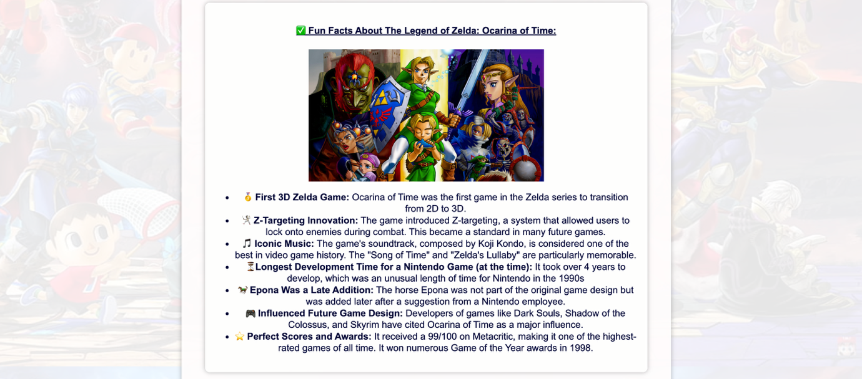
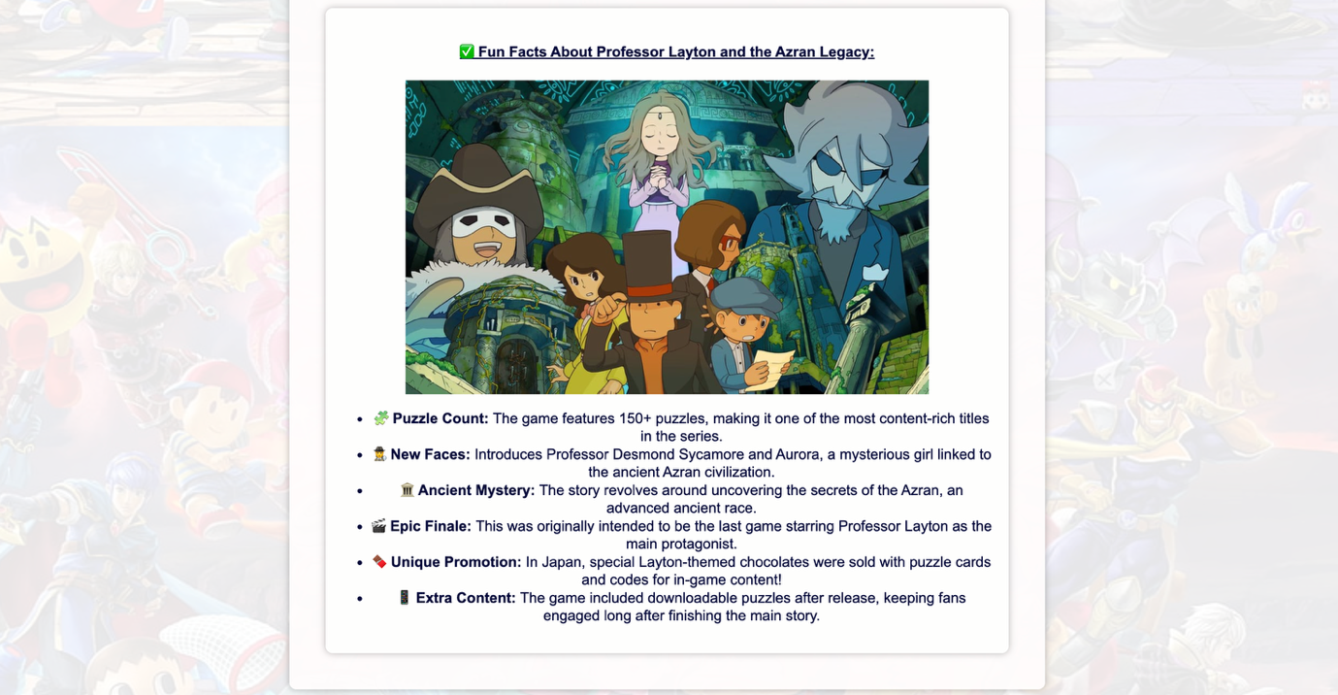

Sony PlayStation Page

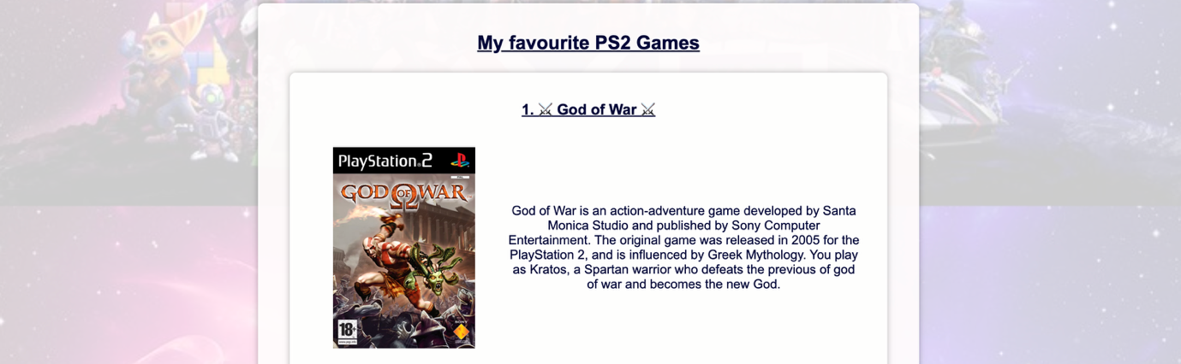
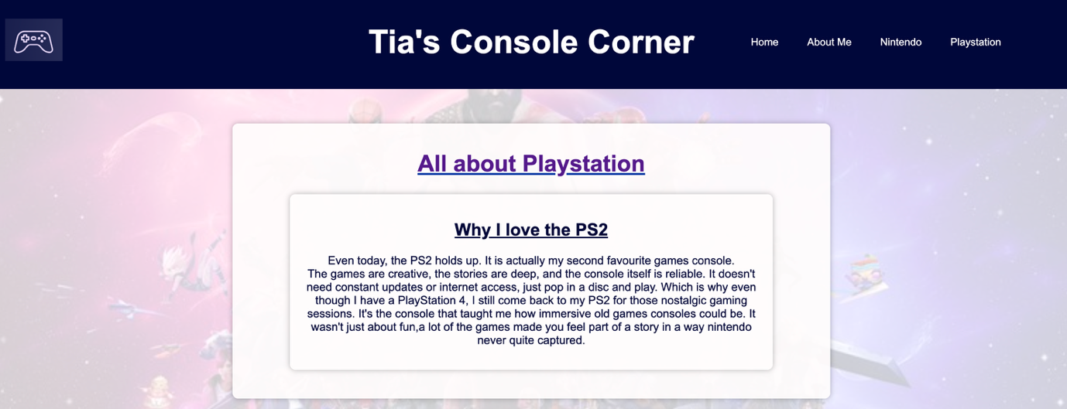
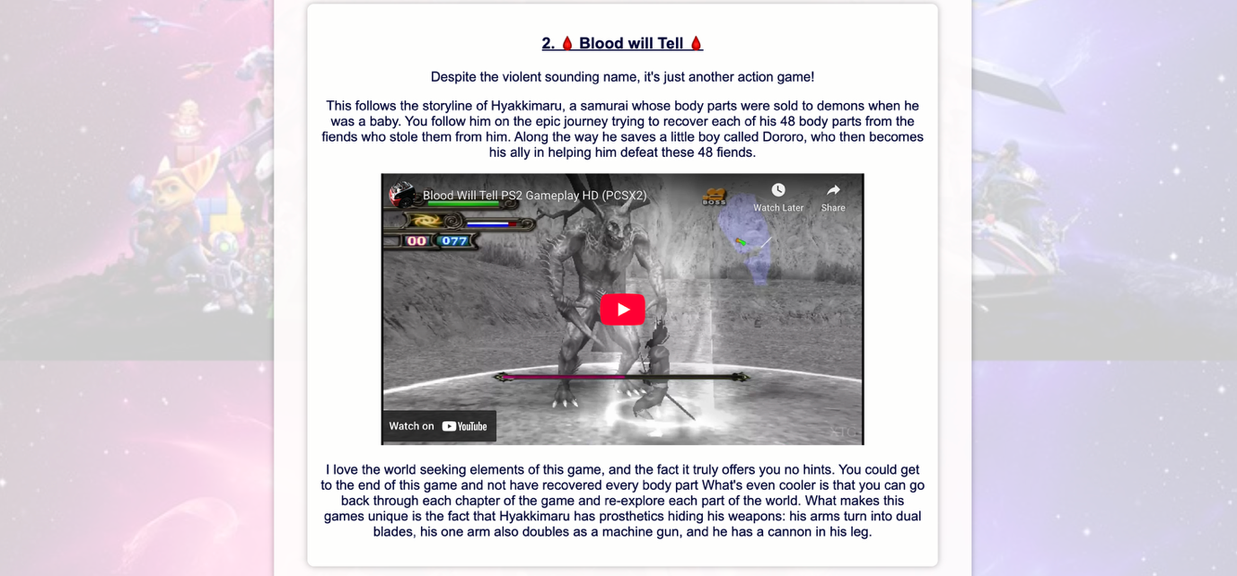
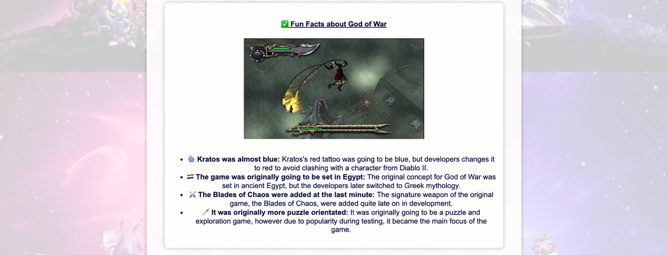
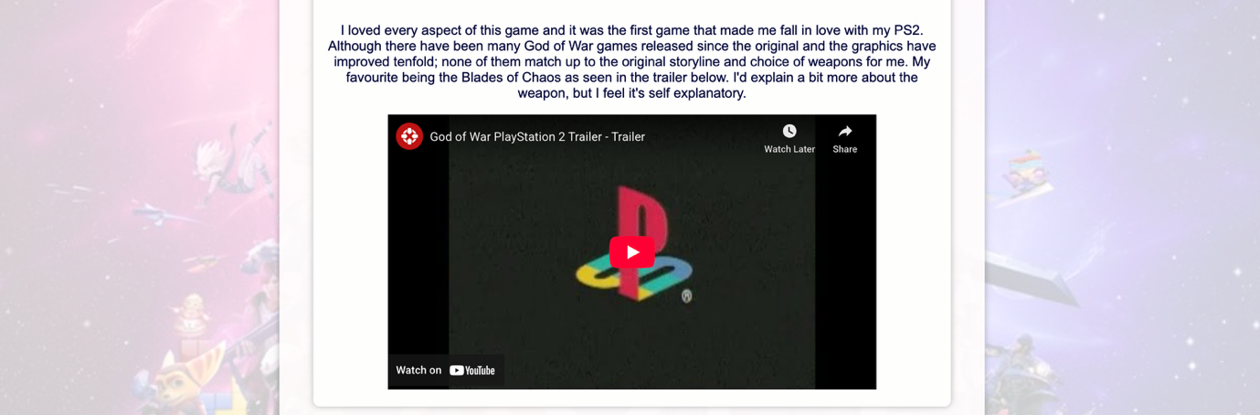
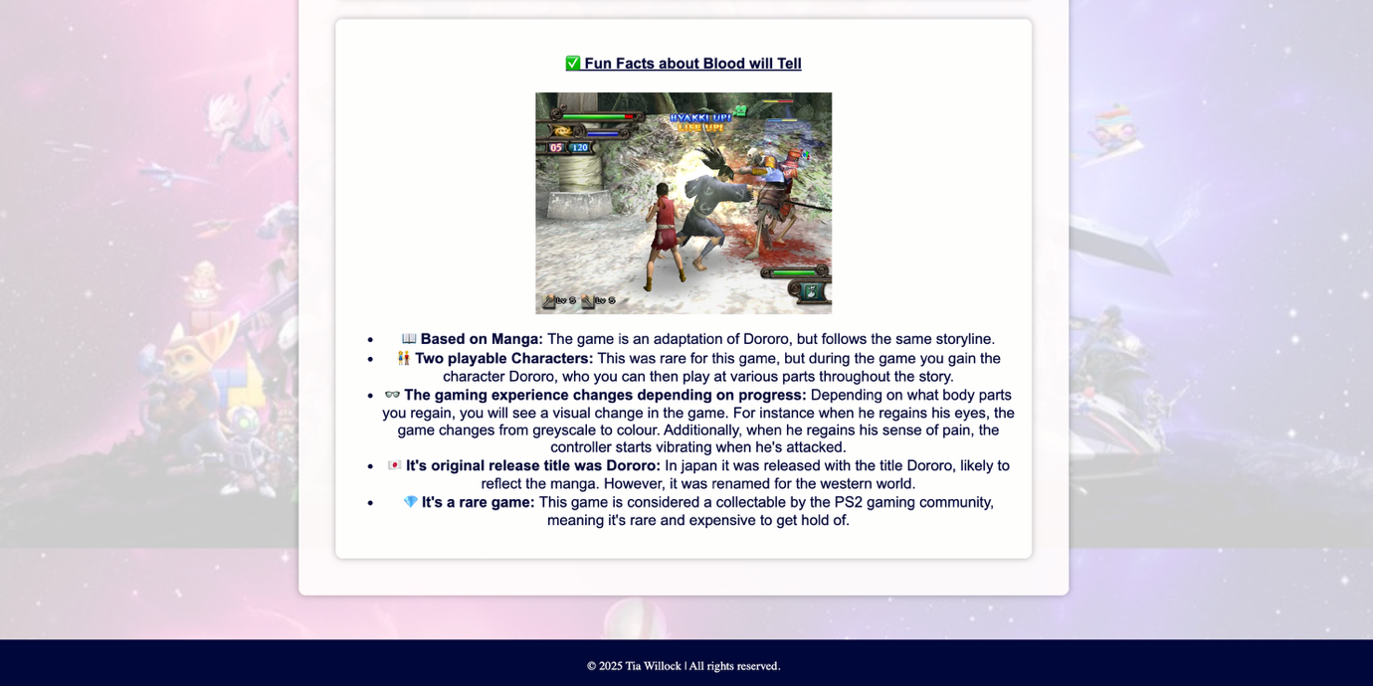

Validation

HTML Validation and Fixes

I validated the html of my homepage using the ‘http://validator.w3.org/’ website. I had four errors.
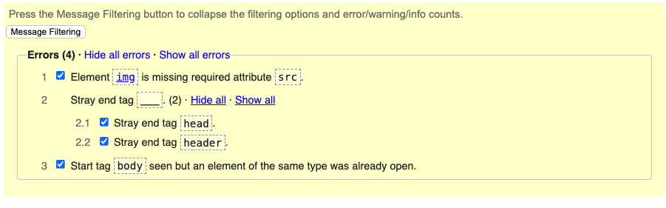
Fig 1. Errors found in my homepage html.

For the first error, I changed the <img> tag to a <div> because the validator required an img src attribute, but I was using a CSS background image instead. Moving to a <div> allowed me to keep the image styling in my CSS file without linking it directly in the HTML. Errors two and three were caused by placing the background image class inside the <head> section. I moved it into the <body> section, which resolved both issues. On multiple pages, I had used a div class for header instead of the <header> element. I replaced the <div> with <header> and updated my CSS selector from ‘.header’ to ‘header’ so the styling still worked. Additionally, I fixed missing <p> tags and removed extra closing <div> tags. Lastly, I removed the obsolete ‘frameborder="0"’ attribute from my <iframe> elements and added ‘border: none’ in my CSS instead. After making all these changes, the result for each page showed “No errors or warnings to show”.

CSS Validation

No validation was required for my CSS, as there were no errors.
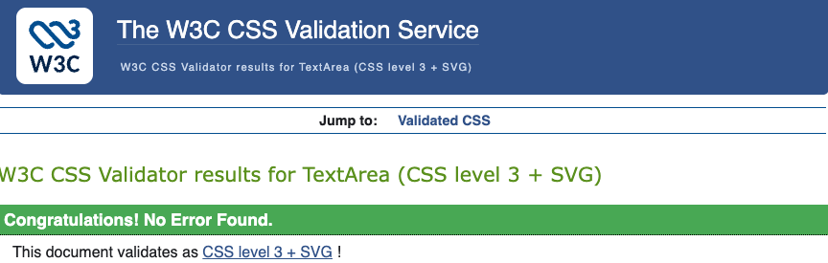

Fig 2. Validation of CSS on W3C website.

Evaluation

Website Usability
The International Organization for Standardization (ISO 9241-11) defines usability as “the extent to which a product can be used by specified users to achieve specified goals with effectiveness, efficiency and satisfaction in a specified context of use” [1].
Usability is vital in web development because it shapes user experience. A highly usable site reduces mental effort, prevents errors, and creates a positive experience that encourages return visits, while poor usability leads to frustration.
Ntoa [1] reviewed principles such as ease of learning, memorability, error prevention, and satisfaction, explaining how these are being adapted for responsive environments. The study found usability remains essential even as user experience expands to include emotions and context. Early testing reduces costs and improves flexibility, but the paper lacks real-world testing and clear developer guidelines.
Alexander et al. [2] showed cultural differences strongly affect usability. Heatmaps revealed Australian users prefer text menus, while Chinese users scan entire pages. The study highlights that universal design does not work; cultural factors must be considered. However, it assumes uniform preferences within cultures and focuses on opinions rather than performance, leaving practical issues like accessibility unaddressed.

Accessibility
Web accessibility ensures that everyone, including people with disabilities, can use websites equally. It means users can perceive, understand, navigate, and interact with content, as well as contribute without barriers [1][2]. Disabilities that affect web use include hearing, cognitive, neurological, speech, physical, and visual impairments [2].
Accessibility benefits all users, not just those with disabilities. For example:
- People using different screen sizes, from phones to TVs.
- Older adults with changes in vision, hearing, or motor skills.
- Users with temporary injuries or conditions.
- Situations with poor visibility or audio.
- Users with slow internet or limited bandwidth [2].
Research by Filipe, Pires, and Gouveia [1] emphasizes that accessibility is both a legal and ethical requirement. The paper includes five reasons why institutions should make web accessibility a priority. They conclude that it will allow the website to reach more customers, boost sales, improve overall quality, reduce legal risks and get ahead of the curve with legal accessibility requirements becoming stricter. They recommend following WCAG 2.2 guidelines to make websites perceivable, operable, understandable, and robust [3]. While the paper explains why accessibility matters, it relies on literature rather than real user testing, limiting practical insights.

Search Engine Optimisation

Search Engine Optimisation (SEO) helps users get relevant search results and, from a web development perspective, improves a site’s visibility on search engines, which is vital for attracting visitors and boosting rankings [1].

Bhandari & Bansal [1] found that effective SEO increases brand visibility and trust, leading to more visitors and higher sales. While the study focuses on marketing rather than technical implementation, it highlights SEO’s importance in overall business strategy and its role in guiding website design.

A recent study examined SEO practices in web development and their impact on visibility and engagement [2]. It identified three key strategies: on-page SEO (optimising content and HTML elements like titles and headings), technical SEO (improving site speed, mobile compatibility, and structured data), and off-page SEO (building backlinks and domain authority). Applying these during development resulted in higher rankings, increased traffic, and better user experience. However, the paper is mainly descriptive, lacks real-world case studies, and does not cover advanced techniques such as AI-driven SEO, making its recommendations potentially outdated as algorithms evolve.

Evaluation of the Completed Website

1. Usefulness (Usability and Utility)
The website demonstrates strong functionality with clear navigation links to four sections: Home, About Me, Nintendo, and PlayStation. The layout is simple and consistent, supported by uniform fonts and a colour scheme that enhances readability. The dark header with white text and light backgrounds with dark text provide strong contrast, meeting accessibility standards. Colourful backgrounds add personality without distracting from content, and the use of CSS properties such as clamp() improves readability across devices.
Each page is well-structured, incorporating headings, descriptive text, and multimedia elements like images and videos to engage users. Content is relevant and informative, combining technical details with personal insights, appealing to both gaming enthusiasts and new players.
To improve, a sticky header could be added for easier navigation on longer pages and external links could be more visually distinct to indicate interactivity. Additionally, interactive features such as polls or comments sections could be included to increase engagement. Furthermore, the content in each section could be a little more standardised so users know what to expect, for example, for each console, I talk about when they are released before talking about why I love them.

2. Search Engine Optimization (SEO)
Responsive design techniques, including clamp() and aspect-ratio, ensure mobile compatibility, improving user experience and reducing bounce rates. However, SEO can be enhanced by implementing HTML tags such as <main> and <section> to improve content structure for search engines. Additionally, while images include alt text, many descriptions could be more detailed to support both SEO and accessibility. Furthermore, the meta descriptions could be edited to better reflect the content of each page and include relevant keywords.

3. Accessibility (WCAG 2.1 Principles)
The website was evaluated against the four WCAG 2.1 principles and is believed to achieve most of the necessary points.

Perceivable: Text and background colours passed AA and AAA contrast checks using Accessible Web’s Colour Contrast Checker. Headings provide clear structure, and WAVE analysis scored the site highly (the lowest was 9.3/10), with minor issues related to alt text quality.

Operable: Navigation is keyboard-friendly, which is essential for users relying on assistive technologies. Interactive elements include hover states, providing visual feedback and reducing confusion. No autoplay elements are present, minimising cognitive load.

Understandable: Language is simple and consistent, avoiding jargon. To improve clarity, bullet-point summaries at the top of each page could help users quickly identify content.

Robust: HTML and CSS validation revealed no errors, and responsive design ensures compatibility across browsers. Further improvements include testing on multiple devices, adding semantic tags, and implementing ARIA roles for better screen reader support.

Comparison of PlayStation and Nintendo Websites

Comparison of PlayStation and Nintendo Websites
Usability:
The PlayStation website has a sleek, modern design with clear navigation and dropdown menus, making it easy to locate content. Each submenu is well organised, and the site provides detailed insights into games, news updates, and community features. However, finding older games is difficult and could be improved by adding an archive section for enthusiasts. In contrast, Nintendo uses bright, playful colours that reflect its family-oriented brand and organises games by franchise, which is intuitive for fans. However, its navigation bar is cluttered with overlapping links, such as Nintendo Switch 2 appearing under multiple tabs, similarly, franchise appears under multiple tabs; this can confuse users. Reducing duplicate links would improve clarity.
Accessibility:
PlayStation passes contrast checks on WAVE and Contrast Checker, meeting WCAG 2.1 standards for normal text. Nintendo’s red-and-white colour scheme fails AA and AAA contrast requirements for normal text, passing only for large text (AA18pt). The colour difference score of 405 confirms poor contrast. WAVE also flagged low contrast, although Nintendo scored 9.2/10 for overall accessibility impact. Both sites allow keyboard navigation, but PlayStation’s consistent contrast gives it an edge.
Mobile Friendliness:
Nintendo adapts well to mobile, retaining its full navigation and content in a scaled-down layout, making it familiar and easy to use. PlayStation’s mobile site removes key sections such as PS4 and services, focusing only on PS5, which limits usability and accessibility for users seeking broader content. This makes Nintendo stronger in mobile responsiveness.
SEO:
PlayStation publishes frequent updates, including game releases and news, and targets broad keywords such as “PS5 Games” and “PlayStation Store”, improving visibility. Nintendo focuses on specific keywords like “Nintendo Switch”, “Mario”, and “Zelda”, attracting targeted traffic but updating less often. PlayStation’s broader keyword strategy and regular updates likely result in better overall SEO performance.
Conclusion:
PlayStation leads in SEO and accessibility, while Nintendo excels in mobile responsiveness and franchise organisation. Overall, PlayStation is the better choice for a consistent user experience across platforms, although Nintendo’s mobile design and franchise-based navigation are strong advantages.

- References:
Here you will list the information sources (e.g. relevant journals, books, online sources and articles) that you have consulted and cited in the main body of your report. Use the IEEE referencing format.
8. Appendices
Cut and paste copies (text listings) of all your HTML and CSS at the end of your report.
(remember that appendices don’t contribute to the word count, so don’t worry of the total size of the report ends up being fairly large because of the listings!)

References
Introduction

[1] F.-C. Tseng, H.-C. Huang, and C.-I. Teng, “How Do Online Game Communities Retain Gamers? Social Presence and Social Capital Perspectives,” Journal of Computer-Mediated Communication, vol. 20, no. 6, pp. 601–618, 2015.
[2] M. Törhönen, M. Sjöblom, J. Vahlo, and J. Hamari, “View, play and pay? – The relationship between consumption of gaming video content and video game playing and buying,” in Proc. 53rd Hawaii Int. Conf. System Sciences, 2020, pp. 2648–2657.

for website usability
[1] S. Ntoa, “Usability and User Experience Evaluation in Intelligent Environments: A Review and Reappraisal,” International Journal of Human-Computer Interaction, vol. 41, no. 5, pp. 1–30, Sep. 2024, doi: https://doi.org/10.1080/10447318.2024.2394724.

[2] R. Alexander, N. Thompson, T. McGill, and D. Murray, “The Influence of User Culture on Website Usability,” International Journal of Human-Computer Studies, vol. 154, p. 102688, Oct. 2021, doi: https://doi.org/10.1016/j.ijhcs.2021.102688.

References for Accessibility
[1] F. Filipe, I. M. Pires, and A. J. Gouveia, “Why Web Accessibility Is Important for Your Institution,” Procedia Computer Science, vol. 219, pp. 20–27, Mar. 2023, doi: https://doi.org/10.1016/j.procs.2023.01.259.

[2] w3c_wai, “Introduction to Web Accessibility,” Web Accessibility Initiative (WAI), 2019. https://www.w3.org/WAI/fundamentals/accessibility-intro/#what (accessed Nov. 15, 2025).

[3] Government Digital Service, “Understanding WCAG 2.1,” GOV.UK, Oct. 10, 2018. https://www.gov.uk/service-manual/helping-people-to-use-your-service/understanding-wcag (accessed Nov. 15, 2025).

References

[1]. [7] R. S. Bhandari and A. Bansal, “Impact of Search Engine Optimization as a Marketing Tool,” Jindal Journal of Business Research, vol. 7, no. 1, pp. 23–36, Mar. 2018, doi: https://doi.org/10.1177/2278682117754016.

[6]
A. Pai, D. Mankame, B. Patil, and V. Dhavalgi, “International Journal of Research Publication and Reviews Exploring SEO Best Practices in Web Development: Enhancing Website Visibility and Traffic Introduction,” International Journal of Research Publication and Reviews, no. 5, 2024, Accessed: Nov. 16, 2025. [Online]. Available: https://ijrpr.com/uploads/V5ISSUE7/IJRPR31796.pdf.

