

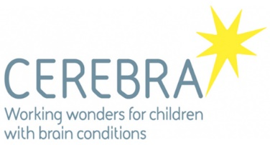

Inclusive water sports study using the Cerebra Standup paddleboard (SUP) adaptions: Health and wellbeing of families and communities.

Background information of the study

- It is well noted, physical activity can provide many health benefits. It has also been shown that participation has wider benefits than just physical health. For example, community and social benefits.
- It is vital in society that these benefits are accessible to all.
- Cerebra Innovation Centre is a collaboration between Cerebra and UWTSD. The team respond to requests from parents and carers, OT’s and teachers to design and develop equipment for children with brain injuries when there is not a suitable product available.
- The CIC team have recently developed an adaptive, seated/tandem paddle board.

Why do the study?

Working alongside Cerebra and additional community organisations (such as Windswept, Dale, Pembrokeshire). The purpose of this study is to explore the benefits and experiences of inclusive water activities for children with differing abilities, their families, and the wider community.

How are we going to research?

- Observations at Inclusive water activities sessions
- Impromptu conversations with all involved
- Blogs created by the Director of organisation (such as Windsept)
- Interviews with family members and wider community (such as teachers, town councillors and residents) and those running the inclusive sessions.

Confidentiality and withdrawal
- Anonymity: a false name or number will be used to code all data.
- Security: All data (interview recordings, blogs and observation notes are protected by digital password and authentication processes, following data protection protocols.
- Withdrawal: you may choose to withdraw any or all of the data relating to you, no reference will be made to you in this study or future published work.

If you have any further questions please feel free to contact me:

Lead Researcher: Dr Kate Piper

Email: k.piper1@uwtsd.ac.uk

Inclusive water sports study using the Cerebra Standup paddleboard (SUP) adaptions: Health and wellbeing of families and communities.

Consent form
After receiving information about the study, I wish to continue to participate in the research please fill in the below consent form:

I, ________________________________________________ consent to participating, as requested, in the research, lead by Dr Kate Piper.
- I have been fully informed of the research project and have discussed the research and future publication opportunities for the lead researcher.
- I agree to audio recording of the interviews and participation or to be quoted by the researcher during event observations.
- I understand that:
  - I will not benefit financially, or otherwise, from taking part in this research.
  - I am free to withdraw from the project at any time and free to decline to answer particular questions.
  - I will not be identified, and individual information will remain confidential.
  - I may ask that the recording be stopped at any time and may withdraw at any time from the session or the research completely.

Signature: Date

