EVENT FEASIBILITY STUDY
The White Lady festival
Rachael Rice
rrice.145610@student.uwtsd.ac.uk

Table of Contents
Executive Summary 2
Introduction 3
Background to Mumbles 3
Festivals 3
The White Lady festival 4
Market Demand 4
SWOT 5
PEST 6
Destination Analysis 7
Stakeholder Analysis 8
Operations 8
Impact Analysis 9
Conclusion and Recommendations 9
Bibliography 10
Appendices 12

Executive Summary
This is a feasibility study on the White Lady festival in Mumbles. Mumbles was once known for its drinking culture however now known for being the gateway to Gower and the best place to live in Wales. There are two events held in Mumbles annually; Here come Summer and Christmas in Mumbles. Festivals are held to give community pride and also a feel good factor. Festivals bring people together from different religious, economic and social backgrounds. The White Lady festival was held in Mumbles to create community pride but to also attract tourists to Mumbles.
Some types of visitor to Mumbles are younger wealthy professionals, mid income families with children and businesses. Having the host destination as Mumbles is a strength as Mumbles already has a significant amount of tourists. The festivals aims were too large for a small scale festival, the aims should have been to create a legacy to make this a lasting festival. Holding the White Lady festival during term time will give families the chance to attend. There needs to be more communication between the organisations as then the event planning can run more smooth and all involved will be aware of any issues. Keeping up with the trends such as veganism will bring a niche market to the festival. Using all forms of social media to promote the event will be a benefit as many different age groups will see the various posts. Mumbles has plenty to do for all ages as there are cafes, bars and a children’s play area there. There are many stakeholders involved with the festival and most of them can be contacted through weekly meetings to ensure there are no problems with any stakeholder.
There are things the festival needs such as lighting and staging that will not be found internally however the food and beverage suppliers can be found internally, saving some money. The festival cannot happen without the TENS license or the blanket street trading consent so whatever the cost they are both necessary for the event. The White Lady festival should consider working with the local market and the Gower chilli festival to provide more for their attendees. The festival should also be spread throughout Mumbles to offer the attendees the chance to explore the host destination more.

Introduction
A feasibility study is the first main document that is made from researching the possibility of an event, which then shapes an opinion on the expertise to host an event (Mallen and Adams, 2013). O’Toole (2011) states that a feasibility study is unbiased and the outcome will be positives and negatives which can be judged to decide if the event can take place. The study can be used in suggestion as a guide for any future events to be held.

Background to Mumbles
Mumbles is considered to be cosy and freethinking; often said to be the gateway to the Gower. Mumbles was once known for its drinking culture with things such as the Mumbles Mile prominent, however the Sunday Times have named Mumbles as the best place to live in Wales. There are high end and also handmade craft shops and surfing gear can also be purchased, also ideal for pampering and relaxation with award winning salons and spas. Food in Mumbles is also important, seafood fresh off the boat can purchased, local grown food with handmade chocolate (Visit Swansea Bay, 2019). Villages that are included in the community council are Mayals, Newton, Oystermouth and West Cross (Mumbles.gov, 2019). There are two events already held in Mumbles; the here comes summer event and the Christmas in Mumbles event- both events consist of live music and road closures.

Festivals
The main reason festivals are held is to create community cohesion and to increase the number of people visiting a specific area. Going to a festival for many gives them a feel good factor, making them want to revisit the same festival or give the desire to go to many different festivals. Festivals are they key to bringing people together, from different economic, social and religious backgrounds to create the same experience and memory. Getz (1991) states that events always tend to play a major role in the host communities.

The White Lady festival
The White Lady festival was a three-day cultural festival that was organised by Mumbles Community Council which consisted of various live music and local business served street food. There was also the It’s a Knockout game which was held on the Saturday afternoon, the game has been held in Mumbles over the last four years which was why it was added to the event. The idea of the White Lady festival for Mumbles gave a sense of purpose as it was something to bring the community together and something to keep the myth of the White Lady around. With 2018 being the Year of the Sea, it might have been a clearer idea to focus the idea on the sea rather than myths or legends which was the year in 2017.

Market Demand
In Mumbles there are 16,600 people living, 7,879 of them are male and 8,721 are female (see appendix 1). Out of the 16,600, there are 16,018 people who consider themselves white, 154 that consider themselves mixed/multiple ethnic groups, 262 that consider themselves Asian/Asian British, 30 that consider themselves Black/African/Caribbean/Black British and 136 that consider themselves another ethnic group (see appendix 2). From the overall population, there are 10,824 people that consider themselves religious, 4,598 consider themselves non-religious and 1,178 have not stated their religion (see appendix 3). There are 11,608 people in Mumbles that are aged between 16 and 74 and 7,217 of those people are economically active (see appendix 4) (Nomis, 2019). From researching these demographics, it can be seen which events would help Mumbles benefit as a community and benefit economically as well as seeing what kind of events would be best held for the people living there. In 2017, there were 4.6 million visitors in Swansea and £417.8 million was spent (Swansea.gov.uk, 2018). Some types of visitor include younger wealthy professionals aged between 25-45 years, mid income families with children, wealthy early retired couples aged 45+ years and also businesses and groups (Swansea Council, 2019).

SWOT
The strengths, weaknesses, opportunities and threats can be seen in appendix 5. First and foremost, having Mumbles as the host destination is a strength that can boost numbers on a smaller scale to begin with, as Mumbles already receives a significant number of visitors as well as community members who enjoy participating in their local events. Both of these things are already considerably useful for holding a local festival in Mumbles. The White Lady festival has plenty of community cohesion behind it from the early planning stages to the event being held, remembering how tightknit the community is could also help to achieve the right event for the area, but at a lower cost due to locals wanting to help out. The festival should involve local businesses to provide food and beverage to boost their profits but to also show the visitors to the festival what Mumbles has to offer in terms of locality and home-made produce; this could help in bringing people back year after year. The main weakness for the White Lady festival is that it has failed before, so people will be less likely to return if something is held again under the same name. Not having a contingency plan is another weakness due to not knowing what else to do if something fails or something unexpected happens. Starting with the idea of a larger scale event, set the event up to fail. This is a weakness as the event had bigger aims to try and achieve, before trying to create a memorable and enjoyable experience for all ages. Opportunities for the festival are the potential increase in tourism it could bring to Mumbles, benefiting the community and the local businesses. Holding the festival on a weekend during term time will give families an opportunity to attend before they go away for their summer holidays. Mumbles local market is held on the second Saturday of every month, so if the White Lady festival was held on the 7th-9th June, it would give opportunity to invite the market to join. The opportunity to develop the festival is always there, by trailing ideas on a smaller scale, there will be more chance to develop the ideas into a festival that is right for Mumbles. The White Lady festival has the opportunity to contribute to the local economy, and also in time the possibility to give back to smaller businesses and projects in the area. The pier development can be seen as both an opportunity and a threat. The opportunity comes from the number of new members to the community and how they could get involved in future local activities however, the threat comes from the possible future lack of investment in other projects due to the £35 million redevelopment plan. The weather is threat to any festival due to attendees changing their mind depending on the weather; however, the change in weather is inevitable. Any festival or event held at the same time is a threat due to people deciding to go to a different event, by holding the White Lady festival on a weekend where nothing else is planned it is more likely that people will attend. An entertainer or food and beverage provider cancelling on the event last minute is a smaller threat, as the entertainment from someone else can go on longer, and the food and beverage servers will have more customers if other providers do not turn up.

PEST
Brexit plays a big part in the politics for holding an event anywhere. With the deal or no deal Brexit looming, people are unsure whether they will be able to go abroad for their holidays, or if they will be made to stay in the UK. This can be seen as positive for the festival as more people could be at home to spend their disposable income at the festival. However, it can also be seen as a negative if the festival needs to get anything from the EU for example, as this could not happen leaving the festival not complete. To hold an event and make it successful there needs to be levels of communication between all persons involved. There needs to be more communication between Mumbles Community Council, Friends of Oystermouth Castle, Mumbles Development Trust, City and County of Swansea and the Oystermouth Castle development manager Erika Kluse. If there was more communication between all of these parties involved, the planning for the event could run more smoothly and all parties would know about any changes that need to happen in the event. Economically, the pound is crashing. People are deciding to spend their money on memories and experiences rather than buying cars or holidays. This can be good for the festival as families are more likely to come spend money and make memories. The White Lady festival will bring more tourists to Mumbles, from the increase in tourism comes an increase in spend; local businesses in Mumbles will benefit from both. The festival will bring the community together from planning the event, to helping out in the event or even just attending. Community is important to Mumble, so helping out by donating chairs will increase the participation; bringing a feel-good factor for the residents in Mumbles. Keeping up with the trends could bring a more niche market to the festivals, trends such as buying local grown food, buying from small businesses or veganism. By using the local businesses in Mumbles to bring the trends, it is also showing what the businesses have in Mumbles. An aim of the White Lady festival should be to compliment other festivals in the area such as the Gower chili festival. If the two festivals can collaborate there could be new markets going to both festivals, creating more income. Developing a free mobile application that has live updates, the programme and a map on would be more cost effective than printing out them out separately. Event organisers can also set up notifications to come from the app to inform the attendees what act is on next. Using social media to promote the event is another cost-effective way to reach different audiences. There could be competitions run for both attendees and businesses to see who can share the post to be seen the most, and if they win they get a free ticket. There is Facebook, Twitter and Instagram to share the event on and by using the different kinds of social media, information can be shared in three different ways. Facebook can be used to share the longer information packed posts, Twitter can be used to share short snip bits of what is happening in the event and Instagram can be used to share pictures of the event grounds coming together. If a hashtag was to be created and people were told to use it, all the pictures would be together and could be posted to social media for people to see. If the event organisers use Eventbrite or Fatsoma to sell the tickets they can be shared onto the social media pages, making it simpler for attendees to purchase tickets. Eventbrite and Fatsoma can be connected to Spotify or Apple music and the organisers can sync up the performers to the page, giving the ticket buyers a sample of what will be at the event (appendix 6).

Destination Analysis
Mumbles has plenty to do for all ages. From the two events that are already held in Mumbles, it is shown that road closures are possible. There are pubs, bars and cafes which varying ages can go into, as well as there being hotels and B&Bs in the area for people to have a small holiday. Oystermouth Castle is in the centre of the town, with easy access to shops. Underhill park is located close to Oystermouth Castle and would be a perfect venue for the festival.

Stakeholder Analysis
Goldblatt (1997) states that “stakeholders are individuals or organisations who invested in the event”. Primary stakeholders could be involved either financially or in service. Primary stakeholders include employees, suppliers and customers. Secondary stakeholders do not usually have direct interaction with the organisation. Secondary stakeholders are however important to the project.
The primary stakeholders that are organisations can be contacted through meetings. A committee meeting with the organisers is an effective way to get different ideas into a space where everyone can add to them. By holding weekly meetings before the planning process begins, the primary stakeholders all have an idea of what the festival will be. Erika Kluse needs to be having weekly meetings also, as everyone needs to be kept up to date with any changes in the festival. Customers can be contracted by emails informing them about the event, various social media posts and posters or flyers around the community. Volunteers can be contacted through social media to start with, and when it gets closer to the event they should be receiving emails. Near to the event, the volunteers should be having meetings and visits to the venue to make sure they all know what they are doing and where they should be going. The food and beverage suppliers can be contacted by email and phone call, then closer to the event date meetings will be necessary; to discuss where they want to be pitched throughout the event. UWTSD Swansea and Swansea University can be contacted by email and regular visits to the venue with the option of discussion if they can come up with any sensible changes. Visit Swansea Bay should initially be contacted by email to decide what is to be put on the website, and then by email or phone call to finalise the advert. The entertainment for the festival can be contacted by email to question if they can perform and then to confirm the performance and if required a visit to the venue. Local businesses can be contacted through a community meeting to find out who would like to participate in the festival (appendix 7).

Operations
Ground hire for the festival can cost nothing if the event is moved to a different location. Security will be needed for the event due to alcohol consumption. The beer tent and food stalls can be from businesses within the community. The entertainment can be from local bands or from university students in a band or DJ’s. Waste collection can be from another set of volunteers or can be from people in the community wanting to help out. The cost for Eventbrite/fatsoma is not calculated as they take a percentage from the ticket sales. All the other items are needed for the festival and cannot be resourced internally. Both the TENS license and the blanket street trading consent are needed to be able to have entertainment, serve alcohol and sell food; there is no way to hold the festival without either of these (see appendix 8).

Impact Analysis
Azmat et al (2014) declares that through cultural events there can be a sense of closeness that is created. Durbarry (2002) states that there is a positive connection between tourism expansion and economic growth, which allows for smaller local businesses to be formed. Some social impacts that could occur from the festival is community pride, and the Mumbles community being proud of an event that was held there. Langen & Garcia (2009) say that it is possible that the community’s landscape could be damaged; environmental impacts of the event are the pollution that could come from the waste being left behind, or the grounds in the castle being damaged due to people walking on it. Economic impacts of the festival include bringing tourists to the destination and bringing them back year after year.

Conclusion and Recommendations
To conclude, it is believed that by making changes to the White Lady festival, it is possible to create revenue and a lasting event for Mumbles. From the market demand section, it is shown that there is a wide demographic of people living there; a cultural festival is something that will help the community. Community cohesion in Mumbles is solid and is also something that needs to be considered every time an event is planned there.
The White Lady festival should look into holding their festival the same time as the Mumbles local market is on, which is the second Saturday of every month. By doing this they are offering the attendees something different and also giving them an insight into what Mumbles market is like. Changing location from Oystermouth Castle to Underhill park will keep the expenditure lower, as holding an event in Underhill park is free. There will also be more space in Underhill park than in Oystermouth Castle meaning traders can have more space; and more space for customers to walk around. There are two nearby universities that can be used to find musical performers for a cheaper price, possibly even for free. There are choirs, DJ’s, bands and even literature performers all available in the area, would also keep the expenditure down. If it is raining during the White Lady festival the acts should be moved onto nearby pubs, cafes and bars. By doing this Mumbles is being used for what it has, and there is no need to cancel the festival. The White Lady festival should be spread into different areas through Mumbles, as this gives visitors a chance to explore Mumbles before going to enjoy the festival in a different location. There could be buses to take attendees to and from various locations to make the event more sustainable.

Bibliography
Azmat, F., Fujimoto, Y., Rentschler, R (2014). Exploring cultural inclusion: Perspectives from a community arts organisations, Australian Journal of Management
Durbarry, R. (2002) The economic contribution of tourism in Mauritius, Annals of Tourism Research, vol 29, issue 3, pp 862-865
Erfurt, R.A., & Johnsen, J. (2003). Influence of an event on a destination’s image- the case of the annual meeting of the World Economic Forum (WEF) in Davos/Switzerland, Tourism Review, vol 4, issue 3, pp 116-125
Getz, D. (2012) Event Studies Theory, Research and Policy for Planned Events, Routledge: UK
Getz, D (1991). Festivals, special events, and tourism, New York, New York: Van Nostrand Reinhold
Goldblatt, J (1997). Special Events: best practices in modern event management, 2nd Ed, New York, New York: Van Nostrand Reinhold
Jani, D., & Philemon, J (2016) Comparison of local and international festival attendees’ motives and perception of festival impacts: Case of Sautiza Busara, Event Management, vol 20, issue 3, pp 341-351
Labour Market Profile – Swansea. Available online at https://www.nomisweb.co.uk/reports/lmp/la/1946157393/report.aspx?town=mumbles . Accessed 13th January 2019.
Langen, F & Garcia, B. (2009) Measuring Impacts of Cultural Events: A Literature Review, Impacts 08: European Capital of Culture Research Programme
Legendary Food & Drink. Available online at https://www.visitswanseabay.com/inspirations/legendary-food-drink/ . Accessed 12th January 2019.
Mallen, C. and Adams, L. (2013) Event Management in Sport, Recreation and Tourism: Theoretical and Practical Dimensions, 2nd Ed, UK: Routledge.
McCrum, K. (2015). Gower Chilli Festival turns up the heat for the fourth year (online). Available at https://www.walesonline.co.uk/whats-on/food-drink-news/gower-chilli-festival-returns-fourth-8812398 . Accessed 12th January 2019.
Mumbles Community Council. Available online at https://www.mumbles.gov.uk/ . Accessed 17th January 2019.
Mumbles Pier plan backed by defiant Swansea councillors. Available online at https://www.bbc.co.uk/news/uk-wales-46109628 . Accessed 22nd January 2019.
Mumbles. Available online at https://www.citypopulation.de/php/uk-parishes-wales.php?adm2id=W04000583 . Accessed 16th January 2019.
Mumbles. Available online at https://www.visitswanseabay.com/destinations/mumbles/ . Accessed 14th January 2019.
Nomis- Mumbles parish. Available online at https://www.nomisweb.co.uk/reports/localarea?compare=1170221838 . Accessed 21st January 2019.
O’Sullivan, D., & Jackson, M.J. (2002) Festival tourism: a contributor to sustainable local economic development? Journal of Sustainable Tourism, vol 10, issue 4, pp 325-342
O’Toole, W. (2011). Events feasibility and development: from strategy to operations, Amsterdam: Butterworth- Heinemann
Ramsey, M (2018) The White Lady Festival 2018 review (online) Available at https://www.mumbles.gov.uk/wp-content/uploads/2018/10/The-White-Lady-Festival-Review-2018-FINAL-Edited-SH.pdf . Accessed 15th January 2019.
Tourism research and statistics. Available online at https://www.swansea.gov.uk/article/6406/Tourism-research-and-statistics . Accessed 15th January 2019.
Williams, C. (2018) The White Lady Festival (online) Available at http://www.enjoyswanseabay.com/the-white-lady-festival/ . Accessed 15th January 2019.
Youle, R. (2018) Mumbles council is accused of ‘squandering’ £26,000 taxpayer cash on ‘washout’ event (online) Available at https://www.walesonline.co.uk/news/wales-news/mumbles-council-accused-squandering-26000-15007524 . Accessed 15th January 2019.
Youle, R., & Dalling, R. (2018) How Mumbles went from just a mile of pubs to the best place to live in Wales (online). Available at https://www.walesonline.co.uk/news/local-news/how-mumbles-went-just-mile-14602891 . Accessed 14th January 2019.

Appendices

Appendix 1
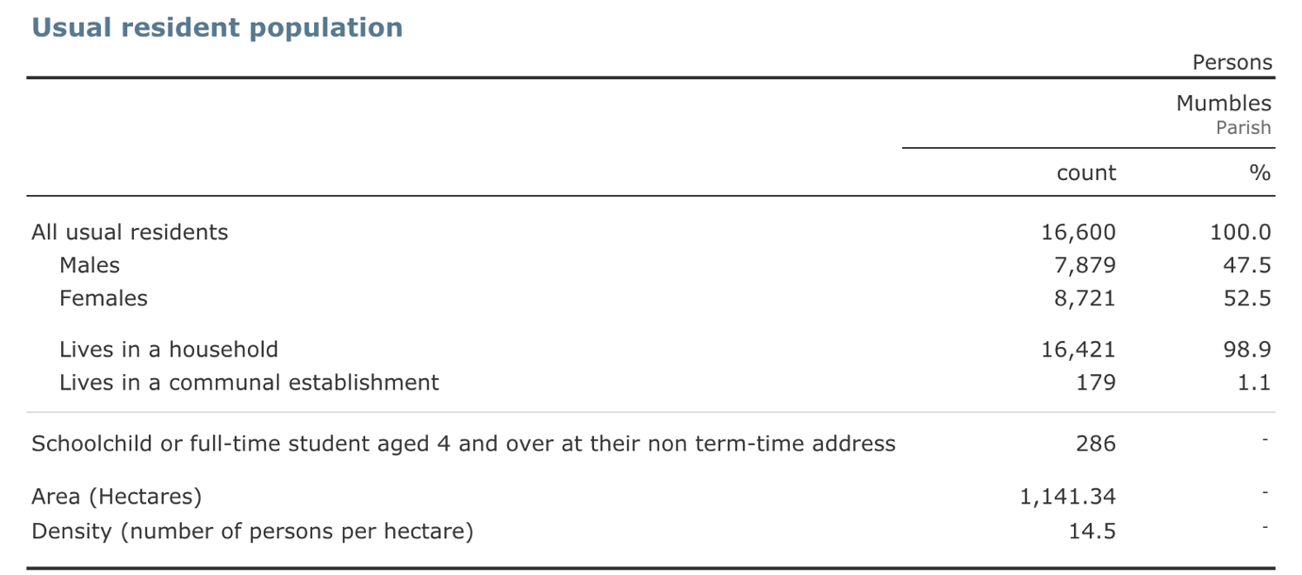
Appendix 2 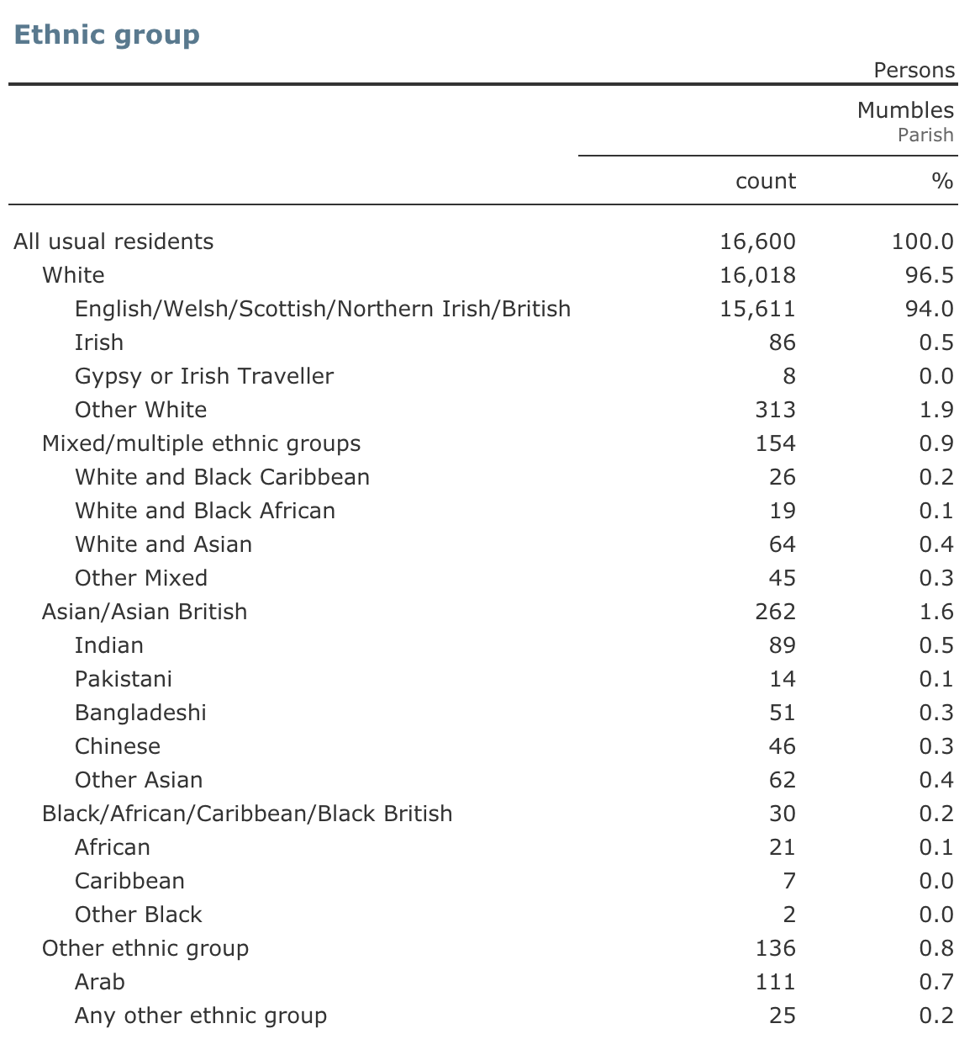

Appendix 3

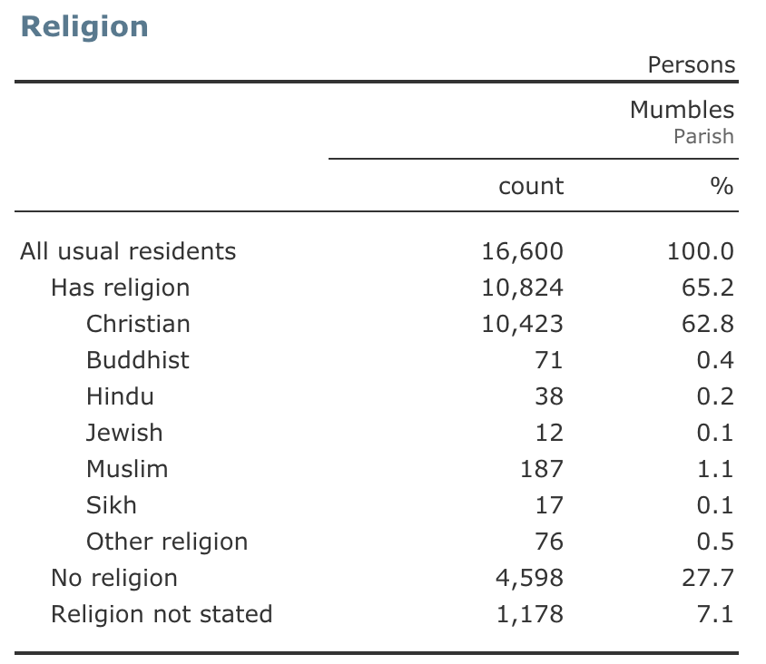

Appendix 4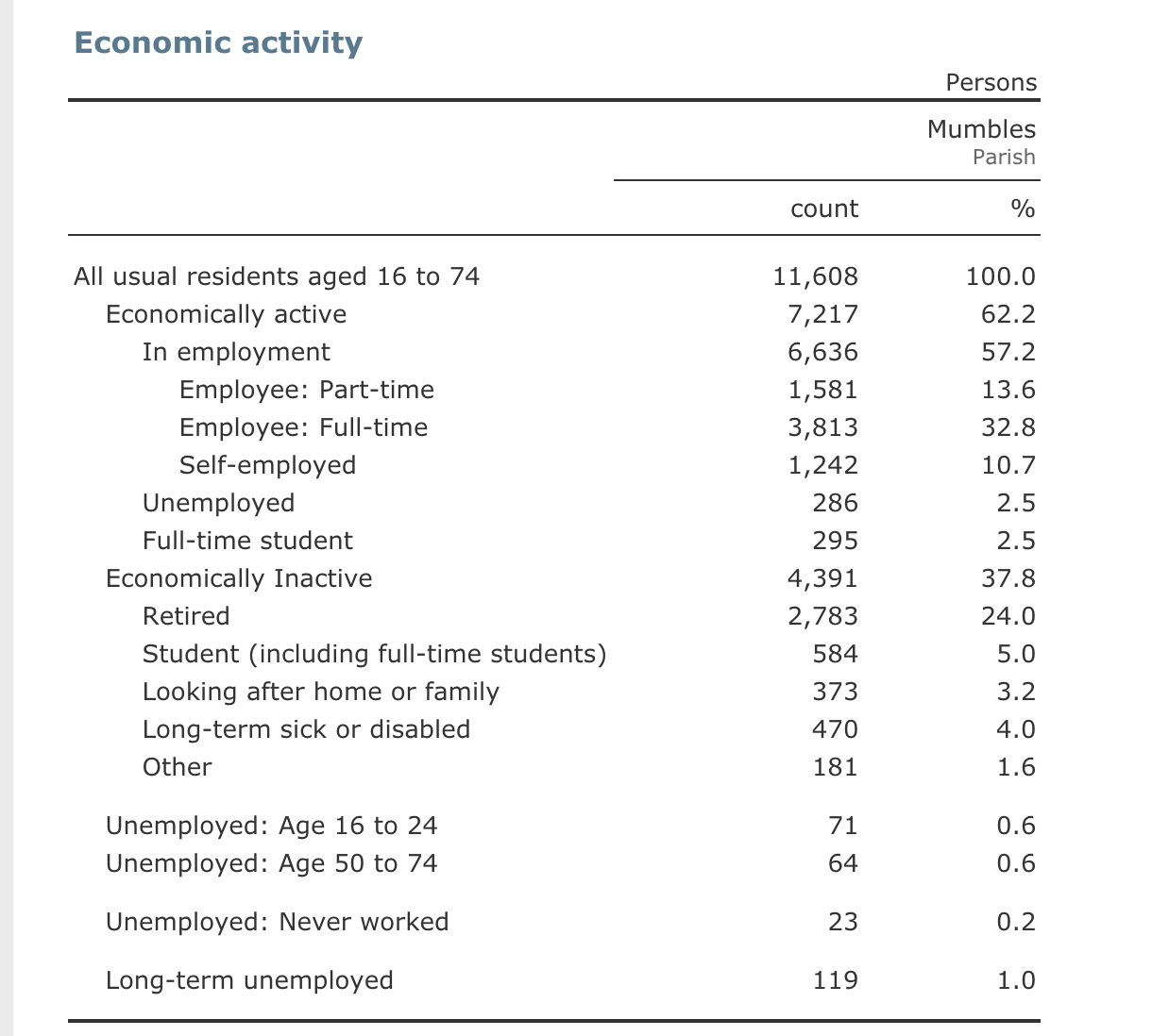
Appendix 5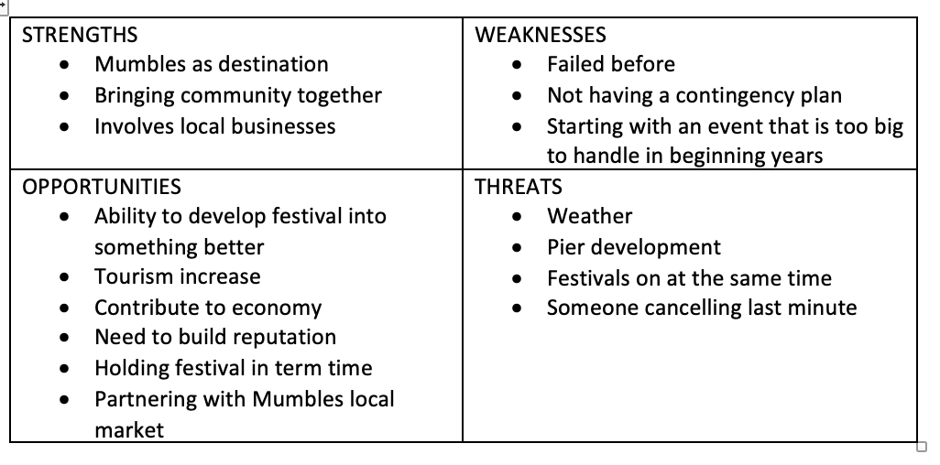
Appendix 6
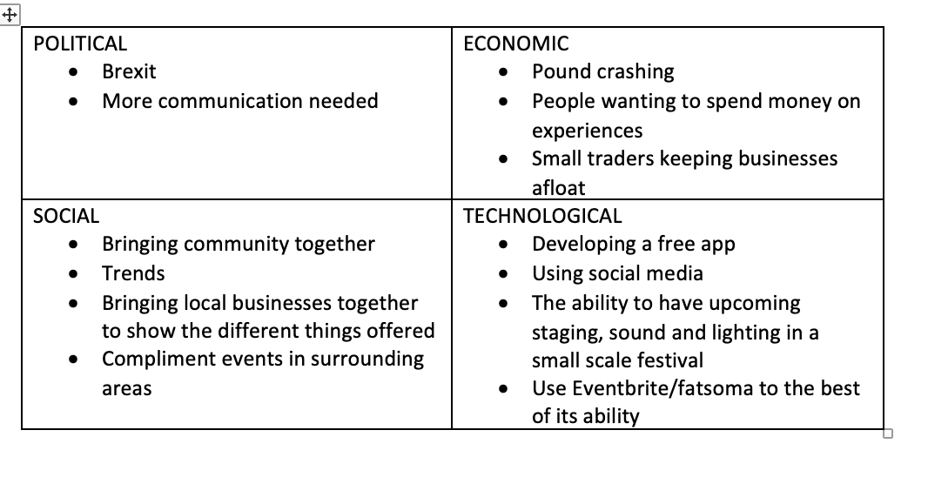
Appendix 7 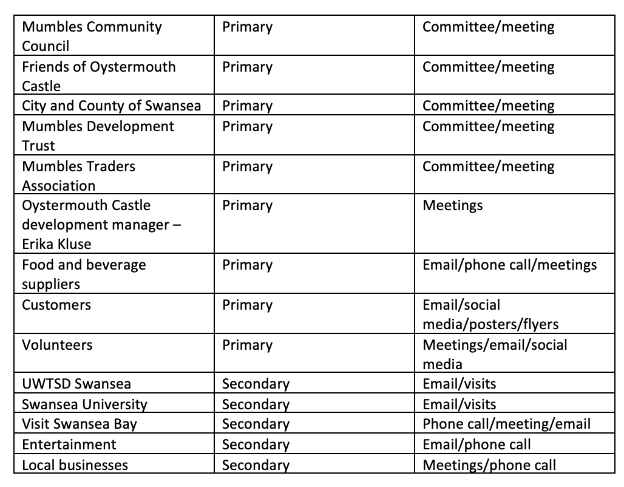
Appendix 8


