Pressure Plate Modifications

These additional tasks build on the work you’ve already done modelling the Pressure Plate and are aimed at developing your familiarity with the way in which you edit or amend component geometry once it’s been defined.
Save your Pressure Plate before beginning your modifications and then ‘save as’ your modified Pressure Plate so that you have each version saved separately.

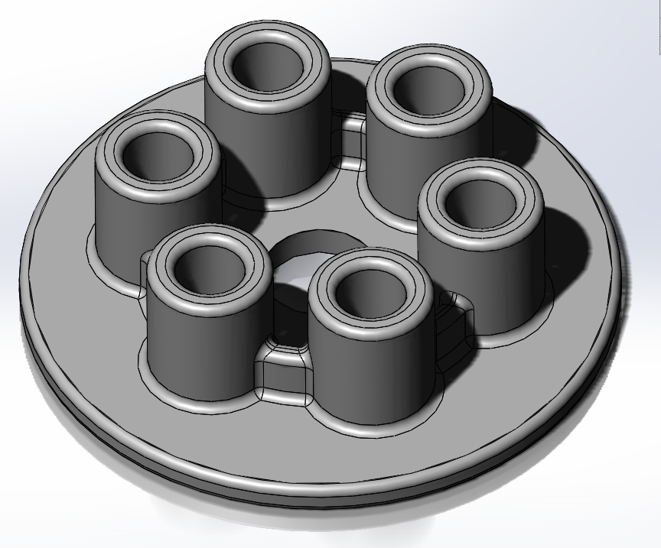

- Amend the cylindrical boss height (pattern of 6) to 25mm.
- Change the number of bosses to from 6 to 5 whilst maintaining the equality of spacing.
- Change the overall/outer diameter of the Pressure Plate to 140mm.
- Amend all the fillet sizes from 2mm to 3mm.
- Change the holes in the bosses to have a 15mm ‘blind’ hole rather than a ‘through’ hole.
- Add a 20mm flat on the other edge of the main body of the pressure plate. The flat should be aligned so that it is parallel with a construction line drawn between the centre of two neighbouring bosses.
- Save your Pressure Plate under a new file name (different from the one used to save the model at the end of the “Getting Started” SolidWorks tutorial. This way, you will be able to retrieve and review both versions.

