Student name: Hanan Mohamed Nur
Student ID number:2430827
Module: changemakers: creativity and value creation
Module code: BMHP5014
Lecturer name: Soban Sadiq
Assignment title: component2:Assignmentreport
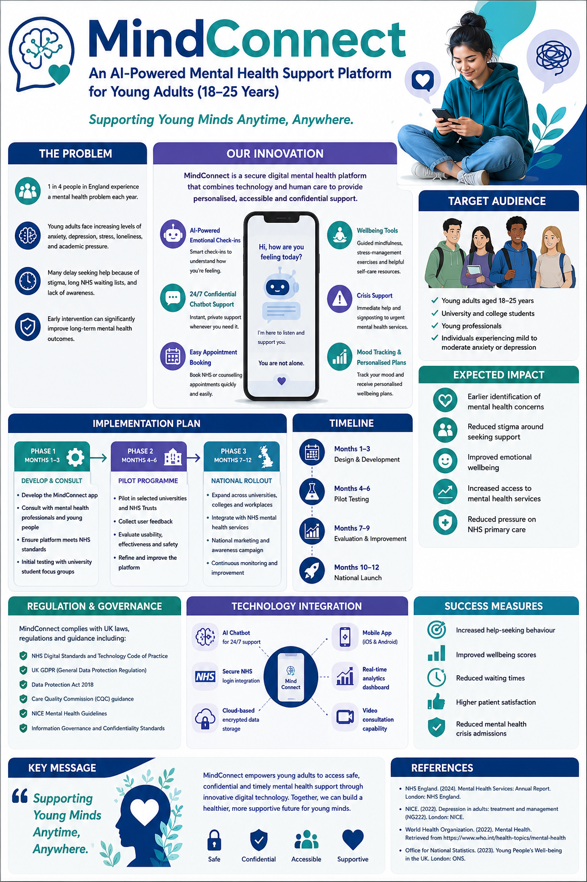
Figure 1. MindConnect Poster
Mental health is one of the most significant public health challenges in the United Kingdom, particularly among young adults aged 18–25 years. This age group experiences increasing levels of anxiety, depression, stress, loneliness and emotional distress due to academic pressures, employment uncertainty, financial difficulties and social media use. Many young people do not receive timely support because of stigma, long NHS waiting lists and limited access to services. Therefore, innovative, accessible and cost-effective solutions are needed to complement existing health and social care services.
MindConnect is an AI-powered digital mental health platform designed to improve access to early mental health support for young adults. The platform combines artificial intelligence, digital wellbeing tools and NHS integration to provide confidential, personalised and evidence-based support. Rather than replacing healthcare professionals, MindConnect complements NHS services by encouraging early intervention and helping users access professional care when required.
The platform includes AI-powered emotional check-ins, a confidential chatbot available 24 hours a day, mood tracking, guided mindfulness exercises, personalised wellbeing plans, appointment booking with NHS or university counselling services and emergency crisis signposting. These features allow users to monitor their wellbeing while encouraging them to seek professional support before their condition becomes more severe.
The target audience is young adults aged 18–25 years, including university students, college students and young professionals. Research indicates that anxiety, depression and loneliness have increased significantly within this age group. Many individuals delay seeking professional support because of stigma or difficulties accessing services. MindConnect addresses these barriers by providing confidential, convenient support through a smartphone application.
The expected benefits extend beyond individual users. Early identification of mental health concerns can reduce illness severity and improve recovery. Greater access to support may reduce pressure on GP practices, Accident and Emergency departments and specialist NHS mental health services. Improved emotional wellbeing can also increase educational achievement, employment opportunities and social participation, benefiting society as a whole.
Implementation would occur in three phases over twelve months. The first phase would focus on software development in collaboration with software engineers, mental health professionals, universities and NHS organisations. User testing would ensure the platform is accessible and user-friendly. During the second phase, pilot programmes would be introduced within selected universities and NHS Trusts to evaluate user satisfaction and effectiveness. Feedback would be used to improve the platform before national rollout. The final phase would involve implementation across England through partnerships with NHS organisations, universities and community health services.
Strong governance is essential because MindConnect processes sensitive health information. The platform would comply with the UK General Data Protection Regulation (UK GDPR), the Data Protection Act 2018 and NHS Digital standards. Clinical guidance would align with NICE recommendations, while oversight from the Care Quality Commission would help maintain quality and safety.
Technology is central to MindConnect. Artificial intelligence provides immediate emotional support, personalised recommendations and appropriate signposting. Encrypted cloud storage protects personal data, while NHS integration enables referrals and appointment booking. Importantly, the platform supports healthcare professionals rather than replacing them. Individuals experiencing severe symptoms or suicidal thoughts would be directed immediately to emergency or crisis services.
Success would be measured through increased help-seeking behaviour, improved wellbeing scores, reduced waiting times, higher user satisfaction and fewer mental health crisis admissions. Continuous evaluation would ensure the innovation remains safe, effective and responsive to users' needs.
In conclusion, MindConnect offers an innovative and practical solution to improve mental health support for young adults in the UK. By combining AI technology with evidence-based healthcare and NHS services, it promotes early intervention, reduces stigma and improves access to support. This innovation has the potential to improve health outcomes, strengthen health and social care services and contribute to the common good.

References
- NHS England (2024) Mental health services. Available at: https://www.england.nhs.uk/mental-health/ (Accessed: 28 July 2026).
- National Institute for Health and Care Excellence (NICE) (2022) Depression in adults: treatment and management (NG222). Available at: https://www.nice.org.uk/guidance/ng222 (Accessed: 28 July 2026).
- National Institute for Health and Care Excellence (NICE) (2022) Mental wellbeing at work (NG212). Available at: https://www.nice.org.uk/guidance/ng212 (Accessed: 28 July 2026).
- World Health Organization (2022) Mental health: strengthening our response. Available at: https://www.who.int/news-room/fact-sheets/detail/mental-health-strengthening-our-response (Accessed: 28 July 2026).
- Office for National Statistics (2023) Measures of National Well-being: Young people's well-being. Available at: https://www.ons.gov.uk/ (Accessed: 28 July 2026).
- Department of Health and Social Care (2019) The NHS Long Term Plan. Available at: https://www.longtermplan.nhs.uk/ (Accessed: 28 July 2026).
- NHS Digital (2023) Mental Health Services Monthly Statistics. Available at: https://digital.nhs.uk/data-and-information (Accessed: 28 July 2026).
- Information Commissioner's Office (2023) Guide to the UK GDPR. Available at: https://ico.org.uk/for-organisations/uk-gdpr-guidance-and-resources/ (Accessed: 28 July 2026).
- Care Quality Commission (2024) Mental health services. Available at: https://www.cqc.org.uk/ (Accessed: 28 July 2026).
- Royal College of Psychiatrists (2023) Mental health and young people. Available at: https://www.rcpsych.ac.uk/mental-health (Accessed: 28 July 2026).

