

Student name: Erika Paola Dorado Cabello
Student ID: 2430471

Module name: Introduction to Physiology
Module code: BMHP5023
Lecturer name: Lou Wells

Assessment: Component 1: Written Assignment (Case Study Report)

1. Introduction
Asthma is defined as a complex and chronic inflammatory disorder of the conducting airways, characterized by a clinical presentation of variable and recurring symptoms, reversible airflow obstruction, and intermittent episodes of bronchospasm. From a clinical perspective as a practice nurse, there has been a noticeable and concerning increase in adolescent patients presenting at the GP surgery with acute exacerbations of their condition. This demographic is especially vulnerable to poor outcomes; they are in a unique stage of ongoing physiological development while simultaneously navigating evolving social and behavioural patterns that often conflict with strict medical management.
As adolescents transition into adulthood and gain greater autonomy, they are increasingly exposed to environmental and behavioural triggers. Significant among these are tobacco smoking, nicotine vaping, and frequent attendance at crowded social environments such as clubs and bars. These specific settings are problematic because they not only increase the patient's exposure to airborne chemical irritants but also significantly elevate the risk of cross-infection and respiratory viruses. According to the (Asthma, 2023) such infections are a major contributing factor to asthma exacerbations, highlighting the critical importance of understanding both the biological mechanisms of the lungs and the lifestyle factors that influence day-to-day asthma control.
The primary risk factors for the development and worsening of asthma include a genetic predisposition, particularly atopy, alongside a wide array of environmental triggers. These include allergens such as pollen and dust mites, exposure to cold air, air pollution, and modern chemical irritants (nhs.uk, 2022) These factors interact in a highly complex manner, where a single night in a crowded, smoky environment can trigger a cascade of inflammation that lasts for days, influencing both the immediate onset and the long-term severity of the condition.
This report aims to critically explore the intrinsic relationship between respiratory physiology and effective asthma management. It will describe in comprehensive detail the structure of the respiratory system, explain the biophysical mechanics of breathing, and provide a rigorous analysis of the physiological process of gas exchange. Furthermore, it will evaluate how specific irritants, such as those found in vapes and cigarettes, contribute directly to airway inflammation. Finally, the report will provide evidence-based recommendations to support adolescents in effectively managing their condition and improving their overall quality of life (Organization, 2023)
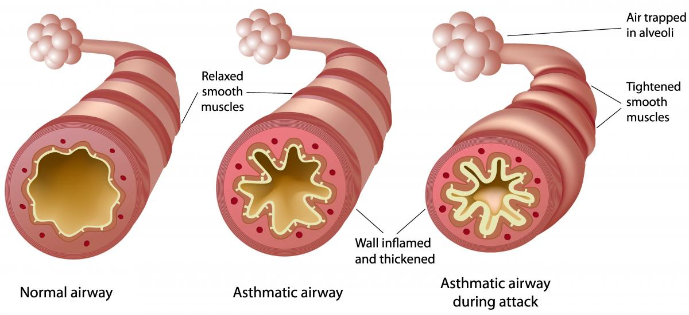
Source: Severe Asthma Toolkit (2024)

2. Structure of the respiratory system
Anatomical Overview
The respiratory system is a highly specialised biological system responsible for facilitating gas exchange between the external environment and the bloodstream. It is divided into the upper respiratory tract (nose, nasal cavity, pharynx, and larynx) and the lower respiratory tract (trachea, bronchi, bronchioles, and alveoli).
In the context of asthma, the bronchial tree is particularly significant. The trachea divides into primary bronchi, which progressively branch into smaller bronchioles. Unlike larger airways, bronchioles lack supportive cartilage and instead contain a higher proportion of smooth muscle, making them highly susceptible to constriction during an asthma attack (Tortora & Derrickson, 2021) This anatomical feature explains why even minor inflammation can result in significant airflow limitation.
The Mechanics of Breathing (Ventilation)
Mechanical respiration is governed by fundamental physical principles, particularly Boyle’s Law, which states that the pressure of a gas is inversely proportional to its volume.
Inhalation (Inspiration):
Inhalation is an active physiological process involving contraction of the diaphragm and external intercostal muscles. This increases the volume of the thoracic cavity, resulting in a decrease in intra-alveolar pressure below atmospheric pressure, thereby allowing air to flow into the lungs.
Exhalation (Expiration)
In healthy individuals, exhalation is largely passive due to the elastic recoil of lung tissue. However, in individuals with asthma, airway narrowing significantly increases resistance, making exhalation more difficult and often requiring active muscular effort. This leads to the recruitment of accessory muscles and contributes to symptoms such as wheezing, breathlessness, and fatigue (West, 2016) As shown in Figure 2, changes in pressure and volume directly influence airflow, and any obstruction disrupts this delicate balance.
This is clinically significant because difficulty in exhalation can lead to air trapping, reduced ventilation efficiency, and increased work of breathing, particularly during acute exacerbations.
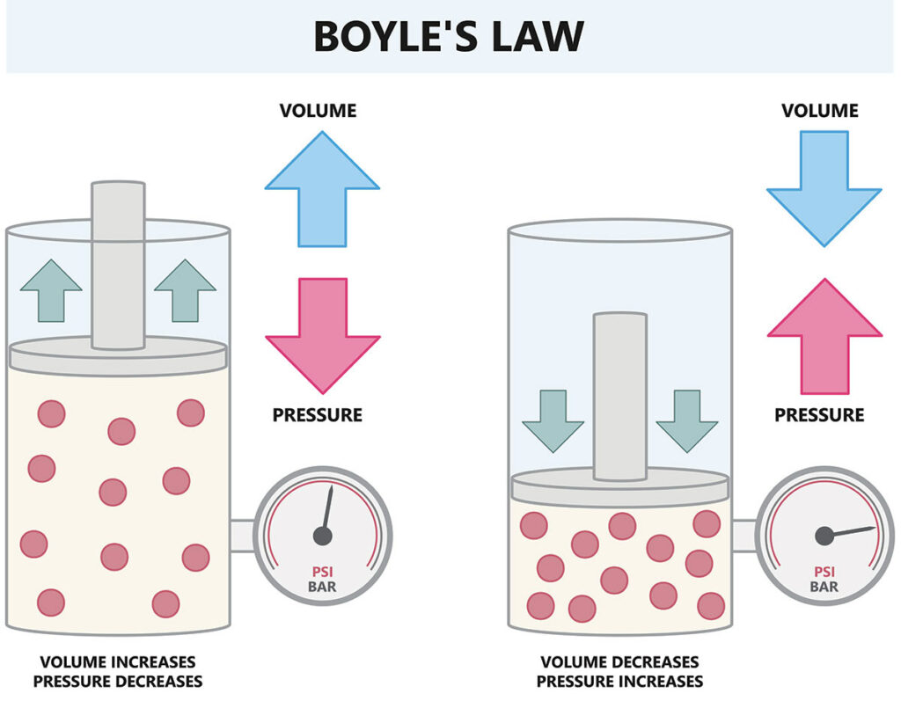
Source: Scuba.com, (2023)

3. Gas exchange in lungs
The Physiology of Diffusion
Gas exchange occurs at the alveolar-capillary membrane, which is extremely thin (approximately 0.5 micrometres), allowing for rapid and efficient diffusion of gases.
Oxygen diffuses from the alveoli, where its partial pressure is higher, into the blood, where its partial pressure is lower, and binds to haemoglobin within red blood cells. Conversely, carbon dioxide diffuses from the blood into the alveoli to be expelled during exhalation. This process is essential for maintaining cellular respiration and energy production. As illustrated in Figure 3, efficient gas exchange depends on both adequate ventilation and unobstructed alveolar surfaces.
Impact of Irritants (Smoking and Vaping)
Exposure to irritants such as cigarette smoke and vaping aerosols introduces harmful chemicals into the respiratory system. These substances trigger inflammatory responses that lead to several pathological changes:
- Airway inflammation and oedema
- Excess mucus production due to goblet cell hyperplasia
- Bronchoconstriction caused by smooth muscle contraction
This combination significantly reduces airflow and limits effective gas exchange, potentially leading to hypoxemia and increased physiological strain on the body (Guyton & Hall, 2020)
Emerging evidence suggests that vaping may expose users to ultra-fine particles capable of penetrating deeper into lung tissue compared to traditional cigarette smoke. This may increase the risk of long-term respiratory damage, particularly in adolescents whose lungs are still developing (McAlinden, 2022) This highlights the importance of early intervention and preventative strategies.
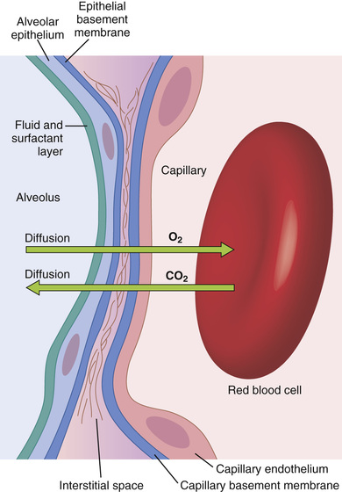
Source: Guyton and Hall (2020)

4. Recording and tracking respiratory functions
Effective asthma management relies heavily on objective monitoring, particularly through the use of Peak Expiratory Flow Rate (PEFR).
Importance of Monitoring
Peak flow monitoring enables individuals to assess how effectively air is being expelled from the lungs, providing an indication of airway narrowing. This is particularly important in adolescents, who may underestimate or become accustomed to their symptoms.
Tracking allows for:
- Establishment of an individual baseline (“personal best”)
- Early detection of deterioration in lung function
- Improved and timely clinical decision-making
- The traffic light system is commonly used:
- Green (80–100%) – well-controlled asthma
- Yellow (50–80%) – caution and need for intervention
- Red (<50%) – medical emergency
Consequences of Not Tracking
Without consistent monitoring, deterioration in lung function may go unnoticed until symptoms become severe. This increases the risk of acute exacerbations, hospital admissions, and potentially life-threatening complications such as status asthmaticus (NICE, 2021) Therefore, peak flow monitoring represents a vital component of effective asthma self-management.

5. Recommendations
A holistic and evidence-based approach is essential to improve outcomes in adolescents with asthma.
Smoking and Vaping Cessation
Exposure to tobacco smoke and vaping aerosols significantly increases airway inflammation and exacerbation frequency. Targeted education and cessation support programmes are crucial in reducing these risks (Organization, 2023)
Environmental Management
Monitoring environmental factors such as air pollution, allergens, and infection risks can help minimise exposure to triggers and reduce the likelihood of exacerbations.
Correct Inhaler Technique
Incorrect inhaler use is common and reduces treatment effectiveness. Regular reviews with healthcare professionals are necessary to ensure correct technique and adherence.
Physical Activity
Moderate and controlled physical activity can improve lung function and overall health. However, it should be carefully managed to prevent exercise-induced bronchoconstriction.
Personalised Asthma Action Plans
Individualised asthma action plans, which link symptoms and peak flow readings to specific actions, empower patients to manage their condition proactively and reduce hospital admissions.
Additional Clinical Considerations
In addition to these strategies, patient education plays a fundamental role in long-term asthma management, particularly among adolescents. Many young individuals underestimate the severity of their condition, which can lead to poor adherence to treatment plans. This emphasises the importance of continuous education delivered by healthcare professionals, including practice nurses, who are well positioned to reinforce effective self-management behaviours. Structured education programmes have been shown to improve adherence, reduce hospital admissions, and enhance overall quality of life. Furthermore, psychological and social factors must also be considered, as peer influence may encourage behaviours such as vaping or smoking. Therefore, interventions should address both physiological management and behavioural change. Early intervention and regular follow-up are essential to prevent severe exacerbations and support long-term control of the condition.

6. Conclusion
In summary, asthma is a chronic and complex respiratory condition that fundamentally alters airway function through a combination of persistent inflammation, acute bronchoconstriction, and the subsequent impairment of gas exchange. This report has demonstrated that the respiratory system’s delicate balance, governed by the mechanical principles of Boyle’s Law and the diffusion gradients of the respiratory membrane, is easily disrupted by external influences. Adolescents in our clinical setting are particularly vulnerable to these disruptions due to a combination of physiological maturation and specific lifestyle factors, most notably the rising prevalence of nicotine vaping and increased exposure to environmental triggers in social environments.
The evidence presented underscores that the airway swelling and mucus hypersecretion induced by modern irritants do not merely cause discomfort; they create a physical barrier to oxygenation that can have serious long-term health implications. However, the outlook for these patients remains positive when a proactive and multi-faceted approach is adopted. Through the diligent recording and tracking of peak flow readings, adolescents can gain an objective understanding of their lung function, allowing for early intervention before symptoms escalate into severe exacerbations.
Ultimately, the successful management of asthma in the adolescent population depends on a synergy between effective medical treatment, targeted lifestyle modifications, and comprehensive health education. Empowering young patients with the physiological knowledge of their own condition is an essential strategy for fostering autonomy and encouraging proactive self-management. By addressing the root causes of inflammation and promoting evidence-based behavioural changes, we can significantly improve long-term health outcomes, reduce the burden on healthcare services, and ensure that asthma does not limit the potential or well-being of the individuals in our care.

References
- Asthma UK (2023) Asthma management and adolescent health. https://www.asthma.org.uk (Accessed: 22 March 2026).
- Barnes, P.J. (2017) ‘Cellular and molecular mechanisms of asthma’, Clinical Science, 131(13), pp. 1541–1558.
- Global Initiative for Asthma (GINA) (2023) Global strategy for asthma management and prevention. https://ginasthma.org (Accessed: 27 March 2026).
- Guyton, A.C. and Hall, J.E. (2020) Textbook of Medical Physiology. 14th edn. Philadelphia: Elsevier.
- McAlinden, P. (2022) ‘The impact of e-cigarettes on adolescent lung health’, Journal of Respiratory Care, 14(2), pp. 45–52.
- National Institute for Health and Care Excellence (NICE) (2021) Asthma: diagnosis, monitoring and chronic management (NG80). London: NICE.
- NHS (2022) Asthma: Causes and triggers. https://www.nhs.uk (Accessed: 22 March 2026).
- Royal College of Physicians (2022) National Review of Asthma Deaths. London: RCP.
- Scuba.com (2023) Dive Science: How Boyle’s Law Applies to SCUBA Diving. https://www.scuba.com/blog/dive-science-boyles-law-applies-scuba-diving/ (Accessed: 1 April 2026).
- Severe Asthma Toolkit (2024) Asthma Pathophysiology. https://toolkit.severeasthma.org.au/management/asthma-pathophysiology/ (Accessed: 7 April 2026).
- Tortora, G.J. and Derrickson, B. (2021) Principles of Anatomy and Physiology. 16th edn. Hoboken: Wiley.
- West, J.B. (2016) Respiratory Physiology: The Essentials. 10th edn. Philadelphia: Wolters Kluwer.
- World Health Organization (WHO) (2023) Asthma fact sheet. Geneva: WHO.

