BA Business Management
LCBB5001: Entrepreneurship
Student Name: Sava Mantchev
Student ID:2028706
Lecturer Name: Nishi Ramsurrun

Table of Contents
Introduction 1
Business Description 1
Industry analysis 2
Porter five forces 3
Operation and management team plan 4
Marketing Plan 5
Financial plan 6
Sources of funds 6
Use of funds 6
Market research 7
Conclusion 8

Introduction
A business plan is a process of setting key strategies to make a business more effective and get maximum outcomes from the business operations and reaching overall business goals (Abrams, 2019). The assignment will cover a business plan for a new company with a new service of using an online marketplace. The report will cover industry analysis using porter's five forces, operation, and management team and their role will be discussed 4p of marketing, and a financial budget will be presented with sources of funds being discussed earlier.

Business Description
The proposed start-up business will be an online marketplace company named “Onedirection.com” and the company will offer their customers various fresh foods and grocery items and daily goods through online services. The company will have a capital of around £1.02 million with an estimated 50 employees in different sections of the company. “Onedirection.com” is planning to operate its business online two-three cities including Manchester, Nottingham, and Liverpool. The vision of this company is to offer the target customer the best quality of food and gives the best shopping experience. To support the business vision, the core objective of the company is to offer a quality product with a low price and free delivery charge so that despite low per-head income, the consumer can afford the best quality of food (Akhmadi and Pratolo, 2021).
Considering the post-Covid situation, technology has merged with the services as a customer can pay their bills with a mobile payment system not only that, they can track their order delivery process using company digital tracking apps until they received it. The company has a high market opportunity as due to Covid-19 people are more conscious of not coming into mass gathering places such as grocery shops and preferring to purchase their daily items through online marketplaces (Chase, 2018). Besides that, young people are fonder of using online platforms to buy any items which will also open up more business opportunities for “Onedirection.com”. In addition to that, since it saves time and the online marketplace offers customers to compare prices and products with other similar sources it is a growing business idea for the future.
Onedirection.com will follow a hierarchy of structure where the founder holds the CEO position and with one business manager along with marketing, operation, and HR each of the departments will be managed by dedicated managers (Choi and Mela, 2020).

Figure-01: Hierarchy of structure of “Onedirection.com”
Source: (Davis and Reilly, 2018).

Industry analysis
Like many other countries, UK online marketplace industry is rapidly growing as currently, the UK is the third largest eCommerce market in the world with about £120 billion in sales annually (Freeling, 2019). This is also the most developed marketplace since online sales cover 22% of total retail sales in the UK.
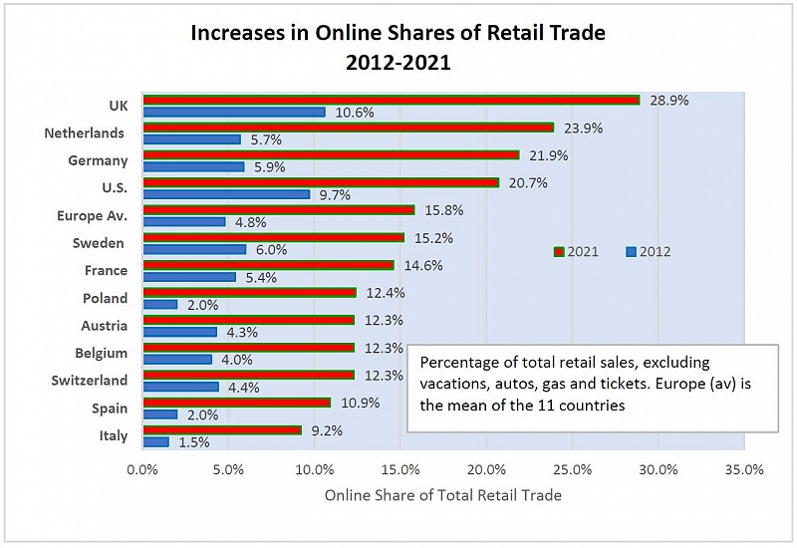
Figure 02: Online shares of retail
Source: (East, 2018).
Two of the dominant eCommerce company in the UK at the moment are Amazon and eBay as these two covers 45% of overall online consumers. Based on these data it is needless to say that online marketplace business idea has a great prospect, particularly in UK online marketplace (Magretta, 2019).

Porter five forces
Threats of new entry – High: Threats of new entry are high in the online marketplace since it does not require high physical investment so any entity with a limited amount of capital can jump into this business. Besides that, the UK government is promoting entrepreneurship and SMEs with flexible business policies, and low taxes in the first year of business (Michaux, Cadiat, and Probert, 2019). So, newcomers would like to cash this opportunity which eventually makes the threats of new entry high.
Threats of substitutes – Moderate: Online marketplace makes the consumer shopping experience comfortable however still a decent number of people follow traditional shopping through physical experiences. Different grocery shops here and there also provide decent quality products which altogether makes the threats of substitute threats moderate (Sellars, 2019).
Bargaining power of customer - High: The bargaining power of the customer will have high in the online marketplace because there are numerous available online marketplaces in the UK that offers a diverse amount of product which increases customer options to choose from (Stanford-Smith and Kidd, 2018). Besides that, customer can compare product price, quality, and delivery process with other company which also increase customer bargaining power.
Bargaining power of suppliers - Low: Suppliers will have low bargaining power because due to the growing online marketplace in the UK, the number of suppliers has increased which decreases their bargaining power. Besides that, some online marketplace companies direct source products from the production area which reduces suppliers' needs.
Competitive rivalry:
Name of competitor | Differentiation
Amazon | They have a wide range of products with high brand value and a huge number of loyal customers (van Waterschoot and van den Bulte, 2021). However, Amazon's product prices are quite high than other competitors in the same industry.
Asda | ASDA is quite known for its price range as they offer products with low price but they have imitated a number of products range and to balance price and product quality customer often has to sacrifice product quality (Abrams, 2019).
Sainsbury | They have huge experiences under their belt in this online grocery field and they have a strong supply chain system, a huge number of employees, and high revenue turnover which makes them a dominant figure in this industry (Chase, 2018).

Operation and management team plan
The business process will be massively online based and most of the business process will be done using the online platform including product placements, marketing process, collecting purchase orders, and monitoring the business progress using online monitoring tools (Choi and Mela, 2020). However, the fresh and raw foods will be collected using a direct supply chain system and the supplier will be selected using an online supply tender to make agreements with the best possible suppliers. In addition to that, the local supplier will get more preferences due to the fact that they are easy to reach and suppliers who use green supply chain process will get high priority as onedirection.com promote the green environment concept.
To transport the raw and fresh products from production sites to the company warehouse, the company will use a vehicle with freezing capacity and heavy carrying capacity. It will reduce the number of transportation costs and keep the product fresh as keeping high-quality products is the company’s mission (Davis and Reilly, 2018).
The product will be placed on the company's own pages and it will constantly get updated every day with the new selling prices. The marketing team will be responsible to manage product presentation and pricing strategies to increase sales and be sustainable in the market. The product will be delivered to the customer within 24 hours of placing an order using quick delivery services and a digital tracking system to reduce any flows in delivering process.
Management team
Name | Skills they bring to the farm
CEO | Sets business targets and provides a guideline for the employees (East, 2018). Makes policies and organization structure to follow by all.
Operation manager | Regulate and control the operation process. generate system and monitor employees to ensure that production is on track (Freeling, 2019).
Marketing Manager | Creates effective marketing strategy to reach more clients, sets product prices to increase sales, and analyzes the market to evaluate business issues.

Marketing Plan
Product: The Onedirection.com company will sell a variety of products to their customer which includes fresh and grocery items the reason to choose this as a core product is caused during the post-covid-19 situation people are less like to go to the store physically due to afraid of infected by a virus (Magretta, 2019). So fresh food products will be supposed to get high demands from the customer. Apart from the fresh product, the company will also sell, home appliances, gadgets, women’s wear, and some other clothing items for kids.
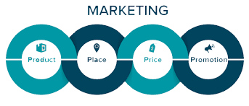
Figure-03: Marketing 4P.
Source: (Chase, 2018).
Price: The company will use a competitive product price strategy to get competitive advantages. The price will be reasonable so that customers from all income levels can purchase the product (Michaux, Cadiat, and Probert, 2019). besides that, different promotional offers, and price discount offers will also be used to increase the sale.
Promotion: The company will use sales promotion and advertising promotion strategies to promote a product. online games, rebates, or coupons will be provided on each sale where the customer will get gift prizes. This will encourage the customers to purchase more. Besides that, to reach more customers in a shorter period of time online advertisement, social media marketing such as Facebook and Instagram marketing and digital advertisement will be used following the artificial intelligence help by suggesting items that people like.
Place: To distribute the product, the direct distribution strategies will be followed where the company will collect the product from different sources, and then according to the customer's online place order, the product will be directly delivered to the customer using a third-party delivery channel (Sellars, 2019).

Financial plan

Sources of funds
Personal savings: Company will use its own capital as its main source of funds and previous business revenue will also be invested here in the new business as a partial source of funding.
Financial loans from the bank: Company will take a bank loan from two public banks with a 5% interest rate and will use this loan as a source of funds.
Family and friends: Some amount will be borrowed from close family members and family but they will not receive the profits share of this loan.

Use of funds
Estimated revenue of one month | £1,50,00

Fixed cost
Fixed cost items | Amount
Rent | £90
Procurement cost | £120
Employee wages | £100
Delivering cost | £50
Marketing cost | £200
Property tax | £150
 | Total= £710
Variable cost
Variable cost item | Amount
Office suppliers | £80
Vehicle expenses | £160
Repairing | £130
 | Total= £370
Profit
One month revenue - (Fixed cost + variable cost) | £1,5000 – (£710+£370)
Total | £13,920

Market research
Political: The government of the UK offers low taxes on revenue for entrepreneur and SME business companies which will help the company to grow business with fewer policy-related issues (Abrams, 2019). Besides that, due to political instability in the world, the fresh food supply has been minimized from the different county which will create a high demand for fresh foods which will also positively impact the business.
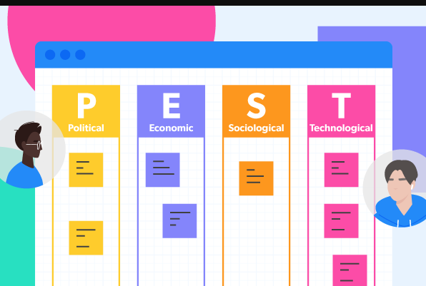
Figure-04: PEST analysis.
Source: (Abrams, 2019).
Economic: Due to covid-19 the inflation rates have increased by 10%, therefore the company will have to pay extra expenses in every phase of their business which will make the profit margin narrow (Akhmadi and Pratolo, 2021). People per head income has decreased due to covid-19 which means people buying ability has declined and people will purchase fewer items than before therefore the overall sale target will also affect.
Social: People these days are now more engaging in online activities and more people like to do their daily shopping using an online marketplace which opens up a huge opportunity for this company to boost their sales (Chase, 2018). However, people are often scared to purchase from the online marketplace due to the lack of online companies’ business commitments.
Technology: Technology has made a revolutionary impact on the online marketplace industry and it will constantly impact the business. The onedirection.com company can use technology to enhance their customer user convenience as they can build apps through which customers can regularly check new products or place orders instantly (Davis and Reilly, 2018). Not only that, they can prepare to increase their product delivering process much smoother using modern tools and software.

Conclusion
The report has illustrated different aspects of business ideas and their various stages. The proposed business idea is an online marketplace business where the company will sell fresh food items and grocery items because in the post-Covid situation people like to go to shops and online shopping is growing each day so it will be a good business idea to launch in the UK market. Using porter's five forces it has been seen that, the threat of new entry is high where the power of suppliers is quite low. Some of the high competitors in this field are Amazon and Asda as they have a high brand image and diversity of product prices. The CEO of the management team can add policy and business targets for the employee. The business will follow a competitive price strategy and will sales and advertising promotion strategy to increase sales. The tentative financial plan of one month has shown that they will have a net profit of £13.920 at the end of the month.

References
Abrams, R.M. (2019). Business plan in a day : prepare a polished professional business plan in just 24 hours! Palo Alto, California: Planningshop.
Akhmadi, H. and Pratolo, S. (2021). Online Marketing of Food Products through Marketplace Platform: A Study of Community Based Online Marketplace of BEDUKMUTU. E3S Web of Conferences, 232, p.02015.
Chase, I.D. (2018). Explanations of hierarchy structure. Animal Behaviour, 34(4), pp.1265–1267.
Choi, H. and Mela, C.F. (2020). Online Marketplace Advertising. SSRN Electronic Journal.
Davis, P. and Reilly, A. (2018). Market power, market outcomes, and remedies in the UK groceries market. Agricultural Economics, 41, pp.93–108.
East, H. (2018). Non‐profit organisations in the UK online database market. Aslib Proceedings, 38(9), pp.327–334.
Freeling, A. (2019). Marketing is in Crisis - Can Market Research Help? Market Research Society. Journal., 36(2), pp.1–6.
Magretta, J. (2019). Understanding Michael Porter : the essential guide to competition and strategy. Boston: Harvard Business, Cop.
Michaux, S., Cadiat, A.-C. and Probert, C. (2019). Porter’s Five Forces. Namur 50Minutes.com.
Sellars, D. (2019). Business plan project : a step-by-step guide to writing a business plan. New York, Ny: Business Expert Press.
Stanford-Smith, B. and Kidd, P.T. (2018). E-business : key issues, applications and technologies. Amsterdam: Ios Press ; Tokyo.
van Waterschoot, W. and van den Bulte, C. (2021). The 4P Classification of the Marketing Mix Revisited. Journal of Marketing, 56(4), p.83.

