DS2 ASSESSMENT WEEK 8
Executive Summary of the Task
I have deciced to chose the Scenerio 1 for my test paper because, The GreenLeaf Grocers is a small business that I can identify with given its need to analyse its stock list. I can use excel to create clear and simple business insights that suits the business requests and needs. Chosing this scnereio also helps me practice my skills whilst reposnding to the business needs.
DS2 Scenario 1: GreenLeaf Grocers

Stock List Current
I chose my tool because this is good for charts, tables and numbers. It helps shows the sales data clearly for a business. I have read a short guide on the UWTSD digital skills web about using tables in Excel. It said tables help make numbers clear, hence it supported my choice.

2.What information I used
items | Quantities
bread | 3
milk | 6
egg | 10
apple | 12
bananas | 14
carrots | 18
pasta | 22
potatos | 30

I used the Stock List Current Quantities from the scenario to identify the stocks that was low and needed restocking or ordering. It helps me to understand the items that needs to be restocked
3. How I created my artefact
Firstly, I typed the data into an Excel table.
Secondly, I used the insert chart button in excel to generate a visual bar chart to make it easier for the supervisor to see the trends in the stocklist items and their quantities
After that I made a bar chart to show the items in an ascending format.
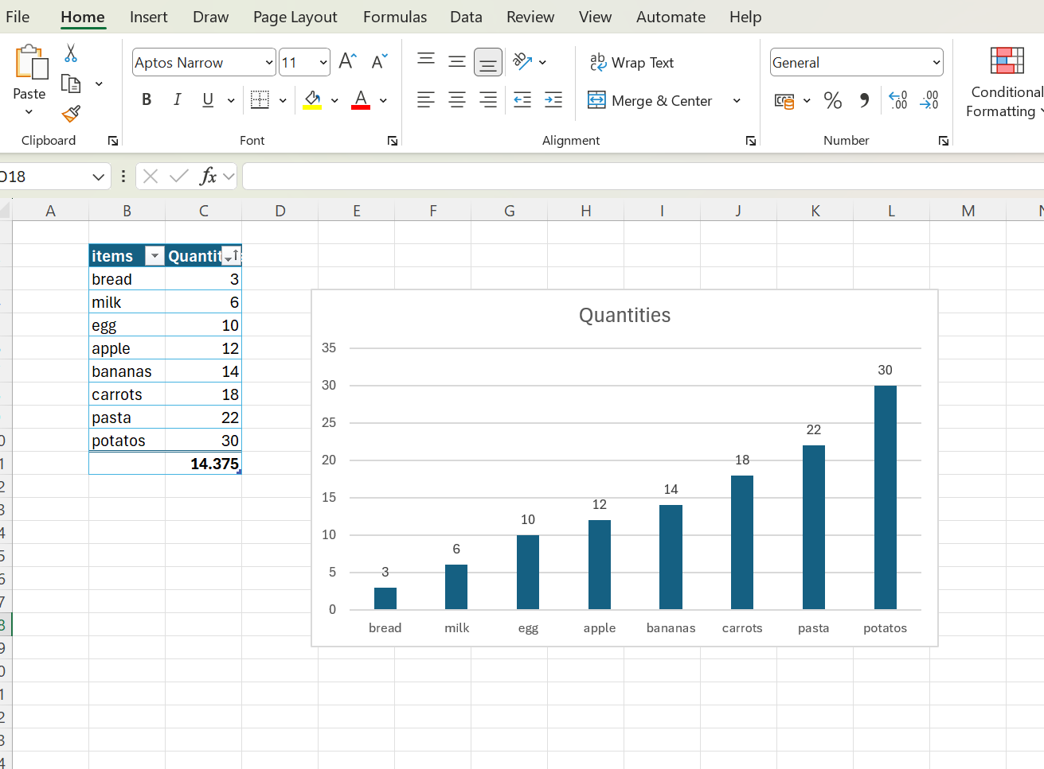
Lastly, I checked the numbers to ensure they are accurate.

4. What changes I made.
At start, my table was difficult to read, so colour and bold headings were added.
Also changed the chart type because the pie chart was confusing.
The labels were made bigger because they were too small.
I also added the total column to make the information clearer
5. Feedback I used.
My tutor said consistency was required in the colours
A classmate said, it need a clearer label
Both of these were changed due to the feedback
6. Final response to the supervisors email
Dear John
I have created the digital bar chart and stock items list artefact and attached it bove for your referral.
Please note that the items that are low are as follows;
Bananna (4)
Bread Loaves (3)
Milk – 2L Bottles (6)

The items that need ordering soon are
Bananna
Bread Loaves
Milk – 2L Bottles

Please let me know if theres any more info information you need.

Thanks
Junior Assisant

