Module Code:LCBB6004
Component 1 Coursework : Written Report
Lecturer: Dr.Hossein Shokri
Yustian Mladenov(2111875)

Contents
Introduction 3
Background History of Barclays PLC 4
Key Business and Corporate Strategies 4
Porter’s Generic Strategies 4
Ansoff Matrix Analysis 5
Value Chain Analysis 6
VRIO 9
Barclays' SAF Analysis 10
Strategy Implementation and Competitive Advantage 11
Effectiveness of Strategy Implementation 11
Competitive Advantage Gained 11
Evidence of Success and Areas for Improvement 12
Sustainability and Competitive Positioning 12
Sustainability Approach 12
Impact on Competitive Positioning 13
Future Strategic Directions and Recommendations 13
Conclusion 14
References 15
Appendix 15

Introduction
Barclays Plc serves as a well-known British company that provides banking services and invests in other countries. It has a history that can be traced back to 1690. Barclays is a big name in the United Kingdom and the global arena of banking, since its primary location is in London (Barclays b), 2023).The purpose of the report is to find out what Barclays's main business and company strategies are, identify the resources and capabilities ,assess the effectiveness of the company’s strategy and see how the company has executed its strategies successfully or faced challenges and examine the company's sustainability efforts. This report will include several strategic analysis models and tools to achieve its goals.

Background History of Barclays PLC
In 1690, Barclays Plc started as a small partner-owned bank in London. It has developed into a big global banking corporation and an important part of the British business world. Barclays was the first bank in the United Kingdom to issue a credit card and first cash machines in the world, strengthen its reputation as an innovative financial institution. Today, it stands out in the market thanks to its long brand history which, environmental care, commitment to sustainability and innovations that meet the challenges and opportunities of modern finance in the global economy(Barclays b), 2023).


Figure 1: Barclays PLC (Barclays)

Key Business and Corporate Strategies

Porter’s Generic Strategies
Generic strategies are the three basic strategies of cost leadership, differentiation and focus open to any business. Porter’s contribution was based on earlier work in industrial economics, exploring how firms compete (Lynch, 2018).
Low-cost leadership: The low-cost leader in an industry has built and maintains plant, equipment, labour costs and working practices that deliver the lowest costs in that industry(Lynch, 2018).
Differentiation: Differentiation occurs when the products of an organisation meet the needs of some customers in the market place better than others (Lynch, 2018).
Focus: A focus strategy occurs when the organisation focuses on a specific niche in the market place and develops its competitive advantage by offering products especially developed for that niche (Lynch, 2018).
The strategy that Barclays Plc is using is Focus. Barclays is focused on offering banking services tailored to meet both current and future customer needs, leveraging digital innovation to enhance customer interactions and promoting community development for a more inclusive and sustainable future. It is also focused on making new financial products and improving services to keep up with changing trends and boost growth in domestic and international markets, while also enhancing the digital customer experience to run their business more smoothly and forming more partnerships, so they can offer new financing options everywhere (Barclays a), 2023).

Ansoff Matrix Analysis
Ansoff’s classic corporate strategy matrix suggests four basic directions for organisational growth. The four strategy directions that are part of this matrix are: Market penetration, Product and service development, Market development and Unrelated diversification(Whittington, 2020).

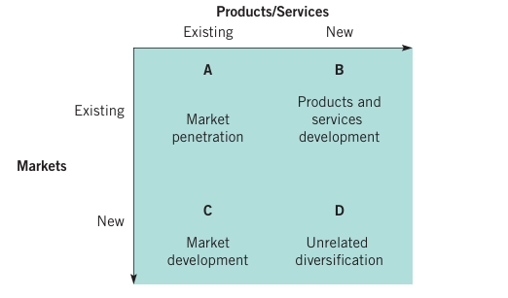
Figure 2 : Ansoff Matrix(Whittington, 2020)
Market Penetration: Barclays wants to grow more in the markets where it already operates. They plan to do this by offering more types of products and services to their customers. This includes things like helping people with transactions, lending money, connecting businesses with financial markets, keeping people's assets safe, and giving advice on investing. By focusing on growing within their existing markets, Barclays hopes to get more customers and become a bigger part of those markets (Barclays a), 2023).
Product Development: Barclays is committed to using technology to make their products and services better. They want to improve the way customers experience their services and make sure they can rely on them. Barclays also plans to update their systems and provide more features to their clients, especially in their Corporate Bank and Private Bank & Wealth Management divisions (Barclays a), 2023).
Market Development: Barclays aims to grow in new areas and focus more on its home market, using its strong reputation in the UK. They want to become a leader in the UK and offer better services to people who have a lot of money. Barclays also wants to be a top choice for big brands in the US, especially in retail, through its US Consumer Bank division (Barclays a), 2023).
Diversification: Barclays wants to make money in different ways by helping communities and supporting projects that help the environment and society. This shows they care about making a positive impact. They also want to strengthen their competitive position in the financial markets and invest more in areas where they can make more money (Barclays a), 2023).

Value Chain Analysis
The value chain describes the categories of activities within an organisation which, together, create a product or service. Most organisations are also part of a wider value system, the set of inter-organisational links and relationships that are necessary to create a product or service(Whittington, 2020).
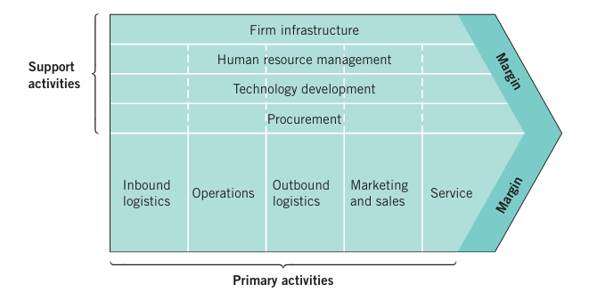
Figure 3: Porter’s Value Chain(Whittington, 2020)

Primary activities:
Inbound logistics- Barclays have created a strong strategic partnerships with a huge corporations from all over the world (Barclays a), 2023).This partnerships can help the company to become more recognized and trusted on the market and also the company can use this partnerships to increase its sales and profits.
Operations- Barclays is committed to achieving a higher standard of operation through their Group-wide cultural program of change. This program pushes co-workers to set new operational standards in five important areas: precision, service, focus, efficiency, and diversity of thought. Their culture is starting to reflect this higher standard, and they are doing everything they can to ensure that everyone has the skills necessary to meet it while rewarding advancement (Barclays a), 2023).

Outbound logistics- Here, Barclays uses the latest technological solutions to ensure the appropriate optimisation of its resources like Barclays One and Online banking (Barclays c), 2023).
Marketing and Sales-Barclays introduced a new content marketing initiative in cooperation with influencers to involve consumers in discussions about common topics such as personal finance, travel, and mortgage refinancing (Barclays a), 2023).
Service- Barclays employ various methods to engage with customers, such as conducting frequent surveys, examining customer complaints, interacting directly, and utilizing data from millions of individual transactions. In 2023 the company gather more than 1.4 million feedbacks (Barclays a), 2023).
Support activities:
Firm infrastructure-For more than twenty years, Barclays has funded more than 200 infrastructure initiatives. Whether it's in the energy sector or social and economic infrastructure, they provide tailored, substantial debt financing to bring ambitious and transformative projects into existence (Barclays b), 2023).
Human resource management- Barclays is committed to cultivating a workforce that embraces diversity and inclusivity, guaranteeing that candidates with disabilities and long-term health conditions are provided with assistance and necessary accommodations not only during the application process but also thereafter. Barclays guarantees that all employees have access to training, career advancement, and promotional opportunities (Barclays a), 2023).
Technology development-Transforming industries through the exploration of cutting-edge technologies, such as AI, to revolutionize business operations and empower individuals to enhance their effectiveness and efficiency (Barclays b), 2023).
Procurement-

VRIO
“VRIO” is a mechanism that integrates two existing theoretical frameworks: the positioning perspective and the resource-based view. It is the primary tool for accomplishing internal analysis. It stands for four questions one must ask about a resource or capability to determine its competitive potential. The four questions are: The Question of Value, The Question of Rarity, The Question of Imitability and The Question of Organization (Barney, 2019).

Resource/Capabilities | Valuable? | Rare? | Inimitable? | Organisational support?
Strong Brand Image | YES | YES | YES | YES
Long History and Experience | YES | YES | YES | YES
Technological Investments | YES | NO | NO | YES

The resources and capabilities of an organisation contribute to its long-term survival and potentially to competitive advantage (Whittington, 2020).
Valuable Resources and Capabilities
Resources and capabilities are valuable when they create a product or a service that is of value to customers and enables the organisation to respond to environmental opportunities or threats (Whittington, 2020).
Thanks to its long history, experience and strong brand image, Barclays can do business in different countries and enter new areas more easily. Their strong brand image comes from being in the banking sector for hundreds of years, which gives them a lot of power around the world. Customers are more likely to trust you because of this. One company that has put a lot of resources into online banking and innovations is Barclays (Barclays b), 2023).
Rare Resources and Capabilities
Rare resources and capabilities are those possessed uniquely by one organisation or by a few others (Whittington, 2020).

Barclays' transformation over centuries is impressive, particularly given the numerous financial downturns, worldwide conflicts, and significant transitions such as the agricultural, industrial, and technological advancements (Barclays b), 2023).Is it really rare to find a company with such a unique experience in banking sector.

Inimitable Resources and Capabilities
Inimitable resources and capabilities are those that competitors find difficult and costly to imitate or obtain or substitute (Whittington, 2020).

Barclays has a long history and a strong brand image that makes it hard for rivals to copy. It has many countries and a strong position in the market, which gives it many benefits, such as a large customer base and a lot of governmental knowledge (Barclays b), 2023).
Organisational support
Barclay’s advanced technology and strong infrastructure make sure customers have good experiences and that company’s systems can handle challenges well. Their good reputation makes people trust them more, reduces customer acquisition costs and keep customers for longer (Barclays a), 2023).This is an examples of how Barclays effectively use its resources and capabilities.

Barclays' SAF Analysis
SAF Analysis is systematically evaluating possible strategic initiatives. The acronym SAF is coming from Suitability, Acceptability and Feasibility(Whittington, 2020).
Suitability
Suitability evaluates if a strategy effectively tackles the primary strategic obstacles encountered by an organization(Whittington, 2020).
Barclays is dominant in capital investing in different global regions, including the EU and North America. Barclays performed really well in 2023 with recorded a pre-tax profit of £6.6 billion, with earnings per share at 32.4p and a tangible equity return of 10.6%.Also the company aided 7.3 million individual customers in initiating new savings accounts or boosting their deposits(Barclays a), 2023). Based on this fact Barclay’s suitability can be considered high.
Acceptability
Acceptability evaluates if a strategy aligns with stakeholder expectations(Whittington, 2020).
Barclays want to gain trust and keep customers by providing innovative products and services that make them happy. The company listen to what their customers want and try to make products and services that help them. There are a few awards received in 2023,like “LinkedIn Top UK Employer which supports the statement that 86% of Barclays' employees would recommend the bank as a great place to work. Throughout the year, Barclays actively interacted with stakeholders on various topics, such as capital strategy and allocation, divisional performance, and the effects of the evolving macroeconomic landscape (Barclays a), 2023).
Feasibility
Feasibility assesses the practicality of implementing the strategy(Whittington, 2020).
Barclays use a framework called Enterprise Risk Management Framework (ERMF) to find and manage risk, which helps the company integrate efficient risk management practices and promote a strong risk management environment (Barclays a), 2023).The fact that Barclays keeps doing well and attract more people that want to use their services shows that it's likely to stay in the market for a long time.

Strategy Implementation and Competitive Advantage

Effectiveness of Strategy Implementation
Knowing that Barclays highly supports the innovations shows that it evolve with the times and adopt new technologies (Barclays b), 2023).The bank put money into mobile and computer banking at the beginning, and it is paying off because more and more individuals are using it.

Competitive Advantage Gained
Strong Position in UK Market: They've been around for more than three hundred years, showing they're dedicated and well-established there. This long history and their presence in the market give them a big advantage. People know and trust Barclays, and they have a wide network of customers and connections (Barclays a), 2023).
Growing Customer Franchise in the US: In the past twenty years, they've grown a lot in the US too. By teaming up with big US companies like Gap Inc. and American Airlines, they've been able to give credit cards to around 20 million people. This helps them make more money and reach even more customers (Barclays a), 2023).
Leading International Markets and Banking Business: They're also a big deal internationally, especially outside the US. Their investment bank is known all over the world for being really good at handling risks and making deals. This lets them compete with other big banks globally and take advantage of business opportunities around the world (Barclays a), 2023).
Competitive Position in Global Markets: They're among the top three in certain financial areas and are ranked sixth in investment banking globally. This shows they're really good at what they do and can compete with the best in the world (Barclays a), 2023).

Evidence of Success and Areas for Improvement
Barclays got a solid strategy in place to make things better for their operational and financial performance, and enhance total shareholder returns. In order to achieve this, they will implement the following actions within the upcoming three years. The actions are called - Simpler, Better and More balanced (Barclays b), 2023). As proof of the successful outcomes from their investments, Barclays declared in December 2022 an expansion of the investment mandate to allocate funds of up to £500 million by the end of 2027 (Barclays a), 2023).

Sustainability and Competitive Positioning

Sustainability Approach
The bank has said that it will become net-zero by 2050. This will mean that every one of its banking and running activities will agree with the Agreement of Paris's goals. Instead, it will focus on investing in and funding green energy projects. Barclays made a promise to help get £100 billion in green loans by 2030. Barclays is working hard to reduce the pollution caused by the projects they finance and to help move the economy towards using less carbon. They're setting tough goals to cut emissions from industries that pollute a lot, and they're thinking ahead about how climate change might affect their decisions (Barclays a), 2023). Barclays is also providing money for projects that are good for the environment and helping businesses transition to cleaner practices. Their choice to be stricter about funding projects that contribute a lot to carbon pollution shows they're serious about being eco-friendly and joining global efforts to fight climate change. Overall, Barclays is taking a big-picture approach to dealing with environmental issues in their financial work, showing they're committed to making positive changes. To appeal to a marketplace that is becoming more aware of environmental problems, means making green products like sustainable investments and ESG(environmental, social, and governance) focused investments (Barclays a), 2023).

Impact on Competitive Positioning
The retail deposits at USCB have increased by 14% annually, showcasing outstanding competitive positioning, strong brand recognition, and the expansion of our partner network (Barclays a), 2023).

Future Strategic Directions and Recommendations
From 2024 to 2026 Barclays have planned to accomplish following activities : Deliver Group returns in excess of 12% RoTE, distribute more than 10 billion of capital to shareholders, Deliver higher quality income, improve their customer and client service by raising their NPS stores and more (Barclays b), 2023).My recommendations for Barclays are to invest in technology as much as possible because nowadays technologies are evolving and I think that this is the future. They can use the technologies not just to attract potential customers and make their work easier and time-saving but also to reduce their expenses. In 2024 AI technologies are the main leaders in the technological environment and I think that Barclays should focus on that.

Conclusion
To find out how Barclays Plc's future objectives fit with new technologies, market growth, and longevity, this study investigated them in detail. Barclays is known as a leader in sustainable banking because it uses cutting-edge technology and cares about the environment. This gives it an advantage over its rivals. The bank is dedicated to meeting the evolving demands of the global financial world because it is environmentally friendly and makes smart investments in technology. To stay ahead in a world that changes quickly, Barclays needs to continue looking towards and changing its plans to keep growing and satisfy the needs of all its partners.

References
Barclays a) (2023) Barclays PLC - Annual Report - 2023, Home Barclays. Available at: https://home.barclays/content/dam/home-barclays/documents/investor-relations/reports-and-events/annual-reports/2023/Barclays-PLC-Annual-Report-2023.pdf
Barclays. b) Our history. Retrieved from https://home.barclays/who-we-are/our-history/
Lynch, R. L. (2018). Strategic management (8th ed.). Harlow, England: Pearson.
Whittington, R. (2020). Exploring strategy: text and cases (12th ed.). Harlow: Pearson.
Barney, J. B. (2019). Strategic management and competitive advantage: concepts and cases (6th ed., global edition). Harlow, England: Pearson.
Barclays Plc. 2024, April 19. MarketLine. [Online] Available at https://advantage-marketline-com.ezproxy.uwtsd.ac.uk/Company/Profile/barclays-plc-gd11-27685_2298152?swot#S0
Barclays. c) Wealth Management. [Online] Available at: https://www.barclays.co.uk/wealth-management/ .

Appendix

SWOT provides a general summary of the Strengths and Weaknesses explored in an analysis of resources and capabilities and the Opportunities and Threats explored in an analysis of the environment(Whittington, 2020).
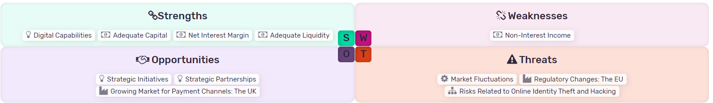
Figure 4: SWOT Analysis for Barclays PLC (MarketLine, 2024)

