  - BMSW4003 – Digital Skills and Research Methods

Impact of Virtual Learning Environment (VLE) – Moodle on Students’

Learning Experience
T1GW3-DSR with SYED JAFFERY

  - Cert HE Skills for the Workplace

Student Name:Vadana Cristina Elena
Student ID: 2028994

Contents
INTRODUCTION 2
Aim of the Research 2
OBJECTIVES OF THE RESEARCH 3
RATIONALE OF RESEARCH 3
LITERATURE REVIEW 4
RESEARCH METHODOLOGIES 4
QUALITATIVE RESEARCH 4
QUANTITATIVE RESEARCH 5
SAMPLE AND SAMPLE SIZE 5
DATA COLLECTION TOOLS 6
ETHICAL CONSIDERATIONS 6
ANALYSIS AND DISCUSSION 7
DESIGN QUESTIONNAIRE 7
GRAPHICAL VISUALISATION AND FINDINGS 8
LIMITATIONS OF THIS RESEARCH 13
RECOMMENDATIONS FOR FUTURE RESEARCH 14
CONCLUSION 15
REFERENCES 16

INTRODUCTION
Virtual Learning Environment is commonly known as VLE. VLE is a collection of integrated tools that enables the management of online learning, student tracking, providing a delivery mechanism as well as access to resources. It’s a technology based platform of learning of numerous course of study. Numerous activities, interactions as well as resources are illustrated inside the structure of a course. VLE is providing a differently advanced platform for both the students and the teachers which assist them to increase learning experiences and utilization of digital solution (Waheed et al., 2020). The focusing purpose of the system is to generate active and interactive learning environments by the assistance of virtual solution. The impact of the virtual learning environment is going to be highlighted in this research report.

Figure 01: UWTSD Logo; Source: ("UWTSD London", 2021)
The prominent University of Wales has been enlightening the students since 1893. This is considered one of the best universities of United Kingdom.

Aim of the Research
The purpose of this research is finding out the influence of virtual learning environment (VLE) - moodle on students’ knowledge expertise at the University of Wales Trinity Saint David London campus.

OBJECTIVES OF THE RESEARCH
Objectives of this research are in the following-
- Successful progress in the digital efficiency of the students.
- Effective information analysis and information to knowledge translation conversance are growing (Hughes, 2020).
- Evaluation of the usage of latest techniques for improving workplace efficiency and employability.
- Identification and evaluation of tasks of literature on virtual learning environment.
- Illustration of the capability of data handling in associated workplace.

RATIONALE OF RESEARCH
The teachers and the support staff are enabled by the virtual learning environment in managing, delivering multiple routine tasks like preparing lesson plans, systematic class administration, observing students distantly with the assistance available resources. For enhancing the total learning experience, the teachers as well as students may be helped by the virtual learning experience. It can be accelerated by this research.

LITERATURE REVIEW
(Waheed et al., 2020): ‘Predicting the academic performance of students from VLE big data using deep learning models’, SalemAlelyani, Saeed-UlHassan, HajraWaheed, Naif RadiAljohani, JulieHardman, and RaheelNawaz are the author and they think the utilization of big data in the anticipation of academic performance can be positive. The concluded facts are provided here. VLE can generate data which turned it to a sustainable data driven decision. Pupils may be intervened early with the anticipation of clicstream data gathered by VLE. It can also predict the student’s situations of risks. The VLE data enhances the capability of network’s prediction.
(Carvalho, Areal, and Silva, 2011): ‘Students' perceptions of Blackboard and Moodle in a Portuguese university, Nelson Areal, Ana Carvalho,and Joaquim Silvaexplores the perception of students’ was another research on learning management system which are known as Moodle and Blackboard. Nelson Areal, Ana Carvalho,and Joaquim Silvaexplores have brought important information o this topic.
(Pagani et al., 2016): ‘The impact of digital skills on educational outcomes: evidence from performance tests’, in 2016 this article was published by Pagani, Argentin, Gui and Stanca on the influence of digital skills and its exploration.

RESEARCH METHODOLOGIES

QUALITATIVE RESEARCH
By the term qualitative research, it means a particular research method in which the approach depends on data collection by the person who is directing the research from personal interviews, observation of participant, questionnaire, records and artefacts, focus groups and first hand observation (Silverman, 2020). In qualitative research, the collection of raw data is generally is non numerical. There are some special purpose cases for using qualitative research like understanding fundamental values, realising the underlying feelings and perceptions that influence the behaviour, recognizing customer needs, improving the hypothesis to test also and to develop the quantitative questionnaire, as well as understanding the language and portraiture of the customers which is used for narrating a service or a product (Silverman, 2020). For evaluating the usage of simultaneous techniques, qualitative research is required for this research.

QUANTITATIVE RESEARCH
Quantitative research means a specific research method which concentrates on quantifying the compilation as well as analysis of data. Quantitative research method is obtained for doing mathematical as well as statistical analysis of the data from the collection (Pagani et al., 2016). The researchers are helped to quantify opinions, behaviors, attitudes, perceptions, and other selected particular variables (Vogt, 2011). This research needs to make a proper use of quantitative research for illustrating the capability of data handling.

SAMPLE AND SAMPLE SIZE
Sample, in the field of statistics and quantitative research, means a specific methodology that indicates a set of objects or individual selected from a statistical population in a fixed method. There are some specific and popular sampling techniques such as systematic sampling, simple random sampling, snowball sampling, clustered sampling, and quota sampling. Simple random sampling will be used in this research (Vogt, 2011). Each and every individual will be chosen randomly and entirely and the sample size will remain one hundred for this research.

DATA COLLECTION TOOLS
In both qualitative and quantitative researches, data is considered very significant because without required data, research conclusion is baseless. There are a number of ways for collecting data. Various techniques are adopted by the researchers such as personal interviews, questionnaires, focus groups, documents, surveys, records, oral histories and observations. Specifically surveys and questionnaires have been chosen for this research as such tools are practically effective and scalable. Moreover these can be executed in lower cost which is very significant. The research is concerned with digital skills and knowledge, QuestionPro, GoogleForms, Qualitrics, Typeform, Surveysparrow, Surveymonkey, Zoho survey and so on. The chosen data collection tool is SurveyMonkey as it provides some advantages such as less data coding and input errors, easier access, cost efficiency, faster and smooth system of distribution and so on. This digital surveys and questionnaires is very time efficient.

ETHICAL CONSIDERATIONS
One of the very significant parts of the research is ethical consideration because the data or information can be personal and confidential. The participants or students who participated in the research must not be harmed physically or mentally with their provided data. The researchers must keep the safety and dignity of the students in mind and it should be prioritized. In case of participation, proper consent of the participants or students must be confirmed.

ANALYSIS AND DISCUSSION

DESIGN QUESTIONNAIRE
A questionnaire for the research is provided here-
- What is your identity?
  - Student user
  - Staff
- Have you been trained on VLE as your lesson?
  - Yes
  - No
- Do you think that Virtual Learning Environment can be use useful comparatively?
  - Yes
  - No
  - Sometimes
- During using VLE, have you identified any obstacles?
  - Yes
  - No
- Why you are convinced to begin using VLE?
  - Your supervisor/teacher inspired you.
  - You followed your classmates and encouraged use VLE.
- Do you think that VLE can add other positive services?
  - Yes
  - No

GRAPHICAL VISUALISATION AND FINDINGS
Question No. 1:
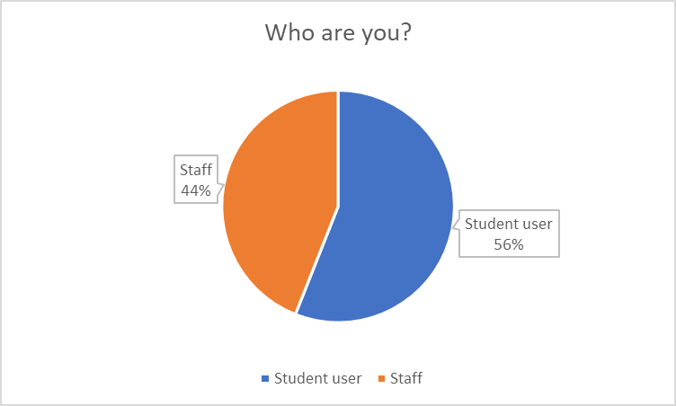
The first question is about the participant’s identity of weather they are students or staffs. The result says that 44% o total participants are staff whereas other 56% are student participants. The staffs include the teachers, staffs and others.

Question 2:
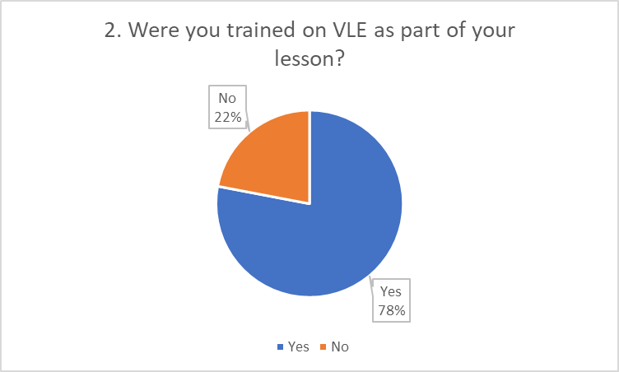
Many of the participants have got the training on VLE as an important part of their education or lessons. The second question deals with weather the participants had the training earlier or not and the research says that the majority of the participants, 78% were trained on virtual learning environment. Other 22% of the respondents were not trained on the VLE. As a consequence, VLE seems to be new to them, but gradually it’s becoming popular. The students and teachers who don’t have any training on is surely to face some disadvantages.

Question 3:
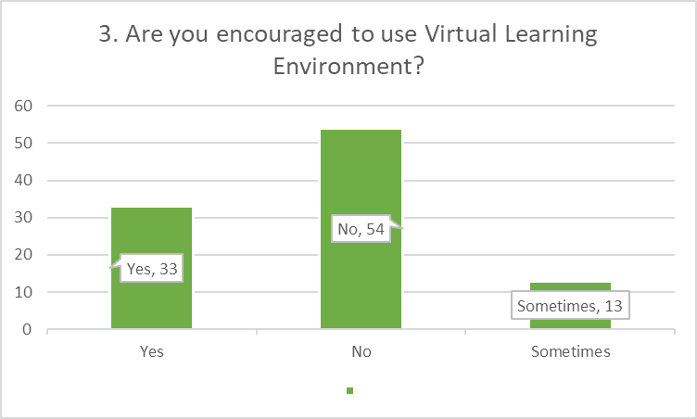
The third question asked in the questionnaire is about the enthusiasm of using VLE to the respondents. Three categories are provided here, the first one is answered yes by 33%, no by 54% and Sometimes by 13%.

Question 4:
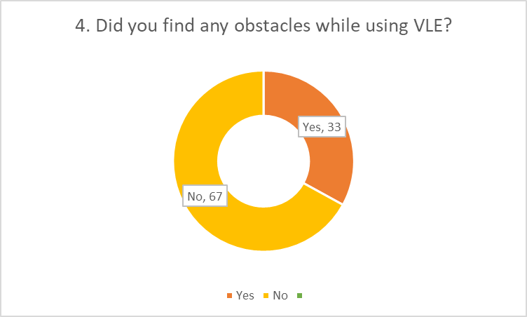
The question number four was about finding obstacles in the period of using VLE, and most of the respondents answer was negative. From the total number of respondent, 67% didn’t find any kind of barriers in using VLE (Waheed et al., 2020). So it is found that the largest amount of respondents didn’t face obstacles in use VLE. On the other hand, there are 33% respondents whose answer is affirmative that they are facing obstacles in the time of using VLE. It means some of the students have faced obstacles in using VLE.

Question 6:
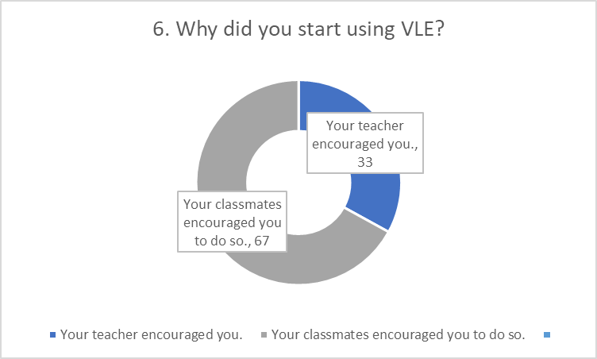

The question number six was about finding out the reasons the respondents of choosing VLE. There were two options and they are the tutor and the classmates. From the total respondents, 67% was thankful to their colleagues and classmates for introducing them to VLE and there were 33% respondents who were thankful to their tutor or superior for introducing it.

Question 7:
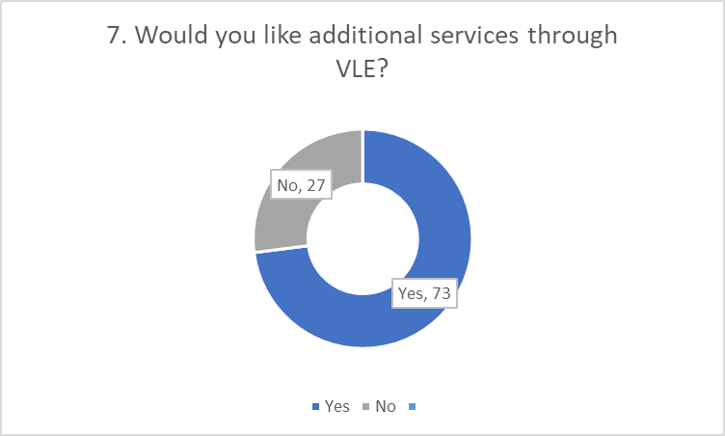
Question number seven includes if the respondents wanted to have some additional services through VLE. 73% from the total respondents answered affirmatively that they would like to have additional services through VLE, while the other 27% respondents answer was negative. VLE needs additional feature set, because the majority prefers it. (Carvalho et al., 2011).

LIMITATIONS OF THIS RESEARCH
For gathering knowledge and information, research is most commonly used method. But while generating knowledge for future utilization, some of the problems and limitations come in light. Such limitations in research may be concerned with methodology or design which can influence the research findings and sophisticate the result in some cases (Flick, 2018). The below discussion is concerned with the limitations of this research report.
- Sample Pattern and Issue of Selection: This research needs to simple and easy. Consequently simple random sampling was chosen for it’s simple nature but this selection technique creates the opportunity to be biased.
- Poor Sample Size: Sample has been chosen as the representatives of the school population but the school population is 10 times larger than 100 who were participated. In fact this population and their opinion on VLE may provide biased information on virtual learning environment.
- Inadequate Works of Literature: While working on this research, I tried to find research work on VLE in reputed websites working with researches, libraries as well as online sources like science.gov, Google Books, Goggle Scholar, Microsoft Academic and so on. But I found a very few works on the virtual learning environment (Maziero, 2015)..
- Limitations in Data Access: There were few hindrances while working on the research report. One of them was Covid-19 which is still going on, I couldn’t approach to many places where I might find more relevant information. It also minimized the response rate of the students to participate in the research. As a result, it had a significant influence on the research conclusion.
- Time Constraints: Research on such topic as virtual learning environment needs enough time which became a great barrier for me to generate a quality work. I had to run here and there for it in very short time (2 months) which had severe impact on the quality of the research.

RECOMMENDATIONS FOR FUTURE RESEARCH
As some of the limitations create quality issues, it’s important to rectify those mistakes. Some recommendations are provided on the basis of limitations for next researches (Flick, 2018).
- For such researches, the researchers must be aware of selecting data sampling technique. Clustered sampling can be more relevant and efficient in such researches. Students and teachers can be separated in different clusters which provide equal chances to both parties.
- As the total population is thousand approximately, the number of respondents should be increased. It can raise the efficiency of the researchers and upgrade the quality of the research reports (UWTSD, 2021).
- An intern or novice should be consulted by the professional or experts before carrying out such responsibilities like researching. Professionally experts are experienced and they know how and where a new comer can be infected with problems, so they can consult a new comer to avoid those mistakes.
- Latest survey methods can be used for higher response and third party survey services is equally effective.
These recommendations can be helpful for the upcoming researches. It can help to avoid the regular hindrances and assist to raise the quality of researches.

CONCLUSION
VLE is a potential platform for learning. The research focus was remained on this digital platform and the impact of VLE: moodle. This research adopted the quantitative research approach on the UWTSD for finding the answer and result. The finding of this research is VLE: moodle has a significantly positive impact on the respondents who were actually students, teachers and staffs of this institution (Maziero, 2015). It is seen that management, teachers are less interested in utilizing the potential of virtual learning environment which is unfortunate. Instead of the students eagerness, concerned management not taking adequate steps to utilize the platform properly. The finding of this research can be of work to learning/teaching profession for the depth understanding of the necessity of VLE in educational institutions.

REFERENCES
Alvi, M., 2016. A manual for selecting sampling techniques in research.
Carvalho, A., Areal, N. and Silva, J., 2011. Students' perceptions of Blackboard and Moodle in a Portuguese university. British Journal of Educational Technology, 42(5), pp.824-841.
Flick, U., 2018. An introduction to qualitative research. sage.
Hughes, S. (2020). University of Wales & University of Wales Trinity Saint David. Retrieved 3 March 2021, from https://university.wales/.
Knowledge Anywhere:: The Advantages and Disadvantages of a Virtual Learning Environment. Knowledge Anywhere. (2013). Retrieved 4 March 2021, from https://www.knowledgeanywhere.com/resources/article-detail/the-advantages-and-disadvantages-of-a-virtual-learning-environment.
Maziero, J., 2015. A random sampling of quantum states a survey of methods. Brazilian Journal of Physics, 45(6), pp.575-583.
Pagani, L., Argentin, G., Gui, M. and Stanca, L., 2016. The impact of digital skills on educational outcomes: Evidence from performance tests. Educational Studies, 42(2), pp.137-162.
Silverman, D. ed., 2020. Qualitative research. Sage Publications Limited.
UWTSD London. uwtsdlondon.ac.uk. (2021). Retrieved 3 March 2021, from https://www.uwtsdlondon.ac.uk/.
Vogt, W.P. ed., 2011. SAGE quantitative research methods. Sage.
VLE (Virtual Learning Environment) Definition. techterms.com. (2017). Retrieved 4 March 2021, from https://techterms.com/definition/vle.
Waheed, H., Hassan, S.U., Aljohani, N.R., Hardman, J., Alelyani, S. and Nawaz, R., 2020. Predicting the academic performance of students from VLE big data using deep learning models. Computers in Human Behaviour, 104, p.106189.

