
In this report I will be exploring different methods of research and the effectiveness of primary and secondary research and talking about the grit scake developed by angela duckworth

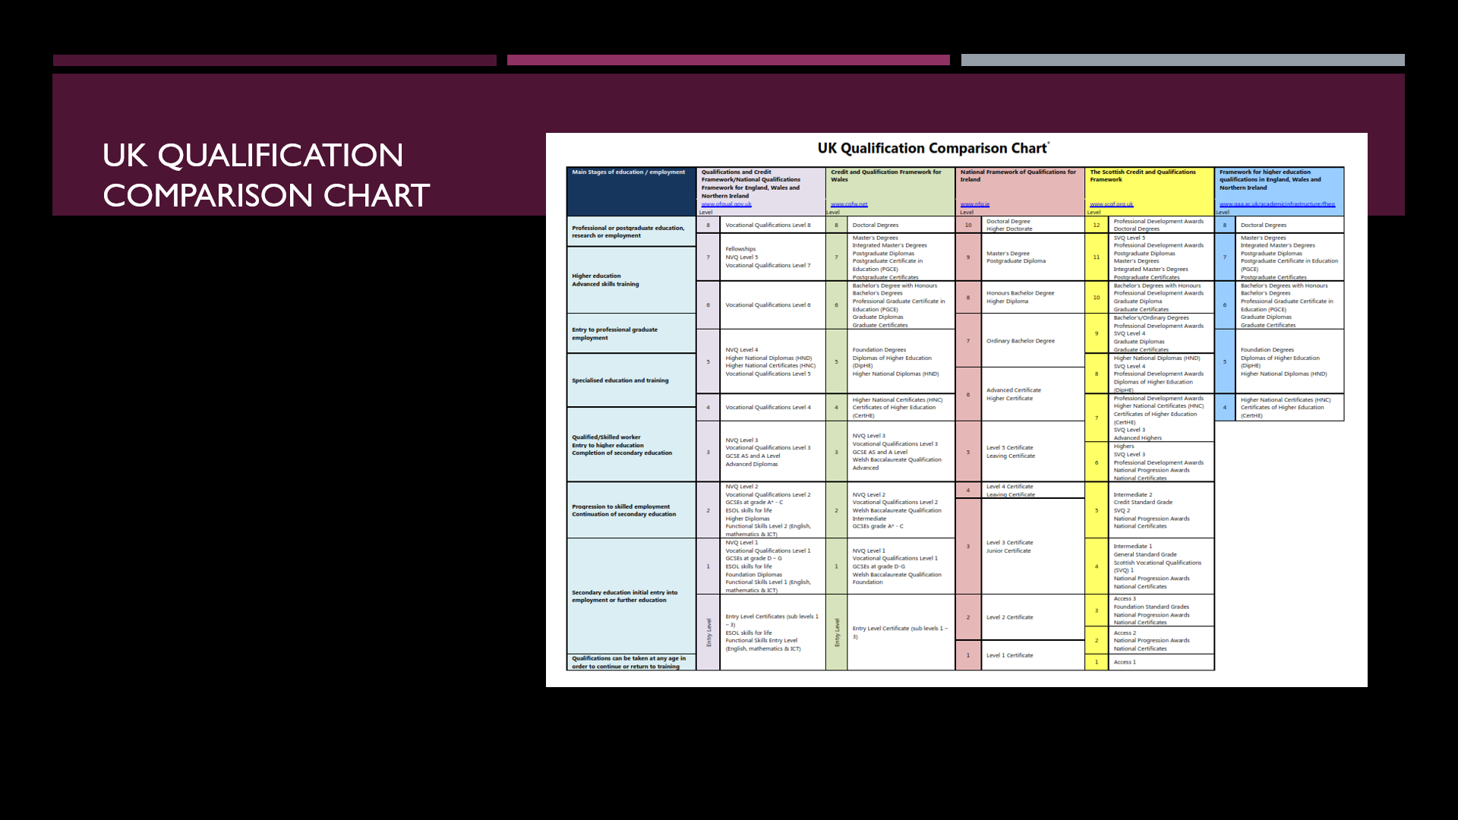
In the UK there are different qualification ranging from sats to gcse and a level and higher education such as under graduate degree in the UK GCSE S on a levels are graded from u to a these qualifications are very key and pivotal in the future young adults under find the potential career path that they choose to go on many believe that the Hardy work in school the better grades you will get and that leads on to my next point about the grit scale and about the perseverance that one needs to excel in educational format in the current climate of the world in some cases qualifications are even the key to progressing in life as to study certain courses you may need to attain a certain qualification or to go to certain schools you may need to get a certain grade just to enter the school this is called an entry grade


- Grit is the tendency to maintain interest in and effort toward very long-term goals
- The Grit Scale is a set of measures designed to measure an individual’s level of perseverance and passion for long-term goals. Grit is calculated by Adding together all the values and divide by 12. The maximum score on this scale is 5 (extremely gritty), and the lowest scale on this scale is 1 (not at all gritty). Grit can be used to estimate the success of people due to the fact that it can implicate how persevering one is and it is thought that people with high grit score will go on to be more successful in future so I have collated some data from some research I’ve carried out and will further analyse this data


Angela Lee Duckworth was born in 1970 and is an American academic, psychologist, and popular science author. She is famous for creating the GRIT scale . Duckworth earned a B.A. in Neurobiology at Harvard College in 1992. Angela Duckworth defines grit as a combination of passion and perseverance. She claims that grit is one of the most important factors of success in life. She optimistically believes that grit is trainable. she was teaching in the 7th grade and during her time she realised that students with high iq were less hard working and that’s how she came up with grit and explored the idea that peoples with more grit can become more successful than people with better grades.
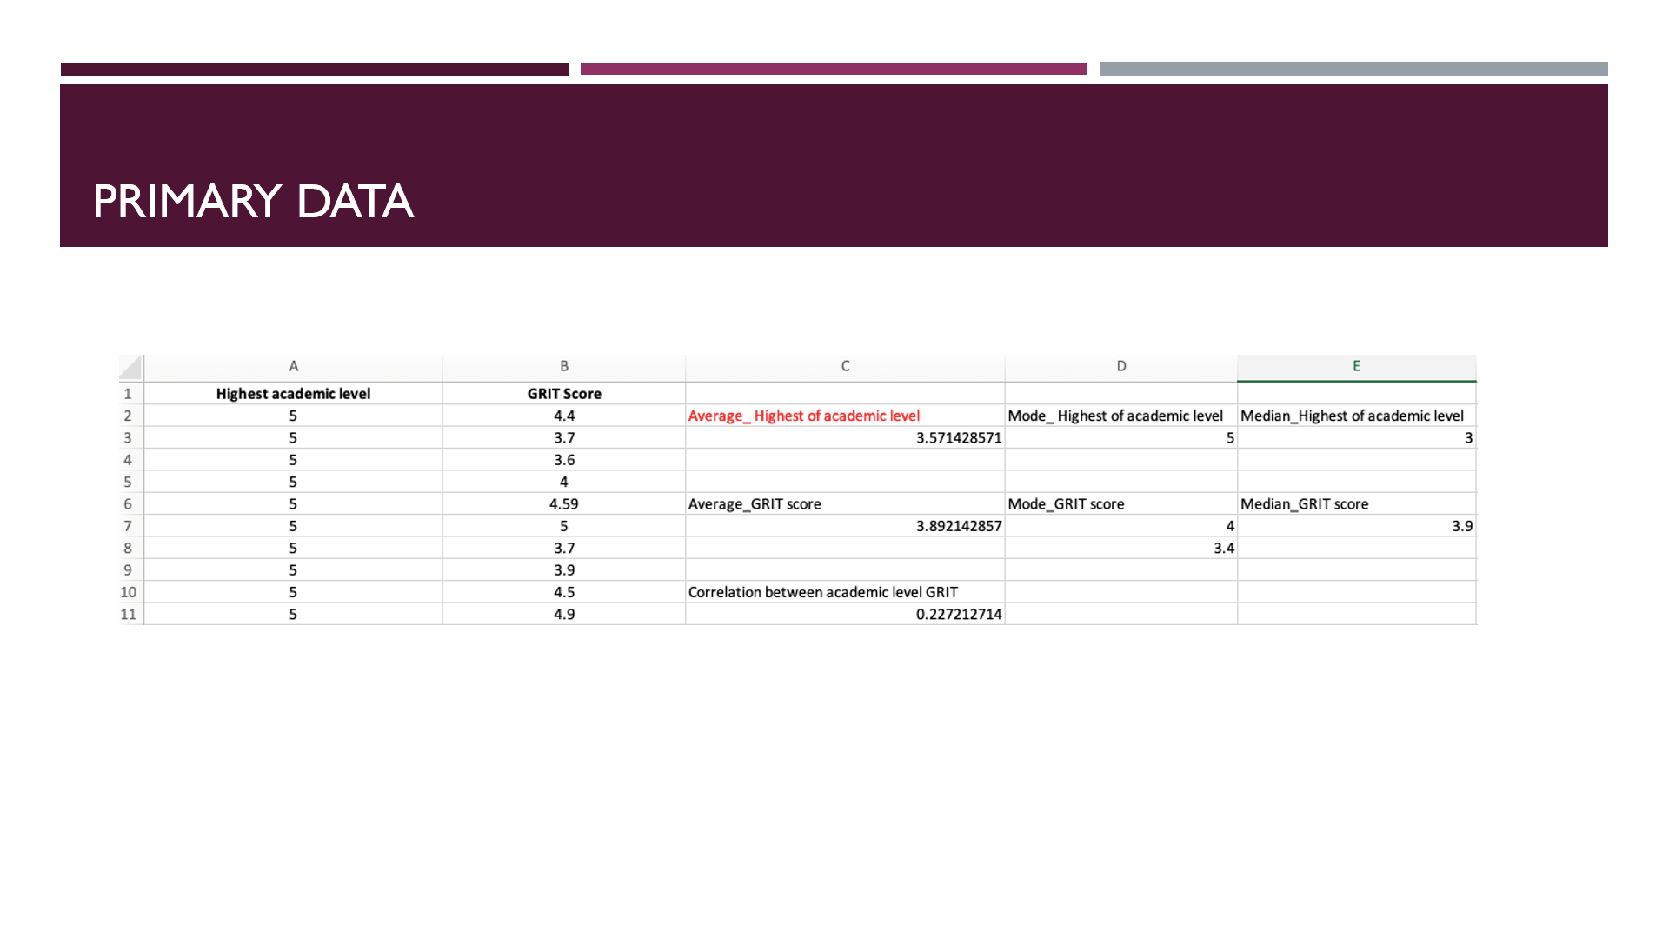

Primary data is data that is collected by one’s self by carrying out research on your own and not using other people research .The average of the highest academic grades was 3.57 I calculated this by adding up the total of the highest academic levels and then dividing and then dividing by the amount of values that were given and this gave me 3.57 I then walk up the average grit score using the same equation and the average great score that I got was 3.89 and in the process of comparing the difference between the grit score under highest academics level the correlation between the academic level and the grit was 0.22 the mode of the highest academic level was five because of the fact that most people’s highest academic level was five on the mode grit score the median of the highest academic level was 3 is the middle number all 5 and the medium git score was 3.9 .the fact that the average grit score was 3.89 shows that the individuals in the sample showed high amounts of grit and that they aren’t shy to persevere in the face of a challenge so from this set of data one can predict that these students will go on to succeed in the future.

Secondary data is data that you have not collected yourself but you can get from the Internet or from another person’s research for example books encyclopaedias and journals . From the data that's been collected from uwtsd students it has been revealed that the highest economic level was 3. The mean average of the highest academic level was 3.29 And the mean average of the grit score was 3.54 I figured this out by I think the sum of total observations divided by the total number observations and the difference between the grit score and the highest academic level was 0.304. The mode of the highest academic level was a score of 3 as that was the most common score between uwtsd students and the mode of the grit score was 3.8. The median grit score was 3.6 and the median highest academic level was 3 The median average is representative of the proposed middle point in a data set. the Median is calculated using the following formula. Median = (n + 1) / 2.

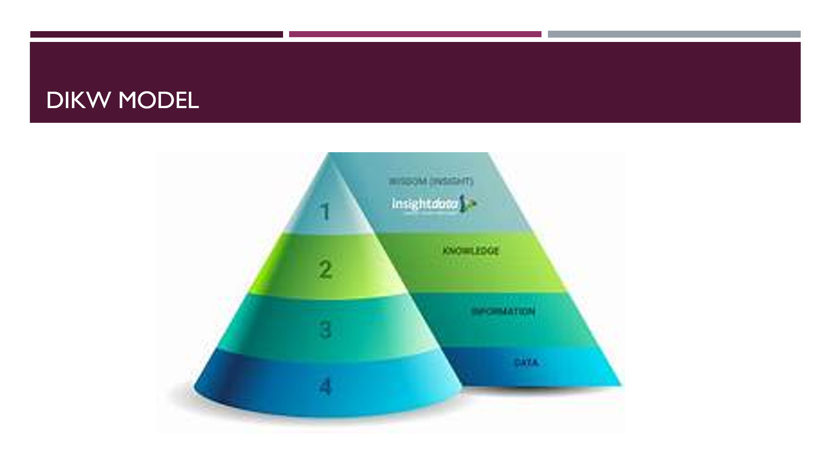

The dikw model is a model that represents how information should be processed and how data should be used the model outlines that data in this raw format has no use That's why this data should then be turned into information and this information is well and good but to truly grasp and use this information correctly the information should then be turned into knowledge and this knowledge then turns to wisdom will . If you just have data and you don't do anything with this data it is useless and can't be used for anything that's why you need information and context From being informed I knowing a lot of information on this topic one can gain knowledge and that knowledge is used to teach others and to have a full understanding of what is going on and how to perfectly analyse this data set and at a certain point knowledge turns to wisdom and once wisdom is attained a topic is fully understood and the wisdom obtained can be used to make logical points and can apply logic to life and analysing data just like how I compared the grit scores of uwtsd students to their highest academic level without knowledge and wisdom you cannot analyse data properly and the data would be useless and no conclusions would be able to be made
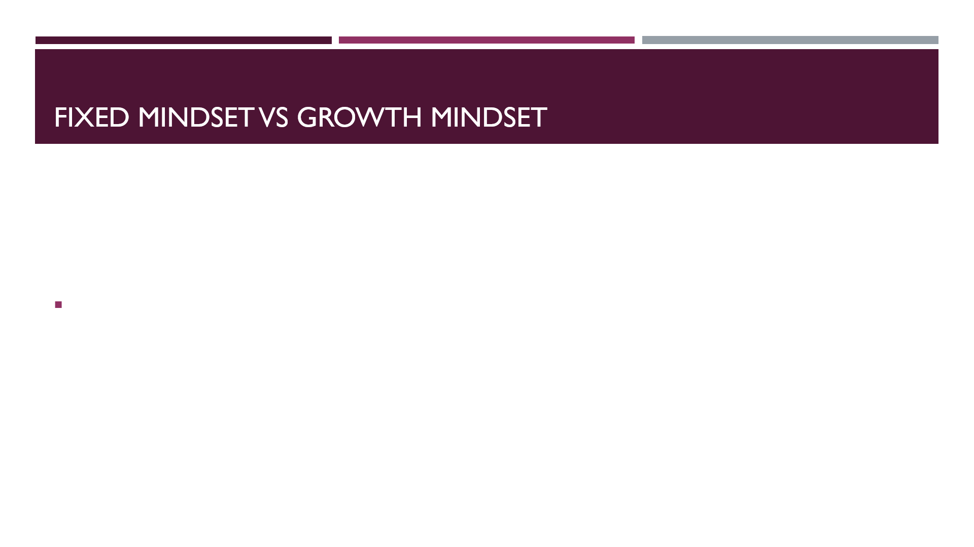
In life having a growth mindset is pivotal as if one has a fixed mindset they will forever be scared to take risks and go to the next step in life and they will never escape their comfort zone and people who are scared to escape their comfort zone will barely go on to succeed in life because people with fixed mindset don’t have high levels of grit so they wont work hard to overcome obstacles and are extremely complacent when it comes to having to push and put in extra shifts in terms of studying and life in general I believe people with a fixed mindset no matter how smart or naturally gifted they are have a ceiling but hose with a growth mindset have unlimited potential .

