10/04/2019
Games Architecture and Mechanics - Assignment 2
Games Architecture and Mechanics - ACCA5017 – Gordon Dickers
Matthew Dickinson – 1708355 – BSc Games Development

Table of Contents
Introduction 2
1. Implemented Features 2
1.1 Implemented engine pattern 2
1.1.1 Input/render/update pattern 2
1.1.2 Variable rate rendering 2
1.2 Object loader implementation 3
References 5

Table of Figures
Figure 1. Implemented game loop 2
Figure 2. obj and bmp loader methods 3
Figure 3. torus.obj data 3
Figure 4 obj vertex loading 3
Figure 5. obj face loading 4
Figure 6. Partially rendered torus 4
Figure 7. bmp loader test 4

Introduction
This report contains details of features added to an existing game loop alongside descriptions of other game engine patterns considered.

Implemented Features

Implemented engine pattern

Input/render/update pattern
A game loop has been implemented containing an input method, a render method, and an update method. The overall game loop is displayed below:
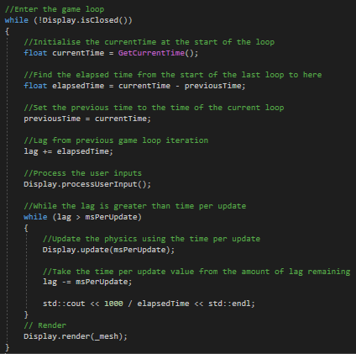
Figure 1. Implemented game loop
At the start of the loop the current time is retrieved and used to calculate the elapsedTime between iterations of the loop. The lag per frame is calculated using this value. User input is processed first as user inputs can affect forces applied to objects that are calculated in the update method. After the game objects have been updated, the scene is rendered.

Variable rate rendering
In a variable time step game loop, the amount of lag is updated based on the amount of real time that has passed between updates. This is used to measure how far behind the game time is from real time. An inner update loop is used to catch up to real time by updating game objects until the lag counter is below the msPerUpdate value. Once the game time has caught up, the scene is rendered. Using this method, the simulation of game objects remains consistent on machines with different hardware, though movement will appear smoother on faster machines [1] [2, pp. 123-133].

Object loader implementation
An existing object loader was modified and implemented into the prototype’s Mesh class.
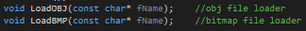
Figure 2. obj and bmp loader methods
The obj loader method loads the object’s vertices, texture coordinates, vertex normals and faces.
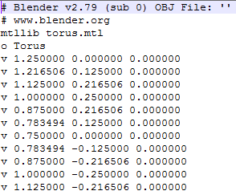
Figure 3. torus.obj data
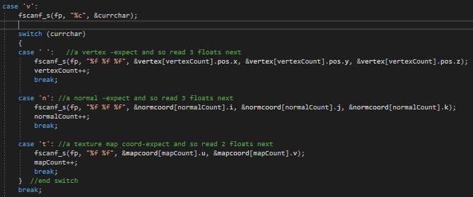
Figure 4 obj vertex loading
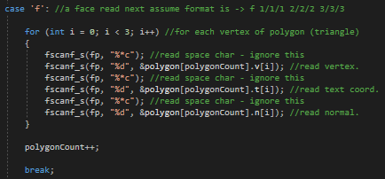
Figure 5. obj face loading

The object coordinates were successfully imported for rendering as seen below.
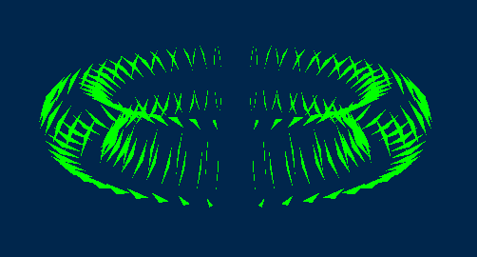
Figure 6. Partially rendered torus
The bitmap loader successfully loaded texture coordinates, however texture mapping has not been implemented.
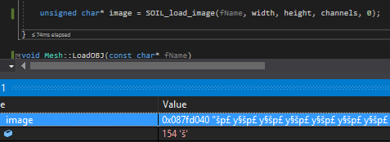
Figure 7. bmp loader test
The SOIL_load_image method returns 0 if loading has failed, otherwise the image has successfully loaded.

References

[1] | G. Fiedler, "Fix Your Timestep!," Glenn Fiedler, 10 June 2004. [Online]. Available: https://gafferongames.com/post/fix_your_timestep/. [Accessed 5 May 2019].
[2] | R. Nystrom, Game Programming Pattern, genever benning, 2014.

