
Module code :LCMB7006
Module :International marketing

SUSTAINABILITY IN GLOBAL COMPANIES

Name:Hashil Ambalaparamban
ID:2241163
Executive Summary
Fevicol is an Indian-originated brand of adhesives owned by the Indian company Pidilite Industries. Depending on the market trends, this company has a stable established business in India compared to Thailand. Fevicol maintains its business ethics in both the country India and Thailand. The target product of this brand is selling across the countries and to the people from rural to urban city areas. This has more or less a similar market in both India and Thailand. This report has outlined a comparative market analysis of India and Thailand to comprehend the threats and opportunities for the business expansion of Fevicol. In addition, in order to outline the market entry mode for these countries (India is the home country), Porter’s five force analysis has been done. Based on this, the market entry mode has been developed. Fevicol stands out in the adhesive industry with a strategic focus on sustainability, inclusive marketing, and global adaptability. Prioritizing innovation, values, and customer-centricity, Fevicol ensures resilience. In order to ensure enduring growth, the company advocates ongoing market research and a steadfast commitment to environmental and social responsibility, positioning itself as a formidable.

Table of Contents
1. Introduction 3
2. Brand Overview 3
3. Situational Analysis of Fevicol in India and Thailand 5
3.1 STEEPLED 5
3.2 Porters Five Forces 9
4. Marketing Strategies 12
4.1 STP 12
4.1.1 Market segmentation 12
4.1.2 Customer persona 15
4.1.3 Market positioning maps 16
4.2 Marketing Mix using 7Ps 18
4.3 Market Entry Modes 20
4.4 Directional Development Strategies 21
5. Recommendation 22
6. Conclusion 23
References 25

1. Introduction
The trend for globalisation has significantly accelerated the expansion of business cross-border with effective adoption of the marketing strategies. Integration of international marketing strategies assists organisations in spreading awareness of their products or services in the emerging market. However, today, the business organisations tend to adopt sustainability in every aspect of the business organisation to minimise their adverse operational impact on the environment. This report has outlined the situational analysis of the two countries to unveil the threats and opportunities for Fevicol. The report aims to explore the international marketing strategy adopted by Fevicol, an adhesive brand for the vast market of India and Thailand by developing comparative insights into these two marketplaces for Fevicol.

2. Brand Overview
Pidlite has experienced notable profit before taxes as a share of net sales in the last fiscal share that is approximately 15.8% as illustrated below (Statista, 2023). The company has become famous due to the launch of Fevicol, a white adhesive. The company has utilized advertisement for the product promotion that has a notable contribution to its success. As reported by Nair (2019), with the help of the advertisements Egg, Vagabond, Bus, and others acts significantly for the business success of Fevicol. In addition, the talented workforce has been involved in the marketing for the products once a week which helps to generate an informative insight on the market analysis.
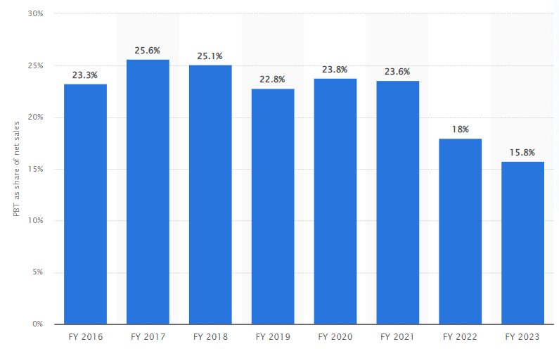
Figure 1: share of net sales
(Source: Statista, 2023)
Fevicol is an Indian-originated brand of adhesives owned by the Indian company Pidilite Industries. It was established in 1963 and became the generic household in the white glue category (Fevicol, 2022a). Fevicol is marketed in almost 54 countries including India, Thailand, the USA, Brazil, Kenya, Nepal and many more (Pidilite, 2016a). The sales revenue of Pidilite Industries was ₹105.97 billion in 2023 (Statista, 2023) (Refer to Figure 1).
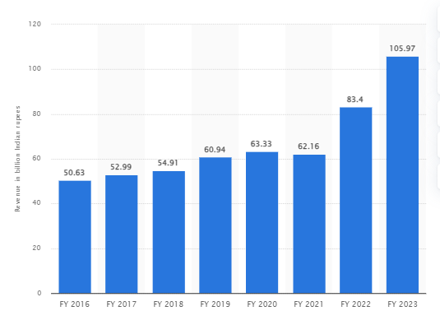
Figure 1: Revenue of Pidilite Industries
(Source: Statista, 2023)

3. Situational Analysis of Fevicol in India and Thailand

3.1 STEEPLED
Factors | Description
Socio-demographics | India:  - Average annual population growth rate 1.2% since 2011 census (Das, 2022) Threat  Thailand:  - The current population of 2023 has increased by 0.15% from 2022 (Macrotrend, 2023): Opportunity
Technological | India:  - Proliferatingindustry 4.0 technology such as block-chain, Internet of Things (IoT), Automation (Deloitte, 2023) Opportunity  Thailand:  - Thailand has adopted new advanced technologies including robotics, automated sensors and drone technology in different industries (CNBC, 2022): Opportunity
Economic | India:  - Employment rate increased from 36.6% (2022) to 36.9% in 2023 (Sharma, 2023) Opportunity  - GDP growth rate stand at 6.3% in 2023-24 fiscal year (Times of India, 2023) Opportunity  Thailand:  - The unemployment rate has decreased by 0.99% in 2023 (Trading Economics, 2023): Opportunity
Environmental | India:  - 86% Indian population prefer eco-friendly and organic products (Indian Retailer, 2022) Opportunity  - Self-Reliant India campaign has shown emphasize on the sustainability in the business practice (Kapoor, 2023). Opportunity  Thailand:  - 76% of Thai customers are aware of using eco-friendly products (Srisathan et al., 2023): Threat
Political | India:  - Corporate tax rate for domestic company and foreign company are 30% and 40% accordingly (PWC, 2023a) Threat  - The political stability index of India is -0.64 (The Global Economy, 2021). Opportunity  Thailand:  - The corporate tax rate for foreign companies is 20% plus 15% final withholding tax with 10% dividend tax (PWC, 2023b): Threat  - The political stability index of Thailand is -0.55 (The Global Economy, 2021). Opportunity
Legal | India:  - Minimum Wages Act, 1948; The Industrial Dispute Act; 1947; The Employee Compensation Act, 1948 (Government of India, 2023) Opportunity  Thailand:  - Foreign Business Law under Public Limited Companies Act, B.E. 2535 (AD 1992) (Deloitte, 2022) Opportunity
Ethical | India:  - National Human Rights Commission protect and monitor business orientation concerning protection of human rights (Government of India, 2018) Opportunity  Thailand:  - Thailand made 8 voluntary pledges on the promotion and protection of human rights (Techagaisiyavanit and Chokprajakchat, 2020): Opportunity
Table 1: STEEPLED Analysis on the India and Thailand
Similarities and Differences
The situational analysis developed above, has provided a meaningful insight regarding the business performance of Fevicol in India and Thailand. Based on the above analysis it has been found that the progressive trend for advanced technology is a great opportunity for the business of Fevicol for both the countries. The rate of increment of the population of a country denotes the probability of the demographic expansion of a business organization. From the above analysis, it is found that Thailand has experienced approximately 0.15% population growth in this year (Macrotrend, 2023). However, the annual growth rate of India is 1.2% since 2011 (Das, 2022). It implies that, with respect to the socio-demographic context, Fevicol has an opportunity to promote its business in Thailand compared to its home country. In terms of the economic condition of the two countries as outlined above has experienced positive economic growth as the employment rate of the two has increased. The rate of employment and the tendency to purchase of the people is directly proportional. From this perspective, it can be said that Fevicol has an opportunity in these two market domains to expand its business.
The political stability plays an important role in the business organisation to operate successfully. In that case, from the above analysis, it is found that both the countries are in good potion according to the report of The Global Economy. However, differences have been noticed in the ranking in the political stability index and comparing this aspect, it can be said, that Thailand is a better marketplace for Fevicol as it is in upper rank from India.
The economic status of India with an enhanced GDP rate and employment and for Thailand with decreasing unemployment rate shows a positive business environment. On the other hand, the high corporate tax is a similar threat that both India and Thailand pose for domestic and foreign companies. This seems harmful for Fevicol to expand its business in India and Thailand. India and Thailand both follow different types of laws regarding business management that make similarities of both countries. Lastly, both the country India and Thailand have actively engaged in maintaining the ethical concerns for business ethics that aims to protect human rights. This reflects an effective business-expanding environment for Fevicol in both the countries. In terms of environmentally conscious business practices, it is revealed that the Indian customers is highly environmentally conscious and choose to purchase products from the eco-friendly brand. In this case, some differences have been revealed that, compare to India Thailand is not so aware of eco-friendly approach that creates difficulty for Fevicol to adopt the green business strategy. As per (Pidilite, 2022), Pidilite has a key focus on implementing eco-efficiency in the operational practice. Therefore, for the Indian market, it creates an advantage for the Fevicol to operate sustainably compared to the market of Thailand.
Fevicol has an effective tendency to incline towards the technological adaptation for seamless operational practices. As reported by Bhot (2022), the Pidlite team has created Azure Data Lake to organise their operational information and create dashboards through PowerBI. From the above STEEPLED analysis, there is a similarity that has been found in that both of the countries have adopted technological advances that act as an opportunity for Fevicol to operate in these two domains.
On the other hand, in socio-demographic factors, Fevicol has faced similarities between India and Thailand due to the population growth rate. In India, the population growth rate is the same since the 2011 census, whereas, population the growth of Thailand has increased (Das, 2022; Macrotrend, 2023). Moreover, 86% Indian population and 76% of Thai customers are aware of using eco-friendly products, that is another similarity between these two countries (Indian Retailer, 2022; Srisathan et al., 2023). Therefore, it can be stated that India and Thailand have similarities in the business environment compared to differences

3.2 Porters Five Forces
Forces | Description
Threats of new entrants | India:  - The Indian Adhesive market size is $2.43 billion in 2022 and is expected to reach $3.76 billion in 2028 (Mordor Intelligence, 2023a) (Moderate)  Thailand:  - The market revenue of adhesives and sealants in Thailand is expected to grow annually by 6% between 2022-23 (Mordor Intelligence, 2023b) (Moderate)
Bargaining power of the suppliers | India:  - 5 companies in India in the Adhesive industry that low the bargaining power of the raw material suppliers (Mordor Intelligence, 2023a) (Moderate)  Thailand:  - More than 10 companies are producing adhesive and sealants in Thailand (Mordor Intelligence, 2023b) (High)
Bargaining power of the Buyers | India:  - It is a B2C business that ₹53-55 billion consumer adhesives included in this industry between 20158 and 2020 (HP Adhesives, 2021).  - However, the target consumer of Fevicol is constant (ET Brand Equity, 2019) (Low)  Thailand:  - High company concentration leads to the low bargaining power of the buyers (Mordor Intelligence, 2023b (High)
Threats of substitute | India:  - Ethylene glycol is a low-cost substitute for synthetic resin (Greene, 2021) (Moderate)  Thailand:  - The utilisation of silicon-based adhesives is the trending demand in Thailand market for daily use (Mordor Intelligence, 2023b) (Moderate)
Competitive rivalry | India:  - Jivanjor, Araldite and others are the top competitors of Fevicol in India (The Economic Times, 2023) (Moderate)  Thailand:  - Henkel (Thailand) Ltd; Selic Corp public Company Limited; H.B Fuller Co. Ltd, Covestro AG and Bostik accounts 70% of this market (Mordor Intelligence, 2023b) (High)
Table 2: Porter's Five Forces on the India and Thailand
Similarities and Differences
Based on the above table (2), it has been observed that market size and revenue of the adhesive industry is progressing positively for both India and Thailand. This reflects moderate threats to the Fevicol brand as the increased revenue indicates successful business, however, the aggressive growth of existing companies poses threats for new entrants. As per the above evaluation, similarities have been found between India and Thailand. Both of the countries have significant market growth that opens the scope for newly emerged companies in this market. Therefore, it creates some difficulties for Fevicol to operate in these two businesses. However, in that case, the impact of this market threat is moderate as the people possess trust in the popular brand instead of the newly emerged brand due to importance of quality. Besides, the high company concentration in Thailand and the constant customer base in India cause low bargaining power of customers and high threats to brands. Moreover, Ethylene glycol and silicone-based adhesives are two substitute products in India and Thailand respectively that are used for making white glue. Thus, this impacts moderately on the business of Fevicol in both companies. The adhesive sector in India is dominated by five large enterprises, indicating a modest amount of supplier rivalry. This implies that suppliers could have some, if little, negotiating influence. However, the fact that more than 10 businesses are manufacturing adhesives and sealants in Thailand suggests that there is fierce rivalry among providers. Because of the intense rivalry, suppliers in Thailand might not have as much negotiating leverage as those in India. Since Fevicol is a B2C company and its target customer base is consistent, buyers in India have little negotiating leverage. This implies that customers are less likely to have substantial negotiation power when it comes to conditions or prices since they have fewer options. In Thailand, however, buyers have more alternatives and influence when engaging with suppliers because of the country's significant firm concentration, which increases their bargaining power.
In India there are 5 major companies that operate in the adhesive industry that cause moderate bargaining power for suppliers, whereas, in Thailand, there are over 10 companies operating actively, which causes fewer options for suppliers to bargain, which impacts the Fevicol brand. Moreover, Fevicol originated in India and has been operating for more than 50 years, so the competitive rivalry is moderate in the Indian market compared to the Thai market.
From the above table, it is revealed that, since ethylene glycol is a less expensive alternative that is used in a variety of uses, there is minor concern about artificial resin replacements in India. Comparably, as the market shifts into silicon-based polymers for everyday usage, there is a negligible chance of threats occurring for the substitution of the product of Fevicol in Thailand. These alternatives to the current items on the market are appealing because they have unique qualities and financial benefits. In Thailand and India, there is fierce competition in the adhesive industry. Jivanjor and Araldite are two competitors of Fevicol in India (The Economic Times, 2023). These rivals are regarded as the leading companies in the glue marketplace in India. In a similar vein, Henkel (Thailand) Ltd., Bostik, Covestro AG, H.B. Fuller Co. Ltd., and Selic Corp public company limited control 70% of the Thai market (Mordor Intelligence, 2023b). This suggests that there is fierce competition in both nations' glue industries.

4. Marketing Strategies

4.1 STP

4.1.1 Market segmentation
Market segment | Target criteria | Target customer |  | Positioning
 |  | India | Thailand | India | Thailand
Geographic | Location | Across country (Pidilite, 2023) | Across Country (Pidilite, 2022) | The company emphasizes selling products throughout the country (Pidilite, 2023) | Pidilite focuses on the sub-urban to urban areas across Thailand (Pidilite, 2022)
Geographic | Category | Rural to urban (Pidilite, 2023) | Sub-urban to Urban area (Pidilite, 2022)
Demographic | Age | No age boundary  (Pidilite, 2016b) | No age limit (Pidilite, 2017) | Pidilite concentrate on selling its vast range of aggressive products irrespective of age, gender, and income standard, however, student carpenter is key user of its products (Pidilite, 2016b) | Fevicol focuses the broad range of customers (Ubuy, 2023)
Demographic | Gender | No gender specific  (Pidilite, 2016b) | No gender boundary (Pidilite, 2017) |  | Fevicol focuses the broad range of customers (Ubuy, 2023)
Demographic | Occupation | Carpenter  Student and other common people (Pidilite, 2016b) | Students, carpenters, craftsmen, artists and others (Ubuy, 2023) |  | Fevicol focuses the broad range of customers (Ubuy, 2023)
Demographic | Income level | No specific income boundary (Pidilite, 2016b) |  |  | Fevicol focuses the broad range of customers (Ubuy, 2023)
Psychographic | Social status | Low to high (Pidilite, 2016b) | Low to High | Pidilite all of its products too low to high and all type of population of society (Pidilite, 2016b) | Pidilite focuses on the low to high customers types
Psychographic | Lifestyle preferences | No special preference (Pidilite, 2016b) | No particular preferences |  | Pidilite focuses on the low to high customers types
Behavioral | Purchasing trend | Low to high (Pidilite, 2016b) | Low to High (Ubuy, 2023) | The brand target mainly population of low o high purchasing trend however, with high brand loyalty (Pidilite, 2016b) | Pidilite is targeting individuals those are loyal to a brand and make repeat purchases
Behavioral | Brand loyalty | High (Pidilite, 2016b) | Moderate
Table 3: STP
Analysis
Market Segmentation in India
Pidilite takes a geographically wide approach in the Indian market, ensuring that its products are available throughout the country. This plan is consistent with the company's aim to serve various groups and contribute to national sustainable development. The company is a demographically diverse group that crosses age, gender, and income lines. The brand inclusive stance is seen in its appeal to a diverse clientele, with student carpenters emerging as important consumers (Pidilite, 2016b). Therefore, by targeting individuals across various social statuses and lifestyles, Pidilite solidifies its position as a brand for all, fostering a sustainable market presence.
Market Segmentation in Thailand
Pidilite tailors its segmentation approach in the Thai market to the distinct characteristics of sub-urban to metropolitan locations. This strategy reflects the company's grasp of regional differences in consumer behaviour and preferences. Pidilite demographic targeting remains comprehensive, with no constraints on age, gender, or income on its goods (Pidilite, 2016b). The company responds to the special demands of the Thai consumer environment by concentrating on students, carpenters, artisans, and others. The emphasis on a low to high purchasing trend corresponds with market realities, allowing Pidilite to tailor its offers different economic strata to Thailand.
India and Thailand positioning
Pidilite portrays itself in India as a brand with a national footprint, emphasising the wide availability of its products. This is consistent with goal of the company to servicing different populations and contributing to larger-scale sustainable practices. Pidilite broad demographic targeting and strong brand loyalty focus position it as a mainstay in the lives of Indian customers, adding to the market long-term viability (Pidilite, 2023). Pidilite advertises itself in Thailand as a brand that knows and caters to the distinct qualities of sub-urban to metropolitan locations. Pidilite creates a strong local presence by connecting its product range with the demands of students, carpenters, artisans, and other groups. The moderate brand loyalty emphasis recognises the Thai market variety, ensuring that the brand stays adaptive and sensitive to changing consumer behaviours.
Pidilite STP approach in both countries displays a sophisticated grasp of regional and demographic diversity, highlighting the brand dedication to sustainability via market relevance and inclusion.
Similarities and differences
Based on above STP analysis, it has been found that, the company Pidilite and sale its branded products of Fevicol with greater similarities for both India and Thailand. The target product of this brand is selling for across the countries and to the people from rural to urban city areas (Pidilite, 2023; Pidilite, 2022). Furthermore, the brand products target all type of age, gender and income level of populaion in both the countries. However, in the context of occupation, carpenters are the key consumer of the products, along with students and common people for daily household activities (Pidilite, 2016b). Moreover, this company company has more similarities in its business and marketing strategies in both markets.

4.1.2 Customer persona
Markets of India and Thailand have diverse cultures depending upon their cultures and requirements. However, Fwvicol has more or less similar market trends in both countries.
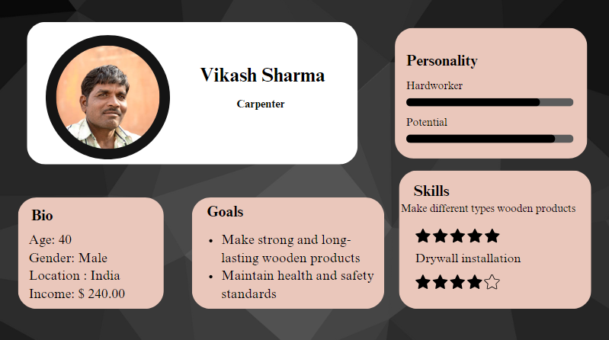
Figure 2: Customer persona for India
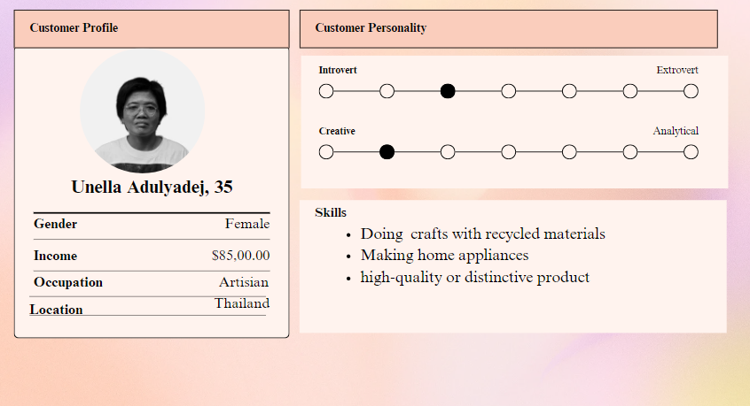
Figure 3: Customer persona for Thailand

4.1.3 Market positioning maps
India:
In the Indian market, Fevicol has operated since 1963 and now it has emerged as the most popular synthetic white resin adhesive in this market (Pidilite, 2016). However, Jivanjor, Araldite and others are the top competitors of Fevicol (The Economic Times, 2023). based on this a market positioning map has been drawn below that illustrates Fevicol is a highly demanded brand due to its that it provides high quality products at low prices. On the other hand, the product quality of the two competitors varies with their price range.
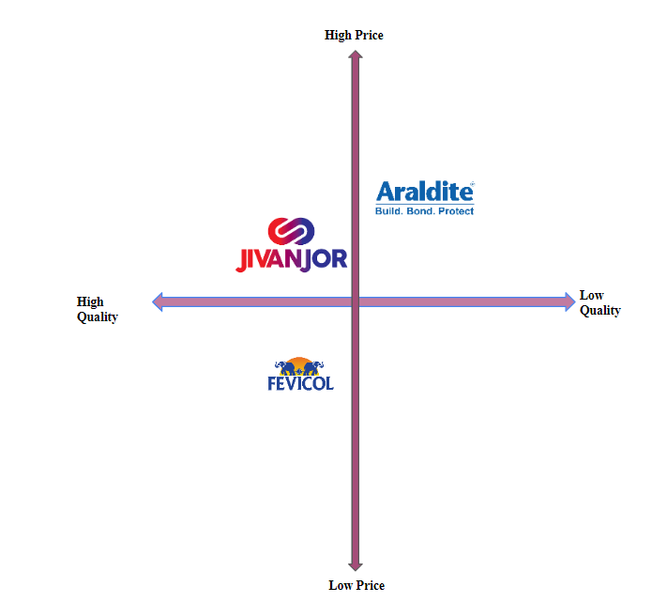
Figure 4: Positioning Map of Fevicol in India
Thailand:
Fevicol also has a strong presence in the market of Thailand. In this market, Fevicol has multiple competitors including Henkel (Thailand) Ltd; Selic Corp Public Company Limited; H.B Fuller Co. Ltd, and Bostik accounts for 70% of this market (Mordor Intelligence, 2023b). Based on this a position map has been developed below that implies that Henkel is the key competitor of Fevicol in the Thai market. On the other hand, Bostik and Selic have varied their product quality with the price range and H.B. Fuller to attract more customers focus less on the quality to compromise with the prices.
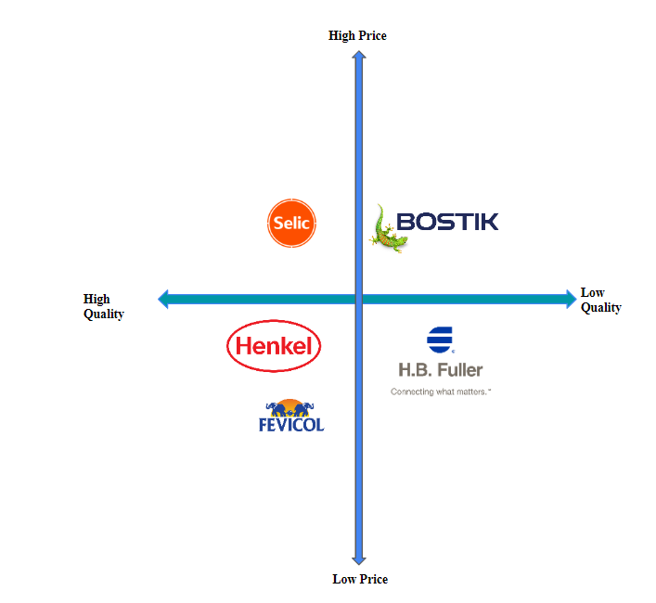
Figure 5: Positioning Map of Fevicol in Thailand

4.2 Marketing Mix using 7Ps
Product- In India and Thailand, Fevicol has multiple products Fevicol Marine, Fevicol MR, Fevicol Shoe Fix, and others (Fevicol, 2022b). Thus there seem to be similar kinds of products in both countries. The product offers commonality and reflects a global uniformity in quality and utility. This consistency enables the brand to create a standardized image, emphasising its commitment to supplying trustworthy and effective products across the world.
Price- In India the price of the products is quite reasonable based on the value of Indian currency, whereas in Thailand it has a high price tag due to the changed currency value there. For instance, the price of MR white glue in India is round ₹300, This aligns with the local economic conditions, making the products reasonably affordable for a wide range of Indian consumers. On the contrary this product price in Thailand is around THB 1350 (around ₹3000) (Amazon, 2023; Ubuy, 2023). This reflects that in Thailand its followers competitive pricing value whereas for India it is value-based pricing. Ability of Fevicol to adapt its pricing approach based on currency variations reflects its flexibility and responsiveness to local economic factors, ensuring that the brand remains competitive while maintaining its commitment to delivering quality products (Bhot, 2022). This dual-pronged pricing strategy underscores Fevicol strategic acumen in navigating diverse markets with distinct economic landscapes.
Place- In India and Thailand, Fevicol has focused on rural, sub-urban and urban areas to sell the products. Customers find products of Fevicol in everywhere the country (Pidilite, 2016b; Pidilite, 2022). This broad reach not only coincides with the brand dedication to servicing a broader range of customer categories, but it also contributes to the brand long-term market presence. Fevicol presents itself as a trustworthy and omnipresent alternative for customers, regardless of their location, by carefully positioning its goods throughout various regions (Sahoo and Ammani, 2017). This strategy not only increases brand awareness but also underscores the commitment of the Fevicol to fulfilling the adhesive demands of a diverse client base.
Promotion- Fevicol promote its products through using social media platform including Facebook, YouTube, and LinkedIn through advertisements in Thailand and India. Furthermore, in India, it is invested in the advertisement filming campaign that roll out its target for exclusive product quality and strength (ET Brand Equity, 2019). In order to increase customer involvement, Fevicol promotional efforts might include interactive content, influencer partnerships, or user-generated initiatives. This multidimensional advertising strategy guarantees that Fevicol not only responds to the changing digital world, but also effectively communicates its brand values and product qualities through conventional media.
People- In the Pidilite industry, employees think as entrepreneurs across all levels (Pidilite, 2018). Moreover, the customer range of Fevicol is broad compared to other similar products in both countries. The Pidilite industry mentality, in which employees at all levels are encouraged to think like entrepreneurs, generates a culture of creativity and devotion (Pidilite, 2018). This distinct viewpoint translates into a dedication to quality and constant improvement, ensuring that Fevicol products satisfy the changing demands of a varied client base. Furthermore, when compared to other similar items, the brand large client base demonstrates an intentional inclusion. Fevicol not only builds a loyal customer base but also contributes to the brand long-term sustainability by fostering a sense of connection and trust among consumers from various backgrounds and preferences.
Process- Fevicol complex sales strategy in India and Thailand, which combines online and offline channels, indicates a smart adaptability to changing consumer demands. In India, the brand sale its products through online retail marketing sites including Amazon, Flipkart and in offline store method as well (Amazon, 2023). Simultaneously, Fevicol maintains a strong presence in traditional brick-and-mortar stores, recognising the value of in-person purchasing experiences for particular market segments.
On the other hand, in the case of Thailand, the products get sold similarly though local retail suppliers such as Ubuy in online mode (Ubuy, 2023). This displays Fevicol adaptability in customising its distribution approach to the dynamics of regional markets. Adopting a dual-channel strategy not only increases market reach but also improves the brand adaptability to the changing retail landscape, contributing to long-term success in both nations.
Physical evidence- In India and Thailand, Fevicol is available in different types of containers as per its quantity and product criteria (Amazon, 2023; Ubuy, 2023). Moreover, the logo of Fevicol is constant across the world this makes constant physical evidencein front of the customers. This consistent branding not only improves brand memory, but also creates a trustworthy and reliable image for consumers in both India and Thailand. The persistent appearance of the emblem across various product containers promotes the brand dedication to quality and dependability, leading to a good customer perception that crosses regional boundaries (Kumar et al., 2021). This coherence in tangible evidence pieces indicates the commitment of Fevicol to sustaining a strong and long-lasting worldwide brand presence.
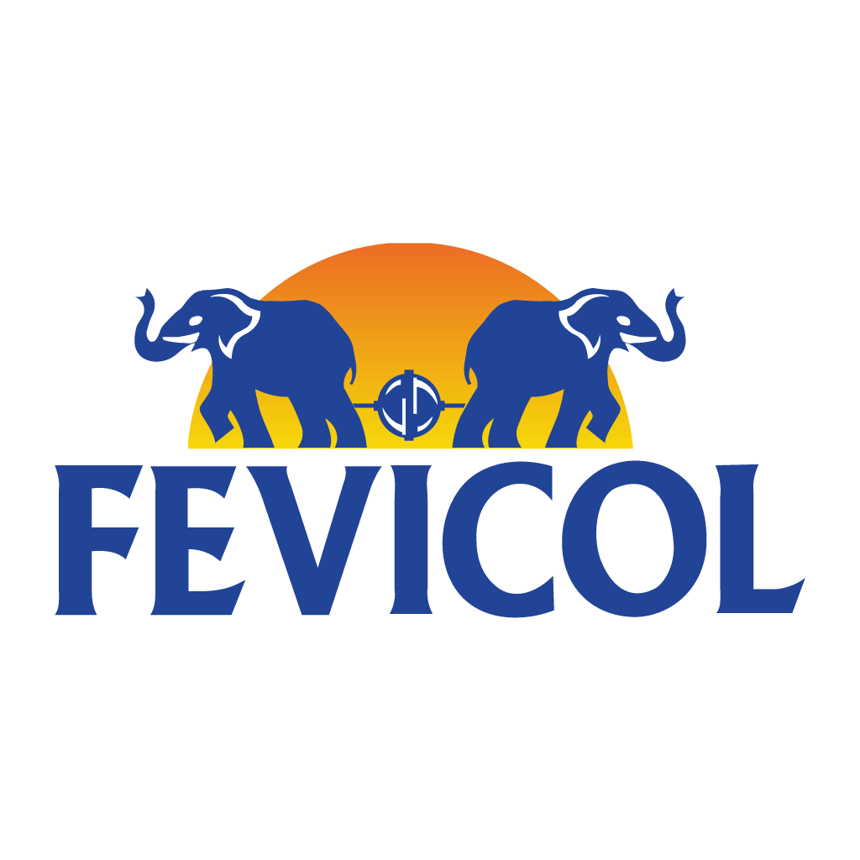
Figure 6: Logo of Fevicol

4.3 Market Entry Modes
Fevicol used different market entry modes in different foreign markets to establish the business. As per the opinion of Johanson and Vahlne (1977), the Uppsala model indicates the gradual acquisition, integration and use of knowledge about foreign markets and operationsof a business (Refer to Figure 7). The Uppsala model is a marketing approach that concentrates on entering and growing foreign markets (Arvidsson and Arvidsson, 2019). It recommends that businesses begin with low-risk nations and work their way up to higher-risk ones as they progressively raise their commitment and participation in overseas markets. The concept highlights relationship-building and market knowledge as crucial components of effective internationalization. In this context, it can be stated that the market knowledge, commitment decisions, market commitment and current activities are employed by Fevicol in different foreign markets.

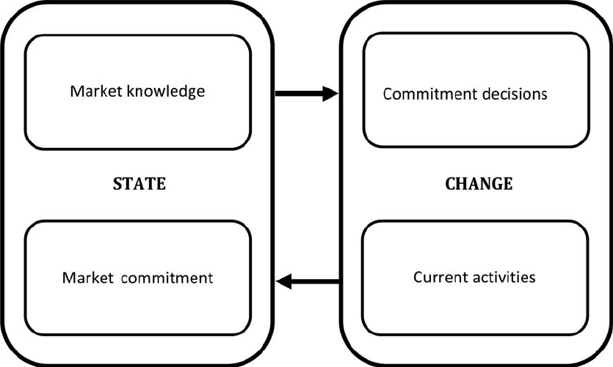
Figure 7: Uppsala Model
(Source: Johanson and Vahlne, 1977)
In the context of the Indian adhesive market, Pidilite takes the top marked market role and Fevicol is the most leading adhesive brand in this market. It is worth mentioning that, as Fevicol is the home brand for India, the brand follows a direct manufacturing and product-selling system in the country (Pidilite, 2016b). On the contrary, the brand of Pidilite Industries is expanding and maintaining its cross-country business through trademark licensing method for Africa, the Middle East and ASEAN countries including Thailand (The Economic Times, 2020). Giving another business permission to manufacture and market goods utilizing the trade name of licensor, technological advances, patents, or trademarks is known as licensing. It is a tactic used by companies looking to enter new markets. With this tactic, the licensee obtains access to well-known brands and goods while the licensor may increase its market position without having to take on a large financial or risky undertaking. Based on the above discussion, it is found that Fevicol has two different modes in India and Thailand as India is its home country.

4.4 Directional Development Strategies
Mission: The mission of Fevicol is to invest, invite, and embrace scientists and talented people for great challenges ahead (Pidilite, 2016c). Moreover, it focuses on serving, supporting and satisfying all valuable customers with excellent technical competency and innovative product competency (Pidilite, 2016c). In order to support this aim, the brand can contemplate additional developments in R&D, supporting innovation in adhesive technology (Noeske et al., 2021). Collaborating with scientists and welcoming new talent will not only improve product development but will also keep Fevicol at the forefront of industry developments.
Vision: Pidilite has the vision to be the most innovative research and technical competence center for sustaining innovation-driven growth across the globe (Pidilite, 2016c). Expanding its global footprint in R&D would not only reinforce Fevicol position as an innovative business, but will also contribute to long-term success. Furthermore, adopting future technologies and remaining at the forefront of industry innovations will correspond with the aim of becoming a pioneering force in the adhesive business, setting a global standard for innovation and technical excellence.
Goals: The brand Fevicol of Pidilite Industries maintains a goal of providing high-quality adhesive products for assisting the carpentry activities along with delivering products for household purposes to the Indian family in India (Pidilite, 2016b). The brand similarly, maintains this goal of selling its exclusive adhesive products to the market in Thailand as well (Pidilite, 2022; Pidilite, 2017). As a result of incorporating sustainability into its goal, Fevicol not only corresponds with worldwide trends but also portrays itself as a socially responsible brand that appeals to environmentally sensitive consumers. Setting goals for community engagement and social impact programmed in both countries can also help to cement Fevicol commitment to being a responsible corporate citizen by fostering positive relationships with customers and communities and contributing to long-term brand loyalty and sustainability.
Values: The brand proactively value the environmental sustainability while manufacturing its adhesive products as it produces synthetic white resin glue for greater environmental sustainability addressing avoidance for cumbersome animal fat glue in India. Besides, it values the aspects of innovation for developing and offering products to Indian customers (Pidilite, 2016b). This comprehensive dedication to values not only strengthens Fevicol brand reputation, but also helps the long-term performance of the company in competitive markets. The brand actively maintains its business values for the marketing and branding in the vast market of Thailand to compete in tough competition.

5. Recommendation
Based on the above discussion, it is found that Fevicol has faced some issues in the Indian and Thai markets.
Improving relationships with dealers and contractors in India:
It is found that due to increasing local players in the Indian market, Fevicol has lost some deals. In order to mitigate this issue, Fevicol needs to improve its relationship with the local dealers and contractors to get more orders. It is important to focus on bargaining power based on the offers that other suppliers provide. As per Belitski and Mariani (2022), collaboration is an effective approach in the business that helps maintain a positive relationship with the stakeholders and enhances the business growth significantly. Fevicol has to put a high priority on learning about and accommodating the unique requirements and preferences of Indian distributors and contractors. It helps to strengthen the bond with them that can help to meet the needs of the local customers by considering their perspectives. The negotiation position of Fevicols is required to be strong to cope with the competing suppliers by providing competitive prices, and flexible terms and conditions for payments.
Intense market research:
The adhesive market in Thailand is highly competitive as it has a huge number of companies and brands offering quality products. In this context, to sustain and make its brand highlight Fevicol needs to emphasise intense market research through which it can get better insight into the changing requirements for branding or marketing its products. Furthermore, harnessing emerging digital market research technology such as social media listening tools and big data analytics can provide a dynamic and real-time insight of customer emotions (Zachlod et al., 2022). Fevicol can modify its branding and marketing tactics quickly by being tuned in to the continuously changing market dynamics, ensuring that its goods resonate with Thailand broad customer base. This multidimensional approach to market research will enable Fevicol to not only efficiently navigate the competitive landscape, but also proactively modify its strategy to correspond with the changing demands of the Thai market.

6. Conclusion
Based on the above discussion, it is analysed that Fevicol has more or less a market similar market in both India and Thailand. However, depending on the market trends, this company has a stable established business in India compared to Thailand. Fevicol maintains its business ethics in both the country India and Thailand. Fevicol guarantees a robust and customer-centric strategy by prioritising innovation, values, and market response. Continuous market research and a commitment to environmental and social responsibility are critical in helping Fevicol to traverse shifting markets while preserving its goal and ambition for long-term prosperity.

References
Amazon (2023). Fevicol MR 1 kg Craft Glue Ultimate Adhesive for Student’s Project Work - Craft Glue & Office Glue Refill Pack : Amazon.in. [online] www.amazon.in. Available at: https://www.amazon.in/Pidilite-Kg-Fevicol-White-Glue/dp/B07GBWN32N?th=1 [Accessed 2 Dec. 2023].
Arvidsson, H.G.S. and Arvidsson, R. (2019). The Uppsala Model of internationalisation and beyond: [online] Researchgate. Available at: https://www.researchgate.net/publication/340756944_The_Uppsala_Model_of_internationalisation_and_beyond#:~:text=The%20Uppsala%20model%20is%20based,a%20determinant%20for%20future%20commitment. [Accessed 15 Dec. 2023].
Belitski, M. and Mariani, M. (2022). The effect of knowledge collaboration on business model reconfiguration. European Management Journal, [online] 41(2). doi:https://doi.org/10.1016/j.emj.2022.02.006.
Bhot, A.M. (2022). How Pidilite is using technology to build stronger bonds with its customers. [online] Microsoft. Available at: https://news.microsoft.com/source/asia/features/how-pidilite-is-using-technology-to-build-stronger-bonds-with-its-customers/ [Accessed 15 Dec. 2023].
CNBC (2022). How Thailand is bringing technology to the table. [online] www.cnbc.com. Available at: https://www.cnbc.com/advertorial/2018/06/18/how-thailand-is-bringing-technology-to-the-table.html#:~:text=Thailand%20has%20shown%20how%20quick [Accessed 2 Dec. 2023].
Das, K.N. (2022). India’s population growth slows as world reaches 8 billion. Reuters. [online] Available at: https://www.reuters.com/world/india/indias-population-growth-slows-world-reaches-8-billion-2022-11-15/ [Accessed 2 Dec. 2023].
Deloitte (2022). Doing business in Thailand A comparative guide. [online] Available at: https://www2.deloitte.com/content/dam/Deloitte/global/Documents/dttl-doing-business-Thailand.pdf [Accessed 2 Dec. 2023].
Deloitte (2023). Tech Trends 2023 - India perspective. [online] Deloitte India. Available at: https://www2.deloitte.com/in/en/pages/technology/articles/tech-trends-2023.html [Accessed 2 Dec. 2023].
ET Brand Equity (2019). Fevicol turns 60; how the adhesive brand stole the heart of Indian consumers with its quirky ads - ET BrandEquity. [online] ETBrandEquity.com. Available at: https://brandequity.economictimes.indiatimes.com/news/advertising/fevicol-turns-60-how-the-adhesive-brand-stole-the-heart-of-indian-consumer-with-its-quirky-ads/70755164 [Accessed 2 Dec. 2023].
Fevicol (2022a). About – Fevicol. [online] fevicol.in. Available at: https://fevicol.in/about/ [Accessed 2 Dec. 2023].
Fevicol (2022b). Fevicol – Trusted brand of adhesive for more than 50 years. [online] fevicol.in. Available at: https://fevicol.in/ [Accessed 2 Dec. 2023].
Government of India (2018). National Action Plan on Business and Human Rights. [online] gov.in. Available at: https://www.mca.gov.in/Ministry/pdf/ZeroDraft_11032020.pdf [Accessed 2 Dec. 2023].
Government of India (2023). List of Enactments in the Ministry | Ministry of Labour & Employment. [online] labour.gov.in. Available at: https://labour.gov.in/list-enactments-ministry [Accessed 2 Dec. 2023].
Greene, J.P. (2021). Synthetic Resin - an overview | ScienceDirect Topics. [online] www.sciencedirect.com. Available at: https://www.sciencedirect.com/topics/materials-science/synthetic-resin#:~:text=The%20glycols%20can%20all%20be [Accessed 2 Dec. 2023].
HP Adhesives (2021). Assessment of Adhesives and Sealants market in India. [online] Available at: https://www.hpadhesives.com/wp-content/uploads/2014/08/CRISIL-Research-Assessment-of-Adhesives-and-Sealants-Market-in-India-15.11.2021-Final.pdf [Accessed 2 Dec. 2023].
Indian Retailer (2022). Rise Of Eco-Friendly Products In Indian Market. [online] Indian Retailer. Available at: https://www.indianretailer.com/article/whats-hot/retail-trends/rise-of-eco-friendly-products-in-indian-market.a7723 [Accessed 2 Dec. 2023].
Johanson, J. and Vahlne, J.-E. (1977). The Internationalization Process of the Firm—A Model of Knowledge Development and Increasing Foreign Market Commitments. Journal of International Business Studies, [online] 8(1), pp.23–32. doi:https://doi.org/10.1057/palgrave.jibs.8490676.
Kapoor, N. (2023). Sustainability must be core of India Inc’s business strategy - ET EnergyWorld. [online] ETEnergyworld.com. Available at: https://energy.economictimes.indiatimes.com/news/renewable/sustainability-must-be-core-of-india-incs-business-strategy/99206890 [Accessed 15 Dec. 2023].
Kumar, S., Dhir, A., Talwar, S., Chakraborty, D. and Kaur, P. (2021). What drives brand love for natural products? The moderating role of household size. Journal of Retailing and Consumer Services, [online] 58(58), p.102329. doi:https://doi.org/10.1016/j.jretconser.2020.102329.
Macrotrend (2023). Thailand Population Growth Rate 1950-2021. [online] www.macrotrends.net. Available at: https://www.macrotrends.net/countries/THA/thailand/population-growth-rate#:~:text=The%20current%20population%20of%20Thailand [Accessed 2 Dec. 2023].
Mordor Intelligence (2023a). India Adhesives Market Size & Share Analysis - Industry Research Report - Growth Trends. [online] www.mordorintelligence.com. Available at: https://www.mordorintelligence.com/industry-reports/india-adhesives-market [Accessed 2 Dec. 2023].
Mordor Intelligence (2023b). Thailand Adhesive Industry Size & Share Analysis - Growth Trends & Forecasts (2023 - 2028) Source: https://www.mordorintelligence.com/industry-reports/thailand-adhesive-market. [online] www.mordorintelligence.com. Available at: https://www.mordorintelligence.com/industry-reports/thailand-adhesive-market#:~:text=The%20Thailand%20adhesives%20and%20sealants [Accessed 2 Dec. 2023].
Nair, P. (2019). Fevicol: The ‘gluing’ journey - ET BrandEquity. [online] ETBrandEquity.com. Available at: https://brandequity.economictimes.indiatimes.com/news/marketing/fevicol-the-gluing-journey/69327544 [Accessed 15 Dec. 2023].
Noeske, M., Mayer, B., Stamopoulos, A.G., Krousarlis, T., Malinowski, P. and Brune, K. (2021). Introduction to Recent Advances in Quality Assessment for Adhesive Bonding Technology. Springer eBooks, [online] pp.1–50. doi:https://doi.org/10.1007/978-3-319-92810-4_1.
Pidilite (2016). Fevicol – India’s Most Trusted Brand| Pidilite. [online] Pidilite. Available at: https://pidilite.com/our-brands/fevicol/ [Accessed 15 Dec. 2023].
Pidilite (2016a). Country Type: Top Country. [online] Pidilite. Available at: https://pidilite.com/country-type/top-country/ [Accessed 2 Dec. 2023].
Pidilite (2016b). Fevicol –About Fevicol. [online] Pidilite. Available at: https://pidilite.com/our-brands/fevicol/ [Accessed 2 Dec. 2023].
Pidilite (2016c). Pidilite» Vision and Mission. [online] pidilite.com.sg. Available at: https://www.pidilite.com.sg/about-us/vision-and-mission/ [Accessed 2 Dec. 2023].
Pidilite (2017). Faq – Pidilite. [online] pidilite.com. Available at: https://pidilite.com/accordions/faq/#:~:text=Is%20Fevicol%20a%20safe%20product [Accessed 2 Dec. 2023].
Pidilite (2018). Leadership Team and Board of Directors| Pidilite. [online] Pidilite. Available at: https://pidilite.com/leadership-team/ [Accessed 2 Dec. 2023].
Pidilite (2022). Global Presence | Pidilite. [online] Pidilite. Available at: https://pidilite.com/global-presence/ [Accessed 2 Dec. 2023].
Pidilite (2022). Sustainability. [online] Pidilite. Available at: https://pidilite.com/sustainability/ [Accessed 15 Dec. 2023].
Pidilite (2023). Pidilite Industries Ltd: Manufacturer of Adhesives & Speciality Chemicals. [online] Pidilite - Industrial Product. Available at: https://www.pidiliteindustrialproducts.com/ [Accessed 2 Dec. 2023].
PWC (2023a). India - Corporate - Taxes on corporate income. [online] taxsummaries.pwc.com. Available at: https://taxsummaries.pwc.com/india/corporate/taxes-on-corporate-income [Accessed 2 Dec. 2023].
PWC (2023b). Thailand - Corporate - Taxes on corporate income. [online] taxsummaries.pwc.com. Available at: https://taxsummaries.pwc.com/thailand/corporate/taxes-on-corporate-income [Accessed 2 Dec. 2023].
Sahoo, D. and Ammani, P. (2017). Fevicol A Tale of Successful Product Positioning. Journal of Emerging Technologies and Business Management, [online] 7(2), pp.13–21. Available at: https://jetbm.imtnagpur.ac.in/journal/vol7/iss2/2/ [Accessed 14 Dec. 2023].
Sharma, Y.S. (2023). India employment rate increases to 36.9% in March quarter, up from 36.6% in December. The Economic Times. [online] Available at: https://economictimes.indiatimes.com/news/economy/indicators/india-employment-rate-increases-to-36-9-in-march-quarter-up-from-36-6-in-december/articleshow/99459664.cms [Accessed 2 Dec. 2023].
Srisathan, W.A., Wongsaichia, S., Gebsombut, N., Naruetharadhol, P. and Ketkaew, C. (2023). The Green-Awakening Customer Attitudes towards Buying Green Products on an Online Platform in Thailand: The Multigroup Moderation Effects of Age, Gender, and Income. Sustainability, [online] 15(3), p.2497. doi:https://doi.org/10.3390/su15032497.
Statista (2023). Pidilite: PBT as a share of sales 2023. [online] Statista. Available at: https://www.statista.com/statistics/1056939/india-pidilite-pbt-as-a-share-of-sales/ [Accessed 15 Dec. 2023].
Statista (2023). Revenue from operations of Pidilite Industries Limited from fiscal year 2016 to 2023. [online] Statista. Available at: https://www.statista.com/statistics/1057497/india-pidilite-revenue-from-operations/ [Accessed 2 Dec. 2023].
Techagaisiyavanit, W. and Chokprajakchat, S. (2020). Dilemma in localising international law in the drafting process of Thailand’s human rights action plan. Development in Practice, [online] 31(4), pp.511–522. doi:https://doi.org/10.1080/09614524.2020.1860195.
The Economic Times (2020). Pidilite Industries completes acquisition of Huntsman Group’s Indian subsidiary for Rs 2,100 cr. The Economic Times. [online] Available at: https://economictimes.indiatimes.com/markets/stocks/news/pidilite-industries-completes-acquisition-of-huntsman-groups-indian-subsidiary-for-rs-2100-cr/articleshow/79038359.cms [Accessed 2 Dec. 2023].
The Economic Times (2023). Pidilite Industries Competitors List - Compare Pidilite Industries Quotes. [online] The Economic Times. Available at: https://economictimes.indiatimes.com/pidilite-industries-ltd/quotecompare/companyid-10460.cms [Accessed 2 Dec. 2023].
The Global Economy (2021). Political Stability by country, around the World. [online] The Global Economy. Available at: https://www.theglobaleconomy.com/rankings/wb_political_stability/ [Accessed 15 Dec. 2023].
Times of India (2023). World Bank maintains India’s 2023-24 GDP growth at 6.3 per cent. The Times of India. [online] Available at: https://timesofindia.indiatimes.com/business/india-business/world-bank-maintains-indias-2023-24-gdp-growth-at-6-3-per-cent/articleshow/104124165.cms?from=mdr [Accessed 2 Dec. 2023].
Trading Economics (2023). Thailand Unemployment Rate. [online] Tradingeconomics.com. Available at: https://tradingeconomics.com/thailand/unemployment-rate [Accessed 2 Dec. 2023].
Ubuy (2023). Buy Pidilite 1 Kg Fevicol Mr White Glue Online Thailand | Ubuy. [online] Ubuy Thailand. Available at: https://www.ubuy.co.th/en/product/3JAPEIG-pidilite-1-kg-fevicol-mr-white-glue [Accessed 2 Dec. 2023].

