Competitive Strategy - Adidas

Strategic Management M3X9111

Jakir Hussein

152101
26/11/2018
Table Of Contents
- Executive Summary.…………………………………………………………….…3
- Introduction..…………………………………………………………………….…4
  - Report Remit..……………………………………………………………….…4
  - Background of Adidas..……………………………………………………...…4
  - Definition of Major Concepts & Porter’s Generic Strategies……………….4,5,6
- Main Body……………………………………………………………………….....6
  - Strategy Implemented by Adidas…………………………………………..6,7,8
  - Advantages & Disadvantages of Strategy……………………………………..8
- Conclusion.………………………………………………………………………...8
  - Recommendations………………………………………………………….….8
- References………………………………………………………………………....9

- Executive Summary

The purpose of this report is to identify the competitive strategy adidas have utilised to develop current market dominance. The report has given examples of activities pursued by adidas to achieve this strategy. Furthermore, the report evaluates the critical strategy adidas have utilised to develop their competitive position.
When hearing the brand name adidas, majority of people instantly picture the well-known organisations that supplies sports clothing, footwear and sports accessories. Originating from Germany, in 1924 Adi Dassler registered the “Gebrüder Dassler Schuhfabrik” with the task set to deliver athletes with the finest possible equipment.
Adidas have used many strategies to dominate the market to achieve competitive advantage through differentiation strategy such as focusing their brand on history development. Keeping the brand logo of the 3 stripes, now the logo is recognised throughout the world it holds a very strong image of the brand. Adidas have kept history and managed to keep up to date and grow the business very well. Adidas have looked into customer needs and wants providing the best quality products and not only that but also taking advantage of the technological benefits of sportswear.
The approaches and strategies adidas have used has now made them very successful today. Their product it worn by celebrities and many other idols. But by using the differentiating strategy can adidas bring in as many consumers as they can? By this question becoming into place it would be recommended if adidas did take into consideration to target every sport every consumer and their competitions consumer they could result in a very good financial gain and an expansion of the organisation.

- Introduction

Adidas is one of the biggest brands recognised today for supplying, designing and creating sports clothing and accessories as well as footwear. They have been involved in the sponsor of many events and celebrity collaboration. The report will identify & evaluate the competitive strategies of Adidas. Furthermore, the report will explain the success of the strategies used by the actions of adidas. Finally concluding with evaluation of the approach engaged by Adidas and recommendations for development.

  - Report Remit

In the report it will explain the procedures of competitive advantage to understand the approach adidas has taken, leading the organisation to become very successful. The strategies utilised by adidas to achieve competitive advantage will be explained in depth. The weaknesses the organisations will stumble across because of their approach will be identified, also the development their competitive position.

  - Background of Adidas

When hearing the brand name adidas, majority of people instantly picture the well-known organisations that supplies sports clothing, footwear and sports accessories. Originating from Germany, in 1924 Adi Dassler registered the “Gebrüder Dassler Schuhfabrik” with the task set to deliver athletes with the finest possible equipment. In august 1949 Adi Dassler carried on with the ongoing process of the organisation and set out to work in Herzogenaurach with 47 employees. On the same day Adi Dassler registered a shoe that would soon become famous with the identity of the 3-stripe logo that is recognised around the world today. Germanies success in the world cup in 1954 escalated the recognition of the brand. The teams victory resulted in the acknowledgement of the boots that wear being used on the pitch provided by adidas. As of the achievement from Germany the brand started to grow rapidly throughout the world. (Group, n.d.)
Looking at the official financial report of Adidas in 2016 the sales figure is 18.483 billion euros with 58902 employees. In 2017 adidas manages to turnover 21.218 billion euros in sales with 56888 employees. The organisation is worth billions proving that many managerial procedures must be in place to tackle with any sort of difficulty or fraud, also for the purpose to be most efficient in the way adidas approach their customers as well as their competitors. Even though in 2017 the company had less employees there was an incline in sales. This could be suggesting Adidas may consider of removing staff that are not needed. Also, on their annual report they mention their mission which is to be the best sports brand in the world. (Adidas, 2018)
In 2016 Kasper Rorsted became the CEO of adidas who was in the tech industry then involved in a laundry & beauty products company that he successfully managed, by tripling the share price within 8 years of employment there. The sales figure has been increasing in adidas since 2017 this may be because of the new CEO and new strategies that have been put into place. It is set that adidas is due to have a sale figure of 190 billion dollars by 2020. (Stork, Kubis, & Kleiner , 2018)

  - Definition of Major Concepts & Porter’s Generic Strategies

Strategy can be defined in many ways, it can be the long-term direction of an organisation, meaning that strategy is about the long-term future of an organisation therefore key issues are investigated. (Johnson, Whittington , & Scholes, 2012). Strategy for an organisation can be a technique used to achieve a target or to solve a problem. The methods used can be specific to the organisation, so it can be vital when selecting the type of strategies to meet objectives.
Business level strategy can be defined as an organization needs to anticipate and adapt to variations by concentrating on the competitive atmosphere. Organizations need to figure out their market from competitors to tackle the competition. This puts management into challenges which may end up in changes. (Drummond, Ensor, & Ashford , 2008).
Furthermore, it can be said that business level strategy is how the individual businesses should compete in their particular markets, the businesses that use this approach are usually concerned about innovation and the appropriate scale and response to competitor activity. This usually relates to businesses that are within a larger cooperation. For example, it can relate to Tesla the car company that has been successful recently, they must produce their products in large amounts at cheap prices to avoid any competitors trying to compete with their price and product. (Johnson, Whittington, & Scholes, Exploring Strategy Text & Cases, 2017).

Competitive Advantage is when an organisation has gained dominance it can provide what its competitors have on offer by providing lower prices or they can charge a higher price, but they differentiate in certain ways which attract customers, e.g. branding, quality, customer service or even location. Competitive advantage occurs when corresponding to important competencies to the opportunities. (Business Dictionary, n.d.).

For further understand of competitive advantage and also the competitive strategy of the organisation adidas, the report will show the Porters Generic Strategies. Porter suggest four business strategies that could be adopted in order to result in competitive advantage. (Riley, 2017)

Porters Generic Strategies

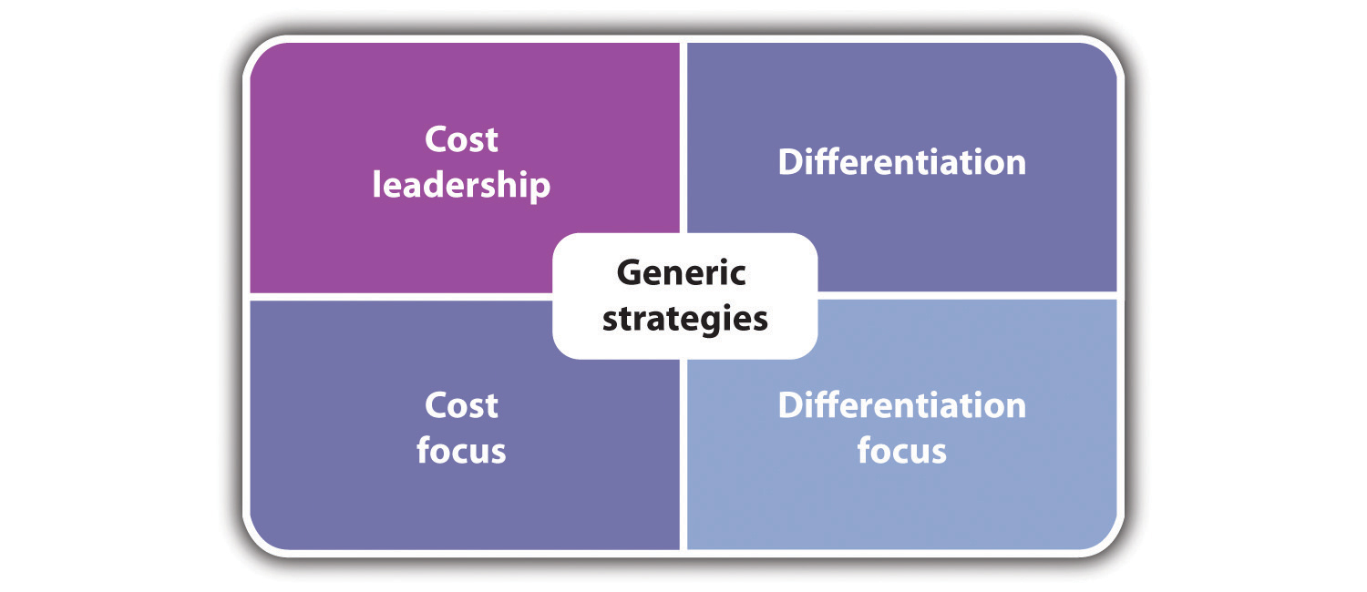
Cost Leadership
This strategy can be taken into effect in 2 different ways resulting in competitive advantage. Firstly, if the costs of production and operating is minimized it will result in higher profits, charging an average price for products or service. For adidas the costs organisations possibly can reduce is the raw materials, production costs and advertisement. Another approach to cost leadership is to increase the market share by reducing the price of product or service, even though the price had dropped the price is still realistic enough for a reasonable profit. Companies like adidas take this approach because of competition such as Nike that seem to charge a higher price for a smaller profit margin. Adidas try to dominate the market share. (Team, 2018)

Differentiation strategy
This strategy is used by adidas the most, this is where the product or service is different from the competitors, you will gain the attention from consumers and customers from standing out this can be achieved in many ways in an organisation one being the brand. Adidas has built a strong brand name and their logo is recognised throughout the world, the three stripes. The matter to this relates back to the nature of the product or service, if you can differentiate through branding, support and functionality this can result in your organisation to succeed. Organizations that use this strategy must have good research on their consumers to keep up to date, fashion and trends so the market understands the benefits of how you are differentiating, furthermore the companies must develop their products or service to always tackle competitors that are also taking the approach of the differentiation strategy. (Team, 2018)

Focus Strategy
Companies that use this strategy are usually focused on a niche market. Gathering information of customer wants and needs the product or service will be maintained by a low cost because they know exactly what the consumer is looking for. Effectively the relationship between the customer and organisation becomes encouraging, due to this it is hard for competitors to enter the market. The disadvantage to this approach is that usually this approach is not enough to satisfy the customer either the differentiation or cost leadership approach will have to be used up to a certain degree. (Team, 2018)

- Main Body

In this part of the report it will go into depth of the strategies that are adopted by adidas and how these strategies are focusing on a competitive approach, and to what extent the approaches are helping adidas gain the benefits of competitive advantage.

  - Implementation of the Strategy

The organisation adidas have managed to focus attention on the differentiation strategy. The company now have determined what is vital for them to keep operating and adapt to the change for consumers and athlete’s needs. The company looked back into their past, learning what values of the past the business can take forward. The companies strategic choices were revised by employees, they discovered how to take forward the effectivity of the past and change it around to meet customer and future needs successfully. The company realised that it held a rich history with experiences from past such as advertising through football an example being Germany winning the world cup. Furthermore, the signature process of the company being used later for the recognition and design of the brand. Taken into consideration of the rich history adidas then could think differently about their strategy. When the company is planning to develop new products is now focuses looking into the past. The history team of adidas is notified when a product is being made to give the products a relevant connection of history as well as adapting to the current trends and fashions. (Ind, Iglesias, & Schultz, 2015). The approach adidas have taken seems to be differentiation as the businesses method is related to the nature of the past this can only be achieved through history and important event that have taken place to give the brand a higher recognition and stand out from others.

The implementation of the differentiation strategy has allowed adidas to focus on not only the sports person but also offering the desirable fashion wear for people that are looking to turn heads in any events. Not only have adidas thought about targeting different type of consumers but also, they focus on the competitors, using a differentiation approach, adidas must develop the product to keep up with competition such as Nike. Adidas always keep up to date to create new innovative products the main focus is to tackle their competitor Nike by providing products at a cheaper rate and also providing better quality products.(allaboutadidas, 2017). We can mention adidas is very focused on winning, their mission is to become the best sports brand in the world. Adidas uses many strategies to achieve their goals, they focus on maximising the visibility of their brand and products. The company have achieved this throughout their existence by always being involved in broadcasted sports events such as the tennis finals and football world cup. If you look at adidas it tends to have a more aggressive approach to the public making everyone more aware, giving it a stronger form of identity. For example, picture shown below.

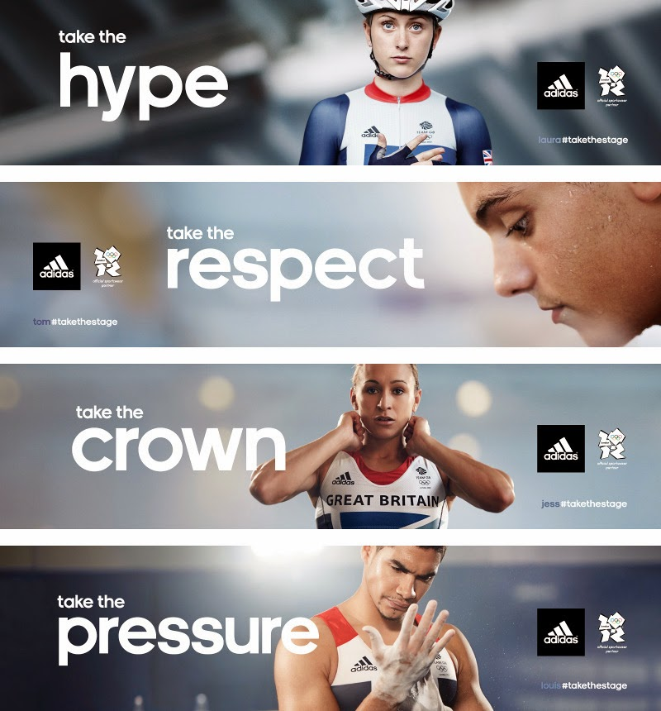
This strengthens the idea of adidas’s competitive advantages. These approaches have made adidas resulting to success in approach to their strategy, gaining a bigger market share which is a vital achievement to the company creating the companies dominance. (Tsarkova, 2015)
The development of technology has attracted organisations to a wider diversity of products which will result in higher customer attraction if consumer needs and wants are provided. Adidas have saw the opportunity and took forward their approach of providing the technological requests from consumers such as performance shoes creates for certain types of sport for example, tennis trainers made or running trainers each product designed in specific ways to increase performance in different sports. This strategy gears the differentiation approach where adidas are always trying to differ to achieve dominance resulting in competitive advantage. But providing the technological products is not enough the product must also get recognition in order to succeed, this is achieved through the process of advertising through celebrities giving the product more acknowledgement, adidas has also gained competitive advantage through these strategies as many consumers may follow the styles of these idols. (Energy, 2017)
Adidas are always focusing on their brand portfolio, they give attention to the core competencies of their footwear and apparel. This allows adidas to lower complexity and gain customer attention in a more resulting manner. The strategy adidas looks over all the time is their branding one being the striped logo which is now recognized throughout the world. This had created the company to differentiate, which has resulted in competitive advantage holding a strong brand name is vital to success the success of adidas because they are trying to become the world’s best sports clothing and footwear supplier. By taking this approach it links back into one the characteristics of differentiation strategy. The strategic choices that adidas have recently implanted is firstly opensource, this allow the company to learn and share ideas, they are opening doors and inviting athletes also consumer to help them create a future culture. This strategy again takes in differentiation strategy skills, the company are engaging with consumers to produce better products and customer needs this approach helps tackle the competitors because ideas will be completely new and differ from the rest as research of product is happening directly with idols and consumers. The company is always staying up to date, focusing on which cities to deliver major products to, adidas have choose main cities such as Tokyo, New York and London to be the places where a lot of business activity will take place. By doing this adidas are trying to achieve customer perspectives and perceptions and what the trends might be. Going into these cities is very ingenious as majority of these places are very well over populated and has a massive diversification in ethnicity and age groups, this could lead to advertisement from consumers. Adidas have achieved their intention to wanting to differentiate in many ways, also many creating competitive advantage for the company. (group, 2018)
  - Advantage & Disadvantage of Differentiation Strategy

Adidas have not really mentioned about having to keep prices high or low in order to gain profit from customers but because they dominate the market at such a high level their prices are lower, they can charge them prices adidas set and still profit this is an advantage of differentiation. Because of the brand using the 3 striped logo adidas has used the differentiation strategy to be recognised from the result of this adidas has created a strong brand name and identity, which then again relates to competitive advantage. For example, this advantage that adidas has created creates the customer to also have loyalty a customer may only wear adidas branded clothing because of loyalty and consumer needs and they will never change and go buy a different brand clothing like Nike. (Foundation, n.d.). This all results the business to become a niche for customers. To some extent is can be said that differentiation can be create the business’s product or service to be bold or too different. For example, many products created by adidas like trainers may seem a bit too different with all the technological advantages of today it can also create the idea if the products actually work and if it is actually more efficient than other products. Another point that can affect a business with a differentiation strategy is that it can exclude potential buyers. For example, adidas focuses products on sportswear, this can be targeting a specific sport and not all sports leaving out potential buyers from other sports leading a consumer to go else wear. (Leonard, 2018)
- Conclusion

Adidas is a very successful brand, the competitive strategy of adidas has played a massive role of it becoming successful. The organisation has shown how it has applied many strategies to gain competitive advantage for example the branding which resulted from adidas using differential strategy. The report has shown and explained the strategies of adidas and how they implanted this to their business to apply to the porters theory of differentiation but also showing some disadvantages.
  - Recommendations

Adidas is very focused on achieving competitive advantage, through the strategy of differentiation, Adidas should investigate the varies types of consumers they may be attracting because they could be missing out on potential customers. Another is adidas don’t look at what the competitors are doing for the other customers going else wear, were as adidas possibly could make similar products likes other brands to get a wider range of consumers.

References
Adidas. (2018). Annual Report 2017. Germany .
allaboutadidas. (2017, october 28). Adidas & Product differentiation. Retrieved from allaboutadidas : http://allaboutadidas101.blogspot.com/2017/10/adidas-product-differentiation.html
Business Dictionary. (n.d.). Retrieved from competitive advantage: http://www.businessdictionary.com/definition/competitive-advantage.html
Drummond, G., Ensor, J., & Ashford , R. (2008). Strategic Marketing Plainning & Control. Oxford: Elsivier LTD.
Energy, N. (2017). A High Level of Added Value to Consumers. Competitive advantage and adidas marketing , 6.
Foundation, T. S. (n.d.). Advantages and Disadvantages of Differentiation. Retrieved from opentextbooks: http://www.opentextbooks.org.hk/ditatopic/17228
group, a. (2018). STRATEGY. Retrieved from https://www.adidas-group.com/en/group/strategy-overview/
Group, A. (n.d.). History. Retrieved from adidas-group: https://www.adidas-group.com/en/group/history/
Ind, N., Iglesias, O., & Schultz, M. (2015). How Adidas Found Its Second Wind. strategy+business(80), 2-4.
Johnson, G., Whittington , R., & Scholes, K. (2012). Fundementals of Strategy. England: Pearson Education Limited.
Johnson, G., Whittington, R., & Scholes, K. (2017). Exploring Strategy Text & Cases. U.K: Pearson Education Limited.
Leonard, K. (2018). Pros & Cons of Differentiation Strategy. smallbusinesseschron.
Riley, J. (2017). Porter's Model of Generic Strategies for Competitive Advantage. U.K.: tutor2u. Retrieved from https://www.tutor2u.net/business/reference/porters-generic-strategies-for-competitive-advantage
Stork, U., Kubis, N., & Kleiner , A. (2018). Leading a Company That Wants to Change Lives through Sports. Strategy+Business , 1.
Team, M. T. (2018). Choosing your route to success . Porters Generic Strategues , 1-3.
Tsarkova, A. (2015). Differentiation and touch points for value creation. p45.

