
Assignment 2:
Operating Systems
CertHE Computing Skills for Workplace

Computer Architecture and Operating Systems. ACCA4022_LON
DR. Redhwan Al-Amri (Lecturer)
University of Wales Trinity Saint David
(London Campus)
Student Name: Danylo Chuiko
Student Number: 2436141
Group: 03
Date: 10.12.2025

Table of Contents
Introduction 1
1. Key functions of general Operating Systems 1
Systems 1
1.1 Process and Processor Management 1
1.2 Memory Management 3
1.3 File System Management 4
1.4 Security and Protection 5
2. Use of Windows OS CLI commands. 7
3. Use of Linux OS CLI commands. 15
4. Use of Windows OS scripts. 20
Script: System Health Check 20
Key Features Demonstrated 22
5. Use of Linux OS scripts. 23
Script: Log File Analyzer 23
Key Features Demonstrated 25
Conclusion 26
References 27
Appendices 29
Tutorial Activity on OS Types from OS Tutorial 1 29
1. LinkedIn Learning course: 29
2. Cisco Network Academy: 30
3. Cisco Network Academy : Operating Systems Basics 32

Introduction
Operating systems are a key component of any computer, as they provide interaction between hardware and user programs. They perform a wide range of functions, including management of processes, RAM, files, connected devices, and security mechanisms. The purpose of this report is to analyze the main capabilities of modern operating systems, as well as demonstrate practical skills in working with the Windows command interfaces. In addition, the report considers examples of creating scripts that allow you to automate typical administrative tasks.
New operating systems perform important, priority functions that ensure the functioning and secure operation of the computer. ОС manage processes, secure operations, file systems, and memory management and interactions with other devices, as well as the security of private data. These capabilities allow users and programs to interact with hardware without the need to perform low-level operations.

Key functions of general Operating Systems
The operating system is an intermediary between the technical components and the user. That is, it converts user requests into instructions for the processor, memory, etc. The key instructions of the OC include:
- Hardware management
- Security schemes
- Access control
- File structure organization
- RAM allocation and protection
- Process and thread management
All these functions are the basis of modern OC. Regardless of any device, Windows, macOS, Linux. Below in subsections from 1.1-1.4 I will explain in detail the functions, including their purpose

Process and Processor Management
Process management is the foundation of any operating system's functionality. The OC controls the creation, execution, suspension, and termination of processes, ensuring their fair and efficient allocation of resources. A process is an active program in execution, and each process has its own address space, state, and set of privileges.
The OC uses schedulers to determine the order in which processes access the central processor. Various scheduling algorithms are applied to optimize waiting time, response speed, and overall system performance. In addition, operating systems support multithreading, allowing a single process to execute multiple threads simultaneously, increasing CPU utilization efficiency. Through synchronization mechanisms, the OC prevents conflicts that may arise when multiple processes access shared resources.

Memory Management
Memory management ensures the allocation of system memory between running processes. But memory is a limited resource, so it is important to monitor the storage and use it efficiently. The OC controls which areas of memory are available, which are busy, and which can be controlled.
One of the main functions of an operating system is support for virtual memory, which allows programs to work with larger amounts of data than the physical RAM. This is achieved through mechanisms such as swapping, segmentation, and paging. The operating system also provides memory protection, preventing one process from modifying another's data, which is a key aspect of stability and security.

File System Management
File system management provides the organization and normalization of data on disks. The operating system defines the directory structure, file storage rules, and provides access to them for users and programs. It performs operations such as creating, opening, and deleting files, as well as controlling access rights and available space on storage devices. Additional mechanisms, such as caching and integrity checks, contribute to fast and reliable access to data. All of this ensures organized and secure data storage.

Security and Protection
Security is one of the key functions of an operating system, as it provides data protection and access control to resourcesю The OC checks who is logging into the system and determines what actions the user can perform. The operating system also monitors suspicious activities, sets security codes, and can use encryption to protect important information for the user. Defense mechanisms prevent unauthorized actions by isolating processes and users from each other. All of this helps ensure the computer runs smoothly and safely, and protects it from threats. [1]
2. Use of Windows OS CLI commands.
Windows Command-Line Interface (CLI), available through Command Prompt and PowerShell. It is a priority tool for managing task automation and diagnostics. Unlike other tools, the CLI provides precise and fast operation execution. In this task, I will show ten key Windows commands with screenshots of their purpose and importance for system administration.
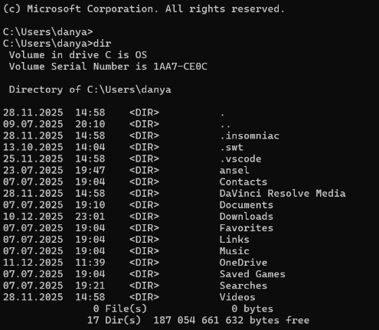
1.Displays the list of files andюThe command quickly shows an enumeration of the content structure and also allows viewing the contents of a selected folder without using Windows Explorer.
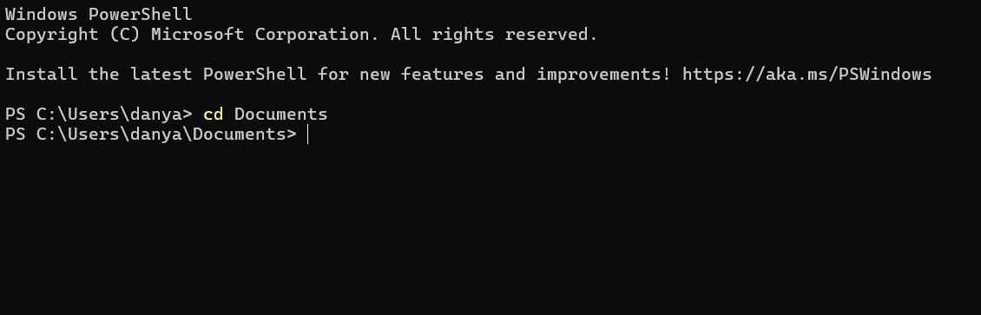
2.Сhanges the working directory. This is the main navigation tool that helps quickly find a file
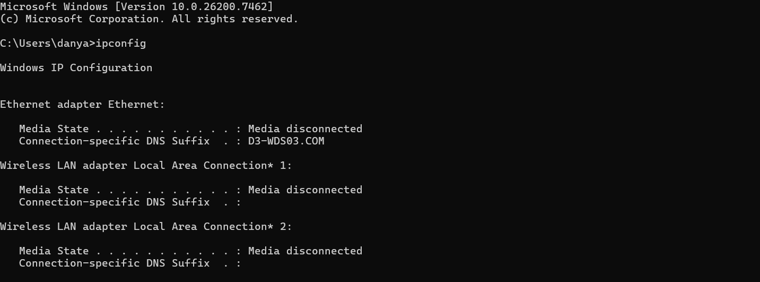
3.Shows information about network settings and IP address. The command is often used for troubleshooting if there is a problem with using the internet.
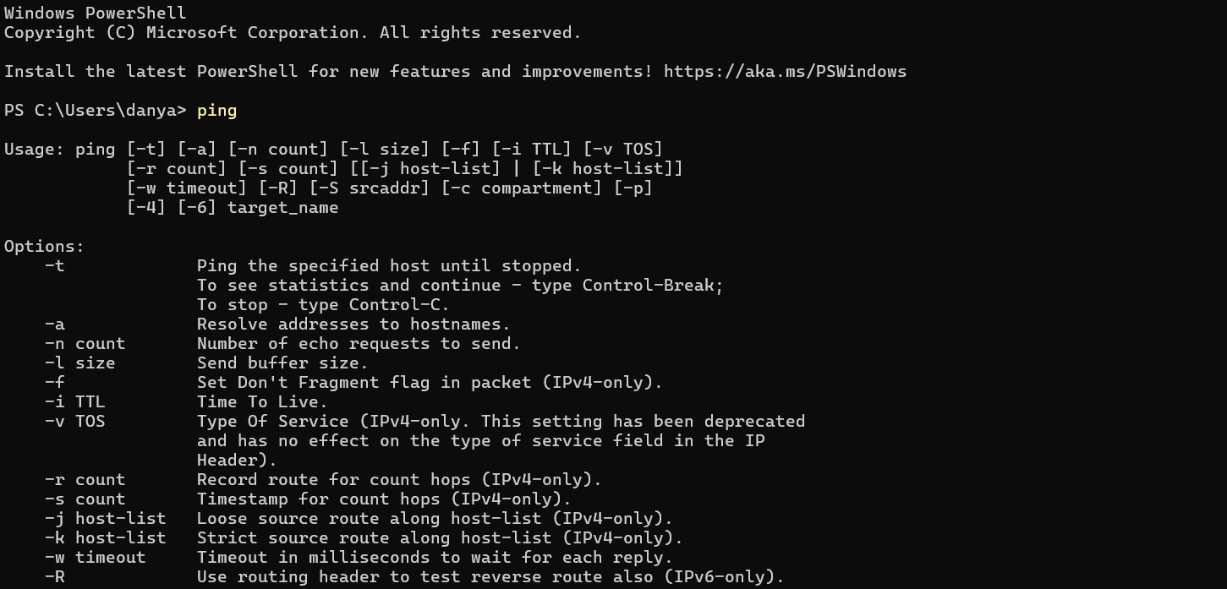
4.Sends test (ICMP) packets to a specified address. To check access to servers and the device's network
It also shows the latency between devices, which is useful for analyzing connection quality.

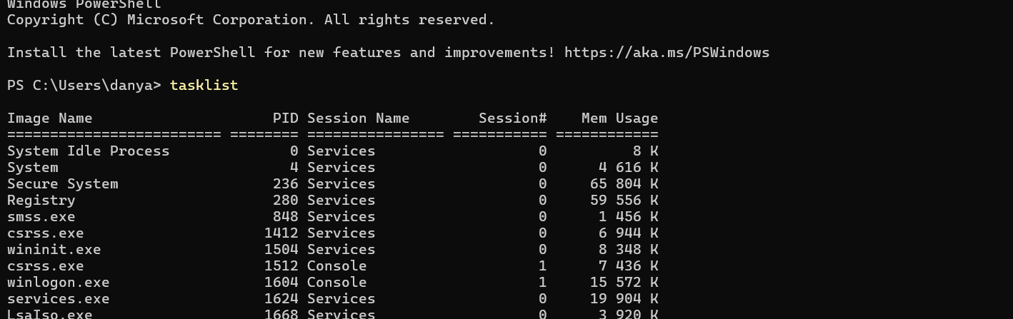
5.Displays a list of all active processes. The command helps monitor system performance and detect malfunctions or suspicious processes.
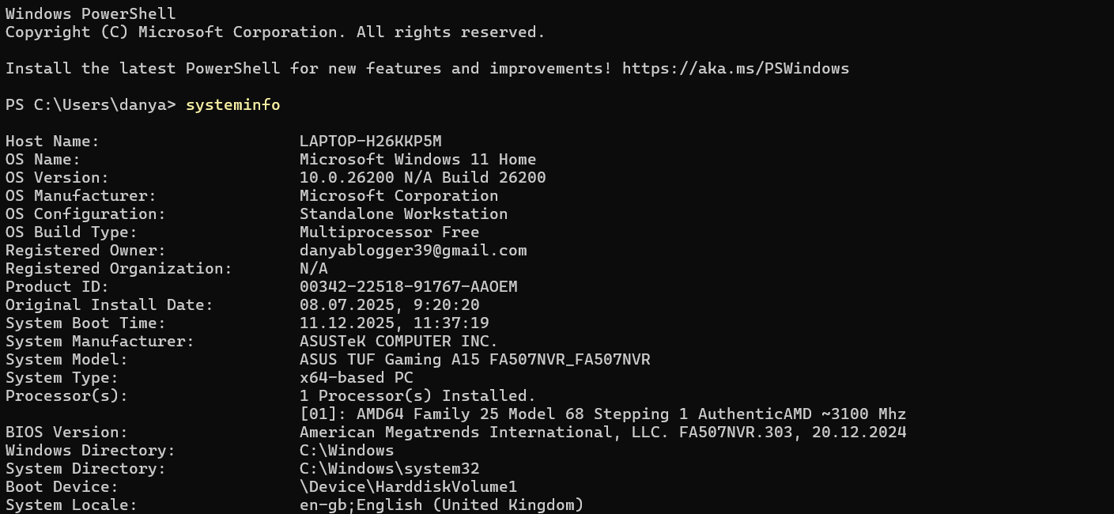
6.Provides detailed information. The operating system version, installation. The command is useful for users and for checking software interconnections.
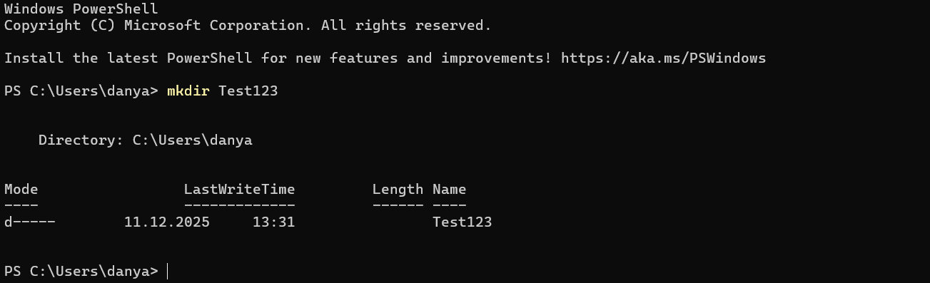
7.Creates a new directory in the selected folder. Often used in structured work environments or in scripts for automation.
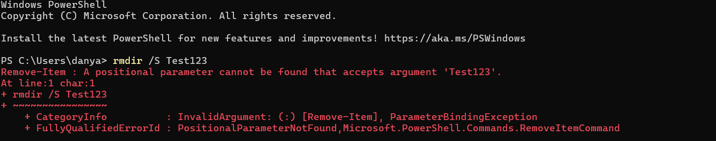
8.Deletes a directory along with all files. It is an efficient and convenient way to clean unnecessary work folders or data.
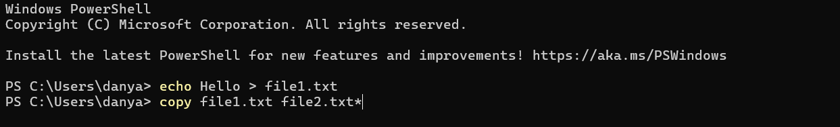
9.Copies a file and moves it to a different location. This command is used for backup purposes.
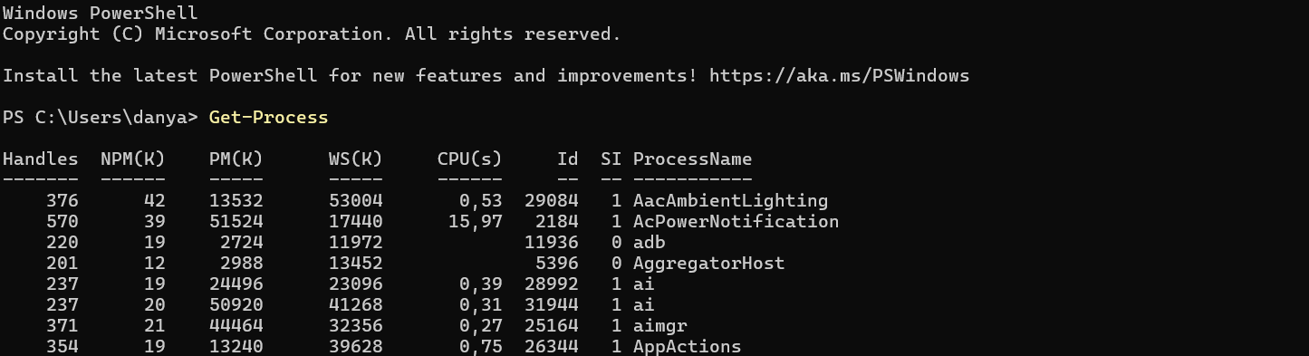
10. Shows detailed information about active processes, including CPU and memory usage. Unlike Command Prompt, PowerShell allows you to filter and process results.
Using these commands allows you to quickly perform basic administrative tasks, diagnose problems, and manage the system without using graphical tools. For the report, a corresponding screenshot and a brief description of the execution result must be added for each command. [2]

Use of Linux OS CLI commands.
The Linux operating system widely uses the command-line interface (CLI). It is implemented with the help of the Bash shell. The CLI allows users to efficiently manage the file system, processes, and more using text commands. This task covers ten basic Linux commands that demonstrate the main capabilities of working with the operating system.
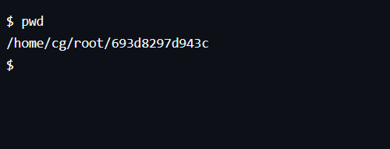
The (pwd) command is used to display the path to the current working directory. It helps the user show their location in the file system.

The ls command is used to view the contents of a directory, which shows a list of files and folders in the current directory.
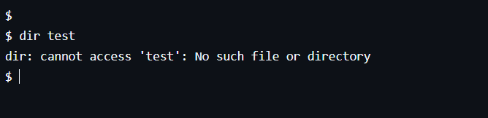
The (mkdir) command is used to create new folders, which helps organize files into an organized structure.
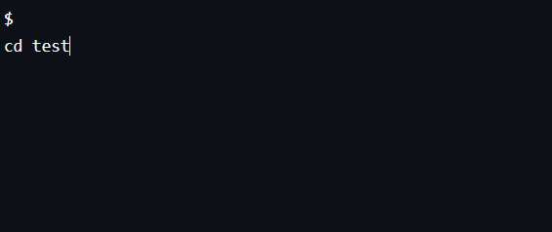
Navigation between directories is done using the (cd) command
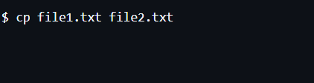
The (cp) command is used to copy files from one location to another, which is useful for backing up data.

The (mv) command allows you to move or rename files and directories.
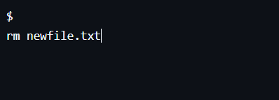
File deletion is performed using the (rm) command, which is used to clean the system of unnecessary data.

An important feature of Linux is the access rights system. The command (chmod) is used to change file permissions and determines who can read, write, or execute a file. This is key for security in multi-user environments.
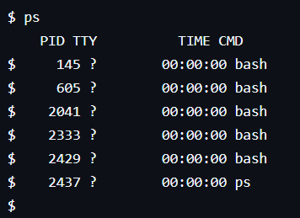
The (ps) command displays a list of active processes in the system
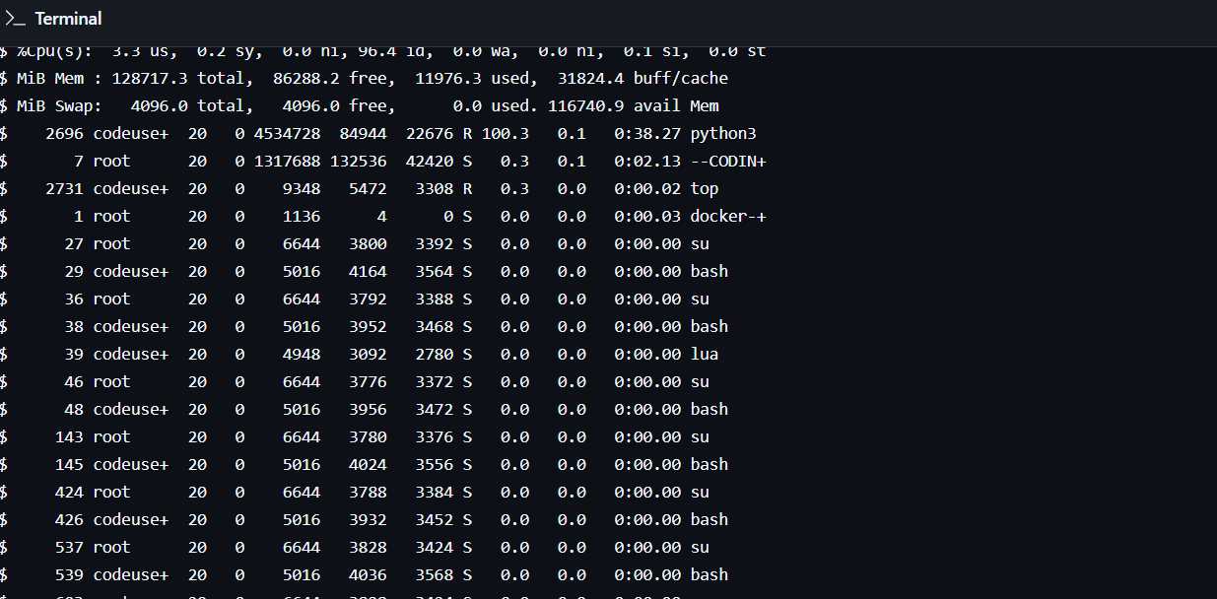
`top` shows dynamic information about CPU usage, RAM, and system load in real time.
So, the commands provided cover the main aspects of working with Linux through the command interface, including navigation, file management, access control, and process monitoring. Documenting the execution of these commands with screenshots confirms practical skills in using the Linux CLI. [3]

4. Use of Windows OS scripts.
Scripts in the Windows operating system are used to automate tasks that are usually performed manually. Instead of entering commands one by one in the command line, a user can create a special script file that automatically executes all the necessary actions. This saves time, reduces errors, and simplifies working with the operating system. In Windows, the most common scripting languages are Batch and PowerShell.
Batch scripts are a simple and accessible automation tool. They run through the Command Prompt and usually have the (bat) extension. Such scripts allow you to automatically create directories, display messages,

Run system commands, and manage files. As part of this task, a simple Batch script was created to demonstrate the basic automation capabilities in Windows. The script executes a sequence of commands: it displays a message to the user, creates a new folder, shows the contents of the current directory, and pauses execution to review the results. This approach shows how multiple commands can be combined into a single executable file.
Besides Batch, PowerShell is widely used in Windows and is a more powerful scripting language. PowerShell allows you to work with processes, services, and system information using an object-oriented approach.
This example demonstrates that even a simple script can perform several actions without user intervention. Such scenarios are especially useful for repetitive tasks, such as preparing the work environment, organizing files, or checking the contents of directories. Using scripts also helps ensure consistent results each time tasks are executed.
However, for demonstrating the basic principles of working with scripts, using Batch files is sufficient, as they are simple and easy to understand for beginners. For this purpose, screenshots are attached to the report showing the script's code and its execution in the Windows command line. This confirms that the script was created and run in practice.
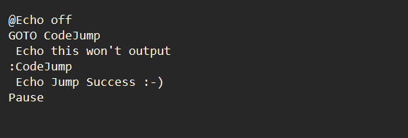
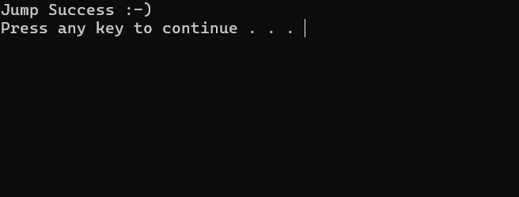
When documenting a task, it is important to show not only the script text itself but also the result of its execution. Using scripts in Windows is an effective way to automate simple tasks. Batch scripts allow users to quickly perform standard operations and are an important tool for basic operating system administration. [4]

5. Use of Linux OS scripts.
In the Linux environment, scripts are used to automate commands that are usually entered manually in the terminal. The most common scripting language in Linux is Bash. Bash scripts allow multiple commands to be combined into a single file and executed automatically, which greatly simplifies the user's work and reduces the number of errors.
Bash scripts usually have the (.sh) extension and are executed through the Linux terminal. They can use standard Linux commands, such as creating directories, working with files, displaying messages, and checking execution results. Even simple Bash scripts are useful for repetitive tasks, such as organizing files or preparing the working environment.
As part of this task, a simple Bash script was created to demonstrate the basic automation capabilities in Linux. The script starts with a shebang line, which tells the system that the file should be executed using the Bash shell. Then the script outputs a message to the user, creates several directories, and displays the contents of the current directory. At the end of execution, the user sees the results of the commands that were executed automatically.
This example demonstrates how a Bash script can perform multiple actions without the need to manually enter each command. This approach is effective in Linux environments, where automation plays a crucial role in system administration. Bash scripts are often used for backup, system maintenance, and carrying out administrative tasks.
Documenting the execution of Bash scripts is an important part of the report. To confirm practical skills, screenshots are included in the report showing the text of the created script and the result of its execution in the Linux terminal. This demonstrates that the script was created and executed independently. Therefore, using Bash scripts in Linux is a simple and effective way to automate basic tasks. 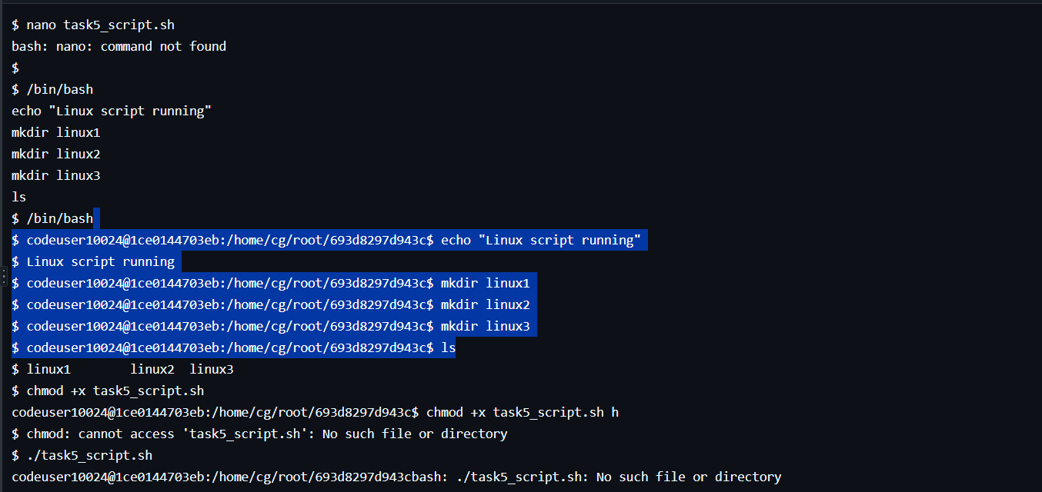
Even simple scripts help to better understand the principles of operating systems and improve efficiency when working with Linux. [5]

Conclusion
This report examined both theoretical and practical aspects of modern operating systems using Windows and Linux environments as examples. The first part of the work analyzed the main functions of general-purpose operating systems, including process and CPU management, memory management, file systems, input-output devices, and security mechanisms. These functions are critically important for the stable operation of computer systems and ensure effective interaction between hardware and software. The practical tasks of the report were aimed at demonstrating the use of the command-line interface in Windows and Linux operating systems. In the Windows environment, the main Command Prompt and PowerShell commands were reviewed, which allow managing files, obtaining system and network information, and controlling active processes. These tools demonstrated that the command line is a powerful means for system administration and diagnostics.
Similarly, in the Linux environment, the use of basic Bash shell commands for navigating the file system, managing files, changing access permissions, and monitoring processes was demonstrated. Practical examples confirmed that working through the command interface provides high flexibility and precise control over the operating system.
The report also paid particular attention to the use of scripts in Windows and Linux. Batch scripts, PowerShell scripts, and Bash scripts allow for the automation of repetitive tasks, reduce the amount of manual work, and increase user efficiency.
Overall, the completion of this report showed that understanding the principles of operating system operation, proficiency with the command interface, and basic scripting skills are important components of training specialists in the field of information technology and provide a solid foundation for further learning and professional development.

References

[1] | P. B. G. a. G. G. A. Silberschatz, "Operating System Concepts, 10th ed.," John Wiley & Sons, 2018.
[2] | M. Corporation, "“Windows Command-Line and PowerShell Documentation,”," Microsoft Learn, 2025.
[3] | The Linux Foundation, "“Introduction to Linux and Linux Command Line,”," Linux Foundation Training, , 2025.
[4] | Microsoft Corporation, "“Automate administrative tasks by using PowerShell,”," Microsoft Learn,, 2025.
[5] | GNU Project, "“Bash Reference Manual,”," Free Software Foundation, 2024.

Appendices

