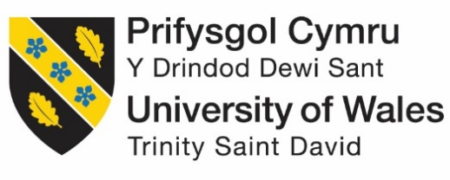

Programme: Master of Business Administration
Module: International Business Concepts
Module code: LCMB7034
Assignment Title: Report

Student name: Amit Jagdishbhai Jikadra
Student Number: 2526285
Lecturer: Dr.Charles Oham
Word count: 5384
Submission Date: 14th August 2026

STRATEGIC MARKET ENTRY ANALYSIS: STARBUCKS CORPORATION'S EXPANSION INTO BANGLADESH

Table of Contents
Introduction 3
Section 1: International Market Entry Report – Starbucks into Bangladesh 4
1. Organisational Classification and Global Strategy 4
1.1 Strategic Categorisation: Bartlett and Ghoshal Analysis 4
1.2 Critical Analysis: Strengths and Limitations 5
1.3 Global Configuration and Geographic Footprint 5
1.4 Competitive Advantage and Value Creation 6
2. Macro-Environmental Appraisal and Market Attractiveness 8
2.1 Host Country Analysis: Bangladesh 8
2.2 Market Entry Analysis Using Dunning's Eclectic (OLI) Paradigm 16
2.3 Identify key factors influencing success 20
2.4 Critical evaluation of the Chosen Market's attractiveness 21
3. Entry Mode Strategy and Strategic Synthesis 21
3.1 Historical Pattern Recognition: Starbucks' Dominant Entry Modes 21
3.2 Strategic Fit and Justification for Bangladesh 24
3.3 Conclusion and Recommendations 26
Section 2: Reflective Account 28
4.1 Description 29
4.2 Feelings 29
4.3 Evaluation 29
4.4 Analysis 30
4.5 Conclusion 30
4.6 Action Plan 31
Reference List 32

Introduction
Starbucks had 40,199 stores at the end of the FY2025 in 87 markets; however, South Asia outside of India has not been fully exploited. The largest obvious hole on the map would be Bangladesh with a population of 173 million people with a specialty cafe market projected to grow 12-14% a year (The Fame, 2026). This report discusses the entry of Starbucks into Bangladesh by June 2026 based on the Bartlett and Ghoshal framework to categorise the strategic posture of the firm, PECL analysis of the host environment, Dunning OLI paradigm to test market attractiveness as well as an entry mode analysis which ultimately gives a recommendation. The report is completed with a Gibbs reflective account.

Section 1: International Market Entry Report – Starbucks into Bangladesh

1. Organisational Classification and Global Strategy

1.1 Strategic Categorisation: Bartlett and Ghoshal Analysis
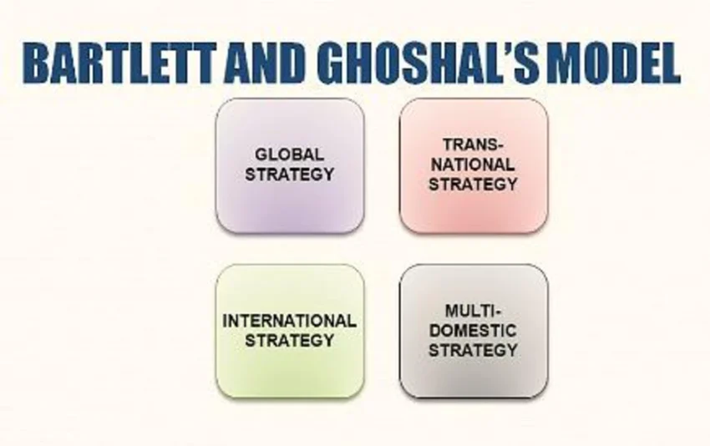
Figure 1: Bartlett and Ghoshal Framework
(Source: Ali, 2023)
Starbucks is nearest to the transnational quadrant of Bartlett and Ghoshal, but its fit is not the best (Macro and Ott, 2024). The company operates a highly centralised system of brand from the Seattle Support Center but allows significant local adaptation of menu, store design and pricing in its 40,199 stores in 87 markets at the end of FY2025. Tata Starbucks with masala chai-franchised 470-plus outlets in 80 cities in India by mid 2025 are alongside 7900-plus stores in China with tea-themed launches and in-app ordering Alipay (PredictStreet, 2025). Such blend - sharp global brand coordination and authentic local flex - is the transnational trademark Bartlett and Ghoshal characterized.

1.2 Critical Analysis: Strengths and Limitations
The importance of this classification is that it embraces the reality of Starbucks as a dual one within a frame. D’Avilla (2026) meant that the brand has a true premium quality-set anywhere in the world and provides local markets a real chance to make the menu, store form and pricing to fit in local taste. Through the lens of adaptive leadership, this is the balancing act that Heifetz writes about- maintaining the core identity and giving decision-making power to those within reach of the real signals of the market.
Its disadvantage is, Liu et al. (2021) posit, that in practice Starbucks is not as transnational as a textbook. Seattle continues to push store experience, brand norms and digital rollout and a Back to Starbucks turnaround by Brian Niccol has made it stricter than weaker, a management stance rather than an adaptive delegation relationship.

1.3 Global Configuration and Geographic Footprint
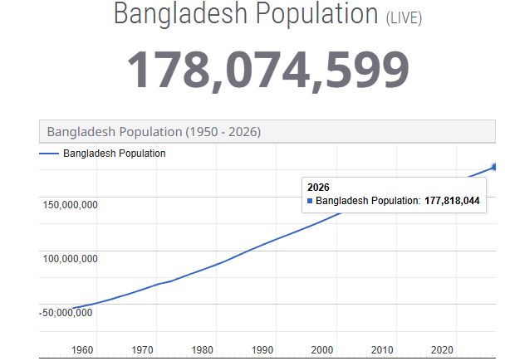
Figure 2: Bangladesh Population
(Source: Worldometer, 2026)
In the FY2025 close, the number of stores in the United States was about 17,000, in China, there were 7,900 stores and the remainder was found in the licensed and joint-venture markets in Europe, Latin America, Middle East, and Asia-Pacific (Islas, 2026). Approximately 53% of the world base is company-operated stores, and the remaining 47 by licensed operations. Net new store openings averaged about 1,700 over FY2025 with fastest growth outside the US being in India, Indonesia and Middle East (Woods, 2026). The side of South Asia outside of India is the blank white space - Bangladesh, Sri Lanka, Nepal and Pakistan are simply blank on the map. The biggest of such gaps by far is Bangladesh, whose 173-million population (Worldometer, 2026).

1.4 Competitive Advantage and Value Creation
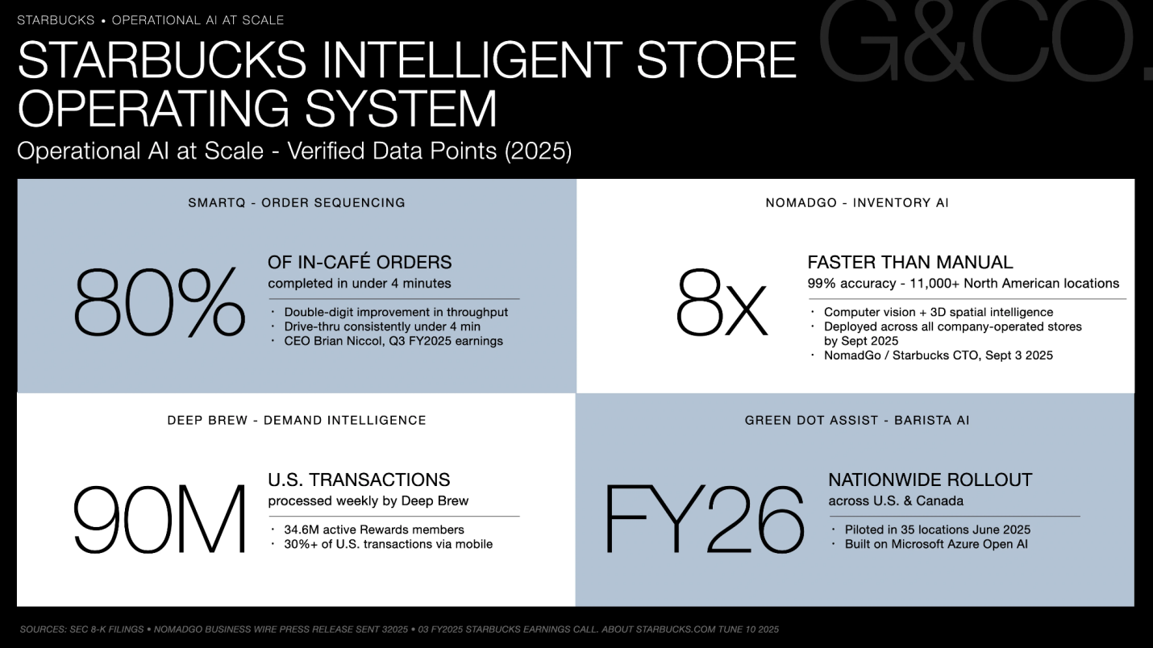
Figure 3: Starbucks Intelligent Store operating System
(Source: G&CO, 2026)
Value creation operates under three engines which include brand premium, real estate density, as well as the digital layer. Starbucks Rewards have also finished FY2025 with 34.6 million active members in the US with nearly 60% of all business tenders being managed by the company, and more than 30% of US transactions managed by mobile order-ahead in Q4 FY2025 (Arunachalam, 2025). Six global roasting plants and the Hacienda Alsacia agronomy centre in Costa Rica anchor the sourcing benefits of 15-25% on similar specialty beans on an equal scale - leverage no comparable chain of scale provides the same source of leverage today that this cafe offers.

2. Macro-Environmental Appraisal and Market Attractiveness

2.1 Host Country Analysis: Bangladesh

2.1.1 Political Environment

The Post-August 2024 Transition
Bangladesh started the year 2026 with an interim government, headed by Nobel laureate Muhammad Yunus, who was sworn in on 8 August 2024 following the resignation and exile of Sheikh Hasina. The fifteen years of existence of the Awami League regime was terminated almost overnight and the interruption has changed the political risk profile that any foreign entry inherits (Al Jazeera, 2024). In 2026, the interim administration is bound to the national elections and the Election Commission has released a voter roll of 125.5 million eligible voters in January 2026 - an increase of about 6.6 million relative to the 2018 voter roll.

Governance and Reform Signals
In 2007, ten constitution, judiciary, police, electoral system and anti-corruption architecture reform commissions presented their recommendations up to 2025. In July 2025, the July Charter of major political parties, established an agreed reform framework, which included nearly 84 constitutional and structural proposals (Haque, 2025). To an outsider, the read between the lines is: there is more predictability in policies on paper than there is in reality being reinstated by institutional memory, and the danger of a successor government heavily pro-reform reconsidering its policies on foreign investment is a fact.

Stability and Investor Sentiment
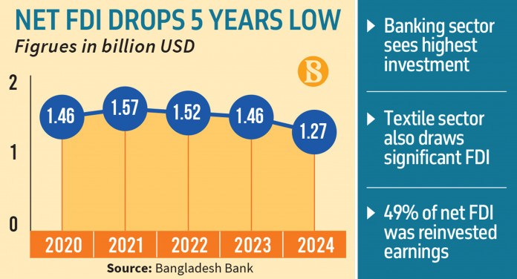
Figure 4: Bangladesh Net FDI
(Source: The Business Standard, 2025)
This has been extended to street demonstrations, vehicle strikes, and campus demonstrations all the way into the start of 2026, albeit of a lesser intensity compared to the height in July-August 2024. By global rankings, the 2025 Global Peace Index in Bangladesh was ranked 123 out of 163 which was a slight downward squeeze against 2023 (BD DIGEST, 2025). FDI inflow fell to 1.27 billion in FY2024-25 which is by nearly 13% less than the previous year and the attitude of foreign capital was wait and watch. Starbucks would be joining at a point where there is a large amount of political goodwill associated with investment in the reform era but at a point where the electoral cycle is associated with a risk of execution that any five year roll out of stores would have to price in (The Business Standard, 2025).

2.1.2 Economic Environment

Growth and GDP Base
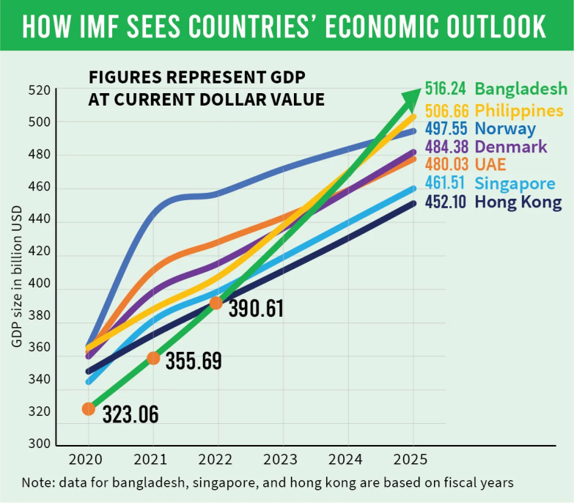
Figure 5: Bangladesh GDP
(Source: The Business Standard, 2026)
The Bangladeshi economy is projected to have a nominal GDP of about $516.24 billion in FY2024-25 which is the second-largest economy in South Asia, only after India. According to the provisional figures by Bangladesh Bureau of Statistics, real GDP growth subsided to 3.97% during FY 2024- 25, which is significantly lower compared to a 10-year average of more than 6% (The Business Standard, 2026). The April 2026 update of the IMF World Economic Outlook estimates an over 5.4% recovery in FY2025-26 (largely due to a recovery in remittances, which hit over 27 billion in FY2024-25), backed by further growth in export earnings in the ready-made garments sector, which remain 84% of merchandise export earnings (Sajid Nahr, 2026).

Inflation, Currency, and Rates
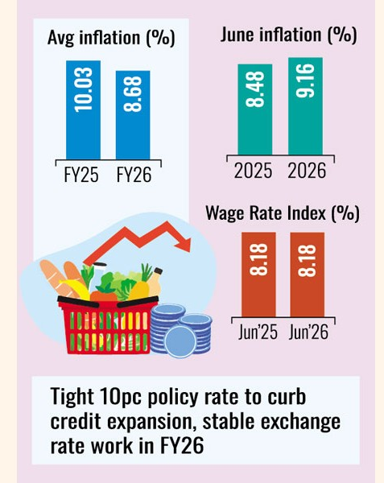
Figure 6: Bangladesh Average Inflation
(Source: The Financial Express, 2026)
No single figure can influence the landed cost of a coffee retailer like inflation. The average Headline CPI in 2024-25 was 10.03% that had dropped to 8.68% by January 2026 with food prices continuing to frequently climb at 8.55% (The Financial Express, 2026). For most of 2025 the policy rate at the Bangladesh Bank was 10%, with a reduction to 50 basis points in early 2026. After falling almost 30% cumulatively since the beginning of 2022, the taka was traded at about BDT 123.56 against USD at the beginning of 2026 (The Financial Express, 2026). The impact of that currency slide directly impacts imported coffee beans, dairy, and equipment costs.

Consumer Purchasing Power
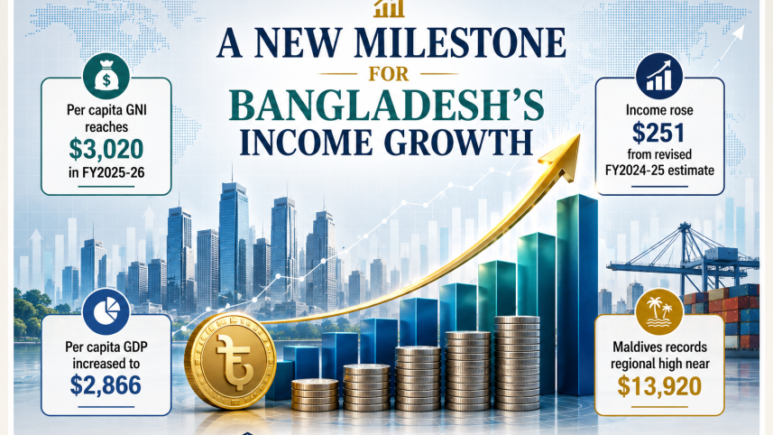
Figure 7: Bangladesh Per capita GDP
(Source: Star Business Report, 2026)
The per capita GDP is projected to hit around 2,866 in FY2025-26 and Bangladesh is on course to leave LDCs in November 2026. The number of the emerging middle and affluent consumer band is approximately 42 million and is clustered around the metropolitan areas of Dhaka (24 million) and Chattogram (5.2 million) (Star Business Report, 2026). A tall latte that costs BDT 450-500 is at about less than half the disposable income of this group, and is pegged to the same price when Starbucks first entered Vietnam in 2013 and Cambodia in 2015.

2.1.3 Legal Environment

Foreign Ownership and Investment Rules
Bangladesh allows 100% foreign ownership in most services sectors, such as food and beverage retailing, via one-stop service portal of the Bangladesh Investment Development Authority (BIDA) which in 2025 has 42 online services covering approximately 80% of the registration and licensing requirements (BIDA, 2025). The minimum local shareholding requirement to operate a cafe is absent and there is also maximum profit repatriation in lieu of Bangladesh Bank with the Foreign Exchange Regulation Act of 1947. Five to ten-year tax holidays can be enjoyed within certain economic zones, but prime spots in Dhaka retail market are not within the economic zones (Hossain, 2024).

Trademark, IP, and Contract Enforcement
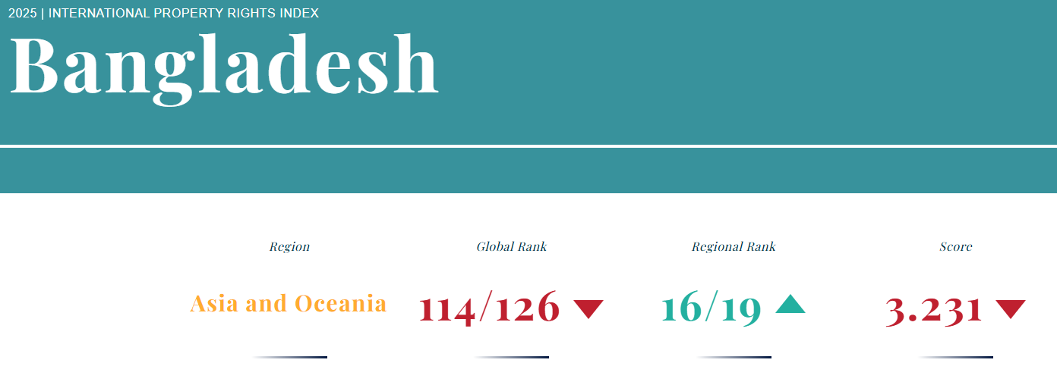
Figure 8: Bangladesh Property Rights Index
(Source: Internationalpropertyrightsindex.org, 2025)
With a 2024 score of 3231 on the 2025 International Property Rights Index, which is considered a weakness in the region and a 1,442-day average time to enforce a contract, as per the latest World Bank Doing Business ranking, Bangladesh is relatively weak in these factors (Internationalpropertyrightsindex.org, 2025). The registration of Trademark under the Trademarks Act 2009 is still slow with the normal time taken of 18-24 months between the time of filing and registering. In terms of a brand as prone to counterfeiting as Starbucks which has over 1,600 counterfeit stores recorded over the past five years, this would argue well to a local partner capable of striving to enact enforcement via ties as opposed to court proceedings (Record Of Law, 2026).

Tax, Labour, and Sector-Specific Rules
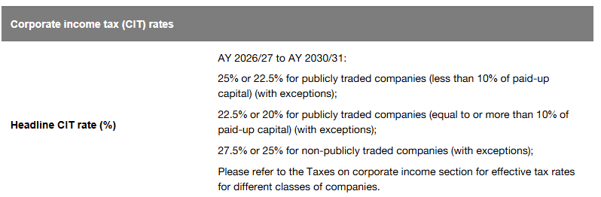
Figure 9: CIT in Bangladesh
(Source: PwC, 2026)
The corporate tax of non-listed companies is 27.5% in FY2025-26 with VAT of 15% on restaurant service and supplementary duty 5% on syrup beverages (PwC, 2026). The roasted coffee duty is at an average of 25% and other assorted charges, making any serious supplier look at local coffee roasting or the bonded warehouse solution. In December 2023, Bangladesh Labour Act 2006 was amended to establish a minimum wage of BDT 12,500, which must be paid to garment workers; the minimums applied to the service sector are established by the wage boards separately and generally are lower, but the working hours and maternity benefits are a standard rule (Fair Labor, 2024).

2.1.4 Cultural Environment

Religion and Consumption Norms
Bangladesh consists approximately 91% Muslims and alcohol is not among the mainstream cafe culture. Any packaged food and beverage has a minimum standard in terms of its Halal certification (International Christian Concern, 2026). Ramadan, will in 2026 last approximately between 17 February and 18 March, remakes daytime (afternoon iftar to evening), replacing morning trade with evening and making dine-ins longer than usual occupancy. The operating experience of Starbucks with iftar menus in Saudi Arabia, UAE and Indonesia (the largest Muslim-dominant country globally with a population of 281 million people) transfers directly to Bangladesh with very few changes (Starbucks, 2026).

Beverage Culture
Bangladesh is still strongly a tea-first country. The consumption of coffee per capita is at just under 100 grams per year as compared to about 700 grams of tea. With that said, the specialty coffee market in urban Bangladesh has become more apparent (Ibrahim et al., 2025). There were more than 20 local specialty chains that operated and sold coffee but North End Coffee Roasters was the largest, with a total of 20 franchise stores by the end of 2025. An established presence of a high-end café culture among urban 18-34s has taken the form of Crimson Cup, Gloria Jeans Coffees and a flush of independent third-wave coffee shops. Mean ticket size at a specialty in Gulshan cafe BDT 350-550 in 2025 (Crimson Cup, 2026).

Hofstede and Youth Signals
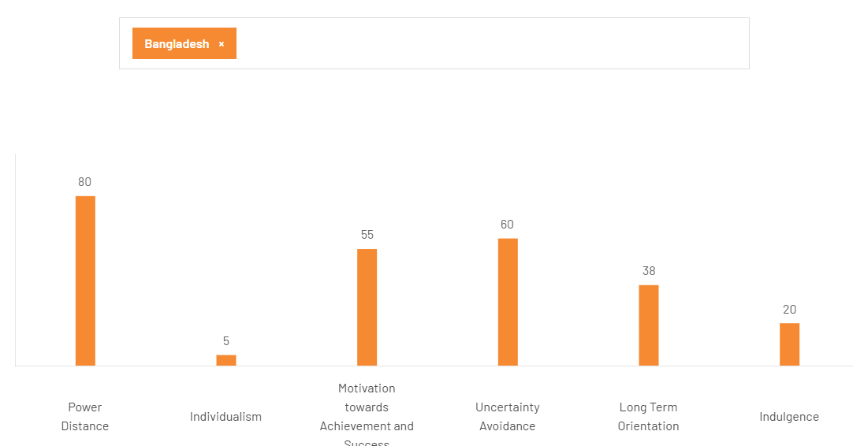
Figure 10: Bangladesh Country Insights
(Source: The culture factor group, 2026)
Bangladesh has power distance of 80 and scoring medium on collectivism (individualism 20) and low on indecency (20) in Hofstede dimension of culture (The culture factor group, 2026). Aspirational Western brands continue to hold status among the younger generation of consumers - some 27% of the population falls in the 15-29 age bracket, smartphone adoption topped 62% in 2025 and mobile financial service accounts under bKash and Nagad reached 235 million by early 2026 (Hossain, 2026). It is this generation of youth who have so far turned KFC, Pizza Hut and Domino into hits in Dhaka. They are brand-loyal, digitally native, and are ready to overpay to get a product that signifies their position.

2.2 Market Entry Analysis Using Dunning's Eclectic (OLI) Paradigm

2.2.1 Ownership Advantages
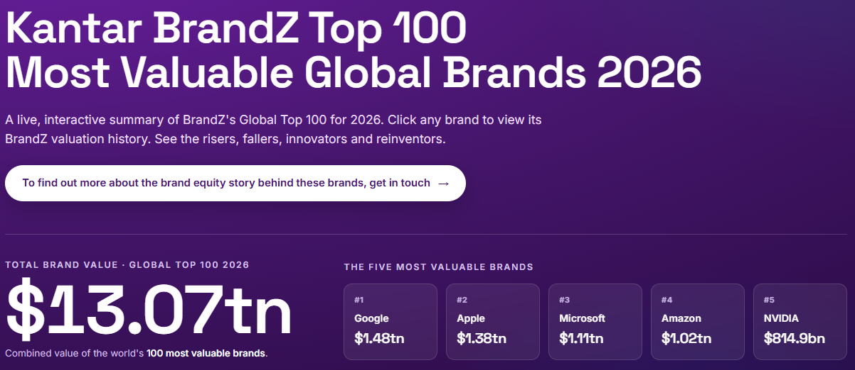
Figure 11: Kantar Brandz valuation
(Source: KANTAR, 2025)
Brand and intangible asset: The ownership benefits of Starbucks are more inclined to be intangible. The Starbucks brand is worth sitting 45th lowest among the best global brands by Interbrand, 2025, topping the restaurants category, at a value of 16.5 billion. Kantar BrandZ ranked it as one of the 60 most valuable global brands in its 2025 ranking (KANTAR, 2025). That brand asset gets the majority of the customer acquisition job on the first day in a market whereby the nearest domestic specialty competitor is operating under 25 locations and there is no international premium chain that has expanded to more than 15 stores.
Operational Systems and Digital Layer: In addition to brand, Starbucks has a system of proprietary beans sourcing and roasting network that is registered under C.A.F.E. Practices ethical sourcing validation on 99% of its coffee (Starbucks, 2025). Over forty years of development and 40,199 stores in countries around the world at the end of FY2025 have made the store operating model perfect. The Starbucks Rewards platform is localised across 34 markets, and had 34.6 million active US members alone as of FY2025. The mobile order-ahead, which has already served more than 30% of US transactions in Q4 FY2025, directly applies to the real-world situation in Dhaka which is riveted in traffic jams and that a 45-minute to 60-minute order-ahead window is an actual and justifiable value proposition (Quartr, 2025).
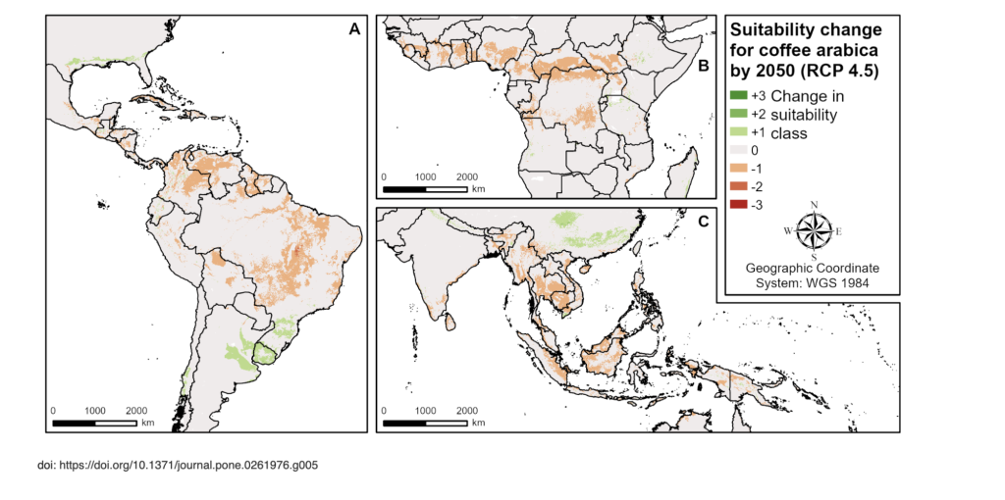
Figure 12: Suitability Change for Coffee
(Source: Clancy, 2026)
Scale and Supply Chain: A buying power that Starbucks can not have an equivalent to expand in Bangladesh would be green coffee buys about 3% of the global supply. This would already confer landed-cost benefits of 15-25% on the same type of specialty beans at the small volumes that a Bangladesh network would produce, during the initial three years, versus domestic roasters ordering the same beans off the same source farms in Ethiopia, Colombia, or Vietnam (Clancy, 2026).

2.2.2 Location Advantages
Market Size and Demographics.
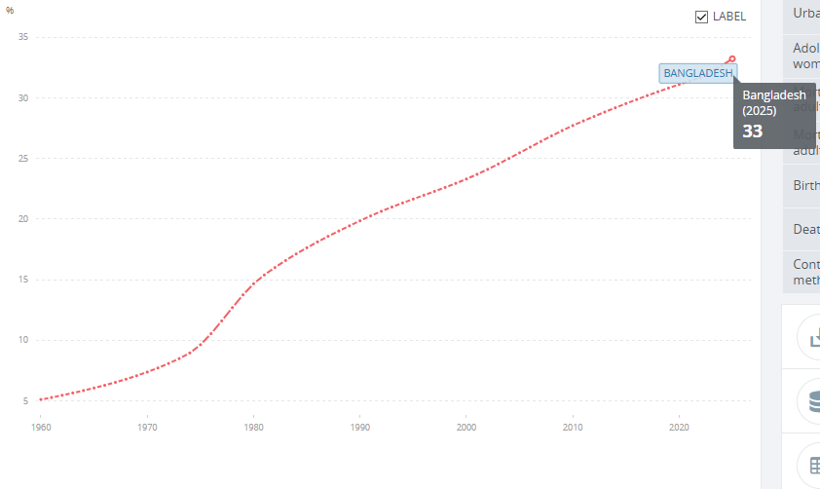
Figure 13: Urbanisation in Bangladesh
(Source: World Bank Open Data, 2026)
The place case is based on the demography and urbanisation. The population of 173 million, the urbanisation rate of 33% and increasing at an average rate of about 3.2/year, and the city of Dhaka with a population of 10 in the top-10 worldwide cities mean that there is a demand base exceeding that of Vietnam (where Starbucks has over 130 stores) and in line with the Philippines (World Bank Open Data, 2026). It is projected that the specialty cafe goods market in Bangladesh will stand at approximately 180 million dollars in the year 2025 and that the market is increasing by 12-14%/ year, compared to the overall GDP growth, which is no more than 5.5%/ year.
Fixed and Real Property and Cost Structure
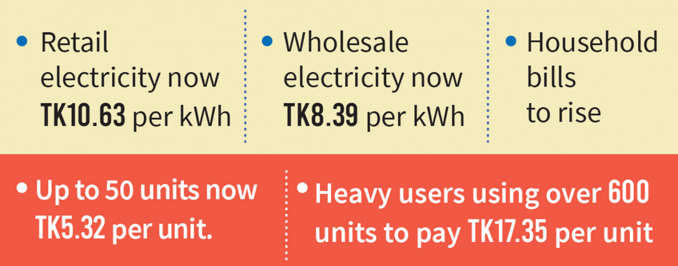
Figure 14: Bangladesh Retail Electricity Price
(Source: TBS Report, 2026)
The price of prime retail space in Gulshan, Banani and Dhanmondi is between BDT 350-600/ square foot/month or about 30-40% lower than the price in Bengaluru or Ho Chi Minh City. Even with Bangladeshi prices maintained in store-level margins, service-sector wages, with baristas earning BDT 15,000-22,000 a month, keep margins healthy (Global Barista Training Academy, 2025). Electricity and gas prices are also relatively competitive with commercial power tariffs averaging at BDT 10.63 per kilowatt hour and gas piping for espresso machines are being bypassed in more recent construction using LPG (TBS Report, 2026).
Regional Fit and Trade.
In November 2026, LDC graduation will also eliminate certain preferential tariffs on exports which are currently enjoyed by Bangladesh, although in the context of a domestic market, retail location this is inconsequential (Showaib, 2026). What is more prominent about the larger location is that Bangladesh occupies a regional vacuum in South Asia of the entire Starbucks regional network enabling supply chain integration with Tata Starbucks India network - Chennai to Chattogram at sea is 36 hours and Kolkata to Dhaka across the terrestrial border is less than 12 hours, through which more than 10 billion dollars of bilateral trade occurred in 2024-25.

2.2.3 Internalisation Advantages
Perils of Pure licensing.
Having no regional operational spine through which to tie its pure licensing means Starbucks is vulnerable to two risks that are unique to Bangladesh. First, brand consistency drift, where there is weak IP enforcement and the 1,442-day contract enforcement timeline. 2, Quality control on perishables, in a market where less than 20 percent of the demand is well covered by cold chains and rather a few specialised suppliers control refrigerated logistics (The Justice Corner, 2026). Neither is a technical issue - both the pre-JV India experiment before 2012 and the 2003 Israeli exit were demonstrations of what Starbucks can do when it focuses on them as technical matters (Kang, 2025).
Risks of Wholly Owned Entry
Wholly owned entry requires local expertise Starbucks lacks BIDA and RAJUK routing, city corporation permits, the landlord networks of Gulshan and Banani where a handful of families own most prime frontage, expats labour regulations in 2023 amendments (Editorial Desk, 2023), and Ramadan trading cycles. These lie within the complicated Cynefin realm in which adaptive leadership is vital. Over the past 10 years, joint venture entrants have achieved the same store profitability 24-36 months earlier than their wholly owned foreign retail counterparts in Bangladesh ( Staff Writer, 2026).

2.3 Identify key factors influencing success
There are four things, which will determine the successful landing of Starbucks in Bangladesh. An example is first, partner quality The combined build time reduces to 24-36 months shorter, rather than building alone, as the conglomerate possesses cold chain and Gulshan-Banani as an outlet to real estate. Second, the timing of the launch is around the February 2026 election, as brand name association with political instability is the largest reputational risk. Third, landed cost control, with an import duty of 25% on roasted coffee, and a taka down nearly 30% from 2022. Fourth, the cultural fit of Ramadan iftar meals, halal certification, and relatively low-price cold coffee that would be offered at a lower price than the BDT 350-550 size of the ticket that was being charged by specialty cafes in Dhaka through 2025 (Crimson Cup, 2026).

2.4 Critical evaluation of the Chosen Market's attractiveness
Bangladesh is a young country in size, and old in age. The demographics is a working one of 173 million, 42 million in the new affluent bracket, 27% between 15-29, over 62% of the population with a smartphone, and a specialty coffee market increasing at 12-14% a year and has an annual basis of 180m US dollars (Haque, 2025). The reality is that the friction exists: coffee consumption is not more than 100 grams per capita per year, inflation is at 10.03% over FY 2024-25, as per the report of The Business Standard (2025b), FDI decreased by 13% to 1.27 billion and grid outages reached up to 4-6 hours a day in some areas of Dhaka.

3. Entry Mode Strategy and Strategic Synthesis

3.1 Historical Pattern Recognition: Starbucks' Dominant Entry Modes

3.1.1 Review of Historical Entry Modes
Market | Year | Entry Mode | Local Partner / Structure
Japan | 1996 | 50:50 Joint Venture | Sazaby League; bought out to wholly owned in 2014 (Baertlein, 2014)
UK | 1998 | Acquisition | Seattle Coffee Company
China | 1999 | Regional Licensing | Three regional partners; fully consolidated to wholly owned by 2017
Middle East | 1999 | Master Franchising | Alshaya Group; over 1,900 stores across 12 countries by 2025
South Korea | 1999 | Joint Venture | Shinsegae; converted to wholly owned in 2021 (Starbucks Stories Asia, 2024)
Germany | 2002 | Joint Venture | KarstadtQuelle
Indonesia | 2002 | Licensing | MAP (Mitra Adiperkasa)
India | 2012 | 50:50 Joint Venture | Tata Consumer Products; 470+ stores by mid-2025 (PTI, 2024)
Vietnam | 2013 | Licensing | Coffee Concepts (Maxim's Hong Kong)
Australia | 2000 / 2014 | Wholly Owned → Licensing | Restructured under Withers Group after 2014 losses
Italy | 2018 | Licensing | Percassi (Landini, 2018)
Israel | 2001 | Joint Venture | Delek Group; exited 2003

3.1.2 Strategic Implications
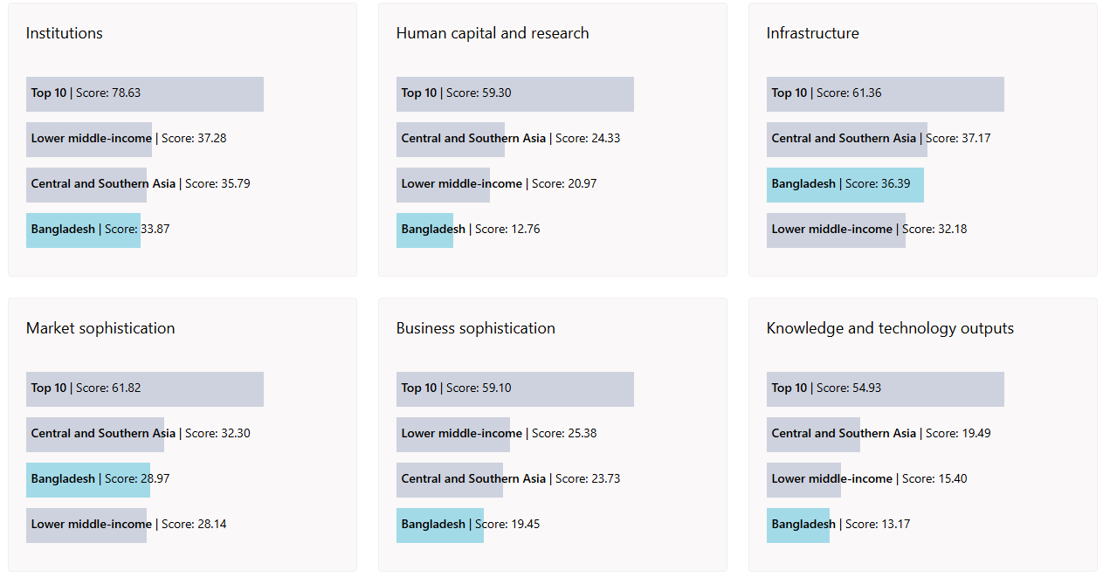
Figure 15: Benchmark of Bangladesh against other economy groupings
(Source: WIPO, 2026)
The line that runs through the history of Starbucks entry is simple: where there is a high level of cultural, regulatory or operation distance partner, internalise when these uncertainties are cleared. In 2026, Bangladesh will be right on that high-distance quadrant in each of the three — the political system will be post-transition, its score on the IPR rating will be 39.7 on the 2024 index and the market of specialty cafes will not have reached more than $200 million (WIPO, 2026). The trend excludes both greenfield wholly owned entry as well as pure master franchising. Both of them fall short of the manner in which Starbucks has actually established sustainable footprints in emerging markets over the past thirty years.

3.2 Strategic Fit and Justification for Bangladesh

3.2.1 Assessing the Suitability
The biggest historical parallels are a 50:50 joint venture with a Bangladeshi conglomerate which has been successful in India since 2012 and Japan since 1996. It fits the habit of Starbucks to favor equity-controlling in long-range markets and provides a local partner with real ownership in brand results and not a passive royalty flow. It was on this exact structure that Tata Starbucks had reached 470 stores in 80 cities in India by mid-2025 the nearest live comparator of what an entrance would look like in Bangladesh in the first year (Mishra, 2026).

3.2.2 Risk and Resource Commitment
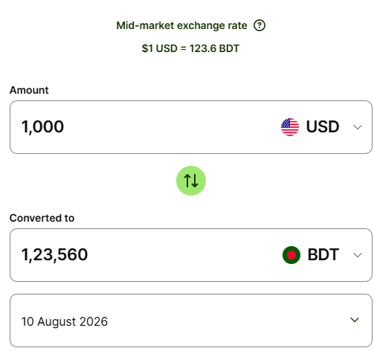
Figure 16: BDT to USD Exchange Rate
(Source: The Financial Express, 2026)
Risks:
Political risk continues to be high up until the February 2026 election, at the end of the volatility and uncertainty axis on the VUCA spectrum. The taki risk exists in reality - since the beginning of 2022 it is decreasing by almost by half, trading at around BDT 123 at USD in early 2026. There is significant operational risk on cold chain and power supply and grid outages of 4-6 hours a day in urban parts of Dhaka during summer peak of 2025 and refrigerated logistics coverage less than 20 percent of national demand. They are complex-domain problems, according to Cynefin and require adaptive and not technical response. A 50:50 JV leaves Starbucks with a maximum $500 minimum capital exposure compared to an all-wholes owned build-out and puts these risks on a partner to which these risks are adequately priced in.
Resource Commitment
A 50:50 joint venture constrains Starbucks initial capital to approximately half of a straight-owned rollout in store fit-out, the roasting plant and cold chain system. Instead of having to put Starbucks on the balance sheet, the other half is absorbed by the local partner and the partner provides land, warehousing and already developed distribution muscle (Eelager et al., 2025). Working capital and licence fees, as well as costs of expatriate deployment remain within the JV envelope. That construction holds capital to the parallel India network expansion and ring-fences Bangladesh cash flow in case the political or currency backdrop unravels in the middle of the rollout (Kennedy, 2026).

3.2.3 Control versus Flexibility
The JV structure maintains brand control with board representation standards agreement and a managing director for operations appointed by Starbucks, but a local partner manages real estate, human resources as well as government relations. Such is the very division that Tata Starbucks is running under, and the division that will see the India network which had 50 stores in 2014 rise by mid-2025 to more than 470 on average (38 net stores a year on average, though two pandemic-impacted years in the interim) (PTI, 2025).

3.2.4 Long-Term Strategic Fit
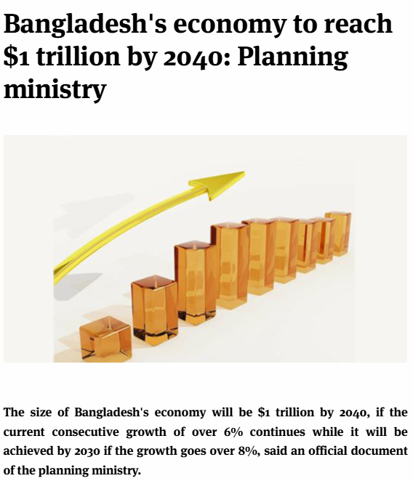
Figure 17: Bangladesh is expected to be a trillion dollar economy
(Source: The Business Standard, 2025a)
Bangladesh would be out of LDC status in November 2026, and in current growth contexts, would have expanded to a trillion-dollar economy by 2040, providing Starbucks with a consistent South Asia expansion narrative that would be a logical complement to the already existing India platform (The Business Standard, 2025a).

3.3 Conclusion and Recommendations

3.3.1 Summary Judgement
Bangladesh is not a clear-cut market. Tea prevails, the coffee consumption is below 100 grams per capita annually and the political transition is incomplete. However the latent clues are a deep- pocket entry: 173m population, 42m within the emerging affluent category, speciality cafe spending increasing 12-14per annum and no international scale competitor with such a high-end offering. The first-mover timing before graduation of LDC is with a narrow/open window.

3.3.2 Recommended Approach
Proceed via a 50:50 joint venture with the two best-qualified in terms of real estate, distribution, and governance, Meghna Group or Transcom. It is a polycentric partnering action, not an ethnocentric export of the Seattle model - a conscious adaptive-leadership action in response to the complicated space which Bangladesh doesn't have placed itself on the Cynefin map. Launch ten outlets in Gulshan, Banani, Dhanmondi and Bashundhara in a period of eighteen months, followed by Chattogram in the second year. Launching should be timed after the February 2026 election is over to prevent being associated with political instability (Fitch Wire, 2026). The menu should be anchored to iftar service and the inclusion of a halal certification considering the 91% Muslim consumer base, introduce adaptations of Bengali sweets as a respectful alternative to the high power-distance and low-indulgence Hofstede profile, and set (priced) a cold coffee tier as younger footfall. Register trademarks far through to the opening of first store and incorporate in a five-year review clause buyout or restructure.

Section 2: Reflective Account
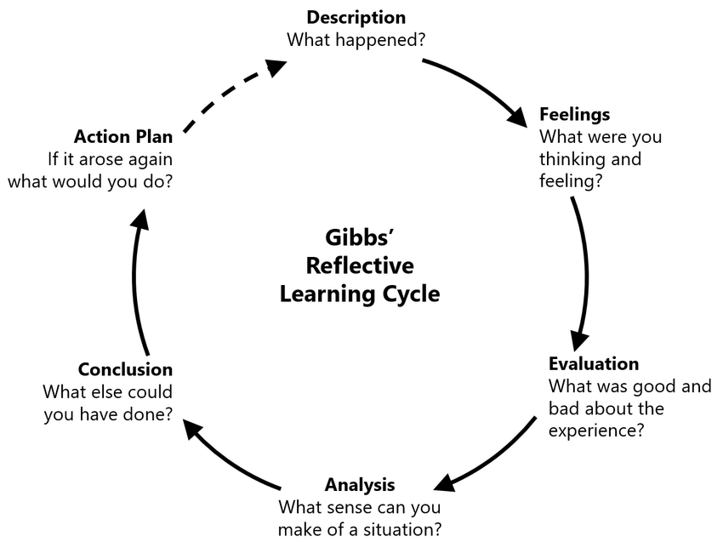
Figure 18: Gibbs Reflective Cycle
(Source: Harithuddin, 2021)
This reflective narrative applies to Gibbs Reflective Cycle to reflect over my experience of developing the Starbucks-Bangladesh market entry report. The six phases of the cycle which include the description, feelings, evaluation, analysis, conclusion and action plan provide a systematic manner to unpack what I did and same as what worked, what did not work and what I would bring forward (Ahmadpour, Shariati and Moghadam, 2025). The point is to show the critical understanding of my personal research and analytical process instead of summarising the report itself, and to determine the actual improvements in the further measurements.

4.1 Description
I was commissioned to develop an international market entry report on behalf of a multinational corporation that is entering a country in which it does not have any presence in terms of an operation. I used Starbucks as a firm and Bangladesh as the market due to the obvious white space between the two on the Starbucks map and the coverage seemed to be absent in comparison to the more familiar case study countries India and Vietnam (Divrik, 2023).
I divided the assignment into three work blocks taking about two weeks. The former block was the framework choice and background of Starbucks. The second one was the country analysis of Bangladesh, which lasted the longest due to the need to make sure that 2025 and 2026 numbers were checked throughout the period of transition of the interim government. The third block was the OLI synthesis, entry mode analysis and this reflection (Uhlig et al., 2023).

4.2 Feelings
Frankly speaking, I entered it on a positive note about Starbucks and totally out of my element about Bangladesh. All I knew (and most important) was gained in reading in the garment sector; therefore, to unpack the political change after August 2024, and the form of the Yunus interim government implied starting with nothing (Akter, Nakamoto and Mahmud, 2025).
The intermediate was really annoying. The economy data of FY2024 to 25 still remained provisional in some areas and I even needed to cross-check data of Bangladesh Bank releases with IMF and World Bank estimates just to feel confident with one figure. Some nights I was unsure of whether the market case was good enough to warrant a recommendation whatsoever (Hinterhuber and Snelgrove, 2021). In retrospect, that skepticism proved to be the most helpful thing that the report received.

4.3 Evaluation
Application of the framework work was successful. Bartlett and Ghoshal, OLI and the entry mode decision placed well with me when I ceased to see them as silos. The best point that I felt is the OLI analysis where the location benefits and internalisation logic is linked to the JV recommendation (HulkApps, 2026).
Discipline in word count proved to be more difficult than I thought. It took me two revisions to get down to 300 words on the environment political setting without losing the context after the transition. I also had an uneven reference list in the initial stages of my study - I would find sources, then I would forget them, and again get some statistics that I had already read (Lumivero, 2024).

4.4 Analysis
The strategy succeeded because I pegged all strategic arguments on how Starbucks actually practiced it in the past as opposed to how an ideal entrant should behave. It became very clear as the entries on Japan, China, India and Middle East were read in order — Starbucks relies on partners in long-haul markets. Bangladesh was practically written once I had noticed that.
The best direct input was the Bartlett and Ghoshal lecture material. It provided me with the terms to explain the queer fit in the case of a pure transnational classification of Starbucks. The map of the three orientations given ethnocentrism, polycentrism and geocentrism made me view Starbucks with an inclination towards geocentrism in ambition but ethnocentrism in implementation, which is why the proposed Bangladesh recommendation was to have a polycentric partner to bridge the gap. The OLI framework, which so far I had considered abstractly, became much less abstract when I cross-linked it with a real firm and a real country (Gupta, Kumar and Mishra, 2024). The cross-cultural literacy readings and Hofstede scores allowed framing the Bangladesh cultural section with consumption norms instead of an overview of a culture in general.

4.5 Conclusion
I also came to understand that, there is not much of a sequence in adapting to the frameworks when it comes to international market entry analysis, but rather interrogating a decision that is alive. The frameworks succeed when they produce questions that I would otherwise not have inquired about - the internalisation logic impelling back against pure licensing the question of, say, pure licensing.
The next time I would run this I would begin with the entry mode choice and back to the country analysis as from the mode question arises the issue of which environment factors are the most important. I would also develop some sort of a source tracker earlier on as opposed to attempting to recreate my trail in reading during the last week.

4.6 Action Plan
The following report will see me correct a word budget per subsection at outline stage as opposed to the first draft, and a running spreadsheet that will track all the statistics that I have to use with its source and retrieval date. They are both minor modifications that would have saved me about a day on this piece (Weiland, 2021). In the long run, I would like to develop a real depth of one emerging market area as opposed to superficial knowledge of numerous. The textbook VUCA environment that is Bangladesh LDC graduation, political reset, and a demographic bulge all falling into the same eighteen months changed how I interpreted the data. This is the entry case studies pattern that I will keep reading about after this module, I will also resolve more live entry case study patterns, as that analytical step of pattern-recognition that I made with Section 3.1 was the most helpful one of all the processes I made (Greenhalgh, 2025).

Reference List
Ahmadpour, N., Shariati, A. and Moghadam, M.P. (2025) “Effect of narrative writing based on Gibbs’ reflective model on the empathy and communication skills of nursing students,” BMC Medical Education, 25(1), pp. 1–9. Available at: https://doi.org/https://doi.org/10.1186/s12909-024-06593-7.
Akter, P., Nakamoto, R. and Mahmud, M.T. (2025) “A comprehensive bibliometric analysis of Bangladesh’s ready-made garment industry research,” BUFT Journal of Business & Economics, 6(1), pp. 135–154. Available at: https://doi.org/10.58481/bjbe/2509.
Al Jazeera (2024) Muhammad Yunus takes oath as head of Bangladesh’s interim government, Al Jazeera. Al Jazeera. Available at: https://www.aljazeera.com/news/2024/8/8/muhammad-yunus-takes-oath-as-head-of-bangladeshs-interim-government
Ali, W. (2023) “A report Global Strategy Assessment of Wendy’s United States of America (USA),” ResearchGate [Preprint]. Available at: https://doi.org/10.13140/RG.2.2.25421.45283.
Arunachalam, H. (2025) Starbucks loyalty program case study: 34.6M growth story, WPLoyalty. Available at: https://wployalty.net/starbucks-loyalty-program-case-study/
Baertlein, L. (2014) “Starbucks buying full control of Japan unit for $914 million,” Reuters, 23 September. Available at: https://www.reuters.com/article/world/americas/starbucks-buying-full-control-of-japan-unit-for-914-million-idUSKCN0HI2I7/
BD DIGEST (2025) Bangladesh’s extreme decline in the global peace index: 33 Places down, 123rd place!, BDDiGEST. Available at: https://en.bddigest.com/bangladeshs-extreme-decline-in-the-global-peace-index-33-places-down-123rd-place/
BIDA (2025) Five New Services Integrated into BIDA OSS. Available at: https://investbangladesh.gov.bd/press-release/five-new-services-integrated-into-bida-oss.
Clancy, H. (2026) Why Starbucks is giving away climate-tolerant coffee trees, Trellis. Available at: https://trellis.net/article/why-starbucks-is-giving-away-climate-tolerant-coffee-trees/
Crimson Cup (2026) Crimson cup Bangladesh | best coffee shop in Dhaka, Crimson Cup. Available at: https://crimsoncupbangladesh.com
D’Avilla, A.N.A. (2026) Research on marketing strategy of Starbucks in Malaysia. Available at: https://www.researchgate.net/publication/400074822_Research_on_marketing_strategy_of_Starbucks_in_Malaysia
Divrik, B. (2023) “International market entry strategies,” Advances in marketing, Customer Relationship management, and e-services Book Series, pp. 1–10. Available at: https://doi.org/http://dx.doi.org/10.4018/978-1-6684-6613-1.ch001.
Editorial Desk (2023) How would RAJUK approve of this irregularity?, Prothomalo. Prothom Alo English. Available at: https://en.prothomalo.com/opinion/editorial/n3pqw1n76q
Eelager, M.P., Dalbanjan, N.P., Madihalli, S., Madar, M., Agadi, N.P., Korganokar, K. and Kiran, B.K. (2025) “Pathways to a sustainable future: Exploring the synergy between sustainability and circular economy,” Sustainable Futures, 10, p. 101208. Available at: https://doi.org/10.1016/j.sftr.2025.101208.
Fair Labor (2024) Wage trends: Bangladesh, Fair Labor Association. Fair Labor Association. Available at: https://www.fairlabor.org/resource/fair-labor-associations-bangladesh-wage-trends-report-and-recommendations/
Fitch Wire (2026) Bangladesh’s Vote Supports Macro Stability, but Reform Delivery Is Key , Fitchratings.com. Available at: https://www.fitchratings.com/research/sovereigns/bangladeshs-vote-supports-macro-stability-reform-delivery-is-key-22-02-2026
G&CO (2026) Starbucks case study: Operational & experience automation: Building the intelligent store operating system 2026 | G & Co., G-co.agency. Available at: https://www.g-co.agency/insights/starbucks-case-study-operational-experience-automation
Global Barista Training Academy (2025) Career opportunities after completing a barista course in Bangladesh, Global Barista Training Academy. Available at: https://gbta.com.bd/blog/career-opportunities-after-completing-a-barista-course-in-bangladesh/
Greenhalgh, T. (2025) “Case studies: A guide for researchers, educators, and implementers,” BMJ Medicine, 4(1), pp. e001623-e001623. Available at: https://doi.org/10.1136/bmjmed-2025-001623.
Gupta, M., Kumar, P. and Mishra, A. (2024) “A review of the discussion on digital transformation in higher education,” Digital Transformation in Higher Education, Part B, pp. 197–229. Available at: https://doi.org/10.1108/978-1-83608-424-220241008.
Haque, M.E. (2025) July charter and constitutional reforms in Bangladesh, ConstitutionNet. Available at: https://constitutionnet.org/news/voices/july-charter-and-constitutional-reforms-bangladesh
Harithuddin, A.S.M. (2021) “A first experience of using failure report as a reflective tool in engineering education,” International Journal of Emerging Technologies in Learning (iJET), 16(18). Available at: https://doi.org/10.3991/ijet.v16i18.24271.
Hinterhuber, A. and Snelgrove, T.C. (2021) Value first, then price, Routledge eBooks. Informa. Available at: https://doi.org/10.4324/9781003177937.
Hossain, I. (2026) Bangladesh on cusp of transition to cashless economy , The Financial Express. Available at: https://today.thefinancialexpress.com.bd/special-issues/eid-ul-azha-comfort-of-going-cashless/bangladesh-on-cusp-of-transition-to-cashless-economy-1779559941
Hossain, R. (2024) Tax holiday for private economic zones may continue, The Business Standard. Available at: https://www.tbsnews.net/economy/tax-holiday-private-economic-zones-may-continue-882931
HulkApps (2026) Mastering the OLI framework: A game changer for global business strategy, HulkApps. Available at: https://www.hulkapps.com/blogs/ecommerce-hub/mastering-the-oli-framework-a-game-changer-for-global-business-strategy
Ibrahim, A.A., Rahman, M.S., Noman, R. and Nur, A.H. (2025) “Tea and tea industry scenario : A review of world and Bangladesh perspective,” International Journal of Tea Science, 18(2), pp. 6–17. Available at: https://doi.org/10.20425/ijts18202.
International Christian Concern (2026) Christians in Bangladesh hold onto fragile stability following elections, International Christian Concern - Giving hope to persecuted Christians since 1995. Available at: https://persecution.org/2026/07/17/christians-in-bangladesh-hold-onto-fragile-stability-following-elections/
Internationalpropertyrightsindex.org (2025) Bangladesh, Internationalpropertyrightsindex.org. Available at: https://internationalpropertyrightsindex.org/country/bangladesh
Islas, L. (2026) How many Starbucks stores does it have worldwide?, Revista Merca2.0. Available at: https://www.merca20.com/how-many-starbucks-stores-does-it-have-worldwide/
Kang, Y. (2025) Starbucks Coffee Company and Tata Starbucks re-affirm coffee leadership and announce a farmer support partnership (FSP) to strengthen the coffee value chain from bean to cup : Starbucks stories Asia, Starbucks Stories Asia. Available at: https://stories.starbucks.com/asia/stories/2025/starbucks-coffee-company-and-tata-starbucks-re-affirm-coffee-leadership-and-announce-a-farmer-support-partnership-fsp/
KANTAR (2025) Discover the kantar BrandZ most valuable global brands, www.kantar.com. Available at: https://www.kantar.com/campaigns/brandz/global
Kennedy, M. (2026) Starbucks reportedly looks to India expansion, Global Coffee Report. Available at: https://www.gcrmag.com/starbucks-reportedly-looks-to-india-expansion/
Landini, F. (2018) Starbucks” Italian dream comes true, but it is not cheap, Reuters. Available at: https://www.reuters.com/article/business/starbucks-italian-dream-comes-true-but-it-is-not-cheap-idUSKCN1LM0G1/
Liu, X., Wang, X., Zhou, X., He, X., Pan, D. and Feng, L. (2021) Analysis of Starbucks’ “Third Place” Cultural Experience Marketing Mode, www.atlantis-press.com. Atlantis Press, pp. 30–37. Available at: https://doi.org/10.2991/aebmr.k.210601.006.
Lumivero (2024) Top 10 ways to improve the academic writing process with Citavi, Lumivero. Available at: https://lumivero.com/resources/blog/top-10-ways-to-improve-the-academic-writing-process-with-citavi/
Macro, S. and Ott, U.F. (2024) “The evolution of the ability to effectively innovate in a transnational organization – a configurational analysis,” Journal of International Management, 30(6), pp. 101200–101200. Available at: https://doi.org/10.1016/j.intman.2024.101200.
Mishra, U. (2026) Tata Starbucks rewrites its India playbook after crossing 500 stores, eyes high single-digit growth, Fortune India. Available at: https://www.fortuneindia.com/business-news/tata-starbucks-rewrites-its-india-playbook-after-crossing-500-stores-eyes-high-single-digit-growth/150142
PredictStreet (2025) Starbucks (SBUX): Navigating a complex brew of turnaround and global challenges, Financialcontent.com. Available at: https://markets.financialcontent.com/stocks/article/predictstreet-2025-12-8-starbucks-sbux-navigating-a-complex-brew-of-turnaround-and-global-challenges
PTI (2024) Starbucks “fully committed” to Indian market, says India JV tata Starbucks, The Economic Times. Economic Times. Available at: https://economictimes.indiatimes.com/industry/cons-products/food/starbucks-fully-committed-to-indian-market-says-india-jv-tata-starbucks/articleshow/116510840.cms?from=mdr
PTI (2025) Starbucks “fully committed” to Indian market: Tata Starbucks, Zee Business. Available at: https://www.zeebiz.com/companies/news-starbucks-fully-committed-to-indian-market-tata-starbucks-334389
PwC (2026) Bangladesh - overview, Pwc.com. Available at: https://taxsummaries.pwc.com/bangladesh
Quartr (2025) Starbucks corporation (SBUX) q4 FY2025 earnings call transcript . Available at: https://finance.yahoo.com/quote/SBUX/earnings/SBUX-Q4-2025-earnings_call-363967.html.
Record Of Law (2026) Starbucks Coffee vs Sardarbuksh Coffee and co. ors, Record Of Law. Available at: https://recordoflaw.in/starbucks-coffee-vs-sardarbuksh-coffee-and-co-ors/
Sajid Nahr, M.S. (2026) Bangladesh’s economy to grow 4.7% in FY26, slow further to 4.3% in FY27: IMF, The Business Standard. Available at: https://www.tbsnews.net/economy/bangladeshs-economy-grow-47-fy26-slow-further-43-fy27-imf-1411496
Showaib, M. (2026) Is Bangladesh ready for LDC exit? , The Financial Express. Available at: https://today.thefinancialexpress.com.bd/editorial/is-bangladesh-ready-for-ldc-exit-1766762975
Staff Writer (2026) Foreign investors bet on revamp of Bangladesh’s informal retail sector, Nikkei Asia. Available at: https://asia.nikkei.com/business/retail/foreign-investors-bet-on-revamp-of-bangladesh-s-informal-retail-sector
Star Business Report (2026) Bangladesh’s per capita GNI surpasses $3,000 for first time, The Daily Star. Available at: https://www.thedailystar.net/business/news/bangladeshs-capita-gni-surpasses-3000-first-time-4195501
Starbucks (2025) C.A.F.E. practices: Starbucks approach to ethically sourcing coffee, Starbucks. Available at: https://about.starbucks.com/press/2024/cafe-practices-starbucks-approach-to-ethically-sourcing-coffee/
Starbucks Stories Asia (2024) Starbucks celebrates 25 years of coffee, connections and community in Korea : Starbucks stories Asia, Starbucks Stories Asia. Available at: https://stories.starbucks.com/asia/stories/2024/starbucks-celebrates-25-years-of-coffee-connections-and-community-in-korea/
Strabucks (2026) Ramadan | Starbucks, Starbucks.sa. Available at: https://www.starbucks.sa/en/ramadan
TBS Report (2026) Power tariff hiked 16.7% as govt moves to cut subsidy burden, The Business Standard. Available at: https://www.tbsnews.net/bangladesh/energy/retail-power-tariff-hiked-tk152-amid-subsidy-cuts-1453181
The Business Standard (2025a) Bangladesh’s economy to reach $1 trillion By 2040: Planning ministry, The Business Standard. Available at: https://www.tbsnews.net/economy/bangladeshs-economy-reach-1-trillion-2040-planning-ministry-570134
The Business Standard (2025b) FDI drops to $1.27b in 2024, lowest in five years, The Business Standard. Available at: https://www.tbsnews.net/economy/banking/fdi-drops-127b-2024-lowest-five-years-1121336
The Business Standard (2026) Bangladesh’s GDP to surpass those of Denmark, Singapore, Hong Kong By 2025, The Business Standard. Available at: https://www.tbsnews.net/economy/bangladeshs-gdp-surpass-denmark-singapore-hong-kong-2025-315460
The culture factor group (2026) Bangladesh, Theculturefactor.com. Available at: https://www.theculturefactor.com/country-comparison-tool?countries=bangladesh
The Fame (2026) The coffee economy: How café culture became big business - the FAME magazine, The Fame Magazine. Available at: https://thefamemagazine.com/the-coffee-economy-how-cafe-culture-became-big-business/
The Financial Express (2026) Average annual inflation cools to 8.68 per cent in FY26 , The Financial Express. Available at: https://today.thefinancialexpress.com.bd/first-page/average-annual-inflation-cools-to-868-per-cent-in-fy26-1783363584#google_vignette
The Justice Corner (2026) Intellectual property law updates Bangladesh: A comprehensive legal overview (2026) | justice corner DB, Justicecornerbd.com. Available at: https://justicecornerbd.com/blogs/intellectual-property-law-updates-bangladesh-a
Uhlig, L., Baumgartner, V., Prem, R., Siestrup, K., Korunka, C. and Kubicek, B. (2023) “A field experiment on the effects of weekly planning behaviour on work engagement, unfinished tasks, rumination, and cognitive flexibility,” Journal of Occupational and Organizational Psychology, 96(3). Available at: https://doi.org/10.1111/joop.12430.
Weiland, K.M. (2021) Should you edit as you go?, Helping Writers Become Authors. Available at: https://www.helpingwritersbecomeauthors.com/should-you-edit-as-you-go-2/
WIPO (2026) Benchmark of Bangladesh against other economy groupings, GII 2025 Innovation Ecosystems & Data Explorer. Available at: https://www.wipo.int/gii-ranking/en/bangladesh/section/benchmark
Woods, D. (2026) Starbucks’ next chapter, Global Coffee Report. Available at: https://www.gcrmag.com/starbucks-next-chapter/
World Bank Open Data (2026) Urban population (% of total population) - Bangladesh, World Bank Open Data. Available at: https://data.worldbank.org/indicator/SP.URB.TOTL.IN.ZS?end=2025&locations=BD&start=1960&view=chart
Worldometer (2026) Bangladesh population (2026) - worldometers, Worldometers.info. Available at: https://www.worldometers.info/world-population/bangladesh-population/

