Introduction
The objective of this report is to provide a general knowledge of Ransomware viruses, with a more detailed view of the Crypto Wall virus. Additionally, this report will provide a general oversight of Malware and viruses in general should the reader wish to gain a better understanding. Finally focusing on the effects of a Crypto Wall virus, what is the virus and how to prevent the virus.

Malware
What is malware?
Malware is a general term for number of potential harmful software programs or files, that infiltrate your computer, tablet, phone or even a company’s local network, also know as malicious software. Malwares are designed for many different reasons from hampering the normal day to day running of a computer to stealing data. It has been said the main purpose of malware is for the developer to yield profit [1].
Types of Malware
There are many different types of malware out there and they all have a different purpose and aim. However below is brief list of the most common types and what they do: [1]
- Adware-Typically based on web browsers to continually display adverts for competitions ETC
- Spyware- Monitors the users activity in the background and without permission
- Trojan- Disguises itself as another file. Once in the system the trojan developer can potentially access anything with your computer
- Virus- Tends to fix itself to other programs or files. Once activated(generally by mistake) it duplicates itself and attaches to files and programs
- Ransomware-Prevents the user from access files by using encryption methods. Developer of the malware will then demand money for an encryption key which may or may not restore the files
Ransomware
It has been said by Winder [2]’Ransomware is a nasty type of malware that’s on the rise’. It is most commonly spread with the use emails that contain infected attachments, or in some cases visiting certain websites can also initiate the download of the malware. After finalising the download, the program will run in the background without the user’s knowledge and start encrypting files. Once the targeted files have been encrypted or when an encrypted file is accessed by the user a pop-up message will then appear on screen. On that pop up is a set of instructions of how the user can gain access to the decryption code after a ransom has been paid. The developer demands the ransom to be paid using cryptocurrency allowing them to avoid being traced [2].

Cryptowall
‘In 2014, CryptoWall infected over 600,000 computers and held over 5 billion files hostage, most of them being in the U.S. Of those infected, less than 1% paid the ransom, but it still garnered over $1 million for the creators [3]. Cryptowall is one of the more severe types of ransomware that is in circulation. Not only will this encrypt the files and data it also deletes shadow copies of the files making recovery of files near impossible to recover without the encryption key. Whilst it is present in the computer it will also scan for sensitive information including passwords and cryptocurrency wallets. The most recent version of Cryptowall(V5.1) uses an encryption method know as AES-256. Many believe this encryption is impossible to crack without the key as it has a vast amount of possible combinations [4]
How it works
Cryptowall uses infected Zip files that are then hidden within PDF files, which then are attachments on harmful emails; See Figure 1 for an example of a harmful email. The PDF files tend be labelled innocuously, once unknowingly opened the virus files will begin to seek out the files it can encrypt. More sophisticated versions Cryptowall will also be able to search through network shares and removeable drives [4]. Some variants of the virus come in the form of an exploit kit, these kits are designed to exploit the weakness of the security in certain programs. Once it has got around the security it infects the program and begins to spread throughout. [5]

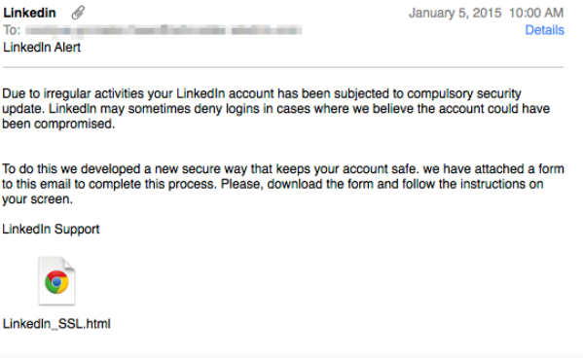
Figure 1 Example of a Phishing email

File encryption
Firstly the virus creates and sends a profile of the infected unit back to the server which the virus is being run from. That server then in turn sends back a reply and then the virus starts to encrypt the targeted files. See figure 2 [4] and 3 [6] for examples of files that are targeted. Along with the encryption it adds a link that redirects the user to payment screen. [7]

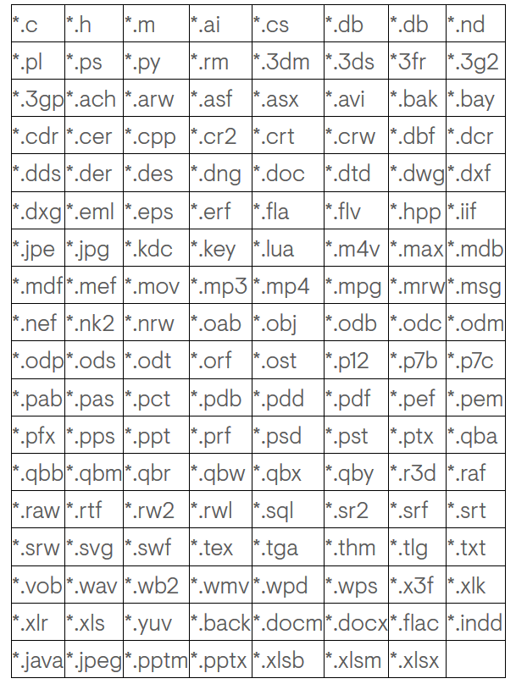
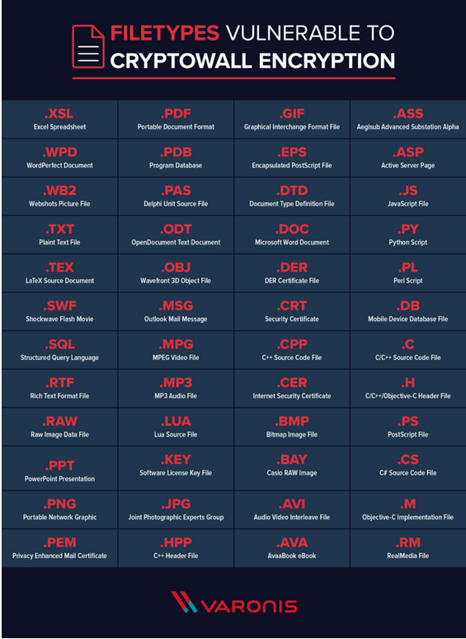
Once infected
Figure 2 Example of targeted files
Figure 3 Examples of targeted files
Once the virus has successfully encrypted all the targeted files, it displays a pop with instructions and a step by step guide on how to pay the ransom. See figure 4 for an example of a ransom note [7]. Once the ransom has been displayed the malware removes itself from the infected machine [4] The payment amounts can range from $200-$10,000 with $500 being the most common amount demanded [8]. On the ransom note will be a link on how to add money to a cryptocurrency wallet usually Bitcoin. Cryptocurrency is chosen method of payment as it is near impossible to trace. Since the first wave of ransomware and CryptoWall viruses infected computers, cybersecurity experts have emphasising the point that you should not pay the ransom. Mathews [9] states that has been found that in a recent report that only 19% of payments have actually resulted in the decryption of files.

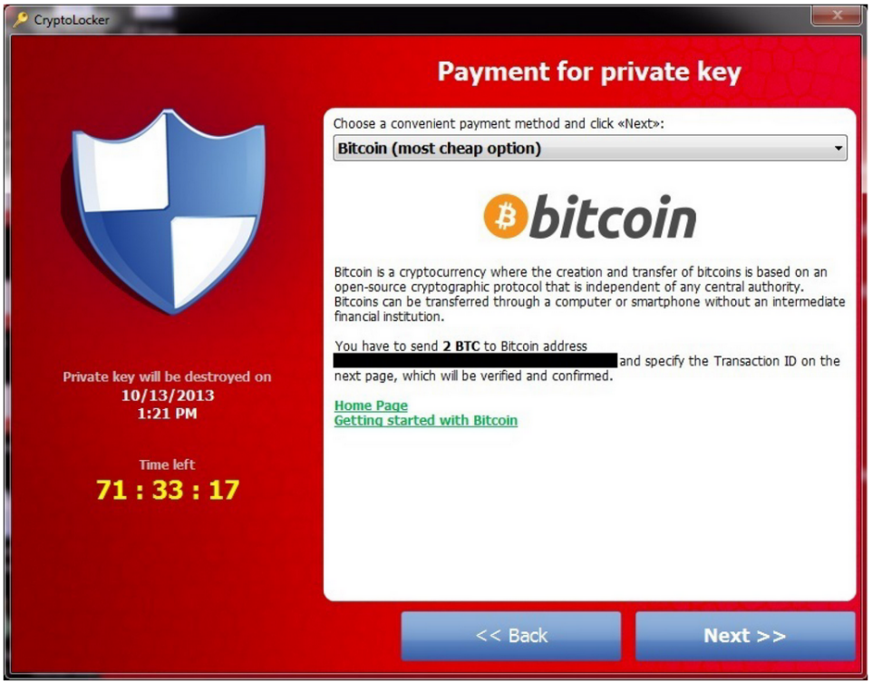
Figure 4 Example of a ransom note

Restoring files
Once files are encrypted it maybe possible to recover these files without paying the ransom. There are a few different methods out there including, restoring from a recent backup, recovery software, shadow copies and cloud base back-ups [10]. However, these aren’t guaranteed to work as recent backs may not be in place, recovery software may not be able to get around the virus, Shadow copies are also targeted by the virus and may no longer exist, and if a cloud base system is linked to the infected computer there is a chance it will be encrypted also.

Prevention
Considered by many as the best way to protect your system from these harmful viruses is to operate a safe browsing strategy [11]. Safe browsing is being aware of what file types are attached to emails and being aware of any link or document that is attached to emails. Maintaining an up to date web browser is also essentially in the defence.
Other common methods can greatly improve the safety of your device, such as:
Keeping the operating system up to date. New updates for OS are constantly being rolled out, these updates often feature patches to known weakness of the OS [6].
Always keep back-ups of your data, not only is this good practise for ransomware attacks but is also extremely valuable for hardware failure [4].

References

[1] | "All about malware," [Online]. Available: https://www.malwarebytes.com/malware/. [Accessed 19 November 2018].
[2] | D. Winder, "Ransomware," PC Pro, no. 261, 2016.
[3] | 9 July 2015. [Online]. Available: https://www.blackpoint-it.com/it-servicesblog-/cryptowall-5-scary-facts/. [Accessed November 2018].
[4] | J. Peters, "The state of cryptowall in 2018," 6 January 2018. [Online]. Available: https://www.varonis.com/blog/cryptowall/. [Accessed 20 November 2018].
[5] | "CrpytoWall," [Online]. Available: https://www.knowbe4.com/cryptowall. [Accessed November 2018].
[6] | "CryptoWall ransomeware threat analysis," Dell, 27 August 2014. [Online]. Available: https://www.secureworks.com/research/cryptowall-ransomware. [Accessed 23 November 2018].
[7] | J. Petters, "CrpytoLocker: Everything you ned to know," Varonis, 22 October 2018. [Online]. Available: https://www.varonis.com/blog/cryptolocker/#_edn1. [Accessed 23 November 2018].
[8] | "CryptoWall," [Online]. Available: https://www.knowbe4.com/cryptowall. [Accessed 25 November 2018].
[9] | L. Mathews, "Why you should never pay a ransomware ransom," 9 March 2018. [Online]. Available: https://www.forbes.com/sites/leemathews/2018/03/09/why-you-should-never-pay-a-ransomware-ransom/. [Accessed 25 November 2018].
[10] | "CryptoWall adn HELP_DECRYPT ransomware information guide and FAQ," 10 July 2014. [Online]. Available: https://www.bleepingcomputer.com/virus-removal/cryptowall-ransomware-information~restore. [Accessed 25 November 2018].
[11] | "CryptoWall Version 3 Threat," 2015.

