Marketing plan written for
Hilton Hotels

Student Name: Ipsita Patra
Student ID: 2231297
___________________

Marketing Essentials BMIH4005
Lecturer-Christopher Wilkin

________________________________

Table of Contents
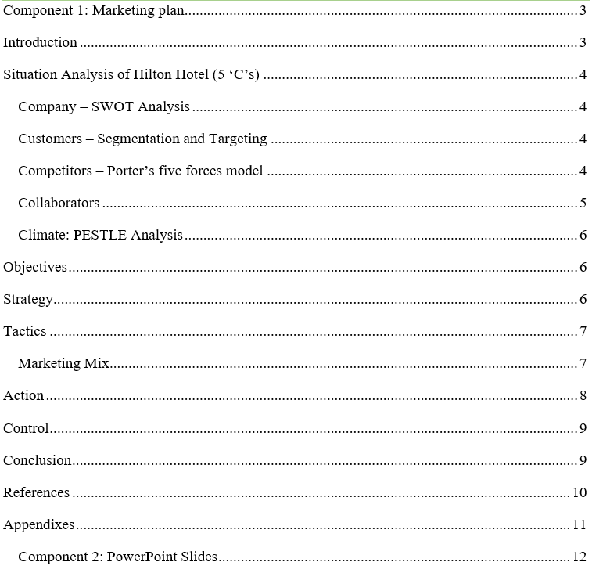

Component 1: Marketing plan

Introduction
A successful marketing strategy can help organise, carry out, and track a business' marketing activities over time (Brooksbank, 2019). Any marketing team within an organisation is allowed to set up its marketing plan if everyone is working towards the same overarching business objectives as stated in the organization's overall marketing plan. One of the objectives of this study is to produce a successful marketing strategy for the Hilton Hotel. The hotel's business environment will be examined using the 5 C's method in this assessment. Hilton's targeted outcomes, marketing strategy, and 4Ps marketing mix are all covered in this study as well. This marketing strategy will additionally offer the Hilton Hotel a management and action plan.

Situation Analysis of Hilton Hotel (5 ‘C’s)

Company – SWOT Analysis
Strengths | Weaknesses
Satisfied Workforces  Strong Brand Recognition  Huge Customers Base  Strong Property Portfolio | Bad Customer’s Review  Data Breach  Lack of Flexibility  Overdependence on the US Market
Opportunities | Threats
Merger and Acquisition  Social Media Marketing  Expansion of Develop Nation | Legal Cases  High Market Competition  The threat of Terrorism and Political Instability

Customers – Segmentation and Targeting
Market Segmentation
Geographic Segmentation | London, Aldwych, Bankside, Canary Wharf, Trafalgar Square, and Tower Bridge.
Demographic Segmentation | Both male and female professionals, business travellers, families, middle-income people, honeymooners, and so on.
Psychographic Segmentation | Adventure seekers, Luxury seekers, Eco-conscious travellers, Culture enthusiasts, and so on.
Behavioural Segmentation | Reward program members, Frequent Travelers, and those seeking value for money.
Target People
The majority of Hilton Hotel's target customers are those looking for affordable lodgings, those seeking a more opulent experience, adventurers, people who care about the environment, male and female workers, and families (Chong, 2020).

Competitors

Threat of new competitors: Hilton must contend with new competitors who enter the hotel industry and give customers lower prices, lower costs, and new value propositions.

Bargaining power of suppliers: There are numerous suppliers that supply the fundamental necessities to hotel businesses (Zhao, 2015). Strong marketplaces among suppliers could have an impact on Hilton's profit margins. This edge is frequently used by dominant service providers to bargain price increases with the hotel industry.

Bargaining power of customers: People search for the greatest deals on products and services. Hilton's financial performance suffered as a result. Customers of Hilton Worldwide Holdings Inc. who purchase less may bargain for price breaks and rewards (Blair, 2020).

The threat of substitute products: A new product or service that fills a market niche differently often results in financial losses. Substitution is a major risk if a prospective competitor's offering offers a very different value proposition.
Competition among existing competitors: High industrial competitiveness lowers prices and profits. Hilton Worldwide Holdings Inc.'s hotel industry is very competitive.

Collaborators
B2B Relationship: Hilton has business-to-business (B2B) relationships with firms in a range of industries. For instance, it interacts with airlines, credit card companies, and travel brokers to provide loyalty programmes, rewards, and discounts to customers.
Partnerships: Hilton has formed strategic collaborations with other companies to expand its market presence and product offerings. Via a relationship with Amazon, for instance, Alexa-enabled devices may be used to control room settings and access hotel information (Reid, 2021).
Franchises: The franchising approach of Hilton enables other parties to run hotels under its brands. Franchisees may run their hotels utilising Hilton's brand recognition, marketing help, and operational expertise (Pyasi, 2021).

Climate: PESTLE Analysis
Political Factors | Economic Factors | Social Factors
Political Stability  Trade Regulations  Pricing Regulations  Wage Regulations | Inflation Rate  Interest Rate  Economic Growth Rate  The efficiency of the Financial Market | Leisure Interests  Attitudes  Culture of people  Education level
Technological Factors | Legal Factors | Environmental Factors
Technological Diffusion  Online Booking  24 Hours online services | Data Protection  Employment Law  Health and safety law  Discrimination law | Climate Change  Recycling  Waste management in the service sector

Objectives The aims of the marketing plan of Hilton Hotel are increasing brand awareness, generating leads and sales, building customer loyalty, and expanding organizational market share through the marketing strategies of the company (Stowell, 2022).

Strategy
Hilton is an international hospitality chain that oversees many hotel brands throughout the range, from upscale to all-inclusive (Atmaca, 2019). USP is based on providing one-of-a-kind, sincere, and memorable experiences for our customers. Hilton intends to provide guests with a sense of local flavour and identity by having each hotel's design, decor, and amenities represent the local community. Hilton differentiates itself from its rivals by focusing on innovation and technology (Pellissier, 2020). For example, with the hotel's mobile app, guests may check-in, choose a room, place room service orders, and get digital keyless access. In addition, Hilton offers loyalty programmes like Hilton Honours, which give frequent visitors with benefits and discounts in exchange for their continued business. Hilton promotes its value proposition using traditional and online advertising, social media, electronic mail, and conventional postal communication.

Tactics

Marketing Mix
Products and Services: The several hotel brands maintained by the Hilton company offer a complete range of hospitality services across the globe. Its marketing mix includes upmarket hotel brands, specialised services such as Hilton Garden Inn, executive services such as extended visit suites and holiday hotels, and other components. Hilton has partnered with a variety of industries to expand its customer base (Chan, 2019). These industries include airlines, vehicle rental businesses, internet platforms, cruise lines, restaurants, retail malls, railroad companies, and financial organisations like American Express. Blue, Silver, Gold, and Diamond members get discounts on Hilton's already inexpensive costs.
Prices: The pricing strategies of the various hotel options within the Hilton group help in this study. Visitors to a Hilton Resort may expect a one-of-a-kind and enjoyable stay since the chain's hotels choose not to be located near airports but rather near bodies of water. This ensures that the exclusive hotels the organisation has negotiated low rates at will continue to do so. To stay in a single Hilton hotel room in India's major cities, you can expect to pay anything from INR 5,000 to INR 35,000.
Places: The Hilton brand has a presence in more than 5100 hotels located in 103 countries throughout the globe (Cooney, 2021). With time, the group has seen enormous growth. Before expanding its presence outside of the United States, Hilton mostly targeted the developed world as its market. In recent years, the firm has shifted its attention to developing nations like India and China to maximise profits.
Promotions: For many years, the Hilton company has been a well-known name in the hotel business. The business has placed a strong emphasis on offering outstanding services and ensuring customer satisfaction. International corporate clients make up the primary market. The group has collaborated with several businesses, large companies, institutions, and other organizations, and their bookings are given priority.

Action

Gannt chart (Own Created)

Control
The unique selling proposition of the Hilton brand is the quality of its service and the warmth with which it greets visitors. Guests at Hilton hotels are used to receiving superior services and amenities (Suprapto, 2021). In most cases, Hilton hotels have the following amenities: Accommodations of the finest quality, replete with all the comforts of home and more, such as high-end towels, sheets, and bedding, as well as a full supply of high-end toiletries. Exceptional attention to each visitor's distinct needs and goals. There is an abundance of spas, gyms, and swimming pools, among other sorts of entertainment. A variety of eateries provide high-quality cuisine and excellent service. Convenient locations in the top cities throughout the world. Among the numerous advantages of staying at a Hilton hotel is a stay that is both restful and beautiful, customised to each guest's preferences and needs. It is an excellent option for both tourists and businesses due to the abundance of amusements.

Conclusion
An efficient marketing plan may be of aid in the organisation, execution, and monitoring of a company's marketing activities throughout a certain time. The overall marketing plan was prepared from the perspective of the Hilton Hotel. The marketing objective of the company is provided in this business plan. The products and services, pricing strategies, placement, and also promotional strategies of this company are provided in this business plan. To analyse the situation of Hilton Hotel, the 5 Cs model is also provided in this business plan.

References
Atmaca, H. (2019). Reflections of the İstanbul Hilton Hotel on Mid-century Hotel Buildings in Turkey. Art-Sanat, 36(4), pp.57–88. doi:https://doi.org/10.26650/artsanat.2019.12.0016.
Blair, E. (2020). The Power of ‘Wow’ to Attract New Customers. Entrepreneur and Innovation Exchange, 15(32). doi:https://doi.org/10.17919/x9q594.
Brooksbank, R. (2019). Essential Characteristics for an Effective Marketing Plan. Marketing Intelligence & Planning, 9(7), pp.17–20.
Chan, S.H. (2019). Microfinance Products and Service Quality in Financial and Quasi-Financial Institutions in China. Strategic Change, 24(3), pp.267–284. doi:https://doi.org/10.1002/jsc.2008.
Chong, S.C. (2020). Target people of Hilton Hotel. Journal of Vision, 20(11), p.1709. doi:https://doi.org/10.1167/jov.20.11.1709.
Cooney, E. (2021). Discordant Place-Based Literacies in the Hilton Hotel, South Carolina Runway Extension Debate. Community Literacy Journal, 9(1). doi:https://doi.org/10.25148/clj.9.1.009298.
Pellissier, R. (2020). A CONCEPTUAL FRAMEWORK FOR THE ALIGNMENT OF INNOVATION AND TECHNOLOGY. Journal of technology management & innovation, 3(3). doi:https://doi.org/10.4067/s0718-27242008000100007.
Pyasi, V. (2021). ‘Franchises System – A New Business Model’ Analysis of Legal Issues Relating with Franchises. SSRN Electronic Journal, 14(9). doi:https://doi.org/10.2139/ssrn.1698487.
Reid, D. (2021). A Philosophy of Partnership. Mentoring & Tutoring: Partnership in Learning, 2(1), pp.34–36. doi:https://doi.org/10.1080/0968465940020108.
Stowell, H. (2022). Business objectives of Hilton Hotel. International Journal of Psychophysiology, 1(2), pp.137–151. doi:https://doi.org/10.1016/0167-8760(84)90034-5.
Suprapto, R. (2021). Pendekatan MetaforaVisual Dalam Gaya Pesan Iklan Televisi Unique Selling Proposition. WIDYAKALA JOURNAL, 5(1), p.24. doi:https://doi.org/10.36262/widyakala.v5i1.99.
Zhao, Z. (2015). Bargaining Power of Suppliers and Buyers, and Accounting Conservatism—Evidence from Chinese Manufacturing Listed Companies. Journal of Financial Risk Management, 04(01), pp.11–21. doi:https://doi.org/10.4236/jfrm.2015.41002.

Appendixes
Porter’s five forces model
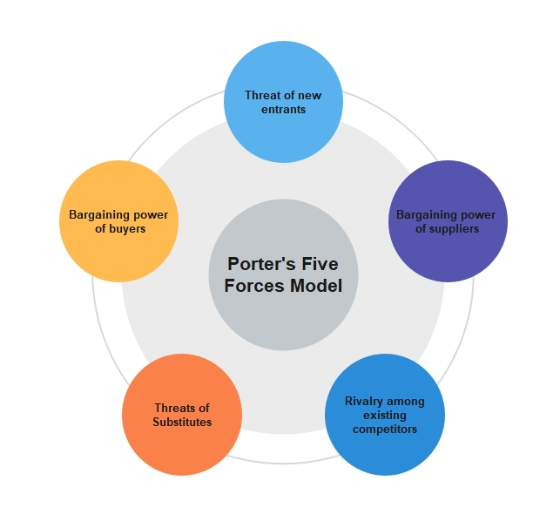
5Cs Model
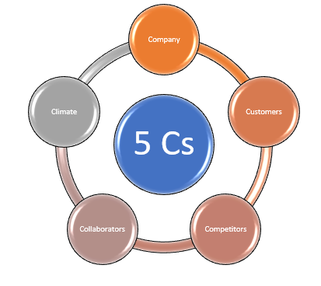

Component 2: PowerPoint Slides
Slide 1
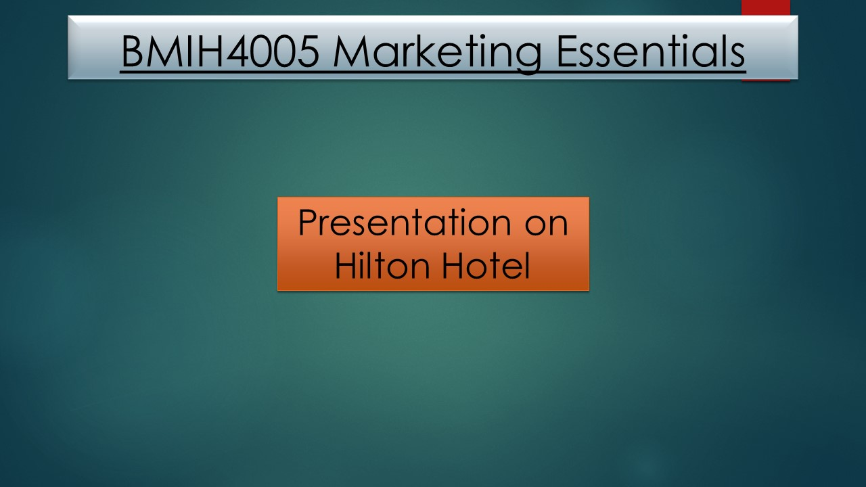
Slide 2
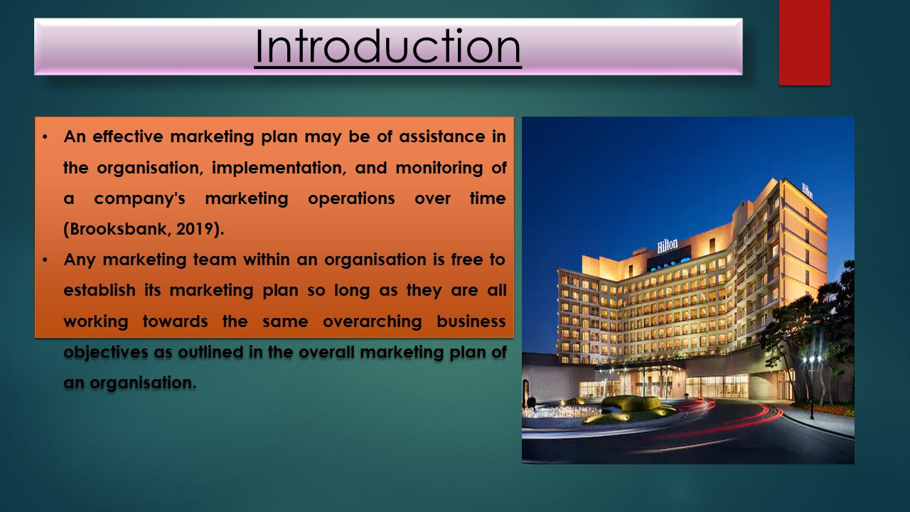
Slide3 3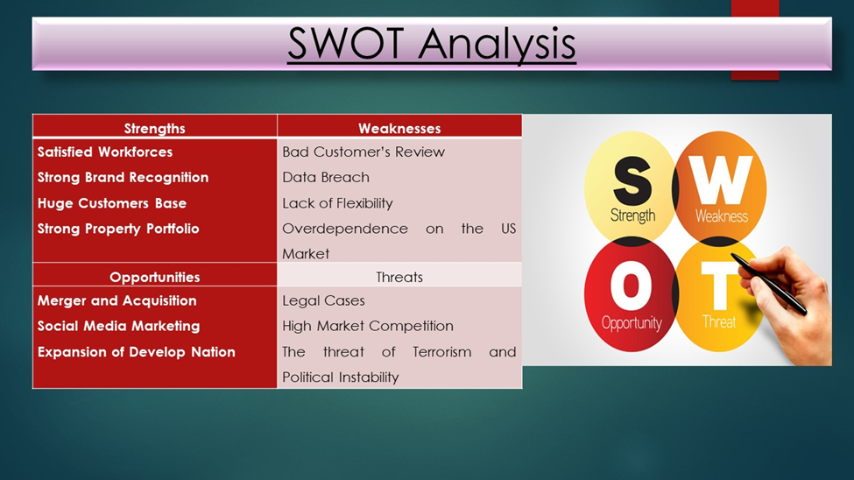

Slide4 4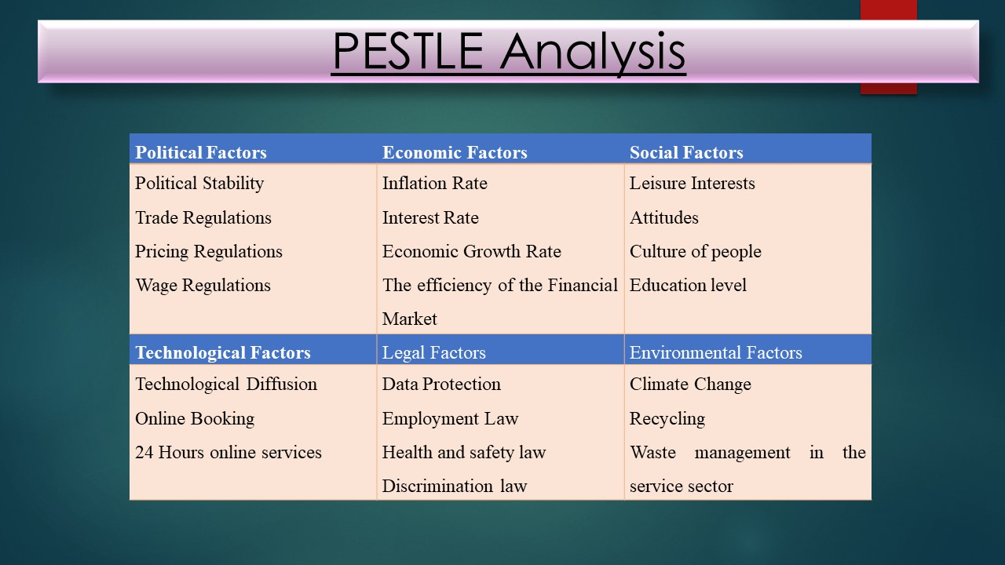

Slide 5
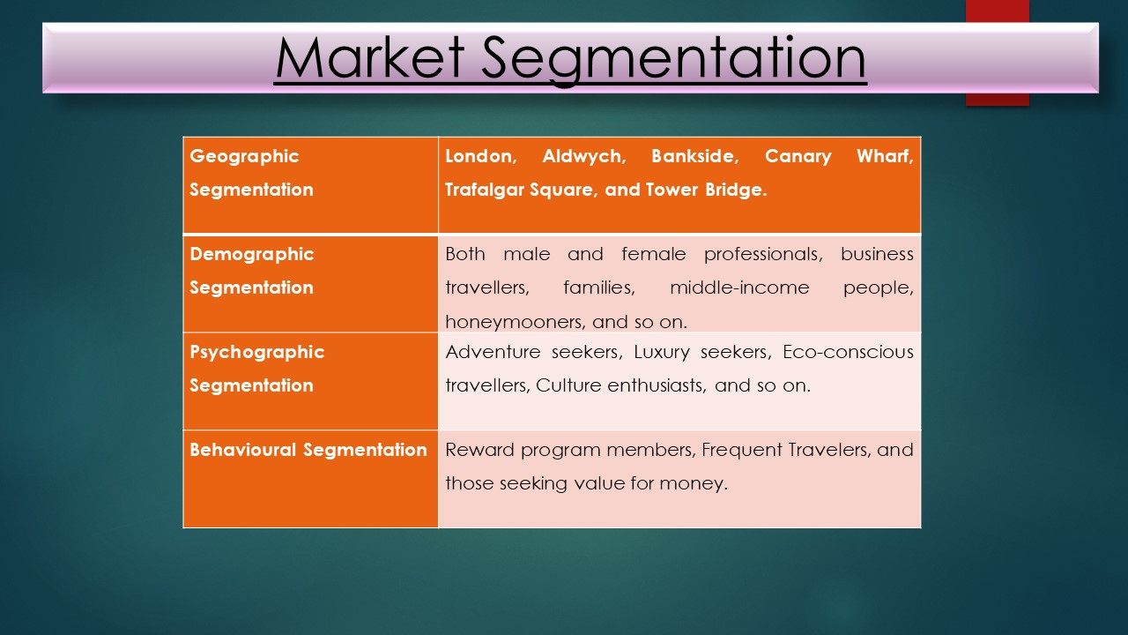
Slide 6
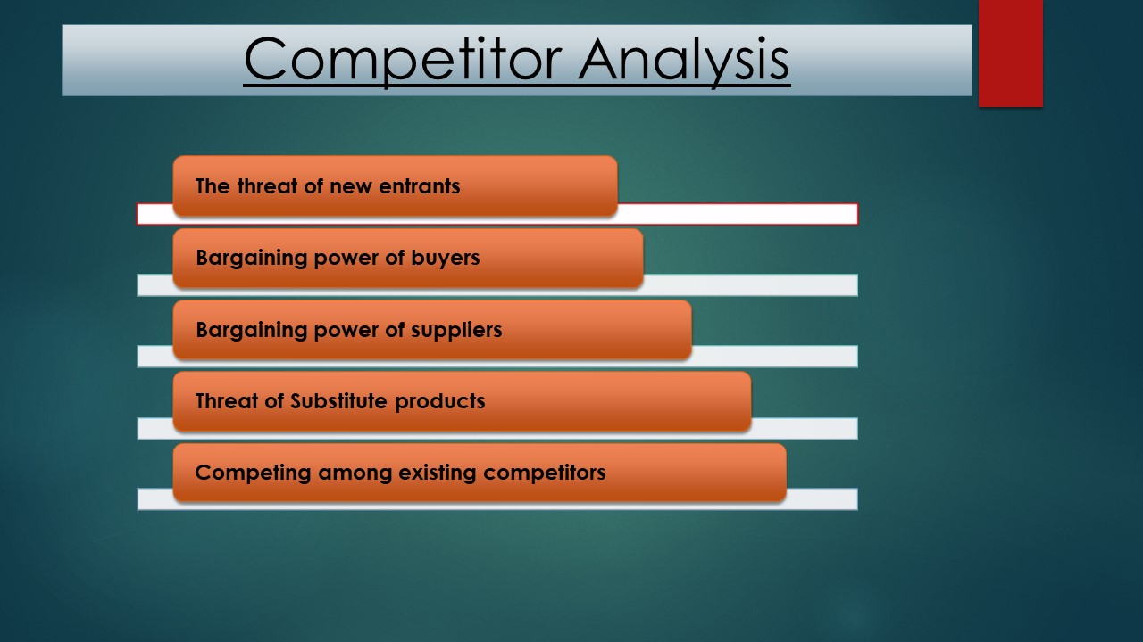

Slide 7
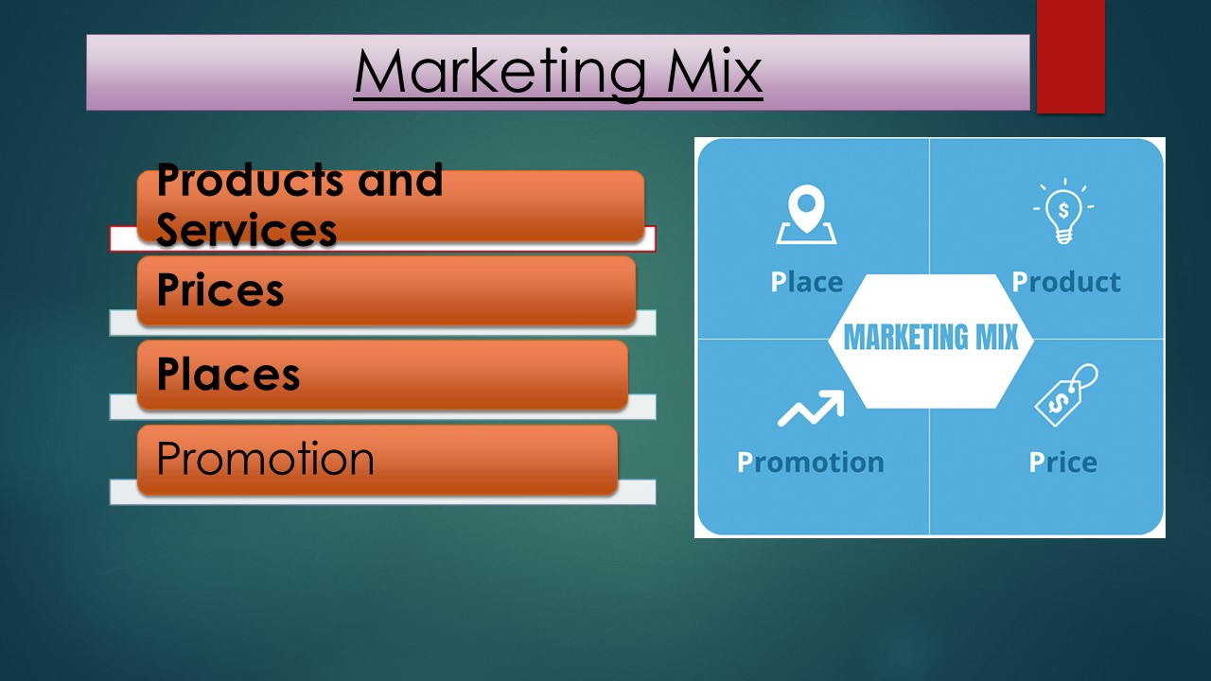
Slide 8
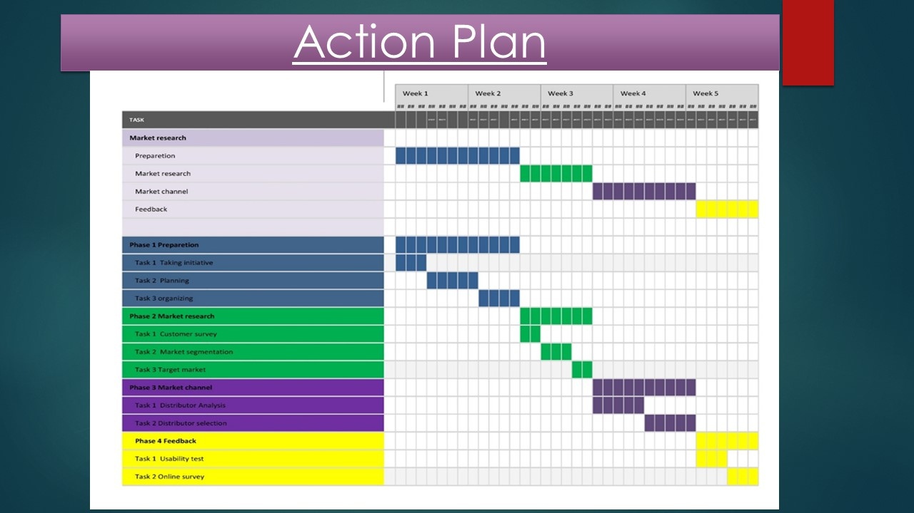

Slide 9
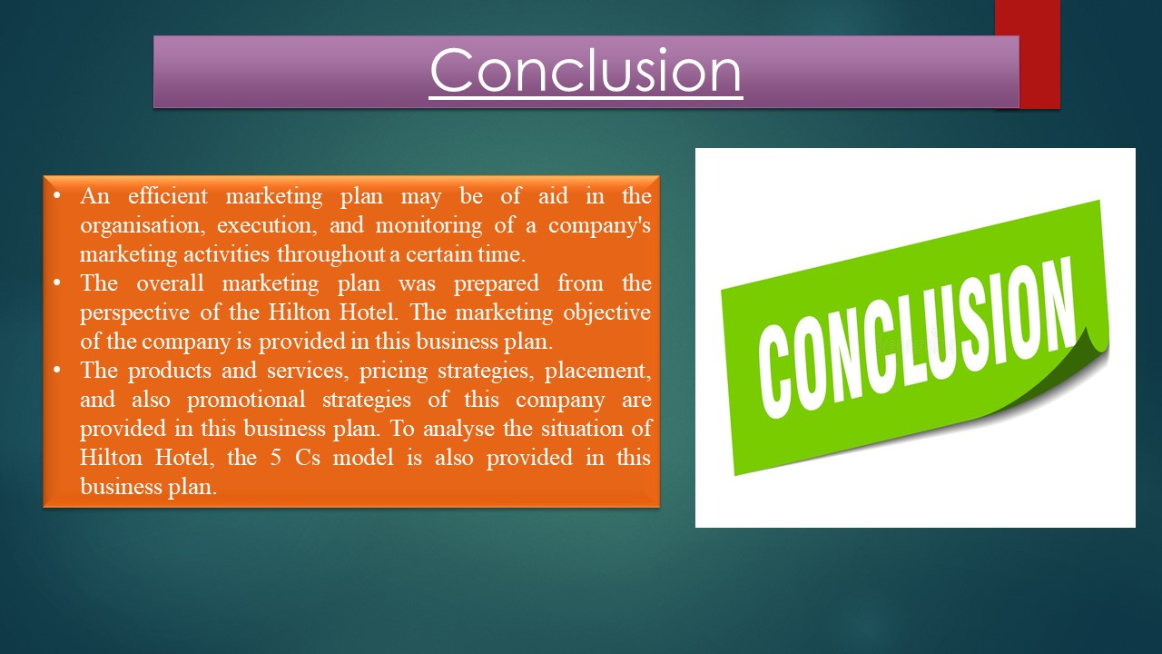
Slide 10


