Youth Policy, Practice and Legislation: Exploring How Policy Shapes the Lives of Young People in Wales

Flag of Wales (Source: Wikipedia, 2024).
Youth policy, practice, and legislation play a significant role in shaping the lives of young people in Wales. The policies that governments create affect education, health, mental wellbeing, youth services, and opportunities for young people to participate and have their voices heard. For youth workers, understanding how policies are formed and implemented is essential to ensure services meet young people’s needs effectively and inclusively (Anderson, 2015).
Since the Welsh devolution referendum in 1997, Wales has gained powers to develop policies tailored to its young people. This has allowed a focus on inclusion, wellbeing, and participation. Policy theory helps explain how these decisions are made. For example, Lindblom’s incrementalism shows that policy often evolves gradually, in small steps, rather than through sweeping changes (Lindblom, 1959). Similarly, Kingdon’s policy window theory highlights how timing, political will, and public pressure can influence which issues gain attention and action (Kingdon, 1995).
This portfolio brings together six blogs exploring contemporary youth issues in Wales: youth policy formation, mental health, participation, education and engagement inequalities, youth crime, and digital pressures. Each blog critically examines relevant policies and legislation, applies theory, and reflects on the implications for youth work practice. Together, these blogs provide a comprehensive overview of how policy shapes services and outcomes for young people, and the role of youth workers in bridging policy and practice.

References
• Anderson, J. (2015) Public policymaking. Stamford: Cengage Learning.
• Kingdon, J.W. (1995) Agendas, alternatives, and public policies. 2nd edn. New York: Longman.
• Lindblom, C.E. (1959) ‘The science of “muddling through”’, Public Administration Review, 19(2), pp. 79–88.


Blog 1: Understanding Youth Policy and Policy Formation

Welsh Government headquarters, Cardiff (BBC, 2025).
Introduction
Youth policy is an important part of shaping the support, opportunities, and services that young people receive. It affects education, health, mental wellbeing, and youth work services, as well as how young people’s voices are included in decision-making. Understanding how policy is formed is essential for youth workers, because it decides what services are available, how they are funded, and the priorities set by government (Anderson, 2015). This blog will explore what youth policy is, how policies are formed, and why policy theory is useful in understanding how decisions affecting young people are made.

What is Youth Policy?
Youth policy can be understood as the plans, strategies, and legislation developed by governments and organisations to address the needs, rights, and development of young people. In practice, this includes youth work provision, mental health support, access to education, and opportunities for participation. Policies guide youth workers and organisations, setting the framework within which they operate. In Wales, youth policy has developed particularly since the Welsh devolution referendum 1997, when powers were transferred to the Welsh Government. This shift allowed Wales to respond more directly to the needs of young people and develop policies that reflect local priorities. Examples of this include the Welsh Government’s Youth Work Strategy and legislation such as the Well-being of Future Generations (Wales) Act 2015, which focuses on long-term wellbeing for children and young people.
Youth policy is not created in isolation; it is shaped by political priorities, social issues, research evidence, and the input of stakeholders, including young people themselves. Policies are also influenced by historical events and the culture of the organisations involved. For instance, the approach to youth work in Wales is shaped by the country’s focus on inclusion, participation, and wellbeing (Alcock et al., 2022).

Policy Formation Theories
Policy theory helps us understand that policy decisions are rarely straightforward or purely rational. Charles Lindblom’s idea of incrementalism suggests that policy often develops in small steps rather than through large, planned changes (Lindblom, 1959). This is particularly true in youth policy, where change may be gradual due to funding limitations, political priorities, or the complexity of addressing young people’s needs. For example, improvements in mental health support for young people often happen incrementally, through pilot schemes or small-scale projects before larger rollout.
John Kingdon’s policy window theory provides another useful lens. He explains that policy change occurs when three streams – problems, policies, and politics – align, creating an opportunity for action (Kingdon, 1995). In youth policy, this could be seen when research highlights a problem affecting young people, policymakers have a viable solution, and there is political will to implement it. Understanding this helps youth workers see why some policies are introduced quickly, while others take years to develop.

Why Understanding Policy Matters for Youth Work
For youth workers, understanding how policy is formed and implemented is not just academic. It helps in planning, advocating, and delivering services effectively. Knowing the background of a policy, the stakeholders involved, and the intended outcomes enables youth workers to better support young people and ensure their voices are included. It also helps in critically evaluating whether policies achieve their goals or need improvement.
Youth policy is also closely linked to funding and resources. Without understanding policy processes, youth workers may struggle to access opportunities or influence decisions that affect their service users. Linking theory to practice, recognising incremental change and policy windows helps workers identify where they can influence decisions and contribute to shaping better outcomes for young people.

Conclusion
Youth policy is central to the support and services available for young people. Policies guide the work of youth services, but they are not created in isolation – they are influenced by politics, evidence, and society. Theories such as Lindblom’s incrementalism and Kingdon’s policy windows help us understand why policy develops in certain ways and the challenges involved. For youth workers, understanding these processes is essential for planning, advocacy, and ensuring that young people’s needs and voices are central to policy decisions. This sets the foundation for exploring Wales-specific youth policy and legislation in the following blogs.

References
- Anderson, J. (2015) Public policymaking. Stamford: Cengage Learning.
- Children’s Legal Centre Wales (2024) How does the law affect you? Law for Under 18s. Available at: https://childrenslegalcentre.wales/ (Accessed: 10 March 2026).
- Kingdon, J.W. (1995) Agendas, alternatives, and public policies. 2nd edn. New York: Longman.
- Lindblom, C.E. (1959) ‘The science of “muddling through”’, Public Administration Review, 19(2), pp. 79–88.
- Welsh Government (2023) Youth Work Strategy 2020–2025. Cardiff: Welsh Government.


Blog 2: Supporting Young People’s Mental Health: Policy and Practice in Wales

NHS Wales doctors supporting a young person (NHS Wales, 2025).
Introduction
Mental health is one of the biggest challenges facing young people today. Many teenagers and young adults experience stress, anxiety, or depression, which can affect their school, friendships, and overall wellbeing. Youth services and government policies have a key role in supporting mental health, but it is not always easy to provide the right support. In Wales, policies like the Well-being of Future Generations (Wales) Act 2015 and the Welsh Government’s Youth Work Strategy aim to improve outcomes, but understanding how these policies work in practice is essential for youth workers who want to help young people properly.
The scale of the problem
Research suggests that about one in three young people in the UK report a mental health issue, with anxiety and depression being the most common (Children’s Legal Centre Wales, 2024). In Wales, mental health has been highlighted as a priority in government strategies, including the National Youth Strategy and local youth work initiatives. Mental health issues can make it harder for young people to attend school, socialise, and take part in their communities. For youth workers, this means spotting risks early, offering support, and connecting young people with the right services.
Relevant policies and legislation
The Welsh Government has created several policies to address youth mental health. The Well-being of Future Generations Act puts a legal duty on public bodies to think about long-term wellbeing when making decisions, including the mental health of young people. The Welsh Government’s Youth Work Strategy also emphasises creating safe spaces, preventative support, and opportunities for young people to develop resilience and coping skills. Locally, Young Futures Hubs provide early support, combining mental health help with education and social opportunities.
Even with these policies, putting them into practice can be difficult. Funding, staff shortages, and differences between local authorities mean not all young people get the same support. This “implementation gap” shows that while policies may look good on paper, reality can be different (Anderson, 2015).
Policy theory and mental health
Policy theory can help explain why mental health has become a focus. Kingdon’s policy window theory suggests that change happens when three things come together: a recognised problem, a workable solution, and political support (Kingdon, 1995). With more evidence of poor outcomes for young people and public concern about mental health, the timing was right for policies to be introduced.
Lindblom’s idea of incrementalism also fits. Improvements in mental health services usually happen step by step, such as pilot programmes or small-scale projects, rather than sweeping changes (Lindblom, 1959). This is practical but can mean services grow slowly and may not meet demand. Understanding these patterns helps youth workers know why change is gradual and where they can influence improvements.
Critical reflection and youth work practice
For youth workers, knowing how policy works is important. Understanding what the Well-being of Future Generations Act is trying to do can help workers plan early interventions and support young people more effectively. Youth workers also give young people a voice, feeding back on what works and what does not.
There are still challenges. Demand for mental health support often outstrips what’s available, and services are not always consistent across Wales. Youth workers have to balance supporting individuals with advocating for better services and ensuring young people don’t fall through gaps.
Conclusion
Mental health is a major concern for young people in Wales. Policies like the Well-being of Future Generations Act and the Youth Work Strategy try to address this, but practical challenges remain. Using policy theory like Kingdon’s policy windows and Lindblom’s incrementalism helps youth workers understand why change happens the way it does. Youth workers are essential in turning policy into real support, helping young people, and making sure mental health stays a priority in youth services.

References
Anderson, J. (2015) Public policymaking. Stamford: Cengage Learning.
Children’s Legal Centre Wales (2024) How does the law affect you? Law for Under 18s. Available at: https://childrenslegalcentre.wales/ (Accessed: 10 March 2026).
Kingdon, J.W. (1995) Agendas, alternatives, and public policies. 2nd edn. New York: Longman.
Lindblom, C.E. (1959) ‘The science of “muddling through”’, Public Administration Review, 19(2), pp. 79–88.
Welsh Government (2023) Youth Work Strategy 2020–2025. Cardiff: Welsh Government.


Blog 3: Giving Young People a Voice: Participation in Policy and Practice
Young people taking part in a Welsh Youth Parliament session (Senedd, 2023).
Introduction
Young people’s participation in decision-making is a key part of effective youth work and policy development. When young people are included in shaping services, strategies, and policies that affect them, the results are often more relevant, inclusive, and sustainable. However, ensuring young people have a meaningful voice is not always straightforward. Barriers can include lack of access, limited understanding of policy processes, and assumptions that young people are “too young” to contribute. In Wales, initiatives such as the Welsh Youth Parliament and local youth councils aim to give young people the opportunity to influence policy and practice, but challenges remain in turning these opportunities into real influence.
The scale of the problem
Despite the importance of participation, research shows that young people are often underrepresented in decision-making processes (Alcock et al., 2022). Many youth services report difficulties engaging young people meaningfully, especially those from marginalised backgrounds. Without genuine participation, policies and services may fail to reflect young people’s needs, resulting in programs that are less effective or even inaccessible. Youth workers are often the bridge between young people and decision-makers, supporting participation, advocating for inclusion, and helping young people navigate complex structures.
Relevant policies and initiatives
Wales has several policies and initiatives that promote youth participation. The Welsh Youth Parliament is a key platform where young people aged 11–25 can debate issues and make recommendations to the Welsh Government. Local youth councils and organisations like Funky Dragon (now replaced with Young Wales) also provide structures for youth input. Policies such as the Well-being of Future Generations (Wales) Act 2015 emphasise participation as part of long-term wellbeing planning, and youth work strategies encourage co-production and consultation with young people.
Despite these policies, challenges remain. Participation can sometimes be tokenistic, where young people are consulted but their input does not influence decisions. Resources and training for youth workers can also be limited, making it harder to support meaningful engagement. Understanding the gap between policy intention and practice is essential for improving youth participation (Anderson, 2015).
Policy theory and youth participation
Kingdon’s policy window theory can help explain how youth participation becomes a focus in policy. Policy windows open when there is public recognition of the problem, available solutions, and political will (Kingdon, 1995). For example, growing awareness of the importance of youth voice, alongside government strategies for youth engagement, created opportunities to strengthen participation structures in Wales.
Lindblom’s incrementalism is also relevant. Participation policies often develop gradually through small pilots or local initiatives before being rolled out more widely (Lindblom, 1959). This step-by-step approach can ensure policies are manageable and adapted to real needs, but it can also mean progress is slow and uneven across different areas.
Critical reflection and youth work practice
For youth workers, supporting participation requires more than just following policy guidance. It involves building relationships, creating safe spaces, and actively encouraging young people to engage in decision-making. Youth workers also advocate for systemic changes to ensure young people’s voices influence real policy outcomes.
One practical example is co-designing activities or programs with young people rather than simply asking for feedback. This approach aligns with the principle of “nothing about us without us” and ensures young people have meaningful input. However, challenges such as limited funding, time pressures, and young people’s varying confidence levels mean participation is rarely straightforward. Youth workers must balance these challenges while still striving to ensure young people’s voices are heard.
Conclusion
Giving young people a voice in policy and practice is essential for effective youth work and creating services that truly meet their needs. Policies like the Well-being of Future Generations Act and initiatives such as the Welsh Youth Parliament provide structures for participation, but practical challenges remain. Using policy theory like Kingdon’s policy windows and Lindblom’s incrementalism helps explain why changes happen gradually and why engagement can be inconsistent. Youth workers play a crucial role in bridging the gap between policy and practice, ensuring young people are not just consulted but are active participants in shaping the services that affect their lives.

References
Alcock, P., Haux, T., McCall, V. and May, M. (2022) The student’s companion to social policy. 6th edn. Hoboken: John Wiley & Sons.
Anderson, J. (2015) Public policymaking. Stamford: Cengage Learning.
Kingdon, J.W. (1995) Agendas, alternatives, and public policies. 2nd edn. New York: Longman.
Lindblom, C.E. (1959) ‘The science of “muddling through”’, Public Administration Review, 19(2), pp. 79–88.
Welsh Government (2023) Youth Work Strategy 2020–2025. Cardiff: Welsh Government.

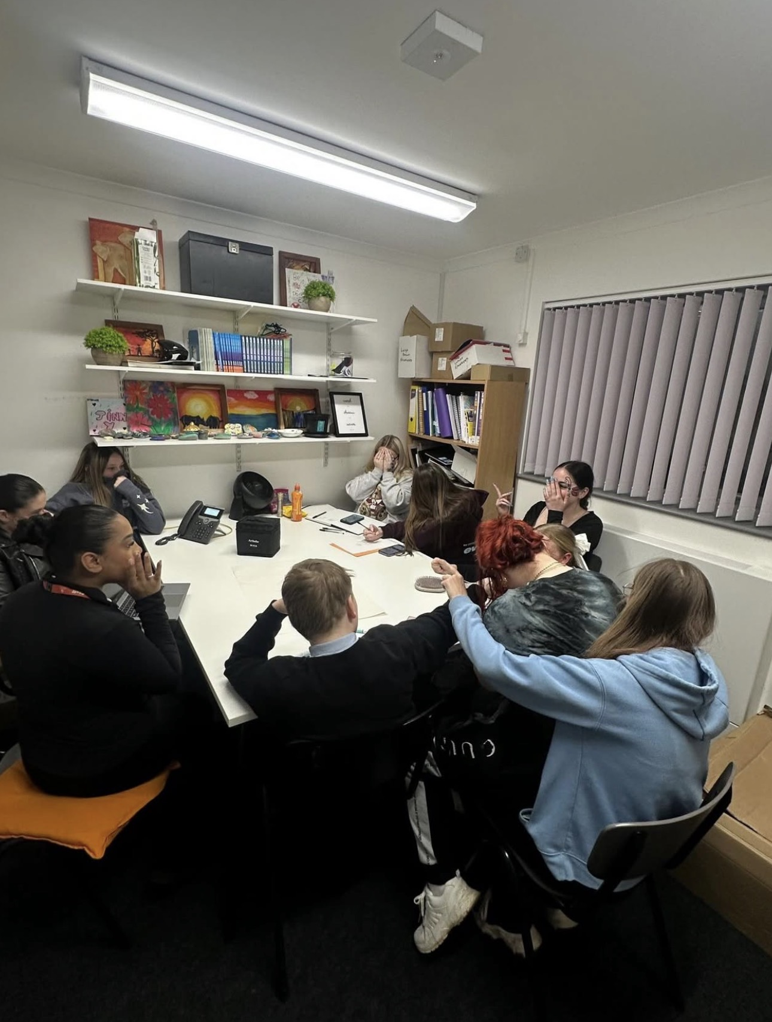
Blog 4: Tackling Education and Engagement Inequalities in Youth Work

Francis, L. (2026) Young people participating in a youth club activity at Evolve Youth Services.
Introduction
Education and engagement are central to young people’s development, but not all young people have equal access to learning opportunities or youth services. Inequalities can arise from background, location, disability, or other barriers. These gaps can impact a young person’s confidence, wellbeing, and long-term opportunities. Youth workers play a vital role in supporting those who may struggle to engage, but this requires understanding how policies aim to reduce inequalities and the challenges in implementing them. In Wales, policies like the Well-being of Future Generations (Wales) Act 2015 and youth work strategies emphasise inclusive education and engagement, yet achieving consistency across communities stays a challenge.
The scale of the problem
Research shows that young people from disadvantaged backgrounds are less likely to access extracurricular and youth work opportunities (Alcock et al., 2022). Barriers can include transport, costs, lack of information, or social exclusion. Engagement challenges also affect attendance in formal education, participation in youth activities, and the ability to develop social and life skills. Youth workers often step in to provide tailored support, create inclusive spaces, and encourage participation, but these efforts are limited by resources and policy constraints. Without targeted interventions, these inequalities can persist into adulthood.
Relevant policies and legislation
Several policies in Wales aim to address education and engagement inequalities. The Well-being of Future Generations Act requires public bodies to consider fairness, inclusion, and long-term outcomes in decision-making. The Welsh Government’s Youth Work Strategy encourages accessible, flexible, and inclusive youth work programs that cater to all young people. Local initiatives, such as outreach youth work and community learning programs, try to target underrepresented groups. Despite these measures, implementation varies, and some young people still miss vital opportunities. The challenge for youth workers is ensuring that policy intentions translate into meaningful engagement for those who need it most (Anderson, 2015).
Policy theory and engagement
Policy theory helps explain how education and engagement inequalities are addressed. Kingdon’s policy window theory suggests that policy change happens when the problem is recognised, solutions exist, and there is political support (Kingdon, 1995). Increased awareness of educational inequalities, combined with research evidence and government interest, has opened policy windows for inclusive youth work. Lindblom’s incrementalism also applies, as improvements in access to services often occur gradually, through pilot programs or phased initiatives (Lindblom, 1959). This step-by-step approach helps manage resources and risk but can result in uneven provision across regions.
Critical reflection and youth work practice
For youth workers, addressing engagement inequalities requires understanding both policy and local context. Creating flexible programs, providing transport, and reducing costs are practical ways to improve access. Youth workers also advocate for young people, feed back on gaps in provision, and develop initiatives that ensure inclusion. Reflecting on theory, incremental policy change highlights why some improvements are slow, while understanding policy windows helps show opportunities to influence decision-makers. Engaging young people directly in designing programs can also improve participation and ensure that initiatives are relevant to their needs.
Conclusion
Education and engagement inequalities stay a significant challenge for youth work in Wales. Policies like the Well-being of Future Generations Act and the Youth Work Strategy provide frameworks to improve inclusion, but practical barriers and uneven implementation persist. Linking theory to practice, Kingdon’s policy windows and Lindblom’s incrementalism explain why change often occurs gradually and why advocacy by youth workers is vital. Youth workers play a key role in bridging the gap between policy and reality, ensuring all young people have opportunities to learn, develop, and participate fully in their communities.

References
Alcock, P., Haux, T., McCall, V. and May, M. (2022) The student’s companion to social policy. 6th edn. Hoboken: John Wiley & Sons.
Anderson, J. (2015) Public policymaking. Stamford: Cengage Learning.
Kingdon, J.W. (1995) Agendas, alternatives, and public policies. 2nd edn. New York: Longman.
Lindblom, C.E. (1959) ‘The science of “muddling through”’, Public Administration Review, 19(2), pp. 79–88.
Welsh Government (2023) Youth Work Strategy 2020–2025. Cardiff: Welsh Government.

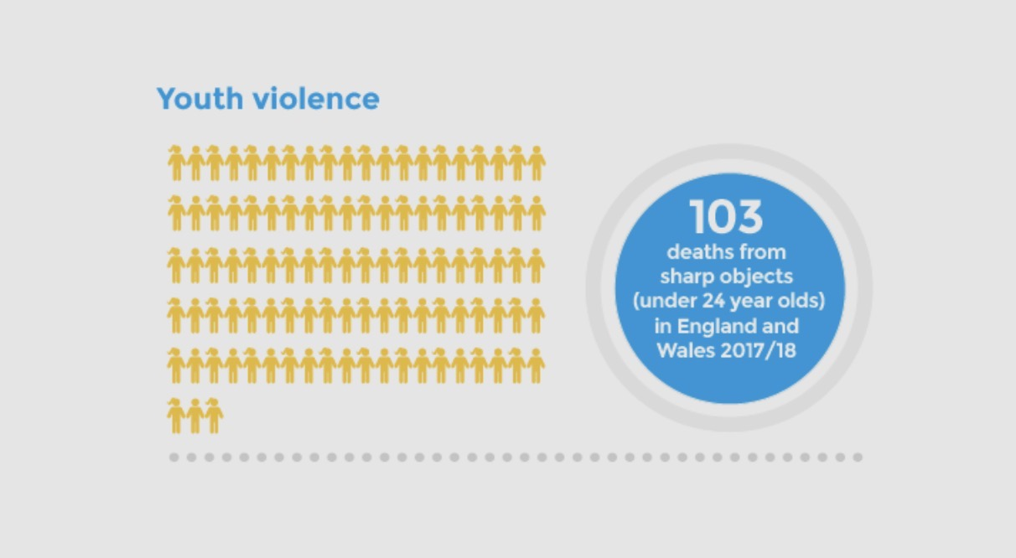
Blog 5: Addressing Youth Crime and Social Exclusion in Wales

Youth violence statistics showing deaths from sharp objects among under-24s in England and Wales (RCPCH, 2021).
Introduction
Youth crime and social exclusion are persistent issues that many young people face, and they often go hand in hand. Young people who are excluded from education, lack support networks, or live in disadvantaged communities are more likely to experience involvement with crime or anti-social behaviour. This is not just a justice issue, it affects wellbeing, life chances, and how young people see their place in society. Youth work plays a critical role in prevention, support, and steering young people away from harmful paths, but understanding relevant policies and the reality on the ground is crucial for effective practice.
The scale of the problem
Recent evidence highlights that young people can be approached or coerced into criminal activity in worrying numbers. In England and Wales, about one in nine young teenagers have been approached by criminals to handle drugs, weapons or money, and many accept due to pressure or lack of alternatives, revealing how easy it can be for young people to become involved in crime at an early age. Social exclusion compounds this risk: young people who are permanently excluded from school are significantly more likely to become involved in serious violence than their peers. For youth workers, this shows that crime isn’t simply a behavioural issue, it’s often connected to social support, belonging, education, and community opportunities.
Relevant policies and legislation
In Wales, the youth justice system is designed to treat young people differently to adults, recognising both their developmental needs and the need for supportive intervention. The Welsh Government has also developed frameworks aimed at preventing offending and supporting early intervention. For example, the Supporting Youth Justice Services to Prevent Offending Framework (2025) brings together multi-agency work to prevent young people from entering the criminal justice system by coordinating services like education, youth work, families support, and safeguarding. The Youth Justice Blueprint in Wales further promotes trauma-informed practice and multi-agency case management to help young people build resilience and avoid re-offending.
At the same time, youth work policy and strategy in Wales emphasise inclusive services, rights-based practice, and preventative work that supports young people before they meet the justice system. However, gaps stay in consistent implementation, and not all young people access these supports equally.
Policy theory and youth crime
Policy theory helps explain why youth crime response often develops gradually and unevenly. Kingdon’s policy window theory suggests that policy change happens when there is public recognition of a problem, practical policy solutions, and political openness to act. In the case of youth crime in Wales, increasing evidence about the consequences of exclusion and exploitation has helped open a window for preventative frameworks that involve education, safeguarding, and multi-agency work.
Incrementalism, another key theory, suggests that policy often develops step by step rather than through big shifts. This can be seen in how youth prevention frameworks, diversion programmes, and collaborative strategies have been introduced over time rather than all at once. While this makes policy more manageable, it can also mean that services vary by area and that young people in some communities still do not receive the same level of support.
Critical reflection and youth work practice
For youth workers, tackling youth crime and social exclusion means more than just responding to offending behaviour. It requires building trusting relationships, providing support before problems escalate, and engaging young people in positive activities that reinforce skills, confidence and belonging. Youth workers act as connectors between policies and young people lived experiences, helping them access services, find alternatives to risky behaviours, and feel supported rather than marginalised.
It also means being aware of wider social conditions. When youth services are underfunded or unevenly available, young people at risk of social exclusion may not be reached before they become involved in offending behaviour. Youth workers can advocate for better resourcing, use local partnerships to increase outreach, and collaborate with schools, families, and justice partners to support young people holistically.
Conclusion
Youth crime and social exclusion are complex issues that cannot be solved by the justice system alone. Policies in Wales, including prevention frameworks and youth work strategies, acknowledge that early intervention, multi-agency support, and inclusive services are key to addressing these challenges. Understanding theory helps explain why changes often occur gradually and why coordinated approaches are essential. Youth workers sit at the heart of this process, turning policy intentions into meaningful support, advocating for young people, and helping young people stay connected and engaged in positive opportunities.

References
Blyth, M. and Solomon, E. (eds.) (2008) Prevention and Youth Crime: Is Early Intervention Working? Bristol: Policy Press.
Children’s Legal Centre Wales (2024) How does the law affect you? Law for Under 18s. Available at: https://childrenslegalcentre.wales/ (Accessed 10 March 2026).
Kingdon, J.W. (1995) Agendas, alternatives, and public policies. 2nd edn. New York: Longman.
Welsh Government (2025) Supporting youth justice services to prevent offending: prevention framework. Cardiff: Welsh Government.

Blog 6: Contemporary Issues Affecting Young People Digital Pressures and Social Media

showing social media pressures on young people (Almond Solutions, 2020).
Introduction
Young people today navigate a world shaped by digital technology and social media, which has transformed how they connect, learn, and express themselves. While digital platforms offer opportunities for creativity, communication, and community building, they also bring challenges. Issues such as online bullying, unrealistic social comparison, digital addiction, and exposure to harmful content can affect mental health, self-esteem, and relationships. Youth workers are increasingly responding to digital pressures as part of holistic support, but there is a need to understand how policy addresses these issues and where gaps stay. This blog explores digital pressures as a contemporary issue, links policy approaches, and reflects on implications for practice.
The scale of the problem
Social media use is universal among young people, and research suggests significant concerns around online safety, comparison, and wellbeing. Young people report higher levels of anxiety and low self-esteem related to online interactions, and incidents of cyberbullying contribute to stress and feelings of isolation. Digital pressure also includes exposure to harmful content, unrealistic standards of beauty and success, and the constant need to be “connected”, which can affect sleep, attention, and mental health.
Relevant policies and legislation
Across the UK, policy responses to digital pressures include online safety laws and education initiatives aimed at empowering young people to navigate digital spaces safely. The Online Safety Act 2023 (UK) aims to make digital platforms safer for children by requiring companies to address harmful content, though implementation is ongoing. While this Act is UK-wide, Wales emphasises digital wellbeing through education policy and funding for digital literacy programmes in schools and youth services. The Welsh Government’s Youth Work Strategy also encourages youth work programmes that build digital resilience, critical thinking, and safe online behaviour.
Despite these frameworks, digital challenges evolve rapidly, and policy can struggle to keep up. Young people’s experiences often go beyond what laws and educational programmes address, leaving youth workers to adapt support strategies in real time.
Policy theory and digital pressures
Policy theory can help explain why digital issues are becoming increasingly recognised. According to Kingdon’s policy window model, issues gain attention when evidence highlights harms, solutions appear, and political or public concern increases. As research shows rising digital wellbeing concerns, policymakers have become more willing to legislate and fund initiatives. Incrementalism also explains how policy responses to digital challenges have developed in stages, with early education programmes and safety guidance expanding over time rather than through single comprehensive reforms.
Critical reflection and youth work practice
For youth workers, addressing digital pressures means understanding both the risks and opportunities of digital platforms. Youth workers can integrate digital literacy into programmes, support healthy boundaries around technology use, and create safe online and offline spaces for young people to express themselves. Co-producing digital wellbeing activities with young people helps ensure relevance and empowers them to lead conversations about online culture.
However, challenges remain. Constant technological change means youth workers must continuously update their knowledge, and resources for digital programmes are often limited. Youth workers also play a key advocacy role, feeding back to policymakers about emerging issues that affect young people’s online lives.
Conclusion
Digital pressures and social media are major contemporary issues for young people, shaping their wellbeing, identity, relationships, and community engagement. While policy efforts like online safety laws and digital literacy programmes aim to support young people, gaps stay as technology evolves faster than legislation. Using policy theory helps explain why these responses develop gradually and unevenly. Youth workers are crucial in translating policy into practice, providing support, building resilience, and advocating for young people in the digital age.

References
Anderson, J. (2015) Public policymaking. Stamford: Cengage Learning.
Children’s Legal Centre Wales (2024) How does the law affect you? Law for Under 18s. Available at: https://childrenslegalcentre.wales/ (Accessed 10 March 2026).
Kingdon, J.W. (1995) Agendas, alternatives, and public policies. 2nd edn. New York: Longman.
Welsh Government (2023) Youth Work Strategy 2020–2025. Cardiff: Welsh Government.
Overall Conclusion
This portfolio has shown how youth policy and legislation affect the lives of young people in Wales. Laws and strategies like the Well-being of Future Generations Act and the Youth Work Strategy set the framework, but how they work depends on how they are put into practice. Youth workers are important in making sure young people get the support they need and that their voices are heard. Looking at policy through ideas like Kingdon’s policy windows and Lindblom’s incrementalism helps explain why changes happen slowly and why workers need to advocate for young people. In the end, good youth work links policy, practice, and the real experiences of young people to make a difference.
References
Anderson, J. (2015) Public policymaking. Stamford: Cengage Learning.
Alcock, P., Haux, T., McCall, V. and May, M. (2022) The student’s companion to social policy. 6th edn. Hoboken: John Wiley & Sons.
Kingdon, J.W. (1995) Agendas, alternatives, and public policies. 2nd edn. New York: Longman.
Lindblom, C.E. (1959) ‘The science of “muddling through”’, Public Administration Review, 19(2), pp. 79–88.
Welsh Government (2023) Youth Work Strategy 2020–2025. Cardiff: Welsh Government.
Children’s Legal Centre Wales (2024) How does the law affect you? Law for Under 18s.

