Programme: Master of Business Administration

Module: Marketing Management

Module code: LCMB7024
Lecturer: Dr Laila Maazouz (London)
Assessment component 2: Marketing Portfolio

Student Name: Prit jenishbhai jariwala

Student ID: 2503896

Word count: 2397 words
Submission date : 17th December 2025

Table of Contents
1.0 Element 1: Segmentation, Targeting, Differentiation and Positioning (STDP) 3
1.1 Company Introduction 3
1.2 New Brand Concept Description 3
1.3 Market Segmentation 4
1.4 Target Audience Selection and Justification 5
1.5 Differentiation Strategy 5
1.6 Positioning Strategy 7
2.0 Element 2: Marketing Mix (4Ps) 8
2.1 Product Strategy 8
2.2 Price Strategy 8
2.3 Place Strategy 9
2.4 Promotion Strategy 11
4.0 Element 4: Reflection 13
4.1 Reflection on Developing the New Brand Concept 13
4.2 Reflection on Creating the Marketing Strategy 13
4.3 Reflection on Preparing and Delivering the Pitch 13
4.4 Key Skills Gained and Areas for Improvement 14
4.4.1 Key Skills 14
4.4.2 Areas for Improvement 14
References 15
Appendix 18
3.0 Element 3: Marketing Strategy Pitch Summary 18

1.0 Element 1: Segmentation, Targeting, Differentiation and Positioning (STDP)

1.1 Company Introduction
In 2024, Adidas registered a 11% rise in revenue to 23.68 billion and said sales growth of 14 % in currency neutral terms at the beginning of 2025 as its brand gathered strength around the world (Adidas, 2024). Adidas supports the growth of its digital and performance divisions and operates in 160+ markets, which confirms it as the second-largest sportswear brand globally (Adidas, 2025).

Figure 01; Adidas Logo
Source: (Britannica, 2025)

1.2 New Brand Concept Description
Adidas Hydrate+ is a brand centred on performance hydration that is meant to build up on the innovation platform of Adidas into functional drinks. It is a concept that combines sport science and brand identity, and provides electrolyte-enhanced formulations to aid endurance, recovery, and accuracy of hydration.
Placed as the logical continuation of Adidas focus on athletic performance, Hydrate+ addresses the changing consumer demands of holistic wellness solutions, including those that are connected to the brand. Consumers are increasingly shifting toward low-sugar, functional hydration, driven by rising health consciousness. The functional Beverage Market is rapidly growing with USD 151.8 billion in 2025, which represents the high demand of the performance-enhancing science-based beverages supporting the active lifestyle (Mordor Intelligence, 2025). The brand assists Adidas in its plan of creating integrated performance experiences among the products, technology, and lifestyle.
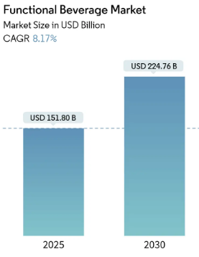
Fig 02: Functional Beverage Market 2025-2030
Source: (Mordor Intelligence, 2025)

1.3 Market Segmentation
Demographic Segmentation
The main target of Hydrate+ will be the adults aged between 18 and 45 years who show strong interest in a structured fitness routine. The industry has a large consumer base in the world with the world registering 184.6 million gym memberships (Aneta Niepytalska, 2024a).
Psychographic Segmentation
The brand target audience consists of people who are health conscious and are performance oriented and need products that are functional and in tandem with the active way of life. This is consistent with the fact that there has been a long-term trend of wellness-based consumption at the global level (HFA, 2024).
Behavioural Segmentation
Behavioural objectives will involve habitual gym-goers and leisure athletes in search of convenient ways of staying hydrated. Purchasing behaviour is connected to a high demand of the performance-enhancing consumables, as the company has 205,180 fitness clubs in operation across the world (Aneta Niepytalska, 2024b).

1.4 Target Audience Selection and Justification
Primary Target Audience
Hydrate+ is aimed at high-performance adults between the ages of 18 to 40 years of age who are using regular training and would like to see measurable improvements in endurance, recovery, and wellbeing. Their preference of practical, science-based items is closely related to a hydration solution that fits a performance system of Adidas.
Secondary Target Audience
Another group of consumers is lifestyle-focused buyers who strive to have a balanced wellbeing and relate athletic brands with credibility and aspirational identity. Although not necessarily high-intensity exercisers, they like convenience, brand loyalty, and holistic wellness programs ingrained into their lifestyles.
Justification
These segments are strategically relevant to target as they are both highly consistent with the brand equity of Adidas that focuses on the innovation, performance improvement, and design focusing on the athletes. The audience groups have also been better placed to take up cross-category brand extensions that will allow Hydrate+ to capitalise on existing loyalty and increase brand cohesion and early penetration in the market with clearly defined behavioural relevance and psychological fit.

1.5 Differentiation Strategy
Scientific Performance Differentiation
Hydrate+ distinctiveness is in the fact that it is an evidence-based product, which is in line with the increase of global requests of functional hydration products. According to the Market Data Forecast (2024) the market demand of the sports drink is estimated to increase to USD 36.24 billion by 2032 as most consumers are shifting to the low-sugar and performance drinks. Placed in this trend, Hydrate+ will ride on the credibility of Adidas as a performance brand to provide a scientifically-based product that appeals to athletes and active consumers who demand quantifiable recovery and endurance results.
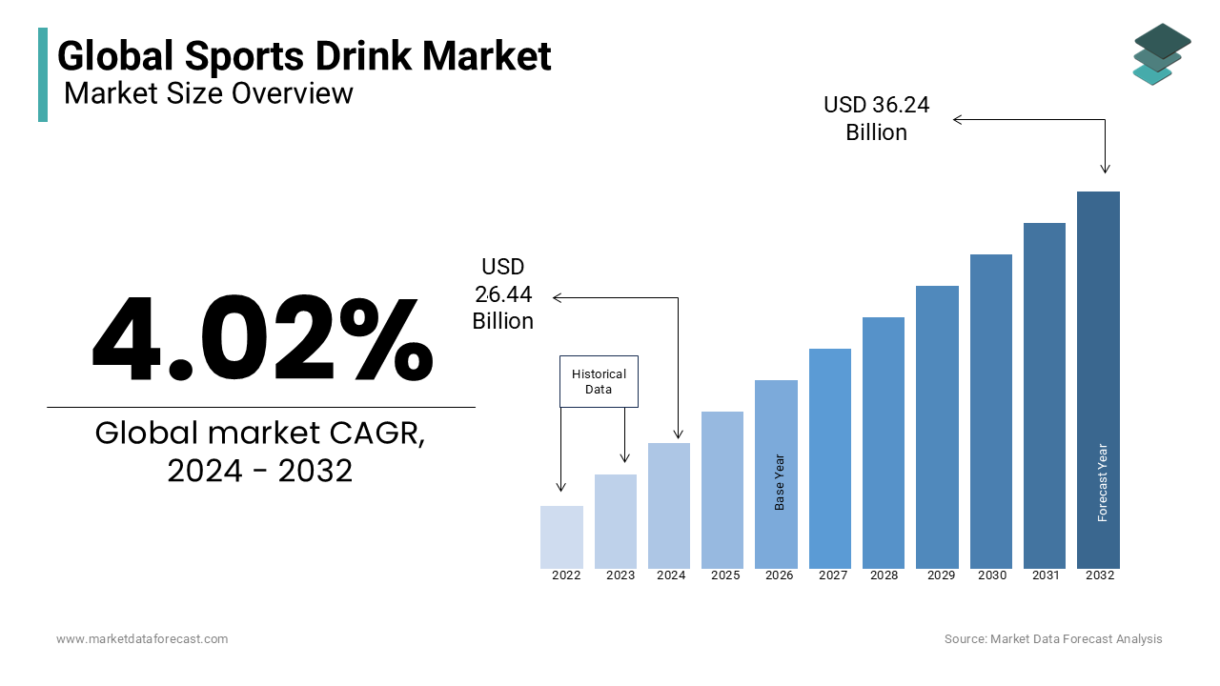
Figure 03: Global Sports Drink Market (2024-2032)
Source: (Market Data Forecast, 2024)
Health-Conscious Differentiation
Hydrate+ also positions itself by complying with the health guidelines in the world, where minimised sugar content and more-clean ingredient listings are in the spotlight. WHO suggests that free-sugars should be kept to less than 10 %of the overall energy and more than 50 nations have issued sugar-reduction or taxation policies to push consumers towards healthier drinks (WHO, 2020).
Brand-Integrated Differentiation
The ecosystem strength of Adidas that covers apparel, footwear, and training technologies forms a seamless performance story that other competitors, such as Gatorade and PowerAde, can never imitate, allowing more engagement of the emotions and multi-category brand loyalty.

1.6 Positioning Strategy
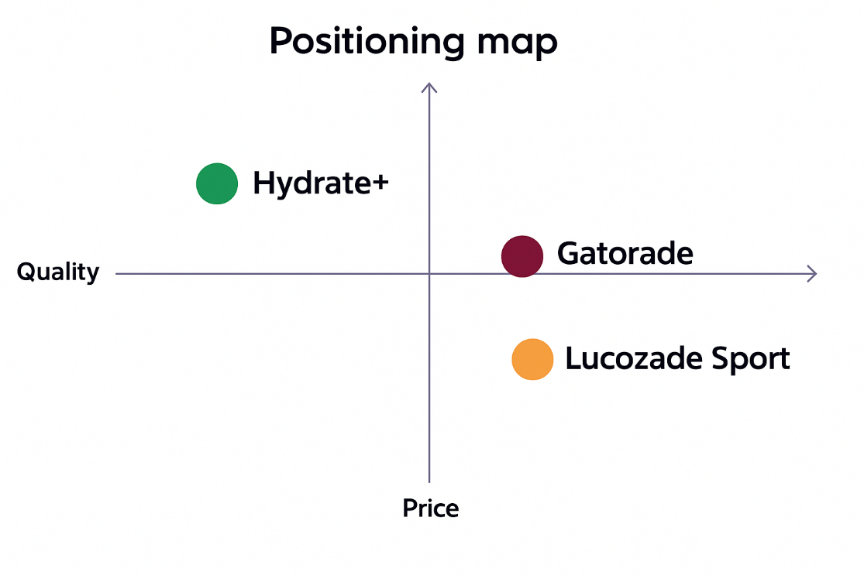
Figure 04: Positioning Map of Hydrate+
Source: (Self Made)
Hydrate+ is positioned as a mid-priced, high-quality performance drink, which is differentiated as compared to the Gatorade and Lucozade Sport which are on the mid-quality and higher price point. This underscores the high quality formulation and value based performance in the sports hydration market of Hydrate+.

2.0 Element 2: Marketing Mix (4Ps)

2.1 Product Strategy
Hydrate+ product strategy focuses on creating a clean-label, scientifically informed hydration drink that reinforces the athlete-based brand of Adidas. The trends of the 2024 consumer preferences allow the drinks that are made out of natural components and have the minimum level of processing to move in a good direction, and according to Innova Market Insights, the claim of no artificial ingredients can be listed among the top ones at the global level (Innova Market Insights, 2025). Hydrate+ will employ balanced electrolyte, natural flavourings, and clear ingredient listings to develop a functional beverage that is in line with shifting performance requirements. The creation of it is a response to the fact that a 2024 study by the Food and Drink Federation includes results suggesting that the brands tend to become more active-lifestyle-supporting and less traditional sugary products (FDF, 2024). The packaging strategy supports the sustainability promises of Adidas. According to McKinsey report on global packaging insights of 2024, 78% of consumers belong to the category of individuals who value sustainable packaging when buying a product, making Hydrate+ shift towards less harmful lightweight and recyclable plastics based on PET. Together, the decisions make Hydrate+ the direct contributor to the overall brand strategy of Adidas, which is high-performance innovation, credible scientific foundation, sustainability leadership, and integrated performance ecosystem.

2.2 Price Strategy
The Hydrate+ pricing strategy is a mid-premium value-based strategy that places the product offer with a position between mainstream sport drinks and the emerging functional wellness beverage. This is in line with the increasing consumer preference towards paying higher prices on healthier formulations. The results of the 2024 Global Health and Wellness Report by Nielsen show there is a clear premiumisation trend in the category with 41% of consumers willing to pay more on beverages with natural or functional or reduced-sugar advantages (NIQ, 2024b). Premium hydration products also continue to outwit lower priced products, which is also revealed by benchmarking. A Circana (2025) market analysis revealed that the premium hydration beverages were increasing by 16 %per year compared to 11.6 %in the mass-market sports drinks, suggesting that value-based differentiation and not low prices were driving the growth of the category. The willingness-to-pay is significantly high in terms of functional categories, which are about 2.2 with beverages and almost 3.8 with enhanced spreads (Okpiaifo et al., 2023). This positive growth signifies a high level of consumer acceptance on high prices of health-oriented formulations, which serves as a support to the Hydrate+ positioning in the mid-premium segment.
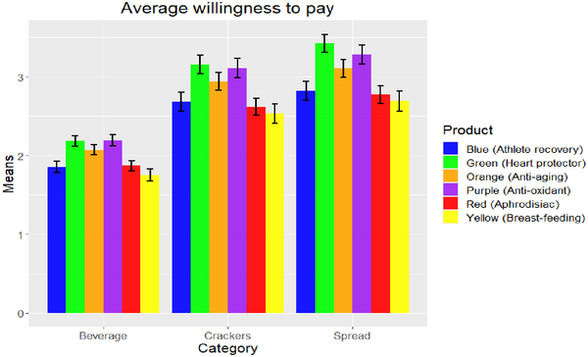
Figure 05: Consumer Willingness-to-Pay for Functional Food and Beverage Categories
Source: (Okpiaifo et al., 2023)
Hydrate+ will thus position itself with a mid-premium price, which includes its clean-label formula, functional value, and positioning as a part of the Adidas performance ecosystem. Value perception is also encouraged with the help of promotion on the basis of Adidas Training and membership, which allows the brand to adjust a premium based not on retail pricing rivalry alone. This plan will be consistent with the brand-wide strategic plan of Adidas in the context of performance credibility, innovation leadership, and premium brand positioning. By positioning Hydrate+ as a higher priced offering in comparison to traditional sport drinks but priced lower than ultra-premium wellness drinks, Adidas supports its brand as an easy to afford but high-performance product and creates consistency across the rest of its product line.

2.3 Place Strategy
Hydrate+ will implement an Omni channel distribution approach that optimises direct-to-consumer (DTC), digital retail, and specific physical retail to cover the performance-oriented consumers. The DTC channel The DTC channel will provide the exclusive formulations and subscriptions package through the Adidas own e-commerce and membership platforms, which will utilise the personalised data to enhance lifetime value and engagement with the ecosystem. Online beverage distribution will be the focus of Hydrate+ to embrace emerging demand in online channels: online beverage sales increased 18.2 %annually to hit the $11.9 billion mark, highlighting the power of the digital medium in beverage distribution (NIQ, 2025).
In the case of physical distribution, Hydrate+ will seek a high end positioning in the sporting goods outlets, gym pro-shops, and convenience outlets where they can buy instantly. C-stores are strategically placed to facilitate impulse and on-the-go consumption as a large portion of CPG purchases occurs in convenience-stores (NIQ, 2024a). Also, the FMCG e-commerce has grown by 11 %in 2024, signifying the continued growth in online grocery and online marketplace penetration justifying a dual online/offline strategy (Euro Monitor, 2024).
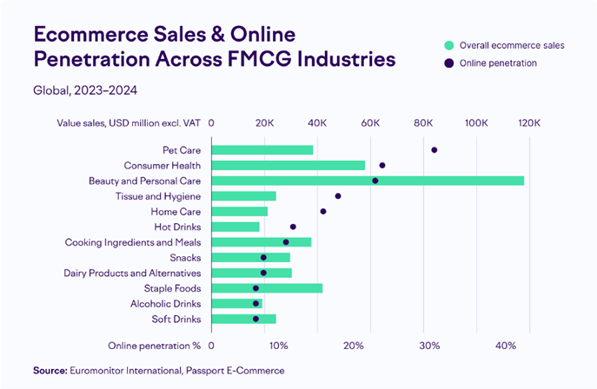
Figure 06: Ecommerce Sales and Online Penetration Across FMCG Industries, 2023–2024
Source: (Euro monitor, 2025)
The channel mix is consistent with the brand strategy of Adidas. DTC and digital channels strengthen integration of the ecosystem and data capture. Gym and retail placements are specialist which reinforces the performance credibility. The convenience and the location in the supermarket are the means of ensuring the wide accessibility as the Hydrate+ can be both an aspirational performance item and a daily convenience product.

2.4 Promotion Strategy
The Hydrate+ promotion will follow a digital-first, performance-based communications mix, which will include athlete endorsement, specific micro-influencer programs, short-form video content, and selective sponsorships in enhancing credibility and trial. Short-form video platforms are favoured by investment as nowadays Shorts and the likes are measured in enormous global consumption with YouTube alone counting billions of daily Shorts views, a crucial channel to reach and connect with a vast audience in a very brief period (YouTube, 2023). The increasing importance of sports sponsorship, which is projected to increase to USD 60.17 billion in 2024 and has a CAGR of 9.2% of increase, is a good move to encourage Hydrate+ to use performance partnerships to achieve greater brand credibility and exposure (Straits Research, 2024b).
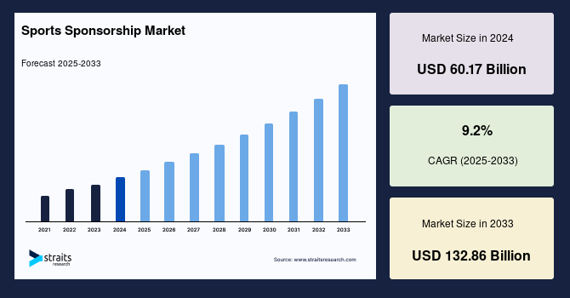

Figure 07: Global Sports Sponsorship Market Size and Forecast, (2024–2033)
Source: (Orange Logs, 2024)
Trial will be transformed into loyalty through tactical sampling of elite training sessions and pro-shop activations, and associative performance credibility through sponsorship of specific sporting properties, which will be regional leagues, endurance events (Straits Research, 2024b). To measure uplift, optimise creative and reiterate offers through subscription bundles and limited editions co-branded drops, Adidas DTC analytics and retailer POS integration will be measured.

4.0 Element 4: Reflection

4.1 Reflection on Developing the New Brand Concept
The Hydrate+ brand idea demanded balancing between being creative and making strategic sense, which made my theories of brand extension operations questionable. I knew that innovation was not enough, and the concept had to be given a useful place in the performance ecosystem of Adidas, not to thin out the brand equity. The critical analysis of the evidence available in the market also compelled me to make justifications as opposed to gut decisions. This exercise made me stronger in terms of how to turn external trends, like the move toward clean-label functional hydration, into a proposition that would be commercially viable and brand-authentic. The experience helped me develop my strategic discipline and strengthen my brand development appreciation, which is evidence-based.

4.2 Reflection on Creating the Marketing Strategy
The development of the marketing strategy needed a new analytical accuracy that I did not actually expect at first. I have not only understood that the successful development of strategies requires well-organised tools, e.g. STP and the 4Ps, but also the skill to question evidence and detect some gaps or constraints in data. This experience enhanced my ability to defend strategic decisions as opposed to revert to generic assumptions. The combination of product, pricing, distribution, and promotion decisions helped to strengthen my vision of the interdependence of these aspects and the fact that the failures in one of the areas may affect the overall performance. The experience also helped me improve my resolution to the commercial goals and brand integrity so that all decisions support the performance-driven nature of Adidas.

4.3 Reflection on Preparing and Delivering the Pitch
Writing and presenting the pitch has involved condensing a complicated strategy into a compelling and coherent story to me, making my thinking in a constrained setting more critical. I understood that persuasive communication is based not on excellent content and message, but purposeful organization, visual presentation, and strict prioritisation of the message. Working on the slides required me to determine the main value of the strategy instead of using the descriptive explanation. The process of delivery showed me that there were shortcomings in my pacing and transitions, which had to be handled in a more deliberate way, in terms of tone and emphasis. The experience helped me to improve my skills of strategic storytelling and understand how to be a confident, credible communicator in professional environments.

4.4 Key Skills Gained and Areas for Improvement

4.4.1 Key Skills
- Increased the critical analysis capabilities by questioning the quality of evidence and finding data shortcomings.
- Improved strategic thinking based on the alignment of STDP and the 4Ps with the overall brand identity..
- Mastered sophisticated communication techniques of reducing complicated knowledge into brief and audience oriented stories.
- Improved visual literacy by creating coherent, data-driven pitch materials.
- Built confidence in professional presentation and strategic decision-making.

4.4.2 Areas for Improvement
I should also learn to synthesise complex information more effectively and be more confident in addressing diverse stakeholder groups. Earlier incorporation of feedback loops, better risk projection in strategic planning, and more repeated development of visual materials would benefit future projects and help them to be more understandable, accurate, and overall more persuasive.

References
Adidas (2024). adidas Annual Report 2024 - adidas Annual Report 2024. [online] adidas Annual Report 2024. Available at: https://report.adidas-group.com/2024/en/.
Adidas (2025) Press releases [online]. Available at: https://www.adidas-group.com/en/media/press-releases/ (Accessed: 04 December 2025).
Aneta Niepytalska (2024a). Essential Gym Membership Statistics 2024: Insights & Trends. [online] WodGuru. Available at: https://wod.guru/blog/gym-membership-statistics/#elementor-toc__heading-anchor-1.
Aneta Niepytalska (2024b). Essential Gym Membership Statistics 2024: Insights & Trends. [online] WodGuru. Available at: https://wod.guru/blog/gym-membership-statistics/#elementor-toc__heading-anchor-1.
Britannica (2025). [online] Britannica.com. Available at: https://cdn.britannica.com/94/193794-050-0FB7060D/Adidas-logo.jpg?w=385 [Accessed 4 Dec. 2025].
Circana (2025). premium hydration beverages grew 16% year-on-year, significantly faster than mass-market sports drinks, indicating that value-driven differentiation, rather than low pricing, drives category expansion. [online] Circana. Available at: https://www.circana.com/news [Accessed 3 Dec. 2025].
Euro Monitor (2024). FMCG e-commerce sales grow by 11% in 2024. [online] Euromonitor. Available at: https://www.euromonitor.com/newsroom/press-releases/june-2025/fmcg-e-commerce-sales-grow-by-11-in-2024.
Euromonitor (2025). [online] Euromonitor.com. Available at: https://www.euromonitor.com/globalassets/newsroom/press-releases/fmcg-graph-1.png [Accessed 1 Dec. 2025].
FDF (2024). State of industry report Q2 2024. [online] The Food & Drink Federation. Available at: https://www.fdf.org.uk/fdf/resources/publications/state-of-industry-reports/state-of-industry-report-q2-2024/.
HFA (2024). Fitness Industry’s Global Momentum Continued in 2024, New Report Shows. [online] Health & Fitness Association. Available at: https://www.healthandfitness.org/about/media-center/press-releases/fitness-industrys-global-momentum-continued-in-2024-new-report-shows/.
Innova Market Insights (2025). Global clean label trends. Nearly 1 in 2 consumers globally. [online] Innovamarketinsights.com. Available at: https://www.innovamarketinsights.com/trends/global-clean-label-trends/.
Market Data Forecast (2024). Sports Drink Market Growth, Size, Share, Trends and Forecast to 2025. [online] Market Data Forecast. Available at: https://www.marketdataforecast.com/market-reports/sports-drink-market.
Mckinsey (2024). Packaging & Paper Insights | McKinsey & Company. [online] www.mckinsey.com. Available at: https://www.mckinsey.com/industries/packaging-and-paper/our-insights.
Mordor Intelligence (2025). Mordor intelligence. [online] Mordorintelligence.com. Available at: https://www.mordorintelligence.com/industry-reports/functional-beverage-market.
NIQ (2024a). The 2024 State of Convenience. [online] NIQ. Available at: https://nielseniq.com/global/en/insights/analysis/2024/the-2024-state-of-convenience/.
NIQ (2024b). Unveiling Beverage Trends in 2024. [online] NIQ. Available at: https://nielseniq.com/global/en/insights/report/2024/unveiling-beverage-trends-in-2024/.
NIQ (2025). The State of Online Beverage Sales in 2025. [online] NIQ. Available at: https://nielseniq.com/global/en/insights/education/2025/online-beverages/.
Okpiaifo, G.E., Dormoy-Smith, B., Kassas, B. and Gao, Z. (2023). Perception and demand for healthy snacks/beverages among US consumers vary by product, health benefit, and color. PLOS ONE, [online] 18(6), pp.e0287232–e0287232. doi:https://doi.org/10.1371/journal.pone.0287232.
Orange Logs (2024). Sponge Clipper Work Log. Createspace Independent Publishing Platform.
Straits Research (2024a). Sports Sponsorship Market Size, Top Share, Demand, Report to 2031. [online] straitsresearch.com. Available at: https://straitsresearch.com/report/sports-sponsorship-market.
Straits Research (2024b). Sports Sponsorship Market Size, Top Share, Demand, Report to 2031. [online] straitsresearch.com. Available at: https://straitsresearch.com/report/sports-sponsorship-market.
WHO (2020). Guideline: sugars intake for adults and children. [online] www.who.int. Available at: https://www.who.int/publications/i/item/9789241549028.
YouTube (2023). YouTube for Press. [online] blog.youtube. Available at: https://blog.youtube/press/.

Appendix

3.0 Element 3: Marketing Strategy Pitch Summary


