  Component One:  What are the key skills required when working in the housekeeping team? 750 words (+/- 10%)  Contribution to Overall Module Assessment: 25% | Student No: | Bianca Petre  2029609
 | Module Title: | Operating Hotel Facilities
 | Module Code: | BMIH4006
 | Lecturer: | Muhammad Cassamo
Introduction
Housekeeping is a critical department within any organization, responsible for maintaining cleanliness, order, and a welcoming atmosphere. Working in a housekeeping team requires a diverse skill set to meet the demands of the job. In this essay, we will delve into the key skills necessary for individuals to excel in the dynamic and demanding field of housekeeping. From attention to detail and time management to communication and problem-solving abilities, each skill plays a vital role in maintaining high standards and creating a positive environment for guests or residents.

Attention to Detail
Attention to detail is a fundamental skill for anyone working in a housekeeping team. Housekeepers must have a keen eye for spotting dirt, stains, and areas that require cleaning or tidying up. It involves ensuring spotless surfaces, properly made beds, and flawless bathroom fixtures. Meticulousness extends beyond visual inspections to include following specific instructions, adhering to cleaning protocols, and handling delicate items with care. By paying attention to even the smallest details, housekeepers can maintain consistently high standards and create an environment that exceeds expectations.
Housekeepers should also have a sense of aesthetics, ensuring that rooms are visually appealing by arranging items neatly, coordinating colors, and paying attention to the overall ambiance. Attention to detail is especially crucial in high-end hotels, where guests expect a luxurious and flawless experience. Additionally, by promptly reporting any maintenance or repair needs, housekeepers contribute to the overall maintenance of the property, ensuring a safe and pleasant environment for guests or residents.

Time Management
Efficient time management is crucial for a successful housekeeping team. Housekeepers often work under tight schedules, needing to clean multiple rooms or areas within a specific timeframe. Prioritizing tasks, organizing workloads, and effectively allocating resources are essential to maximize productivity. Creating a schedule and adhering to it ensures that all responsibilities are met promptly.
Time management also involves anticipating and planning for potential challenges. For example, a housekeeper may need to allocate extra time for deep cleaning or prepare for unexpected events, such as a sudden increase in occupancy. By proactively managing time, housekeeping professionals can ensure that tasks are completed efficiently and without compromising quality.

Communication and Interpersonal Skills
Working in a housekeeping team requires strong communication and interpersonal skills. Housekeepers need to interact with colleagues, supervisors, and guests or residents regularly. Effective communication ensures that everyone is aware of their responsibilities, any special requests are understood, and potential challenges or concerns are addressed promptly.
Clear and concise communication is crucial when relaying instructions or reporting issues to supervisors or other team members. Housekeepers must be able to provide accurate and detailed information regarding room status, maintenance needs, or any guest requests to ensure a seamless workflow. Moreover, they should actively listen to instructions and seek clarification when needed, ensuring that tasks are carried out correctly.

Adaptability and Problem-Solving Abilities
The ability to adapt to changing circumstances and think critically when faced with challenges is essential for housekeeping professionals. They may encounter unexpected situations, such as handling difficult stains, addressing maintenance issues, or accommodating last-minute requests. An adaptable housekeeping team can quickly assess the situation, make informed decisions, and take appropriate actions to overcome obstacles.
Adaptability also involves adjusting to different work environments and evolving industry standards. Housekeepers may need to learn new cleaning techniques, use advanced equipment, or adapt to changes in the organization's policies or procedures. Being open to learning and embracing change allows housekeeping professionals to stay ahead and provide the best service possible.

Problem-solving skills are invaluable when encountering unexpected situations. Housekeepers must think creatively and find effective solutions. For example, if a specific cleaning product is unavailable, they should be able to identify suitable alternatives. Additionally, they may need to collaborate with other departments, such as maintenance or front desk, to address complex issues that require a multidisciplinary approach. By employing their problem-solving abilities, housekeeping professionals ensure that guests or residents have a seamless experience, even in challenging circumstances.

Conclusion
Working in a housekeeping team demands a diverse skill set that goes beyond mere cleaning and tidying. Attention to detail ensures impeccable standards, while effective time management enables maximum productivity. Communication and interpersonal skills foster positive relationships and create a welcoming atmosphere. Adaptability and problem-solving abilities allow for flexibility and efficient resolution of challenges. Each of these skills is vital to the success of a housekeeping team, contributing to overall guest or resident satisfaction and the organization's reputation. By mastering these skills, housekeeping professionals can create a clean, comfortable, and memorable experience for all who enter the doors of the establishment. With their unwavering commitment to excellence, housekeeping teams become the unsung heroes behind the scenes, upholding the highest standards of cleanliness and hospitality.

Word Count | 793

Component Two:
Contribution to Overall Module Assessment: 25%
In this scenario – You have just been promoted to team leader for a floor within the hotel. A guest complains that on their arrival, their room had not been properly cleaned. Create an action plan and answer the following questions.

Problem | Why did it happen? | What are you going to do? | How will you prevent this from happening in the future? | What measures would you introduce to improve team effectiveness?
Room cleanliness issues reported by guest | Insufficient attention to detail during room cleaning processes. | Personally speak to the guest to understand the specific cleanliness concerns. Apologize sincerely and assure the guest that their feedback will be taken seriously. Take immediate actions to address the cleanliness issues in the room. | Conduct regular training sessions for housekeeping staff to reinforce the importance of attention to detail and thorough room cleaning procedures. Implement quality control checks to ensure consistent cleaning standards. | Provide additional training on room cleaning techniques and the importance of thoroughness. Establish a feedback mechanism where guests can provide specific comments on room cleanliness. Regularly review guest feedback to identify trends and address any recurring issues.
Guest dissatisfaction with response to their complaint | Inadequate communication or ineffective resolution of the guest's complaint. | Personally apologize to the guest and assure them that their complaint will be investigated thoroughly. Conduct an internal investigation to understand the reasons behind the dissatisfaction and take appropriate steps to address the guest's concerns. | Implement a robust communication system to ensure prompt and effective response to guest complaints. Train team members on effective complaint resolution techniques and empower them to take ownership of resolving guest issues. | - Establish a clear protocol for handling guest complaints, including designated personnel responsible for resolving issues. Provide regular training on customer service and complaint resolution. Foster a customer-centric culture where all team members prioritize guest satisfaction.
Room readiness issues leading to guest inconvenience | Inefficient coordination and lack of effective communication between departments. | Conduct a thorough investigation to identify the reasons behind the room readiness issues. Improve coordination and communication between housekeeping and front desk teams to ensure seamless room preparation and prompt check-in for guests.. | Implement a streamlined room readiness checklist that includes all necessary tasks and ensures coordination between housekeeping and front desk staff. Enhance communication channels between departments to facilitate real-time updates on room status and readiness. | Establish regular meetings between housekeeping and front desk teams to discuss room readiness and address any potential challenges. Implement a digital platform or software to facilitate communication and task management between departments.
Inconsistent service quality reported by multiple guests. | Lack of standardized procedures and inconsistent training among housekeeping staff. | Conduct a comprehensive assessment of the current training programs and identify areas for improvement. Develop a standardized training curriculum that covers all essential aspects of housekeeping operations. Provide regular training sessions to ensure consistent service quality across all team members. | Implement regular quality control checks to ensure compliance with standardized procedures and service quality expectations. Establish performance evaluation metrics that incorporate service quality as a key component. Provide constructive feedback and recognition to motivate and improve team performance. | Develop a clear set of service standards and expectations for housekeeping staff. Provide ongoing training and refresher courses to reinforce these standards. Implement regular performance evaluations with a focus on service quality. Foster a culture of accountability and continuous improvement within the housekeeping team.
Guest dissatisfaction with overall cleanliness of hotel facilities | Inadequate resources and insufficient attention to cleaning and maintenance of common areas. | Conduct an assessment of the current resource allocation and identify areas where additional resources or staffing may be required. Implement a thorough cleaning and maintenance schedule for all common areas, with a focus on regular inspections and prompt addressing of issues. | Review and enhance the resource allocation plan to ensure sufficient staffing and cleaning supplies for maintaining cleanliness in common areas. Implement a preventive maintenance plan to address potential issues proactively. Encourage feedback from guests regarding cleanliness and promptly address any concerns raised. | Implement a regular cleaning and maintenance checklist for common areas, with assigned responsibilities and follow-up procedures. Provide additional training to staff members responsible for maintaining common areas. Conduct regular inspections and audits to ensure adherence to cleanliness standards in all hotel facilities.

Component Three:
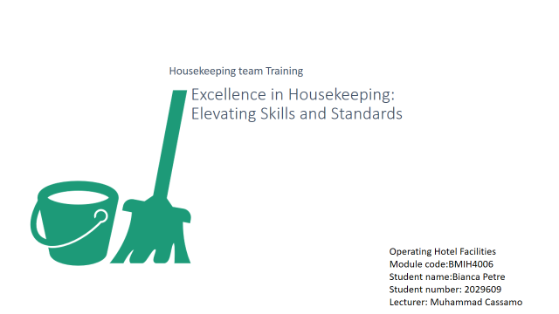
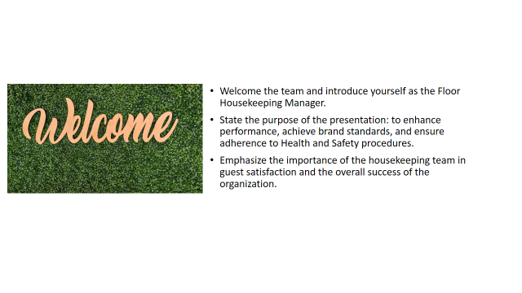
Training Notes:Introduce yourself as the Floor Housekeeping Manager and establish your credibility as a leader. Emphasize the importance of the housekeeping team in guest satisfaction and the organization's success. Set a positive and engaging tone for the training session.
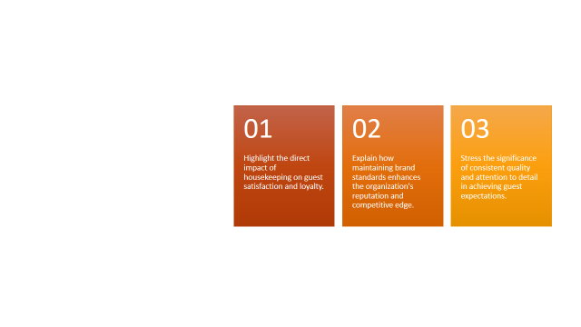
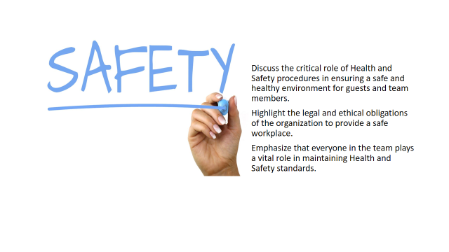

Training Notes: Discuss how maintaining high performance and adhering to brand standards directly impact guest satisfaction and loyalty. Share examples or testimonials that illustrate the positive outcomes of exceptional housekeeping services. Reinforce the team's role as ambassadors of the organization's brand..
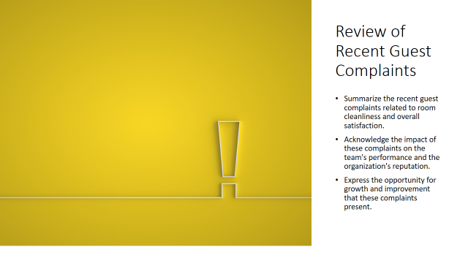
Training Notes: Summarize the recent guest complaints related to room cleanliness and overall satisfaction. Highlight the impact of these complaints on the team's performance and the organization's reputation. Emphasize that addressing these concerns through training and improvement opportunities will enhance the team's performance.
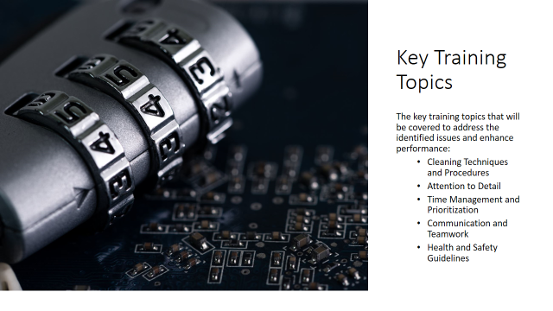

Training Notes: Provide an overview of the key training topics that will be covered. Explain how these topics directly address the identified issues and contribute to maximizing performance and achieving brand standards. Build anticipation and interest in the upcoming training content.

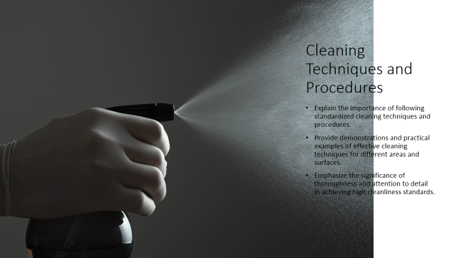
Training Notes: Explain the importance of following standardized cleaning techniques and procedures to ensure consistent cleanliness across all rooms and areas.
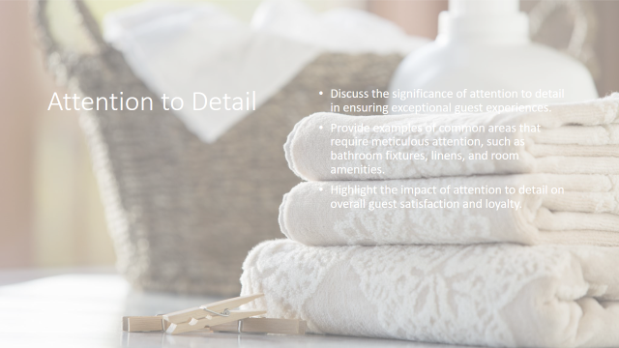
Training Notes: Provide examples of specific areas that require meticulous attention, such as bathroom fixtures, mirrors, and room amenities.
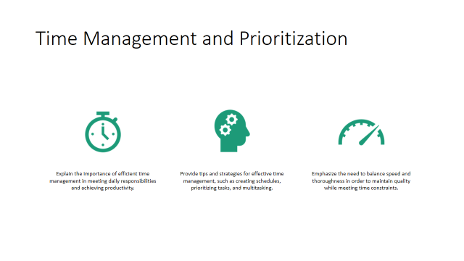
Training Notes: Discuss common challenges in time management, such as managing multiple tasks, handling unexpected situations, and meeting deadlines.

Training Notes: Discuss the different communication channels and methods available, such as in-person, written, and digital communication
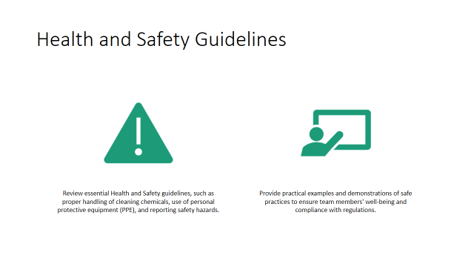
Training Notes: Discuss the proper handling and storage of cleaning chemicals, emphasizing the importance of wearing personal protective equipment (PPE).
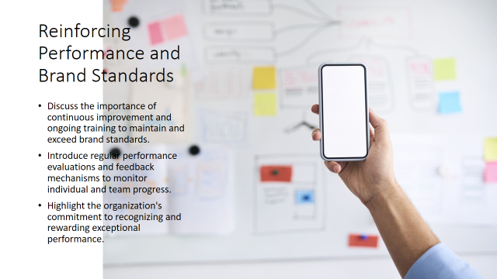
Training Notes: Discuss the importance of continuous improvement and ongoing training to maintain and exceed brand standards. Introduce the concept of performance evaluations and feedback as a way to monitor progress and provide guidance. Highlight any recognition or reward programs that the organization has in place to celebrate exceptional performance.
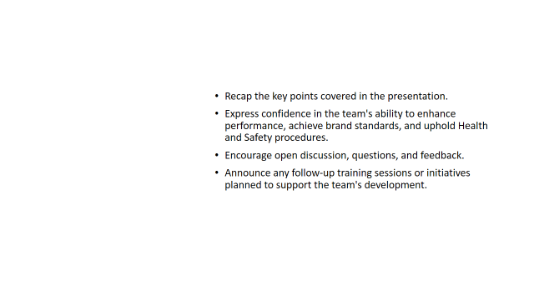
Training Notes:Summarize the key points covered in the presentation. Express confidence in the team's ability to enhance performance, achieve brand standards, and uphold Health and Safety procedures. Encourage open discussion and questions. Announce any follow-up training sessions, initiatives, or resources available to support the team's ongoing development.
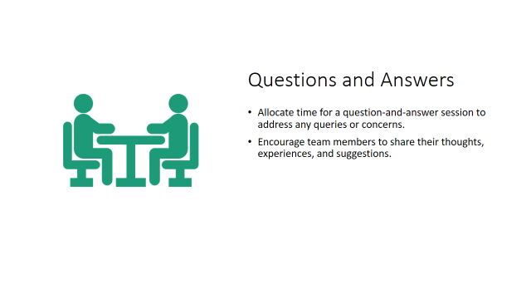
Training Notes: Allocate sufficient time for a question-and-answer session. Address any queries or concerns raised by the team. Encourage an open and interactive dialogue to foster learning and engagement
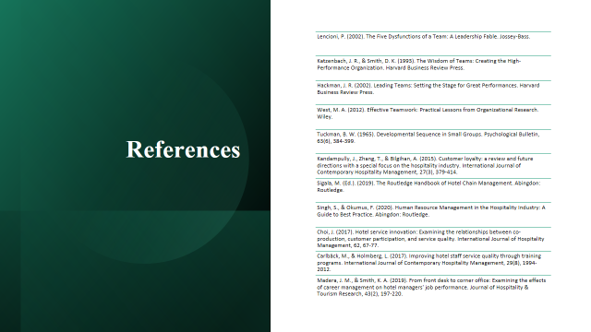

References

- Lencioni, P. (2002). The Five Dysfunctions of a Team: A Leadership Fable. Jossey-Bass.
- Katzenbach, J. R., & Smith, D. K. (1993). The Wisdom of Teams: Creating the High-Performance Organization. Harvard Business Review Press.
- Hackman, J. R. (2002). Leading Teams: Setting the Stage for Great Performances. Harvard Business Review Press.
- West, M. A. (2012). Effective Teamwork: Practical Lessons from Organizational Research. Wiley.
- Tuckman, B. W. (1965). Developmental Sequence in Small Groups. Psychological Bulletin, 63(6), 384-399.

