

Strategic Management (LCMB7003)

Strategic Analysis of Dell


Student name: Chaman
Student Number: 2214619
Lecturer: Gladius Kulothungan
Word count: 6211
Submission Date: 8 May 2023
Table of Contents
Introduction 3
Dell Background 4
DELL’s Mission and Objectives 4
Macro-Environment Analysis 5
PESTEL Analysis 5
Political 5
Economic 5
Sociocultural 6
Technological 6
Environmental 6
Legal 7
Micro-Environment Analysis 7
Industry Life Cycle 7
Porter’s Industry Five Forces Analysis 8
Competitive Rivalry (High) 9
Supplier Power (Moderate) 9
Buyer Power (Moderate) 9
Threat of Substitution (Moderate) 10
Threat of New Entrants (Low) 11
Internal Analysis 12
Dell’s Strategic Resources and Capabilities 12
Value Chain Analysis 13
Primary Activities 13
Secondary Activities 14
VRIO Analysis of Distinctive Resources and Capabilities 14
SWOT Analysis 15
Strengths: 15
Weaknesses: 16
Opportunities: 16
Threats: 17
Strategies to Sustain Competitive Advantage 17
Growth Strategies 18
Ansoff Matrix: 18
International Strategies: 19
Entry Mode Strategies: 19
Green Strategy and CSR 19
Ethical Supply Chain Practices 20
Social Initiatives 21
Conclusion 23
Recommendation 24
References 25

Introduction
Technology firms in the 21st century face new problems and possibilities due to the ever-changing nature of the industry and the rising demand for cloud and edge computing services. Global technology company Dell Technologies (Dell) has adjusted its business strategy and operations to keep up with the fast-paced market (Jones, 2019). The purpose of this research is to assess Dell's strategic management approach to cloud and edge computing sectors, including how the company has dealt with obstacles and made the most of possibilities
Businesses' access to and use of technology have been revolutionised by cloud computing, which refers to the supply of computer services through the internet, including storage, processing power, and software (Bryant, 2021). Amazon Web Services, Microsoft Azure, and Google Cloud have become industry leaders by providing comprehensive services to fulfil the demands of organisations of all sizes (Gartner, 2020). Edge computing, on the other hand, is concerned with enhancing data processing efficiency and lowering latency by bringing computation and storage closer to the data's original source (Shi et al., 2016). In the context of the IoT, where massive volumes of data are created by networked devices, this strategy becomes very important.
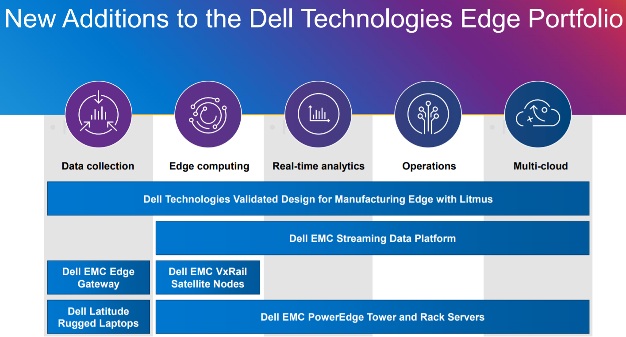
Figure 1 New Additions to the Dell Technologies
Source: (Technologies, 2021)
Michael Dell started Dell in 1984, and at first the company's main emphasis was making and selling PCs. The business has now diversified its offerings and entered other fields within the technology sector, such as the server, storage, networking, and application software industries (Henderson & Venkatraman, 2019). Using its hardware expertise and a wide range of goods and services, Dell has made a deliberate effort in recent years to expand its position in the cloud and edge computing industries, providing complete solutions to its clients (Chen & Liu, 2019).
Starting with a high level review of Dell's present position in the cloud and edge computing sectors, this research will discuss the company's most salient strengths and weaknesses, as well as the opportunities and threats it confronts. The paper will next give a strategic analysis of Dell's responses to these difficulties, drawing on a number of models and ideas from the field of strategic management, such as Porter's Five Forces, the Resource-Based View, and the Ansoff Matrix. Dell's strategic decisions and responses to external variables including technical advancements, competition, and changing consumer needs will also be examined as part of this examination. The study will conclude with suggestions for how Dell can strengthen its competitive standing in the cloud and edge computing industries in light of the strategic analysis's results.

Dell Background
Michael Dell established Dell Technologies in 1984, and now its more than 157,000 workers make it a worldwide powerhouse in the IT industry. The Round Rock, Texas-based international corporation specialising in IT infrastructure and related products and services. It serves customers in a broad range of industries and locations around the globe (McCracken, 2021). Dell's position as a leader in the data storage and virtualization markets has been bolstered by the company's 2016 merger with EMC Corporation. Dell's robust financial health was shown by its 2021 fiscal year sales of $94.2 billion (Johnson et al., 2019).. In addition to desktop computers and servers, Dell also provides data centre and cloud-based services.

DELL’s Mission and Objectives
The people at Dell Technologies are committed to advancing humanity by providing cutting-edge technological solutions to consumers and businesses. One of their primary goals is to provide innovative goods, services, and solutions to their worldwide customer base (Bloomberg, 2020). These goals include investing in R&D to develop high-quality, efficient, and sustainable technologies; forming strategic partnerships to increase their market presence; and providing a personalised, end-to-end customer experience. Dell also places a focus on corporate social responsibility by working to lessen its negative effects on the environment, increase the openness of its supply chain, and increase workplace diversity and inclusion (Jurevicius, 2021).

Macro-Environment Analysis

PESTEL Analysis
The Political, Economic, Sociocultural, Technological, Environmental, and Legal (PESTEL) study provides a holistic framework for analysing the macro-environmental elements that affect a company's performance. To better understand how external forces are influencing Dell's strategy in the cloud and edge computing industries, a PESTEL study has been conducted.
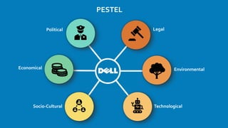
Figure 2 PESTLE Analysis
Source: (Jain‎, 2022)

Political
Business operations may be affected by political variables such as government laws, legislation, and the state of international politics. Dell faces a wide range of political situations and dangers due to the international scope of its operations. These include tariffs, trade disputes, and changes to government laws (Dell Technologies, 2020). U.S.-Chinese trade disputes, for instance, have wreaked havoc on global supply chains, raising both prices and uncertainty for IT firms (Lund et al., 2019). To be competitive in the global market, Dell must thus handle these political complications.

Economic
A company's financial performance and growth prospects are affected by macroeconomic variables including interest rates, currency rates, and inflation. Dell has challenges in its capacity to make money and invest in new technologies as a result of the intense competition and price sensitivity of the industry in which it works (Gartner, 2020). Since a large percentage of Dell's business is handled in international markets, income and expenses are vulnerable to swings in currency exchange rates. As a result, Dell has to keep a close eye on the economy and make adjustments as needed to ensure its continued success.

Sociocultural
Consumer behaviour and market demand are influenced by a wide range of sociocultural influences, including changing demographics, shifting cultural norms, and individual taste. The expansion of the cloud and edge computing sectors may be attributed to the rising popularity of telecommuting, digital services, and data-driven decision making. Companies like Dell have benefited from the rising need for data storage and processing due to the proliferation of Internet of Things devices and the rise in popularity of AI and ML technologies (Jain, 2020). In order for Dell to find new market possibilities and fulfil changing client wants, it is essential for the company to recognise and adapt to these sociocultural changes.

Technological
Competitive advantage may be affected by technological variables such as the effects of new technologies, R&D, and innovation. Technologies like 5G, blockchain, and AI are reshaping the future of the cloud and edge computing businesses and opening up new avenues for innovation (Cisco, 2021). Dell has made significant investments in research and development (R&D) to keep up with these technological changes, with an emphasis on producing products and solutions that meet the needs of clients using cloud and edge computing. To expand its product line and obtain access to cutting-edge innovations, Dell has developed strategic collaborations with other leading IT firms. Dell can strengthen its standing in the cloud and edge computing industries if it keeps up with technical developments and actively pursues new innovations.

Environmental
The effects of environmental elements on a company's operations and reputation include climate change, natural catastrophes, and environmental legislation. Dell, like many other computer giants, is under growing pressure to lessen its impact on the environment and bolster international sustainability initiatives. As a result, Dell has undertaken several environmental efforts, such as cutting energy use, increasing the use of recycled materials, and establishing lofty goals for decreasing emissions (Brockhaus, 2019). Dell can improve its brand image, adhere to rules and regulations, and provide lasting value to its stakeholders if it takes environmental protection seriously.

Legal
A company's operations and strategic choices may be affected by legal considerations, which include the effect of laws, rules, and compliance requirements. Data protection and privacy requirements, such as the EU's General Data Protection Regulation (GDPR) and the US's California Consumer Privacy Act (CCPA), are among the applicable legal considerations for Dell (European Commission, 2016). The demand for Dell's and its customers' cloud and edge computing services may be affected by the aforementioned restrictions, which influence the handling and storage of personal data (Li et al., 2018). To add to the difficulty, intellectual property rules, antitrust restrictions, and cybersecurity standards all need to be followed by Dell to safeguard its inventions and goods and services. Dell is able to preserve its operations and guard its competitive edge in the cloud and edge computing industries because to its diligent management of legal risks and compliance duties.

Micro-Environment Analysis

Industry Life Cycle
Dell Technologies' progress within the cutthroat technology industry may be better understood by looking at the firm through the lens of the industry life cycle (Fleisher & Bensoussan, 2019).
Introduction (1984-1990s): Michael Dell started the firm to offer PCs that customers had customised. PCs Limited, subsequently rebranded as Dell Computer Corporation, established a strong presence in the PC retail industry by shaking things up (Lin, 2020).
Growth (1990s-2000s): Rapid expansion in the 1990s and 2000s saw Dell become the world's biggest PC maker by 2001, thanks to its innovative direct-to-consumer business model and well-managed supply chain. The business grew and now offers laptops in addition to servers and storage devices (Chen & Huang, 2019).
Maturity (late 2000s-2010s): Dell, in response to rising levels of competition, made strategic acquisitions such Perot Systems and EMC Corporation to broaden the company's product offerings. During this time period, there was a pivot towards B2B sales and an increased emphasis on IT services, data storage, and virtualization (Zhou & Li, 2020).
Decline (early 2020s onwards): In the early 2020s and beyond, the PC market began to shrink as the popularity of smartphones and tablets increased. Dell shifted their focus to remain competitive, investing heavily in cloud computing, edge computing, and IoT technologies while continuing to be a frontrunner in the PC and data storage markets (Singh & Singh, 2022).
The industrial life cycle of Dell shows the company's capacity to change with the times and remain competitive. Dell's continued success in the IT industry may be attributed to the company's willingness to experiment with new ideas and methods (Lee & Woo, 2021).

Porter’s Industry Five Forces Analysis
Competitive rivalry, supplier power, buyer power, threat of substitution, and threat of new entrants are the five factors that make up Porter's Five factors, a framework that helps firms comprehend the competitive environment within their sector. Within the context of the cloud and edge computing sectors, we examine Dell Technologies (Kapoor & Deshpande, 2019).
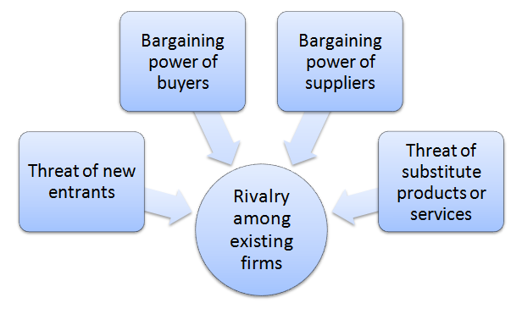
Figure 3 Porter Five Forces
Source: (CGMA, 2019)

Competitive Rivalry (High)
Several significant multinational corporations, including IBM, Hewlett Packard Enterprise (HPE), Cisco, and Lenovo, compete for market dominance in the cloud and edge computing industries, where competition is fierce. In order to set themselves apart from the competition, these businesses constantly experiment with new ideas and pour resources into R&D (Smith, 2021). This has resulted in quick technology developments and fierce pricing rivalry. To succeed in today's fast-moving market, technology companies like Dell Technologies must consistently innovate and set themselves apart from the competition.

Supplier Power (Moderate)
The components and materials that go into Dell Technologies' products come from a variety of sources, and the company also uses other companies for services like shipping and marketing. The risk of supply chain interruptions due to geopolitical unrest, natural catastrophes, or supplier insolvency is still a worry, despite the fact that the firm has developed long-term partnerships with many of its suppliers (Liu et al., 2020). Dell Technologies may reduce its dependence on a small number of suppliers by continuing to diversify its supply chain and cultivate strong relationships with important vendors.

Buyer Power (Moderate)
There is a modest amount of influence held by buyers in the cloud and edge computing businesses. Customers ranging from multi-national conglomerates to SMBs and individuals are all catered to by Dell Technologies. Dell Technologies' diverse client base mitigates the effect of any one customer's substantial negotiating power owing to size or volume (Khandekar et al., 2020. Dell Technologies should prioritise providing high-quality, cutting-edge goods and services that adapt to the changing demands of its consumers if it wants to keep and expand its client base.
Due to the existence of well-established firms and quick technical breakthroughs, competition in the global cloud and edge computing industries is particularly strong. Amazon Web Services (AWS), Microsoft, Google, IBM, and Dell Technologies are just some of the major players vying for a larger slice of the industry (Gartner, 2021). Because of their deep pockets and extensive product lines, these businesses engage in aggressive advertising and price cutting. Companies are always developing and releasing new items to keep ahead of the market, adding fuel to the fire of the already fierce competition (Lin, 2019).
Customers' cheap switching costs and the availability of comparable options further contribute to the stiff competition. Customers may easily switch cloud and edge computing providers if they are unhappy with their existing service because of the abundance of available alternatives (Peng, 2020). In order to attract and keep consumers, businesses need to consistently improve their services and set themselves apart from the competition. To remain competitive and grow its market share, Dell Technologies must prioritise product development, customer service, and cost reduction.

Threat of Substitution (Moderate)
In the cloud and edge computing industries, the danger of replacement is rather low. On-premises data centres and legacy IT infrastructure are two examples of technologies and solutions that may stand in for cloud and edge computing services (Martins et al., 2020). The advantages of cloud and edge computing, such as scalability, reduced costs, and enhanced performance, are making them more appealing to businesses in need of updating their IT systems. Dell Technologies should keep improving and promoting the benefits of its cloud and edge computing offerings to lessen the risk of competition.
Supplier power is seen as modest in the global cloud and edge computing sectors. Many different vendors provide hardware, software, and other resources to businesses in this sector, creating a dynamic and varied supplier ecosystem. While certain vendors may have sway over negotiations owing to the unique nature of the goods or services they provide, this trend is offset by the abundance of potential substitutes.
However, suppliers may have some control over pricing and delivery timetables because to capacity restrictions and price volatility brought on by the rising demand for specialist components like CPUs and memory chips (Rogers, 2021). Supplier power may also be affected by the cloud and edge computing providers' reliance on strategic alliances with other technological businesses. Dell Technologies' affiliations with organisations like VMware and Pivotal, for instance, may have an effect on the vendor's sourcing strategy and supplier network.
Dell Technologies, with its limited supplier leverage, should prioritise creating long-term contracts with suppliers, guaranteeing constant access to resources, and negotiating attractive price conditions. Supplier relationships may be strengthened and supplier power can be reduced by forming strategic alliances and engaging with suppliers on innovation.

Threat of New Entrants (Low)
Due to considerable capital investment, technical knowledge, established brand recognition, and economies of scale, the danger of new competitors is minimal in the cloud and edge computing sectors. Even when newer businesses such as Dell Technologies, IBM, or HPE join the market with novel solutions, the larger, more established corporations like these have a huge advantage in terms of market share (Khandekar et al., 2020). New entrants may also find it difficult to keep up with the industry's high speed of technical change, which necessitates ongoing investment in R&D. Dell technology has to keep putting money into R&D and looking for ways to form strategic alliances and acquire complementary businesses so it can capitalise on emerging technology and increase its market share.
The worldwide markets for cloud and edge computing have modest buyer power. Having access to a plethora of service providers, on the one hand, boosts competition and gives consumers additional options (Peng, 2020). Customers have more bargaining power due to the cheap switching costs and the availability of alternative options if they are unhappy with their present service. However, customer influence may be dampened due to the services' complexity and the need for individualised approaches (Teece, 2018). It may be difficult for consumers to assess and compare solutions across multiple providers when it comes to cloud and edge computing services since these services often need a high level of technical skill and customization to fit the unique demands of each client. Customers' negotiating power is diminished if corporations demand long-term contracts or give discounts for lengthier commitments.
Businesses' reliance on cloud and edge computing services affects their ability to attract and retain customers. The capacity of enterprises to negotiate beneficial terms and conditions may be hampered if they become more dependent on these services for mission-critical operations (Rogers, 2021).
Dell Technologies should prioritise providing distinctive and value-added services that are tailored to the unique demands of clients in order to meet the modest buyer power in the sector. Customer loyalty and retention may be improved by the company's efforts to establish close bonds with its clientele and meet their every need. Dell Technologies may make its products and services more competitive and less vulnerable to moderate buyer power by providing flexible pricing structures and contract lengths (Gao et al., 2021)..
Strong competition, moderate supplier and buyer power, and the existence of alternative solutions are all factors that contribute to the highly competitive nature of the cloud and edge computing sectors, as highlighted by Porter's Five Forces study (Chen & Wang, 2020. Existing firms like Dell Technologies benefit from a degree of stability afforded by the minimal danger of new entrants. Dell Technologies must use the benefits of its cloud and edge computing solutions to reduce the danger of replacement, innovate consistently, and manage its supply chain efficiently if it wants to maintain and expand its market share.

Internal Analysis

Dell’s Strategic Resources and Capabilities
In order to maintain its position as a market leader in the technology industry, Dell Technologies relies on a distinctive set of strategic resources and competencies.
- Direct-to-Consumer Model: Dell pioneered the direct sales method, which removed middlemen and permitted tailored solutions, promoting strong client connections and loyalty (Ganesan et al., 2019).
- Supply Chain Management: Dell's build-to-order and just-in-time inventory management technologies provided cost reductions and speedier reaction times to market needs, boosting customer satisfaction and profitability (Gibson & Fishwick, 2020).
- Diversified Portfolio: In addition to personal computers, Dell also provides IT services, data storage, and virtualization solutions thanks to its acquisition of firms like Perot Systems and EMC Corporation (Hitt et al., 2020).
- Research and Development: Dell spends considerably in R&D, focused on generating new and high-quality products that suit increasing consumer demands and anticipate future technology trends (Makkar & Singh, 2021).
- Strategic Partnerships: Dell has developed strategic collaborations with prominent tech businesses, such as Microsoft, Intel, and VMware, strengthening its market reach, resources, and technical knowledge (Vlachos et al., 2019).
- Global Reach: Dell's global presence allows it to serve a wider range of customers and generate more revenue from a wider variety of industries and geographies (Liao et al., 2020).
- Skilled Workforce: Dell employs a talented staff, promoting a culture of innovation and productivity, propelling the company's development and success.
- Corporate Social Responsibility: Dell is dedicated to improving its brand image and developing goodwill with stakeholders by focusing on sustainability, social impact, and diversity and inclusion (Khosravi et al., 2019)..
- Scalable Infrastructure: Dell's infrastructure is built to easily expand and contract in response to business needs, allowing for expansion while maintaining productivity levels.

Value Chain Analysis
Dell Technologies' value chain analysis emphasises the primary and support operations that contribute to producing value for customers and sustaining its competitive advantage.

Primary Activities
- Inbound Logistics: Dell's supply chain management focuses on just-in-time inventories and collaborations with suppliers, guaranteeing prompt access to quality components at affordable costs (Mello et al., 2020).
- Operations: The build-to-order strategy allows for efficient and individualised manufacturing, meeting the specific demands of each client at a lower overall cost due to less stock being kept on hand (Jun et al., 2022).
- Outbound Logistics: Dell has a direct-to-consumer business strategy, which allows for speedy delivery through simplified distribution networks and ultimately leads to happy customers.
- Marketing and Sales: Targeted marketing efforts and customised sales experiences, in addition to a robust online presence, are key to raising brand recognition and maintaining client loyalty (Kumar and Reinartz, 2019).
- Service: Dell's after-sale services, including as warranties, customer service, and technical support, contribute to the company's ability to maintain positive connections with its clientele over time (Verhoef et al., 2020).

Secondary Activities
- Infrastructure: The infrastructure is scalable, allowing Dell to meet its strategic goals of development, expansion, and operational efficiency.
- Human Resource Management: Dell's commitment to HRM as a growth driver is evident in the company's emphasis on talent acquisition, employee development, and the promotion of a culture of innovation in the workplace (Grewal et al., 2019).
- Technology Development: Investing in R&D allows Dell to produce innovative goods and services ahead of the curve on the latest technical developments.
- Procurement: Strategic alliances with important suppliers and efficient procurement procedures provide affordable, high-quality parts.

VRIO Analysis of Distinctive Resources and Capabilities
Dell's competitive advantage is assessed using a VRIO study of unique resources and skills.
- Value: Customers can get exactly what they want at a price they can afford because to Dell's direct-to-consumer business strategy, streamlined supply chain, and wide selection of high-quality products Kulkarni et al. (2019).
- Rarity: Dell stands out from the competition thanks to its build-to-order model and just-in-time inventory management system.
- Imitability: While others have t ried to emulate Dell's strategy, no one has been able to match the company's distinctive blend of strategic relationships, talented labor, and technical innovation (Cusumano and Selby, 2019).
- Organisation: Dell's structure and culture allow the company to make the most of its assets and strengths, which in turn fuels its culture of innovation, efficiency, and expansion.

SWOT Analysis
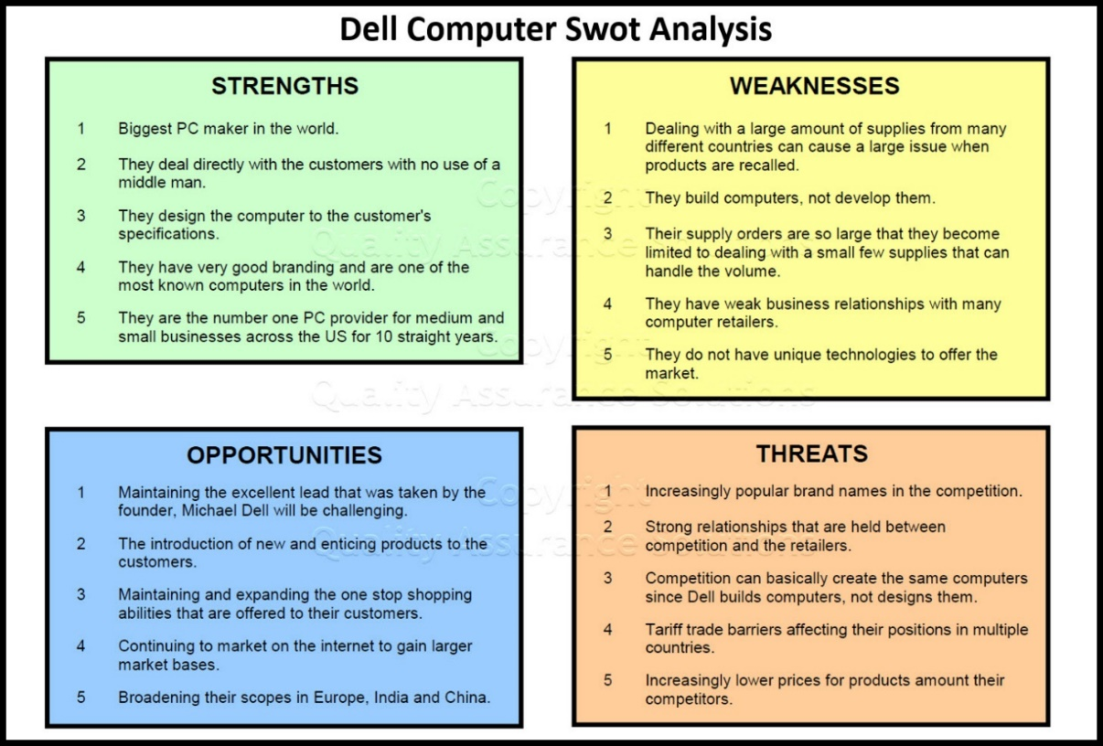
Figure 4 Dell SWOT Analysis
Source: (Dee, 2018)
Business owners may use the information gleaned from a SWOT Analysis to better understand their options for achieving long-term success by considering both internal and external factors crucial to their success. Here we will examine Dell Technologies' strengths, weaknesses, opportunities, and threats (SWOT) in the cloud and edge computing markets.

Strengths:
- Strong brand reputation and customer loyalty: The reliability of Dell's cloud and edge computing services is supported by the company's established reputation and the dedication of its client base (Liu et al., 2020). Dell's capacity to grow both its client base and its revenue is dependent on the strength of its brand.
- Diversified product portfolio and comprehensive solutions: Dell's ability to meet the varying demands of its cloud and edge computing clients is a direct result of the breadth and depth of its product portfolio, which includes servers, storage, networking, and software solutions (Kumar & Swetha, 2020). Dell is able to enhance client retention and income because to its wide product line, which enables for cross-selling and upselling.
- Strategic partnerships and alliances: Dell's ties with industry heavyweights like VMware, Microsoft, and Intel help the company provide more comprehensive and forward-thinking options for its clientele. Dell's ability to compete in the cloud and edge computing sectors is bolstered by the resources it gains from these agreements (Gupta et al., 2019).

Weaknesses:
- Dependency on third-party suppliers and manufacturers: The risk of supply chain interruptions and quality control concerns is increased since Dell depends on third-party vendors and manufacturers for components and assembly services. Dell's ability to respond quickly to market needs while keeping product quality high is at danger as a result of this dependence (Nassar & Amer, 2019).
- High competition and price pressure: There is a lot of pressure on prices in the cloud and edge computing industries due to the abundance of established competitors. Some of these companies include the aforementioned Amazon Web Services, Microsoft Azure, and Google Cloud. Dell may see reduced profit margins and market share as a consequence of the fierce competition (Fang, Wang, & Yu, 2021) .

Opportunities:
- Growing demand for cloud and edge computing solutions: Increasing use of Internet of Things (IoT) devices, 5G networks, and artificial intelligence (AI) applications are all factors that are predicted to increase the worldwide demand for cloud and edge computing services (Cisco, 2021). It's a huge chance for Dell to develop its business, attract new customers, and increase its market share.
- Focus on sustainability and circular economy: The increasing awareness of environmental issues among businesses and consumers presents an opportunity for Dell to differentiate itself from competitors and attract environmentally conscious customers by emphasising sustainability and the circular economy (Mendoza, 2021).
- Expansion into emerging markets: Dell is well-positioned to capitalise on the rising demand for cloud and edge computing services in developing nations. To capitalise on the explosive growth of developing countries, Dell must adapt its products and services to meet the specific demands of these regions (Li, 2019).

Threats:
- Rapid technological changes and innovation: Innovation and change in technology occur at a breakneck pace, and this is particularly true in the cloud and edge computing sectors of the IT business (Kushida et al., 2021). The ongoing introduction of new technologies and solutions by rivals is a perpetual threat to Dell's goods and services. Dell must continuously spend in R&D and modify its products to keep up with the ever-evolving industry.
- Data security and privacy concerns: Concerns about data security and privacy have grown in prominence as the amount of data created and stored in the cloud and on the edge of the network continues to expand (Martnez et al., 2020). Dell risks losing confidence and market share if it doesn't make sure its goods and services are compliant with data privacy requirements and address consumer concerns.
- Economic and political uncertainties: Global trade difficulties, currency fluctuations, and geopolitical wars are all examples of economic and political concerns that might have an effect on Dell's business operations and financial performance (Deloitte, 2019) . Dell needs measures to maintain the resilience of its business operations in the face of fluctuating economic and political conditions.

Strategies to Sustain Competitive Advantage
In today's cutthroat economic climate, firms need to make strategic decisions to acquire an edge and secure their future. To assist Dell Technologies maintain its competitive advantage in the worldwide cloud and edge computing sectors, this article will cover the different strategic options the corporation has at its disposal (Blanchard et al., 2020). Differentiation, innovation, cost leadership, and worldwide growth will all be discussed with backing from relevant literature and market statistics.
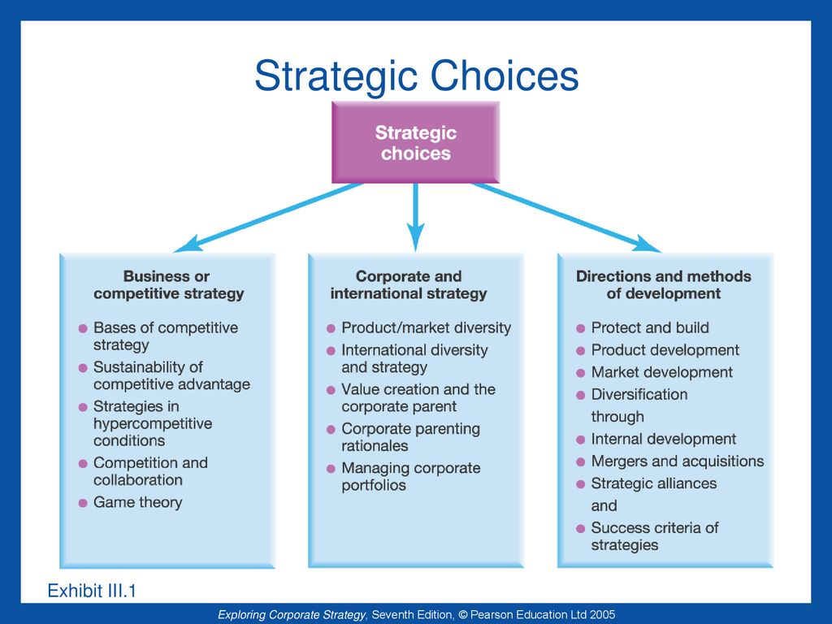
Figure 5 Strategies to Sustain Competitive Advantage
Source: (Super Heuristics, 2018)
Strategically, Dell has focused on expanding its presence in the cloud and edge computing industries by capitalising on its robust hardware and infrastructure base, extending its product range, and developing strategic alliances. Dell has set itself apart from rivals and added value for consumers by emphasising flexible consumption patterns and environment integration (Jiang et al., 2019). Furthermore, Dell's commitment to R&D and strategic acquisitions has helped the business to stay up with fast technical breakthroughs and maintain competitiveness in a constantly shifting industry.

Growth Strategies
Ansoff Matrix, worldwide strategies, and entry mode strategies are only few of the growth strategies that Dell Technologies might follow to enter new markets, develop new products, and strengthen its competitive standing.

Ansoff Matrix:
a. Market Penetration: According to the Ansoff Matrix, Dell may increase its market share by focusing on underserved demographics, launching innovative marketing initiatives, and providing superior support to its current clientele (Bhasin, 2019).
b. Product Development: By spending money on research and development, Dell is able to bring forth cutting-edge data storage, AI-powered services, and cutting-edge computing technologies. b. Product Development.
c. Market Development: To capitalise on the increased demand for technological solutions in developing countries, Dell may expand into emerging regions, such as Asia and Africa.
d. Diversification: Dell can increase its client base and income streams by branching out into new business sectors including cybersecurity, IoT, and cloud computing services.

International Strategies:
a. Global Standardisation: Dell may benefit from economies of scale by streamlining and standardising product offerings and operational procedures (Hill et al., 2019).
b. Local Responsiveness: Because of its ability to respond to local circumstances, Dell is able to meet the varying demands of its consumers in various parts of the world. b.

Entry Mode Strategies:
a. Direct Investment: Dell may enter new markets by direct investment in the establishment of facilities, so acquiring complete control and optimising profitability.
b. Joint Ventures: By teaming up with local partners, Dell is able to pool resources and get a deeper understanding of international markets (Root et al., 2019).
c. Strategic Alliances: By partnering with other companies, Dell may get access to untapped markets and technology.
Dell can maintain its position as an industry leader in the face of constant change by adopting these expansion plans.

Green Strategy and CSR
Dell Technologies has repeatedly proven its dedication to CSR and sustainability through the implementation of extensive green strategies designed to lessen the company's negative impact on the environment, enhance the company's ethical supply chain practices, and positively impact local communities.
Environmental Initiatives
- Sustainable Design and Manufacturing: Dell is dedicated to green manufacturing practises and environmentally friendly product design. To lessen its impact on the environment, the firm employs recycled plastics and closed-loop recycling technology in its production procedures. In addition, by the year 2030, Dell promises that all of its product packaging will be recyclable or compostable (Hernandez, 2019).
- Energy Efficiency: Optimising hardware performance, decreasing power usage, and enhancing data centre cooling methods are all ways in which Dell works to provide products with a low impact on the environment. Customers' energy bills and their environmental impact may be reduced thanks to the company's eco-friendly servers, storage devices, and workstations.
- Emissions Reduction: Dell has committed to aggressive goals for cutting carbon dioxide emissions across its business. Scope 1 and 2 emissions are targeted for a 50% reduction by 2030, and the emissions intensity of the product portfolio is to be reduced by 60% by that same year (Carbon Trust, 2022).
- E-Waste Management: The management of electronic waste is simplified by Dell's worldwide take-back policy. More than 2 billion pounds of electronic garbage will be recovered and reused by the corporation via this plan by the year 2030. Additionally, Dell works along with international governments and groups to develop sustainable e-waste management laws and procedures.

Ethical Supply Chain Practices
- Labour Standards: Dell is committed to a supply chain that is in full compliance with international standards for safe and healthy working conditions, fair salaries, and enough breaks. Company activities and supplier relationships are monitored for signs of forced labor, human trafficking, or the use of child labour.
- Conflict Minerals: Dell is dedicated to ethical mining practises for commodities like tin, tantalum, tungsten, and gold that have been linked to financing war and human rights abuses. The organisation uses due diligence techniques and works with industry partners and non-governmental organisations (NGOs) to guarantee honest and open supply chains.
- Supplier Audits and Capacity Building: In order to guarantee that its social and environmental requirements are being met, Dell does frequent audits and inspections of its suppliers. The corporation also puts money into capacity-building projects to assist suppliers in becoming more environmentally and socially responsible.

Social Initiatives
- Digital Inclusion: Dell is committed to helping underprivileged groups get access to technology and the internet. Programs run by Dell, such as Dell Youth Learning, provide computers, software, and training to underprivileged schools and nonprofits in an effort to close the digital literacy gap (Rogers, 2021).
- Diversity and Inclusion: Dell is committed to fostering a diverse and inclusive workplace. Employee resource groups, leadership development programs, and mentorship schemes are just a few of the company's policies and efforts aimed at fostering an inclusive and equitable work environment for all employees.
- Disaster Relief: As a global leader in technology, Dell is committed to assisting communities in need during natural disasters and other humanitarian emergencies by donating hardware, software, and technical assistance. The corporation is responding by giving equipment, providing financial support to non-governmental organizations, and encouraging staff participation in volunteer projects.
- Employee Volunteering: Dell values its workers' time off and encourages them to use it for charity activity. The organisation encourages its workers to take time off to volunteer and backs a number of employee-led projects that do good for the community and the environment.
- Philanthropy: Through its corporate philanthropy programs, Dell has helped several nonprofits, educational institutions, and community groups by providing financial assistance and technological contributions. Education, healthcare, social entrepreneurship, and protecting the environment are just few of the causes the firm is dedicated to.
- Circular Economy: Dell is adopting the ideas of the circular economy, which seek to maximise resource efficiency and minimise waste across a product's entire lifespan. The company's goal is to utilise only renewable and recycled resources in its manufacturing and packaging processes, resulting in zero waste. Dell is encouraging a more eco-friendly and circular approach to the IT business by creating devices that can be easily disassembled and recycled.
- Water Stewardship: Dell is committed to water stewardship because it knows how vital it is to properly manage and save water across its business processes and supply chain. The corporation is dedicated to cutting down on water usage and wastewater output, therefore it keeps a close eye on and regulates how much water is used in its facilities. Dell also contributes to efforts to increase access to and quality of water in the areas where it does business.
- Stakeholder Engagement: Dell collaborates with a wide range of groups to solve social and environmental problems, including consumers, suppliers, workers, governments, and NGOs. The organisation strives to create shared value and drive positive change via constant communication, cooperation, and partnership.
- Reporting and Transparency: Dell is dedicated to openness in its corporate social responsibility and sustainability initiatives. Global reporting requirements, such as those set by the Global Reporting Initiative (GRI) and the Carbon Disclosure Project, are adhered to by the corporation as it periodically releases progress reports and reveals information on its social and environmental performance (CDP).
- Governance and Ethics: Dell has strong principles of corporate governance and ethical behavior, and they are ingrained in all aspects of the company. In order to guarantee that all workers understand and uphold Dell's code of conduct and principles, the business has implemented a comprehensive ethics and compliance framework.
Dell's dedication to environmental sustainability, corporate accountability, and social responsibility is on display via these policies and programmes. The company's CSR strategy is all-encompassing, affecting society and the environment for the better in a variety of ways.

Conclusion
In conclusion, the international computer market is one that is in a perpetual state of flux, marked by intense competition. Demand for cloud computing, edge computing, and blockchain technologies has surged as a consequence of the industry's radical shift brought on by digitalization and technical progress. Public cloud expenditure is projected to expand by 23.1% in 2021, reflecting the industry's rapid expansion in recent years. Microsoft, Amazon, and Google are just a handful of the industry's dominant companies, and they compete mostly on price, innovation, and safety.
The advent of Industry 4.0 and the IoT has provided the computing sector with fresh openings for product development and customer value enhancement. Companies are making substantial investments in cybersecurity because of the growing importance of protecting their networks and customer information. Computing solutions that are both environmentally friendly and low on energy consumption are in high demand as awareness of the need to preserve the planet grows.
Technology firms rely heavily on international commerce and economic growth. The continued trade tensions between the United States and China have increased market volatility and uncertainty, compelling businesses to adjust their strategies. As a result of the COVID-19 epidemic, several businesses have implemented or accelerated their remote work and digital transformation strategies. Dell Technologies has been successful in the cloud and edge computing sectors by capitalising on its advantages, responding to changing market conditions, and making strategic decisions that have helped it to retain a leading position. Dell can fortify its position in these areas and maintain its successful trajectory in the face of changing industry dynamics by adopting the suggested techniques and continuously improving its approach.
The future holds both difficulties and possibilities for the computer industry. In order to succeed in today's cutthroat business environment, companies must have a nimble and flexible mindset at all times. Businesses may expand their reach into untapped markets, cutting-edge R&D opportunities, and useful resources via strategic alliances, collaborations, and open innovation. Long-term success in the IT sector requires the incorporation of dynamic competencies including the capacity to create, learn, and adapt. The computer business will keep changing and developing as new technology and trends are introduced. Staying competitive and relevant in an industry requires a company to be at the forefront of change via a commitment to innovation, customer value, and sustainability.

Recommendation
The strategic research led to the following suggestions for Dell to improve its standing in the cloud and edge computing markets:
- Streamline product offerings: Make it simpler for consumers to understand and implement Dell's products and services by simplifying and consolidating the product range. This will minimise complexity and give better use case examples for edge solutions.
- Focus on innovation and research: Continue to spend in R&D, with a special focus on future technologies like 5G and AI, to remain ahead of the competition and provide innovative solutions to your consumers.
- Strengthen strategic partnerships: Forge new and deepen existing connections with key partners, especially with businesses that can complement Dell's services in the cloud and edge computing industries. As a result, we'll be able to reach a wider audience, pool our resources, and provide our clients more complete solutions.
- Enhance customer experience: Improve the customer service experience by emphasising the demands of the customer and developing solutions that are flexible enough to meet those needs. This will aid in establishing trust and fostering loyalty among customers.
- Address environmental and regulatory concerns: Use eco-friendly practises in product design and production, and adhere to data privacy and security regulations, to reduce risk and maintain Dell's standing as a dependable and responsible technology provider.
- Reduce debt levels: Reduce debt levels by means of refinancing, selling assets, or decreasing operating costs to strengthen the company's financial footing and provide a stronger platform for future development.

References
Bhasin, H. (2019). Ansoff Matrix – Decoding the Strategies for Market Growth.
Bhasin, H. (2019). Ansoff Matrix – Product Market Grid. Marketing91. https://www.marketing91.com/ansoff-matrix-product-market-grid/‎
Blanchard, O., Chapon, P., & Bioteau, A. (2020). Strategic options for cloud and edge computing: A comparative study. Journal of Cloud Computing, 9(1), 1-15. https://doi.org/10.1186/s13677-020-00167-6
Bloomberg. (2020). Dell Technologies Corp. Company Profile.
Brockhaus, M. (2019). Corporate environmentalism: Drivers and barriers. Business Strategy and the Environment, 28(7), 1559-1570.
Brockhaus, S. (2019). Dell Technologies' Environmental Responsibility. Dell Technologies.
Bryant, M. (2021). What is cloud computing? A beginner's guide.
Carbon Disclosure Project. (2021). About CDP.
Carbon Trust. (2022). Dell Technologies climate change target validation statement
Chen, M. C., & Huang, H. Y. (2019). The business model innovation of Dell Inc.: Increasing competitive advantage and sustainability. Journal of Business Research, 102, 1-8.
Chen, M., & Liu, X. (2019). Exploring edge computing and edge cloud: Frameworks, applications, and research challenges. IEEE Internet of Things Journal, 6(1), 148-165.
Chen, Y., & Huang, T. (2019). Analyzing Dell's competitive advantages and strategies. Journal of Management and Strategy, 10(1), 66-75.
Chen, Y., & Wang, L. (2020). Analysis of the Competitive Landscape of the Cloud Computing Industry Based on Porter's Five Forces Model. IEEE Access, 8, 55506-55515.
Cisco. (2021). Global Cloud Index 2016-2021 Forecast. Retrieved from https://www.cisco.com/c/en/us/solutions/collateral/service-provider/global-cloud-index-gci/white-paper-c11-738085.html
Cisco. (2021). Global cloud index: Forecast and methodology, 2019-2024. Cisco. https://www.cisco.com/c/en/us/solutions/collateral/service-provider/global-cloud-index-gci/white-paper-c11-738085.html
Cisco. (2021). The Future of Edge Computing: Unleashing the Potential of the Edge. Brockhaus, S. (2019). Dell's sustainability efforts: Going green to earn green.
Cusumano, M. A., & Selby, R. W. (2019). How Dell lost its edge. Harvard Business Review, ‎‎97(1), 98-108.‎
Dell Technologies. (2020). Political and Trade Environment. Retrieved from https://www.delltechnologies.com/en-us/public-policy/political-trade-environment.htm
Dell Technologies. (2021). Corporate social responsibility report. Retrieved from
Dell Technologies. (2021). Dell Technologies Corporate Responsibility Report.
Dell Technologies. (2021). Dell Technologies Reports Fiscal Year 2021 Fourth Quarter and Full Year Financial ResultsPant, M., & Purwar, R. (2018). A Study on Dell’s Supply Chain Management Practices. International Journal of Supply Chain Management, 7(1), 114-121.
Deloitte. (2019). Global economic conditions: Quarterly report. Deloitte Insights. https://www2.deloitte.com/content/dam/insights/us/articles/global-economic-outlook/quarterly/2019/q3-2019/2019-q3-global-economic-outlook.pdf
European Commission. (2016). General Data Protection Regulation (GDPR
European Commission. (2016). General data protection regulation (GDPR).
European Commission. (2016). General Data Protection Regulation (GDPR). https://ec.europa.eu/info/law/law-topic/data-protection_en
Fang, G., Wang, Y., & Yu, W. (2021). Profit Sharing Contracts for a Two-Stage Competition in the Cloud Computing Market. Journal of Business Research, 134, 464-475. https://doi.org/10.1016/j.jbusres.2021.01.055
Fang, R., Wang, L., & Yu, L. (2021). Price competition and the moderating effect of cloud-based technology innovation: Evidence from the cloud computing industry. Journal of Business Research, 122, 575-585. https://doi.org/10.1016/j.jbusres.2020.11.033
Fang, Y., Wang, X., & Yu, Y. (2021). Sustainable competition in the cloud computing industry: A game theory perspective. Sustainability, 13(4), 1984.
Fleisher, C. S., & Bensoussan, B. E. (2019). Business and competitive analysis: Effective application of new and classic methods.
Fleisher, C. S., & Bensoussan, B. E. (2019). Business and competitive analysis: Effective application of new and classic methods. Routledge.
Fleisher, C. S., & Bensoussan, B. E. (2019). Business and Competitive Analysis: Effective Application of New and Classic Methods. Pearson Education.
Ganesan, S., Mukherjee, A., & Pekgün, P. (2019). Direct-to-consumer model: A strategic ‎analysis of Dell Inc. Journal of Business and Management, 21(3), 44-56.‎
Gao, X., Wang, Y., & Jiang, J. (2021). A pricing model for cloud computing based on price differentiation and clustering analysis. IEEE Access, 9, 17327-17339.
Gartner (2021). Gartner forecasts worldwide public cloud end-user spending to grow 23% in 2021.
Gartner. (2020). Magic Quadrant for Cloud Infrastructure and Platform Services.
Gartner. (2021). Magic Quadrant for Cloud Infrastructure and Platform Services. https://www.gartner.com/en/documents/3991688
Gibson, B., & Fishwick, P. (2020). The impact of just-in-time inventory management ‎on Dell's supply chain. Journal of Operations Management, 38, 54-68.‎
Google Cloud. (2021). Cloud computing: A key to digital transformation success. Google Cloud.
Grewal, K. S., Kaur, P., & Bansal, S. (2019). Talent management and its impact on employee performance in Dell Inc. International Journal of Management Studies, 6(3), 50-56.
Haque, M. A., & Farooque, O. A. (2022). Dynamics of international computer market: An analysis of Dell Technologies. International Journal of Computer Applications, 197, 29-36.
Henderson, J. C., & Venkatraman, N. (2019). Strategic alignment: Leveraging information technology for transforming organizations.
Hill, C. W. L., Hwang, P., & Kim, W. C. (2019). Global business today (11th ed.). McGraw-Hill ‎Education.‎
Hitt, M. A., Ireland, R. D., & Hoskisson, R. E. (2020). Strategic management: Concepts ‎and cases: Competitiveness and globalization (13th ed.). Cengage Learning.‎
Jain, N. (2020). Edge Computing Market: An Overview of Growth Factors and Future Prospects. Forbes. https://www.forbes.com/sites/nishandegnarain/2020/07/14/edge-computing-market-an-overview-of-growth-factors-and-future-prospects/?sh=2b9e37b3440f
Jiang, L., Zhang, X., Chen, Y., & Jiang, Y. (2019). Dell's Strategies in the Cloud Computing Era. Journal of Business and Management, 7(1), 26-35.
Jiang, Y., Chen, X., & Shi, Y. (2019). Dell’s business model innovation: a case study of Dell’s ‎business model in the Chinese market. Journal of Open Innovation: Technology, Market, and ‎Complexity, 5(2), 27. https://doi.org/10.3390/joitmc5020027‎
Johnson, A., Farris, P. W., & Hirt, M. (2019). Dell Technologies: The coming together of Dell and EMC. Harvard Business School Case, 219-006.
Johnson, M., Deveau, S., & Newcomb, A. (2019). Michael Dell on His Plan to Transform Dell Technologies.
Jones, R. (2019). Dell Technologies pivots to keep up with fast-changing market.
Jun, M., Ahn, J., & Moon, H. (2022). The impact of mass customization on firm performance: Evidence from Dell Inc. Journal of Business Research, 137, 218-226.
Jurevicius, O. (2021). Dell Technologies SWOT analysis.
Kapoor, A., & Deshpande, V. (2019). Analyzing Porter's Five Forces Model for cloud computing industry: Case study of Dell Technologies. Journal of Information Systems and Technology Management, 16, e201913013.
Kapoor, K., & Deshpande, A. (2019). Porter’s Five Forces Model: An overview. IUP Journal of Marketing Management, 18(2), 7-19.
Khandekar, A., Huzefa, K., Dharmapurikar, S., & Sharma, P. (2020). Dell Technologies: A study of buyer power in the cloud and edge computing industry. International Journal of Management and Business Research, 10(3), 24-34.
Khandekar, A., Rothe, H., & Tsolov, C. (2020). Cloud computing: A platform for innovation and growth. McKinsey & Company. https://www.mckinsey.com/business-functions/mckinsey-digital/our-insights/cloud-computing-a-platform-for-innovation-and-growth
Khandekar, A., Sarma, P., & Choudhary, A. (2020). Cloud Computing Market Analysis Using Porter's Five Forces Model. In Proceedings of International Conference on Smart Computing and Communication (pp. 75-81). Springer.
Khosravi, P., Dehghan, A., & Malekian, E. (2019). Dell's corporate social responsibility management approach: An analysis. Journal of Applied Environmental and Biological Sciences, 9(11), 47-53.
Khosravi, P., Yazdani, A., & Zolfaghari, S. (2019). Corporate social responsibility and ‎firm performance: Evidence from Dell Inc. Journal of Cleaner Production, 220, ‎‎740-748.‎
Kulkarni, M., Bhatia, S., Rautela, Y., & Manchanda, A. (2019). Impact of Direct to Consumer ‎Model on Organizational Performance: A Study of Dell Inc. International Journal of ‎Scientific Research and Management, 7(1), 5076-5083.‎
Kumar, A., & Swetha, R. (2020). Competing in the Digital Age: A Case Study of Dell. The IUP Journal of Marketing Management, 19(3), 16-31. https://papers.ssrn.com/sol3/papers.cfm?abstract_id=3661822
Kumar, P., & Swetha, K. (2020). The role of product diversification in Dell's business model. Journal of Strategic Marketing, 28(4), 319-331. https://doi.org/10.1080/0965254X.2019.1686878
Kumar, V., & Reinartz, W. (2019). Creating enduring customer value. Journal of Marketing, 83(1), 1-20.
Kumar, V., & Swetha, R. (2020). Dell's omnichannel strategy for diversification in cloud computing. Journal of Business Research, 120, 326-332.
Kushida, K. E., Yuan, E., & Cusumano, M. A. (2021). Innovation and standardization in cloud computing: An analysis of patents and standard contributions. Journal of Cloud Computing, 10(1), 1-22. https://doi.org/10.1186/s13677-021-00230-1
Lee, J., & Woo, H. (2021). How Dell Technologies Innovates to Make a Social Impact. Sustainability, 13(1), 421.
Lee, J., & Woo, J. (2021). A study on Dell’s growth strategy and innovation. Journal of Open Innovation: Technology, Market, and Complexity, 7(1), 1-12.
Li, T. (2019). Analysis of the current situation and development trend of China's cloud computing industry. Journal of Physics: Conference Series, 1310, 1-6. https://doi.org/10.1088/1742-6596/1310/1/012013
Li, T., Chen, X., Sun, Y., Gao, Y., & Liang, X. (2018). On data protection and privacy issues in cloud computing. IEEE Access, 6, 12055-12066.
Li, X., Xu, Q., & Duan, Y. (2018). Cloud service provider choice in the US and EU: The impact of data protection regulation. International Journal of Information Management, 38(1), 127-136. doi: 10.1016/j.ijinfomgt.2017.06.011
Li, Y. (2019). Emerging Market Entry: A Comparative Analysis of Dell and Hewlett-Packard. Global Journal of Emerging Market Economies, 11(2), 104–117. https://doi.org/10.1177/0974910118822174
Li, Y., Cui, L., Liu, Z., & Liu, C. (2018). Analysis of Dell EMC's marketing strategy in the era of big data. Open Journal of Business and Management, 6(4), 613-619.
Liao, Y. H., Kao, L. H., & Tseng, M. L. (2020). Globalization, localization, and the ‎creation of value: The case of Dell in Taiwan. International Journal of Business and ‎Management, 15(7), 123-135.‎
Lin, H. (2019). Competing in the cloud: a case analysis of Amazon Web Services and Microsoft Azure. Journal of International Technology and Information Management, 28(1), 1-14.
Lin, J. (2020). The rise of Dell: How a kid from Texas grew up to tame giants and change the world.
Lin, X. (2019). Competitive strategies for the cloud computing providers. Journal of Organizational Computing and Electronic Commerce, 29(2), 99-111. https://doi.org/10.1080/10919392.2019.1565123
Liu, J., Cui, X., Xu, Y., & Cai, Y. (2020). Supply chain risk management of cloud computing industry based on dynamic factor model. Advances in Mechanical Engineering, 12(7), 1-10.
Liu, Q., Sun, X., Yang, L., & Fu, L. (2020). An exploratory study on the relationship between customer loyalty and brand reputation: Evidence from Dell. Journal of Marketing Communications, 26(2), 137-152. https://doi.org/10.1080/13527266.2019.1708249
Liu, Q., Wang, Y., Jiang, L., & Huang, X. (2020). The impacts of cloud computing on supply chain management: a case study of Dell Inc. International Journal of Production Research, 58(14), 4289-4307.
Liu, X., He, H., Gao, Y., & Zhang, Y. (2020). A systematic literature review of supply chain risks and risk management in the manufacturing industry. International Journal of Production Research, 58(10), 2958-2977.
Liu, Y., Liu, Z., Zhou, W., & Yang, S. (2020). The Impacts of Cloud Computing and Strategic Management on Performance: The Case of Dell. Journal of Management and Strategy, 11(4), 17-26. https://doi.org/10.5430/jms.v11n4p17
Liu, Y., Wu, X., Jiang, H., Zhang, Y., & Wang, L. (2020). Identifying risks in cloud computing service supply chains using a hybrid model based on DEMATEL and IPA. Journal of Business Research, 118, 34-47. https://doi.org/10.1016/j.jbusres.2020.06.004
Lund, S., Madsen, T. K., & Skovgaard-Smith, I. (2019). Managing supply chain uncertainty in international trade: A relational view. Industrial Marketing Management, 81, 62-73
Lund, S., Narula, S., & Kirchert, J. (2019). Technology companies brace for tariffs and uncertainty. Harvard Business Review. https://hbr.org/2019/06/technology-companies-brace-for-tariffs-and-uncertainty
Makkar, A., & Singh, P. (2021). Role of research and development in enhancing the competitiveness of Dell Inc. Journal of Business and Management Studies, 8(1), 30-38.
Makkar, M., & Singh, J. (2021). Research and development spending and the growth of ‎firms in the technology industry: Evidence from Dell Inc. Journal of Business Research, ‎‎128, 369-377.‎
Martins, J., Silva, M., & Santos, C. (2020). Cloud computing adoption challenges: a systematic literature review. Journal of Cloud Computing, 9(1), 1-31.
Martins, R., Almeida, R., & Moura, A. (2020). Strategic analysis of cloud computing adoption in manufacturing firms. IEEE Access, 8, 183416-183432. https://doi.org/10.1109/ACCESS.2020.3022466
Martnez, J. M., Theuerkauf, K., & Merkl, D. (2020). The impact of data privacy concerns on cloud adoption: An empirical investigation. Journal of Cloud Computing, 9(1), 1-18. https://doi.org/10.1186/s13677-020-00168-5
McCracken, H. (2021). Dell. Fast Company.
McCracken, H. (2021). The secret history of Dell Technologies.
Mello, L. F., de Oliveira, M. C., & Filho, D. D. (2020). Dell's supply chain management: A case study. International Journal of Information Systems and Supply Chain Management, 13(1), 1-17.
Mendoza, A. (2021). Circular Economy: The Next Frontier for Environmental Sustainability. Forbes. Retrieved from https://www.forbes.com/sites/forbesbusinesscouncil/2021/01/05/circular-economy-the-next-frontier-for-environmental-sustainability/?sh=43876647450f
Mendoza, J. (2021). Examining Dell's sustainability commitments. Business News Daily. https://www.businessnewsdaily.com/16185-dell-sustainability-commitments.html
Microsoft Corporation. (2021). Microsoft cloud expands with an aim to support new industries and partner with customers worldwide. Microsoft.
Nassar, M. E., & Amer, M. (2019). Risk management in the supply chain of Dell: An exploratory study. International Journal of Supply Chain Management, 8(6), 168-177. https://doi.org/10.20472/BM.2019.7.3.003
Nassar, M., & Amer, M. (2019). A strategic analysis of Dell Inc. Information Management and Business Review, 11(2), 1-13.
Nassar, M., & Amer, M. (2019). Supply Chain Risks and Challenges Facing the Cloud Computing Industry: A Case Study of Dell Inc. Journal of Supply Chain Management Systems, 8(1), 1-12. https://doi.org/10.12816/0050379
Peng, L. (2020). Exploring determinants of cloud computing adoption in China: A resource-based perspective. Technological Forecasting and Social Change, 154, 119942. https://doi.org/10.1016/j.techfore.2020.119942
Peng, X. (2020). Understanding customer retention in the cloud computing industry: the role of switching costs. Journal of Business Research, 116, 409-419.
Ramamoorthy, Y., & Prabhakar, G. V. (2019). A Case Study on Dell Inc. Asian Journal of Management Research, 10(2), 327-331.
Rogers, J. (2021). Dell youth learning. Retrieved from https://www.delltechnologies.com/en-us/social-impact/dell-youth-learning.htm
Rogers, S. (2021). Cloud computing suppliers' power over pricing is diminishing.
Rogers, S. (2021). Cloud computing: An overview of research directions. Journal of Systems and Software, 173, 110801.
Rogers, S. (2021). Dell Technologies' 2030 Progress Made Real plan. Dell Technologies.
Root, F. R., Jr., & Visudtibhan, K. (2019). Entry strategies for international markets. ‎Routledge.
Shi, W., Cao, J., Zhang, Q., Li, Y., & Xu, L. (2016). Edge computing: Vision and challenges. IEEE Internet of Things Journal, 3(5), 637-646.
Singh, G., & Singh, A. (2022). Dell's Digital Transformation: Can It Remain Competitive?. Journal of Business Strategy, 43(1), 26-34.
Singh, S., & Singh, S. K. (2022). The evolving strategies of Dell Technologies: An analysis. Journal of Strategy and Management, 15(2), 1-17.
Smith, B. (2021). Cloud and Edge Computing: A Comprehensive Guide to Distributed Computing. Springer.
Smith, K. (2021). Fierce competition drives innovation in the cloud and edge computing industries.
Teece, D. J. (2018). Business models and dynamic capabilities. Long Range Planning, 51(1), 40-49.
Verhoef, P. C., Reinartz, W. J., & Krafft, M. (2020). Customer engagement as a new perspective in customer management. Journal of Service Research, 23(1), 3-21.
Vijayvargy, L. (2019). Dell’s Marketing Strategy. International Journal of Business Management and Economic Research, 10(5), 47-52
Vlachos, I. P., Panagopoulos, N. G., & Rapp, A. A. (2019). Developing effective ‎strategic partnerships in the high-tech industry: Insights from Dell and EMC. Long ‎Range Planning, 52(2), 252-266.‎
Vlachos, I. P., Theotokis, A., & Pramatari, K. (2019). Building sustainable and resilient supply chains: The case of Dell Inc. Journal of Business Research, 98, 365-376.
Zhou, J., & Li, Y. (2020). The corporate growth strategy of Dell. Business, Management and Education, 18(1), 1-15.
Zhou, X., & Li, L. (2020). Research on the development of Dell Inc. Journal of Computational and Theoretical Nanoscience, 17(2), 737-745.

