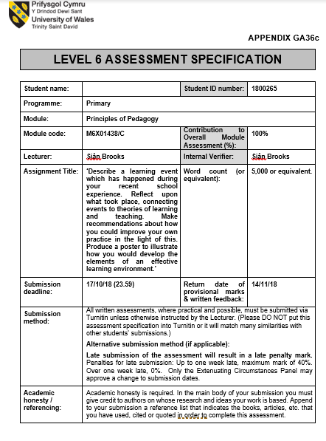

‘Describe a learning event which has happened during your recent school experience. Reflect upon what took place, connecting events to theories of learning and teaching. Make recommendations about how you could improve your own practice in the light of this. Produce a poster to illustrate how you would develop the elements of an effective learning environment.’

Introduction
There have been many influential theories introduced by leading pioneers to explain the ways in which children learn. It is important to recognise how children learn to deliver and implement effective teaching practices within our classrooms.
Key theories such as Jean Piaget’s cognitive constructivism, Ivan Pavlov’s behaviourism and Lev Vygotsky’s social constructivism all have valid viewpoints on how children learn and develop their knowledge effectively.
To get an understanding of the way in which children learn and how these theories are used within teaching practices I will reflect on my observations during a school bridging visit.
The school I visited was an English medium primary school in a small community town in West Wales. The school which has approximately seven hundred and fifty pupils on roll houses a Parent and Toddler group, Flying Start, Foundation Phase, Key stage 2 and Learning Resource Centre.
Prior to my school visit I familiarised myself within the BERA Ethical Guidelines for Educational Research (2018) to ensure I demonstrated professional practice. Upon my arrival to the school I ensured I had written consent by the safeguarding representative to take photos of various materials and resources for my work and read the schools safeguarding policy fully.
For the purpose of anonymity, the names of the school, pupils and teachers will remain disclosed within this piece of work.
My observation
For my observation I was placed in a year four class, which included a total of thirty-two children, one teacher and one learning support assistant. I have chosen to evaluate a maths session for my learning experience as I believe it demonstrated key aspects of child development and interaction.
The session took place on the carpet, where all the children were each given a mini white-board and dry-wipe marker. The teacher then displayed sums on the electronic board which she had already prepared for the lesson. The class were then asked to work out a sum on their own, write the answer on their white-board, and once everyone was satisfied with their answers they were asked to reveal them by holding up the boards.
Once the teacher announced the correct answer, she then asked volunteers of the group to explain to the rest of the class how they worked out the sum. I found this part of the session very inciteful as each time the class revealed three or four different methods for working out the sums.
I was really impressed with the variety of methods the children used to work out the sums. The different methods included column subtraction, partitioning and their own independent approaches. (See figure 1). This was a very interactive session, as the activity uncovered in-depth collaborative discussions between the teacher and the pupils, on their different ways of thinking and retrieving the answers. This session exemplified a metacognition process, the children had the opportunity to think about what mathematical method was right for them and which they felt more comfortable using to work out the sums. 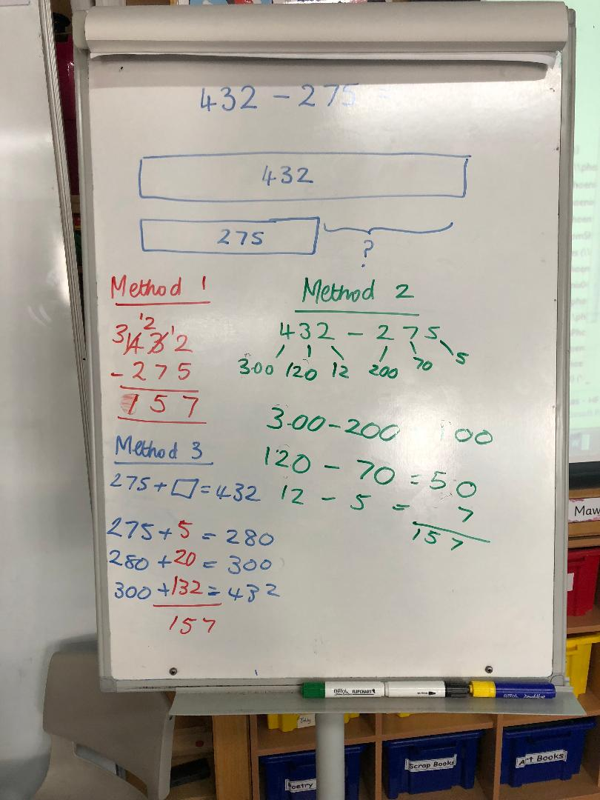 Figure 1.
This was a key moment in the lesson for me as the talk taking place was stimulating the minds of the children and developing their numeracy knowledge further. This was a prime example of dialogic teaching (Alexander, 2008). Indeed, the discussions were developing the whole class’ numeracy abilities, but consequently it was also a major benefit to those children who were struggling with the task, as the number of ways to work out the sum from their peer’s point of view may have been more familiar to their way of learning. The students were sharing their problem solving techniques based on their prior knowledge.
Throughout this session all pupils were actively involved and engaged, this was evident by their enthusiasm each time the answers were revealed by the teacher. It was also reflected by the way in which the pupils were all very keen to share and explain their answers with the rest of the class. This is a prime example of social constructivism, the classroom talk was interactive and worthwhile for all involved. Educational researcher Russell Grigg encourages that such exercises should include constructive dialogue which results in children evaluating, sharing and questioning their own knowledge (Grigg, 2015).
During the session the teacher also used effective questioning whilst the students were describing their different methods. When the teacher was writing out a sum using the column method to the sum 67 +7 she purposely put the 7 under the tens unit and asked “do I put that the 7 there?” When the pupils replied no she then asked “why don’t the I put the 7 there?” To which one child explained that the 7 is a unit, and if the 7 was to go within the tens column it would be a different sum as the 7 would then represent 70. The use of questioning was effective in two ways, it prompted their understanding of prior knowledge and also would have assisted those members of the class who were less able to do the sum or who may have mistakenly set out the sum incorrectly in the columns. The use of the teacher’s questioning here exemplifies the ‘remembering’ category in Bloom’s revised taxonomy. The ‘remembering’ level within the model defines the way in which information is being recalled from long term memory. In this case it was evident that the pupils had been taught the column method, however it was an effective way of the teacher identifying any key misconceptions in the method.
The session was constructive, the only limitation it may have had would be that for those children who were struggling with the activity and couldn’t grasp the calculations, in this case it would have been difficult for the teacher to directly help a particular pupil as it was a class activity. If the teacher were to directly address the child to assist them it may cause embarrassment for that pupil in front of their fellow peers, which would give them a sense of insecurity. In this instance, as this was an opportunity for Assessment for Learning, as the role of a teacher, I would take a mindful note to identify the children who have not been revealing correct answers and plan an alternative session. This will give me an opportunity to focus and assist the children directly with any individual difficulties they may have and explain the method to them on a one-to-one basis.
To record my observation I chose to adopt a qualitive method and wrote notes as I felt my immediate thoughts and perceptions could be recorded as they were happening and be as accurate as possible. I also believed that it was the most convenient method for the class as I wasn’t participating in this part of the lesson and didn’t want to distract the students. I also felt that if I would have taken photos or video recording it may have caused a distraction and the children may have had a change in behaviour, which would not have resulted in an accurate representation of the session. Although I didn’t video record or take photos during the lesson, once the session had finished and the children were outside I asked for permission to take a photo of the white-board which displayed the variety of different methods the children had shared for the final sum. I took this photo as I knew I would elaborate on this specific moment within my work.
If I was to observe the lesson again, I would use a dictaphone and place it out of reach, so the children aren’t aware of it. As my focus is based on the importance of classroom dialogue it will be a beneficial tool, as by recording I can playback exactly what was said in the session word for word and give a more accurate account of the classroom talk.
Overall, I found observing this specific session very beneficial, all the children were actively engaged in the activity, and the level of classroom dialogue was constructive. The session had several qualities, it was fun and engaging for all involved, which was shown by the enthusiasm and contribution of all students within the class. The high level of dialogue between the teacher and students was very encouraging as new methods and thoughts were discussed throughout. It was evident that the children’s learning was being extended by the classroom talk.
Just after the session, whilst having a brief conversation with three pupils I asked them what their favourite subject was, two of whom answered mathematics almost immediately. I then went on to question the pupils, due to my curiosity I then asked why they enjoyed the subject, to which they answered that maths is fun. I believe such positive teaching attitudes and enthusiasm of the subject is paramount in mathematics, as it has been known to traditionally have a negative stigma attached to it. It could be argued that these negative attitudes have been passed down the years by our elders and could have stemmed from a variety of reasons including past experiences, an insecurity of incorrect answers or a lack of support. There have been numerous studies on why this negative attitude towards mathematics is perceived, it was reported in 2009 that mathematics is the second most disliked subject. (Boaler, 2009, cited in Pound & Lee, 2015: 17) As teachers we need to abolish the so-called negative perception of mathematics and demonstrate that mathematics is enjoyable and that numeracy skills are essentially needed in everyday life.
The session I observed exemplified the social constructivist approach to learning, as the children’s cognitive abilities were being built upon from the exploratory talk and collaborative dialogue between the students and teacher, bringing a positive attitude to the environment.
Connection to theory
There are many different influential theories and research methods underpinning the ways in which children learn and develop their knowledge effectively in the classroom. However, having observed an effective dialogue-led lesson, I have chosen to focus my work on social constructivism.
Russian theorist Lev Vygotsky pioneered the importance of social and cultural contexts having a major influence on cognitive development. He believed that the mix of talk and action in the classroom was the driving force of children’s development. Although this work focusses on the children’s development within the classroom ,Vygotsky testified that even during the early stage of life speech leads a young child’s actions and progression in problem solving. “Children solve practical tasks with the help of their speech, as well as their eyes and hands” (Vygotsky, 1978: 26)
Vygotsky’s social constructivist theory emphasises on the importance of language in the process of academic development. His renowned concept of the Zone of Proximal Development (ZPD) highlights that children’s development can be expanded if they are shown guidance. The model demonstrates the difference of development in a child when they perform a task alone in comparison to progressing further within the task with the assistance of a more knowledgeable other, whether that be a teacher or peer. Vygotsky believed that when a child is in the ZPD and has assistance from a higher skilled individual then the child has the encouragement to achieve more within the given task. The image to explain the model further has been clearly illustrated below. (See figure 2) Studies by other scholars such as Lisa Freund have concluded this hypothesis that children who learn more effectively through guidance of a more skilled individual develop further within their ZPD.
Also known as the Doll House Study (Freund, 1990) Freund’s project was an analysis of adult-child interaction when problem solving within a social context. Within the research-based task children were asked to arrange miniature furniture in a dolls house, and to sort the furniture into sections within the wooden structure to represent rooms within a conventional home. Initially, the children’s prior knowledge was assessed to determine what they already understood about furniture placement. Following this, children were grouped into two groups, one group of children worked alone, and the other groups worked with their mothers. The study proved that guided learning is more effective than learning as a lone individual, when children are given the encouragement from a more knowledge other their ZPD is stretched.
I recently witnessed use of Vygotsky’s ZPD model in another classroom observation:
A child in reception class was given the task to sequence the story of Sleeping Beauty by cutting out images and placing them in chronological order in her textbook. This individual child clearly knew the order of the story and understood the task fully, however was struggling using and handling the scissors, the teacher noticed this and explained and demonstrated how to handle the scissors properly. With a little practice the child then mastered how to cut the paper properly and gained a better understand in developing her fine motor skills, which helped the task become more manageable. The child was in the ZPD as she knew how to complete the task, however was finding use of her motor skills more difficult, but with the assistance of the teacher she was able to achieve and successfully complete her goal.
Another theorist with a similar social constructivist mindset during the period of Vygotsky was John Dewey who repeated the viewpoint that children can develop their knowledge through real life social contexts. He argued that everyday acts are a paramount influence on educational development. Dewey illustrated this by exploring the way babies begin to develop through sheer sounds and tones to which they have no understanding of. He uses the example that a mother were to place a hat on the baby’s head and say the word hat slowly at the given moment, the action will have an influence on the baby’s understanding that the object alongside the sound signifies a hat. Thus, the connotation relies on an active connection within a socially shared experience.
Dewey then went on to argue that school has a responsibility to develop each child by its social environment. Hence, schools can succeed in this instance by forming working collaborations in the classroom by a shared activity, giving students the power to influence and cognitively develop together.
Psychologist Jerome Bruner also echoed Vygotsky’s mindset, reiterating that cognitive development is of a social context. Bruner believed that adults have a key role to play in the development of children’s cognitive development. Elaborating on from Vygotsky’s ZPD model Bruner formulated the term ‘scaffolding’ which focuses on how children are supported on building their current knowledge by learning through a range of techniques facilitated by an adult’s demonstration. Then, once the child is able and understands the given task, these assisting measures are taken away, and the adult leaves the child to continue independently. Today, there are a range of scaffolding strategies and techniques implemented in the classroom to help build on children’s developmental needs including activating prior knowledge, the Think-pair-share activity, role-plays and in-depth class discussions.
Elaborating on from how a social context is a main driving force within a child’s cognitive development is the effective use of language. Having already briefly touched on Alexander’s movement of ‘dialogic teaching’ it is important to recognise the meaning behind the pedagogy. Alexander explained that it is all well and good generating talk in the classroom, however the talk needs to be relevant and constructive, not just classroom ‘gossip’. The classroom dialogue needs to stimulate the learners and broaden their knowledge and understanding. (Alexander, 2008) Alexander introduced five main elements explaining what dialogic teaching should be. Purposeful, meaning teachers plan and direct classroom dialogue with objectives in mind. Supportive where students voice their ideas freely, without feeling pressured that they are bringing forward wrong answers and are not judged. Reciprocal meaning teachers and students listen and share ideas between each other. Cumulative where the class build upon their ideas of forms of enquiry. And finally, collective where teachers and students listen and share ideas collaboratively. Alexander believes talk is at the core of learning development. From this, students need to be actively engaged and have a sense of enquiry about them, by questioning and discussion.
Vygotsky’s views have been reiterated by scholars in the more recent years. Fisher and Mercer have recognised from their classroom studies that there are three main types of talk within the classroom, these are identified as disputational, cumulative and exploratory. Disputational talk highlights the disagreements within classroom talk, and occurs when children are not working collaboratively and are independently making their own decisions when this is not intended. Also there is more of a competitive atmosphere within the dialogue rather than working together on a given task. Cumulative talk is when children do share ideas but passively, students just agree with each other and do not question or evaluate these thoughts in an uncritical manner. Finally, exploratory talk which the most effective method of talk within the classroom and where children engage actively in conversation, children elaborate on each other’s viewpoints, ideas may be challenged and questions are asked between the class. (Fisher, 1993 & Mercer 1995, cited in Mercer & Littleton, 2007:51)
During their research Mercer and Dawes (cited in Mercer & Hodgkinson: 2008) focused on two main kinds of dialogue in classrooms, talk between the teacher and pupils, also known as asymmetrical talk, when the dialogue is lead by the teacher. Within this, an appropriate learning environment is introduced, which can sometimes involve an in-depth discussion or explanation. The second type of dialogue is known as symmetrical talk which describes pupil on pupil talk and is more common in group work. Generally asymmetric talk is more commonly used in classrooms, where the teacher inherits more of a definitive and leading role. However, although appreciating that the teacher’s role in the classroom is of high importance, Mercer and Dawes believe it is also beneficial for children to talk between themselves to develop their further knowledge and gain more of an independence. ‘Children need a careful combination of teachers guidance (through whole-class, teacher-led activities) and group work in which they can try out ways of using language to solve problems together” (Mercer and Dawes, cited in Mercer and Hodgkinson: 2008: 70).
By the use of exploratory talk in the classroom, the rest of the class benefit by listening to the speaker as ideas and points of views are being shared collaboratively. Examples of this in the classroom would include; all class members participating, ideas are constructively challenged, and points of views and thoughts are enhanced by others. Researchers believe that classroom talk should have a set of ‘ground rules’ to ensure there is a controlled social order within the classroom, to ensure exploratory talk is effective, these rules will also influence children in coming to terms with social order and contexts in everyday life.
The social constructivist theory has been a major influence of classroom pedagogy, even more so in recent years. Children are becoming more capable active learners, interacting and communicating effectively with their teachers and peers. This is evident by the observations made during personal school visits made recently in comparison to reflecting on schooling in the 1990s. Children are now more hands on in lessons and are given the freedom to be more independent which in turn assists in their growing of confidence.
This social constructivist pedagogy can be underpinned in all aspects of the learning environment. Children should be are encouraged to interactively question points of views, identify key questions and reflect and act upon prior knowledge.
Many theorists focussed on the importance of children actively learning within a social context, constructivists Vygotsky and Piaget pioneering this notion. Although both sharing this perspective, they did have contrasting views on how children developed cognitively. Whilst Vygotsky stressed the importance of a more highly skilled individual guiding children to stretch their knowledge beyond their level, Piaget believed children develop better whilst operating as ‘lone scientists’.
My teaching pedagogy will very much focus on the importance of social interaction within the classroom. I will promote an environment where children are actively involved in their learning process and have the confidence to voice their opinions whilst I undertake the role as a facilitator. I will use the dialogic teaching methods to maintain an actively involved cohort, with the purpose that students develop their interpersonal, inquiry and questioning skills to develop them into citizens required in today’s democratic society.

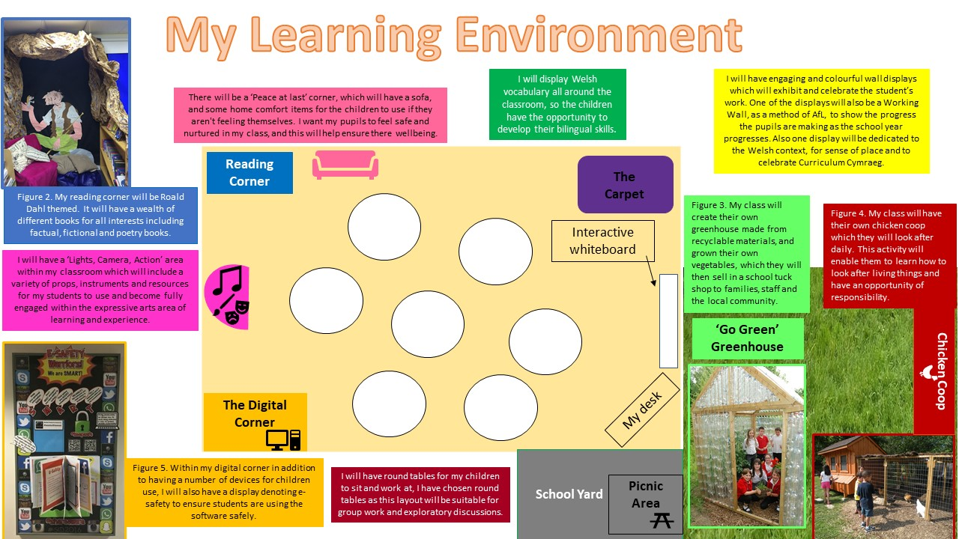
My learning environment
It is evident that the learning environment has a major influence on children’s learning. Within my classroom I will promote a positive and safe environment where children will feel safe, nurtured and ready to want to learn. My classroom will have a Roald Dahl theme. Having observed lessons in a range of schools it is evident that the author’s creativity and humour within his writing captivates young minds and brings enjoyment in the learning environment across the curriculum. In addition, as the author was welsh it also brings a welsh context to the learning environment.
To ensure my pupils feel comfortable and safe within the learning environment I will implement activities during the school day to monitor their wellbeing and how they are feeling. At the start of the school day, during registration I will ask each pupil to score how they are feeling from one to five (one representing very happy and five representing very upset). Depending on the pupils answers they will then be monitored by myself or a learning support assistant. If appropriate, this will then be followed up with a professional, either social services or a safeguarding lead within the school.
In my classroom I will have a reading corner which will be filled with a variety of reading books with different topics and a range of reading levels for an inclusive approach. There will be a variety of different genres of books; fiction, non-fiction, picture books, poetry and encyclopaedias to reflect on the different interests and cultures of my class. The reading corner will be a comfortable and quiet place for students to enjoy and be able to take part in independent or group reading. “Reading and writing are at the heart of pupils’ learning. These skills are vital to education achievement” (Estyn, 2008).
Reading is of high importance within the curriculum as well as being a key tool in building upon children’s cognitive development. In my classroom I will strive to influence my passion for reading to my class, so they too inherit a pleasure for storytelling. I will encourage reading in several ways. Firstly, I will read an extract of an engaging story to the class daily, as well as sparking their interest in reading it will also help them develop further skills such as understanding language and developing their vocabulary further. From this, I will generate discussions on the themes and meanings represented in the book and question the children on their thoughts and analysis of the story. “Reading a book aloud, explaining vocabulary at each reading means that children can acquire 8-12 word meanings per week at school which is enough to maintain average vocabulary gains” (Biemiller, 2007: page number?).
My class will also create their own storybook, will which be similar to a shared writing activity, however on a larger scale. Each week one child will have the opportunity to take the book home and write their own part to the story, following on from the previous student. They will have to come up with a ‘what happens next’. This will encourage their creativity, writing and reading skills.
Due to the continuous development within the digital world it is no wonder that digital pedagogy is being established as a core subject within our national curriculums. Technology devices such as mobile phones, computers, laptops, kindles and Ipads are now more accessible than ever, and are even being used confidently by young children and toddlers.
Educational bosses have understood that this growing phenomenon should be recognised in in the curriculums for our children to develop the digital skills needed to become skilled employable citizens. Professor Graham Donaldson has recognised this and within his report Successful Futures, he has identified digital competence as one of the three core cross-curricular responsibilities in the new curriculum for Wales. The Digital Competence Framework (DCF) is the first element of the new curriculum to be made available for schools to implement within their pedagogy. The aim of the framework is to enable welsh learners to become more “digitally competent and to evolve into enterprising creative and critical thinkers” (Education Wales, 2018).
Within his report Donaldson testifies that children should not just be passive consumers to technology but should develop the competence skills needed to become technologically mindful to ensure they are equipped for life. (Donaldson, 2015)
In my classroom I will have a ‘Digital Corner’ which my pupils will have access to and use a wide range of technology. I will have a different types of devices so the children are given a choice to which ones they are more comfortable in using.
During my bridging days the school I visited had recently implemented rotational lessons, this is where children are grouped by mixed abilities and each group is given a different activity based on the theme of the lesson. The groups then rotate activities and have a go at each activity during that school week. During these rotational lessons one of the activities always involved the use of a technological device, whether it was a multiplication application during numeracy, a research task on a topic, or an application where they created their own presentation. Within my class I would like to implement this teaching strategy as I found it very effective during my observation, the children were actively engaged throughout, and it also gave children a variety of learning methods. I will ensure that one activity will always include a digital activity in my ‘Digital Corner’ when rotational learning occurs in the classroom.
Giving students the opportunity to experience a variety of environments is also important in developing their sense of the world. Outdoor learning gives children the opportunities to extend their perspectives of the world around them through the use of nature, and gives them more of an understanding of the environment and society. It also aids in the fostering of their interpersonal skills, physical development and wellbeing. “The world outside the classroom is the first and most enduring source for children’s learning about our culture, heritage, nature, relationships, values and what it means to be truly literate and number”. (Grigg & Lewis, 2016: 73)
Furthermore, it also gives those less fortunate children the chance to experience a natural environment which they may not have access to in their family home. It forms an inclusive pedagogy, giving all children the advantage to an equal education, further diminishing the attainment gap.
I will integrate the use of the outdoors in my lessons daily as there are a range of benefits to this in assisting in a child’s educational development. Within my outdoor learning environment there will be a chicken coop which the children will manage and maintain, this project will promote sustainable living as well as giving the children an understanding of animal welfare. There will also be a ‘Go Green Greenhouse’ where the children will grow their own vegetables. These outdoor learning projects will also give the pupils an understanding of ambition and economics as they will have the opportunity to sell the eggs and vegetables in a school tuck shop to staff, parents and the local community, raising funds for the school. This project is an opportunity to establish cross-curricular learning sessions. For example, the handling of money whilst selling the items in numeracy, producing advertising materials within creative arts and discovering what living things need to live in science and ICT.
When possible, I will also oragnise off-site educational visits to local galleries, castles, museums and beaches to give my pupils new perspectives and to discover new environments and cultures that are available to them. Off-site visits can be exciting for the children and can bring the curriculum alive with a range of engaging activities, which can also be revisited back in the classroom after the visit.
Conclusion
To conclude, I have witnessed effective teaching practice using the social constructivist approach. Supporting Vygotsky’s view (1978) that the coalition of talk and action is the driving force of children’s cognitive development, I will implement this approach within my pedagogy.
During my observation the children were actively participating and engaged in a constructive classroom discussion. Their learning and further knowledge of mathematical methods were being developed from the use of exploratory talk. From this, I have learnt the importance of classroom dialogue, and to encourage the use of exploratory talk within my classroom. Thus, encouraging children to use the powerful tool to challenge themselves and engage constructively with another. I will encourage my students’ use of metacognition, for them to understand the way they learn and reflect by being questioning and curious individuals.
Welsh education is at an exciting time with the new inclusive curriculum launching in 2020 with the purpose of preparing our students to be ready to lead prosperous lives and ready for work. To ensure my students have the skills and knowledge to become successful citizens of Wales I will ensure valuable learning takes place in my classroom with a focus on intellectual and effective dialogue.
Word count: 4880

Bibliography
Alexander, R. J. (2008). Towards Dialogic Teaching: Rethinking classroom talk 4th ed. UK: Dialogos UK Ltd.
Biemiller A. Teaching vocabulary: Early, direct, and sequential. American Educator. 2001;25:24–28.
Dewey, J. (2013). Democracy and Education - An Introduction to the Philosophy of Education. Bloomfield: Read Books Ltd.
Donaldson, G. (2015) Successful Futures: Independent Review of Curriculum and Assessment Arrangements in Wales
Education Wales (2018) Digital Competence Framework Guidance. Cardiff: Welsh Government
Estyn (2008) Best Practice in the Reading and Writing of Pupils Aged 7 to 14 Years, Cardiff: Estyn.
Freund, L. (1990) ‘Maternal Regulation of Children’s Problem-solving Behaviour and Its Impact on Children’s Performance’ Child Development, p.113-126
Grigg, R. (2015). Becoming an outstanding primary school teacher. 1st ed. Oxon: Routledge, p.183.
Grigg, R. and Lewis, H. (2016) A to Z Of Learning Outside The Classroom. 1st ed. London: Bloomsbury

Mercer, N., Hodgkinson,S. (2008) Exploring Talk in School. London: SAGE

Pound, L. and Lee, T. (2011). Teaching Mathematics Creatively. 1st ed. Oxon: Routledge.
Vygotsky, L., Cole, M., John-Steiner, V., Souberman, E. and Scribner, S. (1978). Mind in Society. United States of America: President and Fellows of Harvard College.

Appendix
Figure 2: . Image taken from Pinterest https://www.pinterest.co.uk/pin/453104412491265271/
Figure 3: Image taken from https://www.pinterest.co.uk/pin/82894449377429284/
Figure 4: Image taken from https://s3-media1.fl.yelpcdn.com/bphoto/l2gDSC9fT2HWwMwkX1tHZA/o.jpg
Figure 5: Image from https://www.pinterest.co.uk/pin/525584219010245148/

