Name: Stancin Raducanu

Student ID: 2543558

Module Name: LCLM 4003 Effective teamworking and communication

Lecturer’s Name: Abdallah Naser
Following are the characters in the video that you must watch before attempting to answer the questions. These character are a team of students working on a project.

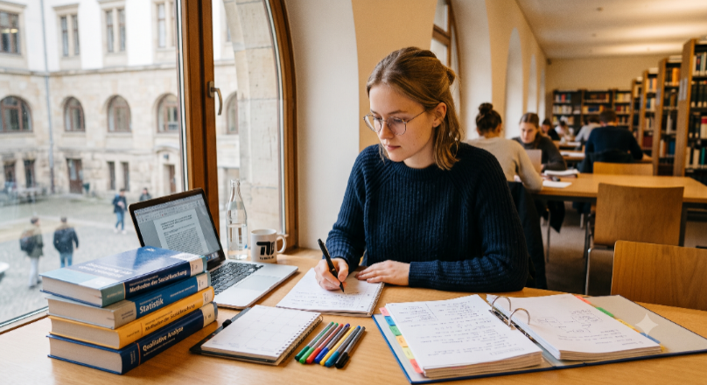 | Lena, a hardworking undergraduate from Germany, approaches her studies with detailed-oriented care and a consistent dedication to quality. Driven by a preference for precision and a reliance on empirical evidence, she consistently delivers exceptionally researched and thoroughly documented work.
 | Omar, an undergraduate student from Jordan whose confidence and persuasive charisma naturally draw others to him. With a natural ability to make quick decisions and a genuine talent for motivating those around him.
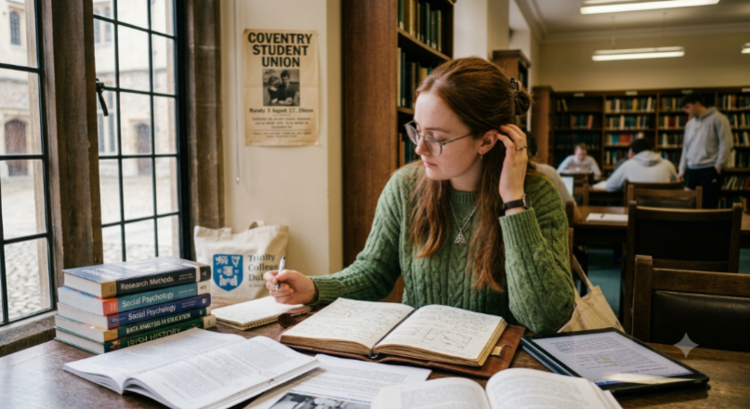 | Hannah, an undergraduate student from Ireland, whose calm manner and sharp intellect are instantly recognisable. Bringing her thoughtful, detail-oriented approach to everything she does, Hannah is a researcher through and through, thriving on evidence and considered evaluation.
 | Kenji, a Japanese undergraduate student known for his calmness, reliability, and strong sense of community. Always prioritising group harmony, Kenji always offers supportive guidance on group projects.
 | Priya, an undergraduate student from India whose vibrant energy and dynamic resourcefulness are instantly recognisable. Bringing her unique blend of passion and practicality to the academic world, Priya is a natural networker and problem-solver.
 | Alex, a computer science major from Canada. Analytical, tech-savvy, and deeply practical, he approaches every academic challenge with a systematic mindset, always finding ways to streamline work using digital tools. He prefers to organise data for projects and fine-tuning workflows.

Watch the video and then answer the following ten questions within the spaces provided. Each question carries equal mark.Each answer should be a minimum of 100 words and a maximum of 150 words.Please note that the questions are grouped by topics, instead of following the timeline. You need to watch the whole video before answering the questions. Please make sure that you provide citation and references for all the relevant concepts you use in answering the questions.

Question 1
Explain what teamwork is, give examples from the video.
Teamwork is when a group of people work together to achieve a common goal. It involves communication, cooperation, trust, respect and supporting one another. Good teamwork means that everyone contributes their skills and idea, shares responsibilities and helps others when needed. For example, in the video, teamwork can be demonstrated when people work together to complete a task, communicate with each other, solve problems or overcome challenges. Team members may also encourage one another and offer help when someone is struggling. This shows that working together can make tasks easier and more successful. Teamwork is important because it builds relationships, improves confidence and helps everyone achieve better results.

Question 2
Omar states that the team has been debating for two hours, the team members look worried. Lena intervenes and argues, Omar intervenes again. Hannah looks troubled.(timestamp: 2:00 –2:56).Identify which of Tuckman's Stages of Team Development this part of the video represents.
I think this part of the video represents the storming stage of tuckman’s stages of team development. During this stage, team members may disagree, challenge each other’s opinions and struggle to reach a common decision. Omar explains that the team has been debating for two hours, suggesting that they are experiencing difficulties reaching an agreement. Lena intervenes and argues, while Omar intervenes again, showing continued disagreement and possible decision between team members. Hannah’s troubled expression also suggests that the conflict is affecting the group. This stage is important because the team must learn to manage disagreements, listen to different perspectives and work towards a shared goal.

Question 3
Identify & explain which Tuckman's Stages of Team Development is the team in during the last 2 minutes of the video (timestamp 4:00 – 5:58).
The team appears to be in the Norming stage of Tuckman's Stages of Team Development. At this stage, team members begin to resolve their disagreements, develop trust and communicate more effectively. They start respecting each other's opinions, accepting different responsibilities and working together towards a common goal. Compared with the earlier Storming stage, where Omar and Lena disagreed and the team struggled to reach a decision, the team begins to develop better cooperation. This stage is important because it helps build positive relationships and creates a stronger sense of unity. As a result, team members can focus more on solving problems and achieving their shared objectives successfully.

Question 4
Explain what Group Decision Making is, provide a relevant example from the video.
Group decision making is a process in which two or more people work together to discus different ideas, evaluate options and choose the best solution problem. It involves communication, sharing options, listening to others and considering the advantages and disadvantages of each option. Effective group decision making allows team members to contributes their knowledge and experience, helping the group reach a better informed decision. In the video, Omar explains that the team has been debating for two hours, while Lina and Omar continue to argue. This demonstrate group decision making because the team is discussing different options. However, their disagreement suggest that they are struggling to reach a common decision.

Question 5
Explain what Nominal Technique is, provide an example from the video.
The nominal group technique is a structured decision making method that helps a team generate ideas, discuss possible solutions and reach a fair decision. Each team member first thinks of ideas independently, then shares them with the group. The ideas are discussed, clarified and ranked or voted on to identify the best option. This technique ensures that everyone has an opportunity to contribute and prevent dominant individuals from controlling the discussion. In the video, an example would be the team using this method to organise their ideas and agree on a solution after debating for two hours. It could help Omar, Lena and the other team members listen to each other and reach a shared decision.

Question 6
What (Thomas-Kilmann model)conflict mode does Priya use when she states "We do not have to choose between being brilliant or being thorough.", and she supports Omar’s framework while giving Lena 48 hours to verify the data?(timestamp 3:20 – 3:36)
I think Priya uses the Collaborating conflict mode from the Thomas-Kilmann Conflict Mode Instrument. This approach involves high assertiveness and high cooperativeness, meaning that a person aims to find a solution that satisfies everyone's concerns. When Priya states, "We do not have to choose between being brilliant or being thorough," she suggests that both perspectives can be combined rather than choosing one over the other. By supporting Omar's framework while giving Lena 48 hours to verify the data, Priya balances the team's need to make progress with Lena's need for accuracy. This demonstrates collaboration because she seeks a win-win solution that respects different opinions and helps the team achieve its shared goal.

Question 7
When the debate between Omar and Lena peaks, Hannah responds by "shrinking back slightly in her chair" and softly trailing off as she is spoken over. Using the Thomas-Kilmann Conflict Mode, identifyand describe Hannah's conflict mode in this scene. ( timestamp 2:00 - 2:45)
Hannah demonstrates the avoiding conflict mode in the Thomas-Kilmann Conflict Mode Instrument . This mode involves low assertiveness and low cooperativeness, meaning that a person avoids confronting disagreements or expressing their concerns directly. When Omar and Lena's debate becomes more intense, Hannah shrinks back slightly in her chair and softly trails off when she is spoken over. Her body language and behaviour suggest that she is uncomfortable with the conflict and chooses not to challenge the other team members. By remaining quiet, Hannah avoids further confrontation; however, her ideas and concerns may be overlooked, preventing her from contributing fully to the team's decision-making process.

Question 8
Identify which Belbin roles Alex and Priya might be demonstrating (e.g., Plant, Implementer, Coordinator, Specialist, Monitor Evaluator, etc.) and explain them with relevant examples from the video.
I think Alex may demonstrate the Plant role if he contributes creative ideas and suggests innovative solutions to the team's problem. Plants are imaginative team members who help groups explore new possibilities. Priya demonstrates characteristics of the Coordinator role because she helps bring different perspectives together and encourages the team to reach a shared goal. At 3:20–3:36, Priya states, “We do not have to choose between being brilliant or being thorough.” She supports Omar's framework while giving Lena 48 hours to verify the data. This shows her ability to balance competing priorities, recognise others' contributions and guide the team towards a practical solution. These roles can help improve collaboration and decision-making.

Question 9
Identify which Belbin roles Omar and Lena might be demonstrating (e.g., Plant, Implementer, Coordinator, Specialist, Monitor Evaluator, etc.) and explain them with relevant examples from the video.
I think that Omar may demonstrate the Implementer role because he supports a framework and appears focused on moving the team towards a practical decision. Implementers turn ideas into organised plans and help teams achieve their objectives. Lena may demonstrate the Monitor Evaluater role because she emphasises the importance of checking the data before reaching a final decision. Monitor Evaluators carefully analyse information, assess options and identify potential problems. Between 2:00 and 2:56, Omar and Lena disagree during a lengthy debate. Later, at 3:20–3:36, Priya supports Omar's framework while giving Lena 48 hours to verify the data. This suggests that Omar values progress, while Lena prioritises accuracy and careful evaluation.

Question 10
After watching the video, decide which Belbin role you would naturally take in this team and why would you take that role?
After watching the video, I would naturally take the Coordinator role in this team. I would choose this role because I enjoy helping people work together, listening to different opinions and making sure everyone has an opportunity to contribute. In the video, Omar and Lena disagree during a lengthy debate, which creates tension within the team. As a Coordinator, I would encourage both members to explain their viewpoints calmly and help the team identify a solution that considers everyone's concerns. I would also ensure that tasks and responsibilities are clearly organised. I believe this role would help reduce conflict, improve communication and guide the team towards achieving its common goal.

REFERENCE LIST

For Tucman’s: Zirar, Araz; Muhammad, Noor; Upadhyay, Arvind. et al. Production planning & control. 2025.

For Group Decision Making: Guo, Zhiya (Alice); Scott, Brent A.; Yan, Ming. Journal of occupational and organizational psychology. 2025.

For Nominal Technique: Gabbay, Murdoch J; Melkonian, Orestis. 2026.

For Belbin roles: Aritzeta, Aitor; Swailes, Stephen; Senior, Barbara. Journal of management studies. 2007.

