

LOCATION: Swansea | LLEOLIAD: abertawe
LEVEL 7 | LEFEL 7
EXAMINATION PERIOD | CYFNOD ARHOLIADAU
July 2021 | Gorffennaf 2021

MODULE CODE: ACCA7029
COD Y MODWL: ACCA7029
ENTERPRISE CORE NETWORKING
TIME: 3 HOURS

Name : Matthew Blake

Student ID : 2008386

Date & Time : 22/07/2021 9:30 – 12:30

This is an individual practical test, held under examination conditions. You will be assigned three Switches and three Routers; you should configure these devices based on the given specifications.

This paper is marked out of 100.

Important Note: This assessment has two parts. Part I and Part II. Complete both parts and submit the work in Packet Tracer along with the configurations in a word document.
Part I
Topology

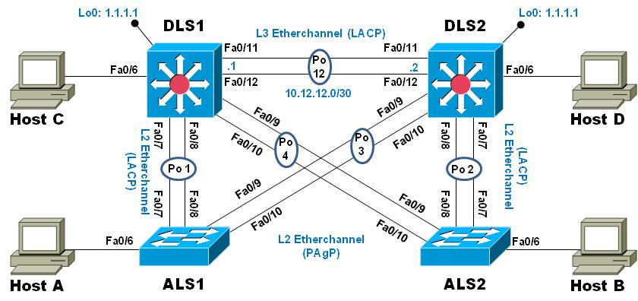

Task 1 – Network Connections (2.5 marks)

Use packet tracer to design the network as shown in the topology diagram. Configure all switches with hostname as shown in the topology.

Task 2 – Configure the network according to specification (40 marks)
    - Shutdown all interfaces on each switch.
    - Configure each switch with a hostname and the enable secret class.
    - Configure trunks and port-channels as shown in the diagram. Issue the no shut command as you go.
      - The connection between DLS1 and DLS2 will be a layer-3 EtherChannel using LACP. DLS1 will use the IP address 10.12.12.1/30 and DLS2 will use 10.12.12.2/30.
      - The Port-channels on interfaces fa0/7 and fa0/8 will use LACP.
      - The Port-channels on interfaces f0/9 and fa0/10 will use PAgP.
      - All trunks will use VLAN 800 as the native VLAN.
    - Configure DLS1, ALS1, and ALS2 to use VTP version 3
      - Use the domain name SoAC with the password cisco
      - Configure DLS1 as the primary server for VLANs.
      - Configure ALS1 and ALS2 as VTP clients.
    - On the primary VLAN server create and name the following VLANs:

VLAN Number | VLAN Name | VLAN Number | VLAN Name
800 | NATIVE | 434 | PARKING
12 | EXECUTIVES | 123 | CUBES
234 | GUEST | 1010 | VOICE
1111 | VIDEONET | 3456 | MANAGEMENT

    - On DLS1, suspend VLAN 434.
    - Configure DLS2 to be a VTP Transparent mode switch using VTP version 2, then locally configure the same VLANs and VLAN names. Suspend VLAN 434
    - On DLS2, create VLAN 567 and name it ACCOUNTING. The Accounting VLAN will NOT be configured or available on any other switch in the network.
    - Configure DLS1 as the spanning tree root for VLANs 1, 12, 434, 800, 1010, 1111, and 3456 and as a secondary root for VLANs 123 and 234
    - Configure DLS2 as the spanning tree root for VLANs 123 and 234 and as a secondary root for VLANs 12, 434, 800, 1010, 1111, and 3456.
    - Configure all trunks so that, with the exception of VLANs 1, 434 and 567, only the VLANs that have been created are allowed to cross the trunk
    - Assign interfaces as access ports to VLANs as follows:
 | DLS1 | DLS2 | ALS1 | ALS2
Interface Fa0/6 | 3456 | 12 / voice 1010 | 123 / voice 1010 | 234
Interface Fa0/15 | 1111 | 1111 | 1111 | 1111
Interfaces F0/16-18 |  | 567
- All unused interfaces will be assigned to the parking lot VLAN and shut down.

    - Configure SVIs on DLS1 and DLS2 in support of all of the VLANs and inter-VLAN routing. Use the following table for subnet assignments:
VLAN | VLAN Name | Subnet | VLAN | VLAN Name | Subnet
12 | EXECUTIVES | 172.16.12.0/24 | 123 | CUBES | 172.16.123.0/24
234 | GUEST | 172.16.234.0/24 | 1010 | VOICE | 172.16.10.0/24
1111 | VIDEONET | 172.16.11.0/24 | 3456 | MANAGEMENT | 172.16.56.0/24
DLS1 will always use the .252 address and DLS2 will always use the .253 address for IPv4 addresses. VLAN 567 on DLS2 will NOT be supported by routing.
    - Configure an interface Loopback 0 on both DLS1 and DLS2. This interface will be addressed 1.1.1.1/32 on both switches.
    - Configure HSRP with interface tracking for VLANs 12, 123, 234, 1010, and 1111
      - Use HSRP version 2
      - Create two HSRP groups, aligning VLAN 12, 1010, 1111, and 3456 to the first group and 123 and 234 to the second group.
      - DLS1 will be the primary switch for VLANs 12, 1010, 1111, and 3456; DLS2 will be the primary switch for VLANs 123 and 234.
      - Configure all groups with preemption. Further configure priority to ensure that the primary switch takes over upon recovery.
      - Use the virtual address .254 as the standby address for all VLANs
      - Configure interface tracking so that each group tracks the local interface Loopback 0 interface.
    - Set the correct UTC time, configure DLS1 as an NTP server and then set the correct time zone.
    - Configure DLS2, ALS1, and ALS2 to use the Management network to synchronize time with the NTP server.
    - Configure HOST C with a static IPv4 address of 172.16.56.50/24 and a default-gateway of 172.16.56.254
    - Configure DLS1 to be a DHCP server for VLANs 12, 123, and 234
      - Exclude the addresses .251-.254 in each subnet
      - Set the DNS server to 1.1.1.1 for all three pools.
      - Set the default router to the HSRP virtual address for each VLAN
    - Obtain IPv4 addresses on Hosts A, B, and D via DHCP.

Task 3 – Test network connectivity and path control (5 marks)
    - What is the show command used to verify that the EtherChannel between DLS1 and ALS1 is configured correctly?
Show Etherchannel
    - What is the show command used to verify the spanning-tree configuration and root bridge (DLS1 or DLS2) for each VLAN?
Show Spanning Tree
    - What is the show command used to verify that the correct SVIs exist and that the correct HRSP routers are primary and standby for each VLAN?
Show ip int bri
    - Verify that NTP is working. DLS2, ALS1 and ALS2 should have NTP sync with DLS1.
    - Verify that HSRP is working. From HOST A, start a continuous ping to 1.1.1.1. Then go to DLS2 and shutdown interface loopback 0. When this occurs, DLS2’s interface tracking should fail, causing it to demote itself from being the virtual gateway for VLAN 123. DLS1 will take over, and the still-running ping should show only minor packet loss.

Part II
Topology

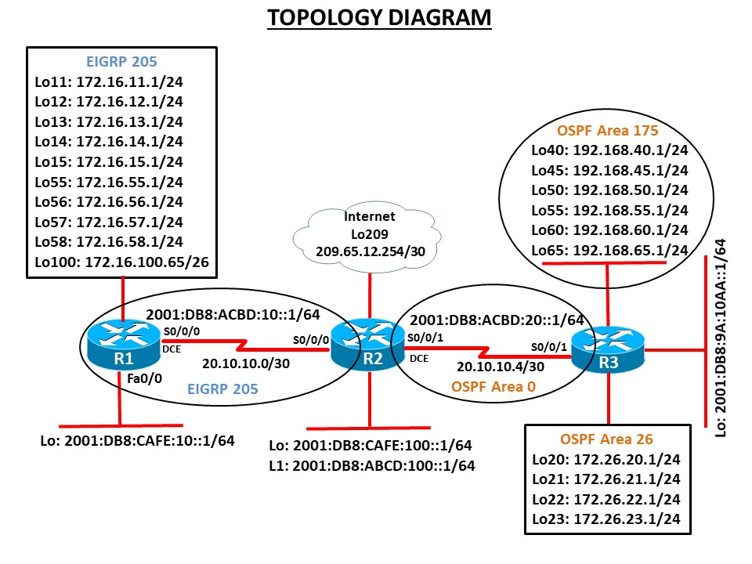

Task 4 – Network Connections (2.5 marks)

- Use packet tracer to design the network as shown in the topology diagram.
- Configure all switches with hostname as shown in the topology.
- Configure all interfaces with the IP addresses shown in the topology diagram.
- Set the bandwidth to 128 kbps on the links between R1, R2 and R3, set the clock rate on the DCE connections as appropriate.
- On IPv6 interfaces, configure global unicast and Link Local address.

Task 5 – Configure Routing (50 marks)

- Configure the routers R1 and R2 to be in EIGRP AS 205. Add all networks as shown in the diagram. Ensure that your network statements are as specific as possible. Disable automatic summarisation.
- On R2 and R3 configure the OSPFv2. Advertise appropriate networks in Area 0 with most efficient wildcard mask.
- On R3, enable OSPF Area 26 and 175 and add all loopback interfaces to appropriate area.
- Use the router identifier 1.1.1.1 on R1, 2.2.2.2 on R2 and 3.3.3.3 on R3.
- Change the OSPF network type on the loopback interfaces so that they are advertised with the correct subnet.
- Configure passive interfaces as required.
- Enable authentication for EIGRP and OSPF links.
- Configure IPv6 routing on all routers. Enable EIGRPv6 between R1 and R2. OSPFv3 between R2 and R3. Advertise networks as appropriate.
- On R2, configure mutual redistribution between OSPF and EIGRP for both IPv4 and IPv6. Assign appropriate metrics where required.
- On R3, configure manual summarization for Area 175.
- On R1, summarise loopback interfaces in its EIGRP update to R2 using manual summarization.
- Configure default route on R2 with exit interface as Lo209. Advertise the default route to all router in the topology.
- On R2, stop advertising the 172.26.20.0 network to R1 using a distribute list and ACL.
Note: Copy the routing table before and after route filter.
- Configure EIGRP for IPv6 for networks shown in the topology.
- Verify network connectivity, all routes on routing table and verify that filtered routes are not present in routing tables of the correct routers.
******

Submission Requirement

- The packet tracer file should be saved as “studentname_id_part_1”, and “studentname_id_part_2” and uploaded onto Moodle.

- In addition to packet tracer file, you must also submit

- This document with all required task (Task 3) completed and
- Notepad with the file name: studentname_Pno_devicename.txt
  - Show running-configuration
  - Show ip interface brief
  - Show vlan brief
  - Sh vtp status
  - Sh etherchannel summary
  - Sh spanning-tree root
  - Sh standby brief

All documentation for your solution should be submitted electronically on Moodle.
It is your responsibility that you submit all the outputs and files correctly.

