
SCHOOL OF ENGINEERING

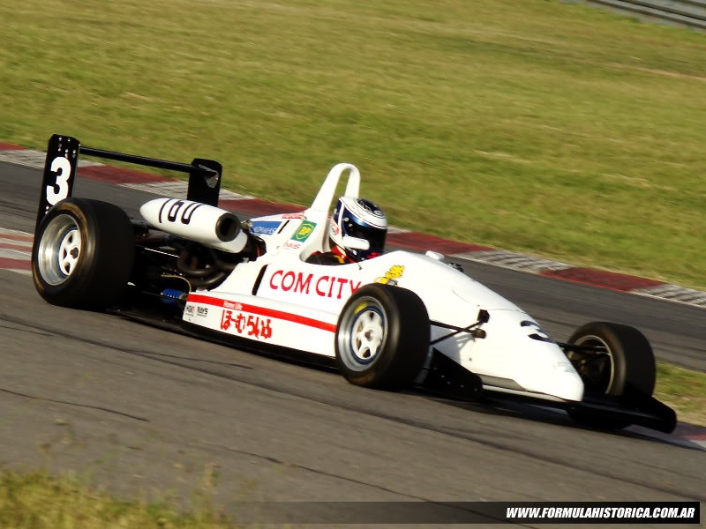

Management, Innovation and Sustainability
Module code: M5X01176
CHASSIS AND SUSPENSION
STUDENT NAME: Zihao liu
STUDENT NUMBER: 1904590

Index.
Contents
1. Index 2
2. Abstract 3
3. Team Roles and Responsibilities 4
4. Personal Roles 6
5. Belbin’s models self-assessment 7
6. Group tasks 11
7. Personal tasks 12
8. Bill of materials 15
9. Special Equipment 16
10. Milestones and gateways 18
11. Areas of concern 19
12. Gantt Charts 22
13. Conclusion 24
14. Bibliography 2
Abstract
The goal of the entire project is to design and optimize the electric climbing/sprinting vehicle based on TOM's F3 Donor Monocoque (Fig. 1) to achieve participation and chase the championship.
The main task of the chassis and suspension group is to divide the chassis tasks into front fork arms, columns, brakes, footpaths, seats, controls, tires, chassis structures and safety devices. First, after a thorough measurement of each component is required, they can perform some simulations on Solidworks & CAD and use the vehicle model to simulate FEA (Finite Element Analysis). Then, according to the results of various simulation experiments on various parts of the car, different upgrade optimization schemes are proposed: after evaluating the upgrade optimization scheme, an optimized model is re-established. Perform the actual test after the initial upgrade to get the actual data after the initial upgrade. Adjust the car's upgrade plan based on the actual data process and implement the final upgrade optimization plan.
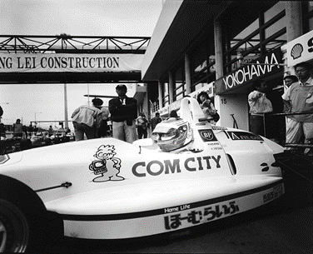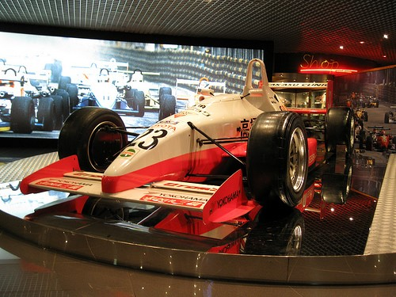
Figure 1 TOM’S F3

Team Roles and Responsibilities.
Table 1. Team Roles and Responsibilities

Name | Team roles | Responsibilities
Sam | Wishbones | Measurements for steering geometry  Measurement and CAD of front wishbones, hubs, body mounts etc  Brakes, Tyres, More CAD
Josh | Steering | The seat, Brakes calipers, disks/pads, Lines/Abs ect, Steering wheel, Harnesses, Pedal box
Richard | Cad and Motor and Battery Packaging | CAD, Motor Packaging, Battery Packaging  Suspension pick up points (for rear suspension arms)  Damper Mounting Points  Material selection for rear chassis
Michael | Chassis frame and  Tyre | Cad for rear chassis frame  Tyre selection  Wheel selection
John Hopkins | Interior controls | Interior controls, Brakes
Liu Zihao | Safety confirmation | Fire extinguishers, Cuts off, Check regulations about formula E and formula 3 racing, CAD about pedal box and brakes.

Personal Roles

Car safety devices: Liu needs a comprehensive review of Formula 3 racing and Formula E racing rules and can choose safe and efficient fire extinguishers and main switches according to the rules to turn off the power and extinguish the fire when the car burns. LIU also needs to select the appropriate size and price of the fire extinguisher and main switch according to the safety rules and evaluate the feasibility of the selected product. (figure 2)

Dimensions: A rough measurement of each component is required using basic instruments and gauges, and the measurement data is organized and organized.

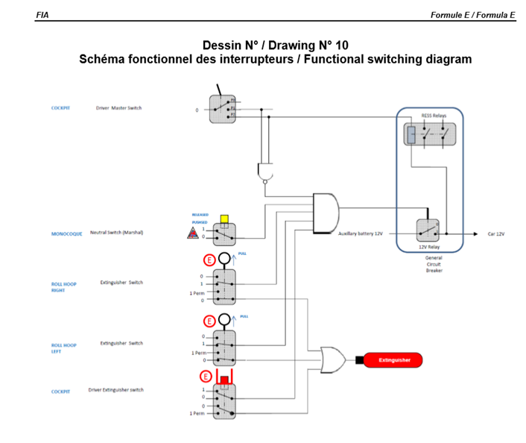 Figure 2
Belbin’s Models Self-assessment.
Personal: In the assessment LIU has got a high score as a Implementer and Plant and very high scores as a Team worker, according to the Belbin model (Belbin, 2019).

Table 2. TEAM SKILLS MANAGEMENT TABLE
 | AVERAGE SCORE | SCORE | LEVLE
IMPLEMENTER | 10.0 | 16 | HIGH
COORDINATOR | 8.8 | 3 | LOW
SHAPER | 11.6 | 11 | AVERAGE
PLANT | 7.3 | 11 | HIGH
PESOURCE INVERSIGATOR | 7.8 | 2 | LOW
MONITOR EVALUATOR | 8.2 | 2 | LOW
TEAM WOKER | 10.9 | 21 | VERY HIGH
COMPLETER FINISHER | 5.5 | 4 | ANERAGE
Among them, Team Worker scored a maximum of 21 points, above the average level of 10.9 points reached 92.7% and the Implementer scored 16 points, above the average level of 10.0 points reached 60% and Plant scored 11 points, above the average level of 7.3 points reached 50.7%.

Different role’s meanings
(Belbin analysis report, 2019)
- Team Worker: Bring cooperation to the team, moderate and rich, with connotation and communication skills. Listen, build, and avoid friction. Collaborators can benefit from disadvantages, actively intervene in potential friction within the team, and direct troublesome people to the right path for team development. They help maintain an energetic team spirit and help other team members serve the team actively and efficiently. Their communicative skills and verbal humour are a valuable asset for the team. They are the kind of listening skills that are good at coping with anecdotes, often showing social, sensitive, interpersonal orientation. However, they often hesitate in difficult situations, such as when a crisis strikes. They are reluctant to take actions that harm others.
- Plant: Bring innovation to the team, dare to dare to do it, and not discipline. Solve the problem. The innovator is the provider of expert opinions, and he often exhibits character characteristics such as high IQ and introspection. His opinions are often first-in-class and dominant in the team. He tends to take a radical approach to solve the problem fundamentally. He is the kind of person who is "big-minded and careless". However, the details are often not within his vision. Too much to be obsessed with one's own opinion, and not to communicate effectively with others. The lack of detail makes them easy to fall into the debate with others.
The ideal score for LIU role in the group may as follows:
Table 3

- Due to the characteristics of his character, scores of action-oriented role and interpersonal orientation have to be high or very high but Laborious and intelligent role do not have to be like that.

Group task
Here is the team's timetable, which contains the group's start time and end time.
Table 4 Group task
Group Tasks | Start Date | End date | Duration
Research hill climb events and vehicles | 2019/9/30 | 2019/11/4 | 35
Weigh existing components | 2019/10/7 | 2019/10/8 | 1
Measuring the mounting points for chassis frame | 2019/10/9 | 2019/10/10 | 1
Design a chassis structure | 2019/10/11 | 2019/11/4 | 24
Design Motor housing | 2019/10/11 | 2019/11/6 | 26
Front Suspension wishbones and uprights | 2019/10/9 | 2019/10/31 | 22
Rear wishbones and uprights | 2019/11/20 | 2020/1/24 | 65
Material Selection for chassis and suspension | 2019/11/25 | 2020/2/7 | 74
Wheelbase and track width | 2019/10/23 | 2020/2/14 | 114
Weight distribution | 2019/11/5 | 2020/2/7 | 94
Brakes – Disks, callipers, lines, servos | 2019/10/21 | 2019/11/27 | 37
Steering | 2020/1/27 | 2020/2/10 | 14
Tyres | 2019/10/21 | 2019/11/6 | 16
Wheels | 2019/10/23 | 2019/11/6 | 14
Controls | 2019/10/28 | 2020/2/21 | 116
Safety devices | 2019/10/28 | 2020/2/28 | 123
Measuring front suspension coordinates for WinGeo | 2019/11/21 | 2019/11/22 | 1
Group Project VIVA | 2019/12/2 | 2019/12/6 | 4
Group Project Report and VIVA | 2020/3/23 | 2020/3/26 | 3
(Chassis and Suspension Team, 2019)

Personal task
The task of LIU is as follows. It contains the start date and end date as well as the specific time of each phased task. LIU will complete a total of 274 hours of work.
Table 5: Personal task
Task | Description | Start date | End date | Number of hours
Group discussion | Every afternoon on Monday | 30/9/2019 | 23/3/2020 | 23
Group meeting | Every day on WhatsApp | 7/10/2019 | 23/3/2020 | 25
Disassembly the race car | Disassemble the chassis and suspension section of the car | 10/10/2019 | 10/10/2019 | 1
Measuring the quality | Measuring the quality of TUB, Rear frame, Hub front, Hub rear, Bottom wishbone, Strut and spring, Nose cone | 10/10/2019 | 10/10/2019 | 3
Check tire | View car tire data and check online for regular tires | 22/10/2019 | 22/10/2019 | 4
Dilara Measurements | Measuring Track, Rear track (outside to outside), Front track (outside to outside), Tea tray height, Rear floor height, Front wing height, Rear wheel width, Front wheel width | 22/10/2019 | 1/11/2019 | 4
Inspection F3 regulations | Check the safety rules of the regulations and find out the circuit diagrams and fire extinguishers that match the car. | 28/10/2019 | 2/11/2019 | 15
Report | Report the results of the individual task with the teacher | 4/11/2019 | 4/11/2019 | 1
Group project week | One week without lecture to work out our group project | 4/11/2019 | 8/11/2019 | 22
Check F E regulations | Check the safety regulations of electric vehicles and the regulations on the selection of fire extinguishers | 4/11/2019 | 5/11/2019 | 6
Lithium battery | How to effectively extinguish fires when lithium batteries burn in different countries and choose the most suitable fire extinguisher | 6/11/2019 | 7/11/2019 | 8
Electric car circuit diagram | Find the matching circuit diagram in the regulations and find the right electrical cutoff | 7/11/2019 | 7/11/2019 | 3
Pedal box | Complete the cad modeling of the pedal box by solid works | 8/11/2019 | 8/11/2019 | 5
Reporting | Finish my report | 11/11/2019 | 15/11/2019 | 20
Price | Check the price of extinguishers and cuts off | 18/11/2019 | 18/11/2019 | 3
Understand the brake system | Get new tasks on braking and understand the principles and construction of the brake system | 12/11/2019 | 14/11/2019 | 6
Required parameters for measuring the parameters of the brake components | Measure the necessary parameters of brake calipers and friction plates | 18/11/2019 | 18/11/2019 | 4
Identify requested pedal force/travel | Measure the travel of pedal and the necessary  parameters of pumps,  Identify requested force of pedal | 19/11/2019 | 19/11/2019 | 4
Assist in measuring steering angle | Assist in measuring steering angle | 20/11/2019 | 20/11/2019 | 1
Check brake disc model | Check brake disc model | 20/11/2019 | 20/11/2019 | 1
Establish brake disc model | Establish brake disc model | 20/11/2019 | 21/11/2019 | 5
The relationship between pedaling and braking | Find the relationship between pedal and brake force: linear or nonlinear | 25/11/2019 | 25/11/2019 | 4
Search and collect information of adjustable brake bias | Search and collect information of adjustable  brake bias | 26/11/2019 | 26/11/2019 | 4
Design braking system | Design braking system | 27/11/2019 | 29/11/2019 | 10
Improve after evaluation | Improve after evaluation | 2/12/2019 | 13/12/2019 | 8
Investigate limitations in manufacturing | Investigate limitations in manufacturing | 6/1/2020 | 17/11/2019 | 6
Improved braking system | Improve based on restrictions | 20/1/2020 | 24/1/2020 | 8
Propose overall improvement measures | Propose overall improvement measures | 27/1/2020 | 31/1/2020 | 10
Implement improvement measures | Implement improvement measures | 3/2/2020 | 14/2/2019 | 14
Investigate limitations in manufacturing | Investigate limitations in manufacturing | 17/2/2020 | 21/2/2020 | 6
Manufacturing various parts of the car | Manufacturing various parts of the car | 24/2/2020 | 3/3/2020 | 16
Evaluate the new  component | Evaluate the new  component | 4/3/2020 | 6/3/2020 | 4
Making ppt | Making ppt | 9/3/2020 | 20/3/2020 | 20
TOTAL |  |  |  | 274

During the implementation of the project, Liu first had to fully understand the regulations of the Formula 3 and Formula Electric vehicles and then learn about the fire extinguisher and the main switch. (FIA FORMULA E CHAMPIONSHIP, 2019)
Secondly, LIU must learn some parts of the braking system in the book Principles of the Car (Yu, 2009) and combine the research with the group project to find a reasonable way to distribute the braking force at the front and rear of the vehicle.

Bill of materials.
It is necessary to buy a fire extinguisher, the main switch of the car
Table 6 Bill of materials

Type | Photograph | Price | Postage
Extinguisher | 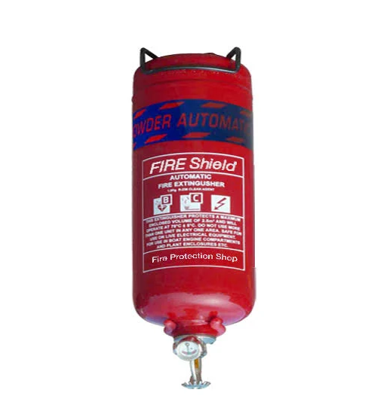 | 280.02 | Free Delivery
Cuts off |  | 22.8 | 7.14
  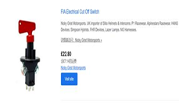

Table 7. Purchase Lead Time
Type | Lead time | Expedited Express
Fire Extinguisher FE35 | 4-5 Days | 1-2 Days
Cuts off | 4-5 Days | 1-2 Days

Special Equipment
During the project, LIU will use software such as SolidWorks and Excel.
◆ Solid works (Fig. 4) is used to measure the CAD model of the brake system by examining the model data from the data obtained from the rough measurements and reconstructing some components as necessary.
Excel is used to organize the measurement results and complete the calculation after programming the brake force distribution.
LIU also needs a variety of equipment to measure the various parts of the car, but the university will provide him with all of these equipment.
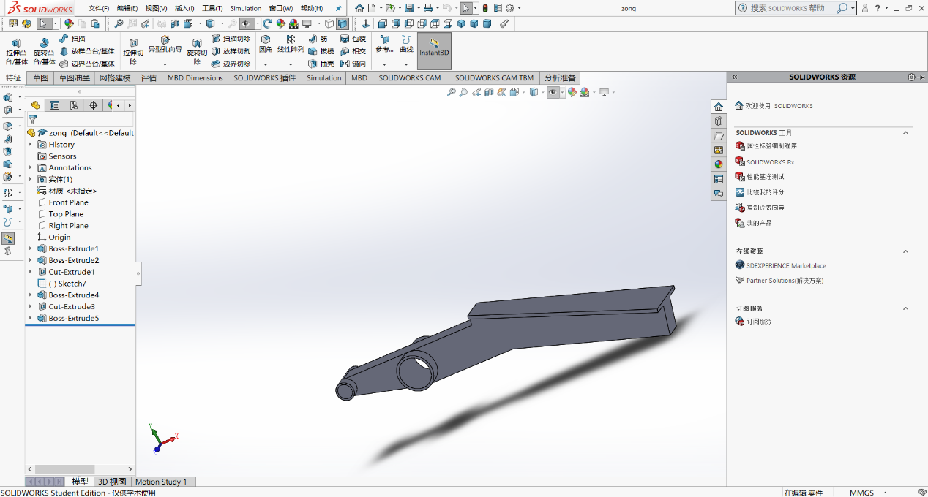
Solid works (Fig. 4)

Milestones and gateways.

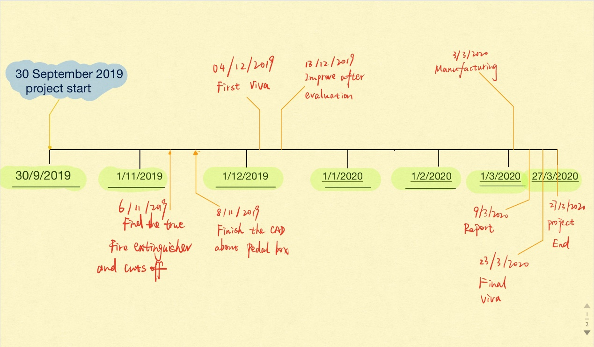

The team's five milestones have been shown on the timeline above. They have just experienced the first project, which was launched on September 30, 2019, but the second project, the first viva, is not far away. The last three are reports, and the final survival period and project end time will be completed in March next year.
To achieve these milestones, LIU needs to establish a series of its own gateways to monitor in real time whether he is ahead of schedule or behind schedule and needs to calculate his ideal bias.
In order to successfully complete these gateways, he must complete these tasks in time. At the same time, in order to motivate him to complete the basic work of the project as soon as possible, he needs to know as soon as possible the principles of measurement, data sorting and understanding.

Area of concern

First, before choosing the right built-in fire extinguisher and racing disconnector, LIU must first know a lot of basic rules, the material of the fire extinguisher, the position of the fire extinguisher on the car, the specifications of the fire extinguisher, the function of the main switch (when a critical situation occurs) Need to close some parts directly), the price of these items is reasonable and so on.
Since the rules book in the course only contains the rules of the formula car, all the rules for designing the Formula 3 car (all the groups) were found in the more than 400 pages of the rule book in the LIU and sent to the group instructor for inspection. The teacher told the LIU team that the electric car was designed. The engine of the car was a lithium battery. To find the most efficient fire extinguisher, it was pointed out that this is the rule of the diesel engine as the engine. The rules for the fire extinguisher found here are not in line with the electric car. When it was the technical rules for the LIU to go to the FIA ​​to inquire about the electric car, but when the LIU was found, the technical rules showed that the fire extinguisher design and selection were all in Appendix J and K, so the LIU went looking for Appendix J and also consulted Goodwood’s and Pikes. Pick the website to find the fire extinguisher that meets the requirements. The quality requirements of the fire extinguisher are finally found as follows: Fire extinguishers All single-seat and sports prototypes in the F, G, H and I period must have a semi-automatic (driver-operated) system, engine room, in accordance with Appendix J Requirements for open cars in Section 259.14.1. It is also recommended that this system be used in all other vehicles with a minimum requirement of safely installing at least 2.5 kg of manual or automatic fire extinguishers on the car; if it is necessary to install two smaller ones, their total capacity must be not less than 3 kg.
Specific choices for fire extinguishers:
In order to ascertain the specific choice of fire extinguishers, LIU has identified the disposal manual for portable lithium battery equipment in aircraft issued by the British Civil Aviation Authority.
In order to improve the fire safety technology of portable lithium battery equipment in flight, in 2003, the British Civil Aviation Authority (CAA) studied the effects of water, halons, FE36, dry powder fire extinguishing agents and fire blankets on fire. Based on this research, the UK CAA issued a disposal manual for portable lithium battery equipment in aircraft. In the experiment, the experimenter selected different types of fire extinguishers to study the speed at which the water-based, halon, FE-36, dry powder fire extinguishing agent and fire blankets extinguished the lithium battery.
The results show that the fire extinguishing method and the type of fire extinguishing agent are important factors affecting the fire extinguishing effect of lithium batteries, and among them, halon and FE-36 have better fire extinguishing effects. Through this study, the British Civil Aviation Authority (CAA) recommended the use of halons and FE-36 fire extinguishing agents to deal with fires that occur when portable lithium battery equipment is flying.
In the market, FE36 fire extinguishers are easier to buy than halon fire extinguishers, so LIU chose FE36 fire extinguishers.

Gantt Charts.
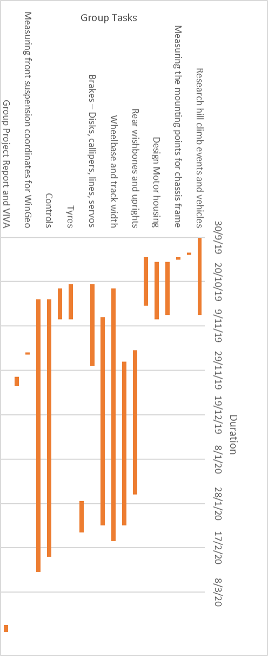
Figure 6. Group Gantt Chart
In this picture (Figure 6), we know each person's respective part of the milestone, the gateway is responsible.
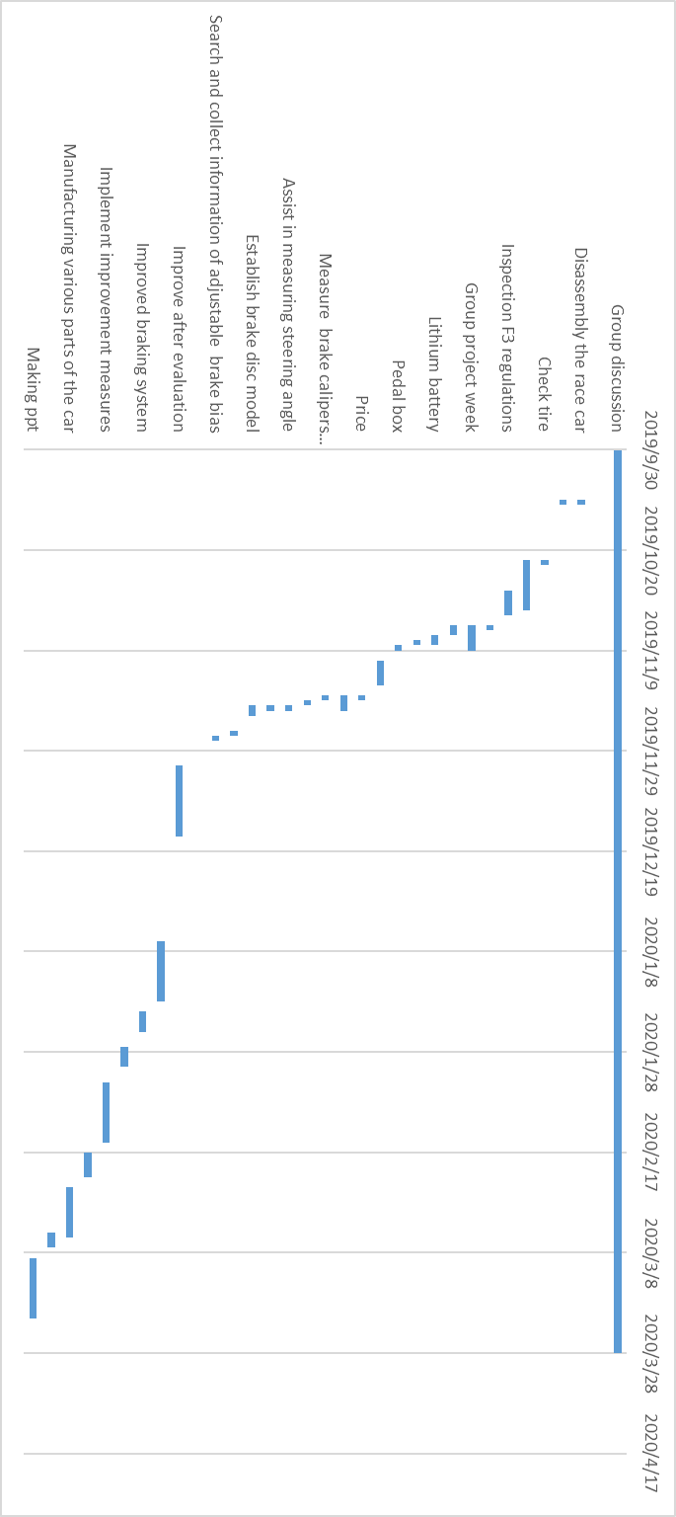
Figure 7. Personal Gantt Chart
Here (Figure 7) is the personal Gantt chart of LIU. My task is broken down into small tasks, so regardless of the progress ahead or behind, LIU can control its progress.

In conclusion.
The project has been going on for 2 months and is currently not completed (2018/11/18), but he will spend more time to complete the expected plan. And complete the task assigned by the team by the end of March.

Bibliography.
1.Belbin. (2019, 11 19). Retrieved from Belbin.com: http://www.belbin.com

2.Belbin analysis report. (2019, 11 19). Retrieved from sina: http://blog.sina.com.cn/s/blog_64ce773601016gw9.html

3.FIA FORMULA E CHAMPIONSHIP. (2019/11/20).
: FIA: https://www.fia.com/regulation/category/109

4.Yu, Z. (2009). Principle of Automobile. Beijing: Mechanical Industry Press.

5. Lain M J，Teagle D A，Cullen J，et al. Dealing With InFlight Lithium Battery Fires In Portable Electronic Devices [J]. CAA PAPER，2003 (4).

6.ZHANG LEI(2017)

http://xueshu.baidu.com/usercenter/paper/show?paperid=8d268be3a5f941483e0150b263ff6132&sc_from=pingtai4&cmd=paper_forward&title=%E6%8A%91%E5%88%B6%E9%94%82%E7%94%B5%E6%B1%A0%E7%81%AB%E7%81%BE%E7%81%AD%E7%81%AB%E5%89%82%E6%8A%80%E6%9C%AF%E7%A0%94%E7%A9%B6%E8%BF%9B%E5%B1%95&wise=0

