Working with data and Forms in VBA

Database selection using forms.
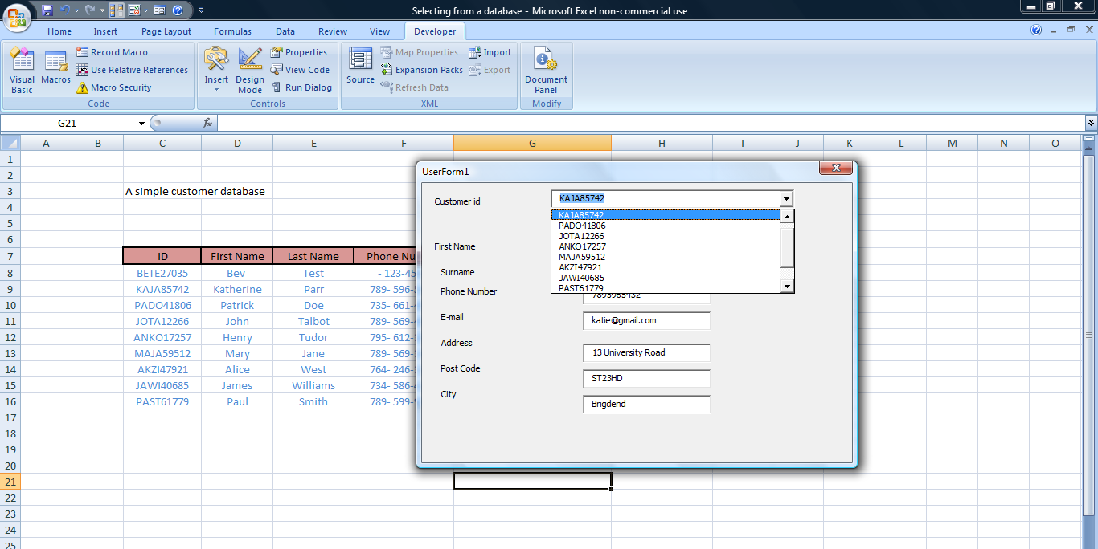

We can use the developer VBA area to set up user forms that will allow us to interact with data lists.
Set up the following simple database in sheet 1 of the workbook.

We will assume that this is a list that can be updated and we will use a form to allow our users to enter new data.

Set up the following form

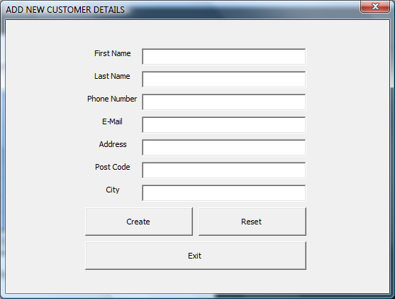

Each text box should be labelled as follows:
TXTBOX_FIRST_NAME
TXTBOX_LAST_NAME
TXTBOX_PHONE_NUMBER
TXTBOX_EMAIL
TXTBOX_ADDRESS
TXTBOX_POST_CODE
TXTBOX_CITY

Because we cannot easily predict the end of the list in our spreadsheet we need to insert our data at the top of the database list under the heading. (We do not want to delete the headings). An easy way to help with this process is to set up a working storage section to hold this variable data. So in the cell directly above each heading we are going to define a range name.
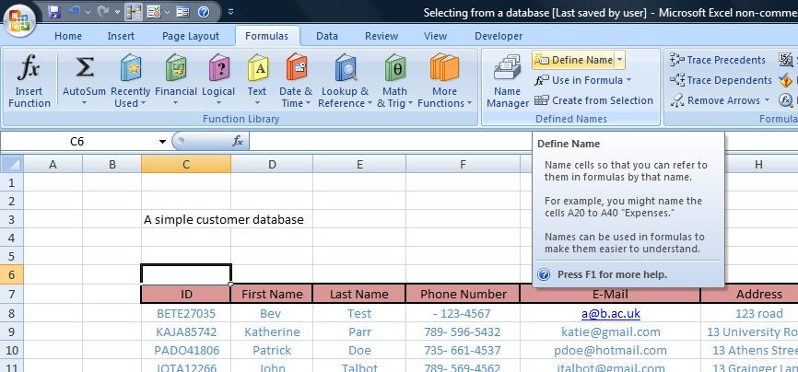

This is done in the formulas tab under define name use the following names:
WS_CUSTOMER_ID
WS_FIRST_NAME
WS_LAST_NAME
WS_PHONE_NUMBER
WS_EMAIL
WS_ADDRESS
WS_POST_CODE
WS_CITY

Add the following code to the create command button
Sheets("Customer_Database").Range("WS_FIRST_NAME").Value = _
FORM_ADD_CUSTOMER.TXTBOX_FIRST_NAME.Value

Sheets("Customer_Database").Range("WS_LAST_NAME").Value = _
FORM_ADD_CUSTOMER.TXTBOX_LAST_NAME.Value

Sheets("Customer_Database").Range("WS_PHONE_NUMBER").Value = _
FORM_ADD_CUSTOMER.TXTBOX_PHONE_NUMBER.Value

Sheets("Customer_Database").Range("WS_EMAIL").Value = _
FORM_ADD_CUSTOMER.TXTBOX_EMAIL.Value

Sheets("Customer_Database").Range("WS_ADDRESS").Value = _
FORM_ADD_CUSTOMER.TXTBOX_ADDRESS.Value

Sheets("Customer_Database").Range("WS_POST_CODE").Value = _
FORM_ADD_CUSTOMER.TXTBOX_POST_CODE.Value

Sheets("Customer_Database").Range("WS_CITY").Value = _
FORM_ADD_CUSTOMER.TXTBOX_CITY.Value

Test the form to make sure that the data is entered into the correct working storage cell

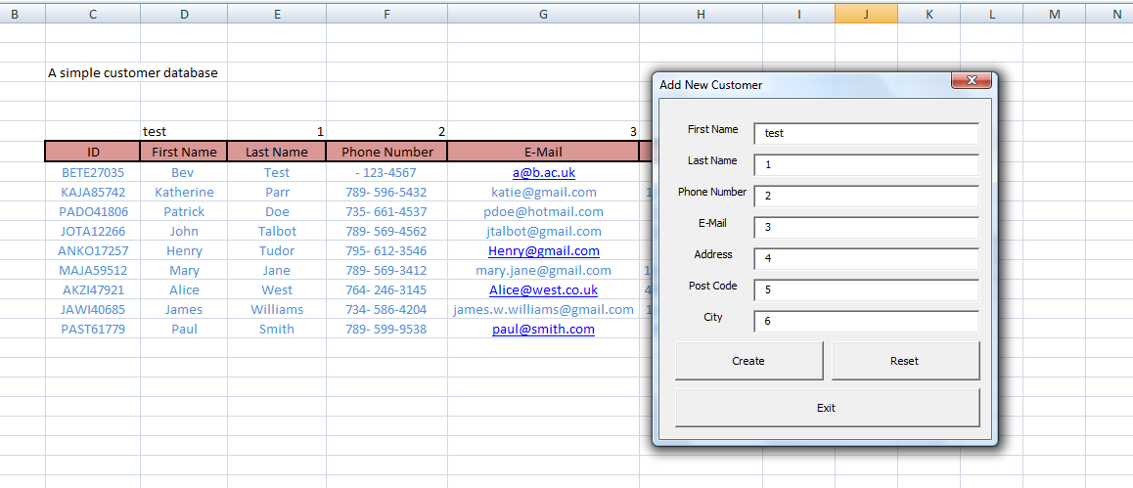

Using code to generate a random number to create a user id

Dim CUSTOMER_ID_STR As String
Dim First_Name_STR As String
Dim Last_Name_STR As String
Dim MaxValue As Long
Dim MinValue As Long
Dim RandomNumber

'Setting the minimum random number can be.
MinValue = 10000
'Setting the maximum of the random number.
MaxValue = 99999
'Initializes the random number generation by using
'the time of the day as a seed
Randomize Timer
'Random Number generation - the variable is stored as an integer.
RandomNumber = Int((MaxValue - MinValue + 1) * Rnd) + MinValue
'Extract first two character of Customer First Name.
First_Name_STR = Left(FORM_ADD_CUSTOMER.TXTBOX_FIRST_NAME.Value, 2)
'UCase converts a string into uppercase characters.
First_Name_STR = UCase(First_Name_STR)
'Extract first two character of Customer Last Name.
Last_Name_STR = Left(FORM_ADD_CUSTOMER.TXTBOX_LAST_NAME.Value, 2)
'UCase converts a string into uppercase characters.
Last_Name_STR = UCase(Last_Name_STR)
'Define Customer ID - Format = XXYY0123456 and assign it to the
'Customer_ID_STR variable as a string.
CUSTOMER_ID_STR = First_Name_STR & Last_Name_STR & RandomNumber

'Insert the Customer ID randomly generated number into the OA_CUSTOMER_ID range.
Sheets("Customer_Database").Range("WS_CUSTOMER_ID").Value = CUSTOMER_ID_STR

The reset button will allow the user to clear the content of the form text boxes we can do this with some simple code that adds blank values to the text boxes

TXTBOX_FIRST_NAME = ""
TXTBOX_LAST_NAME = ""
TXTBOX_PHONE_NUMBER = ""
TXTBOX_EMAIL = ""
TXTBOX_ADDRESS = ""
TXTBOX_POST_CODE = ""
TXTBOX_CITY = ""

Finally to close the form add the following code to the exit button

'Unloads current form
Unload FORM_ADD_CUSTOMER
Now that all our buttons work we need to add some code to copy the content of the row above our headings into the first row of our database list. The easiest way to do this is to record a macro and then copy the code generated from the macro in the CREATE_FORM_ADD_CUSTOMER button subroutine.

The code that you generate in the macro should look something like this :-

Rows("8:8").Select
Selection.Insert Shift:=xlDown, CopyOrigin:=xlFormatFromRightOrBelow
Range("C6:J6").Select
Selection.Copy
Range("C8").Select
ActiveSheet.Paste
Application.CutCopyMode = False
Range("C6:J6").ClearContents

Now we have a database we may wish to select details from the database to use for other events in an application.

Set up the following form

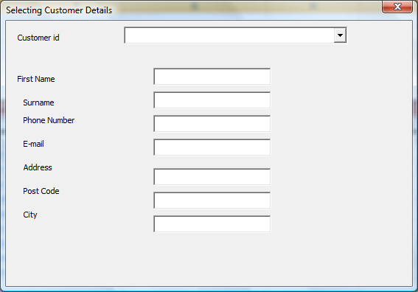

Name the text boxes as above but name the combo box as cmbcustomerid.

The combo box has to reference the whole database as we are going to use it to select customer ids. However we do not know how big the range of the database will become. We therefore have to set up a dynamic reference to the dataset.

We do this in the formula name range section. See the following window and we define a range with a dynamic offset.
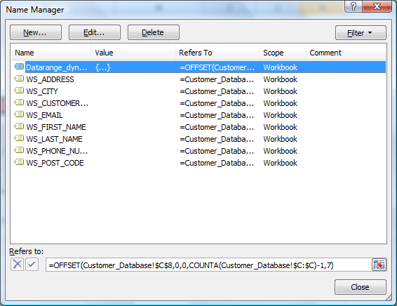

This will allow the combo box to select the correct customer data we then populate the text boxes with the appropriately found data

The code is attached to the combo box event and looks like this :

ThisWorkbook.Sheets("Customer_Database").Activate
Set FoundCustomerInformation = Sheets("Customer_Database").Range("C8", Range("C" & Rows.Count).End(xlUp)).Find(CustomerID)

If FoundCustomerInformation Is Nothing Then
MsgBox ("Error Occured: Customer ID not found.")
Else
Me.TXTBOX_FIRST_NAME = Cells(FoundCustomerInformation.Row, 4).Value
Me.TXTBOX_LAST_NAME = Cells(FoundCustomerInformation.Row, 5).Value
Me.TXTBOX_PHONE_NUMBER = Cells(FoundCustomerInformation.Row, 6).Value
Me.TXTBOX_EMAIL = Cells(FoundCustomerInformation.Row, 7).Value
Me.TXTBOX_ADDRESS = Cells(FoundCustomerInformation.Row, 8).Value
Me.TXTBOX_POST_CODE = Cells(FoundCustomerInformation.Row, 9).Value
Me.TXTBOX_CITY = Cells(FoundCustomerInformation.Row, 10).Value
End If

