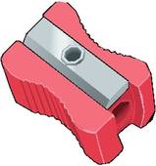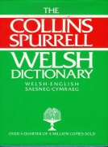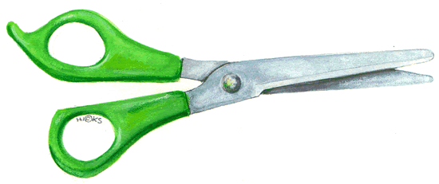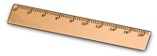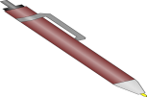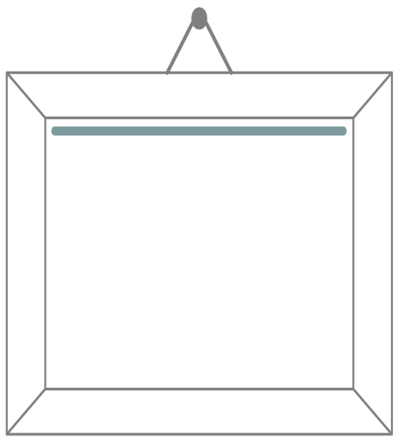
Gwers 1
Gwers 2
_______________________ ydw i.
Rydw i’n ______________________.
Gwers 3
1. P_n
2. _ens_l
3. Pren _es_r
4. R_ber
5. Ge_riad_r
6. Na_wr
7. Pens_liau _iw
8. S_ _wrn
9. Gl_d

1. Pen _____________________ 6. Glud ____________________
2. Pensil _____________________ 7. Siswrn ____________________
3. Pren mesur ____________________ 8. Pensiliau lliw__________________
4. Rwber _____________________ 9. Geiriadur ____________________
5. Naddwr _____________________

Cofiwch!
The following are one letter in Welsh – ch, dd, ff, ng, ll, ph, rh, th

