NAME: ABEL ANTONY JOSEPH
STUDENT ID: 2130529
MBA GENERAL MANAGEMENT
DISSERTATION LCMB7020_LON
2023
SUPERVISOR: JIA MIAO

The Importance of Managing Human Resources for Achieving Business Growth in The International Market.


Master’s Degrees by Examination and Dissertation
Declaration Form.
1. This work has not previously been accepted in substance for any degree and is not being concurrently submitted in candidature for any degree.
Signed: ABEL ANTONY JOSEPH
Date: 16/6/2023

2. This dissertation is being submitted in partial fulfilment of the requirements for the degree of Master in Business Administration.
Signed: ABEL ANTONY JOSEPH
Date: 16/6/2023
3. This dissertation is the result of my own independent work/investigation, except where otherwise stated.
Other sources are acknowledged by footnotes giving explicit references.
A bibliography is appended.
Signed candidate: ABEL ANTONY JOSEPH
Date: 16/6/2023

4. I hereby give consent for my dissertation, if accepted, to be available for photocopying, inter- library loan, and for deposit in the University’s digital repository
Signed: (candidate) ABEL ANTONY JOSEPH
Date: 16/6/2023
Supervisor’s Declaration.
I am satisfied that this work is the result of the student’s own efforts.
Signed: JIA MIAO
Date: 16/6/2023
Abstract

Regardless of the nature, size, or location of an organization, employees are seen as its foundation, and they require both guidance and motivation to achieve success. It is essential to provide direction in managing employees, which ultimately enhances their productivity. The careful consideration and serious discussion of "employee benefit decisions" are crucial because they directly impact a firm's competitive position in the market. Among these decisions, compensation policies such as "health insurance policies" play a significant role in retaining and maximizing employee productivity. The study aimed to recognize the significance of effectively managing employee benefits to attain business growth in the global market. This objective was reinforced by the following four goals: To formulate an understanding of how the management of employee benefits can contribute to business growth, to critically analyse the Harvard model of human resource management within the context of international business, to examine the employee benefits and compensation policies of ten multinational corporations (MNCs) in the UK, utilizing secondary data, and to provide recommendations for improving employee benefits practices to achieve business growth. The study utilized secondary data sourced from MNCs' annual reports, along with an analysis of relevant literature pertaining to the research topic, organized into various themes. The research employs a mixed method approach, beginning with a qualitative method that involves examining previously conducted research works from the period spanning 2015 to 2023. To enhance the credibility of the findings, the study considered the potential influence of Return on Assets (ROA) on the relationship between employee perks and firm growth by including it as a control variable. A qualitative study could provide further insights into employee attitudes and behaviours, considering cultural and historical contexts. The study highlighted the importance of managing employee benefits for business growth, offering recommendations for policy enhancement. It serves as a foundation for future empirical research in different business sectors, emphasizing the significance of effective employee benefit practices.

Content page

CHAPTER 1 INTRODUCTION 5
1.1 Research Background 5
1.2 Research Significance 5
1.3 Aim 6
1.4 Objectives 6
1.5 Research questions 7
1.6 Research Rationale 7
1.7 Research Gap 7
1.8 Snapshot of research methodology 8
1.9 Research Structure 8
CHAPTER 2 LITERATURE REVIEW 10
2.1 Employee Benefits 10
2.2 Types of employee benefits 11
2.3 Impact of Employee Benefits on Business 12
2.4 Harvard Model of Human Resource Management 14
2.5 Employee Benefits and Compensation Policies 15
2.6 Employee benefits influence the performance indicators 19
2.7 Conceptual framework 20
2.8 Conclusion 21
Chapter 3 RESEARCH METHODOLOGY 22
3.1 Research philosophy 22
3.2 Research approach 22
3.3 Research method 23
3.4 Research design 23
3.5 Data collection and analysis methods 24
3.6 Data analysis 24
3.7 Sampling 25
3.8 Ethical consideration 25
Chapter 4 RESULTS 26
4.1 Introduction 26
4.2 Method of analysis 26
4.3 Variables 27
4.3.1 Predictor parameter 27
4.3.2 Response parameter 27
4.3.3 Control variable 28
4.4 Data analysis 28
4.4.1 Distribution Statistics 28
4.4.2 Correlational analysis 30
4.4.3 Regression 33
4.5 Hypothesis testing 38
4.6 Conclusion 38
4.7 Discussion 40
CHAPTER 5 - CONCLUSION 43
5.1 Recommendations 45
5.2 Recommendations for future study 46
6. References 48
7.Appendices 61
1.1 Appendix 1: descriptive statistics 61
2.1 Appendix 2: correlation 62
3.1 Appendix 3: Regression (ROE) 63
4.1 Appendix 4: Regression (EPS) 64
5.1 Appendix 5: Regression (Profit) 65

CHAPTER 1: INTRODUCTION

Research Background
Employees are considered the backbone of any organisation regardless of its nature size or region, and employees need direction and motivation for attaining success. Guidance is mandatory in managing the employee leading to a boost in employee productivity. According to Clark (2023a), nearly 32.9 million were employed in UK, in the initial part of 2023, which was the same in late 2022. The data reveals employment in UK is experiencing a leap after 1983 marking the least in the same year with 23.6 million employments. The initial three months of 2023 had an employment growth rate of 75.8%, which was previously 75.5% for the last three months of 2022. Since 2011, the employment rate in UK has been increasing tremendously, reaching a peak in 2020, and then it slowly started diminishing (Clark, 2023b). In terms of different sectors in the economy, “the private sector” in the UK employed 5 million people in the wholesale as well as retail trade sectors in 2022, marking as the largest employment provider of 2022 succeeded by “administrative and support service activities” providing 2.99 million employments (Clark, 2022a). In accordance with the public sector in UK, “National Health Service”, and the education sector are the biggest providers of employment with 1.9 million and 1.5 million employees respectively (Clark, 2023c). According to Stewart (2022), 53% of UK institutions actively participate in and encourage activities focused on the well-being of the employee, which has reflected in ensuring the sound mental health of the employees. Moreover, 35% of organisations pay moderate attention towards mental health and 26% have focused on “good work” promoting a sound work-life momentum. During the period 2021-2022 governing authority of UK invested around £13.1 billion in activities associated with employment generation and allied activities, which was £13.8 billion earlier thereby showing a slight decline (Clark, 2022b).

Research Significance
“Employee benefit decisions” are one of the vital concerns which should be discussed with utmost seriousness as it have a direct influence on the competitive position of firms in the market. Among the decisions promoting employee benefits compensation policies such as “health insurance policies” adopted by a firm have an eminent role as it will aid in the retention and productivity of the employee (Krekal et al., 2019). Even though the employee benefit decisions are proven to be advantageous for both the employers and the employees, the cost associated it will be considered as a burden for the organisation. Considering the cost, it absorbs the tierce of accumulated labour costs and shows an increase continuously (Gubler et al., 2018). Over the years employee benefit initiatives adopted by a corporate have evolved significantly as firms have taken it as a measure to attain success and competitive advantage. The major advantage of employee benefit schemes is that it will be favourable for the companies in the long run through the retainment of employees and escalates productivity by providing work satisfaction and encouragement (Adebisi and Oladipo, 2015). Being valued by the organisation and assured by employee benefits packages, workers in the organisation will become more committed and dedicated towards the assigned duty (Odunayo, 2022).
Moreover, high competitiveness in the market and the threat of being replaced compels organisations to look after the matter of employee well-being which is now has turned from the basic need of survival to retaining a position in the market and becoming stable in the economy. A healthy and sound workforce attributed to employee benefit programmes contributes to the efficiency in the financial performance of the firm, leading to business growth as well as development (Jaworski et al., 2018). However, failing in providing proper guidance and appropriate employee benefits packages will have an adverse impact on the goals of the company and that will mirror its performance. Thereby exploring employee benefits schemes and implementing them in an organisation with equal importance is vital for a firm’s well-being (Klein and Guillen-Walsh, 2021).

Aim
The importance of managing employee benefits for achieving business growth in the international market.

Objectives
- To develop a concept of how employee benefits management can facilitate the growth of a business.
- To assess the Harvard model of human resource management in the context of international business through critical analysis.
- To investigate the employee benefits and compensation policies of ten multinational corporations (MNCs) in the UK, using secondary data.
- To propose recommendations for enhancing employee benefits practices to achieve business growth.

Research questions
- How employee benefits management can facilitate the growth of the business?
- What is the relation between the Harvard model of human resource management and international business?
- How employee benefits and compensation policies are associated?

Research Rationale
The UK government has made certain employee benefit initiatives as mandatory practice for organisations. Retirement, sick pay, maternity/paternity pay and vacay pay are important compulsory employee benefit policies. There are also attributional policies such as income protection, private as well as critical illness medical insurance and employee support programmes (Quek et al., 2021). A pivotal component of the employee benefits programme is the pension scheme, which is a mandatory provision in UK, and the government has made a minimum compulsory contribution from the side of the employer, which is now confirmed as 3%. Even though the employer can distribute more than of it, UK government policies of maximum limit to allowances need to be followed (Gilchrist et al., 2015). The main concern in regard to employee benefits management is that the nature of people differs the same as in the case of priorities and interests, thereby completely satisfying or fulfilling the needs of every employee is not a possible thing that a firm could perform (Dachner et al., 2021). Government officials being rigid on certain policies, complications may arise for both the parties involved namely the beneficiary and the benefactors. These are the serious issues that emerged in association with the employee benefits scheme in UK (Wiefek et al., 2019).

Research Gap
Regarding the studies after the necessary research and reviewing several literary works, there are a limited number of studies in association with employee benefits’ role in business performance. Especially in the research context of UK, and studies regarding MNCs in connection with employee benefits are very rare to find even though there is a large scope for it (Agubata et al., 2022). This research study will be performed under mixed method, which will assure its reliability and accuracy through the validation using appropriate methods and tools. Integration of both qualitative and quantitative analysis will provide an outcome that will be authentic and credible (Esthi and Ekhsan, 2020). Thereby this research analysis will fill the gap which previous literary works leave behind in terms of the method adopted, context analysed and sample size selected.

Snapshot of research methodology
The research study will follow a mixed method, which is a mixture of performing both qualitative and quantitative analysis for the same phenomenon. For attaining the best outcome which is perfect in every way mixed method will be a great support. Pragmatism philosophy will be applied for this research analysis supported by an abductive approach and exploratory research design. The study will be conducted on the basis of secondary data collected from the annual reports of MNCs. The sample size which is going to be analysed in this research is predetermined as 10, and the quantitative data analysis will be performed with the aid of SPSS statistical instrument. The functions such as “regression, correlation and descriptive statistics” in the SPSS tool will support the secondary quantitative data analysis. In association with qualitative analysis, thematic analysis will be conducted where previous literary works associated with the research topic will be analysed under different themes.

Research Structure
Figure 1: Structure of the research
Chapter 1 - Introduction

Chapter 2 - Literature Review
Chapter 5 – Conclusion & Recommendations
Chapter 4 - Findings Analysis
Chapter 3 - Methodology

Source: Self-developed
The “research structure” of a research work illustrates the outline of the research study in a precise manner, providing an overall preview of the work. The foremost section in a research study is the introduction part comprising the “background, rationale, significance, research questions, aim along with objectives, a snapshot of methodology and the research gap”. Introduction part is succeeded by “review of literature” section where earlier published journals and articles were reviewed and analysed to build a general grasp of the research topic. The third section of the research study is the methodology which deals with the concepts and terms associated with the processes involved in research analysis. The practice of data collection and data analysis is explained in this section. The methodology section is followed by the pivotal section of the research work, the findings and analysis part, where the outcome of the research analysis is derived and interpreted. Chapter four of the research work also consists the discussion section, where the comparative analysis is performed; the research results were compared with the previous study results prescribed in chapter two of the study. The final section of the main body of research analysis is the “recommendations and conclusion section”, this section answers the research question put forward in the research study in its initial part which is the introduction section. Suggestions for improvement and problem solutions were also presented in this part. After the main body, the references and appendices were attached in this research work.

CHAPTER 2: LITERATURE REVIEW
A review of literature is an extensive summary of the previous research that critically analyses based on the topic of the significance of employee benefits management for attaining corporate growth in the global market. The studies from the years 2014 to 2023 are evaluated for this review, which begins with a discussion of the major findings and a critical evaluation of them in light of the aims and research questions.

2.1 Employee Benefits
Employee benefits involve any type of financial or non-financial remuneration given to workers in addition to their basic pay or base salary based on how well they perform for the company. The components of a comprehensive benefits package for employees might include health insurance, life insurance, paid time off, profit sharing, and retirement benefits (Ko and Hur, 2014). Employees receive a perk in addition to their salary, which is a fringe benefit and the workers are inspired by it. The presence of fringe benefits fosters a motivated atmosphere that raises output, sales, and profitability and the employees receive bonuses when they meet specified benchmarks and criteria (Yousaf et al., 2014). According to Idris (2014), businesses are beginning to look to flexible working as an alternative to rising cash rewards, which are believed to be an unsustainable approach for staff retention. Flexible work schedules can reduce stress, boost job satisfaction, minimise tardiness and absenteeism, and boost productivity (Austin et al., 2020). However, a variety of flexible work arrangements provide employees with a number of benefits. Flexibility in the workplace is typically regarded favourably, but it is also believed to be essential for extending the working lives of older employees and assisting businesses. Organisations see flexibility from four related perspectives, including; a specific employee perk, to increase operational effectiveness, being a crucial component of organisational strategy and in order to solve underlying societal inequality (Earl and Taylor, 2015).
Businesses should strive to increase overall efficiency as well as the benefits that employees receive personally and the conditions in which they work and live, this will help employees be more productive at work (Zhang, 2016). Companies may spend on employee benefits and sustain positive employee relations while accumulating significant cash reserves as a result of strong financial performance (Ghaly et al., 2016). Employee reward programmes have a greater impact on employee motivation than on productivity; Executives and employees place the most value on financial benefit programmes; Employees of different genders have different expectations for benefits, and those who are single are more likely than those who are married to think that benefits have a greater impact on job performance (Kossek and Thompson, 2016). However, they can also be influenced by an employee's position within the organisation, accomplishments, and length of service (Stalmašeková et al., 2017).

2.2 Types of employee benefits
Employers should provide their employees life insurance, sick days, dental insurance, and health insurance. In addition, paid holidays, additional unemployment compensation, pension plans, educational and legal support, and a plethora of other benefits, are among the major employee perks (Lemma, 2014). Health insurance may pay for the costs of medical, dental, and vision care for workers and their dependents (Howe, 2014). Hospitalisation coverage is offered by employee health insurance, covering costs associated with admission and discharge. Some employee health insurance plans include payments for the costs of specialists and other medical professionals for follow-up visits (Pitacco, 2014). Employees are more likely to be content when they have more control over their working hours. Offering flexible work hours will, therefore, encourage employee satisfaction, and satisfied employees are the foundation of productive and successful enterprises. Better communication between businesses and employees is another benefit of flexible scheduling (Galea et al., 2014).
Employers may offer benefits for parents, such as on-site childcare, financial aid, or referrals and this can assist working parents balance the demands of their families and employment (Brady, 2016). Family benefits help workers at different levels of their lives balance and juggle their responsibilities to both their families and their careers. These benefits include parental support in the form of advice on family planning, financial assistance for raising children, mental health assistance, and access to speciality care (Caillier, 2016). Remote employment helps employee capacity to maintain a healthy balance between work and life due to the flexibility of scheduling the work and the absence of established hours of labour. One of the numerous flexible work arrangement options is the notion of working from home, combined with a part-time work system and flexible working hours (Nordin et al., 2016). Employee benefits insurance is a type of life insurance policy that an organisation provides to its staff members. It offers its employee health and life insurance in case of unexpected medical or other problems. It aids employers in keeping on board current personnel and luring fresh talent to their organisations (Jaworski et al., 2018). Some companies provide pensions, which are delayed payments that are collected during the employee's employment and given back to them upon retirement. These programmes may be an excellent method to retain staff members and assist them in saving for retirement benefits (Spisakova, 2019).

2.3 Impact of Employee Benefits on Business
The cost of “workers benefits” is still increasing since using more and more benefit programmes, such as traditional pensions, participation, and health care. However, if the employees do not understand the value that they receive, the generous benefit schemes constitute a serious competitive disadvantage (Oladapo, 2014). Lin et al., (2014) stated that The strength of the link between employee benefit systems and overall business success is mediated by the attitudinal and behavioural outcomes that are brought about as a result of employees' psychological well-being.
There is a strong and favourable correlation between employee engagement and output. It has been discovered that intrinsic incentives significantly improve employee motivation and output (Shahzadi et al., 2014). Moreover, motivation has a poor correlation with employee perceptions of training effectiveness. It does not incorporate the training into their regular teaching since they believed it to be unproductive. Motivation has a big impact on employee happiness, and you may increase motivation by designing incentive programmes with the staff's interests in mind. It could lead to the following developments: incentives, both financial and otherwise, Promotional opportunities for employees and discipline for underperformers (Abbah, 2014). The management must make efforts to increase employee motivation both organically and extrinsically by increasing wages and perks, appreciating employee opinions, and supporting initiatives (Jayaweera, 2015). Mangkunegara and Octorend (2015) convey that motivation has been a multidimensional criterion, it appears that each employee's level of self-motivation has been fairly high and needs to be raised again by meeting their fundamental requirements. It’s like getting enough rest, providing suitable perks and paying salaries that reflect employees' requirements encouraging them to perform at their highest level in order to meet organisational objectives. The stronger perceptions of inclusiveness held by workers led to considerably better levels of organisational commitment and job satisfaction. Furthermore, significantly less intention to leave was shown by employees who had higher degrees of organisational commitment (Hwang and Hopkins, 2015).
Ghaly et al., (2016) claim that enterprises in sectors with high levels of labour competitiveness, a need for human capital, and labour mobility are more affected by employee welfare regulations in terms of their cash holdings. Girimurugan et al., (2016) assert that employee wellbeing facilities are crucial for all successful businesses for the reason that they enable the organisation to recognise and address employee issues. The multiple welfare programmes that the corporation provides will directly affect the workers' well-being, physical and mental capabilities, attentiveness, morale, and overall effectiveness, which will result in increased output. As per the study by Guo et al., (2016), increased employee benefits make it easier to recruit, train, and motivate staff, prevent the lossing of valuable human assests, and limit the possibility of improper internal control activity on the part of employees. Moreover, financial restatements were less common in businesses that invested more in employee benefits, particularly those brought on by accidental mistakes.
In the opinion of Kim et al., (2016) welfare systems are characterised as extra advantages that employers give their workers in addition to pay to increase their level of stability, health, and general well-being. Improvements to welfare programmes, such as welfare facilities and effective vacation policies, increased organisational engagement in the service industries. Statement by Ummah, (2017) the welfare of the employee has a negligible impact on the employee's loyalty with changeable employee benefits that are typically economic and services, the benefits frequently have a big effect on a worker's loyalty. Workers benefits, facility characteristics, and variable characteristics are the three factors that most strongly affect employee loyalty. In the views of Clemens et al., (2018) there are spillover effects into jobs that are a little higher up the wage distribution for both insurance coverage and wage effects. Benefit packages designed to be the same for both high - and low-skilled workers can explain the estimated salary and insurance coverage spillovers. Serrano et al., (2018) assert that cynicism suffers a great deal as a result of the economic aspect, and this could be the result of the fact that employees directly benefit from corporate profits through incentive bonuses and an increase in negotiating leverage when profit margins rise.
The adoption and provision of several employee benefits are expensive and might not be practical for businesses with limited resources. Moreover, constant resource inputs are frequently needed to improve staff welfare and working conditions, which could drive up production and operating expenses for new businesses (Messersmith et al., 2018). In the views of Krekel et al., (2019) there is a highly positive link amongst workers productivity, customer loyalty, and employees' contentment with their employer, and there is also a substantial negative correlation between staff turnover and customer loyalty. In the end, greater profitability at the business-unit level is positively connected with higher well-being at work. According to Chandrasekaran and Ganeshprabhu, (2020), employees are happy with a variety of amenities, including technological advancements, medical care, lighting, seating, and drinking water. Welfare programmes have been found to lower worker absenteeism and boost staff productivity. Also, they are closely tied to productivity, and in order to increase both, businesses offer their staff members a variety of welfare benefits. Islam (2020) claims the two most typical long-term employee perks that firms offer are recognised provident funds and gratuity funds, through which it distributes revenues to their workforce. Besides this, long-term employee benefits are primarily restricted to recognised provident plans and gratuity funds Krekel et al., (2019). Additional short-term employee benefits and defined benefit plans were not disclosed in detail. Agubata et al., (2022) point out that the measures of employee benefits, such as gratuity, pension, and medical allowance, have a favourable, considerable impact on organisational growth. The consumer goods industry's employee benefits programmes have a favourable and considerable impact on the business expansion. According to Chanchiaw et al., (2022) benefits for employees are regularly developed and improved in accordance with the trends and directions of benefit want that change in response to external environmental conditions. Employees in the organisation require provident funds to be established, health insurance for workers and their families, planned recreational events, sales incentives, company cars and business cars for use, and annual bonuses provided.

2.4 HRM Model Harvard
“The Harvard Model” was one of the earliest HRM models to be established and it is derived from a work by Michael Beers in 1984. The fundamental idea behind the concept is to improve and strengthen the bond between an organisation and its personnel in order to produce increased output in accordance with the company's objectives (Ihuah, 2014). Asserted that the Harvard model's goal is to define the process of equating the respective interests, which is then expected to influence the organization's decision regarding the type of human resource management practises being used in relation to the organization's policies, employee influence, organisational structures, reward programmes, and the influx and outflow of human resources (Wood et al., 2014). The Harvard model is both the most prevalent and typical example of a soft HRM paradigm and it is fundamentally distinct from other resources in that it regards them as resources, and employees are important stakeholders. It includes the way people relationships with the external environment and internal organisational dynamics (Rok and Mulej, 2014). Harvard’ approach ignores the influence of several stakeholders in influencing the intended HRM. Nevertheless, the model assumes that employee demands may differ from those of the organisation, which may alter their perceptions and assessments of HRM, and builds on behavioural and communication theories like attribution theory (Audenaert, et al., 2014).
Multiple stakeholders, organisational context, and a multidimensional performance construct are all part of the Harvard model's theoretical framework. The Harvard model proposes that the strategies, policies, and procedures of Strategic HRM fall under four major categories: Influence and participation of employees. Human resource flow involves all HRM functions of Employee management; Reward programmes, the monetary and non-monetary rewards given to employees; Work systems which include taking into account the "fit" of employees with their workplaces (Rotich, 2015). The Harvard approach provided by Beer et al., (2015) is composed of six key components: context-specific considerations, stakeholder interests, HR policy choices, HR results, long-term effects, and a feedback loop through which the outputs are fed back into the business and to the stakeholders. The Harvard model presents a systems viewpoint on human resource management, where all the components interact to produce a total that is larger than the total of its parts. The perspective of these processes seeks to further scientific unification and, in HRM, the comprehensive and integrated management of human resources (Bondarouk and Brewster, 2016). There have been produced new HRM viewpoints, including the extended Harvard model, high-performance work systems, high-commitment HRM, and high-involvement HRM. These models can be used as a springboard for including employee well-being as an HRM result.
However, these models don't specifically emphasise worker well-being. While high-performance work systems emphasise employee performance, the Harvard model emphasises stakeholders (Adamovic, 2018). Sato et al., (2020) discovered using the Harvard Model, a well-known HRM theory, difficulties are clarified by identifying areas where HR Systems can be strengthened. However, the Harvard Model's short-term HR outcomes and HRM Policy Choices are the main areas of development. As a result, Sato et al., (2020) confirmed that the goal of identifying the company's issues and encouraging dialogue with management and HR employees of other organisations was achieved. In addition, In a training curriculum for those with some past experience working in human resource departments, this strategy might be applied. The categorising of inputs and results at both the organisational and societal levels is a component of the Harvard model that supports a critique of comparative HRM (Bratton, et al., 2021).

2.5 Employee Benefits and Compensation Policies
In Negash, et al., (2014) opinion the incentive of staffs to work hard is correlated with salary and its components. Direct remuneration, indirect compensation, and non-financial rewards are all forms of reward. Salary, incentive payments, and other benefits and services are only a few of the instances of the numerous sorts of rewards and benefits that can be included in an organisation's compensation plan. However, one of the biggest causes of employee churn is a lack of fair compensation. As specified by Gupta and Shaw, (2014) employees are rewarded with pay, commission, loyalty bonuses, alluring health insurance coverage, paid vacation days, and paid holidays. Higher pay is seen to improve the working environment by fostering more adaptability, efficiency, and performance (Ongel, 2014). Moreover, organisations should offer competitive pay packages, room for salary increases, benefits that are customised to each employee's needs, and flexible work schedules. As stated by Terera and Ngirande, (2014) that retaining employees depends on them feeling satisfied at work and receiving rewards. Therefore, it is imperative that management develop a retention strategy that emphasises employee compensation and work satisfaction as critical components. This implies that management should have the ability to develop a comprehensive incentive structure that comprises factors other than salary.
In accordance with Abou and Imran, (2014) the total compensation, a person receives includes the satisfaction brought on by their employment, therefore staffs who are more gratified with their job are frequently ready to take a lesser Paycheck. Being empowered will make employees more self-reliant and confident, and this extra certainty is advantageous since it supports high levels of productivity and job happiness. Rizal, et al., (2014) states that compensation has a major impact on employee motivation and organisational commitment although it does not have a large impact on staff efficiency. workers performance is significantly impacted by both commitment and motivation. As claimed by Muguongo, et al., (2015) the amount of compensation received does not correspond to their work description, and it was determined that employees’ basic compensation, which includes the pay structure, consistency of the policies, administration, and on-time salary payment, has a positive unfavourable impact on their job fulfilment. However, some businesses just see this as a cost, failing to take into account the strategic advantages of a well-thought-out compensation and benefits plan. From the perspective of Newman, et al., (2015) firm's external reputation will likely be improved by an employee who sacrifices personal gain for the sake of society as a whole and the communities in which they operate. This individual will also likely promote employee pride in their employer and their identification with the company. The statement of Dajani and Zaki, (2015) claims that benefits and compensation are necessary prerequisites for employee engagement. This includes monetary pay as well as non-financial incentives like praise and other perks like on-site childcare, employee support programmes, subsidised cafeterias, travel discounts, additional holidays, and other benefits. The attractiveness of the benefits and compensation that employee receives has an impact on how motivated they are at work.
According to Haider, et al., (2015) Employee retention is strongly influenced by HR practises, and it is inversely connected with training and development and favourably correlated with salary and culture. Moreover, a significant factor in employee retention is a competitive wage and benefits package, but this is not the whole picture. Robescu and Iancu, (2016) convey that the most effective performance-based pay increases are those that are monetary in nature as opposed to intangible. To satisfy the criteria, employees must have a clear understanding of the connection between compensation and performance. They would prefer alternative advantages that clearly demonstrate their rank than cash payment, which is not allowed. As explained by Iqbal et al., (2017) businesses use pay, incentives, stock options, traditional health insurance, and retirement plans as part of their compensation and benefits packages to help retain staff. Bonus or profit-sharing plans are thoughtfully created so that they offer motivating, attainable goals for employees to strive for it. Al Mamun and Hasan, (2017) point out that employees are more likely to be attracted in by a high salary, more generous perks, or greater chances for career progress If they have skills that are in demand.
However, the technique is highly complex and taxing to an organisation in order to meet fundamental demands and give a decent working environment, good pay, and other perks in an economy. Kaur, (2017) opines that companies must overcome a number of obstacles when designing a compensation plan that supports an staff efficiency increasing programme. Despite the claims of many businesses, compensation increases are not necessarily linked to success. Some companies work hard to promote a collaborative culture while still honouring individuals for their achievements. Employees may become frustrated and pessimistic as a result of these inconsistencies. Darma, and Supriyanto, (2017) stated that pay in the form of a salary, wages, bonuses, facilities, amenities, travel perks, and holiday allowance directly influences an employee's performance in a positive way. Worker fulfilment was directly impacted by the salary variable, if the company pays their employees more, employee happiness will increase. In conformity with Khalid and Nawab (2018), the industrial comparisons showed that the service sector can benefit more from both direct and indirect forms of employee participation. Due to the structure of its processes, it was discovered through interviews with manufacturing sector businesses that employee engagement in the financial form has a greater impact on retention. Even though Ben-Nasr and Ghouma, (2018) claim that employee benefit programmes that are too lavish can be viewed as a tactic employed by managers to discourage prospective whistle-blower behaviour on the part of their workforce.
Along with that, it is reasonable to assume that workers who receive large benefits would be less likely to report fraud or improper behaviour in their workplaces. From the perspective of Sudiardhita, et al., (2018) work motivation is positively impacted by compensation, job satisfaction is significantly and favourably impacted by compensation, job gratification is positively and significantly impacted by work motivation, Compensation, work motivation, and job satisfaction all positively and substantially affect employee performance. In the opinion of Bilan, et al., (2020) that greater access to salary and benefit plans is made available to managerial workers. The establishment of equal treatment standards in the workplace must be a concern in the development of social dialogue, the formulation of compensation and benefits policies, as well as the identification of non-discrimination standards for their application. Končar, et al., (2020) claims the significance of a strong correlation existing between employee well-being at work, commitment, motivation, and readiness for job completion in order to boost productivity and achieve higher profitability in enterprises. However, the employees' expectations for their pay and perks, prospects for advancement, job rotation, and job security are not satisfied, they lose interest in their work and become demotivated, leading them to start seeking alternative employment opportunities.
Nguyen, et al., (2020) claim that compensation refers to any monetary gains, rendered services, and benefits received by employees as a result of their job relationship. Direct compensation, such as salary, bonuses, and overtime pay, and indirect compensation, such as bonuses and facilities, are the two ways that compensation is assessed. While non-financial rewards might take the shape of compliments, gratitude, acknowledgement, and time off from work. By the statement of Ali and Anwar, (2021) the development of favourable working conditions and the implementation of competitive compensation plans for employees increases employee satisfaction, motivation, and dedication to the enhancement of an organisation's overall performance. Furthermore, positive tangible advantages are bonuses, help, promotions, and amazing extra money above and above the wage, whereas negative benefits include withholding bonuses and promotions from employees or even cutting their pay. As explained by Sitopu et al., (2021) remuneration includes wages, benefits associated with employment, particular allowances, bonuses associated with or associated with organisational and job success, intense as an achievement reward, and various types of regular assistance and healthcare facilities, pension plans, pay during leave, and disaster relief are indirect benefits. Meher and Mishra, (2022) convey that employee benefits have a big impact on employee happiness, and knowledge management practises have a substantial impact on employee benefits as well. The benefits of knowledge management practice are mainly focused on the motivational elements that can be raised through their application.

2.6 Employee benefits influence the performance indicators
Investors and corporate leaders typically use the study of return on equity to assess how much profit the suitable owner's own capital can provide. The examination of return on equity is crucial for investors since it can show them the advantages of their investments (Dean, 2014). Due to the pull influence, it has on investors to invest, this study is crucial for companies (Purnamasari, 2015). A company's net income is divided by the equity of its shareholders to calculate its return on equity (ROE). It serves as a gauge of a company's profitability and the effectiveness with which those profits are produced. Employee engagement influences employee benefits as the performance indicator, it is frequently employed in modern organisations (Barrick et al., 2015).
Return on assets (ROA) is a measure of a company's profitability in relation to the assets or resources it owns or controls. Investors can use RoA to identify promising stock possibilities when the ratio demonstrates how well a business uses its assets to produce profits (Li and Wang 2014). Remuneration influences employee benefits as the performance indicator, good remuneration for workers has been identified as one of the strategies a business may use to improve employee performance and, as a result, raise productivity. Providing unwanted benefits to employees affects the companies RoA very badly through their revenue and expenses (Ongalo and Tari, 2015).
Return on investment (RoI) is a performance metric used to assess an investment's effectiveness or profitability or to compare the effectiveness of several distinct investments. RoI aims to quantify the amount of return on a specific investment in relation to the cost of the investment (Boyd et al., 2015). The good attitudes and behaviour of employees indicate their performance, such as the capacity to recruit key personnel, the interactions between co-workers the interactions between managers or supervisors and employees, as well as the low rate of labour turnover (Lin et al., 2015).
Earnings per share (EPS) is a crucial financial metric that shows a company's profitability. It is computed by dividing the company's net income by the total number of shares that are currently outstanding. It is a tool that market players typically employ to evaluate a company's profitability prior to purchasing its shares (Fatoki and Olweny, 2018). The quality of the work produced, the quantity of the work generated, the amount of working time, and cooperation with coworkers are all performance indicators, the performance is a comprehensive measure of actual behaviour in the workplace (Sudiardhita, et al., 2018). Employee satisfaction is strong, while business productivity and profitability are at an all-time high. Benefits raise employees' spirits and increase their sense of well-being, which results in higher performance (Pattnaik and Jena, 2020). The degree of employee engagement in a company is crucial when evaluating the results of perks for employees, the employee engagement has always been difficult to define and quantify. However, there are employee engagement metrics that may be tracked and provide vital data regarding the success of employee benefit programmes (Lee, 2021). Measurable metrics such as the typical job completion rate, revenue per employee, profit per employee, overtime per employee, and staff capacity are included. Revenue per employee calculated as a company's total revenue divided by its current number of employees is an important ratio that roughly measures how much money each employee generates for the firm (Yadav et al., 2019). Profit per employee is a measure that may be used to determine the net income of the company divided by the total number of employees.

2.7 Conceptual framework
Short term Benefits

Employee Benefits

Post-employment Benefit
Termination Benefit

Long-term Benefit

Source: (developed by researcher)
Short-term, post-employment, termination, and other long-term employee benefits are the different parts of employee benefits (Ausanee et al., 2021). Employee benefits that are payable within a year and are due at the conclusion of the period are referred to as short-term benefits. In addition to salaries, wages, and health insurance, it also covers paid time off, profit-sharing, bonuses, and non-cash benefits like cars, free access to medical facilities, free or heavily discounted items, and free or subsidised lunches. Post-employment benefits are those that start to be paid out after the employment period has ended. Some examples of these benefits are post-employment medical care, pension, gratuities, provident funds, and gratuities (Llorens, 2021). Long-term benefits are those that are not due for payment for a full year. Examples of long-term benefits include long-term disability compensation, jubilee, and sabbatical leave (Vega et al., 2021). An employee receives termination benefits if their employment is terminated by their employer before their scheduled retirement date or if they choose to accept voluntarily leaving job in return for these advantages, such benefit includes the Voluntary Retirement Scheme (Agrawal and Garg, 2021).

2.8 Conclusion
Benefits for workers are extra perks that businesses provide their staff members on top of their normal pay or income. The employee is the most precious asset in a company, thus it's crucial that management recognises their requirements and provides support for employee engagement and satisfaction. Employee benefits operate as a factor for improved performance and support for the employees when they are provided to them. Monetary incentives can help with staff recruitment and retention to a certain extent, but they also have substantial drawbacks and it may provide short-term benefits. Non-monetary incentives have the power to change the corporate culture, particularly if the benefits package is designed with the workers in mind. Non-monetary incentives and excellent employee recognition programmes, which are made less expensive by their ROI, can both be implemented for relatively minimal costs. The extensive financial benefits packages and non-financial benefits makes the employees feel valued and appreciated, which boosts their engagement and job satisfaction. This can enhance performance, decrease turnover, and create a more positive and effective work atmosphere.

CHAPTER 3: METHODOLOGY

Research methodology is the systematic, theoretical evaluation of the approaches used in a field of research or the theoretical evaluation of the approaches and guiding principles used in a particular area of knowledge. It comprises approaches and strategies for deciphering and interpreting what a researcher wishes to perform (Kapur, 2018). This section details the methods and approaches adopted by the research to investigate the impact of human resources management on the success of MNCs in the UK.

3.1 Research philosophy
It is essential for the researcher to tightly integrate ontology, epistemology, and methodology, and presenting the underlying “research paradigm” aids the reader in comprehending because a certain methodology is chosen. A paradigm is the “basic belief” system or worldview that serves as a framework for research (Antwi and Hamza, 2015). Positivism holds that reality exists apart from people and it is unmediated by our senses and subject to unchangeable laws. Positivism is objective in nature in which researchers serve as observers who do not interfere with or alter the events being seen (Rehman and Alharthi, 2016). On the other hand, interpretivism is subjective nature that rejects the notion that a single, verifiable reality exists independent of our senses. According to interpretivism, truth and reality are made, not found, in socially constructed multiple realities (Dean, 2018). This study has employed the interpretivism philosophy as human resources management is made by humans and it has different perspectives which may change from the perspective of the viewers and different organisations can practice different strategies to attain business growth. To perform a thorough analysis of the Harvard model of human resource management, the interpretivism philosophy had been chosen in this research.

3.2 Research approach
The research approach can be classified based on how and where the research starts. The approach starts from the existing theory and forming and testing the hypothesis refers deductive approach (Bryman and Bell, 2015), which ends in confirming or rejecting the theory. On the other hand, the inductive approach which is the reverse process of the former approach, starts from the observation and helps to form a new theory (Patel and Patel, 2019). When the researchers struggle to polarise to a particular approach as there was no detailed observation or theory defining the problem, the abductive approach is more helpful which begins with "surprising facts" or "puzzles," and the explanation of them is the focus of the research process. The previous observation or theory developed may be insufficient to decide on effective HRM practices, therefore this research applied an abductive approach taking those partial observations as starting point (Awuzie and McDermott, 2017). With taking this as starting point and proceeded to find detailed information and to form a well-defined theory.

3.3 Research method
The two common methods often used in the research are quantitative and qualitative. In the quantitative method, the numerical data is collected and analysed to explain a phenomenon. Because the data in quantitative research are based on random sample selection, they can be applied to a broad population (Askarzai and Unhelkar, 2017). Qualitative research is the act of gathering and interpreting textual data to gain an understanding of how people interpret a situation, which is not achievable with quantitative research. Understanding human behaviour elements is the major goal of qualitative research (Braun et al., 2021). Mixed methods research is the utilisation of both qualitative and quantitative data in a single research topic. It stands for an innovative methodological approach that combines qualitative and quantitative research methodologies that enables nursing researchers to thoroughly investigate complicated issues (Halcomb and Hickman, 2017). Since this project has chosen to use an abductive approach, it has selected mixed methods to thoroughly examine the research problem.

3.4 Research design
Scientific research projects can be divided into three categories based on their objectives: exploratory, descriptive, and explanatory. Exploratory research is frequently carried out in new fields of investigation to produce some early hypotheses regarding that phenomenon (Askarzai and Unhelkar, 2017). The explanatory study looks for explanations for phenomena, issues, or behaviours that have been observed. Explanatory research looks for answers to why and how questions, whereas descriptive research looks at the what, where, and when of a phenomenon (Nayak and Singh, 2017). Since this study will be conducted in mixed methods, the research designs are categorised according to Creswell, (2016) into Convergent Parallel, Explanatory Sequential, Exploratory Sequential, Embedded, Transformative, and Multiphase. The exploratory sequential design is chosen for this study in which quantitative data is collected and analysed in the first phase and qualitative data is collected in the second phase to help explain the and interpret findings of the first (Ragab and Arisha, 2018).

3.5 Data collection and analysis methods
The practise of acquiring data on relevant factors from a sample of research participants is known as data collection. Primary data collection and secondary data collecting are the two methods of data-gathering (Jameel and Majid, 2018). Primary data will be gathered through surveys of businesses and their local stakeholders utilising data gathering techniques such as structured questionnaires, interviews, and surveys (Moser and Korstjens, 2018). In order to gather secondary data for this study, it will be necessary to refer to past research on the relationship between Human resources management and business growth. Data is obtained mostly from the accounts and finance departments of private limited corporations (Awan and Saeed, 2015. The study will be conducted based on secondary data collected from the annual reports of MNCs and previous literary works associated with the research topic will be analysed under different themes. The mixed method in this research starts with a qualitative method which uses the previous research works collected for the year 2015 to 2023. The thematic analysis will be used to find, analysis, and interpret the patterns or themes of meaning within the data set that determining the factors of human resources management practices (Liñán and Fayolle, 2015). The quantitative method uses the secondary sources of annual reports of selected 10 MNC companies in the UK and the annual reports for the year 2016 to 2022 will be used in this research.

3.6 Data analysis
Data analysis is the process of putting the collected data into order, structure, and importance and it is classified into different types based on the data used. The process of developing hypotheses, building instruments, and gathering data culminates in the analysis of quantitative data whereas in qualitative data analysis, correlations between several kinds of data are sought after in broad terms (Kapur, 2018). Statistical methods are used in data analysis to analyse the data and then interpret it correctly (Clark and Vealé, 2018). The SPSS statistical tool will be used to carry out the quantitative data analysis. The secondary quantitative data analysis will be supported by the SPSS tool's “regression, correlation, and descriptive statistics” functions. Thematic analysis, grounded theory, discourse analysis, ethnography, and phenomenology techniques are used in qualitative data analysis (Moser and Korstjens, 2018). In this study, the thematic analysis will be used, which analyses earlier literary works connected to the research issue under several themes and will be done in conjunction with qualitative analysis.

3.7 Sampling
Since the study is focused on UK MNCs, the Top 10 MNC companies in the UK have been selected for the study. This section details the sampling technique used in this study to select the samples from the total MNCs in the UK. Sampling is the process of selecting a subset from a larger population or sampling frame and use to can draw conclusions about a population or making generalisations in light of accepted theory (Sharma, 2017). Sampling techniques are broadly classified into probability and non-probability sampling; with probability sampling, each component of the population has an equal chance of being selected for the sample. Further, this probability technique is classified into five types such as simple, stratified, cluster, systematic, and multistage sampling (Taherdoost, 2016). In non-probability sampling, no random technique is used, rather the investigator's subjective judgement is used to determine which samples to use. Similarly, the non-probability sampling techniques into volunteer sampling, convenient sampling, purposive sampling, quota sampling, snowball sampling and matched sampling (Alvi, 2016). For this study, stratified random sampling will be used in the quantitative process to attain redundancy in the samples, in which the population is divided into subgroups, and the sample is randomly selected from subgroups (Etikan and Bala, 2017). For qualitative analysis, which involves the review of previous literature works, purposive sampling is used to select the articles from online resources such as google scholar, emerald journals and Researchgate (Shneerson and Gale, 2015). This help to find the factors associated with human resources management helping the organisational growth. The articles that underline the link between human resources management and organisational success from the years 2015 to 2023 will be chosen for this study.

3.8 Ethical consideration
Ethical considerations are essential in research to avoid any harm to the participants and misconduct that can affect the creditability of the research. This project will ensure that it adheres to the rules and regulations established by the university. Further, this study ensures that data used in the research are ensured to have truthfulness and accuracy. Then, the secondary data used in the research are ensured with no privacy issues as the data are more sensitive. Further, it is ensured that the business involved in this research will not face any loss due to the data it offered to the study. It is also ensured that the results of the research will not cause any political or legal issues.

CHAPTER 4: FINDINGS

4.1 Introduction
In today's fiercely competitive international economic environment, establishing long-term survival in the international marketplace has elevated to the top of organizations’ priorities lists. Businesses that expand their activities internationally confront a variety of difficulties, including finding and keeping outstanding staff in global markets. Providing effective benefits for staff packages that meet the requirements and demands of a diverse workforce is an essential component of luring and keeping top personnel. The findings and evaluations of a detailed investigation on the importance of managing worker benefits for attaining business success in the global market are presented in this chapter. The study looks into the role that good employee benefits plans, developed and implemented to meet the unique needs of international workers, play in promoting organisational success and the economy. The incorporation of SPSS in this study helped produce accurate and trustworthy results. Numerous global corporations that operate between the years 2016 and 2020 are evaluated, including Apple, Infosys, Wipro, and many others.

4.2 Method of analysis
The research methodology used in the present research is interpretivism, which recognizes the significant role of individual perceptions and interpretations in grasping social processes (Alharahsheh and Pius, 2020). By combining “deductive reasoning”, which is based on current conceptual frameworks and earlier literature, with “inductive reasoning”, the research was able to explore novel findings that emerged from the data by using an “abductive technique” (Awuzie and McDermott, 2017). This method made it possible for the study to successfully navigate the complicated and multidimensional nature of maintaining worker benefits in the international marketplace. The study used an “exploratory sequential design”, a method outlined by Berman (2017), which entailed an ordered and iterative process of gathering and analyzing information to systematically study and comprehend the research topic. The mixed method strategies involved in the methodological chapter contribute more authenticity to the outcomes.

4.3 Variables

4.3.1 Predictor parameter
“Employee welfare activities”, “training activities”, “recruitment activities”, “reward systems”, “monetary motivational activities”, “non-monetary motivational activities”, “compensations”, “benefits”, and “successions”, are selected as predictors to demonstrate the employee benefits in global markets. Hanaysha (2016) pointed out that employee development, recruiting, and welfare initiatives all have a direct bearing on workers' health and gratification. This, in turn, helps to increase business growth since contented and motivated workers are more likely to deliver the best work and have a beneficial impact on the success of the company. Additionally, Ibrar and Khan (2015) emphasize the value of reward programs in tier study, which can include both monetary and non-monetary incentives, in inspiring employees and recognizing their contributions. These incentive programs are essential for promoting employee engagement and motivation, which in turn helps the business succeed and expand. Employers often use the terms "compensation and benefits" to describe the full range of advantages offered to the staff members. This includes things such as pay, bonuses, health insurance, retirement plans, and programmes that support work-life balance (Ahammad, 2017).
Organisations can effectively evaluate employee benefits by utilising these predictor factors, and produce outcomes with the highest level of authenticity and accuracy.

4.3.2 Response parameter
The output parameters of the study include “return on asset”, “earnings per share” and “return on equity”. According to Yanto et al (2021), “return on equity”, Return on Equity (ROE) is a financial ratio that evaluates the profitability of a company by comparing its net income to its shareholders' equity. It reveals the return generated for each dollar invested by shareholders. According to Affandi et al’s study from 2021, a financial statistic called "Return on Equity" (ROE) evaluates a company's performance by looking at the connection between its net revenue and the equity of its stockholders. As a measure of the company's capacity to generate returns and efficiently use shareholder capital, this ratio reveals the profits realised for every dollar invested by investors. The response parameter “earnings per share” (EPS), identifies the percentage of a company's earnings that is assigned to each existing share of common stock (Kumar, 2017). These selected response variables can be employed to acquire important insights into the company's global operations' economic health and degree of success. “Profit” is often used to describe the monetary gain or revenue that a business or person makes after removing all costs and expenses from the total income.

4.3.3 Control variable
The monetary measurement known as return on assets (ROA) determines a company's efficiency by comparing its net revenue to its entire assets and it reveals how successfully a business makes use of its resources to produce profits (Husna and Satria, 2019).

Table 1: Variables and calculation
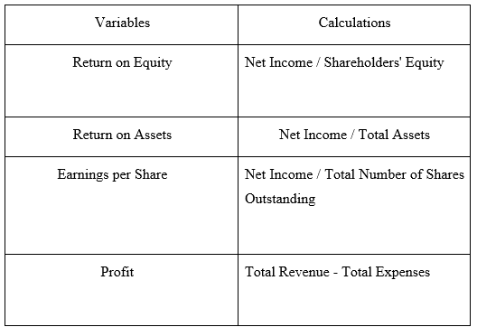
Source: Self Developed

4.4 Data analysis
- Descriptive statistics
- Correlation
- Regression

4.4.1 Distribution Statistics
Descriptive and inferential statistics are two fundamental subfields of statistics that play different functions in the study and interpretation of evidence. The distribution table involves the measures of “mean”, “standard deviation”, and other statistical values. Descriptive statistics, as described by Gravetter et al. (2020), are a set of techniques used for arranging and summarizing the raw data into a structure that is easier to comprehend. On the other hand, Inferential analysis includes extrapolating meaning from the data, such as identifying correlations or causal links (Kaur et al., 2018). Inferences about a population are drawn using statistical techniques that go beyond simple descriptive statistics.
“Recruitment Activities" has a mean value of (174239.36), making it the variable with the highest mean and it demonstrates that firms devote a large portion of their financial backing to recruiting efforts on average. On the other hand, the variable with the lowest mean is “Succession” with a mean of (0.90). This shows that succession planning is given comparatively less consideration and priority inside the organisation. When comparing the means of these two elements, the disparity between them was clearly observed. While recruitment efforts attract a lot of focus and funding, succession planning appears to be underappreciated. This difference can be a sign that the organization's strategic priorities are unbalanced. The business can be putting more of an emphasis on getting external talent than developing internal talent for managerial positions by emphasizing recruitment while disregarding succession strategies. When observing the standard deviation data set, the same variable “recruitment activities” also exhibit the highest standard deviation, with a measure of (238384.370), which shows that there is an extensive variation in the results of the recruitment activities’ efficacy. The “reward system” illustrates the most consistent and predictable behaviour when measured against the other predictors, as shown by its noticeably low standard deviation (0.198).
Skewness provides insight into the level of imbalance in the measured distribution around the mean by figuring out if the skew is to the left or right (Cain et al., 2017). Skewness in statistical computation enables to critically assess a distribution's divergence from uniformity. The distribution is entirely symmetrical if the degree of skewness is zero. The longer right tail is indicated by positive skewness, whereas the longer left tail is shown by negative skewness. On the other hand, kurtosis is a metric that expresses the concentrated nature of the data surrounding the mean along with how the tails of a statistical distribution are shaped (Guvenen et al., 2015). It facilitates the dataset's detection of aberrations or extreme values and positive or negative kurtosis values are possible. If the given distribution contains more positive values, then it is known as “leptokurtic” and it has longer tailed and an elevated peak as compared to a normal distribution. “Platypurtic” is a negative kurtosis that denotes smaller tails and a flatter peak, and which comprises more negative measures.

Variables | Skewness | Kurtosis
Employee welfare activities | 2.822 | 13.124
Training activities | 3.821 | 13.124
Recruitment activities | 2.839 | 9.963
Reward system | 4.841 | 22.331
Monetary motivational activities | 2.043 | 2.551
Non-monetary motivational activities | 2.020 | 2.255
Compensations | 1.558 | 1.434
Benefits | 1.176 | -.399
Succession | -2.750 | 5.792
ROE | 3.023 | 12.571
EPS | 1.776 | 2.425
ROA | 0.429 | -.155
Profit | 1.023 | .081
Table 2: Skewness and kurtosis measures

Source: Self-developed (SPSS)
The skewness measurements in Table 2 make it prominent that the majority of the parameters have positive values, indicating a rightward skewness and a tendency for higher numbers on the right side of their dispersion. Similarly, the dataset of kurtosis metrics shows a strong positive trend, indicating a leptokurtic distribution for the majority of the variables. Compared to a standard distribution, this shows larger tails and a more prominent peak, which suggests a higher possibility of extreme values and possible outliers.

4.4.2 Correlational analysis
In most of the research studies, the commonly used metric to identify the strength among the response and predictor parameters is the Pearson Correlation Coefficient. A mathematical statistic called the “Pearson correlation coefficient” (PCC) is used to describe the strength and pattern of a linear association amongst two random parameters (Zhou et al., 2016). Numerous statistical professions have used it, including data analysis and classification, decision-making, economic evaluation, and biological study.
Table 3: correlation values
Variables | ROE | EPS | Profit
Employee welfare activities | -.320 | -.284 | -.074
Training activities | .096 | .081 | -.074
Recruitment activities | -.075 | -.229 | .472
Reward system | -.240 | -.190 | -.197
Monetary motivational activities | -.061 | .279 | .253
Non-monetary motivational activities | .239 | -.134 | .047
Compensations | .642 | -.299 | .360
Benefits | 0.365 | -0.48 | 0.551
Succession | 0.337 | 0.274 | 0.286
ROA | 0.651 | 0.562
Source: self-developed (SPSS)
The correlation coefficients between each predictor variable and its matching response parameter are shown in Table 3. Insights on the connection between them in the dataset are provided by these values, which measure the intensity and direction of the connection between the predictor and the response
- Association with ROE
A more detailed examination of the correlation values between ROE and its predictors revealed that monetary, recruitment, and training activities had very minimal linkage or negligible association, as indicated by correlation coefficients of -.061, -.075, and.096 respectively. When the “reward system” and “non-monetary motivational activities” were compared to ROE, it was discovered that there was very little correlation between the two measures as their correlation measures are -0.240 and 0.239 respectively. This suggests that the ability of these predictors to influence ROE is constrained. However, “compensation” (0.642) and ROA (0.651) are the parameters which show a moderate connection with ROE. Therefore, it is evident that to fuel business growth and success in global marketplaces, firms ought to concentrate on equitable and effective compensation policies. However, offering reasonable wages to employees can have a more significant impact on ROE. All other remaining parameters exhibit a low connection with the response element ROE, having their values are in between 0.3 and 0.5

Source: self-developed(SPSS)
- Correlation with EPS
In light of the EPS, it is clear that, with the exception of three factors, all predictors exhibit a very weak correlation with the EPS. The predictors “benefits” and “training activities” show a weak and negligible relation as evidenced by their values of -0.48 and 0.081 respectively. However, ROA shows a moderate correlation with EPS, as its correlation value is 0.562.
- Correlation with Profits
While elements “reward system”, “monetary motivational activities” and “succession” exhibit a very low correlation, “benefits” stand out with a moderate connection with a value of 0.551. In addition, the “compensation” and “recruitment activities” portray a low connection with profit as denoted by their respective values of 0.360 and 0.472.
- Significance
Two-tailed significance is a technique used in the field of statistics to assess the statistical significance of a connection or difference in two opposing directions. This method is frequently used to examine whether there is a significant difference or connection between two groups or variables without presuming to know the direction in which the influence would be felt. As per the two-tailed analysis, usually measures less than 0.05 are considered significant, while values greater than 0.05 are regarded as insignificant.
According to an analysis of the two-tailed significance between the parameters, the only predictor that has a substantial impact on all response parameters is “compensation” since its values are lesser than a significant level of 0.05. However, the benefits and succession predictors stand out as being particularly significant with regard to “return on equity”. In addition, the employee welfare activities show significance with return on equity (p=0.023) and earnings per share (p=0.046). According to the preceding findings, the majority of the variables exhibit significance when compared to one of the three variables.

4.4.3 Regression
Choosing the “best” line to fit a set of observations is the goal of regression analysis, which aims to reduce the total squared variances between the observations and the line (Sarstedt et al., 2019).
Regression model
ROE=Return on equity
EPS=Earnings per share
P=Profits
EWA=Employee welfare activities
TA= Training activities
RA=Recruitment activities
MMA=Monetary motivational activities
NMMA= Non-monetary motivational activities
Cs=Compensations
Bs=Benefits
S=Succession
C=Control variable (Return on asset)

ROE=β0+ β1EWA+ β2TA+ β3RA+ β4MMA+ β5NMMA+ β6Cs+ β7Bs+ β8S+C+µ
EPS=α0+ αβ0+ α1EWA+ α2TA+ α3RA+ α4MMA+ α5NMMA+ α6Cs+ α7Bs+α 8S+C+µ
P= γ0+ γβ0+ γ1EWA+ γ2TA+ γ3RA+ γ4MMA+ γ5NMMA+ γ6Cs+ γ7Bs+ γ8S+C+µ

4.4.3.1 Regression with ROE
a) Model Summary
The correlation coefficient (R) value denotes as per the first model is 0.720 and R square constitutes 51.9 per cent total variation in the dependent variable. While introducing the control variable both the R-value and R Square value rise as their respective values are 0.411 and 65.7 per cent. The control variable is assumed to be responsible for an additional 13.8% of the total variation in the dependent variable based on the rise in R-square from 51.9% to 65.7%. The second model’s higher adjusted R-squared value (0.657) when compared to the first model’s lower adjusted R-squared value (0.411) indicates that the model is better equipped to explain the variance in the dependent variable. An expanded proportion of explained variation following the addition of the control variable (ROA) suggests a better fit.
Table 4: Model summary table
Model | R | R Square | Adjusted R Square
1 | .720ª | .519 | .411
2 | .853^{b} | .727 | .657
Source: Self-developed (SPSS)
b) ANOVA
In the ANOVA table, the initial model’s F value is 4.975, showing significance because its significance value (.001) is below the accepted cutoff of 0.05. However, when the control variable ROA is included, the F value increases to 10.386, although the degree of significance stays the same. By raising the F value, it is implied that the model including the control variable offers more convincing evidence in support of the alternative hypothesis than the model excluding the control variable.
Table 5: ANOVA table
Model |  | F | Sig.
1 | Regression | 2.456 | .025^{b}
2 | Regression | 8.234 | <.001^{c}
Source: Self-developed (SPSS)
c) Coefficient
The t-value for the predictor factor “Compensations” in the first model is 3.850 in the specified coefficient table. In the circumstance of the absence of the control variable “ROA”, this shows that the association between “Compensations” and the dependent variable ROE is statistically significant and a greater t-value denotes the statistical significance at a greater degree. However, the t-value for “Compensations” rises to 4.588 when the control variable ROA is incorporated into the subsequent model. When ROA is taken into consideration, the connection between “Compensations” and ROE is shown to have an even more extensive level of statistical significance. The “standardized coefficient”, represented by the beta value, might have fallen in the second model for “Compensations” while the t-value rose. This shows that even while the impact of this predictor on ROE may have diminished when the control variable was taken into account, it is still statistically significant.

4.4.3.2 Regression with EPS
a) Model summary
The model summary table demonstrates that both R-square and adjusted R-square values rise following the addition of the control variable ROA. In particular, the adjusted R-square went from 0.211 to 0.596, while the R-square value increased from 0.356 to 0.679. It implies that model fit significantly improved with the inclusion of the control variable ROA, proving that ROA offers important information that predicts further variation in the dependent variable beyond what the initial predictors could have explained.
Table 6: Model summary table
Model | R | R Square | Adjusted R Square
1 | .597ª | .356 | .211
2 | .824^{b} | .679 | .596
Source: Self-developed (SPSS)
b) ANOVA
When the control variable was added, the F value, which was 2.45 in the initial model, rose to 8.234 instead. It should be observed that while the model is initially significant, adding the control variable causes the significant value to drop from.025 to.001. This suggests that the evidence proving the existence of a relationship between the independent factors and the dependent variable has been reinforced by the addition of the control variable.
Table 7: ANOVA table
Model |  | F | Sig.
1 | Regression | 2.456 | .025^{b}
2 | Regression | 8.234 | <.001^{c}
Source: Self-developed (SPSS)
c) Coefficient table
Initially, the recruitment activities (t = -2.167, p = .036) and compensation (t = -2.524, p = .016) show a substantial connection with EPS. However right after the control variable has been introduced in the subsequently constructed model, the importance of recruitment activities (t = .899, p = .374) decreases, confirming that the association between recruitment activities and EPS is no longer valid or significant in the presence of the control parameter. In the case of the predictor “compensation”, its significant level decreases to (< .001), and the t value also decreases. Although the t-value has diminished, it is still high enough to rule out the null hypothesis and it portrays that there is a substantial connection between compensation and EPS. It also suggests that “Compensation” has a considerable and independent impact on EPS, even after controlling for the effect of ROA.

4.4.3.3 Regression with Profit
a) Model Summary
This data set provides the model summary for the two different models, in this data set, the R-value of (0.720) indicates a moderately strong positive correlation between the predictors and the dependent variable. The R square value for this model- 1 indicated a value (0.519) in this data set, 51.9% of the variance in the dependent variable can be explained by the predictors. The Adjusted R Square value for Model 1 is (0.411), by analysing the data set the Adjusted R Square is slightly lower than the R Square, indicating that there might be some predictors in the model that do not contribute significantly to explaining the dependent variable. Model 2's R-value of (0.720) suggests a fairly significant positive correlation between the predictors and the dependent variable, according to the model's interpretation. The R square value of this model - 2 reveals a value of (0.519), and this suggests that the predictors in this model can account for 51.9% of the variation in the dependent variable (Table 8).

Table - 8 Model summary
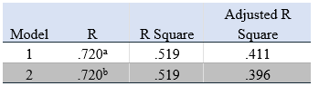
Source: Self Developed
b) ANOVA
This data set provides the ANOVA analysis of the two various models, by analysing models. The F-statistic is statistically significant in both models, as shown by the p-value of ".001." This shows that the regression models are significant and adequately account for the dependent variable's variability. The predictors included in both models are the same, with the addition of the controlled variable "Return on asset" in Model 2. These predictors are being utilised to account for the variation in the dependent variable, "Profit." Overall, both models exhibit strong regression and reflect a large amount of variability in the dependent variable, according to the ANOVA findings.
Table-(9) ANOVA
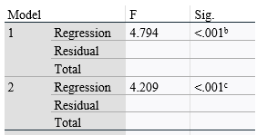
Source: Self-developed
c) Co-efficient
The standardised coefficients, T-values, and p-values for the two models are provided in this data set. Recruitment Activities has the highest standardised coefficient (Beta = 0.426), which indicates that it has the greatest influence on Profit of all the variables in this model. Monetary motivational activities (Beta = 311), employee welfare activities (Beta = .183), and succession (Beta = .178) are other factors with comparatively greater standardised coefficients. Similar to Model 1, Recruitment Activities had the greatest standardised coefficient (Beta = .417), showing that it has a significant influence on Profit in this model as well. Employee welfare activities (Beta = .178), succession (Beta = .184), and monetary motivational activities (Beta = .305) are some other factors with substantially greater standardised coefficients. The statistical significance of the coefficients is assessed by the t-values. The significance (Sig.) values represent the likelihood that the observed t-value resulted from pure chance. A larger Sig. value often denotes a more statistically significant outcome. Recruitment Activities are a statistically significant predictor of Profit in both models (Sig. = 0.002 in Model 1 and Sig. = 0.009 in Model 2). Additionally, statistically significant, monetary motivational behaviours have Sig. values of 0.014 in Model 1 and 0.028 in Model 2. Other variables in both models do not exhibit statistical significance (Sig. > 0.05), including Employee Welfare activities, Compensations, and Benefits.

4.5 Hypothesis testing
The study proposes two hypotheses which are stated below,
H1: Employee perks are important for expanding a company's market share internationally.
H0: employee benefits do not portray any substantial effect on the growth of multinational markets
The vast majority of the predictors, discovered a substantial connection with the dependent variables, indicating that they have an important bearing on the outcomes under study. Nevertheless, it’s important to note that among all the predictors, “compensation” was distinguished apart since it showed importance with each of the response variables. In order to reduce the potential impact of distracting factors and to improve the preciseness of outcomes, control variables are supplementary variables that are taken into consideration. This suggests that the control variables contribute to the strengthening of the association between the parameters.
These associations are significant, which implies that the explanatory variables have a significant influence on the explained variables. In other words, the study demonstrates that employee perks significantly contributed to the growth of international markets. Therefore, the investigation denies the “null hypothesis”, and the findings are compatible with the alternative.

4.6 Conclusion
In order to evaluate the effects of various variables on the expansion of multinational corporations, the findings chapter of the study has evolved through three statistical methodologies. The results of the investigation show that these organizations' growth is facilitated by their involvement in employee benefits activities. This discovery demonstrates the importance of compensation practices in obtaining economic success. One of the primary takeaways drawn from this chapter is that compensation has a more substantial effect on firm growth than other factors. This suggests that firms’ total performance and success can be significantly impacted by the strategic design and execution of compensation systems. The results also showed that the bias caused by the “omitted variable” was significantly reduced by the addition of the control variable, Return on Assets (ROA). The study strengthened the validity of the findings by accounting for ROA’s potential impact on the association between worker perks and firm growth by using it as a control.
4.7 Discussion
This study is conducted to know how employee benefits management is essential for achieving business growth in the international market. The annual reports of 10 selected companies are used to conduct the study using mixed methods. The discussion of the results is coming as follows;
The results of the quantitative descriptive statistics show that organisations are spending more of their financial backing on recruitment activities, and succession planning is the lower on the list which is represented by higher mean value of recruitment activities (174239.36) and least mean value of succession planning (0.90). Further the variable “recruitment activities” exhibit the largest standard deviation with the value of (238384.370), shows the more variations in the results, on the other hand variable reward system has low standard deviation value (0.198). This indicates that organisations are giving more importance to external recruiting than building strong managerial positions. Further, this indicates that the business strategies are unbalanced and recruitment activities among the companies varied widely. The correlations analysis of the results shows that factors including monetary, recruitment, and training activities have a negligence relation with ROE with the coefficient values of -.061, -.075, and 0.096 respectively., further revealing that the factors including “reward system” and “non-monetary motivational activities” also have low correlation value of -0.240 and 0.239 respectively with ROE.
The significance output in the correlation analysis indicates that the factor compensations have a significant relationship with all response variables including ROE, profit, and EPS with significant value of <0.001, 0.01 and 0.035, which are less than significance level 0.05. Then, factors such as benefits and succession were found statistically significant only with ROE at significant value of 0.009 and 0.017. In addition, the variable employee welfare activities are statistically significant with return on equity (0.023) and earnings per share (0.046). These findings related to the significance of predictor variables are consistent with the findings of Yousaf et al., (2014), the presence of fringe benefits encourage motivation and create a positive atmosphere and thereby resulting in increased outputs, sales and profit of the organisation.
Further, this study output, a positive relationship between an employee benefits and organisation financial performance is consistent with the findings of Ghaly et al., (2015), companies that perform well financially may spend on employee benefits and maintain good employee relations while building up large cash reserves. The positive relation between the employee welfare activities with outcomes variables ROE and EPS are in-line with the results of Zhang, (2016), that businesses should endeavour to improve overall efficiency as well as the personal benefits that employees receive and the environments in which they work and live in order to increase employee productivity at work. In addition, these findings are similar to the findings of Lin et al., (2015), employee benefit programmes have a significant impact on overall business performance. The strength of the association is mediated by the attitudinal and behavioural outcomes that are brought about as a result of employees’ psychological well-being. Further, the flexible working schedule increases the bonding and communication between the employer and employees which is one of the most important benefits of flexible scheduling (Galea et al., 2014). Končar, et al., (2020), also claims that enhanced productivity and higher profitability of organisation is attained by the strong correlation between employee well-being at work. However, the employees’ expectations are not met in terms of pay and perks, as well as career advancement and job security are not satisfied, employees become less motivated and lose interest in the job, and as a result search for alternate jobs.
The coefficients output of regression analysis shows the compensation is statistically significant to ROE at t-value of 3.580 and sig. value of <0.001 and significant with EPS at a t-value of -2.524 and sig. value of 0.016 and monetary motivational activities have a significant relationship with the profit of the organisation at sig. value of 0.014 and t-value of 2.561. This shows that compensation plays a crucial role in enhancing the financial performance of the organisation. To favour this statement, according to Nguyen, et al., (2020), compensation is described as monetary gains, rendered services, and benefits obtained by employees for the job they employee has performed. Compensation is evaluated in two ways such as direct compensation (salary, bonuses, and overtime pay) and indirect compensation (bonuses and facilities). The non-financial rewards are given in the form of compliments, gratitude, time off from work and acknowledgement. Further, According to Girimurugan et al., (2016), an organisation should know the difficulties faced by the employees in order to solve the problem and to attain the firm success. The welfare programmes offered by the organisation can alter the employee’s well-being, physical and mental health, morale, attentiveness, and general effectiveness to increase output. The importance of compensation and its relationship with employee engagement is discussed in the study of Dajani and Zaki, (2015), that benefits and compensations are necessary prerequisites for fostering employee engagement. Compensation consists of monetary payments as well as non-financial incentives including praise and additional advantages like subsidised cafeterias, on-site childcare, employee assistance programmes, and extra holidays. Further, it is consistent with the statement of Ali and Anwar, (2021), a favourable working environment and competitive compensation plans enhance employee satisfaction, motivation, and dedication toward achieving organisational performance. Furthermore, bonuses, help, promotions and extra money above the wage are the positive tangible advantages, in contrast withholding bonuses and promotions or even cutting the employee pay are the negative benefits.
The overall results from the ANOVA test show that predictors variables are significant to response variables ROE, EPS and profit at sig. values of <0.001, 0.025, and <0.001 respectively, confirm that employee benefits are important for expanding a company’s market share internationally. In a compensation plan, numerous sorts of rewards and benefits can be included such as salaries, incentive payments, and other benefits. According to Gupta and Shaw, (2014), commission, alluring health insurance coverage, pay, loyalty bonuses, paid vacation days, and paid holidays are the rewards given to employees in organisations. Additionally, employers ought to provide competitive pay scales, opportunities for wage rises, benefits that are tailored to the requirements of each employee, and flexible work hours. From the study’s overall results, it is confirmed that employee benefits produce a significant impact on the overall performance of an organisation. In contrast, the negative relationship between the benefits and companies revenue is explained by Ongalo and Tari, (2015), the ROA of the company may affect badly if the employees are provided with unwanted benefits, while the revenue and expenses are negatively impacted, which is opposed to findings of this study. The results of the study are confirming the output of the previous research works that employee benefits have a significant relationship with employer financial performance (Pattnaik and Jena, 2020). Further, studies found a significant relationship between employee satisfaction and business success while improving the well-being and performance of the employees. This result shows that an organisation should give importance to employee benefits, in order to improve employee performance and organisational performance while enhancing employee satisfaction.

CHAPTER 5: CONCLUSION
The study aimed to identify whether there is any importance in managing employee benefits for achieving business growth in the international market. It also intended to evaluate the role of employee benefits management in facilitating the growth of the business. With the growing globalization, MNCs give importance to human resource management and implement employee benefits to motivate the employees to increase their productivity and thereby the firms can inflate their performance and profit (Wilton, 2019). Employee benefits is a complex personnel management tool for the betterment of human resource management, there is no guaranteed better employee benefits model that can be used by the companies to get the same result with each company (Guest, 2017). From the findings, it has been concluded that various employee benefits such as employee welfare activities, training activities, recruitment activities, reward system, monetary motivational activities, non-monetary motivational activities, compensations, benefits, and succession plays an evident role in generating growth of the business in the international market. By collecting data on all these variables, it has been able to understand the employee benefits and compensation policies of the ten MNCs in the UK thus meeting another objective of the study.
To understand how employee benefits facilitate the growth of the business, the collected data has been analysed using SPSS to conclude. The findings were that employee welfare activities have a negative correlation with succession, ROE, EPS, ROA, and profit which is statistically significant whereas employee welfare activities have a statistically significant positive correlation with the reward system. This can be meant that spending on employee welfare activities will cost the company’s profit, return on equity and return on assets therefore companies can adopt a reward system that is not in terms of money such as time relaxation or leisure activities to boost the employee welfare activities (Arora and Wagh, 2017). The findings show a positive correlation between benefits and compensation and the same is statistically significant, thus the research question of how benefits and compensation are associated is answered therefore. This conclusion is backed by existing literature, according to Sitopu et al (2021), from the perspective of an employee they would prefer to stay with firms that will benefit their career therefore they will be loyal to firms if better employee benefits will be provided this will be influenced by the compensation policies of the firm in terms of employee life in the firm. However, benefit is also related to succession positively whereas it has a negative correlation with the reward system, it is because employees prefer wage increments or financial rewards to that of a non-financial reward system says Spisakova (2019).
The dependent variable ROE has a positive correlation which is statistically significant with compensation, benefits, and succession. Whereas the dependent variable EPS is positively correlated to monetary motivational activities but negatively correlated to compensation. This might happen if the compensation policies of the company are done on the profit share of the firms, this will affect the EPS of the firms (Bennett et al, 2017). The variable profit has a positive correlation with recruitment activities, benefits, succession, and compensation. This means that with productive recruitment activities, better employees can be recruited for the firm, and that in turn will increase the firm performance so that the profit and increased profit can result in better benefits and compensation (Ahammad, 2017). ROA shows a significant positive correlation with dependent variables, ROE and EPS, and also with other independent variables such as training activities, compensation, benefits, and succession whereas shows a negative correlation with the reward system and employee welfare activities. However, numerous literature studies use ROA as an independent variable to show the importance of employee benefits in achieving the company's growth, which is why ROA is taken as a control variable in this study. The model summary table for the dependent variable Return on Equity, shows that the model with the control variable is more fit to the line of regression with a value of adjusted R square .657. The Analysis of Variance shows a statistically significant f value of 10.386 thus the alternative hypothesis employee benefits do affect the ROE of the company is accepted. Similarly, the alternative hypothesis that employee benefits affect the EPS of the firm is accepted with a goodness of fit of .596 and an f value of 8.234. For both response variables ROE and EPS compensation is the only variable which is statistically significant for the model. This does not mean the other variables are irrelevant, this simply means that the other variables are related to the response variable but they are also related to the variable compensation, that their effect is already shown in the compensation variable (Pearl, 2022).
In practice, it is understood that employees prefer monetary motivational activities to non-monetary motivational activities, this might affect the profit policy of the firm as well as the shareholder interests. According to the results, none of the variables show a statistically significant impact on profit even though they are correlated. In the past employee benefit were narrowed down to better working conditions and safety with reasonable salaries, however with the notion of human rights and the growing importance of human resource management, the employee perspective of benefits changed and the firms need to adapt themselves to the changing scenario (Balkin and Werner, 2019). Therefore, this study enables a better understanding of employee benefits and their relation to various indicators of business growth, the same has been connected to the Harvard model of HRM to extend it to the international market. Even though there are numerous employee benefits in prevalence, employees will prefer benefits that aid in their career, and often employees like to associate with firms that have greater brand value. The employee benefit and compensation policies of the top 10 MNCs in the UK are examined in the study to get conclusions. Despite the common difference in the nature of work, the model fitness is good regarding the variable RoE and EPS, this study can be extended to understand the larger population but in the case of profit variable, it will be better to elaborate more on independent variables. This study has been able to reduce the omitted variable biases by incorporating a ‘control variable’ in the study, however, the limitation of time and lack of experience in the field has to be noted in generalizing the study results.

5.1 Recommendations
- For companies
The primary objective of the study was to find out the importance of employee benefits in achieving growth for a business in the international market. Throughout the study findings, it has been concluded that several employee benefits such as employee welfare activities, compensation, succession, recruitment activities, and monetary motivational activities highly affect the growth indicators RoE, EPS, and Profit of the business thus facilitating the economic growth in the international market. The findings are significant for managers, organizations, and supervisors in developing effective human resource management within the organizations. The study has been able to develop the concept of employee benefit management in facilitating the growth of the business, this can be further utilized for developing employee benefit policies in a business. However, it should be noted that employee characteristics are sensitive to the nature of the business, the working environment, the delegation of authority, and the channel of communication in management (Riyadi, 2019). Since the compensation variable shows a huge effect in determining the RoE and EPS of a business, companies can consider effective compensation development programs that will improve employee satisfaction and thereby productivity.
From the existing human resource practices, the study recommends MNCs adopt employee participation in decision-making and give share participation for employees so that they remain motivated and accustom themselves to the cultural and social changes. A sense of authority can urge the employees to work for the business without being reluctant and taking leisure (Jones, 2018). Another important thing to be noted by the management of any business that is considering globalization is the incorporation of ‘green HRM’ practices in the human resource management policy-making of the company. Since the approach is vastly recognized in the modern era, according to Mehrajunnisa et al (2022), employees consider themselves to work with companies whose policies adhere to the growing importance of protecting the environment and the objectives of the organization should be ethical towards the society. The firms can also conduct regular employee surveys to determine how employees feel about the benefit and compensation policies of the companies. According to Smith (2018), companies can establish effective communication channels or virtual teams and thereby collect information on employee wellness, benefits, and health, this will improve employee participation in the organization. Employee participation is an inevitable factor in the growth of the business specifically in international business where conflict of culture is possible (Jurburg et al, 2017). While collecting data from the top 10 MNCs several articles were recognized where awareness among employees is mentioned, from the perspective of the researcher, it will also aid the companies if they track employee awareness regarding the employee benefit policies of the company and should also educate employees to utilize the benefit policies; this will generate transparency in the working of the companies.

Recommendations for future study
For the scope of future research, this study critically analyzed the Harvard model of human resource management in relation to the international growth of a business, however, the Harvard model is a soft HRM practice giving importance to people more than outcomes therefore, in future researchers can employ HRM models such as Fombrun, Guest, and Warwick. These models give a cogent framework for studying HRM incorporating situational factors, also they validate and establish variables and relations to be studied (Thierry, 2018). This study considered ‘Return on Assets’ as a control variable to avoid the bias of omitting variables, while conducting on the topic in the future, one can keep variables such as social contract, culture, and trade unions under control. Even though the employee benefits included in the study shows significant relation in affecting business growth for future scope future studies can incorporate benefits like share partnership and decision-making and their relation to the profit can be studied specifically.
According to the statistical result of the study, the findings from the sample firms can be generalized, however, the sample firms in the study can afford increased expense in implementing innovative and effective employee benefits, in contrast, while extending the topic in the future, one can consider small and medium firms who cannot contribute extra budget for employee benefits. Also, as a result of the explanatory design of research, there is a sphere for understanding factors that impact the employees’ work commitment in a larger sample. There is a potential that the responses of employees may vary in a larger sample particularly if we consider business of different nature. For future reference, researchers can consider employee education, paid vacation days, and retirement savings plans as employee benefit and their importance in the growth of international business. Even though the quantitative study gives a concrete understanding of the importance of employee benefits in the growth of an international business, a qualitative study can widen the frontier in understanding the attitudes and behaviours of the respondents in terms of what they value the most and can also consider cultural and historical contexts. The study can be done as a case study for companies such as Mcdonalds’, Unilever, HSBC, and likewise Toyota. To conclude the study has been able to relate employee benefits and compensation policies and has found out the importance of managing employee benefits for achieving business growth in the international market. Thus, the study succeeded in developing awareness among firms that neglected the need for employee benefits, and firms that employed employee benefits can upgrade their policies and strategies based on the recommendations. Future researchers can take the study as an empirical foundation and can extend the same into other branches of business. Employees, moreover human resource is the backbone of any business’s success therefore it is essential for firms irrespective of the size need to develop competent and practical employee benefit customs (Bratton et al, 2021).

7. Reference.

Ongalo, E. A. and Tari, J. (2015) Effect of Employee Motivation Strategies on Organizational Performance: A Case of Electricity Generating and Distribution Firms in Kenya. European Journal of Business and Management, 7(1), pp.55-65.
- Abbah, M. T. (2014) Employee Motivation: The Key to Effective Organizational Management in Nigeria. IOSR Journal of Business and Management, 16(4), pp.01-08.
- Adamovic, M. (2018) An Employee-Focused Human Resource Management Perspective for the Management of Global Virtual Teams. The International Journal of Human Resource Management, 29(14), pp.2159-2187.
- Adebisi, S. A. and Oladipo, A. O. (2015) Reward System as Strategy for Improving Employees’ Productivity in Nigeria. Revista Eletrônica de Estratégia & Negócios, 8(1), pp.56-84.
- Affandi, F., Sunarko, B. and Yunanto, A (2019) The Impact of Cash Ratio, Debt to Equity Ratio, Receivables Turnover, Net Profit Margin, Return on Equity, and Institutional Ownership to Dividend Payout Ratio. Journal of Research in Management, 1(4), pp.1-6
- Agrawal, J. and Garg, P. (2021) A Case Study on Voluntary Retirement Scheme of Employees Working in MTNL. Turkish Online Journal of Qualitative Inquiry, 12(9). Pp. 1-8.
- Agubata, N. S., Okolo, L. I. and Ogwu, S. O. (2022) Effect of Employee Benefits on Organizational Growth of Consumer Goods Firms in Nigeria. Studia Universitatis Vasile Goldiș Arad, Seria Științe Economice, 32(3), pp.116-137.
- Ahammad, T. (2017) Personnel Management to Human Resource Management (HRM): How HRM Functions. Journal of Modern Accounting and Auditing, 13(9), pp.412-420.
- Al Mamun, C. A. and Hasan, M. N. (2017) Factors Affecting Employee Turnover and Sound Retention Strategies in Business Organization: A Conceptual View. Problems and Perspectives in Management, 15(1), pp.63-71.
- Alharahsheh, H.H. and Pius, A. (2020) A Review of Key Paradigms: Positivism VS Interpretivism. Global Academic Journal of Humanities and Social Sciences, 2(3), pp.39-43.
- Ali, B. J. and Anwar, G. (2021) An Empirical Study of Employees’ Motivation and its Influence on Job Satisfaction. International Journal of Engineering, Business and Management, 5(2), pp.21-30.
- Alvi, M. (2016) A Manual for Selecting Sampling Techniques in Research, University of Karachi, Iqra University, pp.1-43
- Antwi, S. K. and Hamza, K. (2015) Qualitative and Quantitative Research Paradigms in Business Research: A Philosophical Reflection. European Journal of Business and Management, 7(3), pp.217-225.
- Askarzai, W. and Unhelkar, B. (2017) Research Methodologies: An Extensive Overview. International Journal of Science and Research Methodology, 6(4), p.21.
- Audenaert, M., Vanderstraeten, A., Buyens, D. and Desmidt, S. (2014) Does Alignment Elicit Competency-Based HRM? A Systematic Review. Management Revue, 1(1), pp.5-26.
- Ausanee, R., Weerapong, K., Parichat, B. and Sillapaporn, S. (2021) Client and Auditor Conservatism in Timely Loss Recognition of Liabilities for Long-Term Employee Benefits from Thailand’s New Labor Protection Act. 1(1), pp.1-8.
- Austin-Egole, I. S., Iheriohanma, E. B. and Nwokorie, C. (2020) Flexible Working Arrangements and Organizational Performance: An Overview. IOSR Journal of Humanities and Social Science (IOSR-JHSS), 25(5), pp.50-59.
- Awan, A.G. and Saeed, S. (2015) Impact of CSR on Firms’ Financial Performance: a Case Study of Ghee And Fertilizer Industry In Southern Punjab-Pakistan. European Journal of Business and Management, 7(7), pp.375-384.
- Awuzie, B. and McDermott, P. (2017) An Abductive Approach to Qualitative Built Environment Research: A Viable System Methodological Exposé. Qualitative Research Journal, 17(4), pp.356-372.
- Bakotić, D. (2016) Relationship between Job Satisfaction and Organisational Performance. Economic Research-Ekonomska Istraživanja, 29(1), pp.118-130.
- Barrick, M. R., Thurgood, G. R., Smith, T. A. and Courtright, S. H. (2015) Collective Organisational Engagement: Linking Motivational Antecedents, Strategic Implementation, and Firm Performance. Academy of Management Journal, 58(1), pp.111-135.
- Beer, M., Boselie, P. and Brewster, C. (2015) Back to the Future: Implications for the Field of HRM of the Multistakeholder Perspective Proposed 30 Years Ago. Human Resource Management, 54(3), pp.427-438.
- Ben-Nasr, H. and Ghouma, H. (2018) Employee Welfare and Stock Price Crash Risk. Journal of Corporate Finance, 48(1), pp.700-725.
- Berman, E.A. (2017) An Exploratory Sequential Mixed Methods Approach to Understanding Researchers’ Data Management Practices at UVM: Integrated Findings to Develop Research Data Services, 1(1), pp.1-6
- Bilan, Y., Mishchuk, H., Samoliuk, N. and Mishchuk, V. (2020) Gender Discrimination and its Links with Compensations and Benefits Practices in Enterprises. Entrepreneurial Business and Economics Review, 8(3), pp.189-203.
- Bondarouk, T. and Brewster, C. (2016) Conceptualising the Future of HRM and Technology Research. The International Journal of Human Resource Management, 27(21), pp.2652-2671.
- Boyd, J., Epanchin-Niell, R. and Siikamäki, J. (2015) Conservation Planning: A Review of Return-on-Investment Analysis. Review of Environmental Economics and Policy. 1(1), pp. 1-8.
- Brady, M. (2016) Gluing, Catching and Connecting: How Informal Childcare Strengthens Single Mothers’ Employment Trajectories. Work, Employment and Society, 30(5), pp.821-837.
- Bratton, J., Gold, J., Bratton, A. and Steele, L. (2021) Human Resource Management. Bloomsbury Publishing. 1(1), pp. 1-8.
- Braun, V., Clarke, V., Boulton, E., Davey, L. and McEvoy, C. (2021) The Online Survey as a Qualitative Research Tool. International Journal of Social Research Methodology, 24(6), pp.641-654.
- Bryman A. and Bell, E. (2015) Business Research Methods, 4th edition, Oxford University Press, pp.2-31.
- Budd, J. W. (2017) The Effect of Unions on Employee Benefits and Non-Wage Compensation: Monopoly Power, Collective Voice, and Facilitation. In what do Unions do? 1(1), pp. 160-192.
- Caillier, J. G. (2016) Does Satisfaction with Family-Friendly Programs Reduce Turnover? A Panel Study was Conducted in US Federal Agencies. Public Personnel Management, 45(3), pp.284-307.
- Cain, M.K., Zhang, Z. and Yuan, K.H. (2017) Univariate and Multivariate Skewness and Kurtosis for Measuring Nonnormality: Prevalence, Influence and Estimation. Behaviour Research Methods, 49(1), Pp.1716-1735.
- Chanchiaw, T., Luengalongkot, P., Noranitipadungkarn, C. and Klindee, M. (2022) The Need of Employee Benefits a Case Study: Leadway Heavy Machinery Co., Ltd. Journal of Optoelectronics Laser, 41(6), pp.307-311.
- Chandrasekaran, P. and Ganeshprabhu, P. (2020) A Study on Employee Welfare Measures in Construction Industry in India. International Journal of Scientific and Technology Research, 9(1), pp.990-997.
- Clark, D. (2022a) Number of People Employed in the Private Sector in the UK 2022, by Sector [Online] Available from: https://www.statista.com/statistics/677095/employees-by-sector-uk/
- Clark, D. (2022b) Government Expenditure on Employment in the UK 2008-2022 [Online] Available from: https://www.statista.com/statistics/284445/united-kingdom-uk-government-spending-employment-and-support-allowance/
- Clark, D. (2023a) Number of People Employed in the United Kingdom from March 1971 to February 2023 [Online] Available from: https://www.statista.com/statistics/281998/employment-figures-in-the-united-kingdom-uk/ [Accessed on 2nd May 2023].
- Clark, D. (2023b) Employment Rate in the UK 1971-2022 [Online] Available from: https://www.statista.com/statistics/281992/employment-rate-in-the-united-kingdom/ [Accessed on 2nd May 2023].
- Clark, D. (2023c) Number of Public Sector Employees in UK 2022, by Industry [Online] Available from: https://www.statista.com/statistics/284104/public-sector-employment-uk-by-industry/ [Accessed on 2nd May 2023].
- Clark, K. R. and Vealé, B. L. (2018) Strategies to Enhance Data Collection and Analysis in Qualitative Research. Radiologic Technology, 89(5), pp.482CT-485CT.
- Clemens, J., Kahn, L. B. and Meer, J. (2018) The Minimum Wage, Fringe Benefits, and Worker Welfare. National Bureau of Economic Research. 1(1), pp. 1-8.
- Dachner, A. M., Ellingson, J. E., Noe, R. A. and Saxton, B. M. (2021) The Future of Employee Development. Human Resource Management Review, 31(2), p. 100732.
- Dajani, D. and Zaki, M. A. (2015) The Impact of Employee Engagement on Job Performance and Organisational Commitment in the Egyptian Banking Sector. 1(1), pp. 1-8.
- Darma, P. S. and Supriyanto, A. S. (2017) The Effect of Compensation on Satisfaction and Employee Performance. Management and Economics Journal. 1(1). Pp. 1-8.
- Dean, B. A. (2018) The Interpretivist and The Learner. International Journal of Doctoral Studies, 13(1), p.1.
- Dean, J. C. (2014) Investigating Transformational Leadership and Return on Equity Outcomes in Small and Medium-Sized Community Banks (Doctoral dissertation, Indiana State University). 1(1), pp. 1-8.
- Earl, C. and Taylor, P. (2015) Is Workplace Flexibility Good Policy? Evaluating the Efficacy of Age Management Strategies for Older Women Workers. Work, Aging and Retirement, 1(2), pp.214-226.
- Elnaga, A. A. and Imran, A. (2014) The Impact of Employee Empowerment on Job Satisfaction Theoretical Study. American Journal of Research Communication, 2(1), pp.13-26.
- Esthi, R. B. and Ekhsan, M. (2020) The Effect of Millennial Intrinsic Value toward Employee Outcomes with Employee Benefit as Mediating Variable for Strengthening Indonesia’s Startup Business. Solid State Technology, 63(2s), pp. 8856-8871.
- Etikan, I. and Bala, K. (2017) Sampling and Sampling Methods. Biometrics and Biostatistics International Journal, 5(6), p.00149.
- Fatoki, O. I. and Olweny, T. (2018) Effect of Earnings Per Shares on Capital Structure Choice of Listed Non-Financial Firms in Nigeria. 1(1), pp. 1-8.
- Galea, C., Houkes, I. and De Rijk, A. (2014) An Insider's Point of View: How a System of Flexible Working Hours Helps Employees to Strike a Proper Balance Between Work and Personal Life. The International Journal of Human Resource Management, 25(8), pp.1090-1111.
- Ghaly, M., Dang, V. A. and Stathopoulos, K. (2015) Cash Holdings and Employee Welfare. Journal of Corporate Finance, 33(1), pp.53-70.
- Gilchrist, K., Brown, C. and Montarzino, A. (2015) Workplace Settings and Wellbeing: Greenspace Use and Views Contribute to Employee Wellbeing at Peri-Urban Business Sites. Landscape and Urban Planning, 138(1), pp.32-40.
- Girimurugan, B., Santhoshkumar, S. and Abinaya, S. (2016) An Organizational Study and a Study on Employee Welfare with Special Reference to Podaran Foods India Pvt Ltd, Kangayam. International Journal of Emerging Technologies in Engineering Research. 4(11). pp. 1-8.
- Gubler, T., Larkin, I. and Pierce, L. (2018) Doing Well by Making Well: The Impact of Corporate Wellness Programs on Employee Productivity. Management Science, 64(11), pp.4967-4987.
- Guo, J., Huang, P., Zhang, Y. and Zhou, N. (2016) The Effect of Employee Treatment Policies on Internal Control Weaknesses and Financial Restatements. The Accounting Review, 91(4), pp.1167-1194.
- Gupta, N. and Shaw, J. D. (2014) Employee Compensation: The Neglected Area of HRM Research. Human Resource Management Review, 24(1), pp.1-4.
- Guvenen, F., Karahan, F., Ozkan, S. and Song, J. (2015) What Do Data on Millions of US Workers Reveal About Life-Cycle Earnings Risk? National Bureau of Economic Research,1(1), pp.1-6
- Haider, M., Rasli, A., Akhtar, C. S., Yusoff, R. B. M., Malik, O. M., Aamir, A., Arif, A., Naveed, S. and Tariq, F. (2015) The Impact of Human Resource Practices on Employee Retention in the Telecom Sector. International Journal of Economics and Financial Issues, 5(1), pp.63-69.
- Halcomb, E. J. and Hickman, L. (2015) Mixed methods research. Faculty of Science, Medicine and Health - Papers: part A. 2656, pp.2-17.
- Hanaysha, J. (2016) Examining the Effects of Employee Empowerment, Teamwork, and Employee Training on Organizational Commitment. Procedia-Social and Behavioral Sciences, 229(1), pp.298-306.
- Howe, N. (2014) How the Millennial Generation is Transforming Employee Benefits. Benefits Quarterly, 30(2), pp.8-14.
- Husna, A. and Satria, I. (2019) Effects of Return on Asset, Debt to Asset Ratio, Current Ratio, Firm Size, And Dividend Payout Ratio On Firm Value. International Journal of Economics and Financial Issues, 9(5), pp.50-54.
- Hwang, J. and Hopkins, K. M. (2015) A Structural Equation Model of the Effects of Diversity Characteristics and Inclusion on Organizational Outcomes in the Child Welfare Workforce. Children and Youth Services Review, 50(1), pp.44-52.
- Ibrar, M. and Khan, O. (2015) The Impact of Reward on Employee Performance (A Case Study of Malakand Private School). International Letters of Social and Humanistic Sciences, 52(1), pp.95-103.
- Idris, A. (2014) Flexible Working as an Employee Retention Strategy in Developing Countries. Journal of Management Research, 14(2), pp.71-86.
- Ihuah, P. W. (2014) A Review of Soft and Hard Approaches of Human Resource Management and the Success of Real Estate Development in Nigeria. Journal of Business Management and Economic Development, 1(1), pp.16-23.
- Iqbal, S., Guohao, L. and Akhtar, S. (2017) Effects of Job Organizational Culture, Benefits, and Salary on Job Satisfaction Ultimately Affecting Employee Retention. Review of Public Administration and Management, 5(3), pp.1-7.
- Islam, M. (2020) Employee Benefits Disclosure: Recent Evidence from Bangladesh. Employee Benefits Disclosure: Recent Evidence from Bangladesh. 1(1), pp. 1-8.
- Jameel, B. and Majid, U. (2018) Research Fundamentals: Data Collection, Data Analysis, and Ethics. Undergraduate Research in Natural and Clinical Science and Technology Journal, 2(1), pp.1-8.
- Jaworski, C., Ravichandran, S., Karpinski, A. C. and Singh, S. (2018) The Effects of Training Satisfaction, Employee Benefits, and Incentives on Part-time Employees’ Commitment. International Journal of Hospitality Management, 74(1), pp.1-12.
- Jayaweera, T. (2015) Impact of Work Environmental Factors on Job Performance, Mediating Role of Work Motivation: A Study of Hotel Sector in England. International Journal of Business and Management, 10(3), p.271.
- Kapur, R. (2018) Research Methodology: Methods and Strategies. Department of Adult Education and Continuing Extension, University of Delhi: New Delhi, India., pp.1-120.
- Kaur, P., Stoltzfus, J. and Yellapu, V. (2018). Descriptive statistics. International Journal of Academic Medicine, 4(1), p.60.
- Kaur, R. (2017) Employee Retention Models and Factors Affecting Employee Retention in IT Companies. International Journal of Business Administration and Management, 7(1), pp.161-174.
- Khalid, K. and Nawab, S. (2018) Employee Participation and Employee Retention in View of Compensation. SAGE Open, 8(4), p.2158244018810067.
- Kim, J. S., Song, H. J. and Lee, C. K. (2016) Effects of Corporate Social Responsibility and Internal Marketing on Organizational Commitment and Turnover Intentions. International Journal of Hospitality Management, 55(1), pp.25-32.
- Klein, E. I. and Guillen-Walsh, F. (2021) Employee Benefit Plan Review. Employee Benefit Plan Review, 1(1), p.1.
- Ko, J. and Hur, S. (2014) The Impacts of Employee Benefits, Procedural Justice, and Managerial Trustworthiness on Work Attitudes: Integrated Understanding Based on Social Exchange Theory. Public Administration Review, 74(2), pp.176-187.
- Končar, J., Marić, R. M., Vučenović, S. and Vukmirović, G. (2020) Employee Welfare in the Western Balkans Retail Sector: How to Improve it Through Socio-Organizational Variables. Faculty of Economics in Subotica, 27(2), pp.151-170.
- Kossek, E. E. and Thompson, R. J. (2016) Workplace Flexibility: Integrating Employer and Employee Perspectives to Close the Research–Practice Implementation Gap. The Oxford Handbook of Work and Family, 255(1). Pp. 1-8.
- Krekel, C., Ward, G. and De Neve, J. E. (2019) Employee well-being, Productivity, and Firm Performance. Saïd Business School WP, 4(1), pp. 1-8.
- Krekel, C., Ward, G. and De Neve, J. E. (2019) Employee Wellbeing, Productivity, and Firm Performance. Saïd Business School WP, 4(1), pp. 1- 6.
- Kumar, P. (2017) Impact of Earning Per Share and Price Earnings Ratio on Market Price of Share: A Study on Auto Sector in India. International Journal of Research, 5(2), pp.113-118.
- Lee, Y. (2021) Linking Internal CSR with the Positive Communicative Behaviours of Employees: The Role of Social Exchange Relationships and Employee Engagement. Social Responsibility Journal, 18(2), pp.348-367.
- Lemma, B. (2014) Assessment of Employee Benefit Package and Turnover Intension Case Study. Doctoral Dissertation, St. Mary's University. 1(1), pp. 1-8.
- Li, H. and Wang, W. (2014) Impact of Intangible Assets on Profitability of Hong Kong Listed Information Technology Companies. Business and Economic Research, 4(2), p.98.
- Lin, Z., Yao, X. and Zhao, Z. (2015) The Direct and Indirect Impact of Employee Benefits on Firm Performance in China. Asia Pacific Journal of Human Resources, 52(4), pp.476-495.
- Liñán, F. and Fayolle, A. (2015) A Systematic Literature Review on Entrepreneurial Intentions: Citation, Thematic Analyses, and Research Agenda. International Entrepreneurship and Management Journal, 11(1), pp.907-933.
- Llorens, J. J. (2021) Compensation and Benefits. In Research Handbook on HRM in the Public Sector. Edward Elgar Publishing. 1(1) pp. 105-118.
- Mangkunegara, A. P. and Octorend, T. R. (2015) Effect of Work Discipline, Work Motivation and Job Satisfaction on Employee Organizational Commitment in the Company. Marketing, 293(1), pp.31-6.
- Meher, J. R. and Mishra, R. K. (2022) Evaluation of Perceived Benefits and Employee Satisfaction Through Knowledge Management Practices. Global Knowledge, Memory and Communication, 71(2), pp.86-102.
- Messersmith, J.G., Patel, P.C. and Crawford, C. (2018), “Bang for the Buck: Understanding Employee Benefit Allocations and New Venture Survival”, International Small Business Journal, 36(1), pp. 104-125.
- Moser, A. and Korstjens, I. (2018) Series: Practical Guidance to Qualitative Research. Part 3: Sampling, Data Collection and Analysis. European Journal of General Practice, 24(1), pp.9-18.
- Muguongo, M. M., Muguna, A. T. and Muriithi, D. K. (2015) Effects of Compensation on Job Satisfaction among Secondary School Teachers in Maara Sub-County of Tharaka Nithi County, Kenya. Journal of Human Resource Management, 3(6), pp.47-59.
- Nayak, J. K. and Singh, P. 2021 Fundamentals of Research Methodology Problems And Prospects. SSDN Publishers and Distributors, 1st edition, pp.1-162
- Negash, R., Zewude, S. and Megersa, R. (2014) The Effect of Compensation on Employees Motivation: In Jimma University Academic Staff. Basic Research Journal of Business Management and Accounts, 3(2), pp.17-27.
- Newman, A., Nielsen, I. and Miao, Q. (2015) The Impact of Employee Perceptions of Organizational Corporate Social Responsibility Practices on Job Performance and Organizational Citizenship Behaviour: Evidence from the Chinese Private Sector. The International Journal of Human Resource Management, 26(9), pp.1226-1242.
- Nguyen, P. T., Yandi, A. and Mahaputra, M. R. (2020) Factors that Influence Employee Performance: Motivation, Leadership, Environment, Culture Organization, Work Achievement, Competence and Compensation. Dinasti International Journal of Digital Business Management, 1(4), pp.645-662.
- Nordin, N. N., Mohd Baidzowi, F. M. and Razak, R. A. (2016) Understanding the Work at Home Concept, its Benefits, and Challenges towards Employees. Social Sciences Research, 1(1), pp.109-118.
- Odunayo, H. A. (2022) Effect of Organizational Reward System on Employee Performance in Selected Hotels in Lagos Metropolis, Nigeria. Saudi J Bus Manag Stud, 7(7), pp. 206-221.
- Oladapo, V. (2014) The Impact of Talent Management on Retention. Journal of Business Studies Quarterly, 5(3), p.19
- Ongel, E. (2014) The Relationship between Employee Engagement and Organisational Performance: Implementations of Organisations. The International Journal of Social Sciences, 25(1), p.1.
- Patel, M. and Patel, N. (2019) Exploring Research Methodology. International Journal of Research and Review, 6(3), pp.48-55.
- Pattnaik, L. and Jena, L. K. (2020) Mindfulness, Remote Engagement and Employee Morale: Conceptual Analysis to Address the “New Normal”. International Journal of Organizational Analysis, 29(4), pp.873-890.
- Pitacco, E. (2014) Health Insurance. Basic Actuarial Models, Cham, Switzerland: Springer Verlag. 1(1), pp. 1-8.
- Purnamasari, D. (2015) The Effect of Changes in Return on Assets, Return on Equity, and Economic Value Added to The Stock Price Changes and its Impact on Earnings Per Share. Research Journal of Finance and Accounting, 6(6), pp.80-90.
- Quek, S. J., Thomson, L., Houghton, R., Bramley, L., Davis, S. and Cooper, J. (2021) Distributed Leadership as a Predictor of Employee Engagement, Job Satisfaction and Turnover Intention in UK Nursing Staff. Journal of Nursing Management, 29(6), pp.1544-1553.
- Ragab, M. A. and Arisha, A., 2018. Research methodology in business: A starter’s guide. Management and Organizational Studies, 5(1), pp.1-23
- Rehman, A. A. and Alharthi, K. (2016) An Introduction to Research Paradigms. International Journal of Educational Investigations, 3(8), pp.51-59.
- Rizal, M., Idrus, M. S. and Djumahir, M. R. (2014) Effect of Compensation on Motivation, Organizational Commitment and Employee Performance. International Journal of Business and Management Invention, 3(2), pp.64-79.
- Robescu, O. and Iancu, A. G. (2016) The Effects of Motivation on Employees’ Performance in Organizations. Valahian Journal of Economic Studies, 7(2), pp.49-56.
- Rok, M. and Mulej, M. (2014) CSR-Based Model for HRM in Tourism and Hospitality. Kybernetes, 43(3), pp.346-362.
- Rotich, K. J. (2015) History, Evolution and Development of Human Resource Management: A Contemporary Perspective. Global Journal of Human Resource Management, 3(3), pp.58-73.
- Sarstedt, M., Mooi, E., Sarstedt, M. and Mooi, E. (2019) Regression Analysis. A Concise Guide to Market Research: The Process, Data, and Methods Using IBM SPSS Statistics,1(1) pp.209-256.
- Sato, Y, Kobayashi, N. and Shirasaka, S. (2020) Structural Analysis between HR Systems and HR Outcomes to Motivate Employees based on Harvard Model. In 2020 9th International Congress on Advanced Applied Informatics, 1(1), pp. 570-575.
- Serrano Archimi, C., Reynaud, E., Yasin, H. M. and Bhatti, Z. A. (2018) How Perceived Corporate Social Responsibility Affects Employee Cynicism: The Mediating Role of Organisational Trust. Journal of Business Ethics, 151(1), pp.907-921.
- Shahzadi, I., Javed, A., Pirzada, S. S., Nasreen, S. and Khanam, F. (2014) Impact of Employee Motivation on Employee Performance. European Journal of Business and Management, 6(23), pp.159-166.
- Sharma, G., (2017) Pros and Cons of Different Sampling Techniques. International Journal of Applied Research, 3(7), pp.749-752.
- Shneerson, C. L. and Gale, N. K. (2015) Using Mixed Methods to Identify and Answer Clinically Relevant Research Questions. Qualitative Health Research, 25(6), pp.845-856.
- Sitopu, Y. B., Sitinjak, K. A. and Marpaung, F. K. (2021) The Influence of Motivation, Work Discipline, and Compensation on Employee Performance. Golden Ratio of Human Resource Management, 1(2), pp.72-83.
- Spisakova, E. D. (2019) Position of Employee Benefits in Remuneration Structure. Transformations in Business and Economics, 18(2), p.47.
- Stalmašeková, N., Genzorová, T. and Čorejová, T. (2017) Employee Benefits as One of the Factors of Work Motivation. In CBU International Conference Proceedings, 5(1), pp. 448-452.
- Stewart, C. (2022) Aspects of Health and Well-being Being Promoted by Organisations in the UK in 2021 [Online] Available from: https://www.statista.com/statistics/1133733/initiatives-for-employee-well-being-in-the-uk/ [Accessed on 2nd May 2023].
- Sudiardhita, K. I., Mukhtar, S., Hartono, B., Sariwulan, T. and Nikensari, S. I. (2018) The Effect of Compensation, Motivation of Employee and Work Satisfaction to Employee Performance Pt. Bank Xyz (Persero) Tbk. Academy of Strategic Management Journal, 17(4), pp.1-14.
- Taherdoost, H. (2016) Sampling Methods in Research Methodology; How to Choose A Sampling Technique For Research. How to Choose A Sampling Technique for Research, 5(2), pp.18-27.
- Terera, S. R. and Ngirande, H. (2014) The Impact of Rewards on Job Satisfaction and Employee Retention. Mediterranean Journal of Social Sciences, 5(1), p.481.
- Ummah, P. (2017) Effect of Dimensions Employee Welfare against Employee Loyalty of Bank Indonesia Malang. Jurnal Ilmiah Mahasiswa. 5(2). Pp. 1-8.
- Vega-Jurado, J., García-Granero, A. and Manjarrés-Henríquez, L. (2021) Do Firms Benefit from Interactions with Public Research Organisations beyond Innovation? An Analysis of Small Firms. European Research on Management and Business Economics, 27(2), p.100148.
- Wiefek, N., Rosen, C. and Garbinsky, T. (2019) Promoting Employee Ownership: A Look at the States. Journal of Participation and Employee Ownership, 2(3), pp. 183-189.
- Wood, G., Brewster, C. and Brookes, M. (2014) Institutions and Firm Level HRM Practice. In Human Resource Management and the Institutional Perspective. 1(1) pp. 1-14.
- Yadav, R., Khanna, A., Panday, P. and Dasmohapatra, S. (2019) An Analytical Study of Quality of Work Life and Organisational Commitment and their Relation with Revenue Per Employee of Major Companies in India. Journal of Human Resource and Sustainability Studies, 7(2), p.284.
- Yousaf, S., Latif, M., Aslam, S. and Siddiqui, A. (2014) Impact of Financial and Non-Financial Rewards on Employee Motivation. Middle-East Journal of Scientific Research, 21(10), pp.1776-1786.
- Zhang, Y. (2016) A Review of Employee Turnover Influences Factors and Countermeasures. Journal of Human Resource and Sustainability Studies, 4(2), pp.85-91.
- Zhou, H., Deng, Z., Xia, Y. and Fu, M. (2016) A New Sampling Method in Particle Filter Based on Pearson Correlation Coefficient. Neurocomputing, 216(1), pp.208-215.

Appendices

Appendix 1: descriptive statistics
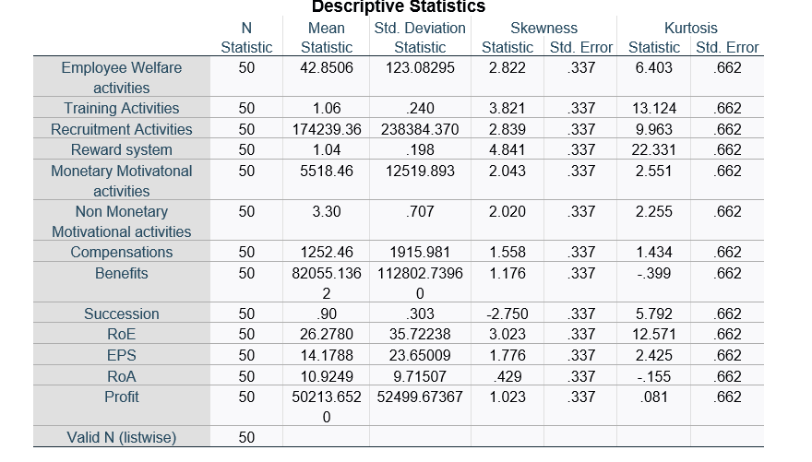
Source: Self-developed (SPSS)

Appendix 2: correlation
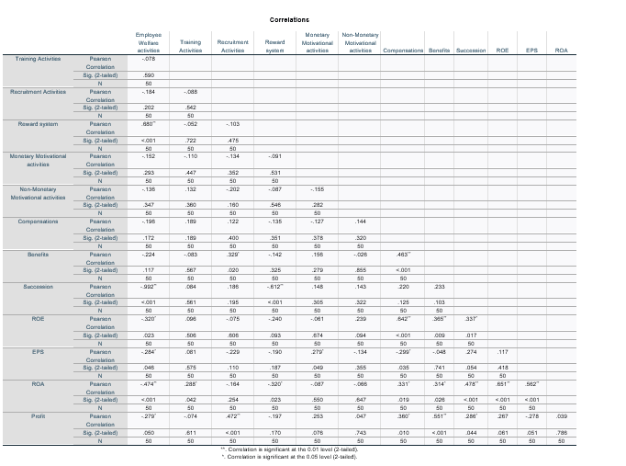
Source: Self-developed (SPSS)

Appendix 3: Regression (ROE)
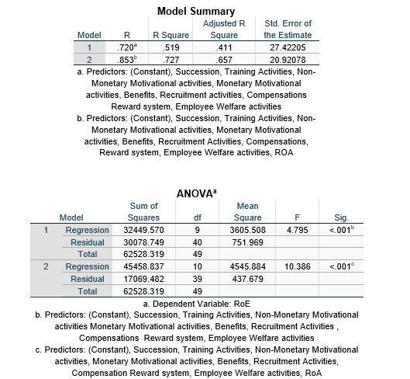
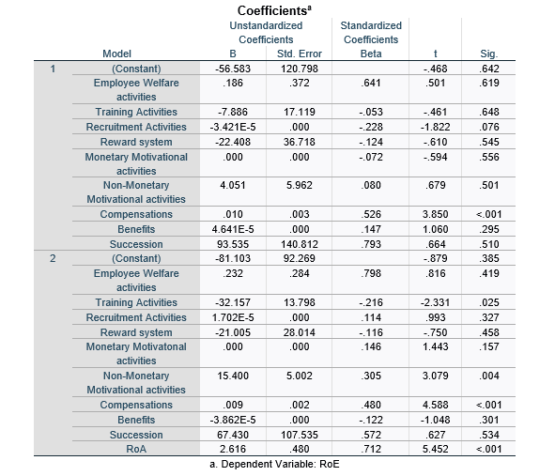
Source: Self-developed (SPSS)

Appendix 4: Regression (EPS)
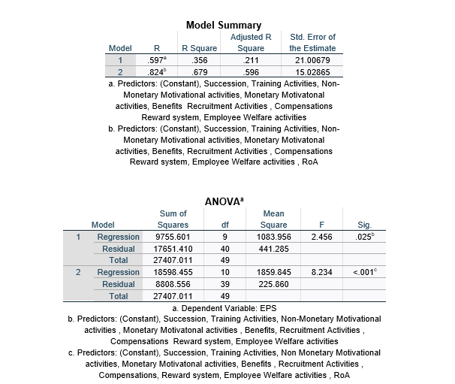
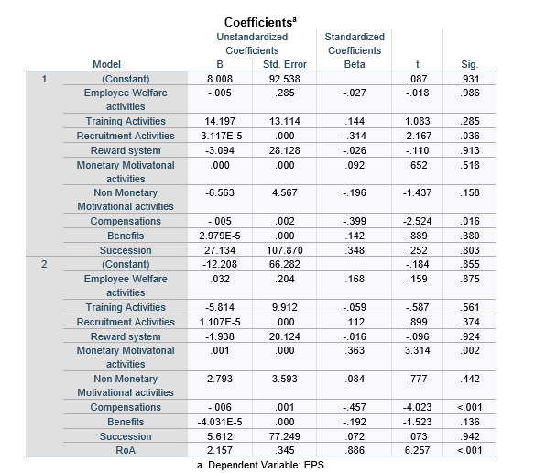
Source: Self-developed (SPSS)

Appendix 5: Regression (Profit)
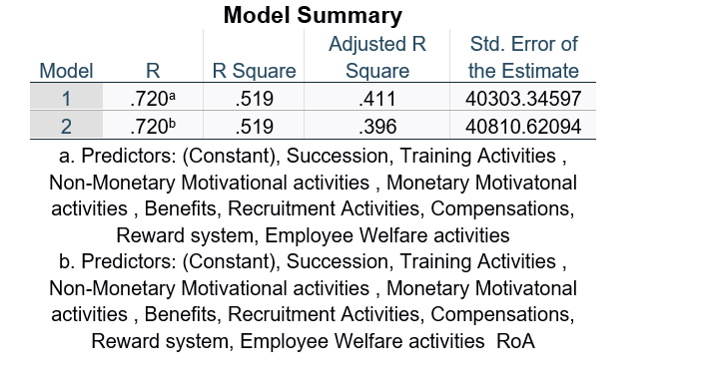
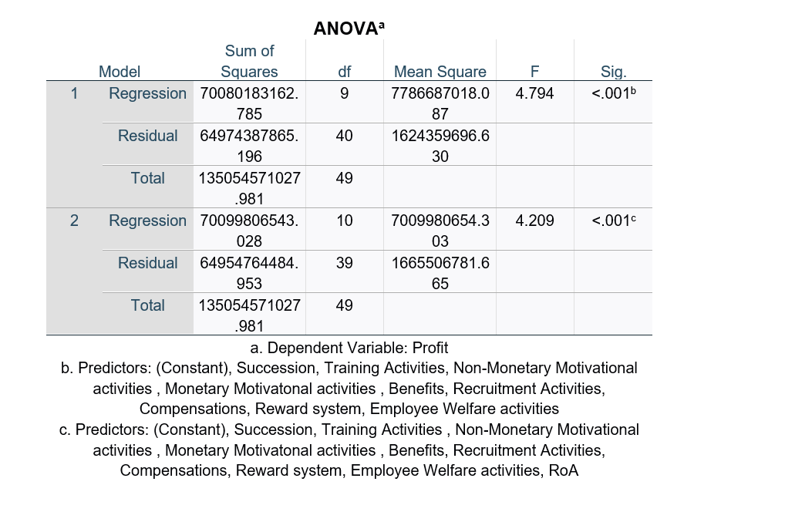
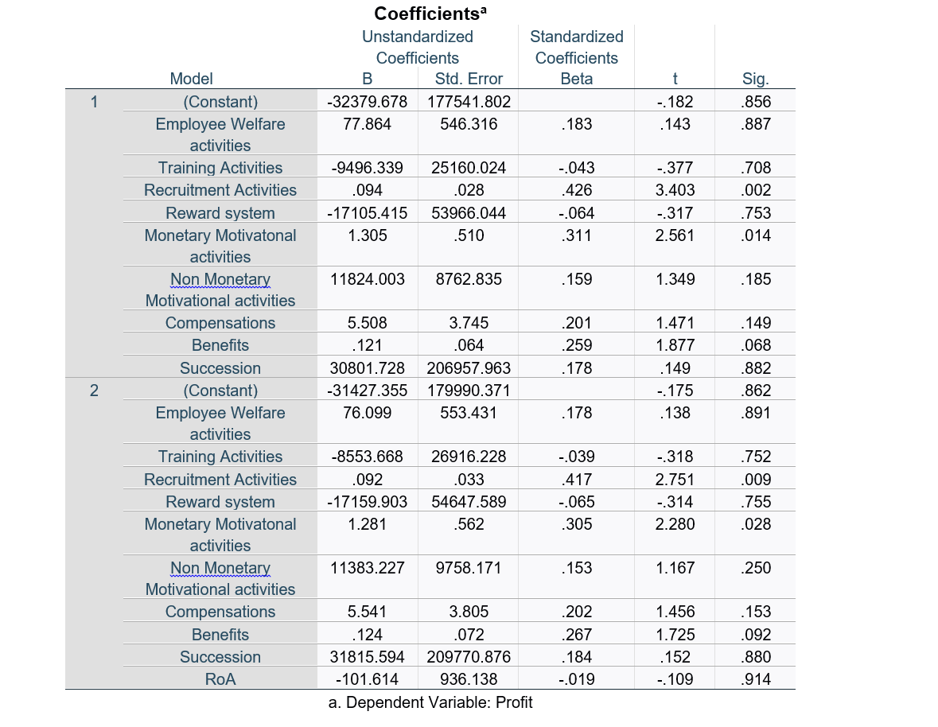
Source: Self-developed (SPSS)

