Conducting penetration testing and incident response on an enterprise network.
By
Ezzulddin Alakkar
2022
Contents

Table of Figures 2
Abstract 3
Introduction 3
Acronyms: 3
Penetration testing 4
The Primary Purpose of Penetration Testing? 4
What is a vulnerability assessment? 6
Types of vulnerability assessments 6
Vulnerability assessments vs. penetration tests 6
Some vulnerability scan forms include: 7
OWASP Top 10 Vulnerabilities 8
What is a Threat? 9
What is Web Application Security Testing? 9
The OWASP testing framework and methodologies 10
Web application security testing 12
Penetration testing tasks and tools 12
Tests with Scope 12
Phases of Penetration Testing 12
Pre-Attack Phase 13
Attack Phase 13
Post-Attack Phase 13
Fingerprint Web Server 13
Penetration testing methodology 16
Planning and intelligence gathering Phase 17
Discovery Phase 18
Assessment Phase 19
Exploration Phase 20
Reporting Phase 20
Develop Steps for Incident Response 21
Pre-incident response phase. 22
During-incident response phase. 22
The main incident response tools 24
Post-incident response phase. 24
RESULTS AND DISCUSSION 25
Conclusion 25
References 26

Table of Figures
Figure 1 The different pen test types 5
Figure 2Classification of Penetration Test (Federal Office for Information Security (BSI), 2012) 5
Figure 3Vulnerability Assessment Versus Penetration Test 7
Figure 4Increasing security cost with SDLC model 9
Figure 5 How to conduct a pen test 10
Figure 6 Typical SDLC testing workflow 10
Figure 7 The Three phases in a Penetration Test 12
Figure 8 Gathered information using Netcraft tool 13
Figure 9 some of the vulnerabilities 13
Figure 10 The figure illustrates the gathered information and opened ports 14
Figure 11 Network Penetration Testing Methodology 15
Figure 12 Gathered information using Netcraft tool 16
Figure 13 Ports status 17
Figure 14 Risk Factor based on CVSS Base Score Risk Factor based on CVSS Base Scoreable 18
Figure 15 Nessus scan 18
Figure 16 The CCFL investigation methodology 3 phases 19
Figure 17The invoice including the cost of investigation and datbase recovery. 21
Figure 18 The incident response report 22

Abstract
Security testing is the only a suitable way for testing the security of web applications under specific circumstances. Part one of this project aims to collect and explain all possible testing method and keep the guide updated. In addition, the project is dealing with security incident response in part two. The penetration test in part one is based on black box penetration testing, “The OWASP Web Application Security Testing method is based on the black box approach. The tester knows nothing or has very little information about the application to be tested”. (OWASP, 2020) The testing model consists of: Web Security Testing Guide v4.2 46 Tester: Who performs the testing activities Tools and methodology.

Introduction
The demand for networking and cloud computing has sharply increased in most organisations. However, the danger linked with cyberattacks and data breaches has also surged. There are always cybersecurity malicious and criminal intrusions to enterprises of all sizes. Therefore, many organisations have applied cybersecurity penetration tests. However, penetration testing is not a straightforward process, it is usually technical in nature (Pratama & Wiradarma, 2019). There are two parts in this paper, cybersecurity penetration testing is considered in the first part, whereas a case study about cybersecurity forensic investigation and incident response will be discussed in the second part. Furthermore, a question of “when does an organisation require a penetration test?” will be answered theoretically and practically in the first part. A company called Healious-Pharma (HPC) has requested penetration testing to be held by an expert tester. In addition, the company has lost important data that needs to be retrieved. Cybersecurity penetration testing and incident response are not an exact science where a group of all potential cases that should be tested can be identified. Thus the OWASP security penetration testing framework has been adopted in this paper.

Acronyms:
- OWASP -Open Web Application Security Project
- SDLS - Security Development Lifecycle
- CCFL – Ceac Cybersecurity and Forensics
- HPC – Healos pharmaceutical Company
- TCP- Transmission Control Protocol
- UDP- User Datagram Protocol

Part one

Penetration testing
Penetration testing can be defined as a way of using different automated and manual techniques to simulate and attack on an institution’s information security arrangement. Penetration tests should be achieved by a qualified and expert penetration tester. Penetration test is also known as ethical security testing or occasionally pen test. The aim is to exploit identified vulnerabilities. However, the testers should also use their knowledge to identify certain weaknesses (unknown vulnerabilities) in an institution’s security arrangements. The process of penetration testing includes an effective analysis of the target system for any potential vulnerabilities that come because of an inadequate or inappropriate system configuration for both of known or unknown hardware of software defects, and operational vulnerabilities in process of technical countermeasures. The analysis can be performed from the position of a potential attacker and can include effective exploitation of security vulnerabilities.
A penetration test is basically an evaluation of information technology infrastructure, networks, and enterprise applications to detect attack vectors, vulnerabilities and manage weaknesses. In a pen test, a simulated malicious attack is achieved by an outsider penetration tester who does not have an authorised tool to access the institution’s systems and/or an insider penetration tester who has some level of authorised access. The first case is known as a black box pen test and the second one is white box pen test.
Penetration testing can also be carried out on mobile applications, client servers, or other devices such as workstations, laptops, tablets, or even Voice over internet protocol (VoIP) devoices. The main steps of a penetration test usually include conduction research and detect vulnerabilities, exploiting weaknesses, reporting findings, and eventually remediating cases. However, outcomes from the research papers showed that the two most popular forms of penetration testing are:
- Application penetration testing (web applications).
- Infrastructure penetration testing (servers, firewalls, and other physical devices). (Kevin, 2012)
On the other hand, automated security analysis and testing tools are sold by several companies. The functions of these tools are limited, and they are designed for applications generally, but not for an organisation’s custom code. According to Michael Howard “Tools do not make software secure! They help scale the process and help enforce policy.”
However, despite the limited functions of these tools, running them does not cost time. (OWASP, 2021)

The Primary Purpose of Penetration Testing?
There are different penetration testing methods, and it is necessary to understand the reason for penetration testing to understand the differences between those methods. A pen test is aimed to test the security of the target institution. However, it seems that this fact is still subject to debate by many people. (Henry, 2021). Henry Kevin argued that some people seem to believe the main goal of penetration test is to achieve a ‘Crimewatch’ style reconstruction of a ‘real’ hacking attempt (Henry, 2021). However, Panama Putu disagrees with this which is supported by the fact that each penetration test’s ending point is a documentary containing details of the tests achieved, vulnerabilities and exploits discovered in addition to suggestions for enhancing security (Pratama & Wiradarma, 2019). It is important to understand the different techniques for assessing security. ‘Black box’ is one technique, and it is carried out when no knowledge is of the network is included. ‘White box’ test method is carried out when the tester has full knowledge of the network, while ‘Gray box’ requires some knowledge by the tester. Ultimately, institutions decide which test to be carried out. The following graph shows the different types of pen tests.

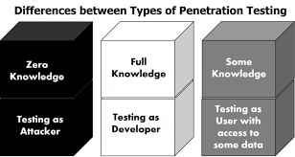
Figure 1 The different pen test types

The black box is the best method when organisations want to discover what hackers can do with their systems. For example, a web application has already been established, but the tester has no access to the source code. In this case, black box testing is preferable.
This type of testing, however, is better carried out after a full security review for the network to verify that the system is actually secure. (OWASP, 2020) In this paper, the concept of black box penetration test will be covered theoretically and practically. Specific criteria must be defined when pen testing is implemented. The following figure illustrates the classification of potential penetration testing. The right side is the defined criteria while the left side is the corresponding factors.

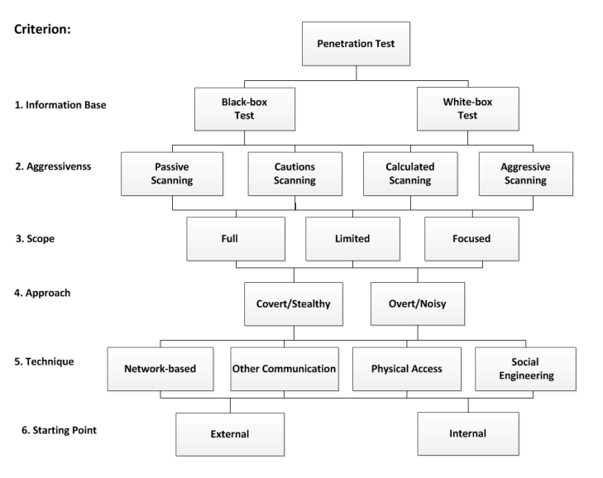
Figure 2Classification of Penetration Test (Federal Office for Information Security (BSI), 2012)

What is a vulnerability assessment?
A vulnerability assessment is the procedures of defining, determining, classifying, and prioritising vulnerabilities in computers, applications, and network infrastructures. (Resencrance, 2021) furthermore, vulnerability assessments help an institution to obtain the important knowledge, understanding, and risk awareness to realise and react to threats its hardware and applications. Some forms of vulnerability assessments can be efficient for institutions of any size, or even individuals who experience risk of cyber-attacks. Large companies or organisations facing continued attacks, on the other hand, will benefit from a full vulnerability analysis.

Types of vulnerability assessments
Vulnerability assessments detect different forms of system or network vulnerabilities. Different tools, scanners, and methods are involved in vulnerability assessments procedure to detect vulnerabilities, risks, and threats.

Vulnerability assessments vs. penetration tests
Vulnerability assessments usually involve a penetration testing element to detect vulnerabilities in an institution’s employees, techniques, and processes. System and network scans are not always capable to identify these vulnerabilities. However, the process is usually known as vulnerability assessments/penetration testing (VAPT). Penetration testing, however, is not appropriate as a full vulnerability assessment, it is, in fact, a separate process. Vulnerability assessments intend to discover vulnerabilities in a network and recommend the suitable mitigation or solution to decrease or remove the risks. Organisations should always implement vulnerability testing to secure their networks especially when changes are applied. For instance, a vulnerability test should be employed when services are added, new tools are installed, or ports are opened. Unlike vulnerability assessments, penetration testing includes detecting vulnerabilities in a network, and attempts to exploit them to attack the system. Although pen testing could sometimes be carried out in alongside vulnerability assessments, the main goal of penetration testing is to confirm whether a vulnerability really exists. Furthermore, penetration testing helps to confirm that exploiting a vulnerability can actually damage the application or network. The following table illustrates the main differences between Vulnerability Assessment and Penetration Test.

Vulnerability assessment | Penetration test
Examine the compliance, effectiveness, and efficiency of IT infrastructure without exploiting or breaking in. | It focuses more on identifying vulnerabilities and gathering more information about the system before exploiting.
It is a necessary before the penetration testing step. | It checks how further the attacker can go, and how serious the attack could be.
Scan and clarify the false positive vulnerabilities in computer systems | It clarifies whether the recent security factors implemented are efficient or not.
It works like a door to check if its locked or not. In terms of authorising someone access or not. | It trying to open the door and see how deep the tester can explore.
Less intrusive and possible does not disturb the IT services. | It indicates the weakness in the IT infrastructure and It is more intrusive.

Figure 3Vulnerability Assessment Versus Penetration Test

Some vulnerability scan forms include:
- Network-based scan it is used to detect potential network security attacks. It can also identify vulnerable systems on wired or wireless networks.
- Host-based scan it is designed to detect vulnerabilities in workstations, servers, and other network hosts. This scan is usually based on examining ports and services.
- Wireless network scan it scans institution’s Wi-Fi networks by constraining on points of attacks in the wireless network infrastructures.
- Application scan is used to test websites to identify popular software vulnerabilities and misconfigurations in network or web applications.

- Database scan can recognise weak points in a database to avoid malicious attacks, such as SQL-injection attacks.

OWASP Top 10 Vulnerabilities
“A vulnerability is a flaw or weakness in a system’s design, implementation, operation or management that could be exploited to compromise the system’s security objectives” (Pratama & Wiradarma, 2019)
According to OWASP, the top 10 risks of a web application can be categorised into:

- Injection
Injection happens when an insecure code is injected into a program by an attacker, SQL injection is an example. This injection flaws can be revealed by application security testing and remediation techniques are suggested such as stripping singular character from user input or writing parameterized SQL queries
- Broken Authentication
A huge security vulnerability can occur by implementing authentication and session management calls incorrectly. Attackers can be easily assume legitimate users Ids if they notice these vulnerabilities. Broken authentication can be mitigated by multifactor authentication.
- Sensitive Data Exposure
Some APIs depend on insecure data transmission approaches, which attackers can easily exploit to access sensitive information such as usernames and passwords. Sensitive data exposure can be reduced by implementing data encryption, tokenization, and disabling response catching.

- XML External Entities
This happens when attackers can upload or involve hostile XML content because of insecure code, integrations, or dependencies. The possible XML entity attack can be mitigated by disabling XML external entity processing.

- Broken Access Control
Sensitive files and systems, or even user privilege settings can be accessed by unauthorised or unauthenticated users with broken access control flaws. Missing authentication can be detected by penetration testing.
- Security Misconfiguration
General security configuration errors are considered risks that enable attackers from accessing sensitive data and site areas easily and quickly.

- Cross-Site Scripting
An attacker can take the advantage of APIs and DOM manipulation to recover data from or send commands to an application. Cross-site scripting enables threat actors to hijack user accounts, spread trojans and worms, access browser histories, and more.
- Insecure Deserialization
Recovering data and objects that have been written to disks or otherwise saved can be used to remotely carry out code in an application or as a door for more attacks.

- Using Components with Known Vulnerabilities
APIs, dependencies, and other third-party components can be exploited by attackers if they themselves are not secure.

- Insufficient Logging and Monitoring

“Failing to log errors or attacks and poor monitoring practices can introduce a human element to security risks. Threat actors count on a lack of monitoring and slower remediation times so that they can carry out their attacks before you have time to notice or react” (VERACODE, 2020)

What is a Threat?
Any malicious internal or external user, or system instability is considered a threat. The threat might damage the resources of value such as the database or file system of an application by exploiting a vulnerability. Systems and applications might experience security threats; therefore, threat modelling has become a popular procedure considered by designers. Applications can use threat modelling as a risk assessment. Threat modelling helps designers to improve mitigation techniques for potential vulnerabilities. Security experts recommend that all applications have a developed and documented threat model. (IriusRisk, 2020)

What is Web Application Security Testing?
A test is the procedure to determine that the security requirements of a company or organisation are applied on their web applications. A web application security test concentrates only on assessing the security of a web application. The procedures include an effective analysis of the application for any vulnerabilities, weaknesses, or technical flaws. On the other hand, the black box penetration test approach is the foundation for the OWASP technique. The ethical hacker has no knowledge about the application to be tested. The OWASP model involves; a tester to achieve the testing procedures, testing tools and methodology, and an application. Penetration testing can be classified into two passive testing and active testing. In passive testing, the ethical hacker works on exploring the application as a user and understanding the application’s logic. Tools, however, can be used to gather information. For example, the tester can observe information about an application from its HHTP headers, parameters, APIs, cookies, etc. On the other hand, the tester in active testing begins to gather information and apply the testing tools through some professional procedures. According to the OWASP’s experts, security is important to be considered in each phase of the Software Development Life Cycle (SDLC) to prevent security bugs from occurring in production applications. Furthermore, involving security in each of the SDLC model reduces the cost of fixing security bugs. The following figure shows a sample of SDLC model with estimated increasing cost of fixing security bugs (OWASP, 2020)

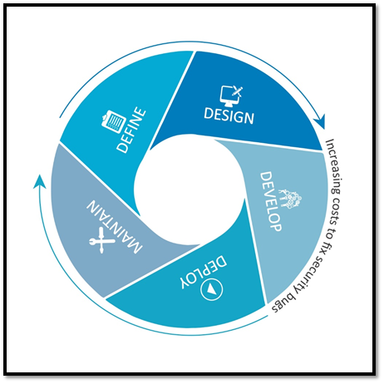
Figure 4Increasing security cost with SDLC model

The OWASP testing framework and methodologies
The OWASP testing framework is a testing framework that can be developed within an institution. Furthermore, it is considered a reference framework included tasks and techniques that are suitable at different levels of SDLC. The main penetration test architecture and strategy in this project are based on the OWASP framework. The research will cover how penetration tools are going to be used to streamline the workflow while assessing the “www.healious-pharma.com” website. After the Pre-engagement Interactions phase of penetration testing, the tester will be gathering information to help with the test and using specific penetration testing tools to scan, find, and analyse known vulnerabilities that are considered to be threats to the website before and post exploitation followed by documenting and reporting the results.

The following figure illustrates the penetration testing steps

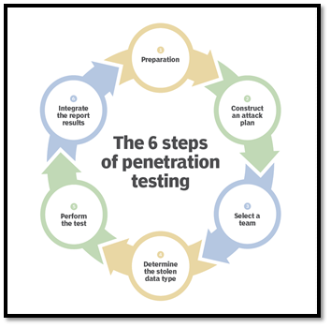
Figure 5 How to conduct a pen test

However, the penetration testing phases are all included within the main OWASP framework activities: before development begins, during definition and design, during development, during deployment, and during maintenance and operations. The following figure shows a typical SDLC testing workflow
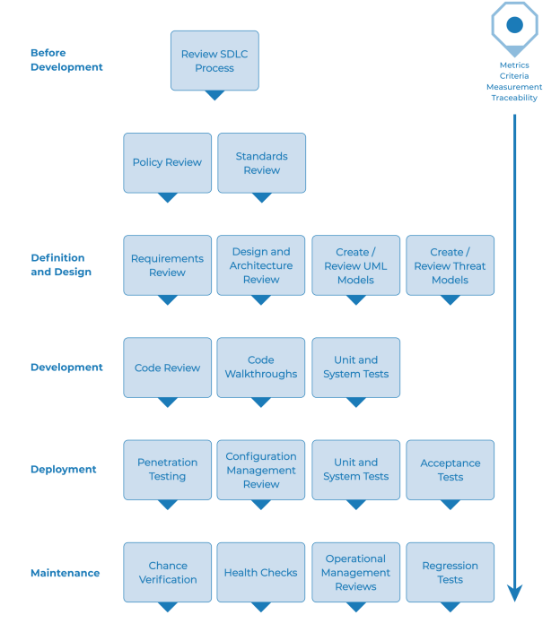
Figure 6 Typical SDLC testing workflow

Web application security testing

Penetration testing tasks and tools
Using the search engines to gather potential sensitive information is the foundation to test a website. It usually includes the diagrams and configurations of a network, archived emails and posts by administrators or other important members, logon procedures, usernames and passwords, cloud service configuration files, and other information. There are many open source and market tools that can be used to gather information such as Nessus, Kali Linux, Canvas, wireshark, and many other tools. (Help, 2021)

Tests with Scope
The scope of penetration test should be carefully specified to determine which device, network, and services should be adopted during the test. It clarifies which of the three metrics of full, limited, or focused test is going to be performed. Defining the scope reduces the complexity and cost. Furthermore, the required test time can also be reduced by determining the scope. However, the scope can be different based on the pre-knowledge and system configuration. (Bishop, 2007)
The tester with a full test examines the entire system, while only part of the system is investigated with a limited access penetration testing. Unlike the full and limited penetration testing in focused penetration testing, only one service is investigated.

Phases of Penetration Testing
A comprehensive penetration testing can be processed by achieving three phases in order, pre-attack phase, attack phase, and post-attack. However, the name of the phases can be different in some resources, but they share the same concept. Furthermore, the description of each phase is taken from the perspective of black-box penetration testing approach. The following figure shows the three phases.

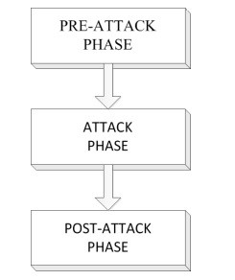
Figure 7 The Three phases in a Penetration Test

Pre-Attack Phase
In this phase, the penetration tester gathers as much information as possible about the target. The successful technique includes passive and active reconnaissance strategies. However, the main activities include port scanning, OS fingerprinting, network mapping, web profiling, and perimeter mapping. (Melmeg, 2022)&( (Graves., 2010)

Attack Phase
The actual compromise of the target is involved in this step. The discovered flaws and vulnerabilities from the previous stage will determine the required attack. In this phase, a variety tools can be used ranging from exploitive to responsive, such as vulnerability scanner, social engineering, and active probing.

Post-Attack Phase
In this phase, the system is restored back to the original pre-test status, which includes for instance reversing of ACLs, removing uploaded root kits files, and restoration of the network devices and infrastructure. A detailed report is required to include, for example but not limited to, all incidents that happened, all activities, and the test outcome. Furthermore, a valid penetration test report must be delivered to define the pen testing’s level of success.

Fingerprint Web Server

The reason for fingerprinting a web server is to detect which type and version of the web server the target is running on. Accurately, web servers which are running old versions of software without up-to-date patches are more vulnerable to popular version specific exploits. While scanning tools such as Netcraft and Nmap may not necessarily find the vulnerabilities, they could lead to exploiting unpatched servers. However, remediation can include procedures such as, hiding web server information in headers, creating an additional layer of security between the web server and the internet by using a hardened reverse proxy server, and updating servers regularly with latest software and security patches. The following figure shows gathered information using Netcraft testing tool
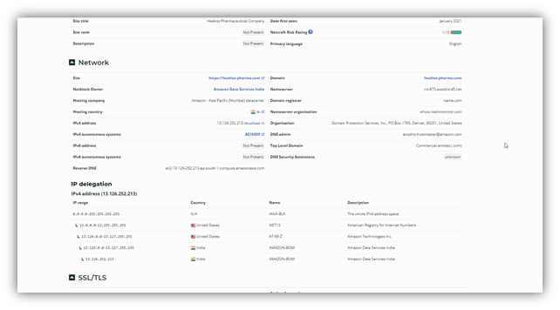
Figure 8 Gathered information using Netcraft tool

Enumerate Applications on Webserver
“Web application discovery is a process aimed at identifying web applications on a given infrastructure” (Resencrance, 2021). In this stage, an active connection has been established with the web application “www.healious-pharma.com” to discover and gather as much vectors as possible which can help to exploit the system further in terms of finding its weaknesses and vulnerabilities. (Purplesec, 2021). The following figure shows some of the discovered vulnerabilities (open ports) using Nmap tool.

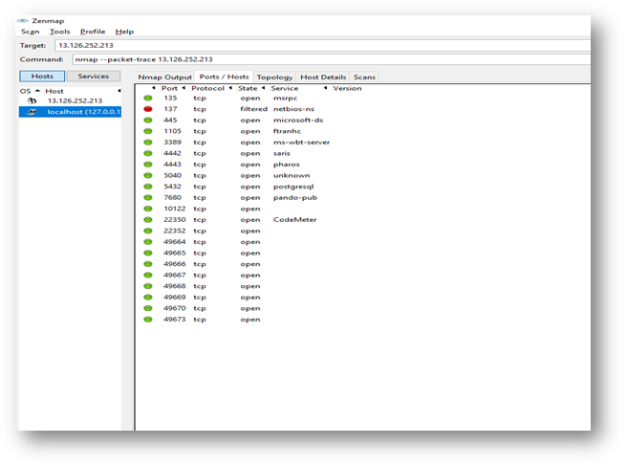
Figure 9 some of the vulnerabilities

All IPs | Open ports | Closed ports | services | Discovered protocols
13.126.252.213  Localhost(127.0.0.1) | 135 |  | MSRPC | TCP
 | 445 |  | MICROSOFT-AD | TCP
 | 1105 |  | FTRANHC | TCP
 | 3389 |  | MS-WBT-SERVER | TCP
 | 4442 |  | SARIS | TCP
 | 4443 |  | PHAROS | TCP
 | 5040 |  | UNKNOWN | TCP
 | 5432 |  | POSTGESQL | TCP
 | 7680 |  | PANDO-PUB | TCP
 | 10122 |  |  | TCP
 | 22350 |  | CODEMETER | TCP
 | 22352 |  |  | TCP
 | 49664 |  |  | TCP
 | 49665 |  |  | TCP
 | 49666 |  |  | TCP
 | 49667 |  |  | TCP
 | 49668 |  |  | TCP
 | 49669 |  |  | TCP
 | 49670 |  |  | TCP
 | 49673 |  |  | TCP
 | 21 |  | FTP | TCP
 | 25 |  | SMTP | TCP
 | 80 |  | HTTP | TCP
 | 110 |  | POP3 | TCP
 | 143 |  | IMAP | TCP
 | 443 |  | HTTPS | TCP
 | 2000 |  | CISCO-SCCP | TCP
 | 5060 |  | SIP | TCP
 | 8008 |  | HTTP | TCP
 | 8010 |  | XMPP | TCP

Figure 10 The figure illustrates the gathered information and opened ports

Penetration testing methodology
The penetration testing methodology can be defined as the series of steps or guidelines used to achieve penetration testing on a network or IT system. Therefore, penetration testing methodology is considered a blueprint for the penetration tester (Ali & Herivato, 2011). A proper practical and theoretical methodology has to be clarified to achieve better performance. In this part, a suitable penetration testing methodology and workflow will be designed. The following figure illustrates the general methodology of penetration testing.

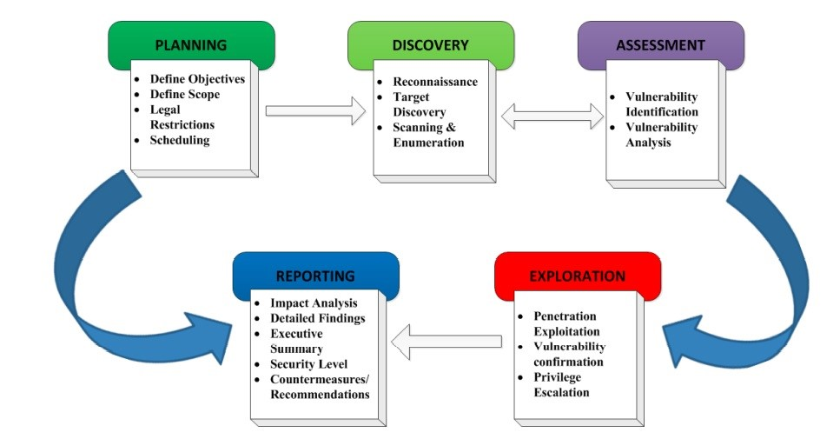
Figure 11 Network Penetration Testing Methodology

Planning and intelligence gathering Phase
Good planning and preparation is required to obtain a successful penetration testing. At this stage, the tester defines all the legal restriction and timing for the project, the scope, and the objectives. (Saindane, 2008), (T, 2002). In this phase, the healios-pharma company’s restrictions and rules need to be defined and considered. The following rules are required by the company:
- contents of the company website strictly not to be modified.
- The tester is required to provide all the discovered vulnerabilities and exploit methodologies, including information required to reproduce and validate the vulnerability and a Proof of Concept (POC).
- Data destruction, privacy violations, and interruption or degradation of services to be avoided.
- Data that does not belong to the tester to not be modified.
- Reported or not yet reported vulnerabilities are forbidden to be used to pivot and discover further vulnerabilities.

The company also requests to exclude the following from the test
- The testers are not allowed to access, download, or modify data of any other account that is not registered to them.
- DoS attack is not allowed to be executed or even attempted.
- Posting, uploading, transmitting, sending, storing, or linking to any malicious software.
- Any testing involved sending of unsolicited or unauthorized junk mail, spam, pyramid schemes or other forms of duplicative or unsolicited messages is not allowed.
- Any test leads to degrade the operation of the services is not allowed.
- Testing third party applications or websites or services that integrate with or link to the Service.

Gathering information is essential to continue with the penetration testing. Nmap has been extensively used to gather information about the hosts number, their IP addresses, the network and the ports, and the operating systems. Live hosts were identified by using Nmap. After that, all the ports were scanned along with OS and services fingerprinting. The following figure illustrates the network segment and all associated Ips.

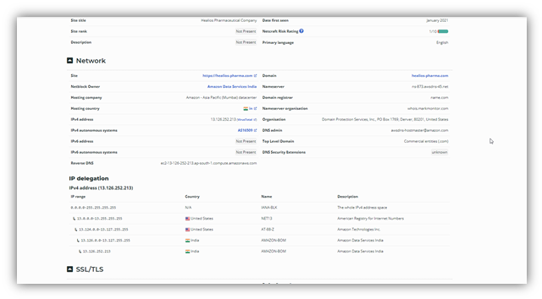
Figure 12 Gathered information using Netcraft tool

Discovery Phase
The former stage was to define the objectives and the scope, and to determine the restrictions. At this stage, the actual test starts by gathering information. However, this step can be divided in substages such as 1. Reconnaissance and Target discovery and 2. Scanning and Enumeration.
This phase provides information about open-source information, techniques, and penetration tools. The most popular tools and techniques include
- Social Engineering
- Dumpster Diving
- Internet Footprinting
Along with the previous step, the open and closed, filtered or unfiltered ports are defined. This step also provides general idea about services running on the hosts. Enumerating the ports status was performed by scanning both the TCP and UDP ports. Different switches were used with TCP scans such as -sX (FIN and Xmas Tree Scans), -sA (ACK Scan) and -sF, and -sS (SYN Stealth Scan). A sniffer observed the network traffic through the scan. Closed ports react to the FIN scan, while open ports do not. This is how FIN scan distinguish the port status. The following figure illustrates the port status. After finding open ports, the next step is to determine services and operating systems running on the hosts.

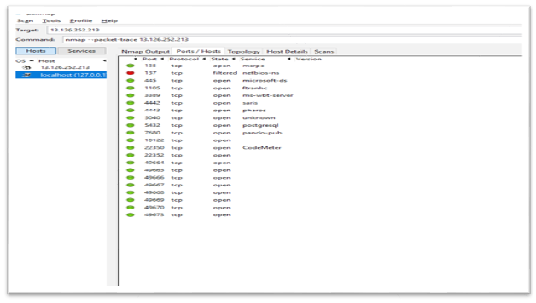
Figure 13 Ports status

Assessment Phase
This stage is almost linked with the discovery stage. The gathered information from the discovery stage is the input for assessment stage and vice versa. At this point, a systematic scan of the network or the system is achieved to identify the importance of security actions, determine security flaws and supply data for the following stages. The assessment stage includes:
- Vulnerabilities Identification
- Vulnerabilities Analysis
Nessus was used to identify the OS running on the hosts, the vulnerable hosts, and services. More investigation is required to verify possible exploits against the vulnerable hosts and services which will be explained in the following stage. However, the table below has been generated from the scan. It reports the vulnerabilities and labels them as critical, high, medium, and low depending on Common Vulnerability Scoring System (CVSS) Base Score8.

Risk factor | CVSS V2 Base score
Critical | 10
high | 9.9 – 7
Medium | 6.9 – 4
Low | 3.9 – 1
info | 0

Figure 14 Risk Factor based on CVSS Base Score Risk Factor based on CVSS Base Scoreable

Target hosts | critical | high | Medium | low
13.0.0.12 | 0 | 0 | 3 | 2
13.124.0.12 | 2 | 0 | 1 | 0
13.126.0.12 | 1 | 0 | 3 | 0
13.126.252.213 | 2 | 2 | 7 | 1

Figure 15 Nessus scan

Exploration Phase
This step can be a challenging step in penetration testing. This step comes after identifying and analysing the vulnerabilities, and then the penetration tester selects attack methods to penetrate the network. Furthermore, the tester has to define the targets properly. After defining the proper targets, the penetration attempt will be applied on the targets. By the end of this stage, a lot of information has been gathered by the penetration tester. This information is ready to be used to break into the target system. The tester, however, needs to consider some external aspects that impact what tools to be used and when. (McDermott, 2000). In this instance, however, vulnerabilities were exploited by using widely suitable exploits. Metasploit has been used during this stage. From the IPs in the previous table, the first three hosts were successfully exploited by using Metasploit. However, the system or network administrators should take some countermeasure by applying patches and activating the live update on the system to protect it or the network against this kind of vulnerabilities.

Reporting Phase
Reporting stage can be achieved in parallel to the other stages or after the exploitation. The evaluation of the vulnerabilities should be included in the report in terms of potential risks, recommendations for mitigating the risks and vulnerabilities. The following should be included in the report: (Wilhelm, 2009) (Wai, 2002)
- Detail reports on both high-level and low-level findings and explanations of the steps necessary to repeat the exploits
- Results including both positive and false-positive
- Official Summary
- Business and functional affects
- Recommendations
- Conclusion

Part two

Develop Steps for Incident Response
Cloud computing has become popular in many organisations and industry. On the other hand, the danger linked with cyberattacks and data breaches have been risen. However, there are always criminal intrusions to enterprises of all sizes. Some recent statistics claims that cybercrimes have risen to more than thirty thousand percent during the current covid-19 pandemic (Head, 2020). Therefore, many enterprises have been adopting some procedures to protect their data. The traditional steps for any incident response include preparing, identifying, containment, eradication, and recovering. (Maayan, 2021). However, defining and applying the suitable incident response phases can guarantee that disruption be an inconvenience, not a disaster. Proactive and reactive are two essential fields to be considered when setting an information security incident response procedures plan. In this paper an incident response plan will be prepared to restore some data and a related formal report will be provided. In this paper, Ceac Cybersecurity and Forensics Ltd (CCFL) has been hired by Healos Pharmaceutical Company (HPC) to investigate an incident of losing and recovering important data. CCFL’s developed investigation methodology includes three phases:
- Pre-incident response phase.
- During-incident response phase.
- Post-incident response phase.
The following figure shows the entire image of the methodology.
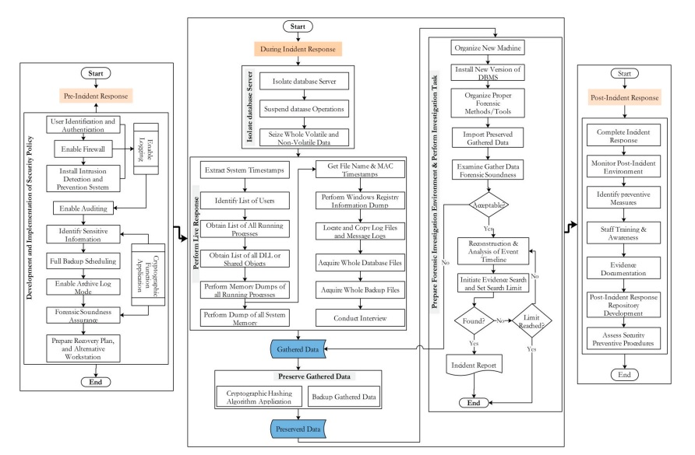
Figure 16 The CCFL investigation methodology 3 phases

Pre-incident response phase.
This stage can be described as a security policy to prepare for a potential database incident. It be applied by companies in order to control and monitor the execution of actions applied to database systems. The main required steps in this phase include: (AL-Dahqmi, Arafat; Siddique, Kamran; Kebande, Victor;, 2020)
- User identification and authentication
- Enabling firewall
- Installing intrusion and detection and prevention systems (IDPSs)
- Enabling auditing and accountability
- Identifying Sensitive Information
- Scheduling Full backup
- Enabling Archive Log Mode
- Forensic Soundness Assurance
- Preparing Recovery Plan and Alternative Workstation: Every company should prepare a strong recovery plan to backup all data and information. The absence of recovering plan can cost companies a lot of money. Therefore, paying for CCFL is inevitable.

During-incident response phase.
This phase is required when the database incident has already happened. It includes a group of procedures to be taken. The database incidents will be checked and discovered by the incident responder as follow:
- Isolating database server: the database server was disconnected by the CCFL’s incident responder so the users cannot access the server during the process of this phase. Processing and operating database must be suspended to provide evidence of any action linked to an intruder.
- Performing live response to recover and store volatile data safely. Live response (LR) also provides a platform for the incident responder to collect non-volatile evidence in a human-readable format. LR can be achieved by the incident responder by following these steps:
- Recording the system time and date
- Identifying the group of users that are currently logged-on the system. The group includes the server users, membership users, and last logged in users
- Listing the running processes
- Collecting memory of all running process to catch cloaking attacks
- Performing dumping the memory of the system
- Obtaining file names and MAC times. Performing dumping of all windows registry information
- Arranging interviews with some of the company staff to collect data
The collected data can include evidence about the intruders’ activities. Forensic investigation environment has been prepared by the responder to perform the investigation procedures to start transferring all the gathered data and evidence to the investigation environment. This is followed by archiving the investigation to find the evidence. All the required investigation team, tools, processes, actions, and methods should be presented in the investigation environment. The previous figure illustrated all the procedures in order.
In the investigation lab, the responder installed a new version of Database Management System (DBMS) which is similar to the lost database system in terms of files, version, and applications. The responder also organised the tools of verification, acquisition, preservation, reconstructing, and analysing data. Furthermore, the responder imported a whole copy of preserved gathered volatile and non-volatile data to the new DBMS. The during-incident response phase also includes searching for evidence, which is the most important step. However, “Pieces of evidence are usually recognized in the database files that are recorded on hard drives and storage devices and media and It is transmitted in binary form that may be relied upon in court. It consists of who, why, when, what, how, and where the malicious transactions were carried out.” (Khanuja & Suratkar, 2014). The following step has been taken by the incident responder when preparing an incident written report to include all the findings and the results. Said report shows the invoice including the cost of the incident response investigation and database recovery.
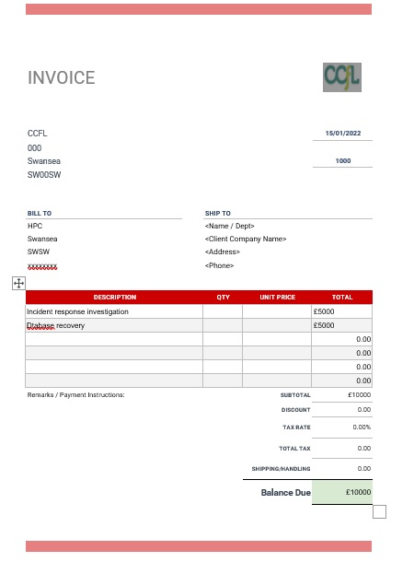
Figure 17The invoice including the cost of investigation and datbase recovery.

The main incident response tools
- Cynet 360
- GRR Rapid Response
- AlienVault
- Cyphon
- Sans Investigative Forensics Toolkit (SIFT) Workstation
The mentioned tools have been used during the incident response. The report has been written to document the investigation processes and the conclusions. It has been written in a way that can be read by non-technical users. Furthermore, the report is robust enough to be used as evidence during a lawsuit and held up against legal scrutiny. Finally, the investigation has concluded, and the data has been restored and recovered. Therefore, the database system has resumed ordinary operations. The database server has also opened for normal users.

Post-incident response phase.
This stage is the last stage of CCFL’s security incident response investigation and database recovery plan. It focuses on gathering information from the previous two phases (pre-incident response and during-incident response) for learning and improving objectives as well as reporting all the investigation processes to be used as a reference for future potential incidents. The following figure shows the provided report.

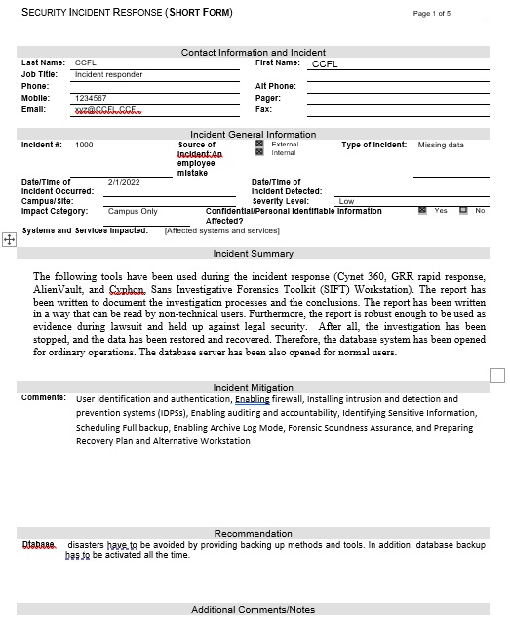
Figure 18 The incident response report

This phase also includes the findings to be written in the report. Furthermore, the report provides the gathered documentation from the during-incident phase, and the analysis techniques and tools, and other findings. The report may also be used in court for any legal action.

RESULTS AND DISCUSSION
The aim is to create a plan to avoid any database disaster, investigate and search for evidence, recover database, and provide a report by implementing this incident response model. A report can also be used to provide a reference for future incidents. The main questions on who should respond to a database incident is a crucial part of the incident response process. Ideally an incident response expert would deal with high priority issues such as these. (Fortinet, 2022).

Conclusion
The penetration test was conducted successfully and recommendations have been given to the Healos Pharmaceutical Company regarding the test such as closing all open ports. Furthermore, the company requested a response to an incident, the incident response has been led by CCFL and successfully achieved. The Healos pharmaceutical Company has been strongly advised to activate the back-up techniques on all devices to keep a copy of all the database safe in any unusual circumstances such as disasters.

References

AL-Dahqmi, Arafat; Siddique, Kamran; Kebande, Victor;, 2020. Towards the Development of an Integrated Incident Response Model for Database Forensic Investigation Field, s.l.: IEEE Access.
COBIT 2019 Framework: Governance and Management Objectives (2019) ISACA.
Fortinet, 2022. Fortinet. [Online]
Available at: https://www.fortinet.com/resources/cyberglossary/incident-response#:~:text=%206%20Steps%20of%20an%20Incident%20Response%20Plan,all...%205%20Step%206%3A%20Learn.%20%20More%20
[Accessed 15 january 2022].
Head, L., 2020. AIS Network. [Online]
Available at: https://aisn.net/5-cybersecurity-incident-response-steps/
[Accessed 11 january 2022].
Henry, K., 2021. Penetration Testing: Protecting Networks and Systems. IT Governance Publishing, pp. 10-11.
IriusRisk, 2020. Threat modelling for banking & finance. [Online]
Available at: https://www.iriusrisk.com/financial-services-ebook-download?utm_medium=paid%20search&utm_source=google%20search&utm_campaign=fs%20&%20banking%20q4%202021&utm_content=adgroup:%20threat%20modeling/modelling&utm_campaign=Finance+Program&utm_term=threat%20mod
[Accessed 11 Novemebr 2021].
Kevin, H., 2012. Penetration Testing: Protecting Networks and Systems. IT governance Puplishing. [Online]
Available at: Http://www.jstor.org/stable/i.ctt5hh74m
[Accessed 16 January 2022].
Khanuja, H. K. & Suratkar, S. S., 2014. Role of metadata in forensic analysis of database attacks. s.l., IACC, pp. 457-462.
Maayan, G. D., 2021. Best Practices for Cloud Incident Response. [Online]
Available at: https://devops.com/best-practices-for-cloud-incident-response/#referrer=https%3A%2F%2Fwww.google.com&amp_tf=From%20%251%24s&ampshare=https%3A%2F%2Fdevops.com%2Fbest-practices-for-cloud-incident-response%2F
[Accessed 15 January 2022].
OWASP, 2020. OWASP. OWASP Web Security Testing Guide. WSTG – v4.2. [Online]
Available at: https://owasp.org/www-project-web-security-testing-guide/v42/4 Web_Application_Security_Testing/00-Introduction_and_Objectives/README
[Accessed 11 November 2021].
OWASP, 2020. OWASP. WSTG – v4.2. [Online]
Available at: https://owasp.org/www-project-web-security-testing-guide/v42/
[Accessed 11 November 2022].
OWASP, 2021. OWASP. WSTG – v4.2. [Online]
Available at: https://owasp.org/www-project-web-security-testing-guide/v42/
[Accessed 16 January 2022].
Pratama, P. & Wiradarma, A., 2019. Open Source Intelligence Testing Using the OWASP Version 4 Framework at the Information Gathering Stage (Case Study: X Company). Computer Network and Information Security, 02 July, pp. 8-12.
Purplesec, 2021. Purplesec, Types of penetration testing. 2021. [online]Available from: https://purplesec.us/types-penetration-testing/. [Online]
Available at: https://purplesec.us/types-penetration-testing/
[Accessed 11 November 2021].
Resencrance, L., 2021. vulnerability assessment (vulnerability analysis) 2020-2021. [Online]
Available at: https://searchsecurity.techtarget.com/definition/vulnerability-assessment-vulnerability-analysis
[Accessed 11 November 2021].
VERACODE, 2020. VERACODE, Application Security. [Online]
Available at: OWASP Top 10 Vulnerabilities | Veracode
[Accessed 11 Novemeber 2022].
Help, S. t., 2021. 19 Powerful Penetration Testing Tools Used By Pros In 2022. [Online]
Available at: https://www.softwaretestinghelp.com/penetration-testing-tools/
[Accessed 20 November 2021].

marking criteria and Student FEEDBACK

This section details the assessment criteria. The extent to which these are demonstrated by you determines your mark. The marks available for each criterion are shown. Lecturers will use the space provided to comment on the achievement of the task(s), including those areas in which you have performed well and areas that would benefit from development/improvement.

Common Assessment Criteria Applied (Assignment 1) | Marks available | Marks  awarded
1. Engagement with Literature Skills
Extent of research and/or own reading, selection of credible sources, application of appropriate referencing conventions.
You have carried out relevant research. However, some of the research aspect could do with more referencing. The IEEE (numbering) reference style is not use. Avoid the use of too many websites and use more peer reviewed articles. Try utilising more the university online resources and journals. (Grade mark: 53.33%) | 15 | 8
2. Knowledge and Understanding Skills
Extent of knowledge and understanding of concepts and underlying principles associated with the discipline.
Your research aspect demonstrated understanding of the given assignment. However, see comment above to improve this section. The practical aspect lacks full understanding. (Grade mark: 53.33%) | 15 | 8
3. Cognitive and Intellectual Skills
Analysis, evaluation and synthesis; logic, argument and judgement; analytical reflection; organisation of ideas and evidence
See comment to improve abstract and introduction. The discussion for both task 1 and 2 is done in a more general way similar to literature review. These need to be critically analyse discussing the findings from the given case studies. Task 2 need to outline the methodology steps to be taken to carry out the investigation. Conclusion needs to be improved. This should summarise your key areas of the report. The schedule to execute the potential solution not done, cost solutions not done, recommended solution partially given and invoice for the forensics investigation portion. No chain of custody document or sample generated report done (Grade mark: 50.00%) | 40 | 20
4. Practical Application Skills
Deployment of methods, materials, tools and techniques; application of concepts; formulation of innovative and creative solutions to solve problems.
There are pen-test screenshots but not clear if they were taken from the given website to carry out the test on. (Grade mark: 44.00%) | 25 | 11
5. Transferable Skills for Life and Professional Practice
Attributes in professional practice: individual and collaborative working; deployment of appropriate media; presentation and organisation.
A presentable work (Grade mark: 60.00%) | 5 | 3

Assignment Mark (Assessment marks are subject to ratification at the Exam Board. These comments and marks are to give feedback on module work and are for guidance only until they are confirmed. ) | Late Submission Penalties (tick if appropriate) |  | 50%
 | Up to four weeks late |  | 50%
 | First Attempt? |  | 50%

