Mental Disorders and Psychopathology BMHP6006
Assessment 1: Debate & Supporting paper.
Lecture: Bianca Sanfilippo.
Student Name: Sevzhihan Hasanova.
Student Number: 2020999

Topic: Dementia in Alzheimer's disease
Introduction.
In this paper, I will discuss about International Statistical Classification of Diseases and Related Health Problems 10th Revision (ICD-10) Version for 2010.
Chapter V
Mental and behavioural disorders(F00-F99)
Group: Organic, including symptomatic, mental disorders (F00-F09).
Classification: F00* Dementia in Alzheimer disease (WHO,2010). The dementia in Alzheimer's disease will be the focus.
Organic and symptomatic mental diseases are a collection of mental disorders that all have a clear origin in brain disease, brain injury, or some other trauma that causes the brain to malfunction, as stated by the (ICD-10) classification system. The dysfunction can be primary, which occurs when an illness, injury, or trauma solely affects the brain; secondary, which occurs when a systemic disease or disorder only affects the brain as one of numerous organs or physiological systems it affects; and tertiary, which occurs when the dysfunction results from a combination of both primary and secondary causes.
What is a Dementia in Alzheimer's disease: Dementia is a type of illness that is caused by a disease in the brain and is typically either chronic or progressive, meaning that it becomes worse over time. It interferes with a wide variety of upper cortical activities, including memory, reasoning, direction, comprehension, arithmetic, the ability to learn, language, and judgement. The mind is in a state of disarray. Changes in emotional control, social behaviour, or motivation frequently accompany cognitive issues; nevertheless, there are instances in which these changes occur before cognitive problems. People who have Alzheimer's disease, cerebrovascular sickness, or other conditions that affect the brain in some ways are more likely to experience this syndrome than healthy individuals.
Who suffers from Alzheimer's disease: Alzheimer disease is a major kind of neurodegenerative dementia that affects the brains. (Nation Institute of Again, 2021.). Alzheimer disease is the most common kind of dementia, and it mostly impacts the cerebral cortex of the brain. It is not entirely apparent what causes this condition; however, it is distinguished by several unique neuropathological and neurochemical characteristics. The onset of the sickness is often undetectable, and its progression over a period of many years occurs in a manner that is both progressive and consistent over the course of the condition. The most important component in developing Alzheimer's disease is just becoming older. The elderly is at an increased risk than other age groups. After reaching this age, one's likelihood of developing Alzheimer's disease roughly doubles approximately every five years. Alzheimer's disease is the primary contributor to dementia in older persons and affects one in six people over the age of 80. We are not aware of the specific factors that led to this. One possible explanation is that, on average, women live longer than men. Women who have gone through menopause and had a drop in their oestrogen levels have been found to have an elevated chance of developing Alzheimer's disease.
Causes of Alzheimer: It is believed that the accumulation of abnormally large amounts of proteins in and around brain cells is what causes Alzheimer's disease (NHS,2021).
According to the World Health Organisation (2022), Alzheimer's disease is responsible for 60–70% of all cases of dementia.
According to the Alzheimer's Association (2019), dementia is the seventh largest cause of death among diseases and is one of the most worrisome causes of disability among people who are aged around the world.
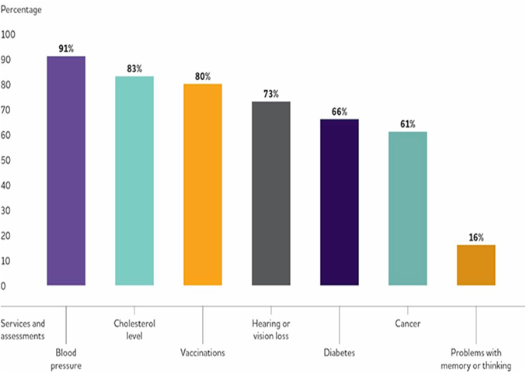
Source: https://alz-journals.onlinelibrary.wiley.com/doi/10.1016/j.jalz.2019.01.010

Signs and symptoms associated with Alzheimer's disease: Memory difficulties. Speech, concentrating, planning, or organising, orientation (Alzheimer’s Association, 2022).
It's possible that problems with vision or language will appear first, rather than memory problems. A person whose Alzheimer's disease is in its early stages will have periodic changes in their mood due to the progression of the disease. It is possible for them to have feelings of anxiety and despair, in addition to an increased level of irritation. A lot of people find that conversation, along with their hobbies and interests, can rapidly become less interesting to them. It may be challenging to adjust to the changes that dementia brings about, not only for the person who is affected by the condition but also for those who are close to them.
Diagnosis of Alzheimer: According to (HNS,2021) Assessed with a pen-and-paper test. Examining the patient's blood (checking the tau and beta-amyloid levels). Brain scan. CT (computerised tomography). MRI (magnetic resonance imaging).
Historical view of Alzheimer: Emil Kraepelin (1856–1926), a doctor in Germany, categorised dementia into senile dementia and presenile dementia in 1910. He was the first person to call the disease "Alzheimer's disease," after Alois Alzheimer (1864–1915), who detected pathological evidence of presenile dementia while he was his student. He did this in honour of Alzheimer, who lived from 1864 until 1915. During the Middle Ages, mental illnesses such as depression and dementia were thought to be a type of punishment that God had to unavoidably inflict because of the sins that humans had committed. This belief persisted even though modern medicine has disproved this notion. At this point in history, the cause of dementia had not been properly defined, thus people believed that unusual behaviours and mental symptoms induced in dementia patients were due to demon possession. This belief stemmed from the fact that the cause of dementia had not been identified. As a direct consequence of this, those who suffer from dementia are typically more hostile. During the vast witch hunts that took place across Europe in the 14th and 15th centuries, patients suffering from dementia were a common type of victim. These hunts took place between the years 1400 and 1500 (“Alzheimer’s Disease: Past, Present, and Future.”,2017).
Current treatments of Alzheimer disease: A person who is seeking to live a healthy life despite having the illness has a variety of options available to them, including drug therapies, care and support that does not include the use of medicines. It is critical that the individual be given the opportunity to consult with a knowledgeable professional regarding their diagnosis. The medication may reduce feelings of anxiety, make it simpler to recall things, improve concentration and motivation, and help with aspects of day-to-day life such as cooking, shopping, and hobbies. It may also make it easier to remember things. The levels of specific chemical messengers in the brain are increased, which is the reason why they are so effective. There are many different strategies that can be utilised to help a person with dementia keep their independence while also adjusting to changes in their life, such as memory loss. These include logistical issues such as aiding the individual in creating a habit and making use of a weekly pill box to keep track of medication (NHS,2021).
Recommendations: Activity that keeps a person mentally, physically, and socially engaged can be of tremendous help to a person who has Alzheimer's disease throughout the course of their condition. They should try to maintain their participation in the interests that offer them joy, and they should also give some thought to trying out some new things to do in their spare time. For example, engaging in regular physical activity such as swimming, walking, or tai chi; engaging in mental activity such as reading or playing puzzles. Participating in activities such as singing, dancing, or making music as a part of a group engaging in activities such as arts and crafts or other hobbies visiting a nearby museum or gallery going on day trips. Staying mentally and socially active (HNS,2021).

Reference list.
Alzheimer's Association. “2019 Alzheimer’s Disease Facts and Figures.” Alzheimer’s & Dementia, vol. 15, no. 3, Mar. 2019, pp. 321–387, https://doi.org/10.1016/j.jalz.2019.01.010.
Alzheimer’s Association (2022) What is Alzheimer’s Disease? Available at: https://www.alz.org/alzheimers-dementia/what-is-alzheimers.(Accessed :2 April 2023).
Alzheimer’s Society (2022) Risk factors: Who gets Alzheimer&#39; s disease? Available at: https://www.alzheimers.org.uk/about-dementia/types-dementia/who-gets-alzheimers-disease. (Accessed 5 April 2023).
Bondi, Mark W., et al. “Alzheimer’s Disease: Past, Present, and Future.” Journal of the International Neuropsychological Society, vol. 23, no. 9-10, Oct. 2017, pp. 818–831, https://doi.org/10.1017/s135561771700100x.
NHS (2021, July 5) Alzheimer’s disease. Available at: https://www.nhs.uk/conditions/alzheimers-disease/ (Accessed 3 April 2023).
National Institute on Aging. “Alzheimer’s Disease Fact Sheet.” National Institute on Aging, 2021, www.nia.nih.gov/health/alzheimers-disease-fact-sheet.(Accessed 20 Mar. 2023).
Reynolds, David S. “A Short Perspective on the Long Road to Effective Treatments for Alzheimer’s Disease.” British Journal of Pharmacology, vol. 176, no. 18, Mar. 2019, pp. 3636–3648, https://doi.org/10.1111/bph.14581.
Ritchie, Hannah, and Max Roser. “Causes of Death.” Our World in Data, 14 Feb. 2018, ourworldindata.org/causes-of-death?utm_source=newsletter&utm_medium=email&utm_campaign=covid_bytes_daily_newsletter. (Accessed 10 Apr. 2023).
“Treatment and Support of Alzheimer’s Disease.” Alzheimer’s Society, 2019, www.alzheimers.org.uk/about-dementia/types-dementia/treatment-support-alzheimers-disease#content-start. (Accessed 7 Apr. 2023).
World Health Organisation, WHO (2010) ICD-10 VERSION. Available at: https://icd.who.int/browse10/2010/en#/F30-F39 (Accessed:6 April 2023).
World Health Organization. “World Health Statistics 2022.” Www.who.int, 20 May 2022, www.who.int/news/item/20-05-2022-world-health-statistics-2022. Accessed 1 Apr. 2023.

Appendix:
1.
2. 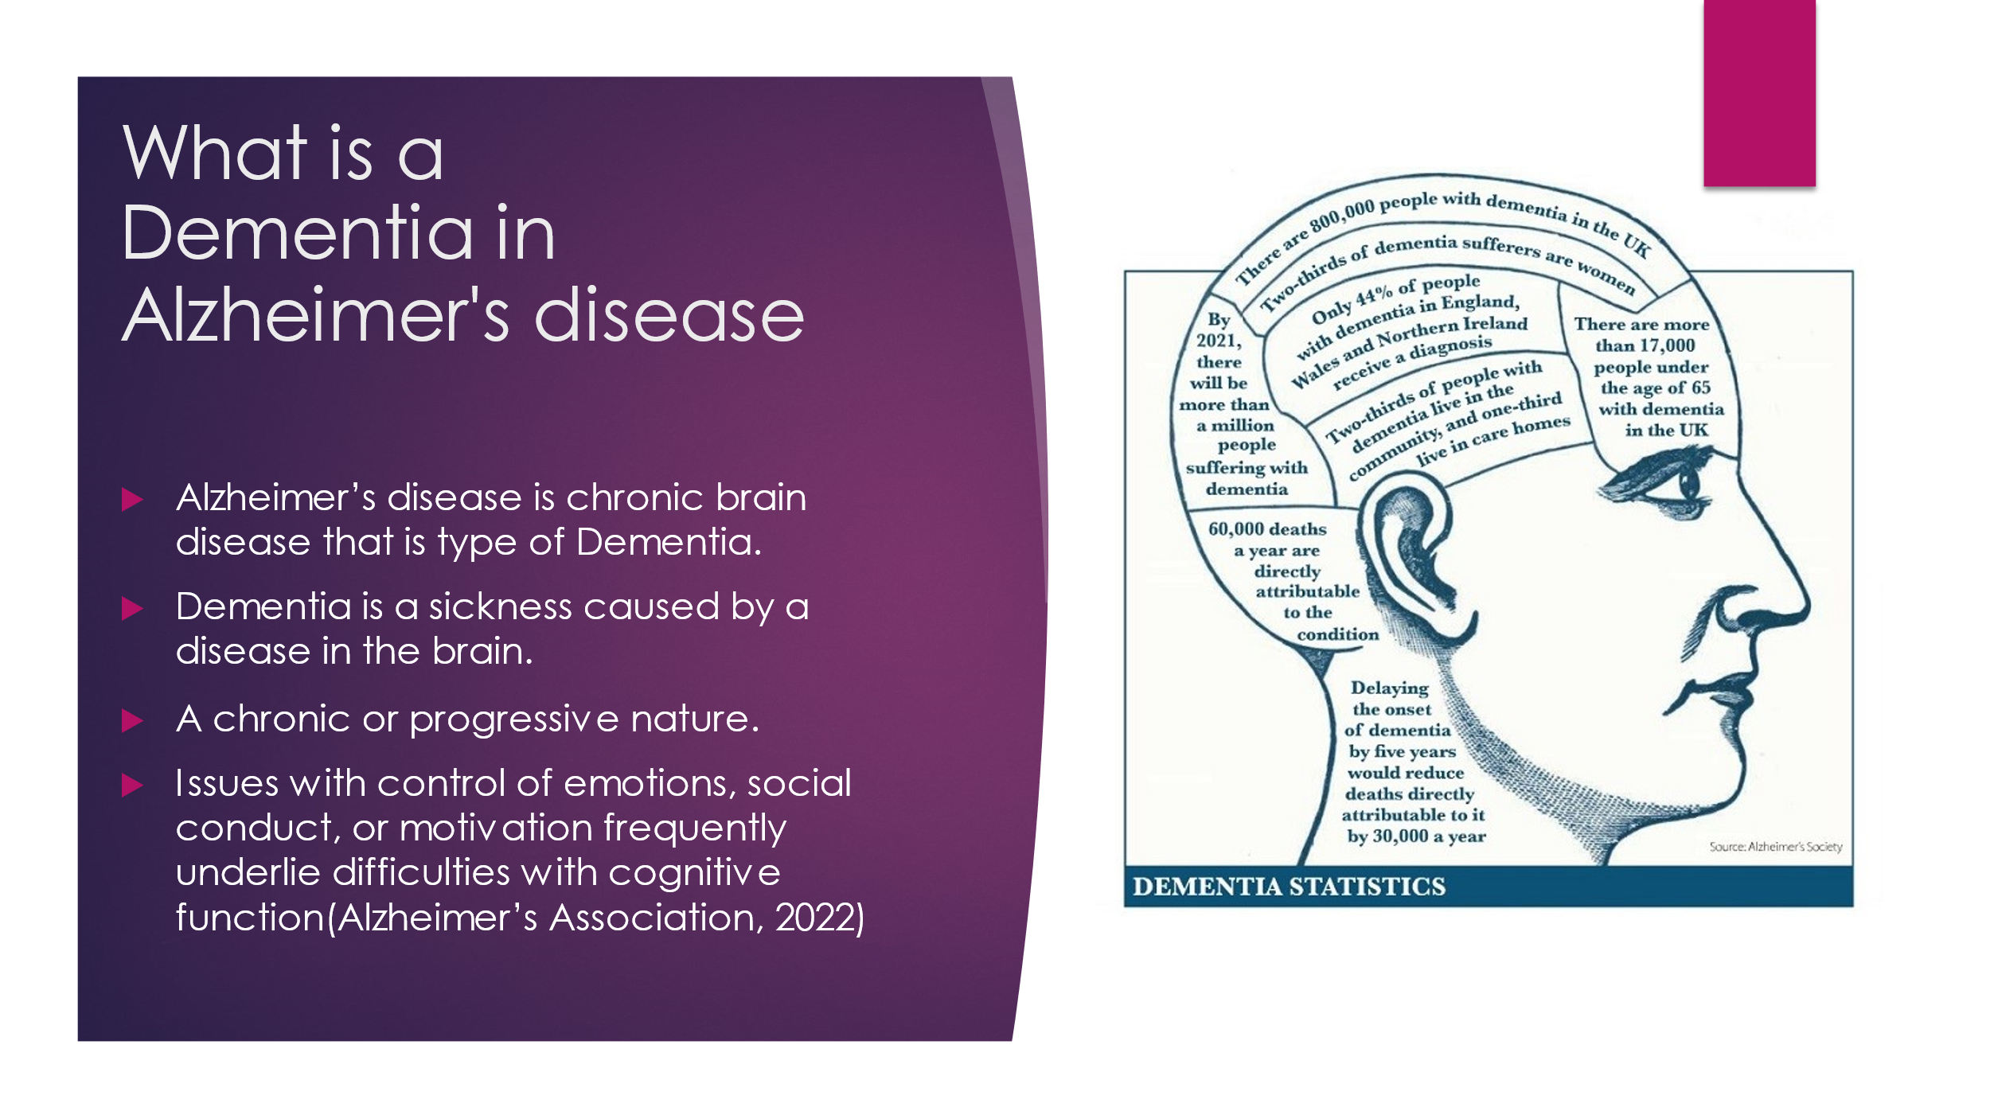
3. 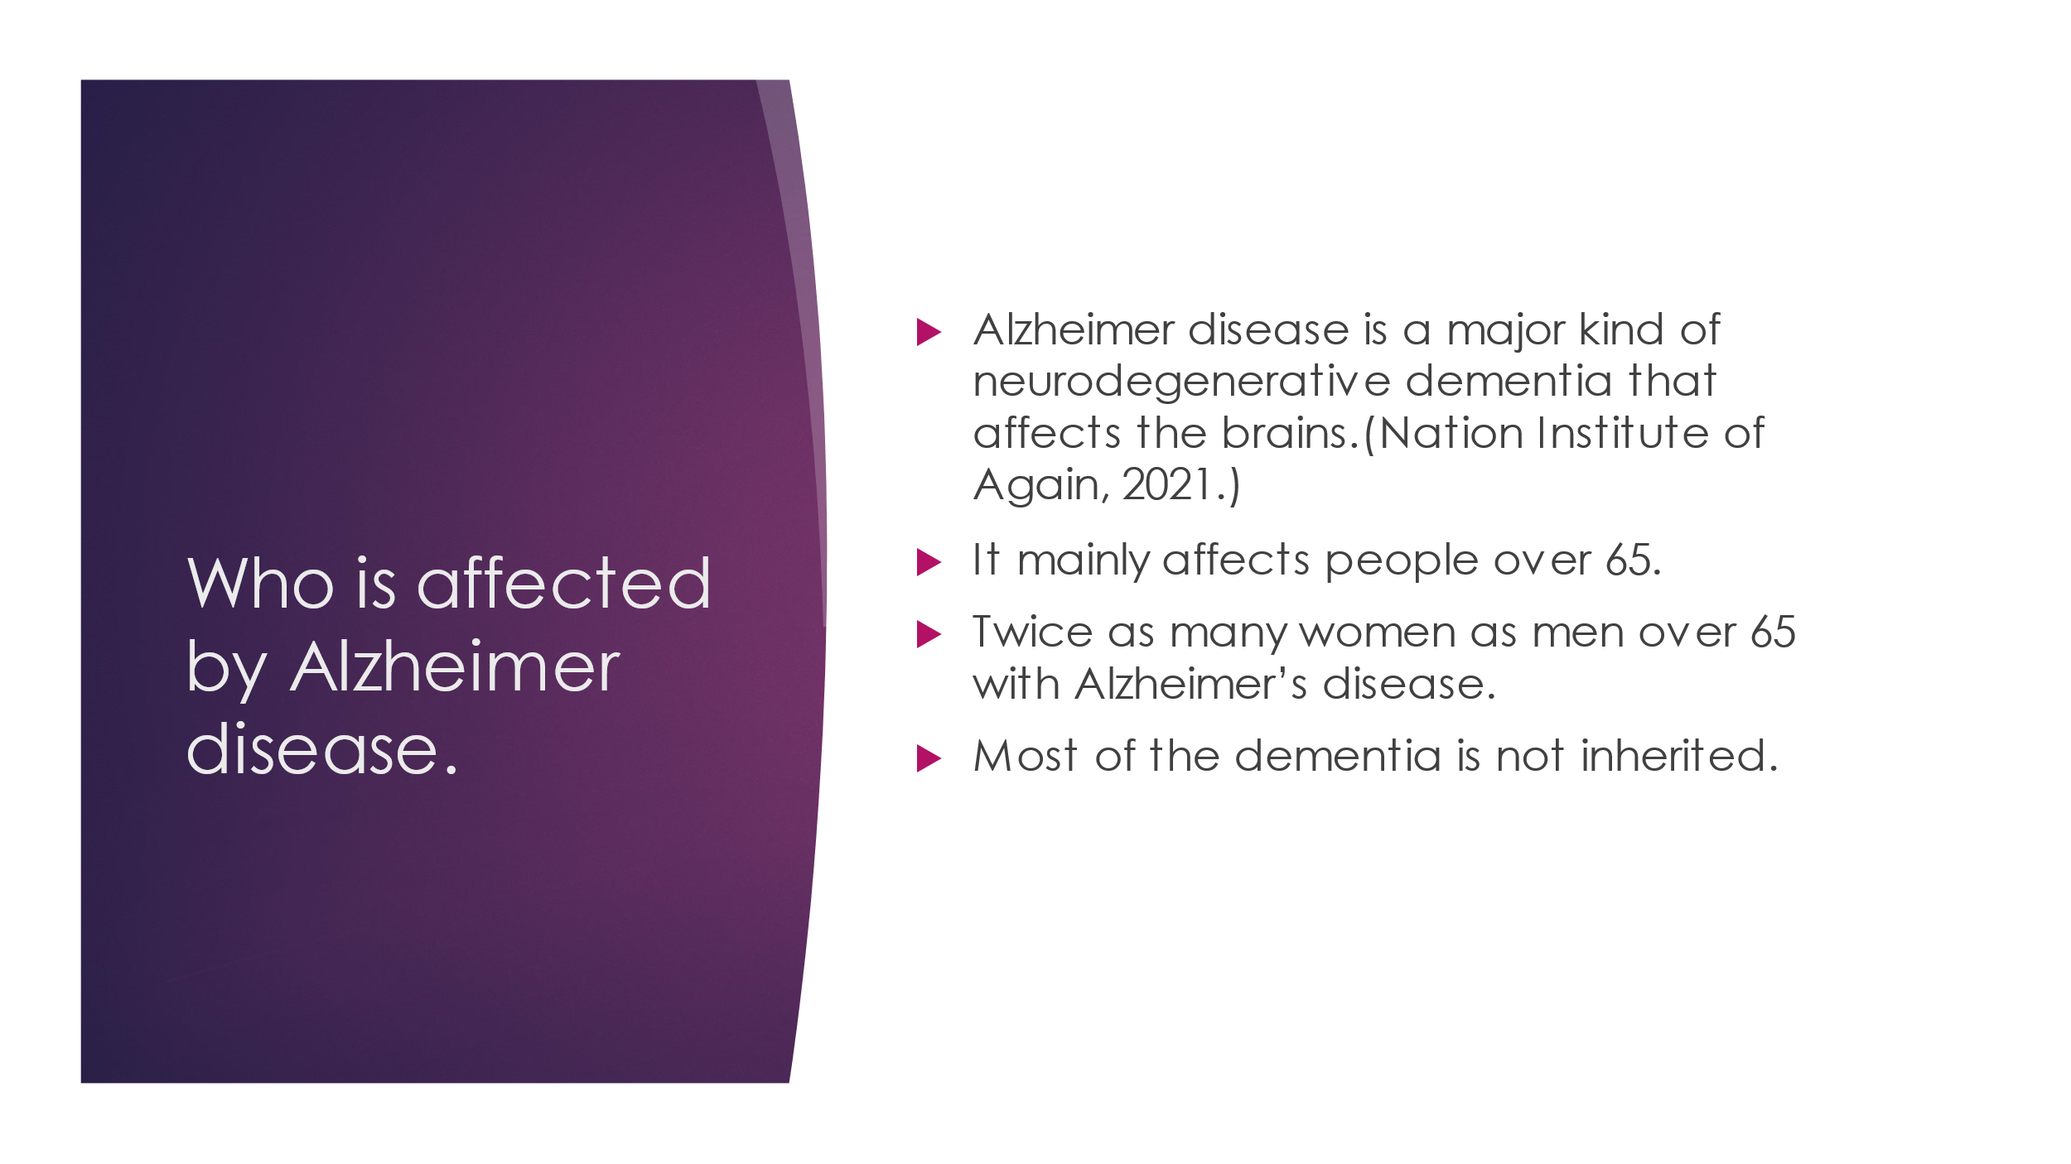
4. 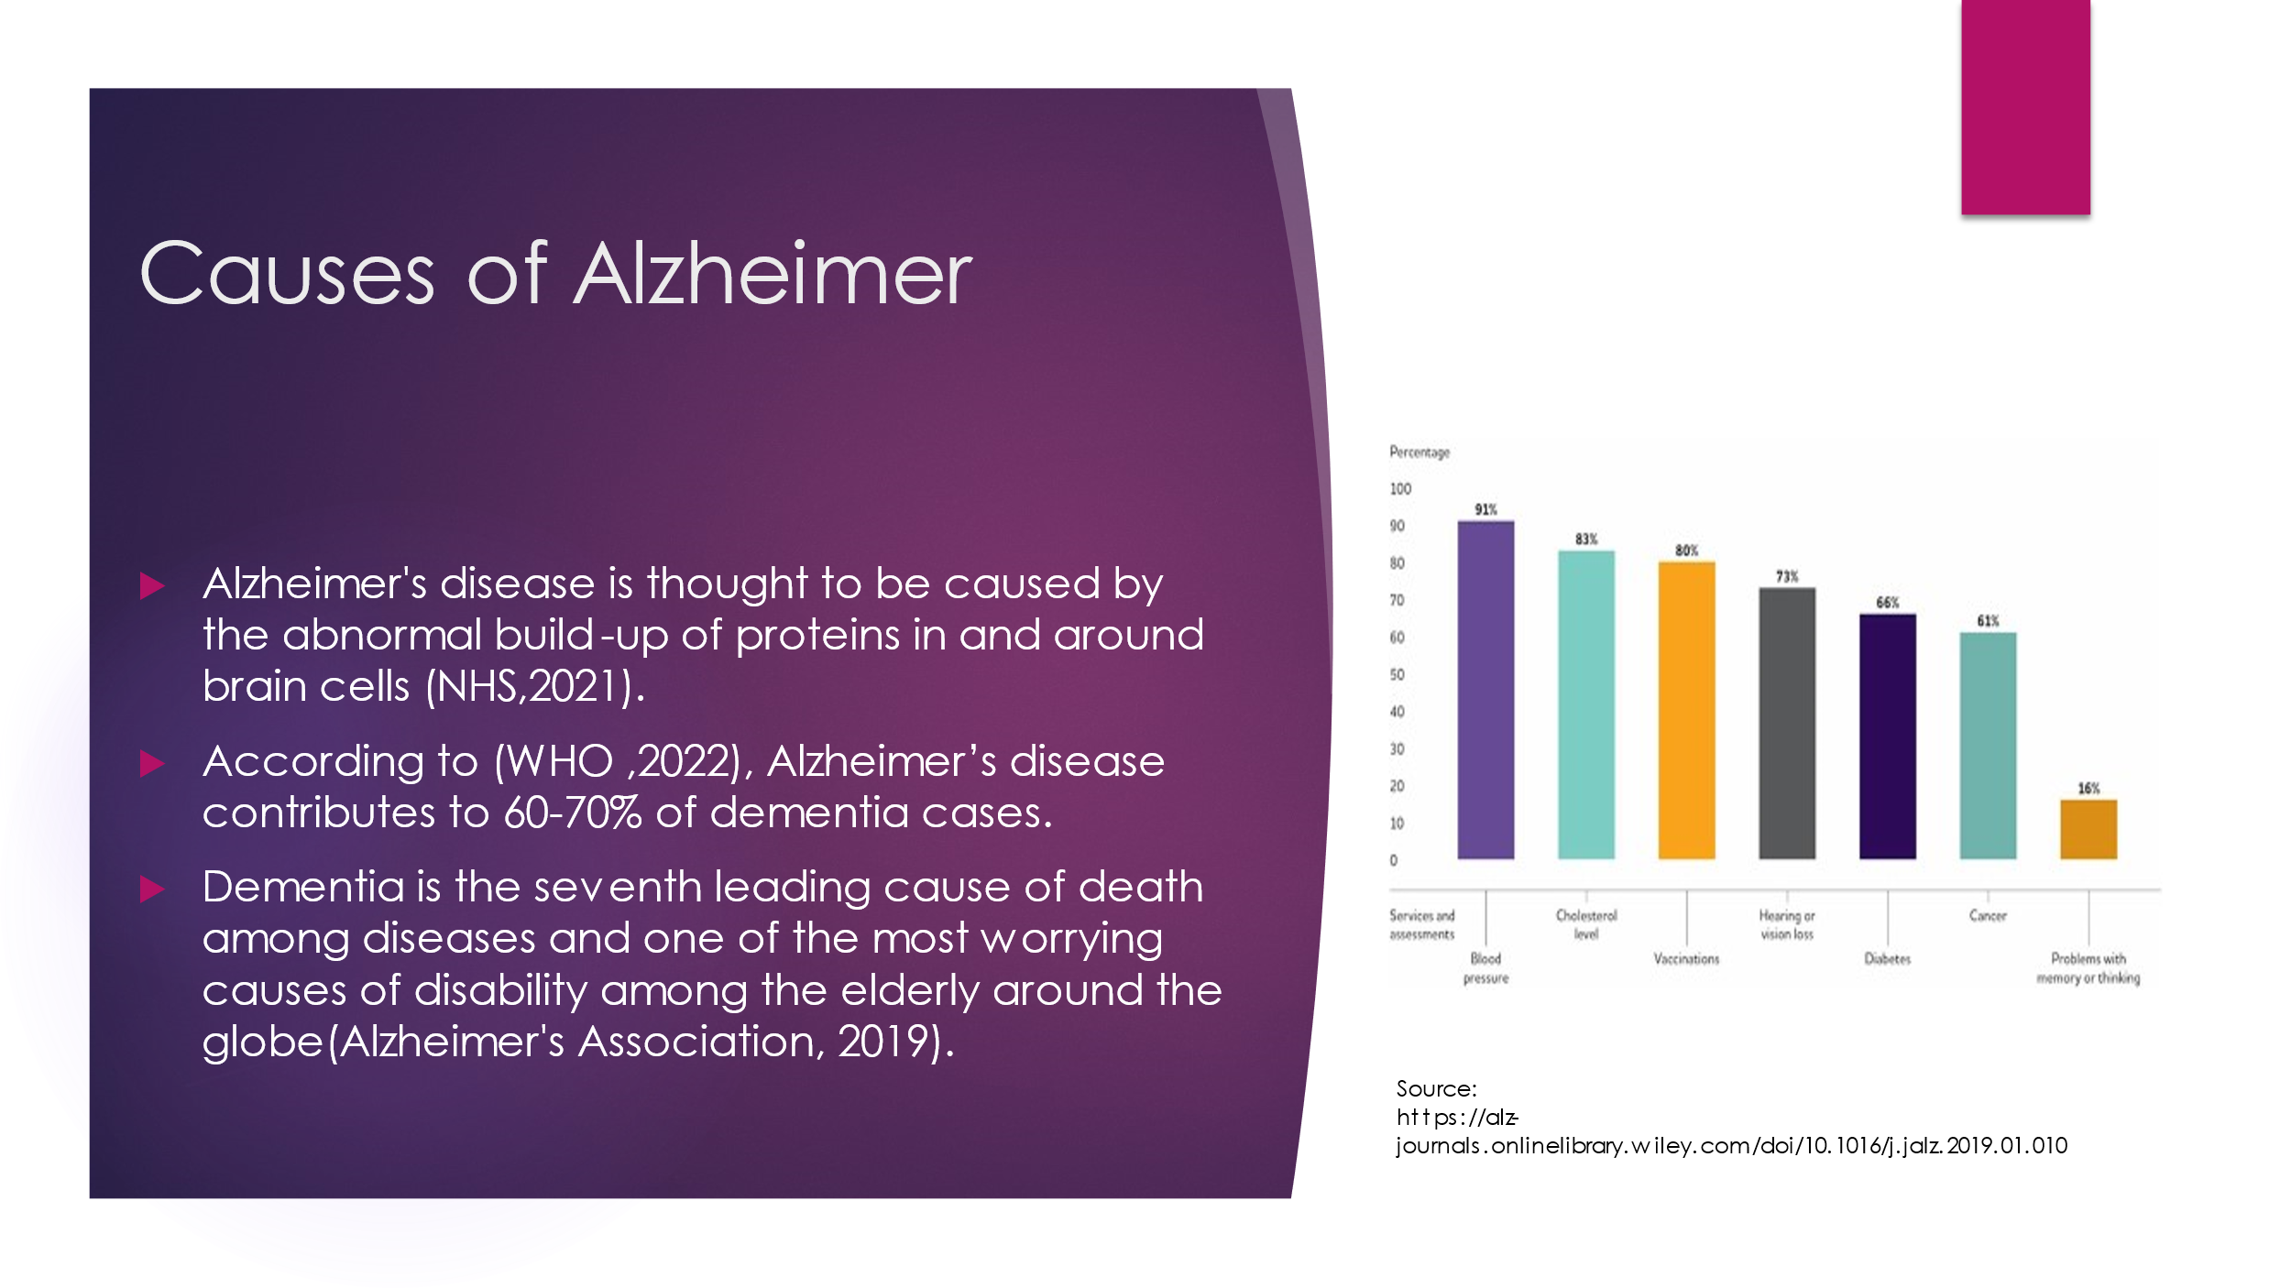
5. 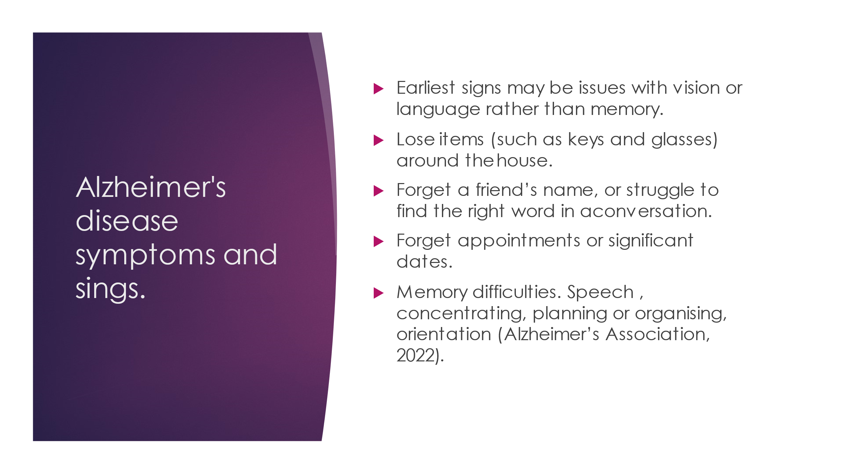
6. 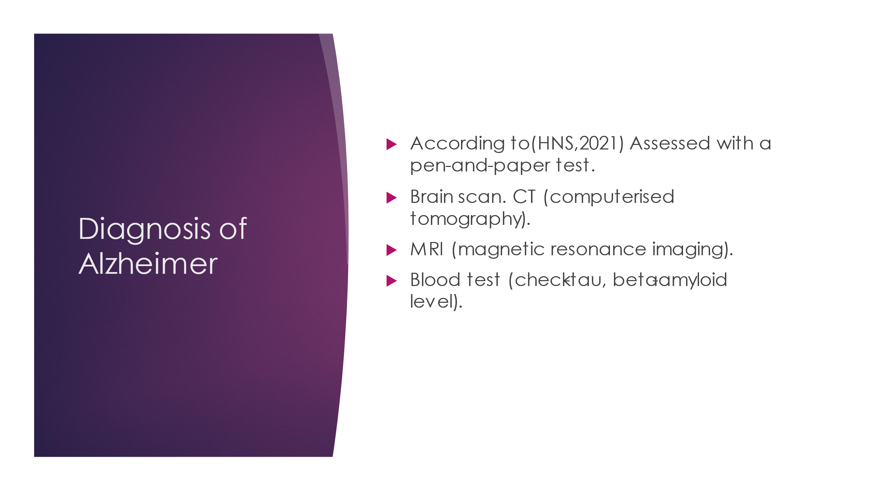
7. 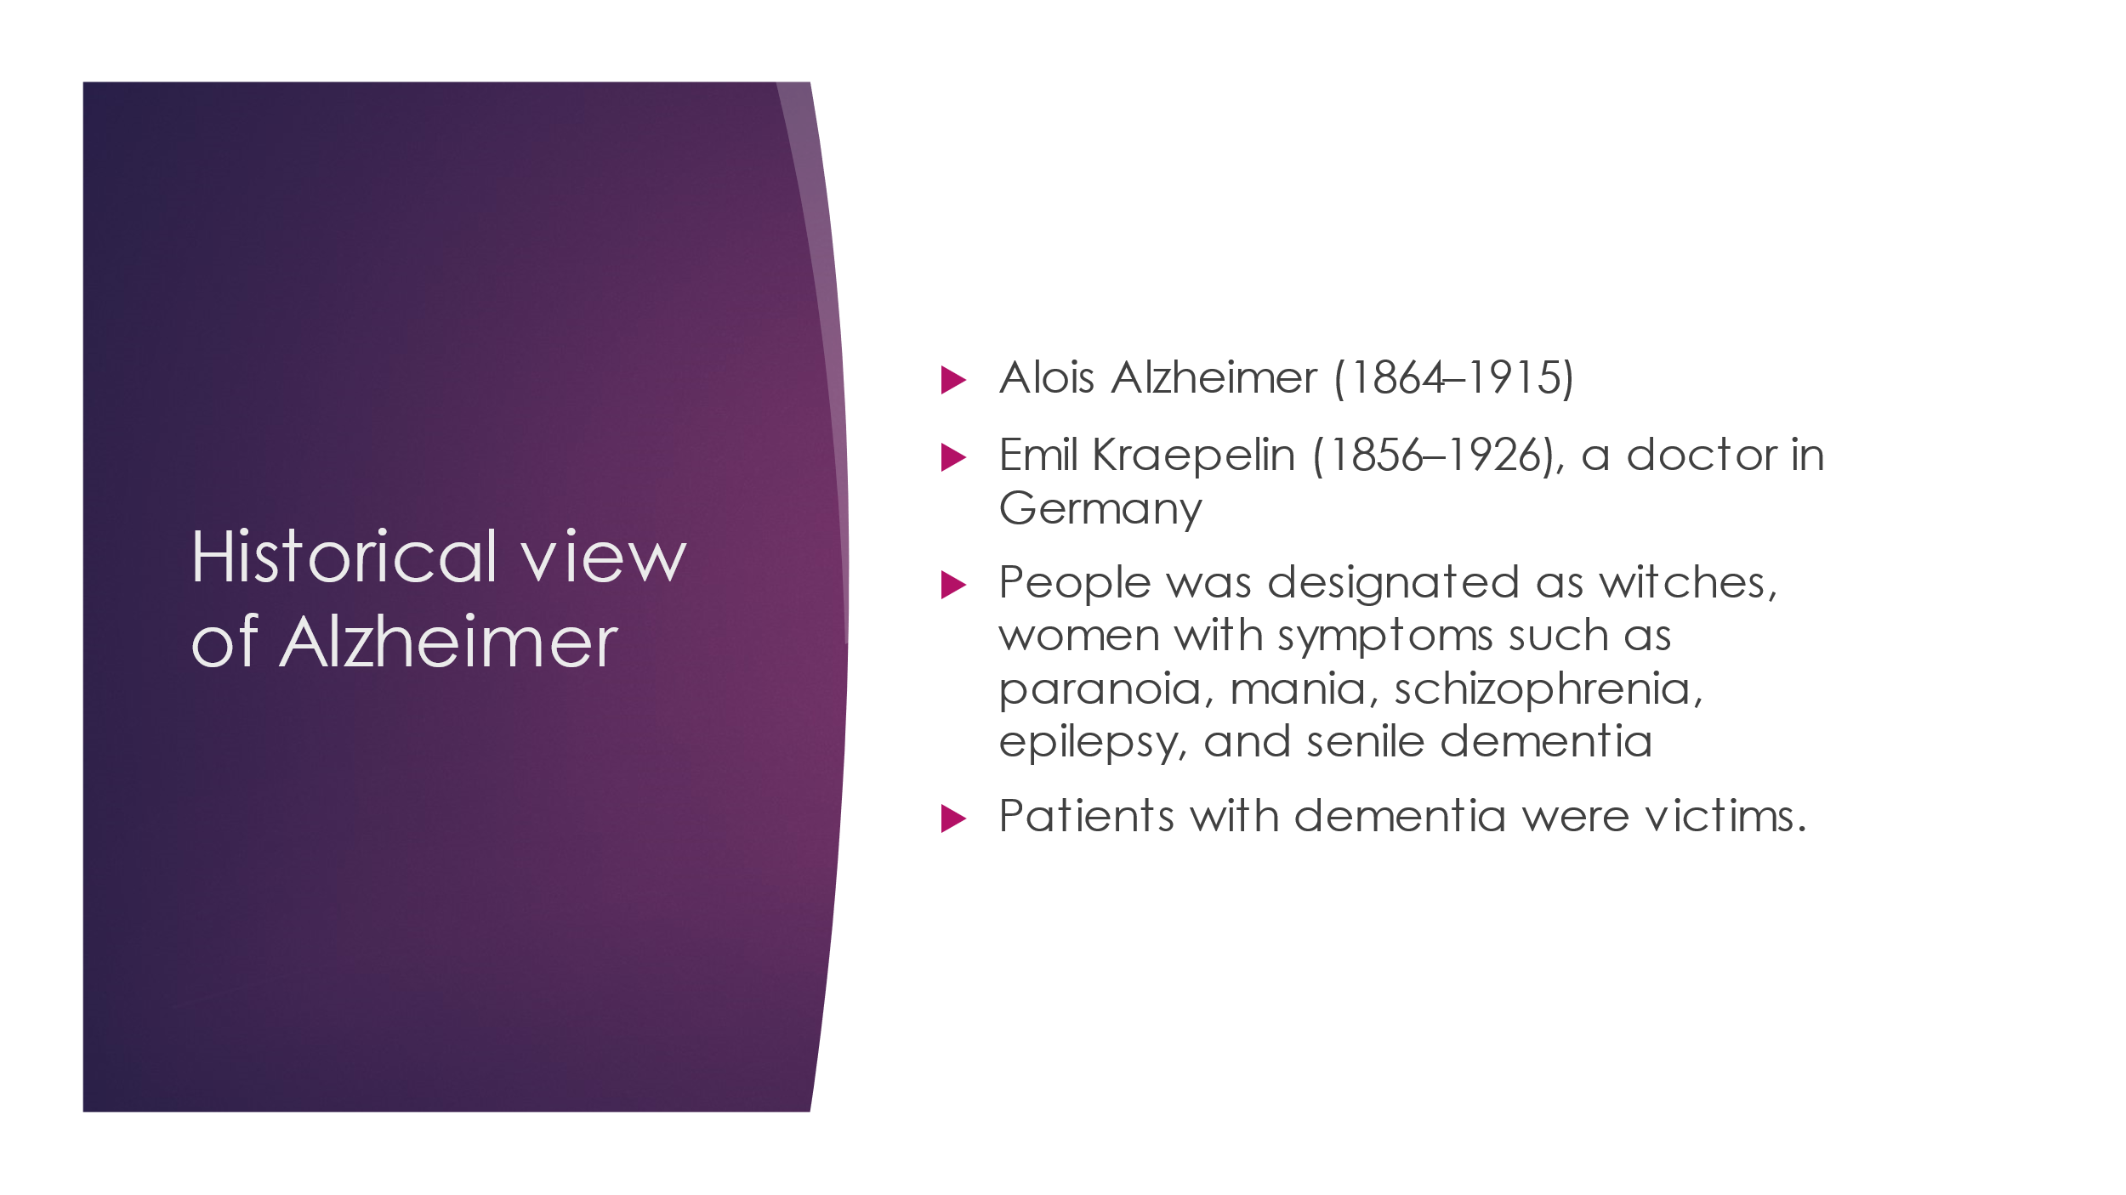
8. 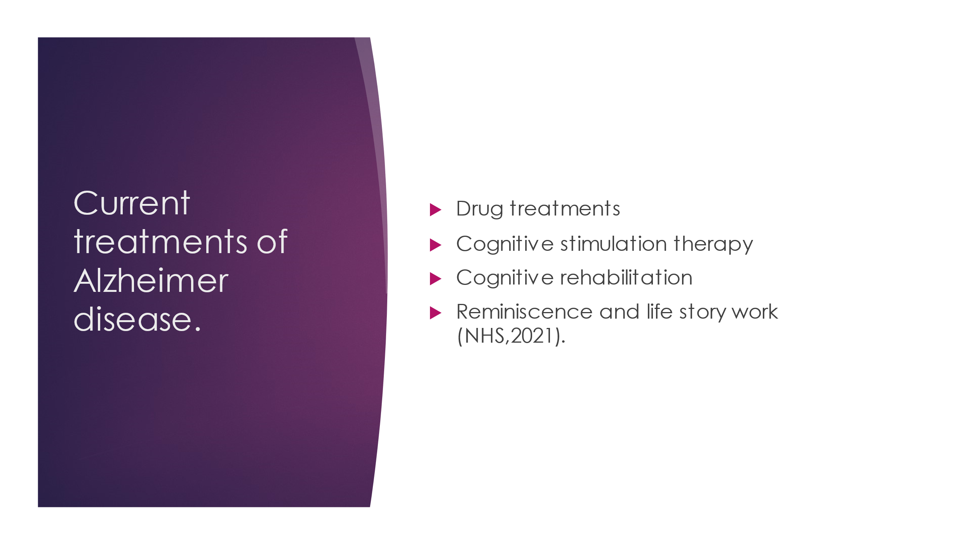
9. 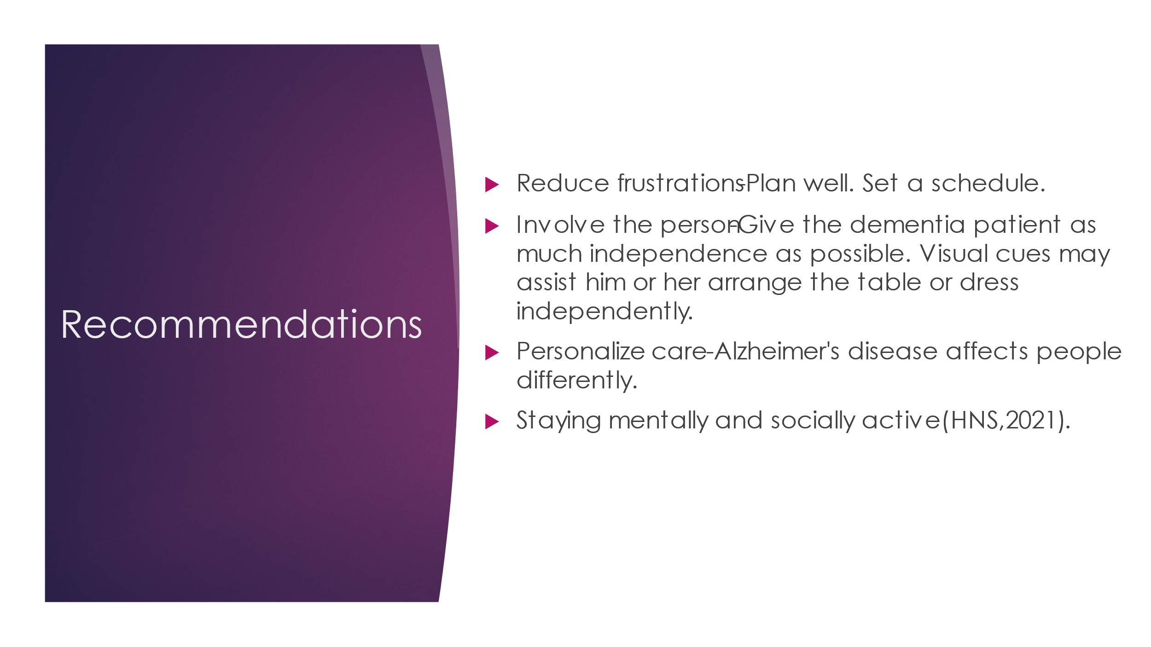
10. 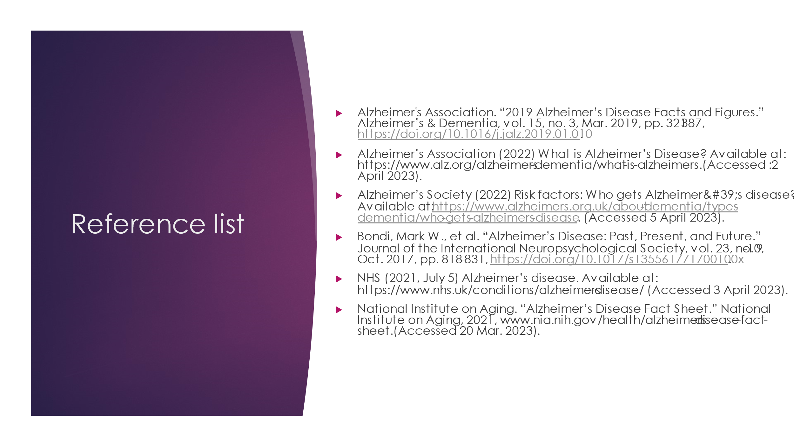
11. 

