Title Page

Name: Rashida Morton
Student Number: 2112665
Lecture Name: Muhammad Islam
Module Code: BMSW4002 Effective Team Working and Communication

Table of content

Title Page 1
Introduction 1
What is teamwork 2
Model of team development 2
Team Roles 4
What are the benefits of teamwork? 5
What are the barriers to effective teamwork identified in the scenario? 6
Conclusion 7
Reference list 7

Introduction
This report focuses on effective teamwork and communication, which took into consideration this case. Teams and teamwork help to promote deep learning that occurs through interaction, problem-solving, cooperation and collaboration (Johnsons&Johnsons,1995). There are many activities that are designed to help teams work together effectively and build self-confidence to reach the common goal. I will be using Tuckman's model and Belbin's theory to show how we can effectively work as a team and communication clearly to solve problems. Tuckman's model 1965 finds a 5-stage process which describes the formation of a team, while Belbin concentrates on the roles within teams.

What is teamwork
Teamwork occurs when a group of people combine their knowledge, abilities, and talents to work toward a common objective. This is also a vital component of the workplace culture. Nowadays, many companies consider a candidate's cooperation abilities while deciding whether to hire them. Communicating, careful attention, and keeping eye contact are other components of teamwork.An effective team can be form in several ways, which has been done by Tuckman's and Belbin’s models. A team ranges from two to several individuals working as one to achieve a common goal to which they are mutually committed (Morgan, 2017, p204) Teams are collectively accountable, they also plan together collaborate, collectively and decide on further actions, focus on team goals and outcomes and work together on collective task King and Lawley, (2016)

Extreme environments present particular social, physical, and emotional difficulties when working in a team. Team members are dedicated to the project's success as well as their shared goals, which include the team's success. Successful teams strive for the best result and are highly motivated. Team members must establish a setting where they can work together effectively and, in some cases, can contribute more than if working as an individual. A positive interdependent team environment brings out the best in each person enabling the team to achieve their goals at a far superior level (Johnson&Johnson,1995, 1999). People advertise, and team members strive for success, contribute and learn.

Model of team development
Tuckman's model
A paper based on a literature study and titled Developmental Sequence in Small Groups was published by Bruce W. Tuckman in 1965. The article concentrated on two aspects of group formation: interpersonal interactions and task activity. He put up a five-stage model, where each stage must be completed correctly in order for the group to function effectively. It wasn't until the article's summary that he coined the terms "forming," "storming," "normalising," "performing," and "adjourning," but he later noted that they "would come to be used to describe developing organisations for the following 20 years and which probably account for the paper's success" (Tuckman 1984, 14).
Tuckman model uses a five-stage model in team development
FORMING- seeking guidance, learning and comprehending the responsibilities and goals of the team, and getting to know the team members. The model's first phase is called "testing and dependency." At this point, the group starts to get focused on the work.
STORMING- addressing and resolving any conflicts inside the group and figuring out each person's function within the group. The second stage is a period of intergroup strife. Polarisation over interpersonal concerns and a lack of cohesiveness define this period. Members of the group try to maintain security by avoiding venturing into uncharted territory in interpersonal relationships. According to Tuckman (1965, 386), "as a means of expressing their individuality and rejecting the establishment of group structure,
NORMING- begin functioning as a team by understanding and respecting one another's viewpoints, deciding on the team's rules, and making progress toward the final goal. The third stage is when the group becomes cohesive. Members of the group discuss their personal viewpoints and embrace one another's quirks. There are established norms and roles. This step, according to Neuman and Wright (1999), involves creating mutually understood mental models and figuring out how to collaborate most successfully. According to Tuckman (1965), at this phase, members begin to feel an affinity for the group and work to preserve and perpetuate it. Conflicts between tasks are avoided in an effort to maintain harmony.
PERFORMING- working efficiently and autonomously, making decisions and resolving issues, and delivering excellent performance - According to the first model, the group develops "functional role relatedness" in the last stage (Tuckman 1965). The group acts as a "problem-solving tool" by adapting and taking on roles that will improve the task activities. Task performance is supported by the structure. Roles become functional and adaptable, and group energy is directed toward the goal.
ADJOURNING- as the project comes to a conclusion, the team is successful, and you move on to new endeavours, you could feel depressed. Group and Organizational Studies encouraged Tuckman and Jensen to publish an update of the model in 1977. At the time, Mary Ann Conover Jensen was a PhD candidate with a background in counselling psychology, and Tuckman served as the director of educational research at Rutgers University. Together, they read the team development literature and went over the original model again. They established a fifth step, called "adjourning," based on this analysis. This adjustment was made in accordance with a model of the group life cycle in which separation is a crucial concern throughout the group's existence. The revised model
Tuckman and Jensen (1977) revised the model of small-group development.
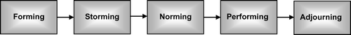

Team Roles
Belbin model
Meredith Belbin developed the idea a team need a balance of personalities and roles if they are to be successful. There are nine roles divided into three categories.
Shaper- Extremely driven, bursting with nervous energy and determined to succeed. Like to push the limits, take the initiative, and inspire others, and can be brazen and irate when dissatisfied or aggravated. Most people who are active and perform well under stress make excellent managers.
Planter- There is a lot of creative potential among innovators. They typically enjoy working independently, without assistance from the other team members. Usually reserved and delicate to compliments and reproaches. Excellent for generating original thoughts and taking on difficult problems.
Co-ordinator- The ability to mobilise a group behind a common goal. They happily delegate because they are assured, trustworthy, and mature. They keep their cool when under pressure. Quickly identify a person's abilities and use them to further a group's objectives. A coordinator would be helpful for a team because of the diversity of skills and personalities present.
Monitor Evaluator- Cautious, sober-minded individuals. Those who deliberate carefully are frequently very critical thinkers. Typically, carefully consider all the information before making conclusions. Vital for analysing problems and evaluating concepts and suggestions.
Resource investigator- Excellent communicator with other organisations as well as inside the group. Natural mediators with a keen eye for fresh opportunities. Capable of figuring out what options are available and what can be done. A calm, inquisitive personality who is receptive to the possibilities of everything novel. Excellent for finding resources and facilitating discussions.
Implementer- Having good organisational skills, a love of routine, and practical common sense. A methodical approach to problem-solving, dependable, and diligent. Regardless of whether they enjoy the assignment, they will complete it.
Team worker- Team members who are encouraging. Being versatile and adaptable to many circumstances and people intelligent and diplomatic decent listeners Reduce conflict good at accepting input from all members of the group.
Completer Finisher- Rarely fail to follow through and pay close attention to detail. They begin what they can't finish and dislike being careless. They are reluctant to delegate and would rather complete work on their own. Good at jobs requiring close focus and a high level of accuracy.
Specialists- They take great pride in learning specialised knowledge and technical skills. Upholding professional standards and advancing their own field are top priorities. very devoted. When making judgments requiring in-depth experience and expertise, they are frequently called upon to provide the technical expertise.

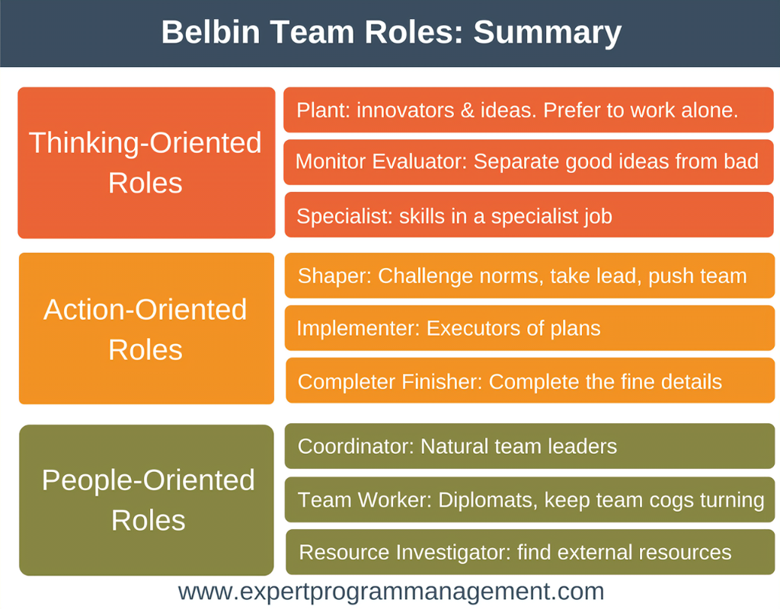

What are the benefits of teamwork?

Working in a team exposes you to a variety of scenarios that provide fresh viewpoints. You'll begin to recognise each team member's individuality through your lengthy chats together, which can persuade you to act differently. You'll advance as you learn more about your team and reaching your common goal, Employees develop ties that can develop into trust and respected when they work as a team and achieve. It is in our nature. Additionally, it's beneficial for your company since staff members who get along well with one another are more likely to:
Clearly communicate with one another and encourage and support one another. It is understandable why successful organisations place such a high importance on teamwork. In a team effort, multiple people are accountable for the same objective. Most importantly, teammates evaluate and rely on the calibre of one another's work. When one team member's performance declines, the others are knowledgeable and driven to assist them in getting better. So, some of the benefits of working in a team are
- Getting the jobs done quicker
- You can bounce ideas off each other
- Better Problem solving
- Boosted productivity
- Happier team members
- Enhanced personal growth
- Fewer mistakes
- The whole team benefits when goals are achieved

What are the barriers to effective teamwork identified in the scenario?
A huge barrier in effective teamwork is a lack of communication which, in turn, lead to
In conflict and Disagreements, clear communication is very important as its gives everyone the understands and knowledge they need in order the complete the team’s goals within the team. all team members must show respect as a lack of respect impacts the whole team.
Team formation is very important for all to be assigned roles. It takes time for people to learn the necessary teamwork abilities; frequently, this involves going through various stages as they adjust to joining a new team. Team creation is essential for any successful business. If you want to achieve the finest results, you must make this process simpler.

The forming, storming, norming, and performing phases of a team's usual evolution through time are described in a model created by renowned psychologist Bruce Tuckman. The key is understanding how to swiftly assist people in going from forming to becoming productive.
Poor commitment and poor constitution to achieving the common objective for the team is highly damaging for the team to achieve their goal. It is the duty of a leader to not only provide your team with specific instructions but also to show them how their work advances the goals of the organisation as a whole. Keeping employees aware of how their actions affect the company might inspire them to work hard while keeping in mind their personal responsibilities.

Additionally, you get to watch as your staff members develop throughout the course of the business. Since employees continue to be the primary factor in the success of the company, their continuous growth is more important than just fulfilling responsibilities. In other words, the best employee is the one that goes above and beyond expectations and becomes a priceless asset to the organisation. Dividing your team into groups like Meredith Belbin will help the team by being well-balanced based more on behavioural contributions than on job titles.
Self-aware people who can change their behaviour to fit the situation and the needs of the company. Finding the right individuals performing the correct duties resulting in more effective teams. Team discussions that are depersonalised and discuss team contributions in a shared language, making decisions based on facts and information rather than a "gut feeling" that can be biased. Assurance when making choices concerning other people and understanding the behavioural strengths and shortcomings that a CV may not always make clear.

Conclusion

The manager must provide the team with a clear direction, enable some frameworks, and encourage appropriate behaviour in order to lessen friction. To accomplish a shared objective, the team must be genuine in their cooperation. The team requires a strong direction that ensures everyone knows what they must accomplish to achieve the common goal. The team needs supportive structures, such as the correct number of individuals working on a given task while upholding shared ideals. The team needs a supportive organisation with good management that pay attention to the staff and consider their individual wants and concerns. The team needs expert instruction to cooperate in resolving team conflicts and comprehend crucial elements required to create an efficient team. A great leader is necessary for leading outstanding teams. Leaders that aren't scared to adjust their strategy are those who set challenging objectives that are regularly improved upon and attained. Building groups, whether in the workplace, competitive sports, or your community, involves a deep understanding of people, their traits, and what motivates them to collaborate with others. Egos must be controlled for a group to form since they constantly and unceasingly demand respect and recognition. A leader who can create substantial groups is valuable because group building is an art. History has shown that it requires a specific kind of leader with distinctive qualities.

Reference list

- R Meredith Belbin, Management Teams: Why They Succeed or Fail (Butterworth Heinemann, 2nd ed., 2004)
- Tuckman, B. W. 1964. Personality structure, group composition, and group functioning. Sociometry, 27(4): 469–487.
- Middleton, T. (2022). The importance of teamwork (as proven by science). [online] Work Life by Atlassian. Available at: https://www.atlassian.com/blog/teamwork/the-importance-of-teamwork.
‌
- www.belbin.com. (n.d.). Why Use Belbin Team Roles? [online] Available at: https://www.belbin.com/about/why-use-belbin.
- ‌(Advantages of effective teamwork | nibusinessinfo.co.uk, 2017)
(Belbin Team Role communication styles, 2022)
- (Forming, Storming, Norming, and Performing: Tuckman’s Model for Nurturing a Team to High Performance, 2017)
- Tuckman, B. W. and Jensen, M. A. 1977. Stages of small-group development revisited. Group and Organization Studies, 2(4): 419–427. [Crossref],
- Tarricone, P. and Luca, J., 2002. Successful teamwork: A case study.
- Successful teamwork: A case study - Edith Cowan University. https://ro.ecu.edu.au/cgi/viewcontent.cgi?article=5007&context=ecuworks

