
Module Name: Digital skills for personal Development and business Groth
Module Code: Bmsw4008
Assessment 1: Component portfolio
Student Name: JESSIE MCCRUM
Student Number:2504851
Lecturer: Philippa Fitzgerald
Deadline: Friday 21st November 23:59PM

AI Acknowledgement
I confirm that I have not presented any AI generated materials as my own work.
I confirm that I have copies of my drafts, notes, and other resources I used, which I may be asked to provide in evidence.

Contents
Component 1 – Research and Planning Template (500 words) 4
Source Exploration (200 words) 4
Key Challenge for Students (100-150 words) 4
Key Opportunity for Students (100-150 words) 4
Planning Your Report (100 words) 4
Timeline for Component 2 4
Component 2 – Answering the Question (800 words) 5
Introduction (100-150 words) 5
Challenges Students Face (150-200 words) 5
Opportunities Digital Tools Provide (150-200 words) 5
How Students Can Adapt (200-250 words) 5
Conclusion (100-150 words) 5
Component 3 – Reflective Presentation 6
Slide 1 (Overview) 6
Slide 2 (Research) 6
Slide 3 (Planning & Writing) 6
Slide 4 (Challenges) 6
Slide 5 (Successes) 6
Reference List 7

Component 1 – Research and Planning Template (500 words)



Key Challenge for Students
I have found that one of the challenges student’s face is to access to technology and infrastructure meaning that they do not have the funds to update technology and software this effects studying worldwide also broad band connection in some countries
Limited financial resources to invest in advanced digital technology I have had this experienced myself as when I first started I didn’t have access to the right technology such as a laptop this made my learning hard had to store my work on paper
I think this challenge is very important as it effects students with there learning also finding evidence storing information.

Reference
Technology Infrastructure and Accessibility
Inequalities in access to technology and availability of digital infrastructure are the main
Obstacles in implementing digital innovation in the education sector. Not only limited to urban areas,

this challenge extends to rural areas which may still be hampered by limited internet access. In some
regions, infrastructure gaps limit the ability of educational institutions to adopt modern technology.
The impact is felt on students and educators, who may not be able to optimally access digital learning
resources, exacerbating educational disparities. Addressing these challenges requires serious
investment in equitable digital infrastructure, supportive policies, and training for educators and
students. Collaboration between government, the private sector and educational institutions is key to behind. According to Dananga Mulyana
ensuring that digital innovation can be accessed inclusively, without leaving some communities

Key Opportunity for Students
1. Benefit of digital tools
The benefit of digital tools provided are learning management systems (LML) which is a software based platform which makes it easier for managing on line learning and training programs
2. Evidence
Learning management system (LML) brings about significant transformation in education management giving educational institution the ability to centrally manage learning content with lml institutions can provide more flexible learning access allowing students to access materials anytime anywhere additionally lml also provides the ability to track students’ progress with greater accuracy and detail

refrance
Learning Management System (LMS)
The implementation of a Learning Management System (LMS) brings about a significant
Transformation in education management, giving educational institutions the ability to centrally
Manage learning content. With an LMS, institutions can provide more flexible learning access,
Allowing students to access materials anytime and anywhere. Additionally, an LMS also provides the
ability to track student progress with greater accuracy and detail, facilitating more effective
monitoring of individual achievement and development. On a broader level, an LMS creates a
collaborative platform where teachers and students can interact, share information, and work together
in a digital environment. With features such as discussion forums, online assignments, and other
collaboration tools, LMS opens up opportunities for more interactive and integrated learning in the data era according to Dadang mulyana

3. Reflect
E learning is an amazing way to learn as it gives you opportunity to learn around home life and work life so you’re not stuck to a class room.

This is valuable to know the tools such as this software will benefit me also could help manage my studies this software would be useful

Planning Your Report (100 words)
I will focus on both challenges and opportunities equally as I will understand the pros and cons of both sides as this gives me an equal understanding with both sides.

1. Tools a plan to use
Time management also Google software and Library also use peel and CRAAP

2. Structure Report
I will structure my report by collecting all necessary information also make it easy to read my evidence

Timeline for Component 2
Task | Date/ Deadline
Finish research | 19 .11.25
Draft first section | 13.11.25
Complete first draft | 18.11.25
Final editing | 21.11.25

Component 2
My report will cover
The challenges in digital era The access to technology and info structure
Limited financial resource
The opportunity’s the benefits digital tools provide such as updated soft were such as (LML) and the opportunity to be able to learn from the home Environment instead of a classroom

Introduction
Im looking for the opportunities and challenges in this report on digital era
The latest technological development in digital era how the advanced software is and technology has made it easier for students to learn and studies with e learning is a form of learning conducted those electronic media such as lap tops computers phones so students ant bound to class rooms also the importance of software such as (LML) this helps massively with organizing your study we are also looking at the challenges such as limited financial resources to invest in advanced digital technology

Challenges Students Face
Inequalities in access to technology and availability of digital infrastructure are the main obstacles.

creadable source
Scholashipin the digital age
Information,infrastructure and the internet
Christine L Bongman

Technologies of information
Infrastructure 14

The challenge of access to technologies
This impact’s the students study as they cannot access the write data on store any work so this affects there learning

Opportunities Digital Tools Provide (150-200 words)

The positive opportunities using digital learning tools
Software like (LML) is a digital tool that students use to store data this makes it easier for the student to store their work and also a good learning program its always updating with it makes it easier to study and mange learning
1

How Students Can Adapt
Learning Management System (LMS)
The implementation of a Learning Management System (LMS) brings about a significant
transformation in education management, giving educational institutions the ability to centrally
manage learning content.
Creadable source

Published june 2025
Article
Authors Omotoyosi Odebiyi
Afum uzorka

I think this type of learning management software improve learning as it gives you a good source of management in your studie

These digital tools make it capable to work from your home also when used well it enhances your study makes it easier

Give three practical suggestions for how students can succeed in a digital learning environment

Time management
Building good digital skills
Literacy skills

Organizational tools = Browser
It’s a system that brings things together to a single point
Witch works better for finding and learnig also resherch

Conclusion

I have found that one of the challenges is access to technology
Limited financial resources to
Invest in advanced digital technology
Suggestions

Improving digital infrastructure
To enhance engagement
Provide faculty training

Component 3 – Reflective Presentation

Slide 1 (Overview)


Slide 2 (Research)
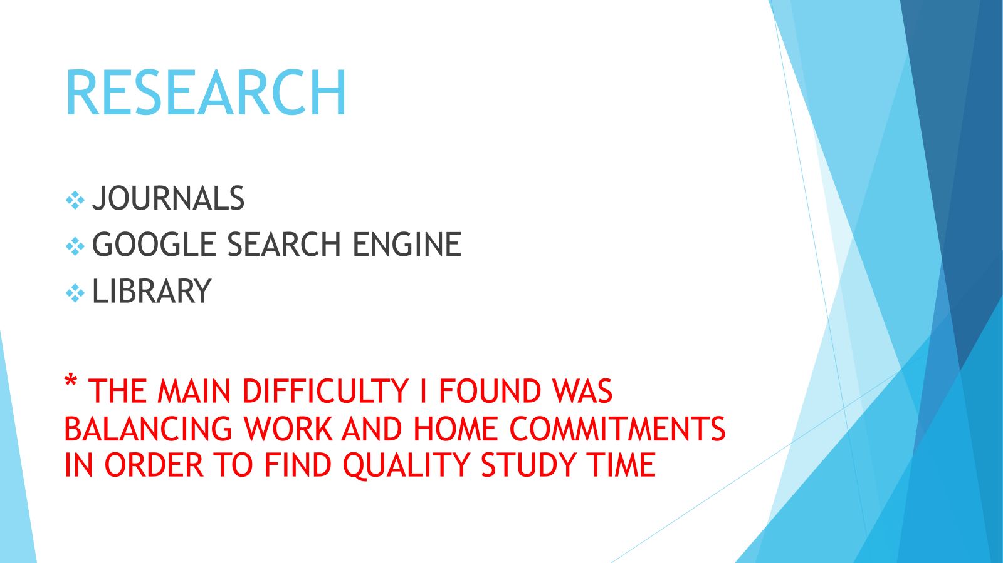

Slide 3 (Planning & Writing)
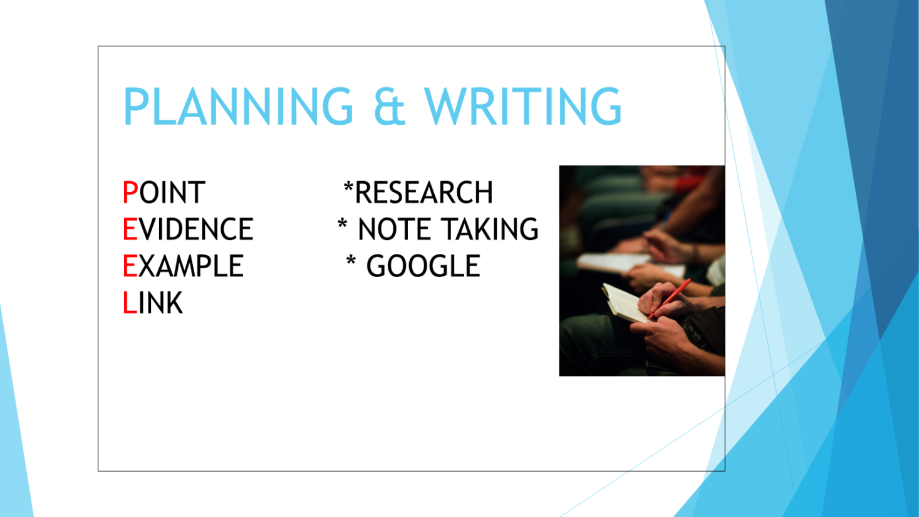

Slide 4 (Challenges)
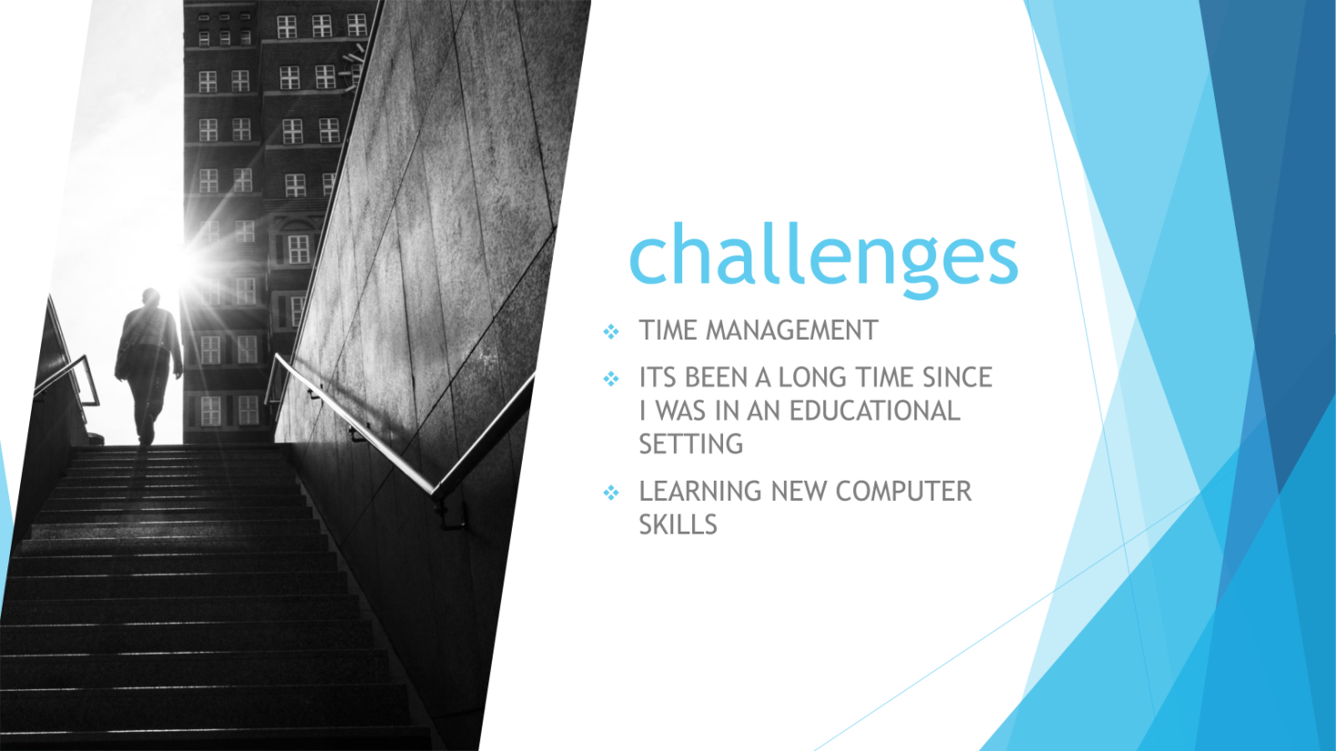

Slide 5 (Successes)

Reference List
**Include 10 references, formatted in the Harvard Referencing style. List the references in alphabetical order.

