Maryam Ali Zoda (2531289)

DESIGN AND IMPLEMENTATION OF A RELATIONAL DATABASE SYSTEM FOR AUTOPARK MANAGEMENT SYSTEM

Student name: Maryam Alizada
University: UWTSD
Course and code ACCA4023
Instructor’s name Suresh Shanmugasundaram
July 21, 2026
Table of Contents
1. Introduction 3
2. Scenario Analysis and User Requirements 3
3. Entity Relationship Design 3
4. Data Structure and Table Implementation 4
5. Constraints and Data Validation 6
6. Normalisation to Third Normal Form 7
7. Query Development 8
8. Report Creation and Management Use 12
9. Testing and Evaluation 13
10. Reflection and Future Improvements 14
11. Conclusion 14
Reference List 16

Introduction.
The need for a structured database for the Auto Park Management System arose because its manual method of tracking parking spots, vehicle entries, customers, slots, and payments carried an unnecessary risk of inaccuracy, data duplication, and data loss. The assignment brief required that there should be a relational database system using Microsoft Access that had entities, relationships, 3NF normalisation, records, queries, reports and validation proof. This kind of database system is pertinent in the UK environment, as the number of vehicles owned and driven on the roads is increasing, which calls for precise parking services. As at the end of 2025, there were 42.3 million licensed vehicles in the UK, out of which 2 million are zero-emission vehicles [14]. Also, in the year ending June 2025, there was a total of 336.9 billion vehicle miles in Great Britain [15]. This report outlines how the Auto Park database was designed and implemented,

Scenario Analysis and User Requirements
The main issue with the scenario was that the data concerning the processes in Auto Park was collected manually, which decreased accuracy and prevented management from monitoring slot availability and income. A relational database was selected because of the capabilities of Microsoft Access that support subject-based tables and relations between the tables if required [10]. The following were selected as the most important: Parking Site, Parking Slot, Customer, Vehicle, Booking, and Payment. Parking Site: location data; Parking Slot: parking slot data; Customer: customer data; Vehicle: vehicle data; Booking: booking data; Payment: payment data. This is an entity selection that reflects the business process of the client who arrives with a vehicle, gets a slot assigned, makes a booking, and pays. Structured transactional data is best suited to relational databases, which support integrity, consistency, and differentiation among records [6].

3. Entity Relationship Design

Figure 1: Relationship Diagram
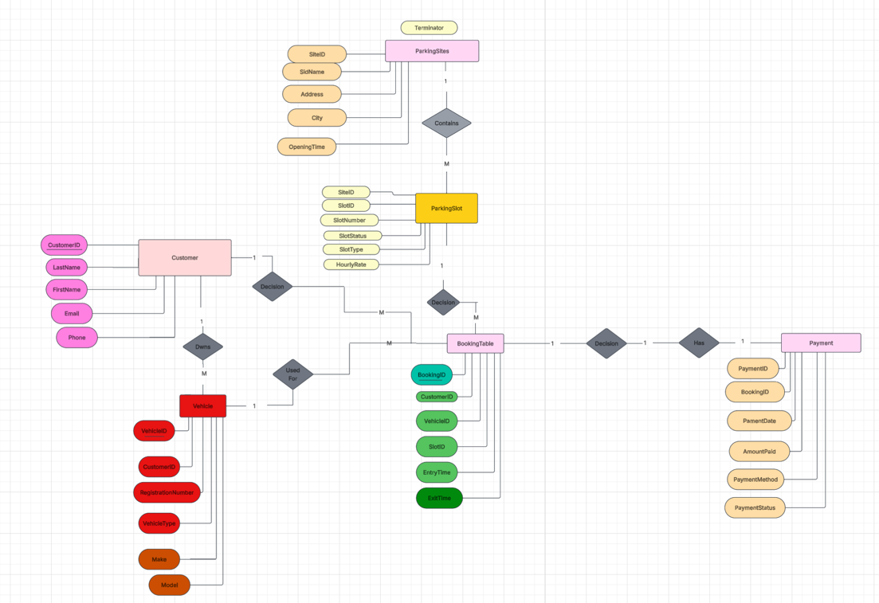
The ERD was created to demonstrate the interactions among the six core tables, including primary and foreign keys. The relationship diagram developed in Access is shown in Figure 1. Parking Site is in a one-to-many relationship with Parking Slot since a single site may have multiple parking spaces. Customer is in a one-to-many relationship with Vehicle since one customer can own more than one vehicle. Customer, Vehicle, and Parking Slot are all related to Booking, since every booking must specify who parked, which vehicle was parked, and in which slot. Booking is then linked to Payment, since all financial transactions must be linked to an event in parking. The significance of the ERD design is that it graphically depicts entities, attributes, keys and relationship paths prior to implementation [7]. The last relationship structure also prevents repetition of the same information about the customer, site or vehicle in the booking records. This enhances logical coherence and helps fulfil the assessment criteria for correct entities, attributes, relationships, keys, and cardinality.

Data Structure and Table Implementation

Figure 2: Parking Site Sample Data

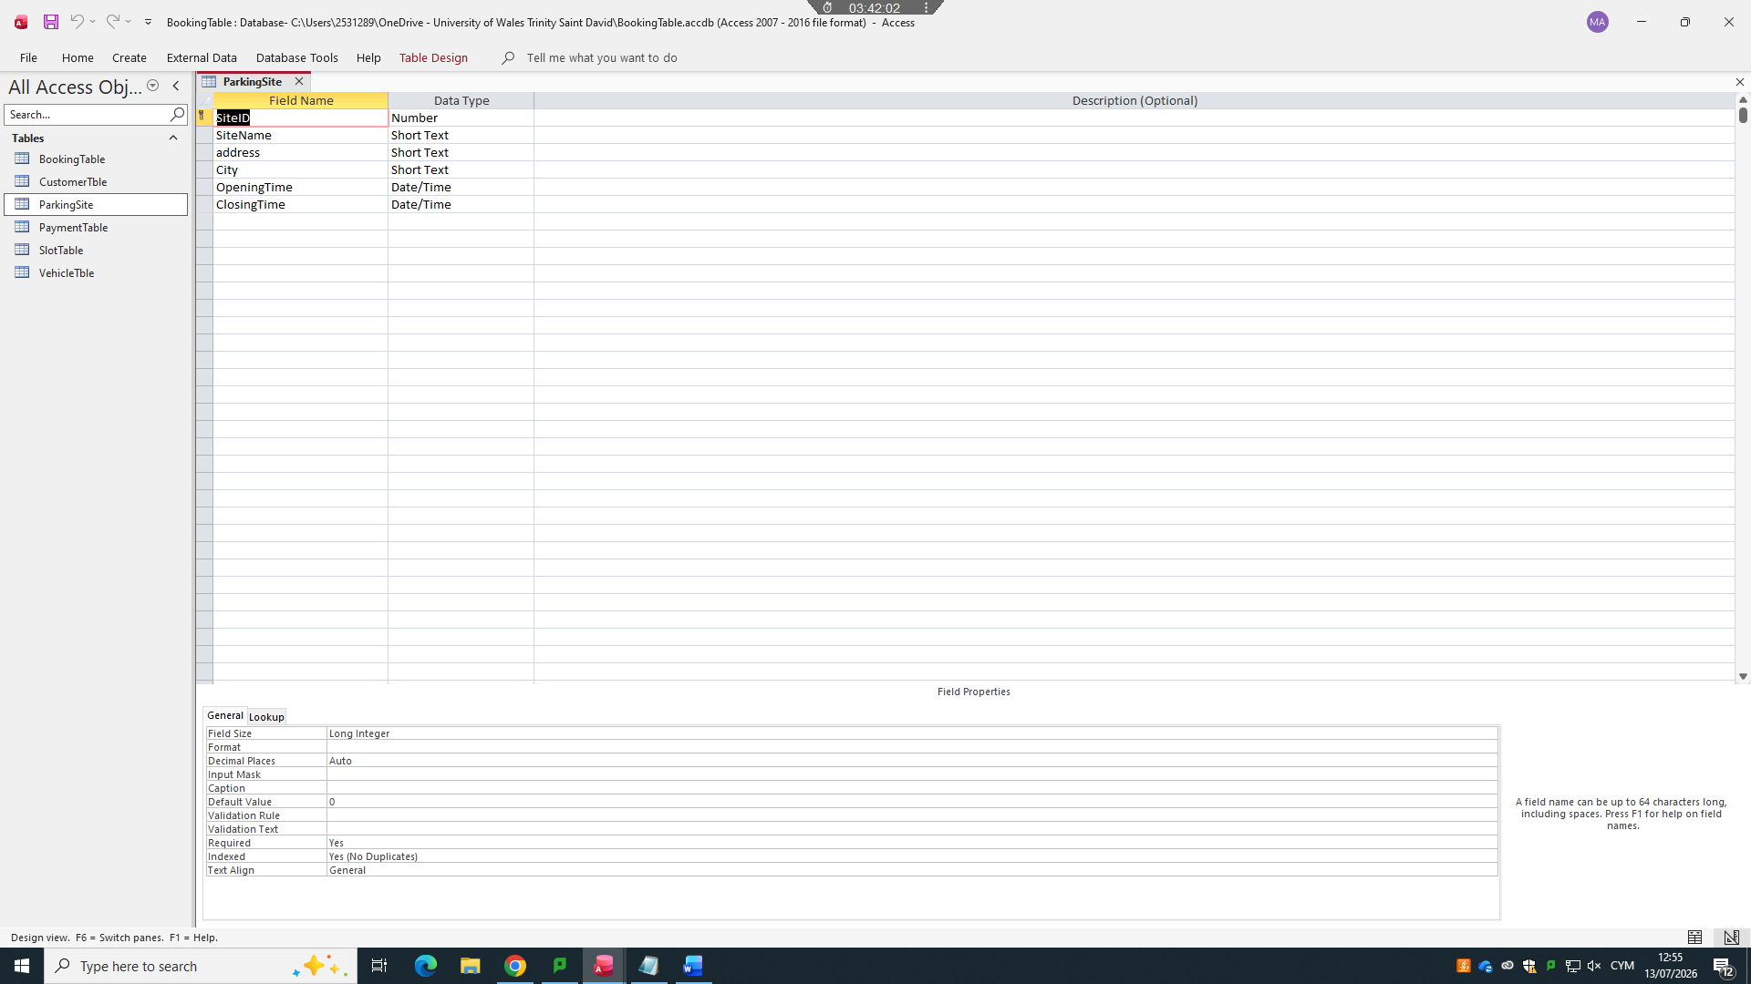
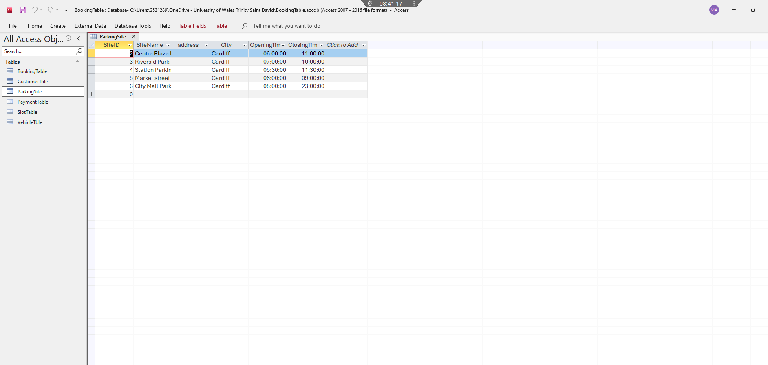

Figure 3: Customer Sample Data
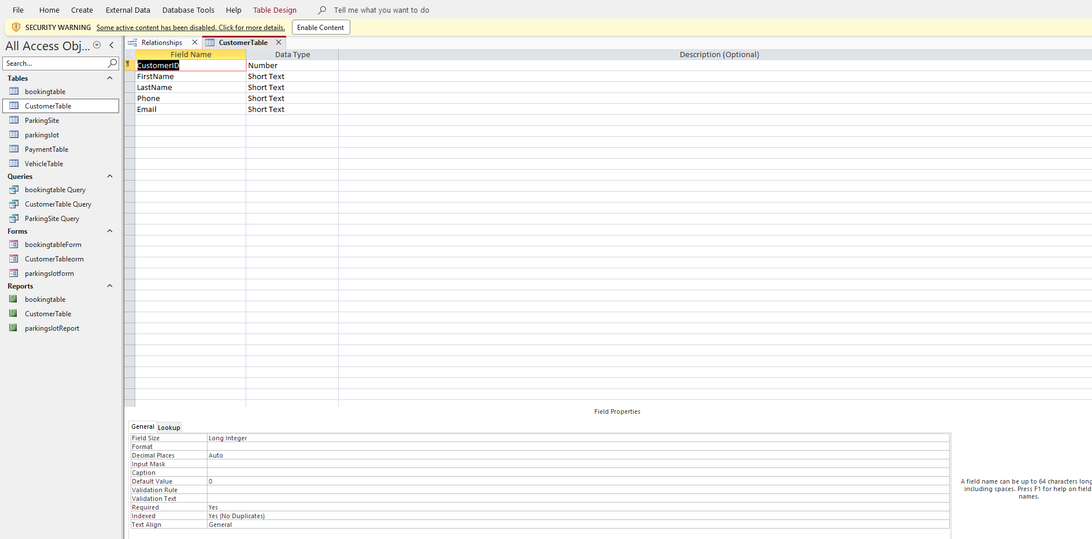


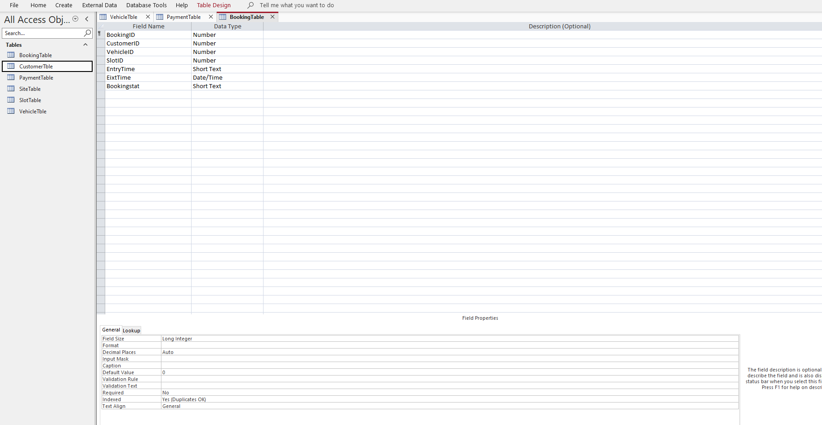
Figure 3: Customer Sample Data
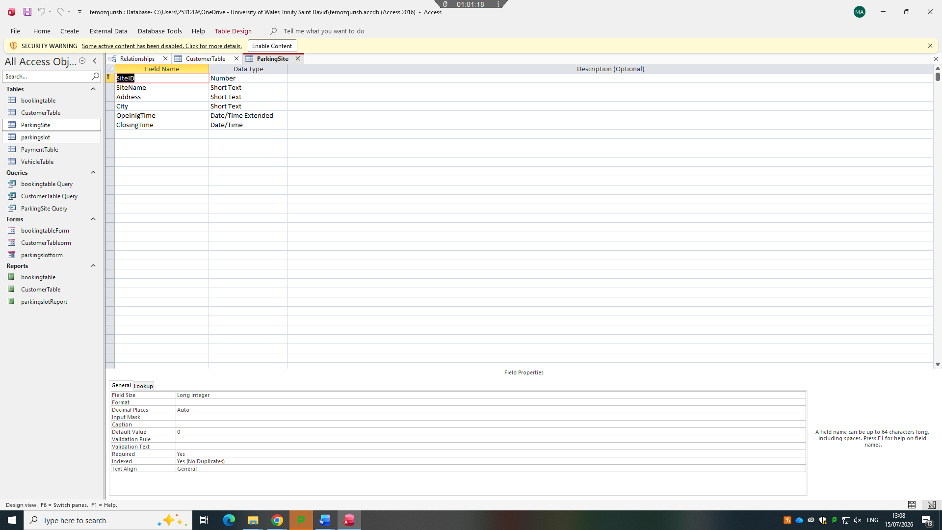


Figure 4: Parking Slot Sample Data
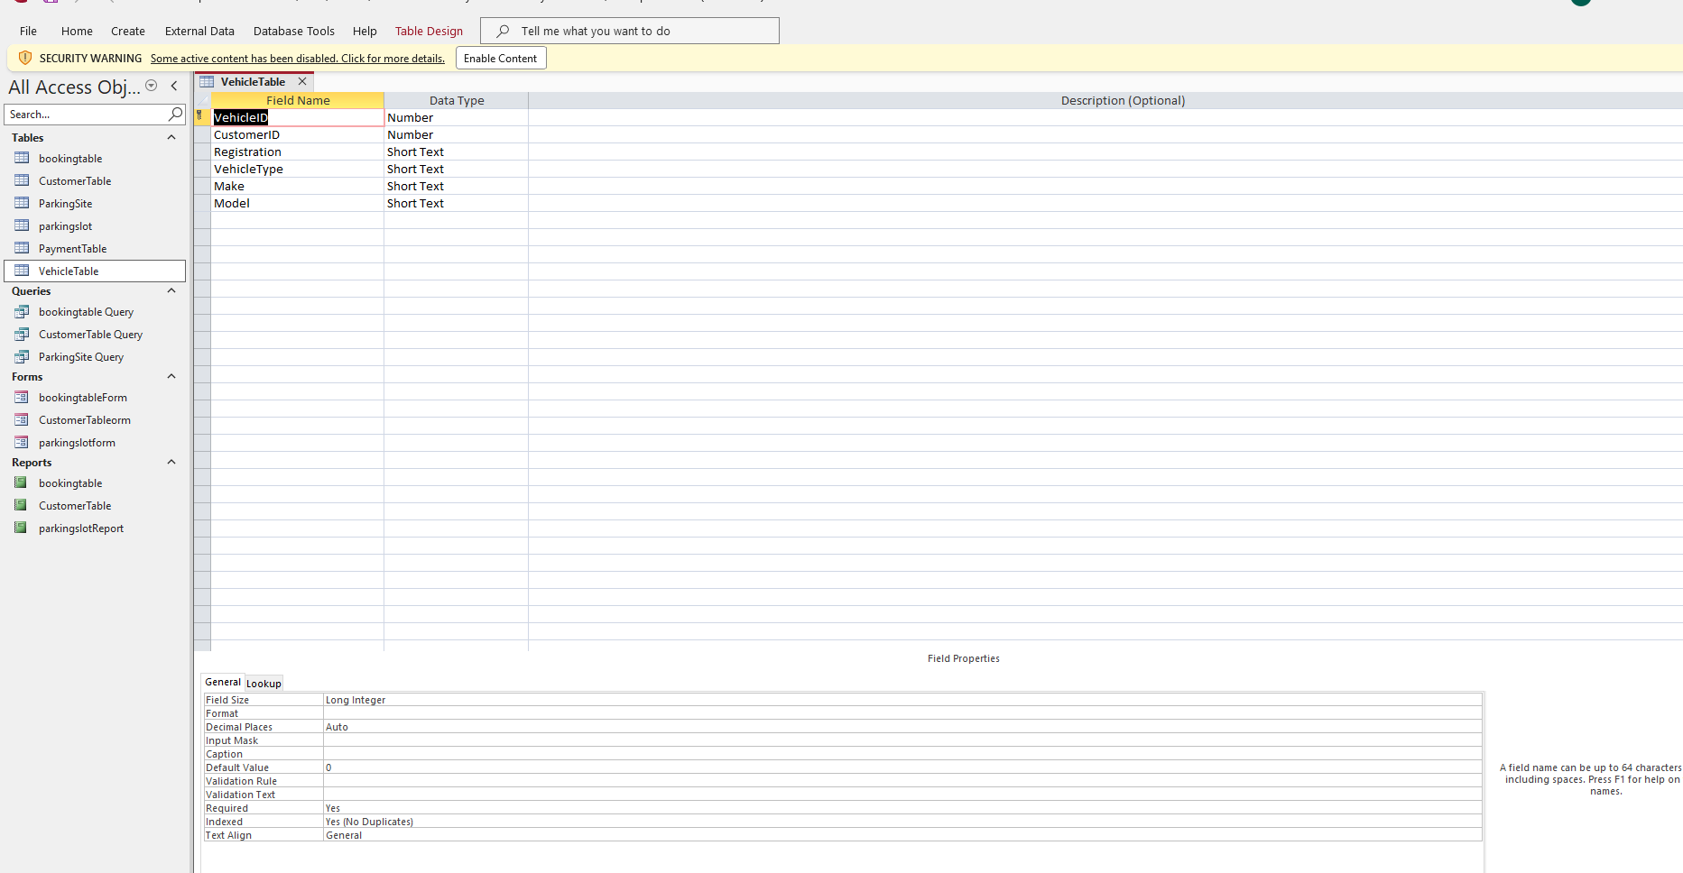


Figure 5: Vehicle Sample Data

Figure 6: Booking Sample Data

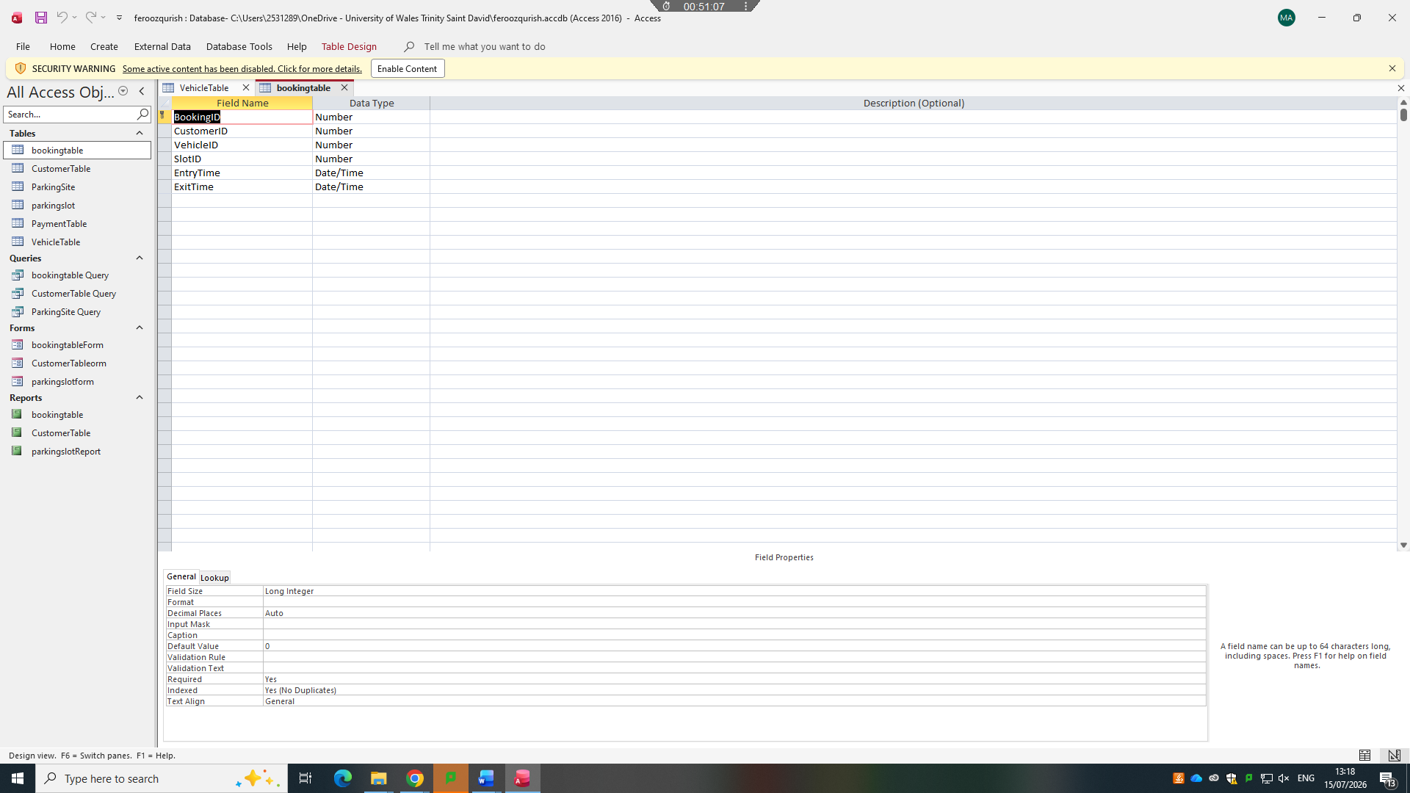

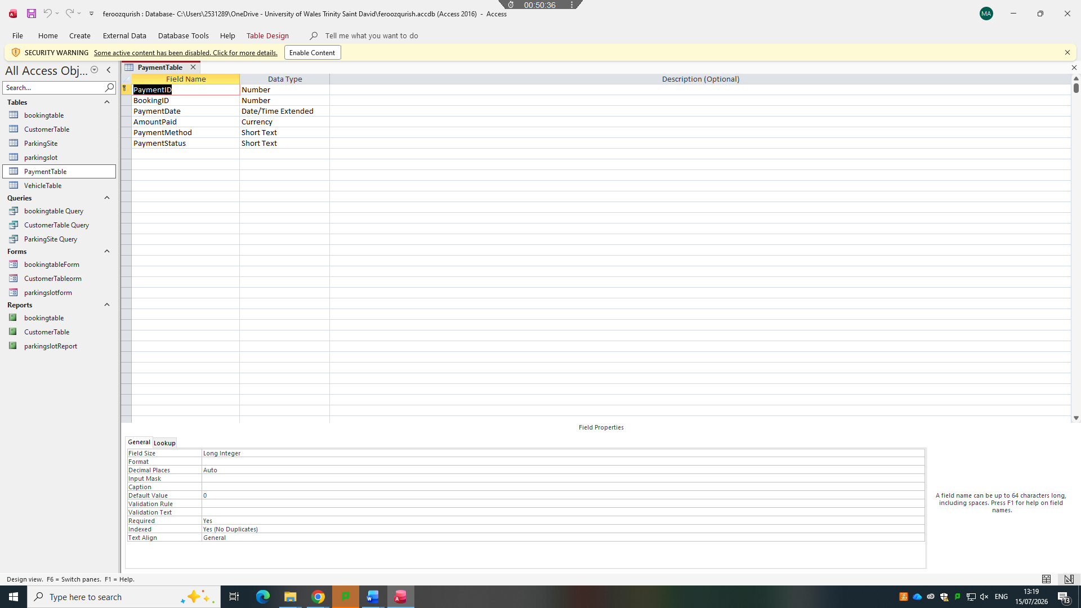

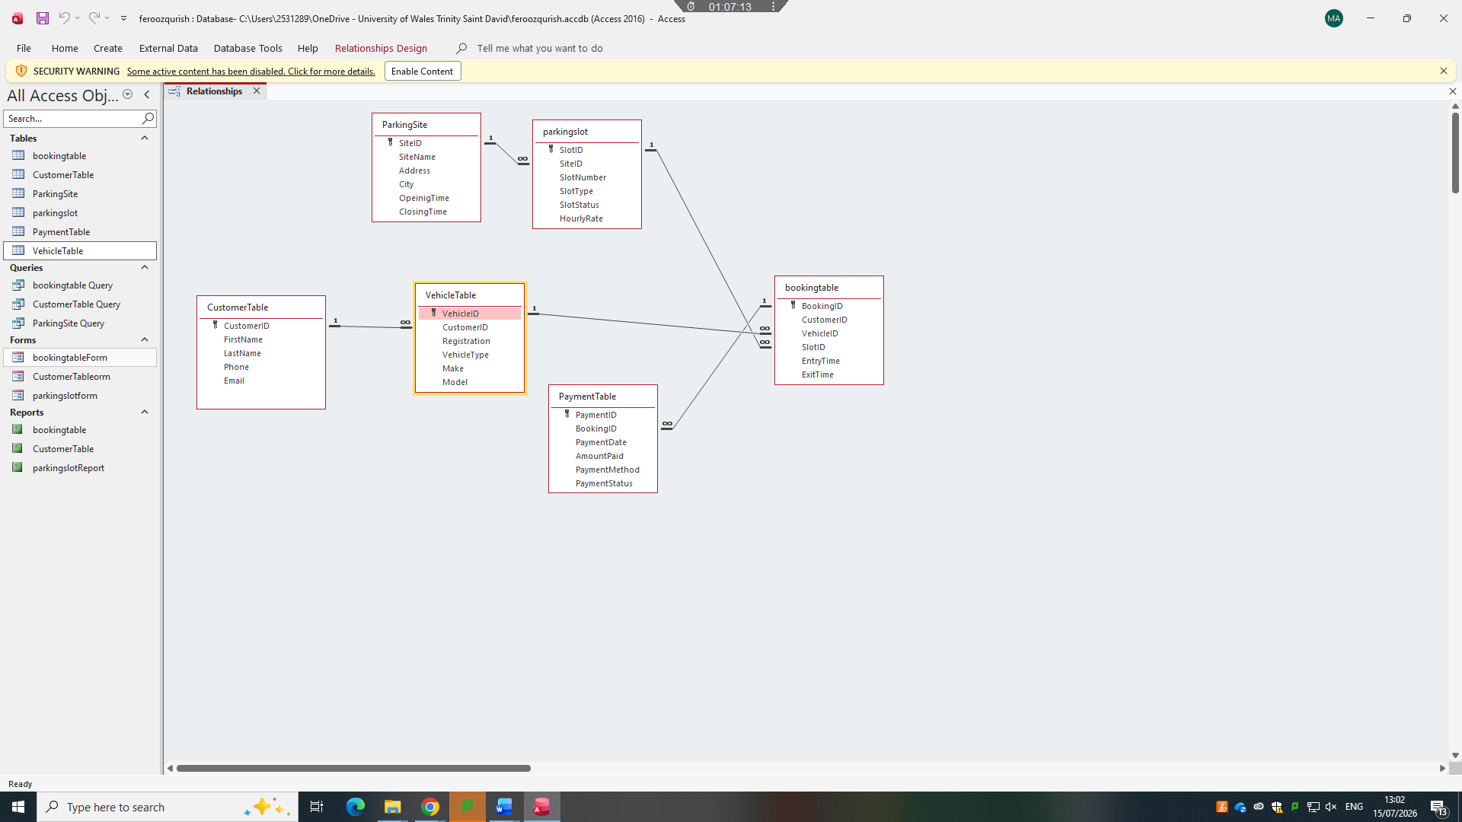
Figure 7: Payment Sample Data
The database was deployed in Microsoft Access with six tables with well-defined primary keys. Parking Site has Sited, Parking Slot has SlotID, Customer has CustomerID, Vehicle has VehicleID, Booking has BookingID, and Payment has PaymentID. Foreign keys were included where records were required to connect with another table such as SiteID in ParkingSlot, CustomerID in Vehicle, CustomerID, VehicleID and SlotID in Booking, and BookingID in payment. The sample data is included in each of the tables in Figure 2 to Figure 7. The table design is based on the principles of database design since each table accommodates a single major subject and does not keep various business entities in a single location. Recent database studies have also indicated that well-organized database projects must have conceptual modelling and practical implementation knowledge, such as SQL query development [9]. Table design, field names and data types in this system have been selected to accommodate actual operational activities like finding available slots, log active bookings and summaries of paid revenue.

5. Constraints and Data Validation
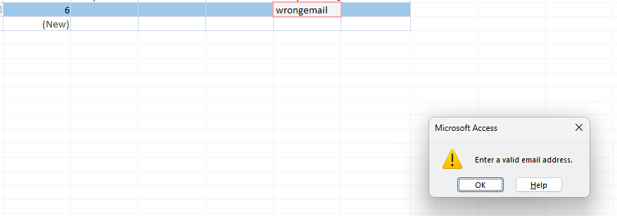
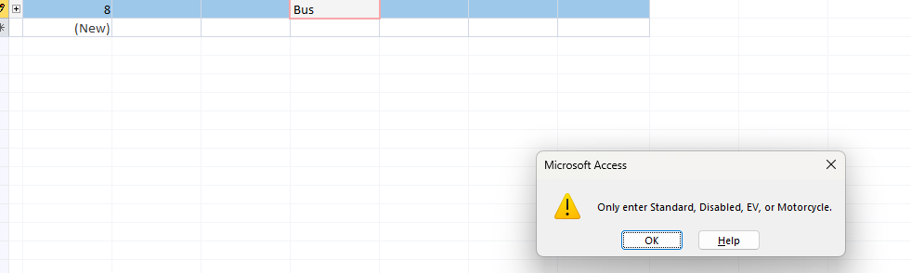
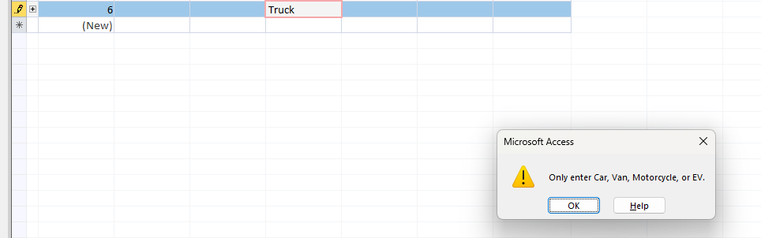
Figure 8: Validation Evidence
Validation rules were incorporated to enhance data accuracy and eliminate incorrect entries. In ParkingSlot, the Slottype was limited to Standard, Disabled, EV, and Motorcycle, and the Slot Status was limited to Available, Occupied, and Maintenance. HourlyRate and AmountPaid were limited to values that were equal to or above zero. Customer Email used a basic pattern rule to require an email format, VehicleType was limited to Car, Van, Motorcycle and EV, BookingStatus was limited to Active, Completed and Cancelled, and PaymentMethod was limited to Cash, Card and Online. According to Microsoft, Access validation rules may verify data when entered and enhance accuracy and consistency in desktop databases [11]. Relationship referential integrity was also imposed and cascade update was enabled and cascade delete was disabled. This design eliminates invalid foreign key records e.g. booking of non-existing customer. Figure 8 validation screen shot affirms that the system that was put in place was tested against wrong entries.

6. Normalisation to Third Normal Form
The database was normalised to a Third Normal Form to eliminate duplication and eliminate update anomalies. Under the First Normal Form, all fields were intended to store one value, e.g. there was a single registration number per vehicle record and a single payment method per payment record. Non-key fields were dependent on their entire primary key in Second normal form as each table has one primary key that is used to identify one subject. Under Third Normal Form, non-key fields were maintained as dependent as well as on the primary key and not on other non-key fields. As an example, the names and emails of customers are not stored in Booking multiple times but in Customer. Recent relational database literature confirms that normalisation is employed to prevent redundancy and to have clean and efficient storage [8]. The design can also retain conceptual meaning as it is translated into implemented relational schema, a fact that facilitates greater database integrity [2]. All in all, the 3NF simplified the system and it was less susceptible to inconsistent updates.

7. Forms devalobments

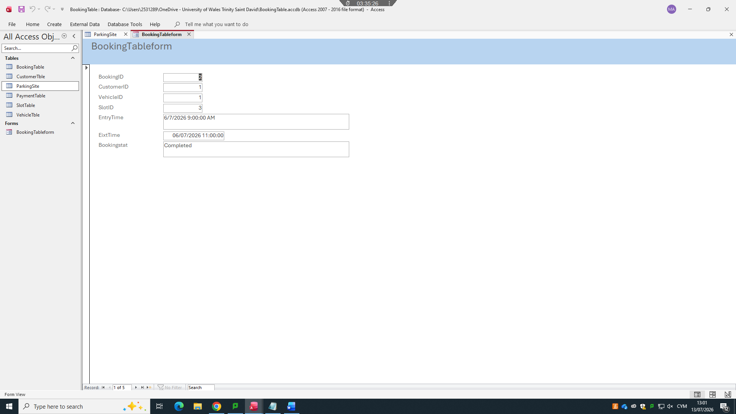
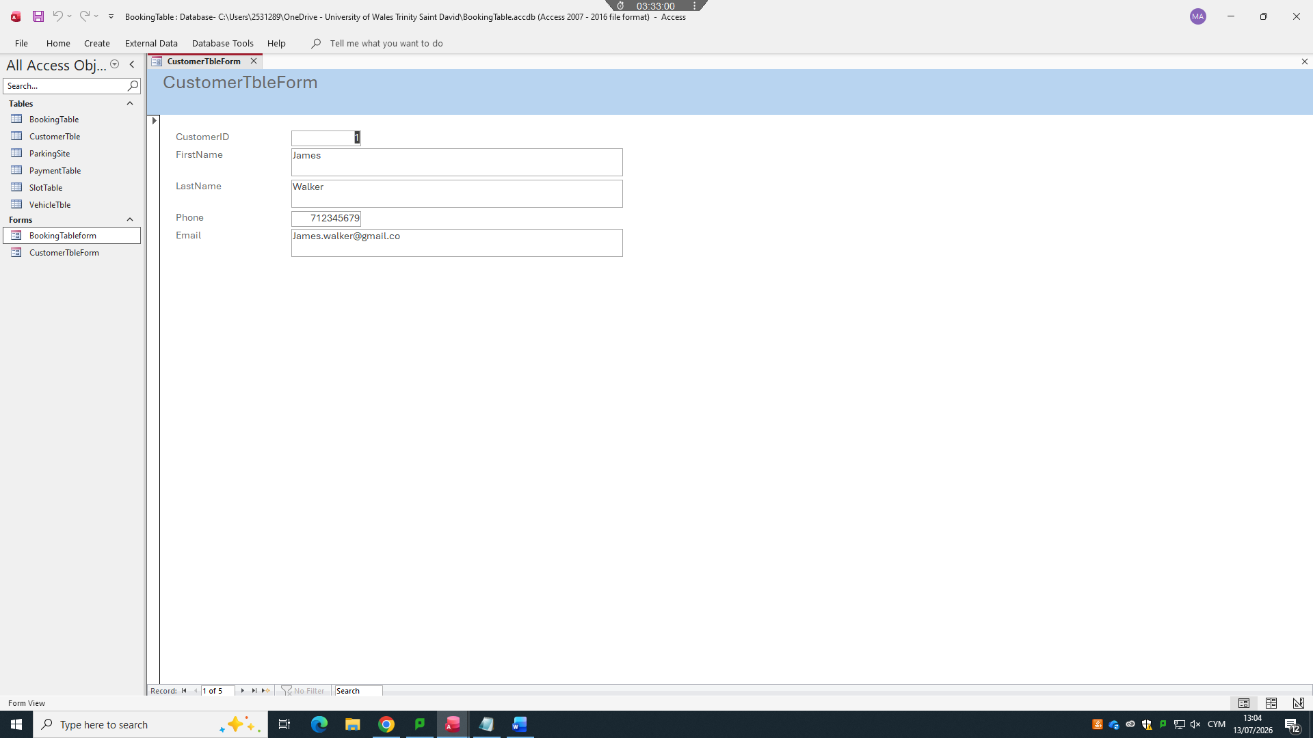
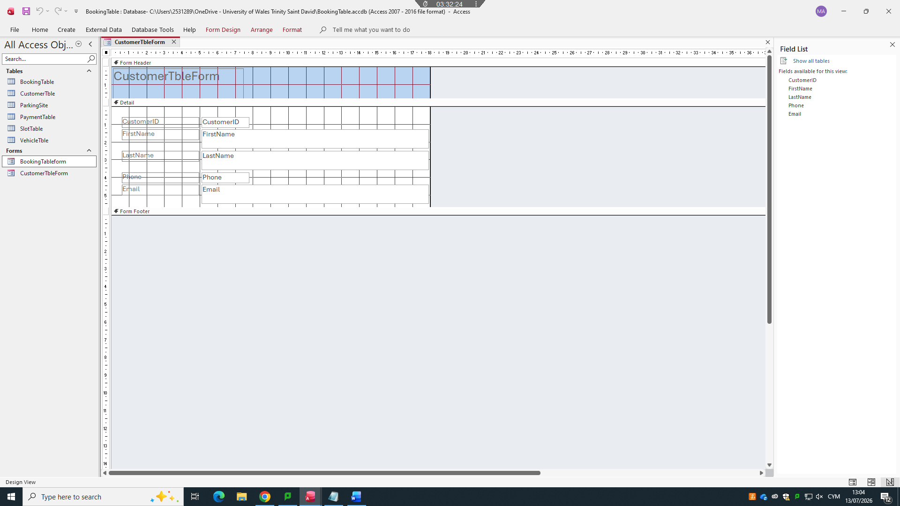

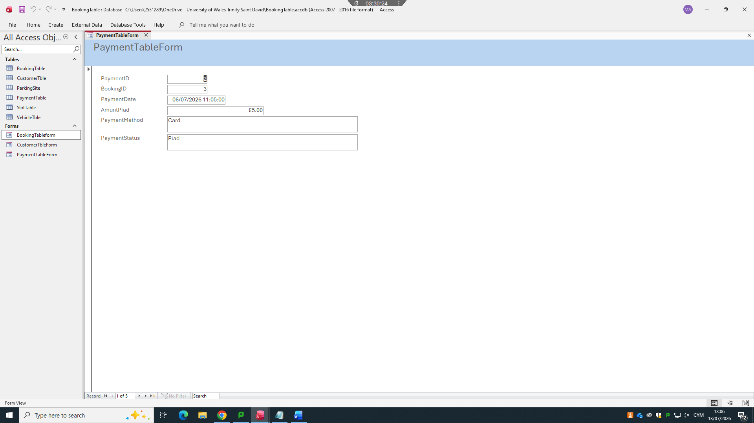

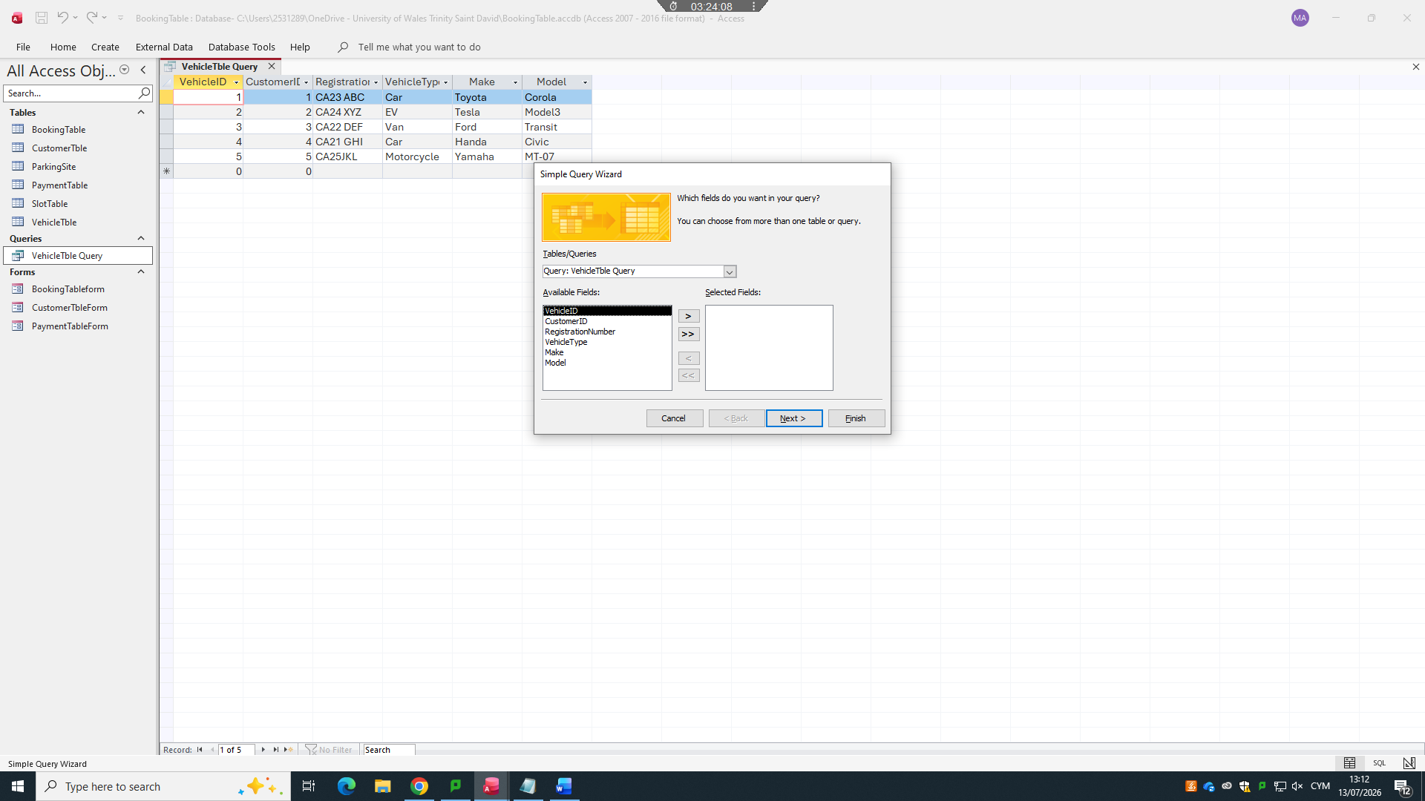
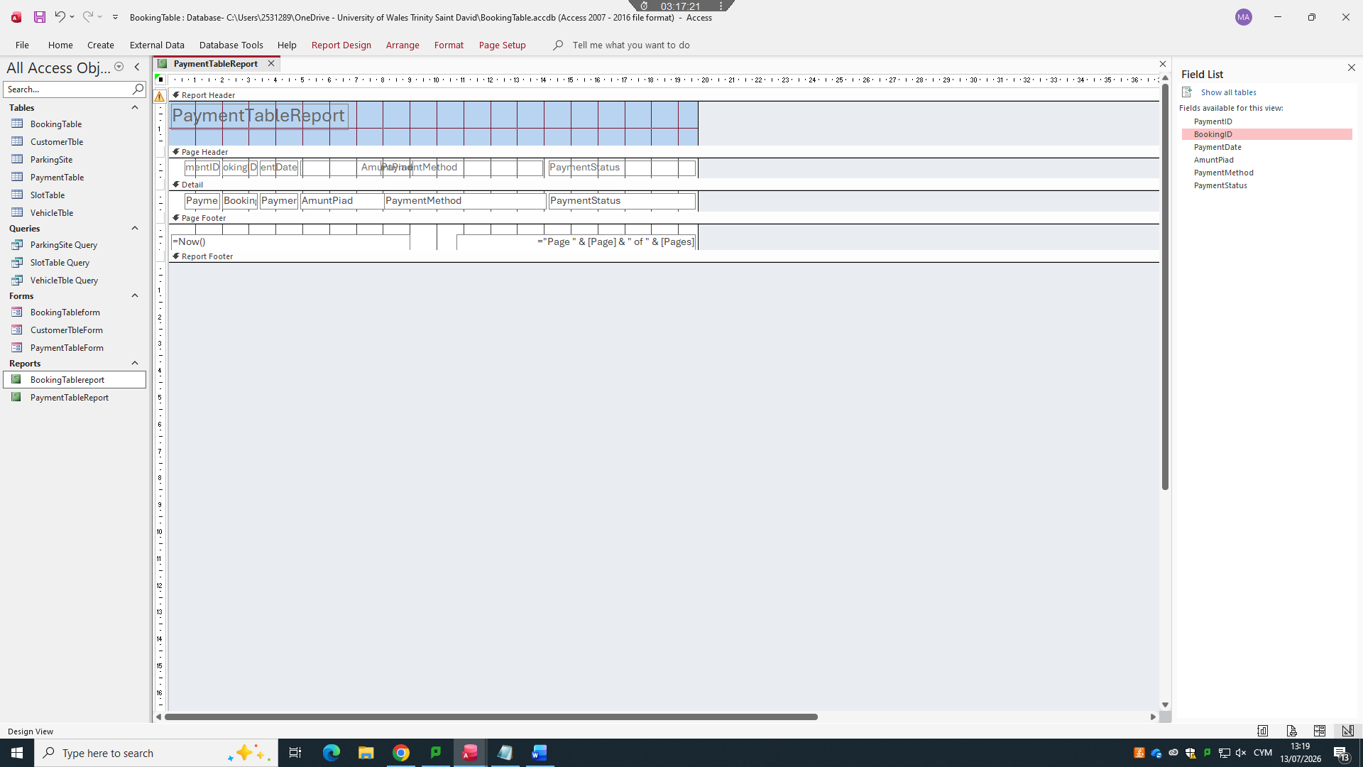
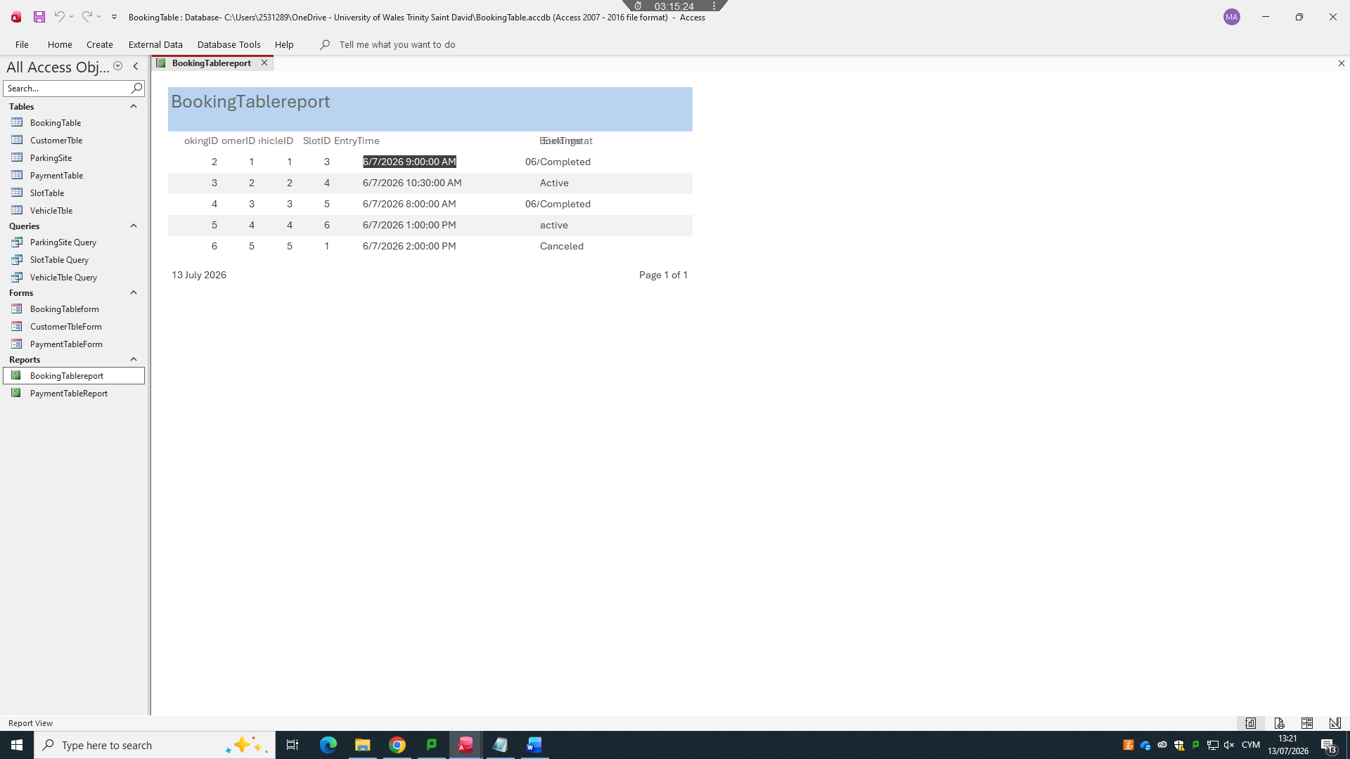

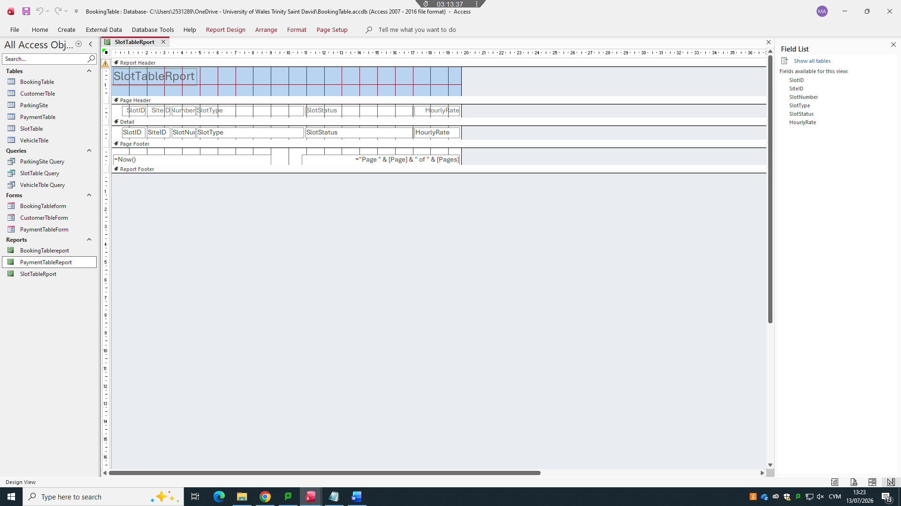
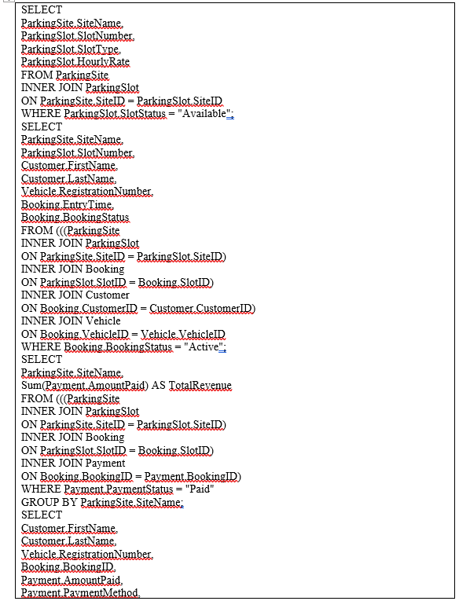
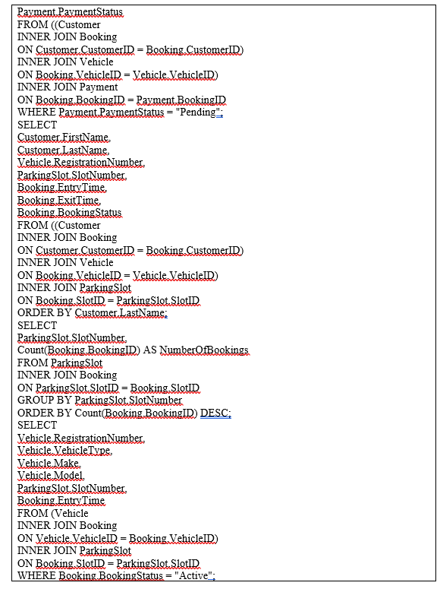
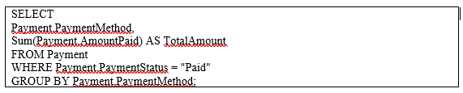
Figure 9: Query Created
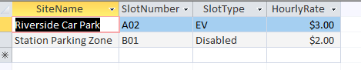
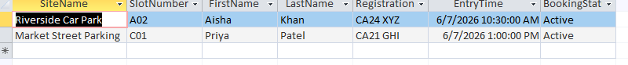
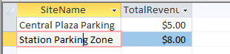
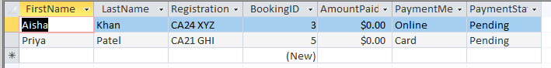
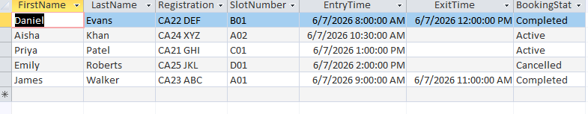
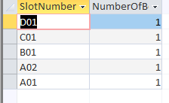
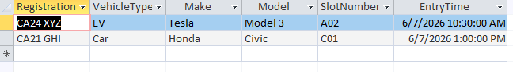
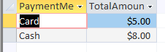
Figure 10: Query Output
Eight questions were developed to illustrate the practical application of the system. Figure 9 depicts the generated query objects, whereas Figure 10 indicates query output evidence. Q1_AvailableSlotsBySite reduces the number of available spaces and assists staff in making decisions during slot allocation. Q2_CurrentlyOccupiedSlots displays active reservations, customer names, registration numbers, and check-in times. Q3_RevenueBySite is the amount paid per parking site. Q4_PendingPayments finds out bookings in which payment is yet to be made. Q5 CustomerBookingHistory displays customer usage history. Q6_MostUsedParkingSlots The number of times each slot was used. Q7_ActiveVehiclesCurrentlyParked contains vehicles that are currently parked. Q8_RevenueByPaymentMethod summarises by payment method. Database work based on queries is essential, since the user requires retrieving useful information rather than just storing records [3]. These questions thus indicate that the database is not merely a storage file, but a functional information system for operational and management decision-making.

8. Report Creation and Management Use
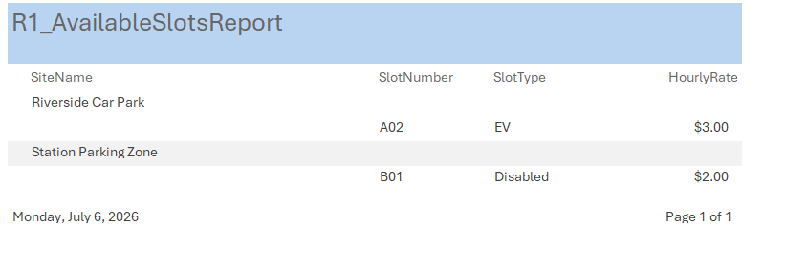
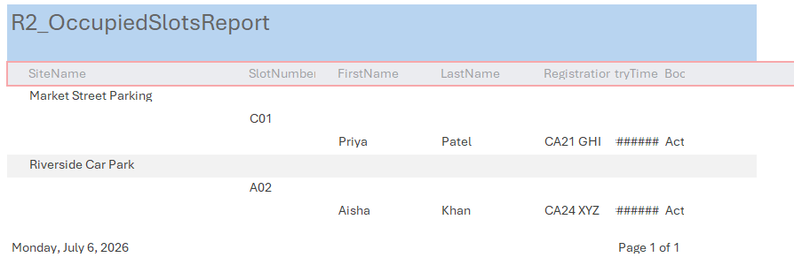
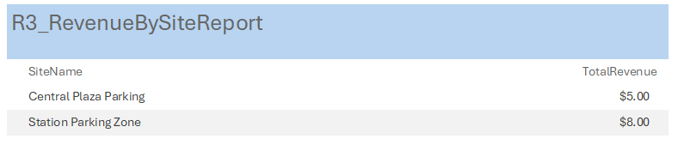
Figure 11: Report Review
The completed queries were converted into management reports to make the results easier for Auto Park staff to read. The report preview evidence is presented in Figure 11. The Available Slots report helps control days by operation; it presents areas that can be distributed to customers. Occupied Slots report assists the staff in trackining the movements of the active vehicles and also to seeing which vehicles are present and which are parked. The Revenue by Site report assists the management to compare the revenue at various parking sites. This reporting feature is used in response to the scenario requirement that involves tracking slot occupancy, revenue trends and operational performance. UK public service data guidance highlights the need for data to be secure and managed effectively across its lifecycle [12]. Despite AutoPark being a simplified assignment scenario, the principle is applicable since the data on parking needs to be accurate when a customer enters until the time of paying. The reports are thus practical in nature as they convert database data into information that can be used in operations.

9. Testing and Evaluation
Testing was done to ensure that the database was in compliance with the key functional requirements. The first test was to verify the invalid email formats were rejected in the Customer table. The second test was to verify the rejection of an invalid SlotType like Bus. The third test was a test to see whether a negative amount of payment was rejected. The fourth test was to confirm that an invalid Booking Status, like Open, was rejected. The fifth test evaluated the possibility of making a booking with a non-existing CustomerID. In Figure 8, the validation evidence indicates that the system disallowed invalid input. In the study of data management, it is emphasized that quality mechanisms should be considered where systems are developed to be stored in the long-term, published and used [4]. The testing ensured that the field validation and referential integrity were functional. This enhances the assurance that the system is capable of providing the right parking records, dependable queries and consistent management reporting.

10. Reflection and Future Improvements
The main benefit of the Auto Park database is that, it converts the manual parking records to a corresponding system with clear tabular, relational and validation rules, queries and reports. The design meets the requirements of the assignment as it captures sites, slots, customers, vehicles, bookings and payments. It also supports the availability, occupancy and revenue enquires in operational decision making. However, the system remains simplistic since it does not include automated price calculation, real-time slot updates, employee logins, or audit logs. The higher level would automatically calculate AmountPaid according to the EntryTime, ExitTime and HourlyRate. It may also comprise a dashboard that shows real-time occupancy, EV slot occupancy, unsuccessful payments and daily revenues. Centralised systems are becoming increasingly popular as a block in analysis and decision support in the modern approaches to data management [5]. Consequently, the future needs to develop more on automation, depth in security and reporting as compared to merely adding more tables.

11. Conclusion
The developed database in Microsoft Access provides a realistic solution to the relationship in the AutoPark Management System scenario. These are six related tables, primary keys, foreign keys, enforced relationships, validation rules, sample data, eight queries and management reports. The relationship design and ERD depict how the parking sites, slots, customers, vehicles, bookings, and payments are related to one another. The 3NF architecture reduces redundancy, and it is easy to maintain. The query and report output reflects on the way Auto Park can monitor the slot availability, booking, pending payments, customer history and revenue. Validation rules, referential integrity also ensured that data which were entered incorrectly were rejected. The system usually meets the brief by showing database design skills, and a practical implementation. The final database can be further improved with automation, real-time Dashboards and improved user access control.

Reference List
[1] W. Khan, T. Kumar, C. Zhang, K. Raj, A. M. Roy, and B. Luo, “SQL and NoSQL Database Software Architecture Performance Analysis and Assessments: A Systematic Literature Review,” Big Data and Cognitive Computing, vol. 7, no. 2, 2023. Available: https://www.mdpi.com/2504-2289/7/2/97. Accessed: Jul. 6, 2026.
[2] G. L. Guidoni, J. P. A. Almeida, G. Guizzardi, and N. Guarino, “Preserving conceptual model semantics in the forward engineering of relational schemas,” Frontiers in Computer Science, 2022. Available: https://www.frontiersin.org/journals/computer-science/articles/10.3389/fcomp.2022.1020168/full. Accessed: Jul. 6, 2026.
[3] S. W. Dietrich, “Databases for STEM success: lessons learned,” Frontiers in Education, 2024. Available: https://www.frontiersin.org/journals/education/articles/10.3389/feduc.2024.1414458/full. Accessed: Jul. 6, 2026.
[4] V. Villarreal, A. E. García, and C. Collazos, “A methodological approach for data standardization and management of Open Data portals for scientific research groups,” Frontiers in Computer Science, 2024. Available: https://www.frontiersin.org/journals/computer-science/articles/10.3389/fcomp.2024.1420709/full. Accessed: Jul. 6, 2026.
[5] P. Wieder, F. Lemke, M. Wójcik, and R. M. Bonnici, “Toward data lakes as central building blocks for data management and analysis,” Frontiers in Big Data, 2022. Available: https://www.frontiersin.org/journals/big-data/articles/10.3389/fdata.2022.945720/full. Accessed: Jul. 6, 2026.
[6] S. Lifschitz, “Bio-Strings: A Relational Database Data-Type for Dealing with Large Biosequences,” Data, vol. 7, no. 3, 2022. Available: https://www.mdpi.com/2673-6284/11/3/31. Accessed: Jul. 6, 2026.
[7] N. Abdelaziz, “Identifying and addressing common undergraduate misconceptions in database design,” Frontiers in Education, 2025. Available: https://www.frontiersin.org/journals/education/articles/10.3389/feduc.2025.1554089/full. Accessed: Jul. 6, 2026.
[8] S. Abdellaoui, “SQL and NoSQL Databases: A Comparative Study with Practical Examples,” Engineering Proceedings, vol. 112, no. 1, 2025. Available: https://www.mdpi.com/2673-4591/112/1/72. Accessed: Jul. 6, 2026.
[9] O. Ak, “Use of generative AI in database courses: a role-based approach,” Frontiers in Education, 2026. Available: https://www.frontiersin.org/journals/education/articles/10.3389/feduc.2026.1795408/full. Accessed: Jul. 6, 2026.
[10] Microsoft, “Database design basics,” Microsoft Support, 2024. Available: https://support.microsoft.com/en-us/access/database-design-basics. Accessed: Jul. 6, 2026.
[11] Microsoft, “Restrict data input by using validation rules,” Microsoft Support, 2024. Available: https://support.microsoft.com/en-us/access/restrict-data-input-by-using-validation-rules. Accessed: Jul. 6, 2026.
[12] Central Digital and Data Office, “Ensuring government data drives improvements in public services,” GOV.UK Blog, Dec. 5, 2023. Available: https://cddo.blog.gov.uk/2023/12/05/ensuring-government-data-drives-improvements-in-public-services/. Accessed: Jul. 6, 2026.
[13] Department for Science, Innovation and Technology, “State of digital government review,” GOV.UK, 2025. Available: https://www.gov.uk/government/publications/state-of-digital-government-review/state-of-digital-government-review. Accessed: Jul. 6, 2026.
[14] Department for Transport, “Vehicle licensing statistics, United Kingdom: 2025,” GOV.UK, Apr. 29, 2026. Available: https://www.gov.uk/government/statistics/vehicle-licensing-statistics-2025/vehicle-licensing-statistics-united-kingdom-2025. Accessed: Jul. 6, 2026.
[15] Department for Transport, “Provisional road traffic estimates, Great Britain: July 2024 to June 2025,” GOV.UK, Oct. 2, 2025. Available: https://www.gov.uk/government/statistics/provisional-road-traffic-estimates-great-britain-july-2024-to-june-2025/provisional-road-traffic-estimates-great-britain-july-2024-to-june-2025. Accessed: Jul. 6, 2026.

