

Module Name: Entrepreneurial Innovation,
Module Code: BMBM4011,
Assignment Name: Developing a Venture plan for sustainable delivery and longevity,
Student Name: Beth Woolley
Student Number:
Lecturer: Robyn Griffiths,
Deadline: 24 April 2026.

Wordcount: 2, 147.

Developing a Venture plan for sustainable delivery and longevity,

StudySync is a digital application designed to support higher education students in managing academic workloads more efficiently through integrated scheduling, study tracking and personalised analytics. StudySync is used to address a growing demand for accessible, technological-driven solutions to help balance academic and personal responsibilities.
StudySync uses a freemium business model which offers the free core services to encourage users to join, and a premium version that unlocks additional features. This approach aligns directly with StudySync’s student audience for low cost, whilst also creating a scalable revenue. First-year financial projections show a modest loss of £300 due to marketing and development. However, using this freemium model shows strong potential for long-term profitability as the user base grows.
StudySync will remain sustainable due to the continuous improvement approach. This is where StudySync will incorporate user feedback and data analytics every quarter to improve the application. This implementation plan focuses on launching a minimum viable product within the first-year, and then with the continuous updates to enhance user experience.
Overall, StudySync presents a viable and scalable business opportunity with a clear value proposition and realistic pathway to sustainable growth within the competitive digital market.

StudySync is a free productivity application designed to help university students remain focused and help with academic effort. This application has several popular study methods build in, such as Pomodoro-style timers. This helps limit the number of times students have to go off the app, which helps limit distractions. StudySync also includes reward-based incentives and study rooms to create a familiar environment. The primary target is university students, specifically those who work alongside their studies, who often find it difficult to keep track of assignment dates, and maintain focus. Since the recent popularity of technology among students, it highlights the importance of mobile applications to support learning and time management (Ceci, 2019).
Research conducted by Liu et al. (2023) shows that students in higher education struggle to remain focused and manage their time effectively. The increase in academic pressure mixed with external distractions like social media or part time work has led to an increase in procrastination and an overall decline in academic performance (Anwar, Anwar and Amir Hamza Marwan, 2022). This is seen more in higher education students as they have to manage their individual study hours alongside lectures and part time employment without guidance (Zimmerman, 2002). As a result, a large number of students look for digital tools to help with organisation and also encourage focus and engagement.
StudySync addresses these issues by combining traditional study methods, such as the pomodoro study timers with a reward-based system that creates an incentive for academic effort. Users can set their individual study goals, track current assignment due dates, and earn points based on the time spent doing academic work. These points are then converted into discounts or vouchers to be used at the partnered businesses. This approach is supported by motivation theory, which suggests that rewards can enhance engagement and consistency (Harackiewicz and Sansone, 2000). In addition, virtual study rooms create a sense of accountability, allowing users to study alongside each other which has been proven to increase motivation through social influence and peer support (Bandura, 1986).
This concept is supported by the ever-going need for digital productivity tools, as well as the increased reliance on mobile applications among students. As technology geta more advanced and more integrated into teaching, there is a clear pathway for StudySync to increase motivation.

Strategy For Longevity:

StudySync is likely to achieve long-term success as it aligns with what the target audience requires, as well as having the ability to adapt to the changes in the digital market to remain unique. Higher education students rely heavily on mobile applications and the internet to manage their academic and employment workloads, which creates a sustained demand for tools that support productivity, organization, and focus (Statista, 2021; Wolters and Brady, 2020). Unlike other productivity applications on the market, StudySync is designed specifically for students, which allows them to keep track of academic challenges such as procrastination, lack of structure and inability to remain focused (Zimmerman, 2002).
StudySync focuses on integrating study techniques such as Pomodoro timers onto one platform to reduce the need for students to switch between applications, which in turn reduces the number of distractions and increases efficiency (Mark, Gudith and Klocke, 2008). This market positioning provides a strong structure for longevity, as the pressure students face is ongoing and unlikely to diminish over time (Zimmerman, 2002). Additionally, the continued integration of technology into teaching shows that there is increasing opportunity for innovative digital learning tools, supporting the long-term viability of applications such as StudySync (HolonIQ, 2023).
The reason StudySync stands out against competitors is since it combines several productivity features with motivational incentives which creates a more engaging and student-focused experience in comparison to existing applications. According to Porter (1985), organisations can achieve competitive advantage by being different to competitors, which StudySync demonstrates by integrating several different study skills, reward systems and social features. While productivity applications such as Forest app focus on motivation through gamification where users gain a streak badge and Todoist focuses primarily as a task organiser, neither provide an integrated platform that combines both productivity, motivation and peer interaction.
StudySync stand by targeting students specifically and incorporating a reward-based system that over time turns into tangible rewards, such as discounts or vouchers. This creates an added bonus for users and encourages consistent engagement, whereas competitors lack the bonus effect, as a simple streak badge doesn't create the same level of serotonin that a real-world discount does (Switchfly, 2025). Additionally, the included study rooms bring in a social element that creates accountability and motivation which further strengthens StudySync’s position. As a result, StudySync offers a more reliable and consistent solution in comparison to its competitors, which increases its ability to retain and keep users' long term, such is essential for longevity.
Customer retention is essential to the long-term success for StudySync, as the application relies on consistent user engagement over time. StudySync encourages this through a mixture of reward-based incentives and habit-forming features which motivates users to use the application on a daily or weekly basis. The inclusion of real-life rewards and progress trackers promotes routine, which is directly linked to habit creation and long-term engagement (Gardner, Lally and Wardle, 2012). StudySync reinforces positive study behaviours by rewarding users for continues academic effort which over time increases the likelihood that users will continue to use the application.
Additionally, the reward system provides external motivation by providing tangible benefits such can further push motivation and encourage repeated use (Deci and Ryan, 2000). The self-motivation theory backs this up as motivation can be achieved by internal and external factors (Ryan and Deci, 2017). StudySync also enhances customer retention through its virtual study rooms, which helps users create a sense of accountability and community. This social aspect increases continuous participation, as students remain more engages when they feel connected to others (Bandura, 1986). As a result, StudySync continuous to attract new users but also provide several incentives for current users to continue to use the application, which in turn supports long-term sustainability.
StudySync also shows strong potential for growth, which also supports long-term sustainability. As the number of users increases, StudySync can expand its partnership with businesses to provide a wider range rewards which then increases the value to users whilst also creating additional revenue opportunities. This platform-based growth model benefits from network effect, where the number of users increases the value of the application (Parker, W and Sangeet Paul Choudary, 2017). However, this growth relies on StudySync reaching a critical number of users and partners. Without early adoption, the effectiveness of network effect may be limited.
Additionally, StudySync has the potential to expand further than university students into other markets such as professionals seeking productivity tools or just everyday life organisation. The flexibility of a digital platform also allows for continuous updates and further development which helps ensure the app remains relevant to users' needs. This supports long term growth, as the application is not limited to one audience.
Furthermore, creating partnerships with universities or other educational institutions could increase credibility through recommendations and encourage use on a larger scale. This expansion strategy allows StudySync to grown sustainably whilst maintaining its purpose (HolonlQ, 2023). Rapid expansion into newer markets may reduce the apps student-focus core purpose, meaning that StudySync needs to carefully adapt into new markets to keep their competitive advantage.

Figure One: Business Model Canvas:
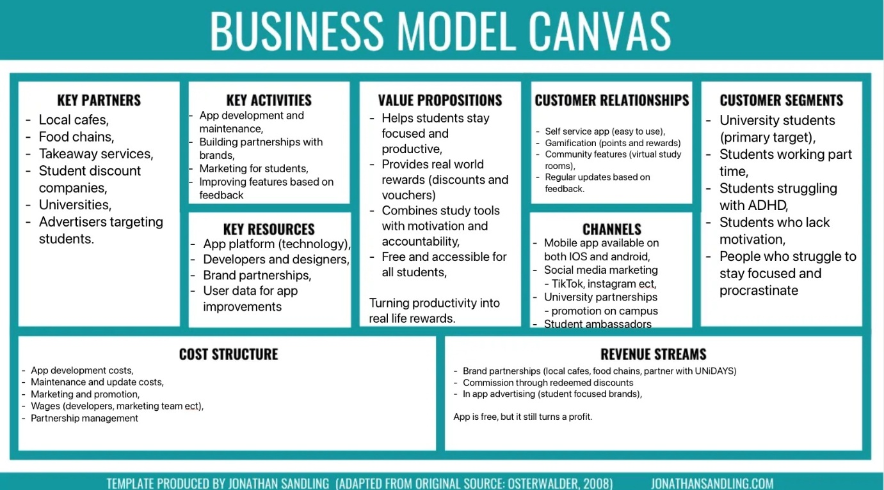
As shown above, StudySync’s business model aligns its value proposition, revenue streams and customer segments to support long-term sustainability.

Viability / Finance:
StudySync will adapt a freemium business model, which offers a free version to attract users along with a premium subscription that unlocks advanced features such as advanced scheduling tools, personalised study analytics and cloud syncing. This approach aligns with students as it aligns with their need for budget-conscious purchasing (Allingham, 2020).
Within the first year StudySync is projected to attract 100 users by using targeted marketing and word-of-mouth through university systems. Of these 100 users, roughly 20% will convert to the premium version. With a monthly fee of £4.99, this should generate £100 per month, leading to £1,200 in annual revenues.
StudySync initial costs are expected to remain low due to the digital nature of the platform. Development costs are expected to reach no more than £1,000, which reflects the cost-effective development tools and support from freelancers. Marketing conducted on social media and other student aimed platforms is expected to cost StudySync £300. The ongoing updates and support for the application is expected to cost £200 annually. This results in an estimated cost for £1,500 for the first year.

Table One: First Year Financial Projections:
Category | Calculation | Annual Value
Premium Users | 20 users x £4.99 x 12 months | 1,200
Total Revenue |  | 1,200
Development Costs | One time estimate | 1,000
Marketing costs | Annual estimate | 300
Maintenance Costs | Annual estimate | 200
Total Cost |  | 1,500
Net profit/Loss | Revenue - costs | -300

As shown in table one, StudySync is likely to operate with an initial loss of £300 within the first year. However, this is typical for early years for digital ventures, where initial investment is curial to build a user base. As the number of users increase over time, with relatively low marginal costs that platform has strong potential to become profitable. Therefore, the financial outlook suggests that StudySync is a viable and scalable business idea, with realistic potential for long-term sustainability.
The revenue streams and cost structure parts of the Business Model Canvas are in line with these financial assumptions. While the premium subscription shows a consistent and scalable source of income, whilst the freemium model emphasises the accessibility for students. Additionally, the cost-effective framework shows sustainability with the business model aligning with the use of digital platforms and key resources which are outlined in figure one.

Implementation & Learning Loop:
StudySync will be implemented into the digital market using a phased approach to ensure efficient and continuous development. At first a minimum viable product (MVP) will be launched will focus on the core features such as scheduling tools and study trackers. This will allow StudySync to enter the market quickly whilst minimising costs and risks. The MVP will be tested in small focus groups in Universities to gather early feedback and identify and usability issues before a wider launch. This approach reflects the Build-Measure-Learn cycle, which allows for continuous innovation based on real user data (Ries, 2011, Bygrave, Zacharakis and Wise, 2023).
Once initial testing is completed, StudySync will be introduced to a wider market through targeted digital advertising, including social media and University based networks. This approach aligns with the customer segment of the Business Model Cavnas whilst also ensuring a cost-effective promotion. This early launched period will prioritise user acquisition and engagement to help support the long-term growth strategy shown in figure one.
Key aspects of StudySync’s long-term success are the integration of a continuous learning-loop. User feedback will be collected through in-app surveys, user data analytics and the focus groups to understand what users like, and what they need. This data will then be used for future updates and improvements to ensure the platform remains relevant and up to date with user's needs. Having this quarterly feedback from customers is key to making sure StudySync can achieve market fit (Blank, 2013).
Additionally, performance metrics such as user retention rates, premium upgrade rates and engagement levels will be continuously monitored to evaluate the effectiveness of the platform. Strategic adjustments can then be made based on these insights, which as refining features or adjustments to the pricing model. This approach will ensure that StudySync remands adaptable in a competitive digital market.
Overall, the mixture of phased implementation and structured learning loop supports the long-term viability of StudySync, allowing for continuous improvement and sustainable growth.

Figure Two: Build-Measure-Learn:
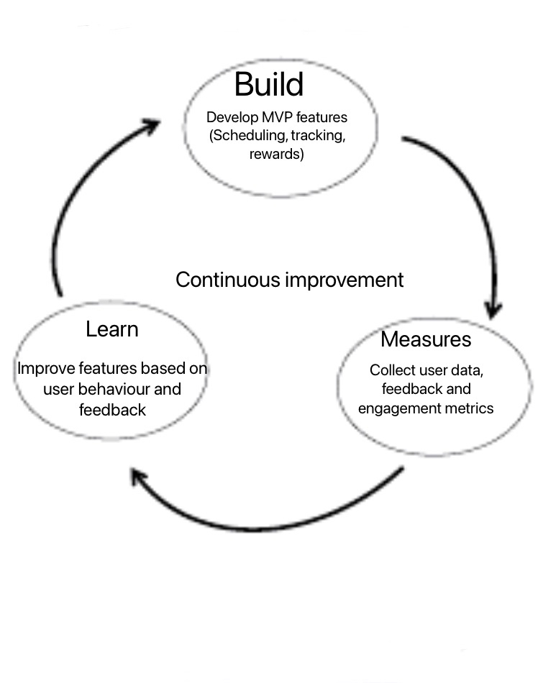
As shown in Figure Two, Study Sync follows a continuous improvement cycle.
StudySync shows strong potential for long-term success through its student-focused core values, as well as its scalable freemium model and data driven development approach. Whilst an initial £300 is lost, the projected growth shows development and financial security within the future. It is recommended that StudySync proceeds with the MVP development and repetitive improvements to ensure sustained user engagement and market relevance.

Reference list
Allingham, T. (2020). Save the Student. [online] Save the Student. Available at: https://www.savethestudent.org/shopping/best-free-trials-uk.html.
Anwar, M., Anwar, A. and Amir Hamza Marwan (2022). Impact of Social Media Usage on Academic Procrastination. [online] ResearchGate. Available at: https://www.researchgate.net/publication/363306209_Impact_of_Social_Media_Usage_on_Academic_Procrastination.
Bandura, A. (1986). Social Foundations of Thought and Action. Prentice Hall.
Blank, S. (2013). Why the Lean Start-Up Changes Everything. [online] Harvard Business Review. Available at: https://hbr.org/2013/05/why-the-lean-start-up-changes-everything.
Bygrave, W.D., Zacharakis, A. and Wise, S. (2023). Entrepreneurship.
Ceci, L. (2019). Topic: Mobile app usage. [online] www.statista.com. Available at: https://www.statista.com/topics/1002/mobile-app-usage/.
Deci, E.L. and Ryan, R.M. (2000). The ‘What’ and ‘Why’ of Goal Pursuits: Human needs and the Self-Determination of Behavior. Psychological Inquiry, 11(4), pp.227–268. doi:https://doi.org/10.1207/S15327965PLI1104_01.
Gardner, B., Lally, P. and Wardle, J. (2012). Making health habitual: The psychology of ‘habit-formation’ and general practice. British Journal of General Practice, 62(605), pp.664–666. doi:https://doi.org/10.3399/bjgp12x659466.
Harackiewicz, J.M. and Sansone, C. (2000). Intrinsic and extrinsic motivation : the search for optimal motivation and performance. Burlington: Elsevier.
HolonIQ (2023). 2023 Global Education Outlook. [online] www.holoniq.com. Available at: https://www.holoniq.com/notes/2023-global-education-outlook.
Liu, Z., Xie, Y., Sun, Z., Liu, D., Yin, H. and Shi, L. (2023). Factors associated with academic burnout and its prevalence among university students: a cross-sectional study. BMC Medical Education, [online] 23(1). doi:https://doi.org/10.1186/s12909-023-04316-y.
Mark, G., Gudith, D. and Klocke, U. (2008). The cost of interrupted work. Proceeding of the twenty-sixth annual CHI conference on Human factors in computing systems - CHI ’08, [online] pp.107–110. doi:https://doi.org/10.1145/1357054.1357072.
Parker, G.G., W, M. and Sangeet Paul Choudary (2017). Platform revolution : how networked markets are transforming the economy - and how to make them work for you. New York: W. W. Norton & Company, Cop.
Porter, M.E. (1985). Competitive Advantage.
Ries, E. (2011). The Lean Startup. London: Portfolio Penguin.
Ryan, R. and Deci, E. (2017). Self-determination theory: Basic psychological needs in motivation, development, and wellness. New York: Guilford Press.
Sandling, J. (n.d.). Business Model Canvas Template [FREE DOWNLOAD} | JONATHAN SANDLING. [online] jonathansandling.com. Available at: https://jonathansandling.com/business-model-canvas/.
Sirois, F. (2022). Speaking of Psychology: Why we procrastinate and what to do about it, with Fuschia Sirois, PhD. [online] Apa.org. Available at: https://www.apa.org/news/podcasts/speaking-of-psychology/procrastinate.
Statista (2021). Topic: Digital learning in the UK. [online] Statista. Available at: https://www.statista.com/topics/8518/digital-learning-in-the-uk/?srsltid=AfmBOopJQUvb2zv5KuIuOn98re3ImD-thaARkud5CbJslDVLKPAk5QDD [Accessed 16 Apr. 2026].
Switchfly (2025). Reward Psychology in Loyalty Programs: Why Humans Love Points and Perks. [online] Switchfly.com. Available at: https://www.switchfly.com/blog/reward-psychology-loyalty.
Wolters, C.A. and Brady, A.C. (2020). College students’ time management: A self-regulated learning perspective. Educational Psychology Review, [online] 33(4), pp.1319–1351. Available at: https://link.springer.com/article/10.1007/s10648-020-09519-z.
Zimmerman, B.J. (2002). Self-Regulated Learning and Academic Achievement : Theoretical Perspectives. Routledge Uuuu-Uuuu.

