MODULE CODE: LCBB4004
MARKETING FUNDAMENTALS ASSESMENT 1
ESTEE LAUDER

Lecturer: Malani Gunaratnam

Student name: Alina Munteanu
Student number: 1920430

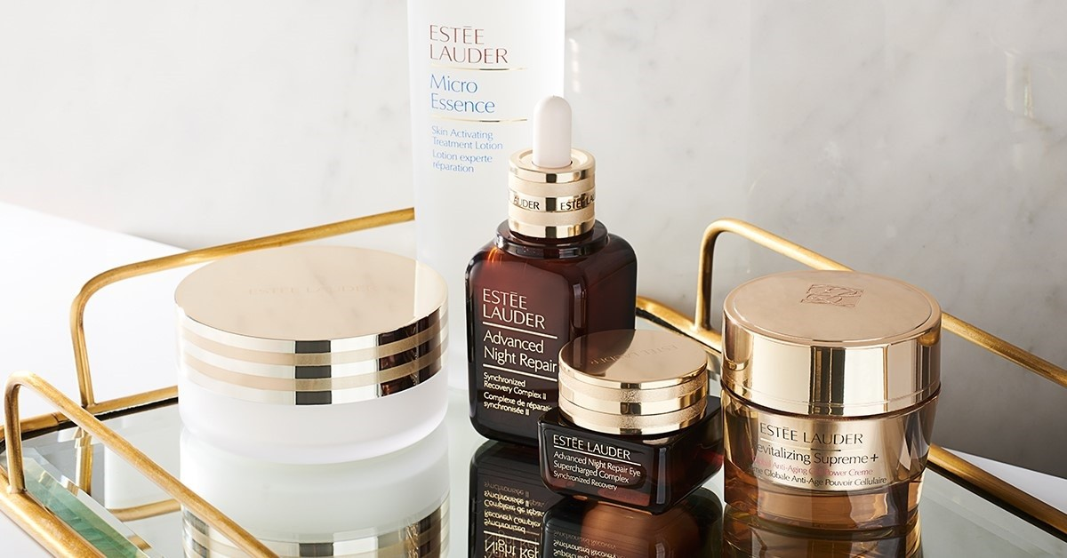

Table of Contents

Overview of the company 3
Range of products 4
Products 6
Estee Lauder Pleasures 7
Pricing strategy 8
Location 10
Direct and indirect distribution strategy 10
Promotion scheme 11
Reference list 13

Overview of the company
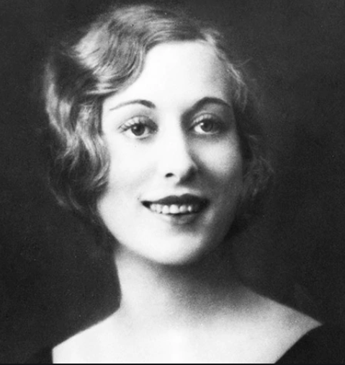
Fig 1: Mrs Estee Lauder
Source: elcompanies.com
Estee Lauder is the founder of the company, and she was a visionary and a role model for millions of people. She was a challenger and had the dare to dream and brave enough to fight and managing to have it. She was ahead of her time when she not only dreamt of the brand but developed it and established it while being a wife in her household. Mrs Estee Lauder started the business with four ranges of skin and beauty care products with a single premise that every woman can be beautiful. She had the passion, philosophy, and with her perseverance, she changed the face of the cosmetic industry. The world has changed completely after she launched her brand in 1946, and she always believed in the power of women, and that is why her company now engages with women in more than 150 countries. Started from just four products Estee Lauder now have their range of products such as in skincare they have moisturisers, eye care, masks and makeup remover. Under makeup, they have a range of lipsticks, foundation, and much more and in fragrances, they have their range of perfumes. In haircare, they have a range of shampoos, conditioners, styling products, finishing sprays and hair colour products. Their headquarters is in New York, and their products are sold in approximately 150 countries under brand names like Tommy Hilfiger, La Mer, Bobbi Brown, Aveda and many more (elcompanies.com). They operate in 150 countries and have more than 1500 freestanding stores (elcompanies.com). The company engages 84% female workforce worldwide, 55% female vice presidents in several stores and some in even higher positions and 39 employee resources groups (elcompanies.com).
Logo of the company


Source: esteelauder-me.com
Estee Lauder logo is one of the most popular and well-recognised logos in the fashion and makeup industry. Their logo does not have any symbols; rather, their logo is very much simple which is represented just by their brand name. The colours they used to make the logo is white, which symbolises excellence in their field, reliability, nobility and purity. The overall style of its logo has remained consistent over the years. It can be said that their logo or symbol of the brand is much simpler compared to the other brands in the cosmetic industry. Their main belief is to excel, and they always wanted everyone in the company to remember the art and excellence of Mrs Estee Lauder, and that is why their symbol is a representation of her name.

Range of products
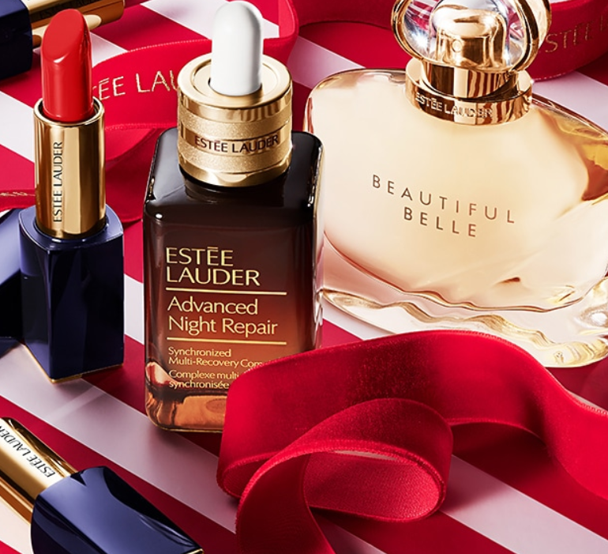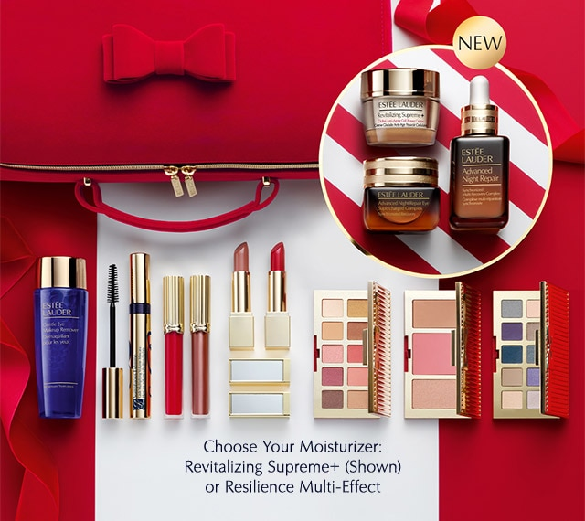

Fig. 2 : Estée Lauder Product

Source : (Estée Lauder Official Site, 2020)

Their products are designed with so much love and excellence that their customers can feel the warmth of Estee Lauder through their products, and she will always be alive in the heart of their customers. Started just by four kinds of products and now their brand has several ranges in or under skincare, haircare, fragrance and other departments. Under skincare products, they have moisturiser, serum, eye care, masks treatment lotion and other treatments. All these skincare products not only make sure that their users will get stunning and shiny looks, but they will also take care of their skins and fight with the issues they are having. All their skincare products are manufactured in such a way that they can also be used for dull and tired-looking skin, ageing, lines and wrinkles, lip care, loss of firmness and pores in the skin. They have both single products and collection products as customers sometimes want to collect all the products to take care of the best care of their skin. They have a range of combo products named as advanced night repair, daywear, nightwear, nutritious, resilient multi-effect and many more.
Under makeup products, they have a foundation, powder, bronzer, blush, highlighter and many more just for the face. For eyes, they have mascara, brows, eyeshadow and eyeliner. For lips, they have lipsticks, lip gloss, lip pencil, lip care, shimmer finish, gloss finish and many others. In accessories, they have brush and tools. For makeup also they have single as well as collections products. The range of their collection products do have attractive and indeed beautiful names such as Bronze Goddess, Double Wear, Futurist, Sumptuous and Pure Colour Envy.
Under fragrances, they have a range of products divided into categories named as fragrance family, notes and collections. Under the fragrance family, they have four fragrances which are named as fresh and light blossom, lush and rich bouquets, warm and glowing woods and sensual and luxurious orients. Under notes they have amber, peony and pink rose, rose and tuberose and jasmine and sandalwood. Under collections, they have twelve fragrances, some of which are named as beautiful, pleasure, senior and other than that also have collections of men's fragrances and private collections.

Products
Advanced Night Repair Eye Supercharged Complex

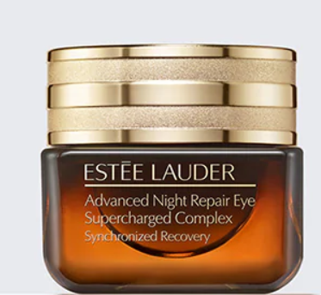
Fig 3: Advanced Night Repair Eye Supercharged Complex
Source: esteelauder.com

This is an eye care product and helps to fight the dullness with causes around the eyes due to heavy UV pollution, lack of sufficient sleep and other factors. The product comes in two variants 15 ml and 100 ml. The price of the 15ml variant is £46, and the price of the other variant is £306. The makers state that the sparkle of the youth is in the eyes, and that is why everyone must take care of their eyes as much as they take care of their hair and skin. The super changed treatment helps their users to fight with the visible impact on pollution on their eyes. It renews the skin so that it can fight puffiness, lines and dark circles. The brightens the skin, and a single application can hydrate the skin for 24 hours.

Sumptuous extreme lash multiplying volume mascara

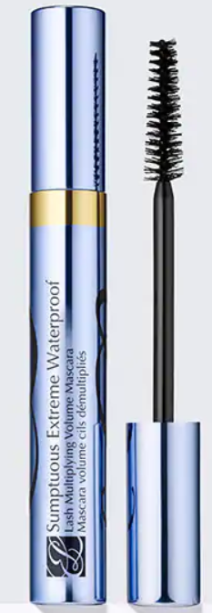
Fig 4: Sumptuous extreme lash multiplying volume mascara
Source: esteelauder.com
For this mascara, after applying it, the users will notice the shine in their eyes and their lashes will seem to magnify, multiply and grow to extremes. After applying it, the eyes will look brighter, wider and seductive. This mascara comes with an extreme blend of three-volume formulas. The formula acts like lash extensions, multiply and grow the look for lashes. The brush which comes with these mascara has two types of bristle, flexible one to carry the formula and solid fibres to comb and separate. The product comes in two variants one in 8 ml which costs £26 and the other one in 10 ml, which costs £32.50.

Estee Lauder Pleasures

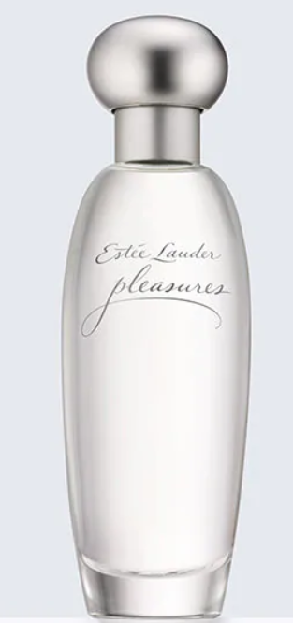
Fig 5: Estee Lauder Pleasures

Source: esteelauder.com

The makers stated that it is one of the simplest pleasures of life which is fresh as a flower after rain. The product is a fragrance, and it comes with a spirited blend of lilies and jasmine. The actual design and idea of this product were developed in 1995 when the brand was making airy fragrances for their customers who love light fragrances to wear. This particular product is not made by Estee Lauder, but it is made by Evelyn Lauder in sheer quality. Some of the ingredients which are used in this fragrance are Alcohol Denat, Pleasures, Geraniol, Limonene and many more. The product comes in four variants 30 ml for £44, 50 ml for £56, 100 ml for £80 and 15 ml for £27.

Pricing strategy

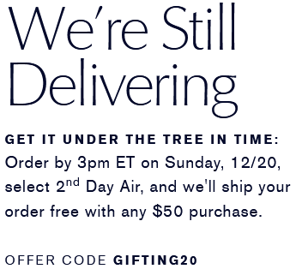
Fig. 6 : Discounts

Source : (Estée Lauder Official Site, 2020)

The brand believes that if someone does want to stay in style and is very much obsessed with beauty and if they get products at low prices then they will always prefer to pay the price for it even if it is high. Estee Lauder does make cosmetics and accessories which are very much costly, which is only for upper-class customers their target market mainly consists of women who are belonging from upper class or who are very much beauty conscious. The brand makes luxury cosmetic products that can be considered as one of the motivators which convince and motivate their customers to buy their products. Estee Lauder is a global skincare brand for women, and they are well known for their prestigious range of products which comes in wide varieties and in different price range. Majority of the stores of Estee Lauder are located in malls, and that is why it can be said that most of their customers are either from the upper class or belong from the Y and X generation. They do offer their products in great quality, and it also does benefits their users but other than that, their pricing strategy is also unique and generally after viewing all their variants and prices their users will end up buying the largest variant because they will think that buying the largest variant in the price mentioned will be very much beneficial for them. Their pricing strategy is set up in such a way that all their users will think that buying the lowest variant in the price mentioned will be a loss for them.

Their location

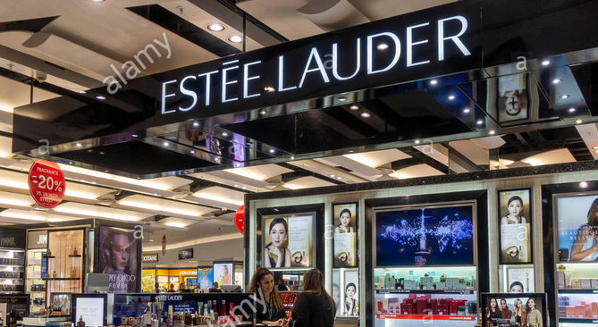
Fig 7: Estee Lauder stores

Source: alamy.com

As mentioned earlier, most of their stores are located in either mall or in shopping areas. Looking at their locations, it can be said that they try to attract customers who visited malls more often or the regular customers of the shopping areas in metropolitan cities. Their product comes in high quality and even in higher prices, and that is why their target audience are ones who are very much conscious about their products or the ones who belong from the upper class and do want to try or use their product. By opening their shops in malls or in shopping areas also do the word-of-mouth marketing of their brand as daily thousands of people visit both the places and that is why their store location strategy is very much superior as they have a reason behind this too which attracts and serve customers who belong from the group of their target audience.

Their direct and indirect distribution strategy

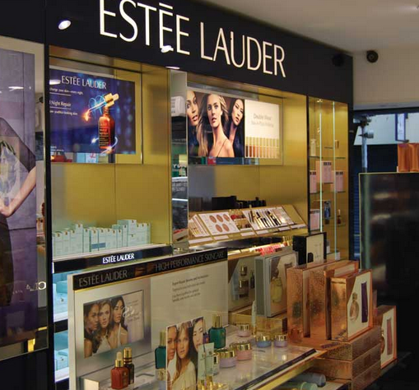
Fig 8: Their retail store

Source: (Estée Lauder - Store Vinyls, 2020)

They do have both direct and indirect distribution strategy by which they try to attract and serve a wider range of customers. Direct distribution strategy is the one in their showrooms in which they do sell their products directly to their customers. The direct distribution also gives the brand huge control over the whole process. In indirect distribution, the brand does have several of their wholesalers, retailers who do sell their products. Because most of the brands cannot have their own stores in each region of the world and that is why Estee Lauder do take the help of indirect suppliers by which they try to reach their products to various regions of the world in which they do not have any stores of their own. Indirect distribution helps Estee Lauder to create a strong customer base even in the countries or regions in which they have no stores of their own.

Promotion scheme

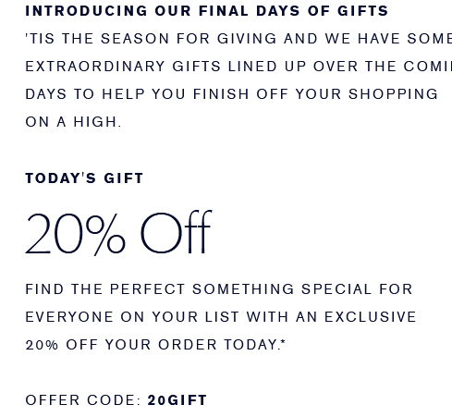
Fig 9: Their promotional scheme

Source: (Estée Lauder Official Site, 2020)

By looking at their official website, it can be seen that they do offer their customers with daily discounts only for the customers who are buying their product from websites. The brand does offer both online and offline service to their customers, and it can then be said that they always try to attract their customers in their own way. Majority of their products do come with high price tags which can only be afforded by upper-class people and by giving discounts it can be said that they are trying to attract even the audience who do not belong from the upper class but do want to use their products. Online mode of shopping also helps them to reach out to a lot of audience as the majority of the audience and now preferring online shopping more than offline. Their website is also very much attractive by which they try to communicate with their customers, and their customers can buy or even have a look at the description and price of all their products in detail.

Reference list
Displayone.co.uk. 2020. Estée Lauder - Store Vinyls. [online] Available at: <http://www.displayone.co.uk/Est%C3%A9e-Lauder-Display-Vinyls> [Accessed 19 December 2020].
Elcompanies.com. 2020. The Estée Story. [online] Available at: <https://www.elcompanies.com/en/who-we-are/the-lauder-family/the-estee-story> [Accessed 19 December 2020].
Estee Lauder - Official Site. 2020. Estée Lauder Official Site. [online] Available at: <https://www.esteelauder.co.uk/> [Accessed 19 December 2020].
Estee Lauder - Official Site. 2020. Estée Lauder Official Site. [online] Available at: <https://www.esteelauder.co.uk/> [Accessed 19 December 2020].
Estee Lauder Middle East Coresite. 2020. Beauty. [online] Available at: <https://www.esteelauder-me.com/> [Accessed 19 December 2020].
Estée Lauder Official Site. 2020. Advanced Night Repair Eye Supercharged Complex | Estée Lauder Official Site. [online] Available at: <https://www.esteelauder.com/product/685/55125/product-catalog/skincare/eye-care/advanced-night-repair-eye-supercharged-complex/synchronized-recovery> [Accessed 19 December 2020].
Estée Lauder Official Site. 2020. Estée Lauder Official Site. [online] Available at: <https://www.esteelauder.com/> [Accessed 19 December 2020].
Estée Lauder Official Site. 2020. Estée Lauder Pleasures | Estée Lauder Official Site. [online] Available at: <https://www.esteelauder.com/product/12853/2094/product-catalog/fragrance/fragrance-collections/pleasures/este-lauder-pleasures/eau-de-parfum-spray> [Accessed 19 December 2020].
Estée Lauder Official Site. 2020. Sumptuous Extreme Waterproof | Estée Lauder Official Site. [online] Available at: <https://www.esteelauder.com/product/637/25335/product-catalog/makeup/eyes/mascara/sumptuous-extreme-waterproof/lash-multiplying-volume-mascara#/shade/Extreme-Black> [Accessed 19 December 2020].
Limited, A., 2020. Stock Photo - Estee Lauder Store In Terminal Five, London Heathrow Airport, UK. [online] Alamy. Available at: <https://www.alamy.com/estee-lauder-store-in-terminal-five-london-heathrow-airport-uk-image259395823.html> [Accessed 19 December 2020].

