Ways of perceiving

This exhibition will be looking into a series of artworks that have an element of political controversy. I will be touching upon this because in the world today there is too much focus on what the likes of Teresa May, Donald Trump and Vladimir Putin is arguing about and its putting everyone on the planet apart from them on edge because we don’t know if they’ll trigger World War 3 and kill everyone. The artists I will be including in my exhibition are Shepard Fairey, Banksy, Pablo Picasso, Norman Rockwell and Terry Richardson. I believe all of these artists use my theme in their own unique way in what they put into their pieces or even the medium they use. What I hope to achieve from this exhibition is to shock people and open their eyes into what the world they live in is truly like now and in the past with such horrid things such as racism and war, which I think will open the minds of the viewers and hopefully make them think of what changes that could be made, to make the world a better place to live in.
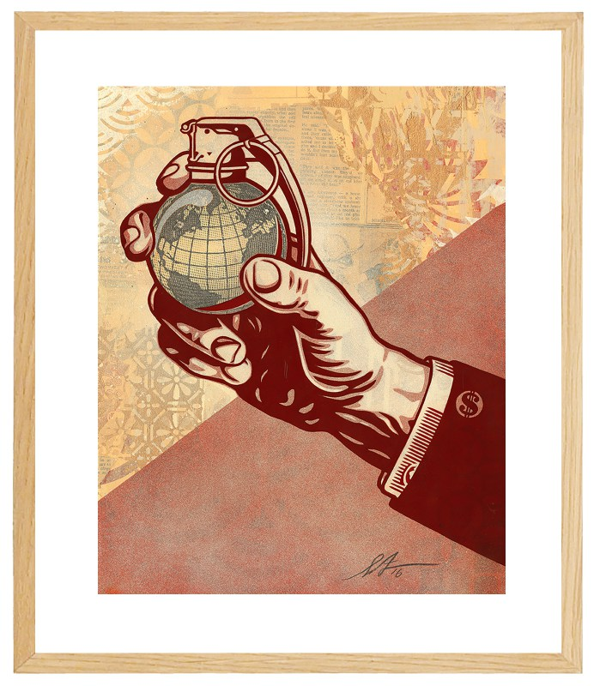

Earth Crisis, Shepard Fairey, 2016
Firstly, I have chosen to exhibit a piece by Shepard Fairey, which is titled ‘Earth Crisis’, which was produced in 2016. The piece is a screen-print, printed over collage. In this piece you can see a hand, and an arm donning a suit, with a cufflink imprinted with a dollar sign. The hand is holding up the world, which is made to look like a grenade. This piece is a part of a series, which emphasises the state the world is in because of the more powerful individuals, which have the power to make change, but are only making things worse. I have chosen to include this piece because it shows the hierarchy in society, the piece shows this with the suit symbolising power and authority, also with the cufflink imprinted with a dollar sign, which shows that money controls the world with this it incorporates the world being held up by the hand. I have placed this piece where I have because it has a street art sort of feel to it, which would look in place outside.

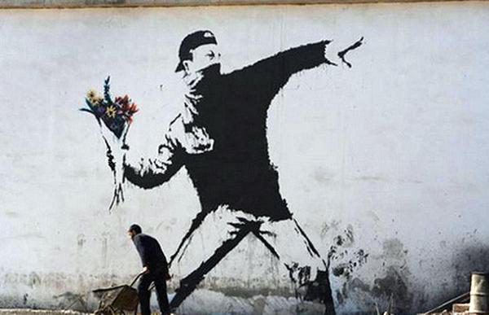

Flower Thrower, Banksy, 2003
Secondly, I have included a street art piece by Banksy, which is called ‘Flower Thrower’. This piece is recognised around the world and is one of the most iconic pieces of street art that Banksy has produced. It has been put together using stencils and spray paint. The piece is said to remind people of images taken of the 1960’s campus and street riots and is also connected to the Jerusalem gay parade incidents. The name is taken from a poem called “Wage Peace” by Judyth Hill, the poem was written after the events of 9/11 in 2001. I have chosen to use this piece in my exhibition because it shows two elements that you wouldn’t think would be put in the same piece of artwork, the terrorist element, which adds an element of horror to the piece and the flower element symbolises peace. I have chosen to place this where I have in the exhibition because its street art and I believe it will be more effective if it was on the outside of the exhibition.
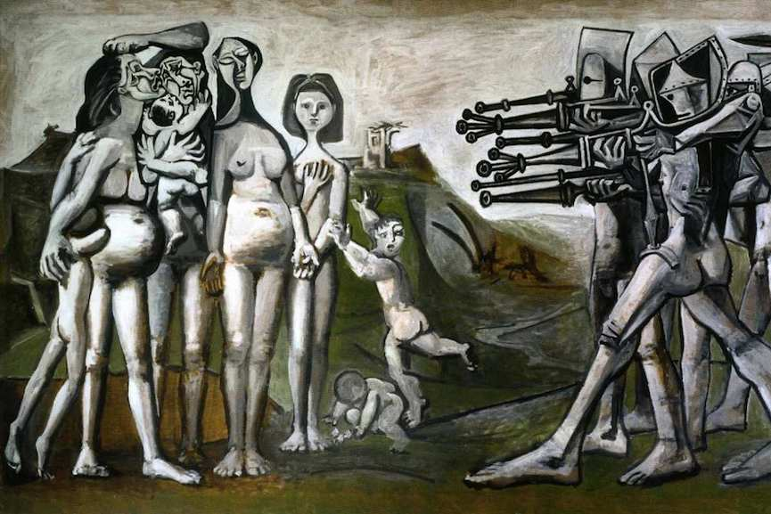

Massacre in Korea, Pablo Picasso, 1950
Thirdly, I have chosen to include a painting by Pablo Picasso, which is called ‘Massacre in Korea’, this was painted in 1950. This piece is said to be comparing the American army in North Korea to the Napoleon army, who were tyrants of Europe. Expressed in this piece is a group of civilians being killed by anti-communist forces, the civilians are depicted to be heroes as the misshapen firing squad. I have chosen to use this piece in my exhibition because it is very hard hitting and expresses a lot of anger and pain. I have chosen to make this piece in large scale to bring out the raw emotion of the piece.

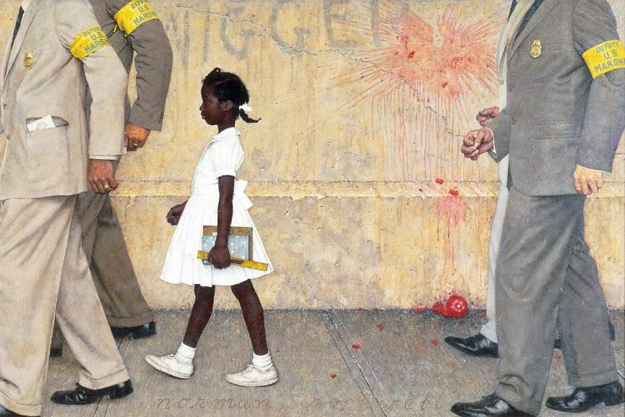

The problem we all live with, Norman Rockwell, 1964
Penultimately, I have chosen to include a painting by Norman Rockwell in 1964. As you can see in this painting there is a young girl, possibly being escorted from school by the way she’s holding books and a ruler, also she is being escorted by older white men which heavily symbolises racism, which could trigger a lot of angry emotions in certain racial groups. This painting also draws a light on the racism in America in the 1960’s. Racist graffiti, limited freedom of movement and racial segregation in schools was the harsh reality of what it was like in southern America in the 1960’s, so reportedly Norman Rockwell produced this painting to shine a light on the racism that was taking place in America in these times. An editor of a magazine comments on himself introducing the painting to his children, he states, “Rockwell’s picture is worth a thousand words… I am saving this issue for my children with the hope that by the time they become old enough to comprehend its meaning, the subject matter will become history”, this quote is saying that racism will fizzle out and no longer be a thing. I have chosen to put this painting in my exhibition because it’s a very emotionally powerful piece of art that adds raw emotion to my exhibition so that the viewer will see how life was like for different races in the mid 1900’s.

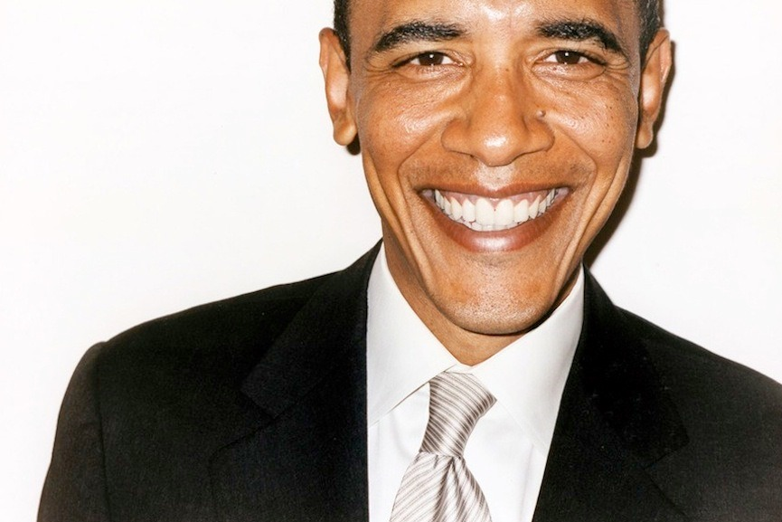

Portraits of president Barak Obama, Terry Richardson, 2012
And finally, I have chosen to include a photography piece taken by Terry Richardson, which was taken in 2012. This photograph is a portrait of former President of America, Barak Obama. Its not the like the usual type of portrait an American President would traditionally have, its more of an informal type of photograph. A blogger called Andrea De Costa states in one of her blogs that “many people have argued that one of Obama’s biggest strengths was the bond and engagement he was able to draw from the youth”, this quote is stating that Barak Obama is very in touch with the younger generations of the United States. This photograph is done to free the true face of the president to gain more supports of him by showing that he’s a down to earth sort of person. I have chosen to put this in my exhibition because it adds a different area of art to what else I have included in my exhibition and adds a more diverse feel from the more illustrated pieces I have already incorporated. I have placed this piece right at the back of my exhibition, and it is on a very large scale, because I feel that it will be more effective if it was in a bigger scale.

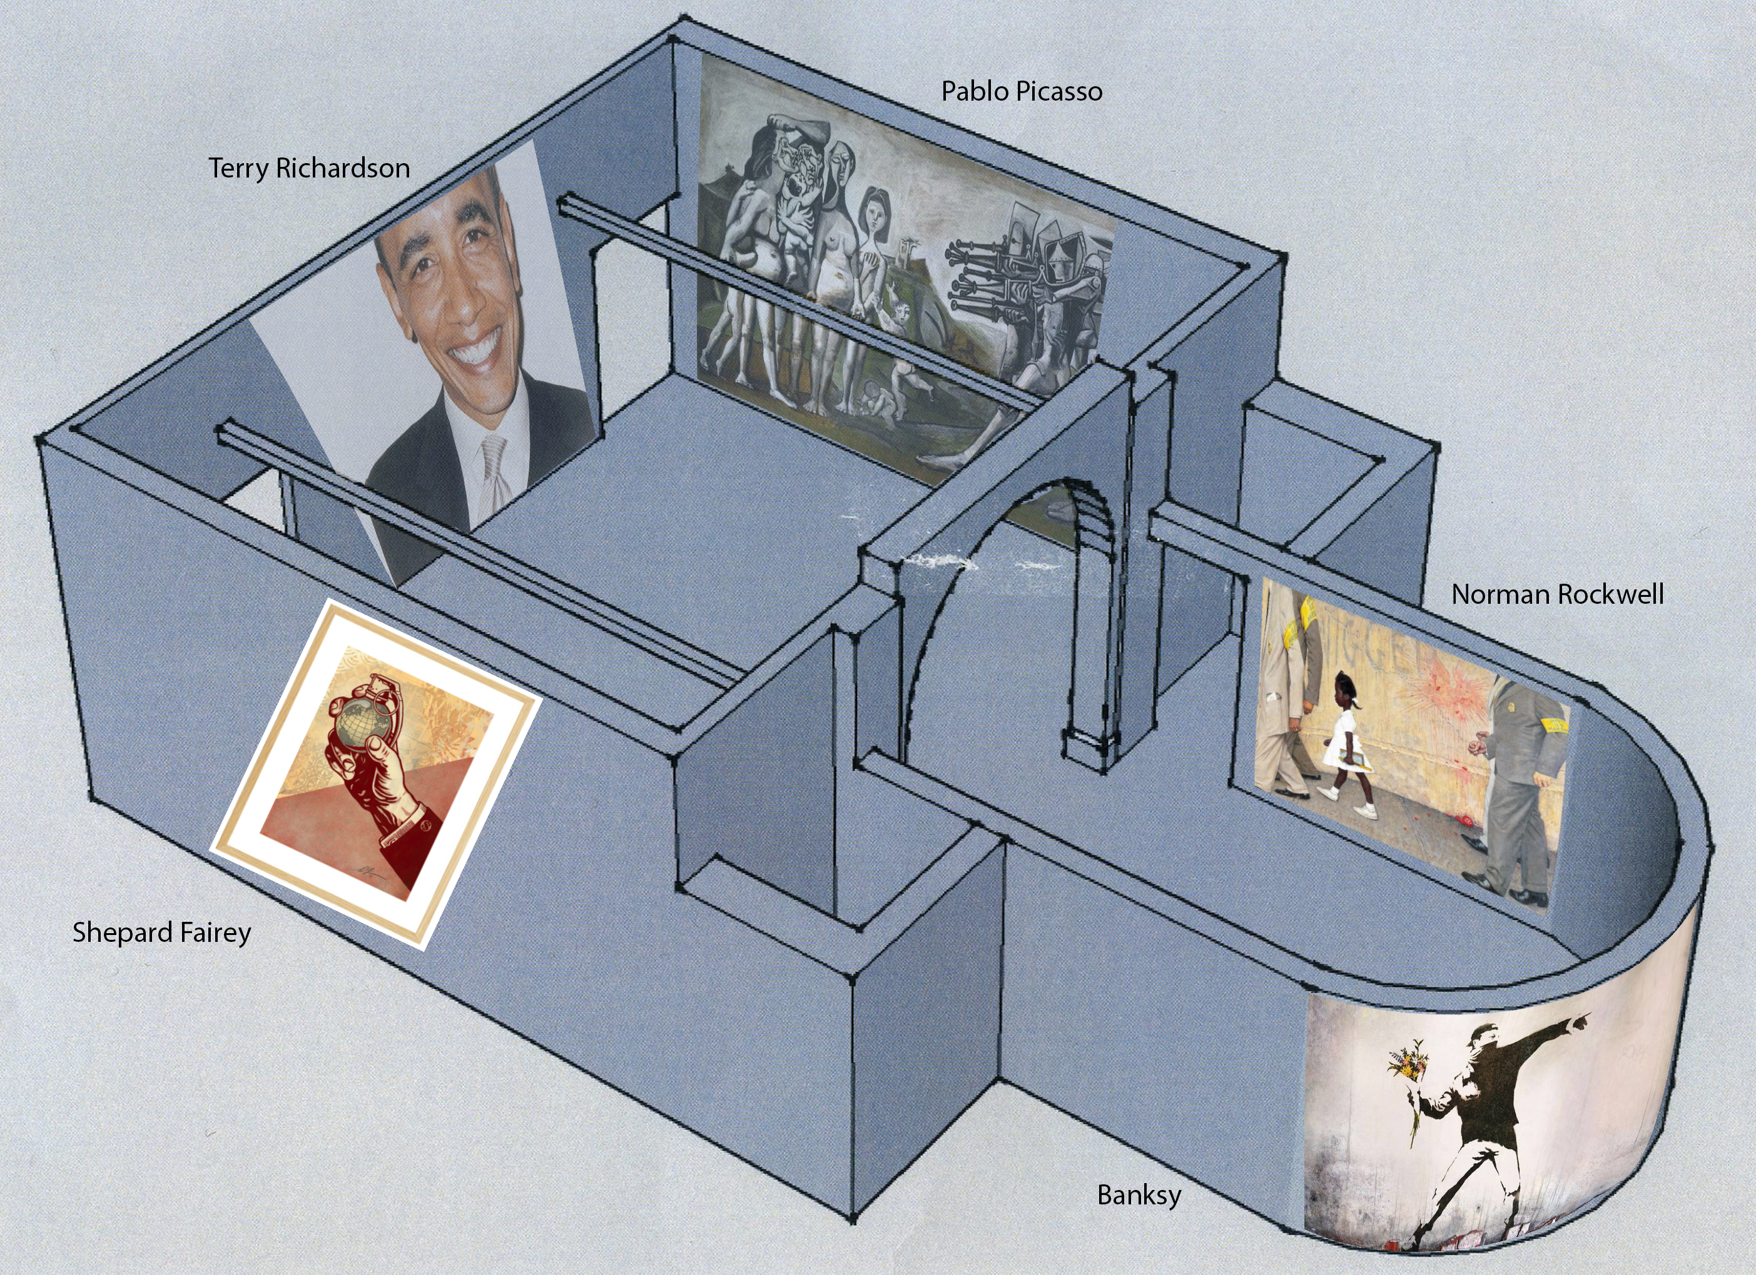
My exhibition floor plan
Bibliography

Shepard Fairey
Obey Giant. 2018. Earth Crisis - Obey Giant. (ONLINE) https://obeygiant.com/exhibitions/earth-crisis-galerie-itinerrance/. (02 May 2018).

Banksy
Widewalls. 2018. Banksy – Flower Thrower from 2003, Widewalls. (ONLINE) https://www.widewalls.ch/political-art/flower-thrower/. (Accessed 02 May 2018).

Pablo Picasso
Widewalls. 2018. Pablo Picasso – Massacre in Korea from 195, Widewalls . (ONLINE) Available at: https://www.widewalls.ch/political-art/massacre-in-korea/. (02 May 2018).

Norman Rockwell
Widewalls. 2018. Norman Rockwell – The Problem We All Live With from 1964, Widewalls. (ONLINE) Available at: https://www.widewalls.ch/political-art/problem-we-all-live-with/. (02 May 2018).

Ruby Bridges, The Problem We All Live With. 2018. The Problem We All Live With. (ONLINE) http://www.nrm.org/thinglink/text/ProblemLiveWith.html. (02 May 2018).

Terry Richardson
Widewalls. (2018). Terry Richardson – Portraits of President Barack Obama, 2012,| Widewalls. (ONLINE) https://www.widewalls.ch/political-art/portraits-barack-obama/. (02 May 2018).

Andrea da Costa, (2018). Harvie Avenue, (ONLINE) https://www.harvieavenue.com/portraits-of-barack-obama-by-terry-richardson-2012/ (02 May 2018).

