Bitabrata Chowdhury (1713201)
RAJ & CO PVT LTD

TESCO REPORT

Executive summery
Tesco is losing their customer to Lidl & Asda day by day, the simple purpose of this report is to find out the problems what it is facing, navigating all the avenues, understanding the scope, nature & the impact of those problem & finding out probable solution through proper SWOT, PESTLE & STAKE HOLDER analysis. This report will come up with recommendation which will probably be helpful to gain back the customer support as it used to be in past years.

Table of Contents
Executive summery 1
1. 0.Terms of reference 2
2. 0. Procedure 3
3.0 Introduction 4
3.1. Main Findings 6
3.2The nature 7
3.3The scope 8
3.4 The impact 9
3.5 SWOT analysis 11
3.6 pestle analysis 12
3.7 Stakeholder analysis 13
4. 0. Conclusion 15
5.0. Recommendations/options 16
6. 0. Appendices 17
7.0. Acknowledgement 20
8.0. Reference /Bibliography 21

0.Terms of reference

Laura James on 20.02.2019 have requested a report on Tesco about the ongoing problem which the organization is facing and due to that having continued shift in customers shopping at the discounters of another retailer like Aldi and Lidl. In one sentence facing the core problem of losing the customer day by day.

The purpose of this report is to to come up with realistic suggestion about how Tesco can hold on its customer after analysing there past & recent problem in depth

A brief summary of the problem has to be outlined while navigating the ongoing problems in Tesco for example (why there is a shift of customers towards discounter Aldi & Lidl/ cost cutting in the deli & fresh fish departments etc), detecting them, understanding the scope, nature & the impact of those problem & finding out probable solution through proper SWOT, PESTLE & STAKE HOLDER analysis.

As a business analyst Mr B. Chowdhury will compile this report by latest 29.03.2019

0. Procedure

- Contains procedure adopted to prepare the report
- Included sources of information
- 2.1 Website, Journal, Newspaper & Online Newspaper .

3.0 Introduction



Tesco as the name speaks is perhaps has become a well-recognised brand with the supermarket environment. In 1919 Jack Cohen first traded from a small stall in the east London with a bold statement “Put affordable food in the reach of everybody “(Tesco.com 25/01/19).

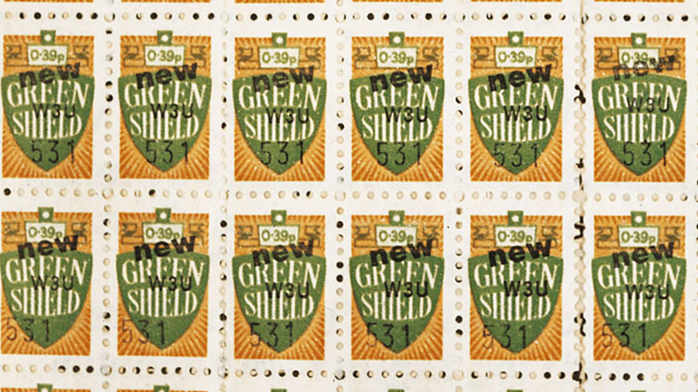

“Tesco open its first shop in 1929 in Burnt Oak Edward. During the period 1940-50 it opens its first self-service store and supermarket in 1963 ‘green shield ‘stamps where started at the check-out which in return could be traded at a local ‘green Shield ‘stamp shop.”(Tesco plc,2019)

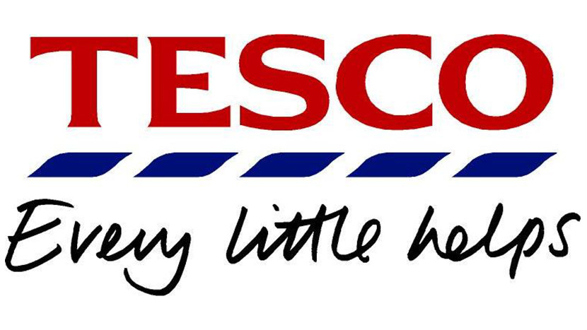

At times Tesco started lot of other things like Tesco Extra, which in turns started to see Tesco entering the electrical goods market. European stores & even as far as in India it was open. The launch of Tesco club card attracted like 5 million customers in 5 years, by then Tesco have overtook Sainsbury’s in market share. It even entered in the financial sector, offering savings accounts. In 2000’s entered in online shopping, in the Tesco Value, Tesco Mortgages linked to the club card.Tesco even widely contributed towards by introducing 5p plastic bag invest in local communities ‘green ‘ space project ,free fruit instore for children ,was introduced for healthy eating in low price .it also merges with wholesale bookers group & launches ‘Jack ‘ with a aim to bring ‘great testing food at the lowest price ‘ .
Tesco is now under saviour pressure after the proposed merger of Sainsbury and Asda. The ongoing unknown circumstances of Brexit environment is also a large problem which is constantly hurting the food /product supplies from Europe. Tesco is also likely to embark cost cutting in terms of staff & also closing their online garments sale. The staff in deli & the fresh fish section is also being removed or have less hours. One of the continued problems of Tesco is also the continued shift in customers shopping at the discounters in Aldi & Lidl .The report is going to be a analytical studies about the problems that Tesco is facing & what is the nature ,scope & impact of the problems This report will also help us to analysis the problems using SWOT, few method of PESTLE & also Stakeholder matrix .
To Conclude, this report will help us to find out the possible solution or suggestion through which perhaps Tesco can find out the way to emerge the supermarket leader once again

3.1. Main Findings
Tesco the third largest retail in the world measured by gross revenue & ninth largest retailer in the world measured by revenues. Tesco was founded by Jack Cohen in 1919 as a group. “As the word goes saying that every action have its opposite reaction & hence Tesco by the side of its rapid growth & profitability have its problem also & off late it is growing which in terms bringing out the core mother problem of all business is (LOOSING ITS CUSTOMER TO OTHER COMPITETOR )”.(Tesco.com,2019)As this reports will flow ,throughout the problem will be discussed & it would also try to find out the reason & a possible suggestion as how to overcome them .
It was learned through research that number of problems have hit Tesco at times which have hit it with its outcome. Out of the many notable problem some are like the horse meat burger scandal which rocks the company in 2013 &as a result its share went down drastically. Tesco club card problems which created huge customer outrage and eventually Tesco have to hold back the changes in the clubcard.
“a major fallout between Tesco and one of its biggest suppliers, L’Oréal, which led the French Cosmetics giant to threaten legal action after a disputed payment of about £1m demanded by Tesco” (bbc.co.uk .as cited in Ahmed,2015). Warning bell is also sounds by Laurie Mcllwee about financial control after the problem was discovered in polish business in 2012. Among all the continuation of the problems the customer doesn’t wait around to pass the judgement in the hind side they pass their own judgement everyday & they go shop elsewhere. It is utmost important to hold its customer in any ways & that’s the back bone of the business. Day by day competitors also creating more pressure, according to the research Asda was 6% cheaper than Tesco by December 2015. Other side with the growth of discounters Aldi and Lidl are also providing tough competition. Tesco in the first biggest of its kind so people will always expect lower prices and they need a price which they could trust .Tesco have also tried to resolve its various problems time to time .”Britain’s largest supermarket chain said on Wednesday that one of the biggest burger plant in Europe had failed to source , as demanded ,all ingredients from the uk and Ireland and had been dropped for “breach of trust”(Meikle and Lawrence,2013).Eventually they announce that they will not take products from the supplier in future . “Tesco has unveiled its new discount chain called Jack’s that aims to tackle the rising threat posed by German rivals Aldi and Lidl “(bbc.co.uk.as cited in Jorden,2018). Tesco seriously hope Jacks can meet up the change to Aldi and Lidl discount. The suspension of deal in Tesco club card with the train booking website RedspottedHanky before two months before it was due to be axed is also a black spot with the customer relation ,”After a series of complaints to Tesco on social media, the deal is now listed as unavailable on the clubcard website – although a statement on the page says – we are working with the partner to bring back the product back in the coming days”(Moneysaving experts ,2018) as a outrage in customer eventually the management have to hold the idea back.

Further research in this report will illustrate henceforth how the problem have arrived and who is affected due to this problem & what impact have the problem created due to this aftermath

3.2The nature
To start with the problems horse meat in frozen burger problem which shocked the business but it came out of the words as with a paper adds which state that “what burger have taught us “ the second page state “the problem we’ve had with some of our meat lately is about more than burger & Bolognese . It's about some of the ways we get meat to your dinner table. It's about the whole food industry. And it has made us realise, we really do need to make it better. We've been working on it, but we need to keep going, go further, move quicker. We know that our supply chain is too complicated. So, we're making it simpler ... Seriously. This is it. We are changing"(Horse meat press release ,2013).
L’Oréal problem also damaged the Tesco image a bit -henceforth the blame game soon started It is believed a failure of leadership, not a failure of the business, not a failure of the people who work hard every day in the business. “When you're the CEO, if it goes well, you get credit. If it doesn't go well, you must take responsibility and Phil Clarke has taken that responsibility and paid the price with his job."(Hiscott.2015).
Tesco also faced a stiff competition from discount that of Aldi & Lidl.
In 2018 Tesco suddenly tried to end deal for purchasing train ticket through its club card as a reward point gaining facilities which eventually have to be revoked due to customer outrage.
Tesco have always tried to make profit through staff control policy also, earlier it is senior high payroll cut but of late to cut cost it has decided to cut jobs of 9000 jobs. “Tesco confirms 9000 jobs under review in latest round of changes, fresh food counter & colleague room staff primarily affected, merchandising hours will also be reduced and a simplified stock control system will be rolled out ” (Jashan,2019).
Now let’s see what the Scope of the problems is .

3.3The scope
While discussing about the scope or what effect did it have due to the problems created from time to time the biggest effect came in to the business itself, Tesco undergone financial loss due to the time to time facing problem, less customers footfall rather increasing customer to the competitors like Asda ,Lidl etc .The customers have also suffer due to the mismanagement like ,in the issue of the club card it’s the customers who started to suffer as they can’t buy train ticket through the free point which Tesco promised ,as the deal was stopped suddenly.
Due to the cost cutting from time to time the employee have a huge set back as they are uncertain about their job future in the company and not even the staff but also it changes the higher level managers position also which in return create a panic in the staff as it shows the unrest position of the managerial structure within the company
“Tesco was condemned yesterday for failing to pay the Living Wage to shop workers while turning failed executives into millionaires. Bosses at the firm, which posted a record annual loss of £6.4billion last year, faced fierce criticism over the supermarket’s decline at an annual meeting of its small shareholders” (Mail online,2019).
The mention quotation also shows how shareholder also attacked the boss of Tesco after it emerge that the taxpayer is topping up employee income which they stated as “slave wages “

3.4 The impact
In researching the impact that the problems of Tesco it is found that in 2015
“Tesco has crashed to the biggest loss ever recorded on the Uk high street, Slumming £6.4 billion into the red as a result of huge write-downs on the value of its property portfolio and stock”. (The guardian.com,2019).
One the other major impact of the problem is the cost cuts as a result the retailer, which have more than 300,000 UK employees and more than 3,400 stores, planed to redeploy 9000 direct employee into customers service roles .major footfall of customers are finding the discounters of Asda & Lidl much more cheaper than Tesco as a result loosing of customers to the competitors ,

“profit fell 29.1 percent in Asia and by 3.3% in central Europe, partly offsetting’s growth of 47.6% in the Uk and Ireland where the £3.7bn acquisition of wholesaler booker has allowed Tesco to expand to provide food to restaurant, bars and small grocers”. (Reuters,2018).

The profit margin is also going down as a result of the problem ,as the growth percentage is not meeting expectation .This is some of the impact it is having due to the recent problems It have already discussed in this report .
Now after going through the nature, scope & the impact of the current problem Tesco is facing currently this report will do a SWOT observation clearly illustrated with the box chart after this

3.5 SWOT analysis

’it is impossible to accurately map out a small business future without first evaluating it from all angles, which includes an exhaustive look at all internal & external resources & threats’’ .(Fallon ,2018) said bonnie Taylor chief marketing strategist at ccs innovations, A SWOT accomplishes this in four straightforward steps that even rookie business owners can understand and embrace

STRENGTH  Strategy  Market share  Diversification  Product choice  Tesco mobile  Recent CEO strong will power  Increase in stock price (0.6%) from last trading session | WEAKNESS  Share price  Fines  Court pending cases  Falling public opinion  Ongoing lot of investigation & fines misrepresenting profits.  Wrong decision of buying restaurant & later selling them in loss
OPERTUNITIES  More chances to diversification in more overseas  Push towards more in online product  Increasing the premium range of product  Clear chances to increase strategies – like in the banking sector | THREAT  Brexit  Strong competition from rival like Asda & Lidl  Losing customers daily basis for price issue  Too much cost cutting to gain more profit margin effecting staff turnover.  Merging of Sainsburys and Asda

Details input of swot can be found in Appendices section

This report will now try to research the problem through PESTAL Analysis

3.6 pestle analysis



“PESTAL analysis is a very important framework for strategic planning. It is used by strategic planners to analyse the macro-environmental factors that affect a business. PESTEL stands for Political, Economic, Social, Technological, Environment, and Legal. The article ‘PESTAL analysis & its application’ provides more information on how to apply PESTEL analysis in a given context”. (sodry,2019).

This report will try to focus on POLITICAL, TECHNOLOGICAL & LEGAL Analysis regarding to Tesco

Details input of PESTAL can be found in Appendices section

3.7 Stakeholder analysis
“Investor, regulators, customers-everyone wants a piece of Tesco .The UK supermarket chain has come under fire from two big shareholder over what they see as a distracting ,expensive takeover of wholesaler Booker Group .A financial regulator has used Tesco to experiment with compensating victims of market abuse and customers just want low price, as always .This last challenge is the one that could really knock things off course”(reuters.com,as cited in Foley,2017).
The stockholder could be individual or a group which could be effect because of the changes or result of the particular organization.

LEVEL OF INTEREST

HIGH

LOW

POWER

LOW
HIGH
A. MINIMUM EFFORT  STAKE HOLDER HAVE LOW POWER AND LOW INTERREST  FUTURE RECUITERS | B. KEEP INFORMED  STAKE HOLDER HAVE LOW POWER AND HIGH INTEREST  Example for Tesco  COMMUNITY, THE STAFF
C. KEEP SATISFIED  STAKE HOLDER HAVE HIGH POWER AND LOW INTEREST  GOVERNMENT AGENCIES, | D .KEY PLAYERS  STAKE HOLDER HAVE HIGH POWER AND HIGH INTEREST  TESCO MANAGEMNT /BORD OF DIRECTOR  CUSTOMER

This above flow chart of stake holder analysis of Tesco explains the position & why they are important in the well-being of the company
It is believed after the research that Tesco have a steering wheel strategy that involves the community in a big way and the all-important tag line of “every little help” is a result of this steering wheel strategy

“Today ,every store & every company within Tesco group has their steering wheel to manage performance .This puts the people on the ground in control .The steering wheel has also been translated into different language to ensure it is used to engage frontline staff in all countries that Tesco is operating in” (Marr,2019)

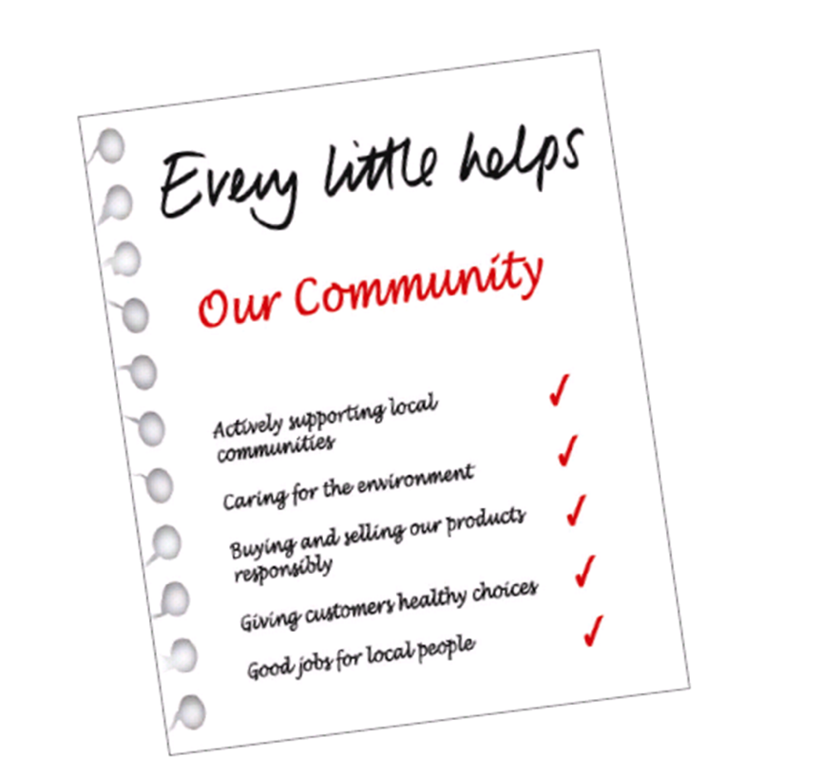
The steering wheel also helps staff to communicate quite easily
Few more details of the Tesco steering wheel are placed in the Appendices section

4. 0. Conclusion

After the details research of Tesco ‘s problem it is seen that being at deep trouble in times to times ,Tesco have tried to bounce back with new strategy & new will power ,let it be in the case of the horse meat scandal ,let be in the Loreal scandal ( not paying the huge amount of dues ) ,let it be in the club card problems or the latest huge competition with Asda & Lidl discounter Tesco have always fought back ,it have been able to find out solution by means of which it seems to be holding it ground in anticipation to get back its old glory of being the cheapest supermarket in Uk .The recent job cuts in its deli & fish counters as a strategy of its cost cutting have brought an worst impact into its staff moral & Tesco is still dealing it with counter strategy of staff bonus on the other hand . The most major threat is the merger of Sainsbury & Asda which will give Tesco a hard run if not “THE” one of the fierce competitions of recent times.

The details analysis which have been conducted about the problems Tesco have faced in although out its business will help to find out some recommendation which could be vital for the further upliftment of the business

5.0. Recommendations/options

Few recommendation & options

- The main customers or market holder needs to be convinced that there is no bigger hick up again is waiting in recent future.
- Solid, firm strategy have to be made to make the road map of recovery the old glory smooth
- The investor has to be convinced by the strategies & by doing that investment will start to come again slowly & steadily but it is not a quick fix story.
- Tesco should hold its ground to be different that from Asda & Lidl & have to regain the trust of the customer that it is the best place to come for cheap & best quality product
- By virtue of its brand tag line “every little help “it had already the magic words to convince the customers that Tesco understand its customers’ needs very well & it should emphasise more on that ground which in turn will get more people
- Should treat its employee as the employee treat each & every guest so that if its inner management is good it’s very easy to get good sales through

6. 0. Appendices

SWOT DETAILS

STRENGTHS
Tesco is currently Leading market share at 28.1%
They have got now wide Product choice and variety
Tesco have Successful diversification strategy of Tesco Mobil which is running good as the clothing line
The new director has also pushed things with more will power
Strategy making is far more constructive in some areas
“NEWS BITES US -OTC Tesco plc (OTCBB: TSCDF) traded at its 172-day high of £US 3.14. Tesco stock price have increased 2.0c(0.6%) from last trading” (Melbourne news bites ,2019)

WEAKNESSES
Tesco bad reputation - Investigation and fines for misrepresenting profits. Tesco charged with fraud in 2017
Its Share price as of 25th April 2017 below its peak what it was promised up before
Tesco Currently market share as of 25th April 2017 stands at 28.1%, its nowhere near its goal of projected 32%
Some costly wrong decision and did not match with the company’s ethos for example investing to buy Giraffe restaurant and Nobbies garden centre. Then looking at the losses in revenue margin, selling it in loss price

OPPORTUNITIES
Introduction of Jacks to challenge the discount of Aldi & Lidl seems to be a good opportunity to get back customers Increased premium range products
Tesco Bank is a good idea to further diversify
Flourishing more online business
Expanding overseas is a very lubricant opportunity

THREATS
Market share gains from low cost rivals such as Aldi and Lidl
Falling value of the pound resulting in price increases for Tesco
With the uncertainty of Brexit its hard to calculate the risk factor coming ahead

PESTAL ANALYSIS

Political – Tax measure of Uk government have affected Tesco, increase in vat percentage is a key political factor. The low spending of customers & increase in the vat had a impact on the profit margin
The government FAT or Sugar tax have also affected the sales revenue of certain product. Future incorporation of any other tax due of Brexit may hit them also.

Technological –
The management have to be very careful about the disruptive technology which comes frequently ,example e-grocers .Tesco have step into new technological phase through Mobil segment ,which is the way forward .Innovation in technology is the key need for the hour as the scope of this will push the profit margin ahead .Disruptive technology will increase in future for sure & will bring more value to the customer.

Legal
Law could be killer in terms of fine’s for example if Tesco force organization to sell product less against the rate set by organization involved with supermarket industry it can have significant fines .The financial service act also have its control in Tesco as Tesco sell credit card ,loan ,mortgage etc .The legal aspect could be a big hindrance if it is not placed nicely to the concern bodies .

STAKE HOLDER ANALYSIS

“The corporate steering wheel provides strategic focus by communicating what matters the most in a simple and easy to understand framework .it includes 20 corporate objectives across five perspective” (Marr,2019)

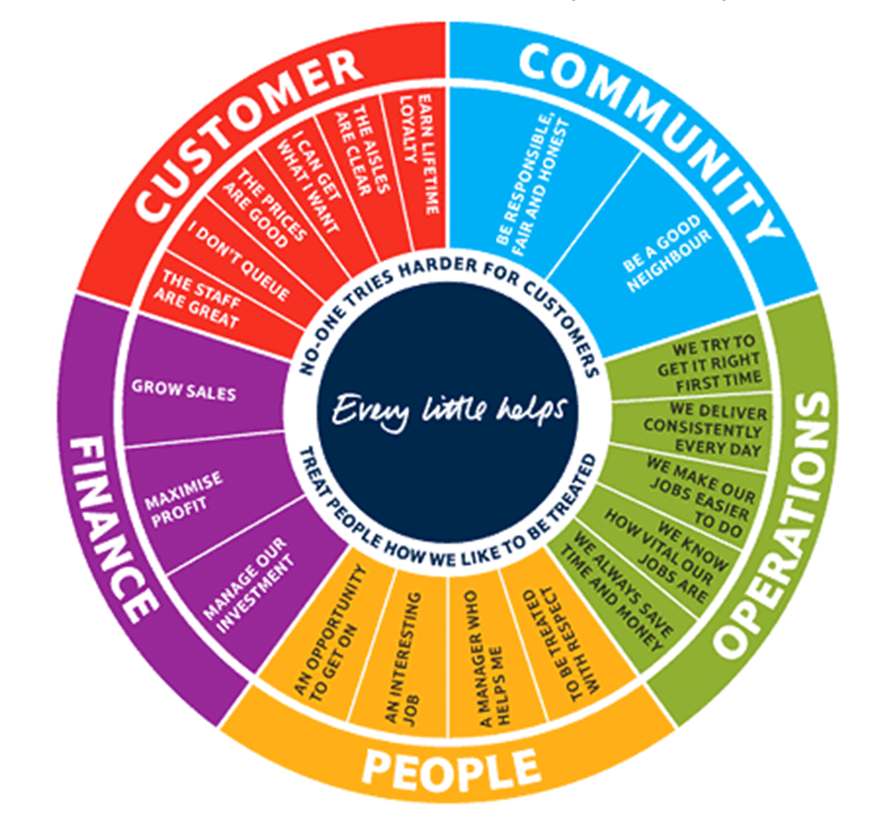
For example
Community perspective it explains to be a good neighbour, be responsible, to be fair & to be honest always. Suppose for the financial perspective have to go slow to achieve Maximise profit & to help to manage investment etc

7.0. Acknowledgement

It’s being really good to get the help of lecturer Laura James, specially beside giving the regular assessment specification ,or regular day to day lecture ,she had gone out of her ways to help to learn the outline in word format in Microsoft word ,now it is easy to write reports in a professional way
Also, she had showed the way to find out journals from Uni library & showed how to do research through MarketLine etc.

Lecturer Jessica Shore also have helped to show the way the report should be structured in a professional way when sought for help in this particular report writing

8.0. Reference /Bibliography

Ahmed, k. (2019). Tesco where it went wrong. (online) www.bbc.co.uk. Available at: https://www.bbc.co.uk/news/business-3086632 (Accessed 25 Mar. 2019).

ASA Upholds Complaint Against Tesco "Horse Meat Press Release". 2013. World Food Regulation Review, 23(5), pp. 13-14.

Bernard Marr. (2019). Bernard Marr | Intelligent Business Performance. (online) Available at: https://www.bernardmarr.com/defult.asp?contentID=1052 (Accessed 29 Mar. 2019).

Foley, J. (2017). Tesco have three issues, but only one matters. (online) Available at: https://www.reuters.com/...tesco-has -three-issues-but-only-one-matters-idUSK... (Accessed 27 Mar. 2019).

Fallon, n. (2018). Swot Analysis: what it is and when to sue it (online)www.businessdaily.com. Available at:
https://www.linkedin.com/in/nicolemariefallon.html (Accessed: 26 Mar.2019)

Guardian, (2019). Tesco reports record £6.4bn loss/business/The Guardian. (online)Available at: https://www.thegurdian.com/business/2015/apr/22/tesco-suffers-records-64bn-loss (Accessed 27 Mar. 2019).

Graham Hiscott, H.D., 2015, Jan 20. Tesco boss was 'failure'. Daily Record, 34.

Jorden, D. (2018). Tesco’s new discount chain Jack’s takes on Aldi and Lidl (online) www.bbc.co.uk. Available at: https://www.bbc.co.uk/news/business-45572731 (Accessed 25 Mar. 2019).

Jahshan, E. (2019). 9000 jobs at risk as Tesco confirms fresh round of cuts - Retail Gazette. (online) Retail Gazette. Available at: https://www.retailgazette.co.uk/blog/9000-jobs-risk-tesco-confirms-fresh-round-cut... (Accessed 23 Mar. 2019)

Moneysaving expert, (2018). Anger as Tesco unexpectedly pulls top Clubcard offer. (online) Available at: https://www.moneysavingexpert.com> news > 2018> November (Accessed 25 Mar. 2019)

Meikle, J. and Lawrence, F. (2013). Tesco drops Irish supplier over horsemeat scandal. (online) the Guardian. Available at: https://www.theguardian.com/business/2013/jan/30/horsemeat-scandal-tesco-drops-supplier (Accessed 25 Mar. 2019)

Mail Online. (2019). Tesco shareholders attack bosses over staff's 'slave wages'. (online) Available at: https://www.dailymail.co.uk/news/article-3141191/Tesco... (Accessed 27 Mar. 2019).

Reuters, (2018). Tesco shares suffers as pressures abroad overshadow UK growth. (online) Available at: https://Uk.reuters.com/...tesco-shares-suffers-as-pressures-abroad-overshadow-u... (Accessed 27 Mar. 2019).

Sodry, s. (2019). (online) Howandwhat.net. Available at: https://www.howandwhat.net/pestel-analysis-of-asda/ (Accessed 28 Mar. 2019).

Tesco plc. (2019)). Tesco plc. (online)Available at: https: www.tescoplc.com.(Accessed 21 Mar.2019)

Tesco.com. (2019). Tesco: Online Groceries, Banking & Mobile Phones. (online) Available at: https://www.tesco.com (Accessed 21 Mar. 2019).

“Tesco Hits Six months high March 19.2019 16:00 EDT” News Bites US-OTC (Melbourne)2019: News Bites Us -OTC,2019-03-19, (Accessed 25 Mar. 2019)

