Synthesize a Solution to a Potential Real-Life Scenario
Jasitharan Kugathasan P151435, Computer Networks and Cyber Security; Module: Computer Forensics, Lecturer: Dr. Carlene Campbell

Table of Contents
I. List Of Figures 1
II. List Of Tables 1
III. Abstract 1
IV. INTRODUCTION 1
V. RESEARCH ON TOOLS USED FOR COMPUTER FORENSICS 2
A. File systems 2
B. Recovery of deleted lost files 4
C. Multimedia forensics 7
D. Network forensics 7
E. Email forensics 8
VI. Terrorist Attack Case 9
VII. Conclusion 11
VIII. Appendix 11
A. Forensic Report 11
B. Invoice 11
IX. Bibliography 11

List Of Figures

Figure 1:Binwalk 5
Figure 2: Bulk Extractor 5
Figure 3:Chkrootkit 5
Figure 4: Foremost 5
Figure 5: Galleta 5
Figure 6: Hashdeep 6
Figure 7:Volafox 6
Figure 8: Volatility 6
Figure 9:Photorec 7

List Of Tables

Table 1: Level Of Forensic Analysis 4
Table 2: Types Of Files Generated 9
Table 3: Analyzed Forensic Images 10

Abstract
This report covers the analsis of computer forensic tools, multimedia forensic tools, Email forensic tools and Network forensic tools. This report contains Computer forensic analysis of terrorist case and tools used for analysis the case. This report provide what procedure used in case analysis.

INTRODUCTION
Computer Forensics is method of investigating an electronic data to detect and prevent from any crimes. It is the practice of analyzing and collecting digital data in legally accepted way.
Computer forensics is any sort of legal issues which computer is involved. For example, analyzing hard drive or network data
To find any traces of hidden files to support legal issues. [1]
The computer forensics are mostly use by the military, Government agencies, Law firms, Criminal prosecutors, academia, Data recovery firms, Corporations, Insurance companies and by Individuals.

There are different types of computer forensics,
- Network forensics – which monitors and analysis network-based activities to find any trace of cyber-attacks.
- Mobile Device Forensics – which analysis the sim cards, smartphones, GPS devices tablets and gaming consoles to check any kind of suspect activities.
- Digital Image Forensics – To examine the digital photographic images to check or prove the metadata of the image files to find its history.
- Memory forensics – To make image of random-access memory (RAM), Hard drives or any removeable drive to analyses or recover any electronic data for evidence.
- Digital Video/Audio Forensics – Analysis and evaluation video recordings and sound recordings whether it’s been modified from original recording.

This report provides research aspect on various tools used in each type of computer forensics and a case study based on real-world scenario.

The case study is, a terrorist attack was planned to bomb the Mason International airport at Fiji. The terrorist planned to fly from Heathrow International Airport London. The terrorist was shot dead by police at Heathrow airport. The terrorist carried a dell laptop running windows XP and the laptop was in standby mode.

This Dell Laptop need to analyze to find any important evidence related with the case using computer forensics method.

RESEARCH ON TOOLS USED FOR COMPUTER FORENSICS

Computer forensics tools are Graphical User Interface (GUI) or command-line to perform a certain task. Tools are built for the purpose of user friendly. There are many tools available for computer forensics, this report contains mostly used computer forensic tools. There is open source tool, in which the source code is opened to public and closed source tools which source code is not published to public.

File systems
File system is the format of data structure in which files organized or partitioned. There file system used for Compact Disk (CD), Digital Versatile Disc (DVD), Blu-ray Disc (BD), Hard drives and Flash drives. File system is the database, which contains physical location of the data and its data. These data organized in folders, which is called directories. [2]

Most of the evidences are searched in file system, evidence can be found anywhere in file system, file system is analyzed to find files, recover deleted files and to find hidden files. The non- volatile storage is organized into volumes. Volumes stores collections of data that user or application can write and read. Volume consist of two concepts, which is partitioning and assembly. Partitioning is dividing single volume in to multiple volumes and assembly is combining multiple into one larger volume. Volume is common contents of file system, database or temporary swap space, temporary swap space is mostly used by Linux systems. Volume is mainly analyzed to find file system and other electronic data located and to find for any hidden data.

EnCase
Encase is forensic tools which is widely used investigation, this software is windows based and can obtain information and analyze information data. The encase is capable of analyzing these formats HFS+, NTFS, FAT, Ext2/3, UFS, JFS, Reiser and JFS. AIX LVM and Microsoft windows dynamic disk supported to EnCase software. EnCase is capable of gathering information like view all graphical contents, key word searches, recovering deleted files, listing files and directories and identifying unknown files using hash database.
The EnCase has got its own scripting language called EnScript. Many tasks can be automated using EnScript. NTFS encrypted files can decrypt using Add-on module support and local disk suspect data can be mounted.

ProDiscover
ProDiscover allows file systems like NTFS, Ext2/3, FAT, UFS and windows dynamic disk. This ProDiscover tools is based on local and network-based tools. This tool is supported only in Microsoft windows for obtaining and analyzing computer data. It can recover the deleted file, lookup using keywords, unknown files are discovered using has database.
ProDiscover source code can be analyzed to see performance of the tool under purchased license.

Access Data Forensic Toolkit
Forensic Toolkit (FTK) is also windows platform-based software, which analyze and obtain data. Forensic Toolkit supports these formats type Ext2/3, NTFS and FAT. This forensic toolkit is specialized is searching application-level analysis. Creating sorted index in the file system makes the individual search are faster. Forensic toolkit can view or analyze different file types and many email formats are supported. Forensic toolkit is capable of viewing file and directories in file system, fetch the deleted files, keyword searches, fetch all the graphical contents like images, it has the function of identifying unknown files using hash database and forensic toolkit has tools for password recovery and decrypting files. Forensic toolkits got ability to provide searches on different kinds of file characteristics.

The Sleuth Kit and Autopsy
The Sleuth Kit (TSK) is based on Unix systems, The Sleuth Kit is command -line analysis tools. The Autopsy is graphical user interface (GUI) of TSK. The sleuth Kit and Autopsy can analyze the file system of FAT, Ext2/3, UFS and NTFS file systems. The Sleuth Kit and Autopsy can create timeline of file’s activities, it can view directories and files, can search files using keyword search and uses hash database to find unknown files.

ASR Data SMART
SMART is Linux-based tools which was developed by Andy Rosen. Andy Rosen developed it for Expert Witness and it is called now EnCase which is windows based tools. SMART has an advantage of analyzing many files system of Microsoft and Linux based systems. It can analyze file systems of Reiser, JFS, HFS+, UFS, Ext2/3, NTFS, FAT and CD-ROMS.
SMART can filter images and files by search, deleted files can be recovered, it can list all graphical content and uses hash database to find unknown files. [3]

There are different kinds of data in the modern hard drive, like Operating System (OS), games, applications, backups, Operating System meta data’s, boot blocks, virgin block which is start-up software, allocation table and files attributes, user files and directory blocks. These different kinds of data which is user stored or computer generate files, which have different levels of data acquisition and analyze.

Level of analysis | Search Types | Description
0 | Normal Files | The File System contains information’s of file attributes, file names and contents of files. These files can be accessed by directly.
1 | Temporary Files | The temporary files are Web browsing cache files, spooler files of the printer, application help request files. These files are not deleted from the system automatically. These remains unless user delete them.
2 | Deleted Files | The hard disk blocks is not over written, when the files are deleted from file system. The file references is removed from the directory instead. logically erased not physically. These files can be recovered using tools.
3 | Retained Data Blocks | When the data is recovered from the hard drive, recovered data are not belonged named file. In this level, information of slack space, virtual memory and the data of the level 2 can be obtained which are partially overwritten. Most of the formatted disk’s are recoverable using advanced forensic recovery tools.
4 | Vendor Hidden Files | Vendor Hidden Files only can be accessed by particular vendor commands. Bad-Blocks are managed using blocks and drive’s controlling programs in this level 4.
5 | Data Overwritten | The overwritten data could be recovered using advance forensic tools in this level.
Table 1: Level Of Forensic Analysis

These various level of data recovery in the hard disk, these could be recovered using the tools or manually with understanding of hard drive function and system functions. [4]

TestDisk
TestDisk is developed for recovering the lost partitions and for make bootable disk to work again. TestDisk is one the most powerful tool used for data recovery. TestDisk can recover any sort of damage caused by programs or applications. TestDisk can analyze various type of file systems Sun ZFS, wii WBFS, XFS, SGI Journaled File System, UFS and UFS2, Sun solaris 1386 disklabel, ReiserFS, NTFS, NSS, Mac partition map, LVM and LVM2, Linux swap 1 and Linux swap 2, Linux RAID, Linux LUKS, Linux GFS2, Linux Ext2/3/4, Linux btrfs, JFS IBM journaled File System, HFS, HFS+ and HFSX, exFAT, DOS FAT 12, FAT 16 and FAT 32 partitions, CramFS, BSD disklabel and BeFS. TestDisk can run on different type of Operating System such as Mac OS X, SunOS, OpenBSD, NetBSD, FreeBSD, Linux, all versions of Microsoft Windows and DOS. TestDisk is capable of performing:

- FAT tables are fixed
- Boot sector of FAT12, FAT16 FAT32 are rebuilt
- Backed up FAT32 boot sector is recovered.
- Deleted partitions FAT, exFAT, NTFS and Ext2/3/4 are copied.
- MFT are fixed using MFT mirror
- Partition table are recovered.
- Deleted partitions are recovered [5]

Recovery of deleted lost files

UFS Explorer
UFS Explorer is multi-platform software which supports operating system (OS) like Microsoft Windows, Linux and Mac OS. This tool is commercial tool developed by SysDev Laboratories. The UFS Explorer supports multiple filesystem like NTFS, exFAT, HFS, ReiserFS and EXT.

Diskinternals Linux Recovery
Diskinternals Linux Recovery tool is developed by Diskinternals, Diskinternals is free tool, which supports Microsoft Windows. EXT2, EXT3 exFAT, FAT, NTFS, HFS and ReiserFS are supported file system. [5]

Binwalk
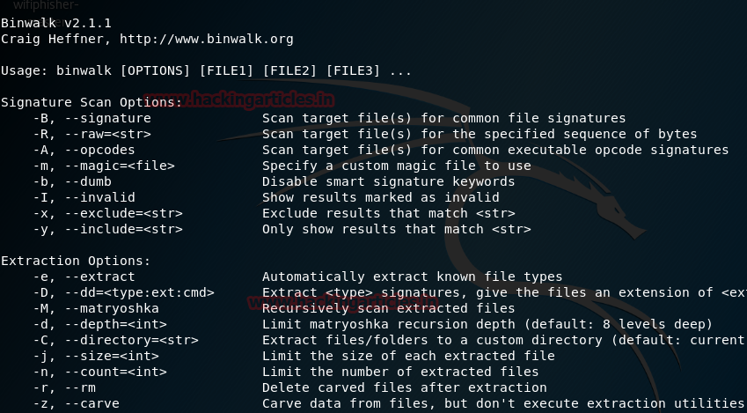
Figure 1:Binwalk
Binwalk tool is very powerful tool which searches executable code and embedded files. Binwalk tool used mainly in dealing with Image files. This tools extract information hidden in firmware images. This tool is supported in Unix-based systems and written in programming language called python using libmagic library.

Bulk Extractor
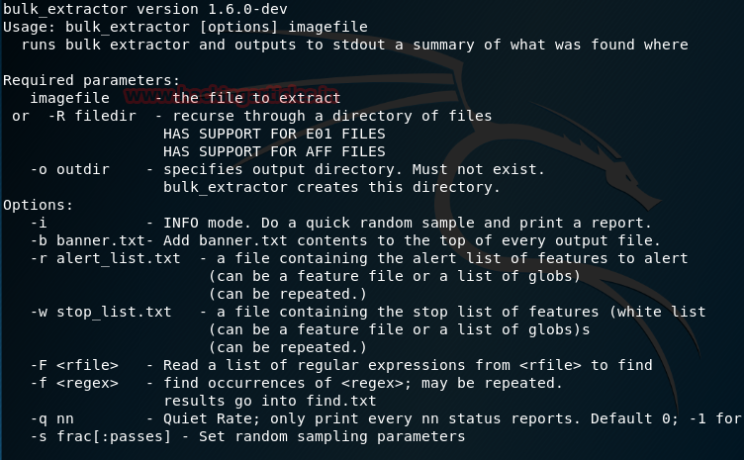
Figure 2: Bulk Extractor
Bulk Extractor full out information like Credit Card information’s, URL, E-mail Addresses and etc. Bulk Extractor is used for disk images, files and directories. Partially corrupted files can be recovered using this tool and compressed files can be recovered. Bulk Extractor have the feature of creating the word list on obtained data. This tools can be used to recover password and decrypt files. This tools Unix based platform.

Chkrootkit

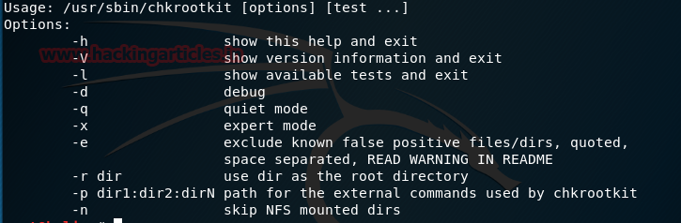
Figure 3:Chkrootkit
Chkrootkit tool is used in capturing live boot settings and check for rootkits installation. This can find any binaries modifications made to rootkit. Chkrootkit tool is capable of obtaining deep information about temporary deleted files, logs deleted details and string replacement like quick and dirty strings. Chkrootkit tool is Unix-based system.

Foremost
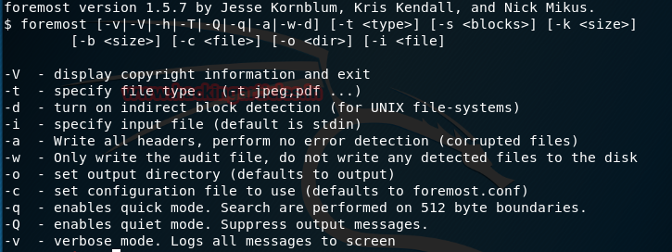
Figure 4: Foremost
Foremost is open source tool, which can obtain data from formatted drives. It recovers the data but the file name may not be recovered. Foremost uses referencing header and footer list when the directory information is not present. This tool was developed by special agent of US Air Force. This tool is Unix-Based tool.

Galleta
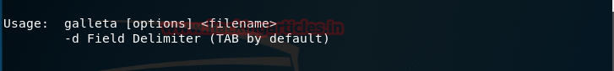
Figure 5: Galleta
Galleta puts cookies information into a format that could be exported in to spreadsheet for analysis. Galleta can arrange obtained data into easy readable for forensic analysis. Galleta is Unix-based System.

Hashdeep
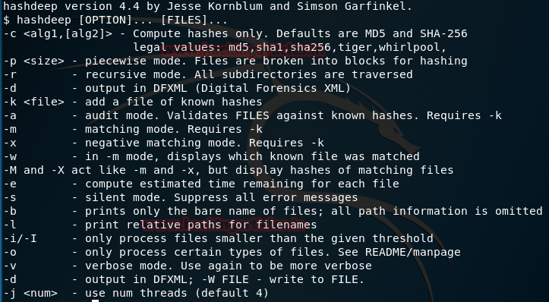
Figure 6: Hashdeep
The Hashdeep is used to analysis the hashes, MD5 hash and SHA-256 hash are focused mainly. Hashdeep verifies the existing files has been modified or replaced, missing or match files. Hashdeep do repeated hash calculations with multiple algorithms. Hashdeep is Unix-Based System.

Volafox
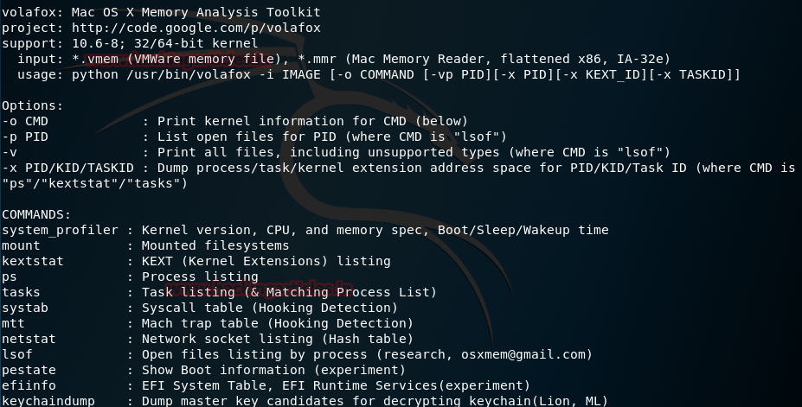
Figure 7:Volafox
This tool is written in programming language called python and Mac OS X operating system based. The Volafox is used for memory analysis. This tool can analyze, if any malicious programs, malware or any other virus programs loaded in to system memory.

Volatility
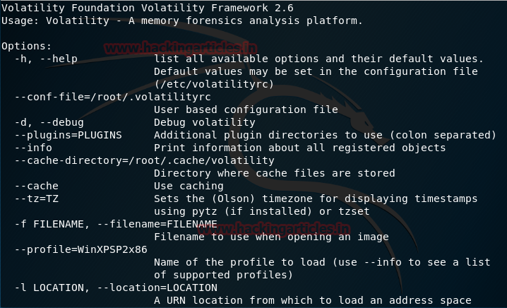
Figure 8: Volatility
Volatility is the most popular forensics tool, which is used in analyzing computer Random Access Memory (RAM). RAM is volatile memory which losses data loaded into it when the power is switch off or when computer is turned off. Volatility can be used in various memory dump. This tools can support 64 bit architecture and 32 bit architecture in Windows and Linux operating system. Volatility can analyze crash dumbs, raw formats and hibernation files. It can provide information about machines run state. Sometimes the password or decrypted files are stored in Random Access Memory, it easy to obtain and analysis those file quickly rather than doing additional analysis to obtain those information’s. [6]

Multimedia forensics

The multimedia Forensics is analyzing file audio, video and photos for any evidence. The types of photo formats are tif, bmp, png and jpg. The types of video and audio formats are flv, avi, mp4, wma, mp3 and wav. In multimedia forensics mostly the forensic investigator focus of deleted file modified or altered files and steganography.

PhotoRec
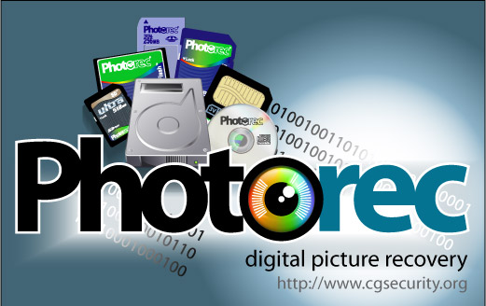
Figure 9:Photorec
PhotoRec is one of the powerful carving tool used for recovering multimedia file, PhotoRec is not only used for recovering multimedia files, it can recover other type of supports files formats. PhotoRec is capable of running in multiple platform like Windows, Linux and Mac OS. The PhotoRec can inspect all existing block in hard drive. [7] The supported file system analysis are HFS+, Ext2, Ext3, Ext4, exFAT, NTFS and FAT. PhotoRec is open source tool, which can work with different medias such as CD-ROMS, Memory stick, smart media, MMC and memory cards. [8]

Foremost
Foremost Linux based tools which need configuration for process the carving. The process of carving is done by finding header files and footer files. [7] The Foremost can work on image files, created using dd command, EnCase and Safeback. Foremost is developed by Air Force Office of Special Investigation, United States and The Center for Information Systems Security Studies and Research. [9]

Network forensics

When computers are connected together sharing data, software applications or hardware the possibility of malicious attack is high. There are different many types of computer network which are analyzed based on the network infrastructure, Local Area Networks (LAN), Wide Area Networks (WAN) and Metropolitan Area Network (MAN) these types of networks analyzed depending on situations. There are attack based on network components such as MAC Address Spoofing, MAC Flooding, ARP Poisoning and Man-In-The-Middle Attack. The most targeted device on the network is router. When the router is taken control breaking through the firewall, the whole network is taken control by the hacker. Many tools available on network forensics.

ProDiscover
ProDiscover can obtain image drive remotely and work in a live environment getting information and analyzing information of network and this tool can analyze file systems.

PyFlag
The PyFlag is forensic tool which analyze the captured network traffic. This tool analyze the large volume and disk image. It captures the website and reconstruct them, how the user viewed the website.

NetworkMinor
This tool capture data from website, to capture the network traffic. NetworkMinor is the sniffer tool and collect data about the host system other than getting information about network traffic in other words, it is focused on host centric than packet centric.

NetWitness
NetWitness is a network forensic tool which detect the any virus or threats automatically. This tool can capture traffic data of network and analysis real time.

NetIntercept
NetIntercept network forensic tool which capture network data and collect network data for later analysis. This tools make sure the integrity of the data kept during the analysis with hashing capabilities. NetIntercept is used for detecting the spoofing. Packet analysis generated as report in this tool and have capability of data mining. This tool help in finding important information.

NetDetector
NetDetector is real-time observation of network, This tools similar to NetIntercept and NetWitness. Network intrusions detected based on signatures and anomalies. This tool is specialized in re-developing raw data.

OmniPeek
OmniPeek allows forensic investigator to obverse each and every part of the network in real time. This tool can capture and analyze network traffic data. It is capable of Mine traffic data and search data.

SilentRunner
SilentRunner is network forensic tool which visualize, analyze and capture the network activities by intrusion, to find any abnormal activities before or after the incident. It help to play back the incident in sequence of time and this tool can monitor network traffic. [11]

Wireshark
Wireshark tool is developed to analyze, capture and filter network traffic. Wireshark is Graphical User Interface (GUI) and it is open source. This tool supports the Packet Details Markup Language (PDML), Packet Filtering and protocol decoding. The Wireshark can capture packets on any system and network card supports sniffing. Wireshark capture network data real-time and filter through protocol.

tshark
tshark is network protocol analyze tool which is command line based. It can save files in formats which wireshark does. tshark is used in capturing network packets.

dumpcap
dumpcap is developed to capture network packets, which is the command line interface tool of wireshark. The dumpcap take fewer system resources than wireshark to capture network packets. The traffic sniffing tools are limited by many Operating System. [12]

Email forensics

MailXaminer
MailXaminer is email forensic tool which can recover deleted emails and corrupted emails. It supports the email formats of MBOX, MBX, TBB, IMM, OLM, OST, PST, EML, EDB and NSF. Corrupted Calendar or Contacts can be recovered using MailXaminer. MailXaminer Supports the email applications formats such as Hotmail, Yahoo, Gmail, IMAP, Mozilla Thunderbird, Lotus Notes and Outlook.

Add4Mail
Add4Mail analyze the store email on hard drive to produce evidence. Add4Mail got feature of analyzing IMAP webmail’s such as Gmail, Yahoo, Fast mail, AOL mail, GMX mail and outlook. Email evidence can be exported in pdf formats. This tool have features of filtering emails data through keywords, logical operator and regular expressions, date, time and by text. The email can be searched using body content, header, contents and by date. This tool can recover email from recycle bin and filter duplicate emails. Add4Mail work on multiple OS platform such as Mac OS X, Linux and Microsoft Windows. [13]

Terrorist Attack Case

A terrorist was shot dead in Heathrow International Airport. The terrorist intention to bomb the Mason International Airport in Fiji flying from Heathrow International Airport London. A terrorist brief case with dell laptop running Microsoft Windows XP service pack 2 was handed to Mr. John for forensic analysis. Mr. John will be forensic investigator for this case. Forensic is analyzing any digital data for any evidence to prove any crime. The photograph taken at the scene and the finger print in dell laptop confirmed the dell laptop belonged to the terrorist who was shot down at Heathrow International Airport London. In this case, john is the incident handler. The terrorist has be shot dead. The information is obtained from the terrorist belongings for future reference. Incident handler cannot appear in court and incident handler hasn’t got any power to appear in court whereas expert analysis the report produced by incident handler and appear in court to provide the evidence. This report is being analyzed as incident handler.

The forensic investigator noticed dell laptop running windows XP service pack 2 and the dell laptop was in standby mode. The process of the digital forensic is to collect information then analyze the information and then present it to the court for evidence. The investigator must follow certain step to do the forensic analysis. The forensic investigator should maintain the chain of custody from the begin to the end until submitting to the evidence to the court, securely store the evidence and create document trail in electronic or paper. In forensic investigation the original evidences are not examined for security reason of making changes to the evidence accidently or intentionally. Instead of examining the original evidence drive, evidence drive are copied or imaged for forensic analysis using bit stream imaging process. There is software procedure of making copy of the evidence drive, in case of overwriting any drive or modifying accidently, there is hardware for making copy procedure to evidence drive. The write blocker is the hardware device for imaging the evidence drive. Mr. John noticed the dell laptop was in standby mode, the information in the Random Access Memory (RAM) can be imaged. The Random-Access Memory (RAM) is volatile memory, all data in volatile memory get erased when computer is powered off. Imaging Random Access Memory (RAM), the recently loaded application or activities could be analyzed. There are many kinds of tools which could use to image volatile memory, such as LiME Linux Memory Extractor. The image volatile date can be analyzed using Volatility, Volatility is memory forensic tool.

The Forensic investigator must image the hard drive using write blocker or dcfldd in Kali Linux or in FTK Imager. The imaged hard drive examined to find and deleted files, corrupted or damaged files, hidden files, swap space, registry setting and event logs. The imaged file is hashed. The hash is to prove the data is not modified intentionally or accidently. The below table show more deep files information of the, which data to look for.

Files Generated By User | Files that are protected User | Files Generated by system
database | Steganography files | Backup files
Media files such as Video, Audio and images. | Compressed files | Printer Spool files
Documents such as pdf, spreadsheet and presentation. | Hidden files | History Files
Address books and internet book marks | Files mismatch | Temporary Files
 | Encrypted Files | Log Files
 |  | Cookies
 |  | System Files
 |  | Configuration files
Table 2: Types Of Files Generated
The imaged hard drive is analyzed with two software which is Access Data Forensic Toolkit FTK Version: 6.4.0.70 and Autopsy Version 4.10.0. These two-analysis tools used in Microsoft Windows platform.

The Image files matched with terrorist motivation. The images are related with airport maps and baggage area of Heathrow international airport and Mason Airport.

The Related Images
baggae1.bmp | heathrow airpot.jpg | image.jpg
baggae1.jpg | heathrow airport.png | images1.jpg
baggage2.jpg | image2.bmp | london.jpg
fiji.jpg | image2.jpg | mason1.jpg
heathrow airport.bmp | image3.jpg | mason_bar.jpg
mason_bar2.jpg | baggae.bmp
Table 3: Analyzed Forensic Images

The image file consists of a passport information, the person named in passport seemed to be British citizen and the person name is Badat Saajid Muhammad. Date of birth 28 March 1979. The passport image states the passport was issued in Gloucester and it expire date was 22nd April 2007. This passport image was created on 18th December 2018. Image file name is “passport.jpg”.

The image file name “pexels-photo-46710.jpeg”. This image file is not related to the case. All the image file has been verified with Stegosuite which is steganography tool to find any hidden information’s.

The video file containing September 11 attack, Brussels bombing attack, video containing information about Heathrow International Airport, PM Modi Speech on terrorism, Saudi Crown Princes Speech about peace, President Obama speech on strategy Against ISIS, video about Fiji airport runway, Vishwaroopam south Indian movie about terrorism, Terror attack at Istanbul airport, The world’s most wanted Islamic State Terrorist, “Baarishon Ki” romantic song and “UNNAI PIRINDHU” a video song. These video files contains motivational terrorist videos.

The “blue.mp4” is not a video file, the file extension was mismatched. The original file extension is image/jpeg.

The audio files contains general audio like songs. Some audio’s are related to terrorist motivational and some files extension are mismatched.

“Indian.mp3” is image/jpeg file and “london.wav” was mismatched, the original extension is image/jpeg. The “Indian.mp3” picture is been verified, it is the passport of an Indian women named Ramadugula Sita Maha Lakshmi, Date of birth 23/09/1959, Place of birth Gundugolanu and the passport issued on 11/10/2011 expires on 10/10/2021.

There are 333 HTML documents found, two of the html documents contains Wikipedia information about Heathrow International Airport and Mason Jewett Field. These two files provide information on coordinates and other information about airport. Rest of the file are unallocated.

There are 10 documents found, four of them are readable and other documents are unallocated.
The document “About Susan.docx” which is encrypted document. This document was decrypted by Access Data Password Recovery and the password is “plan”. This document contains “Susan eats truffles under pressure, that helps everything before 0wning Major Brad at the 8th”. The “Bank.xlsx” is excel document which is encrypted. This excel document is decrypted using Access Data Password recovery and the password is “money”. This contains information’s of Merlin and Ibrahim bank details. Mason Jewett Field.docx contains information of airport and Heathrow Airport.docx contains information of airport.

There are four pdf files, bh-asia-02-shah.pdf which contains slides of information about firewall, networking and hacking. Heathrow Airport.pdf contains information about Heathrow Airport. ANJANA.pdf is mismatched extension. The file is MPEG video and contains a video song.

Plain text “H3110.txt” contains information related with intension of attack. The text file contains “ Hello bomb the mason airport at Fiji this Sunday” this text was replaced with special characters matched with letter to hide information. This wasn’t extracted using any tools, this information is readable with match of the special characters with the each letter. The text file “log_2018_11_13.txt” log files of Icecream screen recorder software.

The email address extracted using Autopsy 4.10.0. The autopsy have found 743 email address in the file system. These email addresses, MS Outlooks and chat history are analyzed with email forensic software called paraben Email Evidence Examination (E3 EMX).

The executable files are extracted with the help of Autopsy 4.10.0. There are 81 “.exe” files, most of them are seem to be Microsoft products activator. There are 1057 “.dll” executable extension and there “.cmd” which is command line executable scripts.

Conclusion
The report contains computer forensics analysis tools on File System, Multimedia forensic, Email forensic and multimedia forensic. The tools, which are analyzed in this report are old and new tools. The computer forensics is the technics used to extract information or analyze information for any evidence. There are many tools and technics used in computer forensic, there are new possible way of hiding information or extracting information could be developed in computer world as the technology grows every year. These forensic technics are developed into tools, These different tools can perform different technics to analyze the data.

This contains report of terrorist attack case analysis. The case is analyzed using Access Data Forensic toolkit Version: 6.4.0.7.0, Autopsy Version: 4.10.0. The email is analyzed using paraben Email Evidence Examination (E3 EMX), encrypted files are decrypted using Access Data Password recovery tool and the steganography is analyzed using Stegosuite. There are many tools which can extract information more further. The report generated by FTK haven’t got report of email analysis. The report generated by autopsy contains the report of email analysis.

Bibliography

[1] | "Introduction to computer forensics," [Online]. Available: https://forensiccontrol.com/resources/beginners-guide-computer-forensics/.
[2] | T. Fisher, "Lifewire," 16 01 2019. [Online]. Available: https://www.lifewire.com/what-is-a-file-system-2625880. [Accessed 24 03 2019].
[3] | B. Carrier, File System Forensic Analysis, 2005.
[4] | B. K. R. S. T. S. Bhanu Prakash Battula, "Techniques in Computer Forensics: A Recovery Perspective," International Journal of Security (IJS), vol. 3, no. 2, p. 35, 2009.
[5] | "TestDisk," 18 04 2015. [Online]. Available: https://www.cgsecurity.org/wiki/TestDisk. [Accessed 28 03 2019].
[6] | S. L. ·. T. Shon, "Improved deleted file recovery technique for Ext2/3 filesystem," onilne Publication, New York, 2014.
[7] | R. Chandel, "hackingarticles," 06 01 2018. [Online]. Available: https://www.hackingarticles.in/forensics-tools-kali/. [Accessed 25 03 2019].
[8] | N. F. Nurhayati, "The Analysis of File Carving Process Using Photorec and Foremost," Jakarta-Indonesia.
[9] | cgsecurity, "PhotoRec," 18 04 2015. [Online]. Available: https://www.cgsecurity.org/wiki/PhotoRec. [Accessed 26 03 2019].
[10] | foremost, "foremost," [Online]. Available: http://foremost.sourceforge.net. [Accessed 26 03 2019].
[11] | m.-h. maras, Computer Forensics, jones and bartlett, 2014.
[12] | S. Davidoff, Network Forensics Tracking Hacker Through Cyberspace, Prentice Hall, 2012.
[13] | H. S. V. C. Vamshee Krishna Devendran, "A Comparative Study of Email Forensic Tools," online, Kennesaw, GA, USA, 2015.

marking criteria and Student FEEDBACK

This section details the assessment criteria. The extent to which these are demonstrated by you determines your mark. The marks available for each criterion are shown. Lecturers will use the space provided to comment on the achievement of the task(s), including those areas in which you have performed well and areas that would benefit from development/improvement.

Common Assessment Criteria Applied (Assignment 1) | Marks available | Marks  awarded
1. Research-informed Literature
Extent of research and/or own reading, selection of credible sources, application of appropriate referencing conventions.
You have demonstrated your own research. However, as an academic work you need to use updated credible, peer reviewed articles. Your references were mainly website (Grade mark: 55.00%) | 20 | 11
2. Knowledge and Understanding of Subject
Extent of knowledge and understanding of concepts and underlying principles associated with the discipline.
You have demonstrated understanding of the concepts and underlining principles. However, more depth and strength of your statements could be apply. Consult academic survey papers (IEEE, Science Direct, Elsevier, etc.) next time to help in this area. (Grade mark: 56.67%) | 15 | 8.5
3. Analysis
Analysis, evaluation and synthesis; logic, argument and judgement; analytical reflection; organisation of ideas and evidence
Very good evaluation of the case study. It would be good to maintain the order of writing and numbering to match the development of the case for easier reading and marking. Otherwise, well written and appropriate softwares/tools identified for the case scenario. Fees invoice file submitted. In your conclusion it would be good to add recommendation or future work. (Grade mark: 84.44%) | 45 | 38
4. Practical Application and Deployment
Deployment of methods, materials, tools and techniques; application of concepts; formulation of innovative and creative solutions to solve problems.
Copy was created without modification. Process used (FTK tools), additional files uploaded to Moodle. (Grade mark: 100.00%) | 15 | 15
5. Skills for Professional Practice
Attributes in professional practice: individual and collaborative working; deployment of appropriate media; presentation and organisation.
Proper cover page could be done for your assignment; separate table of content and the rest of the report body. Formatting required and there are some grammatical errors such as contraction grammar  (Grade mark: 50.00%) | 5 | 2.5

Assignment Mark (Assessment marks are subject to ratification at the Exam Board. These comments and marks are to give feedback on module work and are for guidance only until they are confirmed. ) | Late Submission Penalties (tick if appropriate) |  | 75%
 | Up to four weeks late |  | 75%
 | First Attempt? |  | 75%

