PROGRAME :BA BUSINESS MANAGEMENT

MODULE : Leadership and Management, Theory and Practice

MODULE CODE: LCBB6003

MODULE LEADER: MUSHFIQUR RAHMAN ASSIGNMENT TITLE : GROUP REPORT AND PRESENTATION

NAME:

Marius Moldoveanu (2023028)

Slide 11: Long-Term Sustainability
- Welch's leadership practises are sustainable if his initiatives and modifications last.
- Welch's leadership style produced short-term results, but its long-term effects should be examined (Snihur, Thomas and Burgelman, 2023).
- The rigorous and competitive workplace may have stressed and burned out employees, lowering morale and well-being.
- GE may have needed to adapt Welch's leadership model to changing business landscapes and employee expectations for long-term survival.

Speaker Notes:
Welch's leadership practises are sustainable if his initiatives and modifications last. Welch's leadership style produced short-term results, but its long-term effects should be examined.
Short-term results over strategic planning are a risk. Focusing on quick benefits may have overlooked opportunities or underinvested in future development and innovation.
The rigorous and competitive workplace may have stressed and burned out employees, lowering morale and well-being (Poór et al., 2023).
GE may have needed to adapt Welch's leadership model to changing business landscapes and employee expectations for long-term survival. Leadership practices must be evaluated and improved to ensure the company's success after Welch.

Slide 12: Leadership Style and Organizational Culture
- Jack Welch's tough leadership formed GE's culture.
- His direction energised the organisation.
- Welch's boundaryless organisation promoted cooperation and innovation, aligning with GE's mission of breaking down creative and responsiveness barriers (Allio, 2023).
Speaker Notes:
Jack Welch's dynamic and demanding leadership shaped GE's culture. His leadership gave the organisation purpose and energy. Performance and outcomes became the culture. Welch's boundaryless organisation promoted cooperation and innovation, aligning with GE's goal of tearing down boundaries for creativity and responsiveness (Allio, 2023).

Slide 13: Leadership Style and Organizational Culture (Cont.)
- Welch's strict management may have hurt employee morale. Some workers excelled, but others struggled to balance work and life.
- Company culture affects staff commitment and retention (Aranki, Suifan, and Sweis, 2019).
- Performance-driven cultures helped GE succeed.
- Keeping personnel who fought the culture may have been challenging.

Speaker Notes:
Welch's rigorous leadership may have affected staff engagement and retention. Some employees thrived in such an environment, but others may have struggled to combine work and life. Organisational culture affected employee commitment and retention (Aranki, Suifan, and Sweis, 2019). Performance-driven cultures kept employees engaged and helped GE succeed. However, keeping staff who battled with the culture could have been difficult.

Slide 13: Impact on Stakeholders
- Welch led stakeholders differently.
- Some employees flourished in the performance-driven culture, while others suffered with Rank and Yank. Welch's market cap growth helped GE stockholders.
- Customer loyalty required exceeding expectations and beating competitors (Rafiq, Rai and Hussain, 2020).
- Welch had to confront scandals to maintain stakeholder trust.
- Stakeholder grievances needed open communication and ethical decision-making.
Speaker Notes
Welch's leadership affected stakeholders differently. Some employees thrived in the performance-driven culture, while others struggled with the Rank and Yank system. Welch's market capitalization growth benefited GE shareholders. However, short-term focus and probable neglect of long-term strategic planning may have generated concerns. Under Welch, the company's creative and high-quality products and services determined customer pleasure and loyalty. Maintaining customer connections required meeting customer expectations and outperforming the competition (Rafiq, Rai and Hussain, 2020). Maintaining stakeholder trust and confidence during Welch's tenure required addressing any scandals or problems. Addressing stakeholder complaints required open communication and ethical decision-making.

Slide 14: Leadership Legacy and Succession Planning
- GE's identity is performance excellence and boundaryless organisation.
- Welch's leadership changed GE.
- GE's succession planning identified and developed leaders.
- Welch's talent management prepared talented executives for leadership shifts (HBR, 2020).
Speaker Notes
GE's culture was shaped by Jack Welch. Performance excellence and boundaryless organisational frameworks become GE's identity. Welch's vision and activities transformed GE during and after his tenure.
GE's succession planning methodology identified and groomed future leaders. Welch's talent management helped prepare skilled executives for leadership changes (HBR, 2020). His successors had to adapt to new problems and opportunities while building on Welch's legacy to succeed.

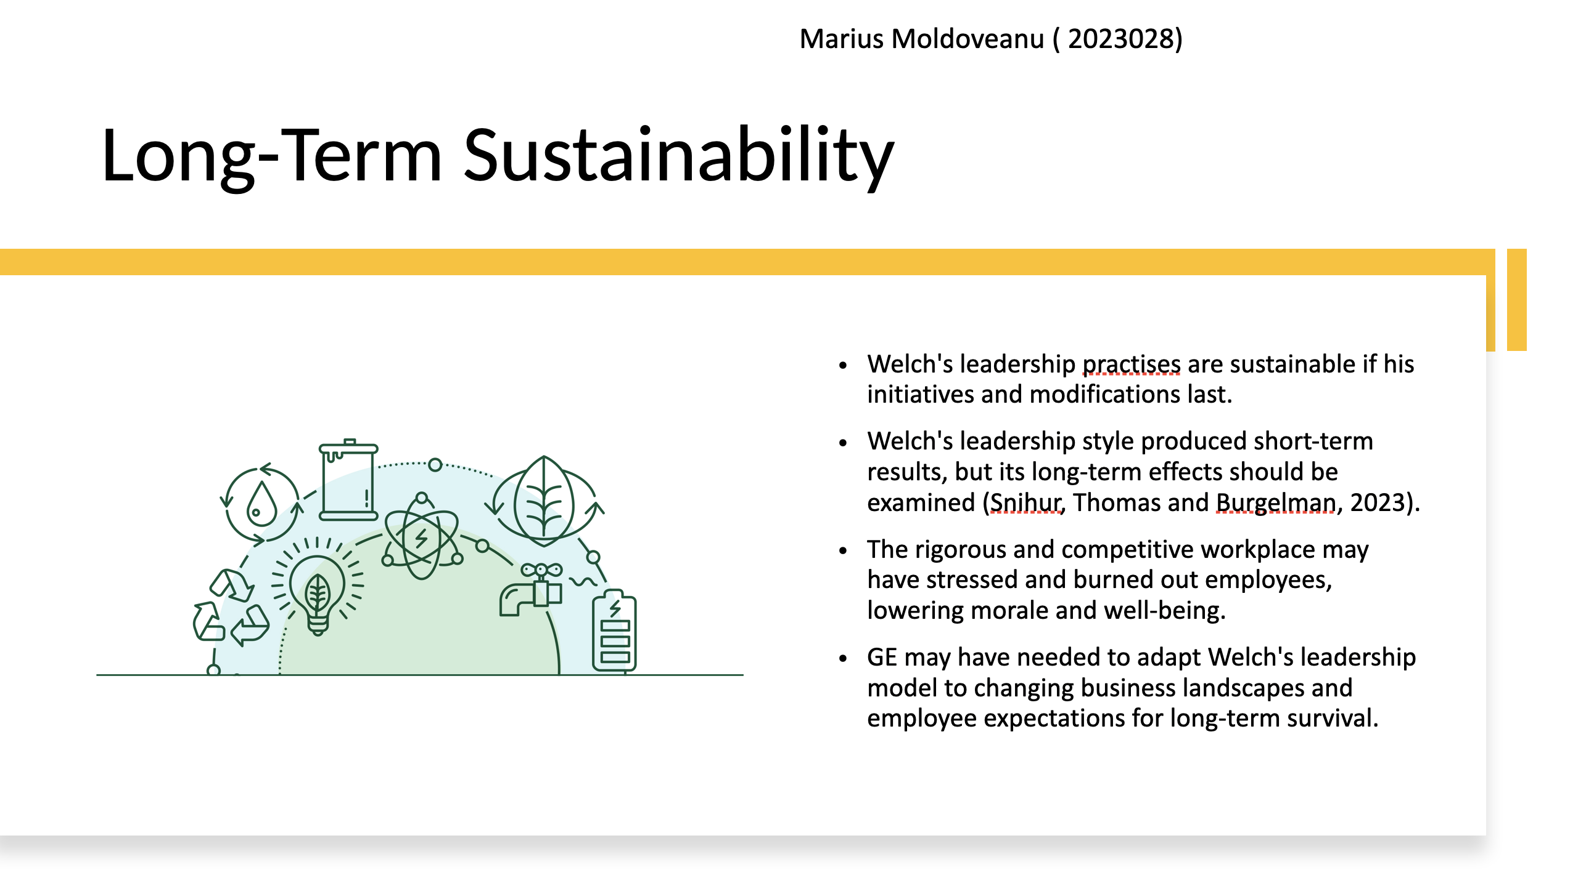
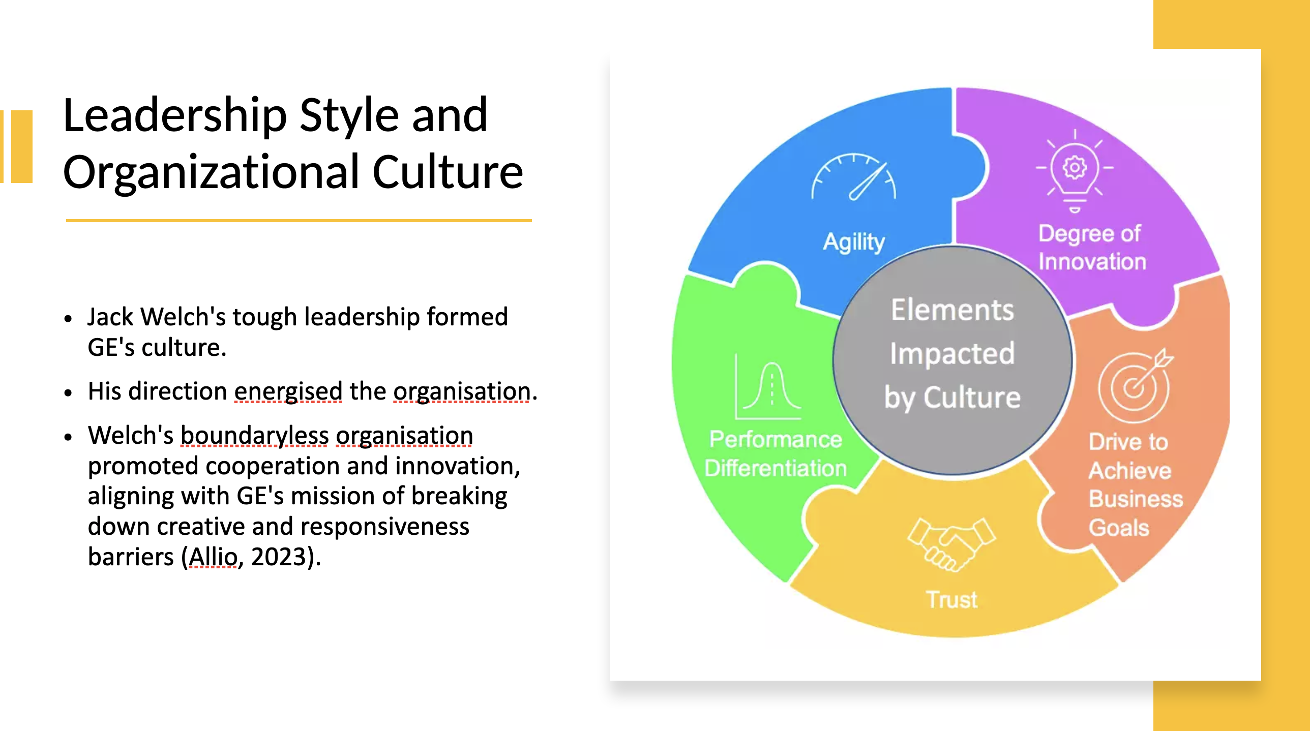

Reference

Allio, R.J., 2023. Preparing leadership for daunting 21st Century challenges. Strategy & Leadership, 51(1), pp.3-9.
Aranki, D.H., Suifan, T.S. and Sweis, R.J., 2019. The relationship between organizational culture and organizational commitment. Modern Applied Science, 13(4), pp.137-154.
Carbone, J. and Black, W.K., 2019. The problem with predators. Seattle UL Rev., 43, p.441.
Economics, 2020, “Competitiveness”, Available at: https://www.economicsonline.co.uk/global_economics/competitiveness.html/ [Accessed on 17th July 2023]
Gelles, D., 2022. The Man Who Broke Capitalism: How Jack Welch Gutted the Heartland and Crushed the Soul of Corporate America—and How to Undo His Legacy. Simon and Schuster.
Gelles, D., 2022. The Man Who Broke Capitalism: How Jack Welch Gutted the Heartland and Crushed the Soul of Corporate America—and How to Undo His Legacy. Simon and Schuster.
HBR 2020. The Jack Welch Era at GE. Available at: https://hbr.org/1989/09/speed-simplicity-self-confidence-an-interview-with-jack-welch [Accessed on 4 Jan 2023].
HBR, 2020, “Jack Welch’s Approach to Leadership”, Available at https://hbr.org/2020/03/jack-welchs-approach-to-leadership [Accessed on 19th July 2023]
Hunkenschroer, A.L. and Luetge, C., 2022. Ethics of AI-enabled recruiting and selection: A review and research agenda. Journal of Business Ethics, 178(4), pp.977-1007.
Karpen, I.O., Vink, J. and Trischler, J., 2022. Service design for systemic change in legacy organizations: A bottom-up approach to redesign. In The Palgrave Handbook of Service Management (pp. 457-479). Cham: Springer International Publishing.
Masenya, T.M., 2022. Integrating talent and knowledge management practices in the new normal business environment: developing future leaders in public sector organizations. In Navigating the new normal of business with enhanced human resource management strategies (pp. 113-144). IGI global.
MBM, 2021, “How to Fix Low Morale in the Workplace: A Guide For Leaders”, Available at: https://www.makingbusinessmatter.co.uk/low-morale/ [Accessed on 18th July 2023]
Pennsylvania State University, 2023, “Decentralisation, Centralisation and Devolution in publicly funded health services: decentralisation as an organisational model for health care in England”, Available at: https://citeseerx.ist.psu.edu/document?repid=rep1&type=pdf&doi=a0fdc0b3901df63e26bb011281c59f826f54bc09 [Accessed on 17th July 2023]
Poór, J., Szabó, K., Balog, K., Barna, Z. and Hámori, T., 2023. CASE SYNOPSIS First, we present the key socio-economic characteristics of the Hungarian economy and labor market. Next, we review the place and role of FDI (foreign direct invest-ment) in the Hungarian economy. The first acquisition and European investment of General Electric (GE) was Tungsram in Hungary in 1990. It was a challenge for both. The Global Human Resource Management Casebook, p.75.
Puhan, T.X., 2019. Managing Change and Innovation. Available at SSRN 3371800.
Purwanto, A., Kusumaningsih, S.W. and Prasetya, A.B., 2020. Did Transformational Leadership Elitist and Antidemocratic? A Literature Review. International Journal of Social, Policy and Law, 1(1), pp.1-11.
Rafiq, M.R., Rai, I.H. and Hussain, S., 2020. The impact of logo shapes redesign on brand loyalty and repurchase intentions through brand attitude. International review of management and marketing, 10(5), p.117.
Snihur, Y., Thomas, L.D. and Burgelman, R.A., 2023. Strategically managing the business model portfolio trajectory. California Management Review, 65(2), pp.156-176.
Vaia, G., Arkhipova, D. and DeLone, W., 2022. Digital governance mechanisms and principles that enable agile responses in dynamic competitive environments. European Journal of Information Systems, 31(6), pp.662-680.
Valparaiso University, 2021, “Self-Centered vs. Humanity-Centered: The Most Critical Continuum for Choosing Today's Leadership”, Available at: https://scholar.valpo.edu/cgi/viewcontent.cgi?article=1455&context=jvbl [Accessed on 17th July 2023]
Welch, J. and Byrne, J.A. 2001. Jack: Straight from the gut. Warner Business Books.

