Module name: Changemakers: Creativity and Value Creation
Module code: BMHP 5014
Lecturer name: Dr Laila Surani
Student name: Nicole Jones
Student ID: 2246941
Table of Contents
Poster 3
Introduction 3
Identifying the Problem 3
Innovation Overview 4
Who Benefits and How 4
Implementation Strategy 5
Public Engagement / Dissemination 5
Conclusion 6
Reference List 7

Poster
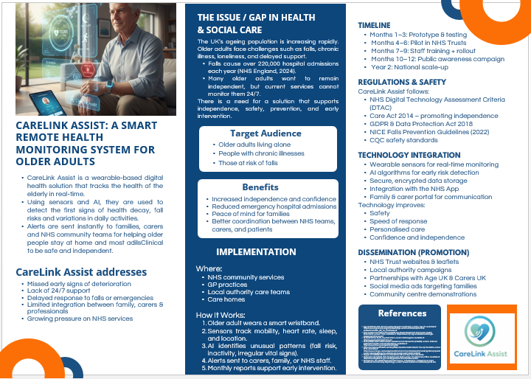

Introduction
The UK ageing population poses ever-growing challenges to health and social care services, notably in relation to the independence, safety and wellbeing of older people. Currently, one in five people in the UK are aged over 65 and this is expected to increase dramatically in the next two decades (ONS, 2024). Many older adults have been hoping to maintain their independence for as long as possible; however, are at increased risks for such things as falls, chronic illness, loneliness, cognitive decline, and delayed access to support. Caused by falls alone, over 220,000 people are admitted to hospital annually and over PS2.3 billion is spent by the NHS (NHS England, 2025). In light of such gaps, this pitch is for CareLink Assist, a smart remote monitoring solution aimed at helping geriatric populations to live independently by bettering real-time data, early detection and better care coordination.

Identifying the Problem
The existing health and social care system is under mounting pressure from acute staff shortages, mounting waiting lists and limited capacity for provision of personalised home-based monitoring. Many older adults do not get their deterioration found out because the teams in the community cannot keep an eye on them 24/7. Research highlights that the earlier the disease is caught and the sooner it is intervened, the less the need will be for hospital admissions, the more the quality of life will improve and the less there will be a crisis (Age UK, 2019). In addition, family members are often anxious in the unable check up on their loved ones regularly. This is an innovation that is trying to fill these critical gaps with a proactive, tech-enabled solution.

Innovation Overview
CareLink Assist integrates both wearable sensors, AI-based analytics, and the main components of remote monitoring such as digital communication tools to enable 24*7 remote monitoring and personalised support. The system monitors things like vital signs, mobility, sleep and location, and employs AI software to identify early warning signs such as when patients are becoming more inactive, have irregular heart rhythm or high risk of falling. Data is safely shared with families, carers, GPs and the NHS community health teams via an integrated app.
This innovation is based on the principles of creativity, value creation, as well as social innovation. According to the Innovation Diffusion Theory (Rogers, 2003), technologies have a higher chance of being adopted if they have recognisable advantages, compatibility with existing systems and are easy to use - all of which CareLink Assist is. Similarly, Empowerment Theory focuses on allowing a control of the decisions and capacities to the individuals (Zimmerman, 2000). The innovation helps older people to be autonomous, to live their own lives with confidence.

Who Benefits and How
The main beneficiaries of CareLink Assist are older people, especially those with chronic illnesses, mobility problems, or who are on their own. The innovation prevents them from being more dangerous inside the sense of emergency situations and gives them the possibility of early treatment. Families and carers and get the benefit of peace of mind, better communication and less emotional and physical burden NHS staff such as community nurses and GPs can get real-time access to data allowing more targeted and proactive care. This is in line with the NHS Long Term Plan (2019), which stresses on digital-first care and helping people to age well where they live.
Policy, legislation and Standards
The initiative is in line with the Care Act 2014 which requires the local authorities to promote independence, wellbeing, and prevention. It also helps the Health and Social Care Act 2012 by facilitating the delivery of integrated care and minimising unnecessary hospital use. Data security and confidentiality are in enrolment with GDPR and the UK Data Protection Act 2018 and personal health information is suitably protected. As a digital health tool, CareLink Assist would go through NHS DTAC (Digital Technology Assessment Criteria) to ensure its safety, effectiveness and interoperability. Guidelines from NICE (2025) on falls prevention provide further evidence for this reason to use continuous monitoring technologies.

Implementation Strategy
A 12-month phased plan for implementation is started. First, a prototype is created and used with a small group of older people. Next two NHS Trusts are chosen to be part of a pilot programme to test usability, reliability and clinical outcome. Training will be conducted for the community nurses, OTs and social care staff for using the platform and interpreting the data. Following the success of a pilot, wider implementation will take place in local government, GP practices and care homes. Expenses that involve wearable device procurement, staff training, maintenance, and app support all consequently add up to cost. To make it more inclusive, as subsidies or government funding may be considered, especially for elderly people with lower incomes.
Risks include possible technical failures, digital literacy issues and issues with data sharing. These will be resolved through continued support, informed consent processes and oversight through humans. Whilst technology cannot substitute for human care, it improves the decision-making process and makes intervention possible even earlier. The system will also integrate with the NHS App, to support a continuity of care.

Public Engagement / Dissemination
The key to the success of CareLink Assist is effective public engagement. A national awareness campaign will bring its benefits to the forefront and will make use of television, social media, GP surgeries and community centres. Collaborations with Age UK, Carers UK and local council will help to reach older people and carers. Community workshops will be conducted to provide demonstration and hands-on experience in order to build trust. Healthcare professionals will be involved through the NHS Trust newsletters, online webinars and professional networks.

Conclusion
CareLink Assist provides a future ready, life-changing solution to help improve the independence, safety and wellbeing of the older generation across the UK. Its combination of wearable technology and AI analytics coupled with integrated communication, supports ageing in place alongside reducing pressure on overstretched NHS services. Grounded in evidence, leveraged by policy and in line with the empowerment principles, this innovation has the potential to greatly improve the lives of older people and their families as well as contributing to the common good.

Reference List
Age UK (2019) Later Life in the United Kingdom: Factsheet. London: Age UK. Available at: https://www.ageuk.org.uk/globalassets/age-uk/documents/reports-and-publications/later_life_uk_factsheet.pdf
Care Quality Commission (CQC) (2023) The Single Assessment Framework: Quality Statements. London: CQC. Available at: https://www.cqc.org.uk/assessment/single-assessment-framework
NHS (2019) The NHS Long Term Plan. London: NHS England. Available at: https://www.longtermplan.nhs.uk/
NICE (2025) Falls in Older People: Assessment and Prevention (NG249). London: National Institute for Health and Care Excellence. Available at: https://www.nice.org.uk/guidance/ng249
Office for National Statistics (ONS) (2024) Population Estimates for the UK, Mid-2023. London: ONS. Available at: https://www.ons.gov.uk/peoplepopulationandcommunity/populationandmigration/populationestimates/bulletins/annualmidyearpopulationestimates/mid2023
Rogers, E.M. (2003) Diffusion of Innovations. 5th ed. New York: Free Press.
UK Government (2018) Data Protection Act 2018. London: The Stationery Office. Available at: https://www.legislation.gov.uk/ukpga/2018/12/contents/enacted
Zimmerman, M.A. (2000) ‘Empowerment Theory’, in Rappaport, J. & Seidman, E. (eds.) Handbook of Community Psychology. London: Kluwer Academic Publishers, pp. 43–63.

