DS 1 Assignment

My Screenshots/Photos
- Please add 4–6 screenshots or photos of your digital life.
- You can use your phone or laptop.
- For each screenshot, write one or two sentences explaining what it shows.

Screenshot/Photo 1
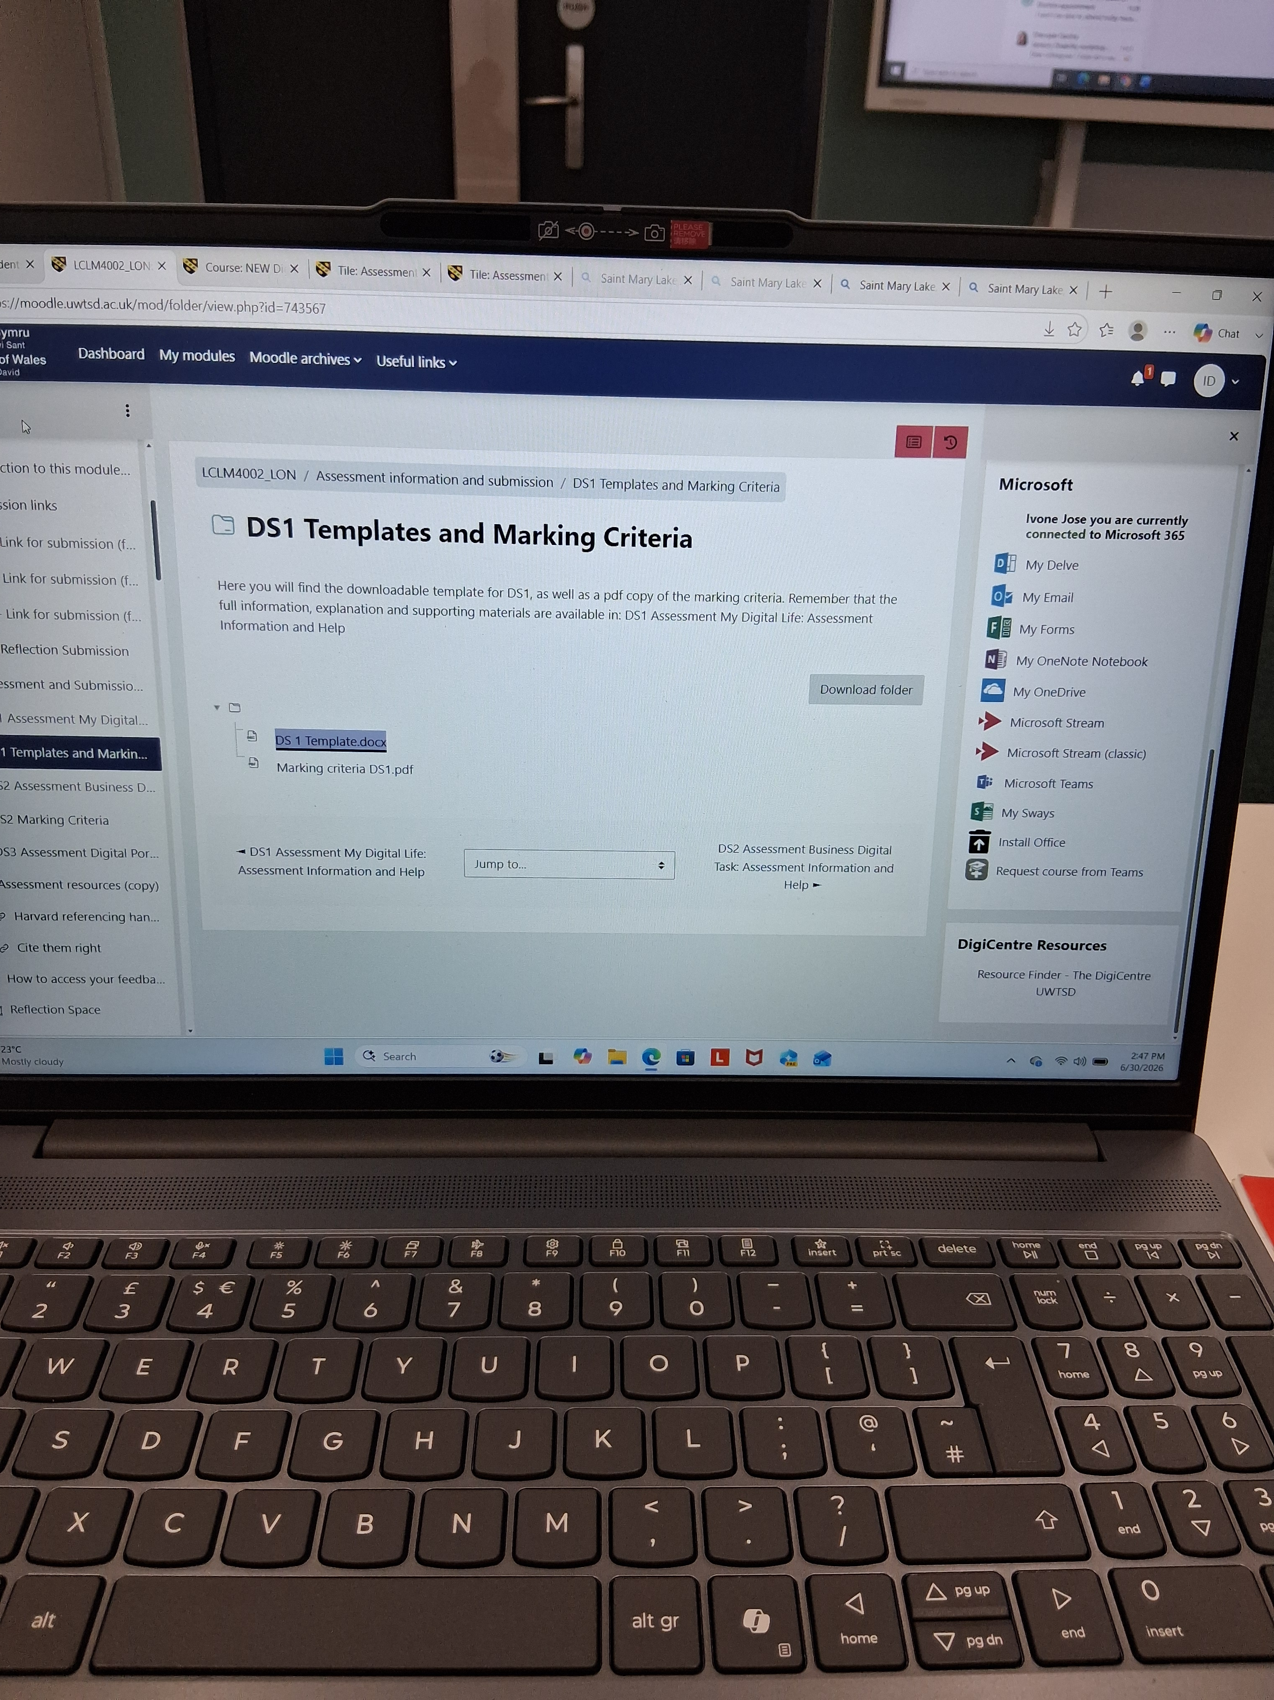
This picture was taking from my laptop is the screen regarding my studies

Screenshot/Photo 2
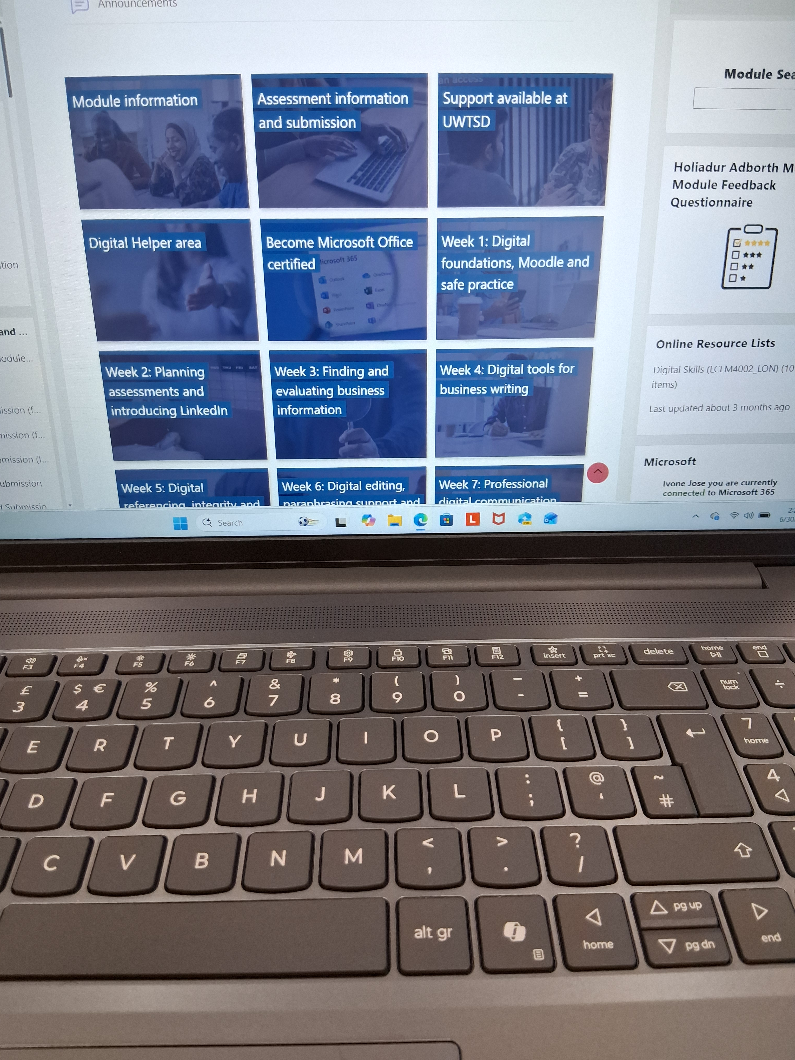
Again this is from my laptop when I was doing my homework

Screenshot/Photo 3

This picture is a card writing in my native language wishing good morning to

Screenshot/Photo 4
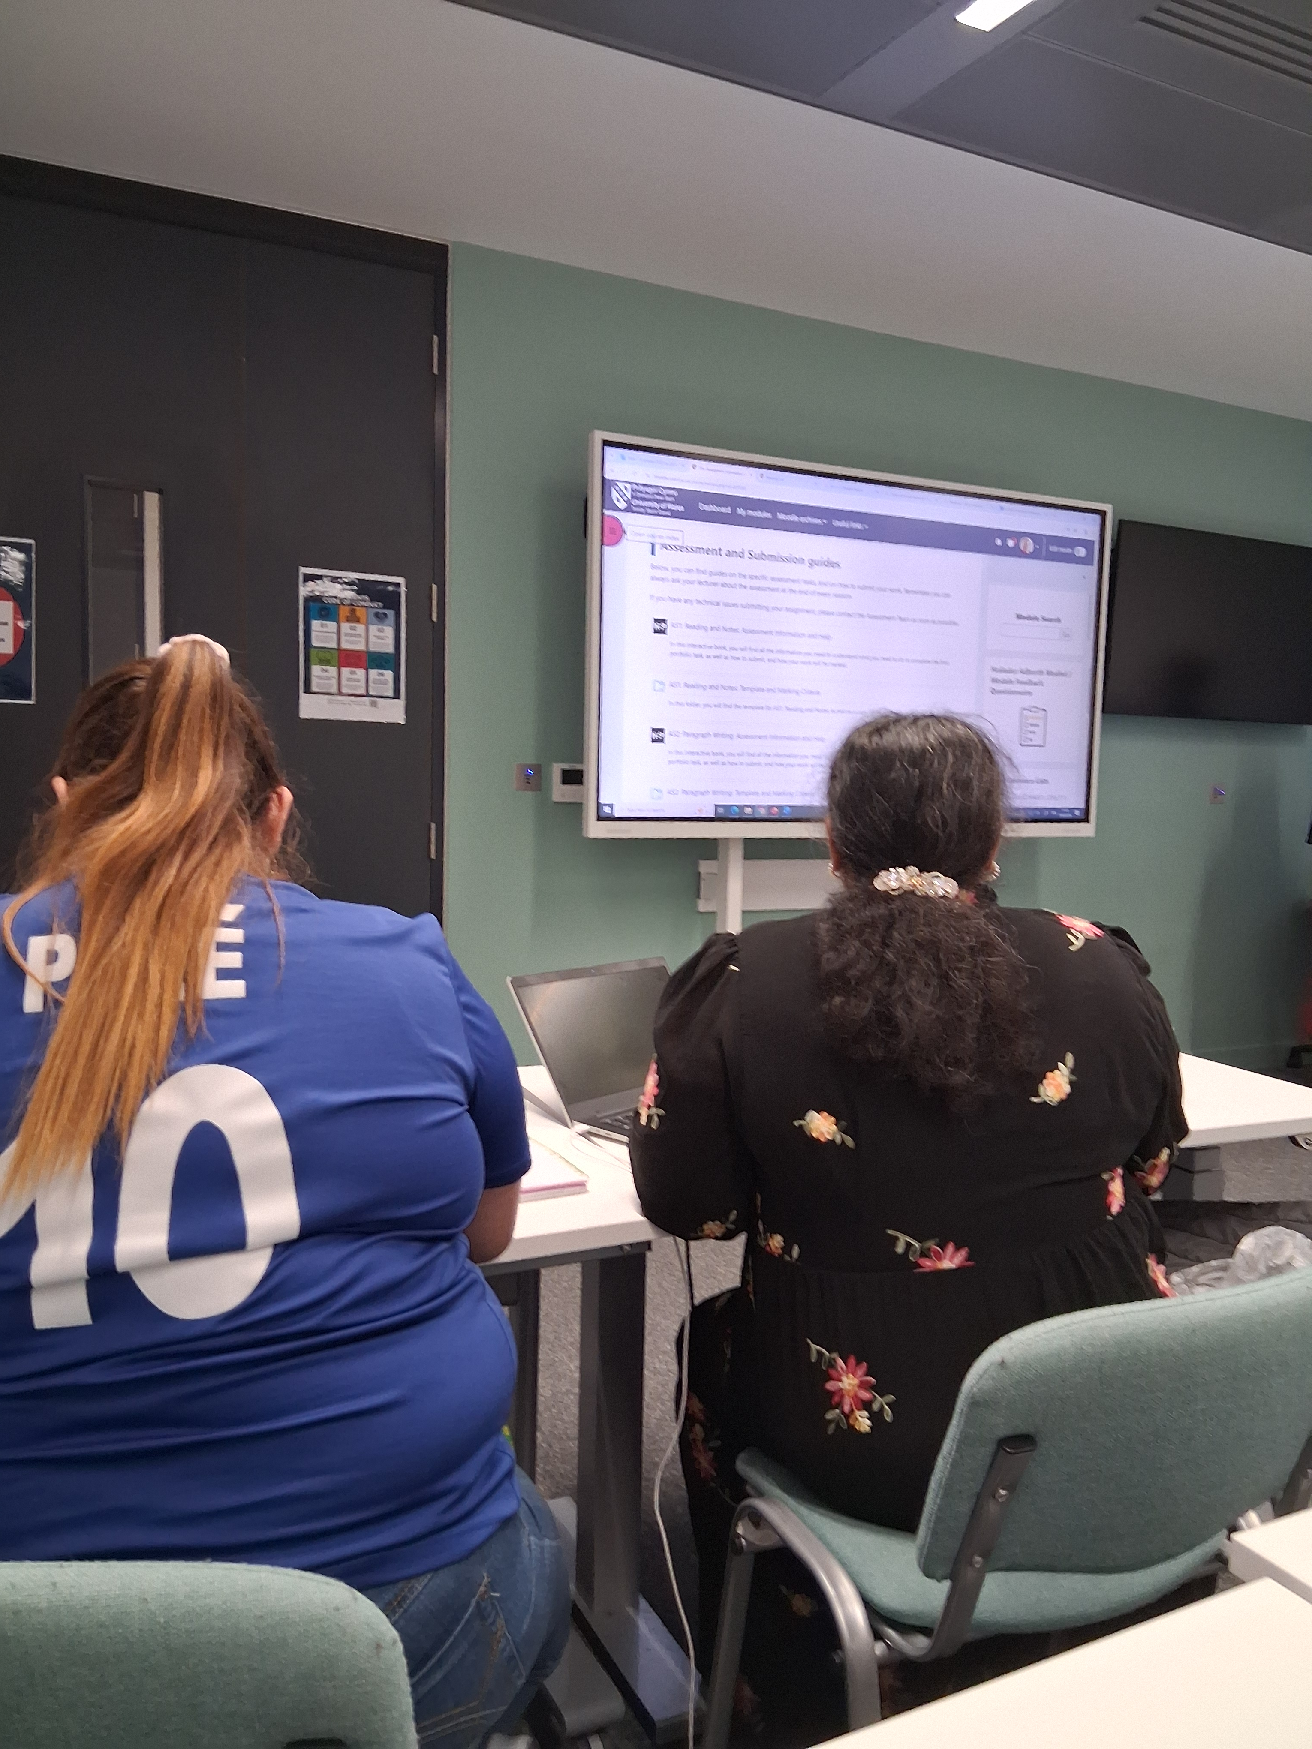

This is a picture of 2 of my class mates on our business class studies

Screenshot/Photo 5

[Write what this shows of your digital life]

Screenshot/Photo 6
[Insert Photo/Screenshot below]
[Write what this shows of your digital life]

My Short Reflection
- Write 5–8 simple sentences about your digital life.
- You can use the sentence starters below if helpful.
I use digital tools to communicating with people all around the wold
I feel confident enough to use the tools
I would like to improve so I would be able to do my work without any delayed
I often use those tools to play games, and shopping
I sometimes feel nervous about using digital tools because of the scums
I hope this module will help me with my studies
Digital skills are important for me

Sentence starters
- I use digital tools to …
- I feel confident when I …
- I want to improve …
- I often use these tools: …
- I sometimes feel nervous about …
- I hope this module will help me …
- Digital skills are important for me because …

You can write more if you want.

Dear Sir.

I would like to let you know that Im having some difficulties some difficulty with my studies because Im not familiar with the technology.

Kind regarding
Ivone

Submission Checklist
Before you submit, please check:
​​​ ☐ I added 4–6 screenshots
☐ I wrote short sentences for each screenshot
☐ I wrote my short reflection
☐ My work is my own
☐ My file opens correctly
​​☐ My file opens correctly

