Savin Luke
1810328@student.uwtsd.ac.uk

Abstract
This report investergates the affect of the values that are in a PID controller and the importance of tuning for the required output.
OME – Instrumentation And Control
1810328

Contents
Abstract 0
Table of Figures 1
Introduction 2
Method 6
Results 8
Discussion 12
Conclusion 13
Equations for Single Block Functions [12] 14
References 17

Table of Figures

Figure 1: Open-Loop Control System [1] 2
Figure 2: Block Diagram of PID Controller [2] 3
Figure 3: Output signals of P, P-I, P-D, PID [5] 3
Figure 4: Effects of the KP, KI, and KD [6] 4
Figure 5: PID System 6
Figure 6: Untuned Output 8
Figure 8: Tuned Controller Parameters 8
Figure 9: Tuned Output Scope 9
Figure 10: Tuned Output 9
Figure 11: Pole-Zero Map of the tuned System 10
Figure 14: Single Block Transfer Function 10
Figure 15: Single Block Output Scope 11
Figure 17:Pole-Zero of the Single Block (Zoomed) 11
Figure 20: Comparison of PID and Single Block systems 12

Introduction

A control system is an automated device that takes input and regulates it to control a process or other device. They are regularly installed in industrial plant applications to control and regulate the output of flow, pressure, temperature, or speed of a process. Control systems are also wildly used in everyday domestic processes such as a thermostat controller on the boiler or the cruise control in a car.

For the various tasks that a controller can be used for, there are many various types of controllers. The two common types of controllers are an open-loop or closed-loop system. Open-loop control systems are relatively simple in design in which the input is not affected by the output. For example, a toaster where the input would be time and the output would be the how long that heat is applied.

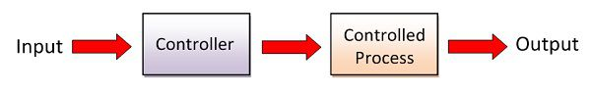
Figure 1: Open-Loop Control System [1]

The advantage of an open loop is that they are cheap and simple to run and operate. The problem with an open-loop is that they are not accurate and cannot change the output automatically without manual feedback because of this, open-loop systems are not suitable for complex processes. The input signal cannot compensate for any disturbances that occur in the system that may alter the output signal. To be able to calculate for this error, a feedback loop installed. This changes it to a closed-loop system.

A closed-loop system is able to monitor the output of the system by taking the process output and redirecting it back into the input. The system subtracts the output signal from the input signal. This gives an error signal that the system can adjust to. The most simples closed-loop system is called a Discrete Controller, where once the system has reached its set point value it the system turns itself off. A discrete controller is easy and cheap to maintain but only has two output states (On/Off) and never settles on the setpoint and creates an oscillating signal.

For better control and accuracy for maintaining the setpoint, a PID controller is used. As stated in its name, a PID controller uses three control terms, Proportional, Integral, and Derivative. The three terms of the PID calculates and controls the output signal so that there is zero error between the setpoint and process value. To accurately calculate the error value uses the PID terms by;
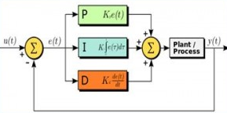
Figure 2: Block Diagram of PID Controller [2]

- Proportional (K_{P}) – The proportional value is calculated by ‘the actual value of a controlled device minus the desired value’ [3]. The proportional value is the current value of the system and decreases the steady-state error. With this alone in a system, however, the set value can never be reached.

- Integral (K_{I}) – The Integral controller removes the steady-state error that occurs from the P controller. The I controller takes the past error values from the P controller and integrates it over time. However, with the P-I controller in the system, it can result in the overshooting of the setpoint and cause oscillation.

- Derivative (K_{D}) – ‘The derivative is taken from the output response of the system variable instead of the error signal.’ [4]. It uses the rate in which the error changes, which dampens the effects of overshoot and oscillation that can be caused by the P-I and stabilises the system. The derivative is also able to reduce the time it takes for the system to settle.

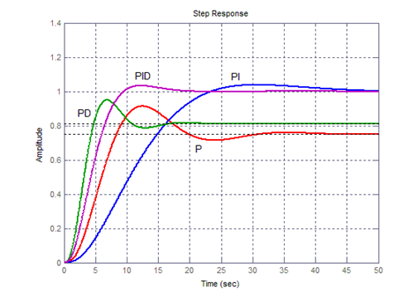
Figure 3: Output signals of P, P-I, P-D, PID [5]

The table below shows the effects of the K_{P}, K_{I}, and K_{D} have in a PID controller.

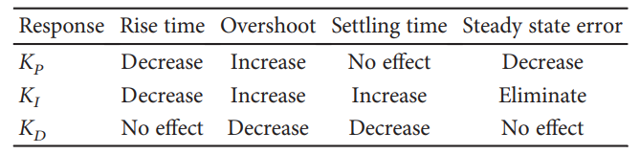
Figure 4: Effects of the KP, KI, and KD [6]

With all three calculations occurring simultaneously from the controllers, the system can produce a zero steady state error by reducing the oscillation and eliminating the overshoot. It is vital to get these correct for there to be stability in the system. As seen, the stability can be affected by the incorrect K_{p}, K_{i,} and K_{d} values, but other factors need to be taken into account, such as noise and lag.

A variable outside the system usually causes noise, which disrupts the steady-state. For example, noise can be ‘caused by wear and tear on the sensor or some physical obstruction that causes the sensor to send an inaccurate reading to the controller.’ [7]. If the noise is known and well recorded in a system, it can be tuned out by the derivative. The system can also be installed with filters to suppress the noise affecting the system. A delay in the system usually causes lag. It needs to be measured when designing the system as it can cause the signal to begin to oscillate, causing the system to fail and the plant being damage.

To better understand the stability of the system, it can be represented using several graphs;

- Pole Zero Diagram – A Pole Zero Diagram shows the response of the system if the transfer function is known. The poles are ‘The complex frequencies that make the overall gain of the filter transfer function infinite.’ And the zeros are ‘The complex frequencies that make the overall gain of the filter transfer function zero.’ [8]

- Nyquist Diagram – This plots the various values of frequency that occur in the control system. Distance from the origin on the graph equates to the gain of the system. It can also represent the phase shift between the input and output by the angle from the origin. The point in which unit circle

- Bode diagram – ‘Bode diagrams are graphical representations of the frequency responses and are used in solving design problems. Magnitude and phase functions are shown on separate graphs using a logarithmic frequency scale along the x-axis.’ [9]

There are several ways to tune and work out the values of K_{p}, K_{I,} and K_{D}, to ensure that the system runs as efficiently and smoothly as possible. One method is called the Ziegler Nichols method. This method involves increasing the gain of the K_{p} value so that the output signal begins to oscillates. ‘Once oscillation starts, the critical gain K_{c} and the period of oscillations P_{c} are noted.’ [10]. The problem with using this method is that it requires a physical plant that needs to run up to an unstable condition that could cause damage. The other physical testing method is called the Cohen-Coon method. The Cohen-Coon method requires running the plant and measuring three of the process responses, process gain, the time constant, and the dead time in the beginning.

The other option of tuning a system is using model-based tuning. This method requires using computer software to design and model the system. Using this method, it is possible to adjust the PID values easily or to put in the system requirements. With computer modeling, it is possible to simulate these systems before they are implemented into a process.

When designing a PID controller for its desired process, the correct parameters must be implemented to provide an effective and responsive system to achieve a steady-state at the set point. It has been reported that ’80% is badly tuned and operates inappropriately or at least not optimally (Yamamoto and Hashimoto (1995), Bialkowski (1993), Ender (1994)). These studies indeed show that 30% of the PID loops work in manual and that another 30% of the loops increase short term variability of the process to be controlled (typically due to a too strong integral action). Looking closer at the PID’s under study, even 25% of the loops use default factory settings’ [11]. If a controller is poorly designed or badly tuned, it can result in the system failing in three key areas. The system can fail to reach or overshooting past it’s set point or can oscillate. As a result, the plant can get damaged by reaching its upper limits. It can also prove more expensive to run as the system wastes energy being continuously turned on and off to reach a steady state.

As stated before, the importance of a well-tuned and stable controller is vital for an efficient and productive process, especially in an industrial setting. Therefore this report has investigated the design of a PID controller within a system. The process is required to be under control within a two-second period and has an overshoot of less than 5%, and, as such, the system has to be tuned to achieve these requirements. The results from the tuned system were then validated against a single transfer function, and comparisons were made.

Method

To better understand the full effects of the PID controller, a system was designed in a simulation software MATLAB and Simulink. Figure 5 below shows the design of the system.

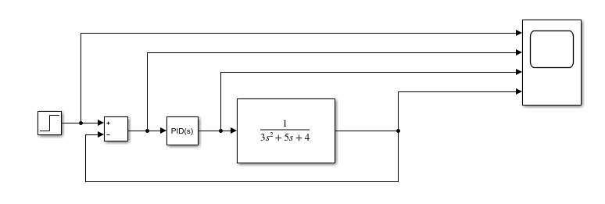
Figure 5: PID System

The system contained the following components.
- Step Input – The step input was used as the set point for the system to aim for. For the simulation, the value was set at one.
- Error Calculator Block – The error calculator took the Step input and minus the value from the feedback loop.
- PID Controller – For the Initial simulation, the values of the P, I, and D did not change.
- Transfer Function – The transfer function was used to simulate the process. The transfer function was represented with the equation below.

$$G\left(s\right)=\frac{1}{as^{2}+bs+c}$$

The variables values (a, b, and c) in the denominator of the equation were predetermined and are stated in the table.

a | b | c
3 | 5 | 4

- Scope – The scope took several components within the system to monitor the output of the components.
- Feedback Loop – The feedback loop was used to close off the system and to reinsert the process value back into the Error Calculator.

Once the system had been modelled in MATLAB, it was run in a simulation for 10 seconds. The results allowed for a baseline for the system to be tuned from. The tuning was able to be done within Simulink by adjusting the Response Time and Transient Behaviour. The requirements for the tuned system were it needed to be under control within two seconds and an overshoot of less than 5%.

The tuned system was validated by converting the closed-loop system to an open-loop single transfer function. The K_{p}, K_{I}, K_{D}, and N that were generated from the tuned system were inserted into several mathematical equations for the conversion. The single transfer system was then compared to the tuned system.

Results

The PID controller was simulated and ran for 10 seconds with the given values for the transfer function. Below are the readings from the scope in order of Step input, Error Calculator Block, PID Controller, and the Transfer Function.
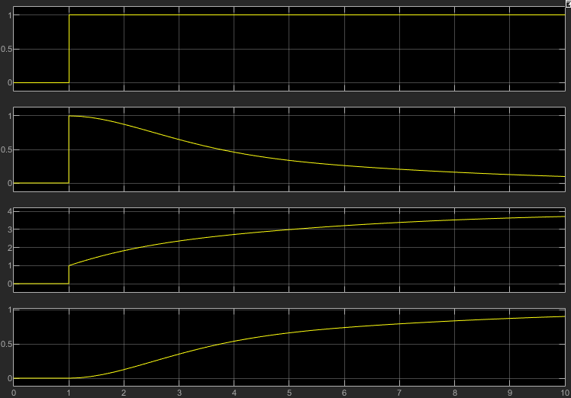
Figure 6: Untuned Output
The graphs show that the system is stable without tuning, but the system never reaches its set point. The time it takes for the system to reach this takes 10 seconds.

The system was then tuned using the Response Time and Transient Behaviour sliders to the requirements. The table below shows the new parameters from the tuned system.
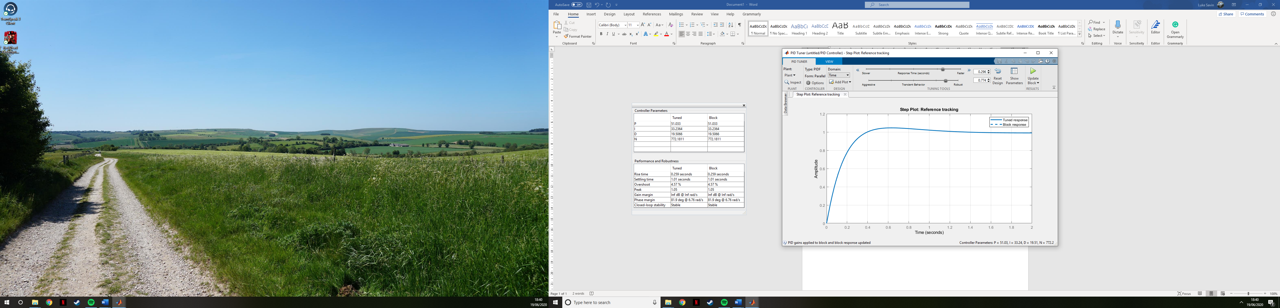
Figure 8: Tuned Controller Parameters

The scope from the tuned system shows a more aggressive and quicker response time.
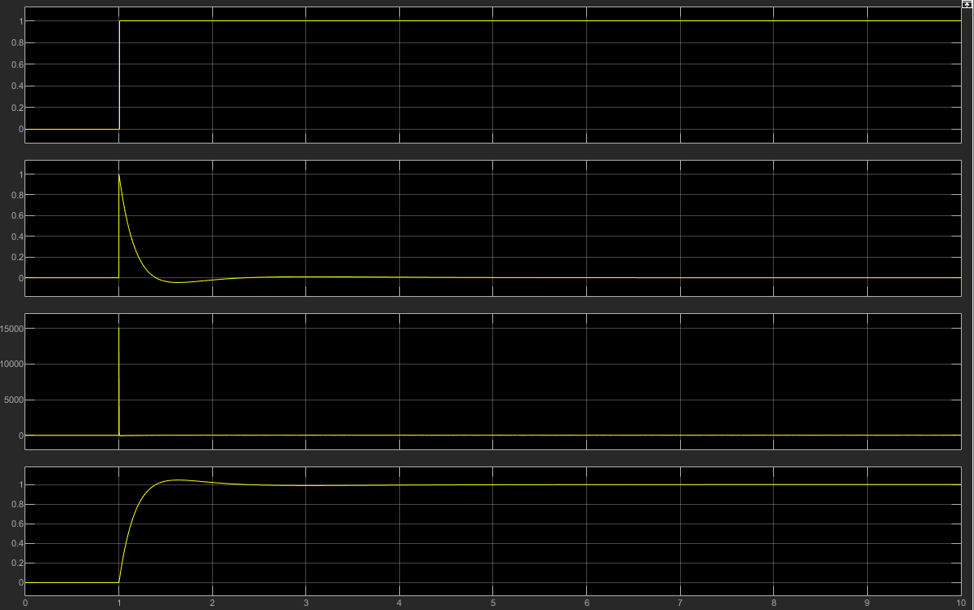
Figure 9: Tuned Output Scope

A closer look at the output of the system shows that there was a small overshoot, to begin with, but the setpoint is reached quicker and has a 0 steady state error.
Figure 10: Tuned Output

A Pole Zero map was plot using MATLAB and showed that all the Poles and Zeros that are plotted on the Real axis and left to the imaginary axis, showing that the system is stable.

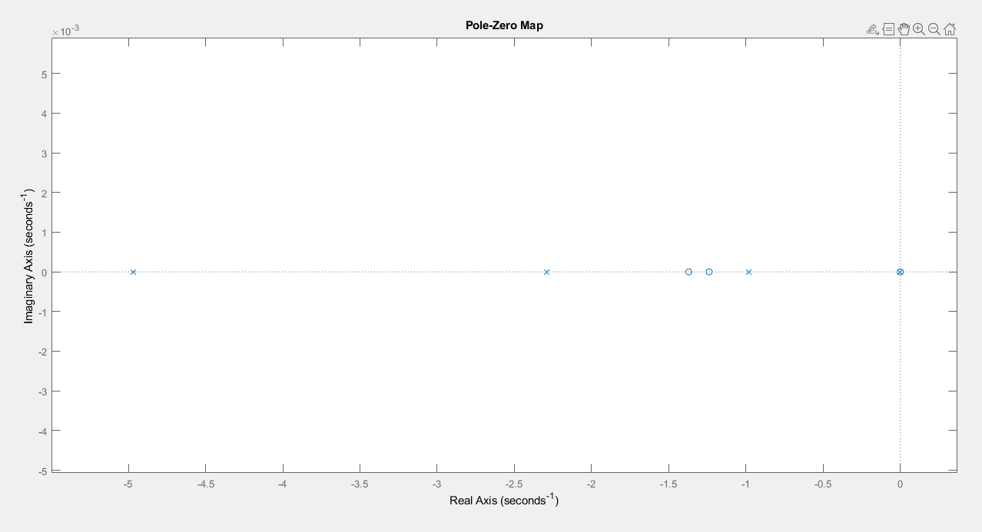
Figure 11: Pole-Zero Map of the tuned System

To validate the tuned system, the K_{p}, K_{I}, K_{D}, and N values that were obtained were used to find the closed-loop transfer of the system as a whole to make a single block transfer function. To do this, the K_{p}, K_{I}, K_{D}, and N were inserted into a mathematical equation to give a new value for the numerator and denominator of the single block.

The system was redesigned with a single block transfer function with the new values and a set input and scope.
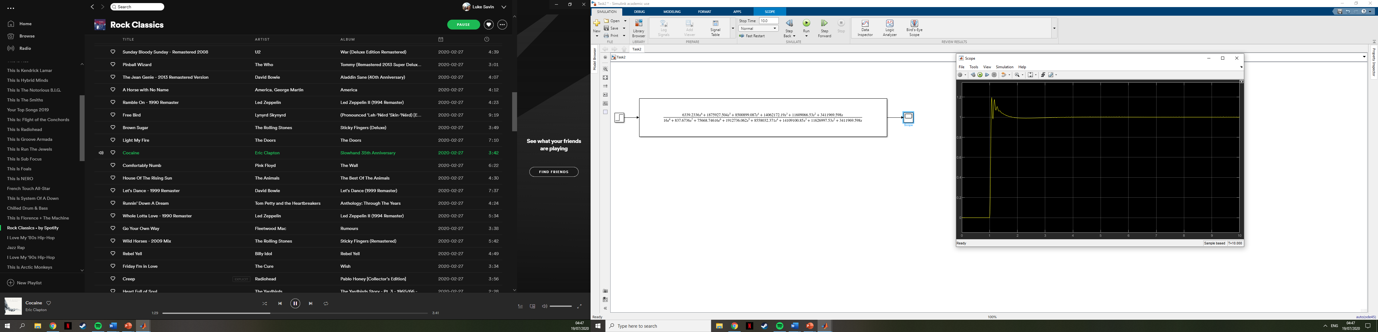
Figure 14: Single Block Transfer Function

After running the simulation, the scope shows that the initial gain of the system is even quicker and has a more significant overshoot. This is then followed by slight oscillation before reaching the setpoint.
Figure 15: Single Block Output Scope

A Pole-Zero map was again created to show the stability of the system. It shows that all the poles and zeros are left of the imaginary axis, meaning it is stable, but there is a conjugate pole pair that represents the decay that occurs.
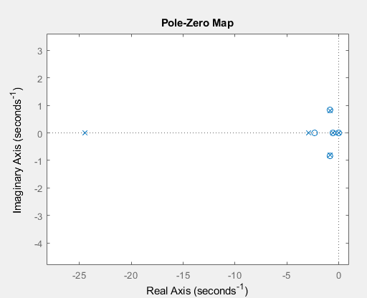
Figure 17:Pole-Zero of the Single Block

Discussion

The graph below represents the output responses from the two systems. The expected results were that the two outputs were similar. The error that occurred in the difference between the two signals can be put down to human error while calculating the mathematical equation for the single block.
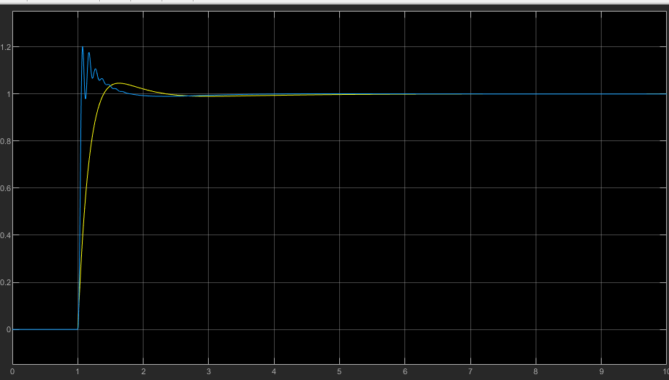
Figure 20: Comparison of PID and Single Block systems

The initial output signal of the single block system has a much more aggressive rise than the PID system, as week as a more substantial overshoot. The PID controller has an overshot but not as extreme as the single block and to brought under control in smoother action. In contrast, the single block suffers from oscillation before being brought under control at the set point. Both systems reach the set point at approximately the same time and stable after this. The overshoot and oscillation that occurs are caused by the initial aggressive reaction rate.

Conclusion

This report has looked into control system for processes and, more exclusively, a PID controller and their properties that affect the output. To prove out that the tuned modeled PID, the values were put into mathematical equations. Unfortunately, due to human input, an error occurred during the working out, which resulted in the single block showing a different response. Even though the single block system becomes stable once reaching the set point, it could not be used in the real world as it does not meet the requirement of having less than a 5% overshoot. If this was put on a system, it could damage the process and costing the company.

This shows the importance of tuning and testing the system. For the most efficient and stable controller, it's essential to tune the system. With prior knowledge of PID controllers, it could be advised to use heuristic methods of tuning, such as Cohen-Coon or Ziegler-Nichols. These methods can be used in hand with Pole-Zero and Nyquist diagrams and other techniques to gain a full understanding of what is occurring in the system. But as shown in this report calculation can be incorrect, and with the advantage of modern technology, it is easy to adjust the values, so that the controller performs in a way that is required the system

Equations for Single Block Functions [12]

Using the PID tuner in MATLAB, the following values were obtained:

Kp: 51.033
Ki: 33.2364
Kd: 19.5066
N: 772.1811

So the transfer function of the PID controller will be:

$$K_{p}+K_{i}\frac{1}{s}+K_{d}\frac{s}{\frac{1}{N}s+1}$$

$$51.033+\frac{33.2364}{s}+19.5066\frac{s}{\frac{1}{772.1811}s+1}$$

To calculate the forward path transfer function of the system, the controller’s transfer function must be multiplied by the transfer function of the process.

$$\left(51.033+\frac{33.2364}{s}+19.5066\frac{s}{\frac{s}{772.1811}+1}\right)×\left(\frac{1}{3s^{2}+5s+4}\right)$$

$$\left(51.033+\frac{33.2364}{s}+19.5066\frac{s}{\frac{s+772.1811}{772.1811}}\right)×\left(\frac{1}{3s^{2}+5s+4}\right)$$

$$\left(51.033+\frac{33.2364}{s}+19.5066\left(s÷\frac{s+772.1811}{772.1811}\right)\right)×\left(\frac{1}{3s^{2}+5s+4}\right)$$

$$\left(51.033+\frac{33.2364}{s}+19.5066\left(s\left(\frac{772.1811}{s+772.1811}\right)\right)\right)×\left(\frac{1}{3s^{2}+5s+4}\right)$$

$$\left(51.033+\frac{33.2364}{s}+19.5066\left(\left(\frac{772.1811s}{s+772.1811}\right)\right)\right)×\left(\frac{1}{3s^{2}+5s+4}\right)$$

$$\left(51.033+\frac{33.2364}{s}+\left(\frac{15062.6279s}{s+772.1811}\right)\right)×\left(\frac{1}{3s^{2}+5s+4}\right)$$

$$\left(\frac{\left((s\left(s+772.1811\right))×51.033\right)+\left(s+772.1811\right)33.2364+s\left(15062.6279s\right)}{s\left(s+33.2364\right)}\right)×\left(\frac{1}{3s^{2}+5s+4}\right)$$

$$\left(\frac{772.1811s^{2}+39406.7181s+33.2364s+25664.5199+15062.6279s^{2}}{s^{2}+33.2364s}\right)×\left(\frac{1}{3s^{2}+5s+4}\right)$$

$$\left(\frac{15834.8084s^{2}+54469.346s+25664.5199}{s^{2}+33.2364s}\right)×\left(\frac{1}{3s^{2}+5s+4}\right)$$

$$\frac{15834.8084s^{2}+54469.346s+25664.5199}{\left(s^{2}+33.2364s\right)\left(3s^{2}+5s+4\right)}$$

$$\frac{15834.8084s^{2}+54469.346s+25664.5199}{4s^{4}+5s^{3}+4s^{2}+99.7092s^{3}+166182s^{2}+132.9456s}$$

$$\frac{15834.8084s^{2}+54469.346s+25664.5199}{4s^{4}+104.7092s^{3}+170.182s^{2}+132.945s}$$

The block diagram can now be redrawn as:

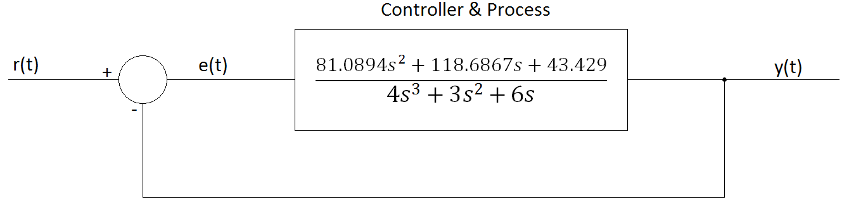
$$\frac{15834.8084s^{2}+54469.346s+25664.5199}{4s^{4}+104.7092s^{3}+170.182s^{2}+132.945s}$$

Now we remove the feedback loop and calculate the transfer function of the system as a whole.
Using:

$$TF=\frac{G}{1+GH}$$

Where TF is the transfer function of the whole system, G is the forward path transfer function, and H is the transfer function of the feedback loop, in this case, $H=1$

$$TF=\frac{\frac{15834.8084s^{2}+54469.346s+25664.5199}{4s^{4}+104.7092s^{3}+170.182s^{2}+132.945s}}{1+\left(\frac{15834.8084s^{2}+54469.346s+25664.5199}{4s^{4}+104.7092s^{3}+170.182s^{2}+132.945s}\right)×1}$$

$$TF=\frac{\frac{15834.8084s^{2}+54469.346s+25664.5199}{4s^{4}+104.7092s^{3}+170.182s^{2}+132.945s}}{\frac{4s^{4}+104.7092s^{3}+170.182s^{2}+132.945s}{4s^{4}+104.7092s^{3}+170.182s^{2}+132.945s}+\frac{15834.8084s^{2}+54469.346s+25664.5199}{4s^{4}+104.7092s^{3}+170.182s^{2}+132.945s}}$$

$$TF=\frac{\frac{15834.8084s^{2}+54469.346s+25664.5199}{4s^{4}+104.7092s^{3}+170.182s^{2}+132.945s}}{\frac{4s^{4}+104.7092s^{3}+170.182s^{2}+132.945s+15834.8084s^{2}+54469.346s+25664.5199}{4s^{4}+104.7092s^{3}+170.182s^{2}+132.945s}}$$

$$TF=\frac{\frac{15834.8084s^{2}+54469.346s+25664.5199}{4s^{4}+104.7092s^{3}+170.182s^{2}+132.945s}}{\frac{4s^{4}+104.7092s^{3}+16005.9904s^{2}+54602.291s+25664.5199}{4s^{4}+104.7092s^{3}+170.182s^{2}+132.945s}}$$

$$TF=\frac{15834.8084s^{2}+54469.346s+25664.5199}{4s^{4}+104.7092s^{3}+170.182s^{2}+132.945s}×\frac{4s^{4}+104.7092s^{3}+170.182s^{2}+132.945s}{4s^{4}+104.7092s^{3}+16005.9904s^{2}+54602.291s+25664.5199}$$

$$TF=\frac{\left(15834.8084s^{2}+54469.346s+25664.5199\right)\left(4s^{4}+104.7092s^{3}+170.182s^{2}+132.945s\right)}{\left(4s^{4}+104.7092s^{3}+170.182s^{2}+132.945s\right)\left(4s^{4}+104.7092s^{3}+16005.9904s^{2}+54602.291s+25664.5199\right)}$$

$$TF=\frac{63339.2336s^{6}+{1658050.12s}^{5}+{2694799.363s}^{4}+{2105158.603s}^{3}+{217877.384s}^{5}+{5703441.644s}^{4}+}{16s^{8}+418.8368s^{7}+{64023.9616s}^{6}+{218409.164s}^{5}+{102658.0796s}^{4}+{418.8368s}^{7}+10964.01656s^{6}+1675974.45s^{5}+{5717362.209s}^{4}+{2687311.347s}^{3}}$$
$$⋯$$
$$\frac{+ 9269702.241s^{3}+{7241427.204s}^{2}+{102658.0796s}^{4}+{2687311.347s}^{3}+{4367639.326s}^{2}+3411969.598s}{+ 680.768s^{6}+{17820.66817s}^{5}+{2724091.518s}^{4}+{9292873.11s}^{3}+{4367895.971s}^{2}+{531.78s}^{5}+{13920.56459s}^{4}+{2127916.394s}^{3}+{7259101.577s}^{2}+3411969.598s}$$

Collecting like terms…

$$TF=\frac{6339.2336s^{6}+1875927.504s^{5}+8500899.087s^{4}+14062172.19s^{3}+{11609066.53s}^{2}+3411969.598s}{16s^{8}+837.6736s^{7}+75668.74616s^{6}+{1912736.062s}^{5}+{8558032.371s}^{4}+{14109100.85s}^{3}+{11626997.53s}^{2}+3411969.598s}$$

The block diagram can now be redrawn again as a single block.
r(t)
y(t)
$$\frac{6339.2336s^{6}+1875927.504s^{5}+8500899.087s^{4}+14062172.19s^{3}+{11609066.53s}^{2}+3411969.598s}{16s^{8}+837.6736s^{7}+75668.74616s^{6}+{1912736.062s}^{5}+{8558032.371s}^{4}+{14109100.85s}^{3}+{11626997.53s}^{2}+3411969.598s}$$

References

[1] | Circuit Globe, “Difference Between Open Loop & Closed Loop System (with Comparison Chart) - Circuit Globe,” [Online]. Available: https://circuitglobe.com/difference-between-open-loop-and-closed-loop-system.html. [Accessed 14 07 2020].
[2] | ElProCus - Electronic Projects for Engineering Students, “How Does a PID Controller Work? - Structure & Tuning Methods,” [Online]. Available: https://www.elprocus.com/the-working-of-a-pid-controller/. [Accessed 17 07 2020].
[3] | Arrow.com, “PID Controller Basics & Tutorial: PID Arduino Project,” 01 11 2019. [Online]. Available: https://www.arrow.com/en/research-and-events/articles/pid-controller-basics-and-tutorial-pid-implementation-in-arduino. [Accessed 17 07 2020].
[4] | S. Y. S. G. Sena TEMEL, “DISCRETE TIME CONTROL SYSTEMS,” MIDDLE EAST TECHNICAL UNIVERSITY.
[5] | Sysbook.sztaki.hu, “System Book,” 2020. [Online]. Available: http://sysbook.sztaki.hu/sysbook6.php?page=97&lang=en&left=intro&right=theory. [Accessed 2020 07 18].
[6] | S. S. A. S. A. K. S. S. Zuwwar Khan Jadoon, “A Comparative Analysis of PID, Lead, Lag, Lead-Lag, and Cascaded,” Journal of Healthcare Engineering, no. 2017, p. 13, 2017.
[7] | Control Engineering, “Noise and disturbances in process control,” 2020. [Online]. Available: https://www.controleng.com/articles/noise-and-disturbances-in-process-control/#:~:text=Noise%20can%20also%20be%20caused,occur%20when%20the%20setpoint%20changes.. [Accessed 19 07 2020].
[8] | Pilot.cnxproject.org, “Poles and Zeros in the Z-Plane,” 2020. [Online]. Available: http://pilot.cnxproject.org/content/collection/col10064/latest/module/m10556/latest. [Accessed 2020 07 19].
[9] | W.-K. Chen, The Electrical engineering handbook, Amsterdam: Elsevier academic Press, 2005.
[10] | Ni.com, “PID Theory Explained,” [Online]. Available: https://www.ni.com/en-gb/innovations/white-papers/06/pid-theory-explained.html. [Accessed 18 07 2020].
[11] | P. V. Overschee, “RAPID: The End of Heuristic PID Tuning,” IFAC Proceedings Volumes, vol. 33, no. 4, pp. 595-600, 2000.
[12] | S. Mosey, Assignment Task 2 Worked ExampleFile, Swansea, 2020.

