

Programme:
Master of Business Administration
Module Title:
International Marketing: Principles and Practices
Module Code:
LCMB7026
Module Lecturer:
Tushara Balendran
Title:
International Market Entry Strategy and Marketing Mix Analysis of Toyota: A Comparative Study of Japan and the United Kingdom
Submitted By:
Ajith Nagarajan
Student ID:2525947
Submission Date: 13 August 2026

Table of Contents
AI Use Acknowledgement 4
Section 1: International Market Entry Strategy and Marketing Mix of Toyota in Japan and the UK 6
1. Introduction 6
2. Comparative Analysis of Japan and UK Markets 6
2.1 PESTLE Analysis 7
2.2 Hofstede Culture Dimension 13
2.3 Segmentation: Japan and the UK 17
3. International Marketing Mix (7Ps): Toyota Japan and United Kingdom 23
4. Toyota Market Entry Strategy in the UK 30
5. Ethical Issues in Toyota’s Marketing Mix 31
6. Recommendations for Toyota’s Future International Marketing Strategy 32
Section 2: Reflective Account Using Gibbs’ Reflective Cycle 34
References 39

AI Use Acknowledgement
I have utilised various web page and AI-supported resources to prepare this assignment entitled “International Market Entry Strategy and Marketing Mix Analysis of Toyota: A Comparative Country Study of Japan and the United Kingdom”. These resources were utilized in different stages of the work including researching, planning, organising, proofreading, paraphrasing, editing and improving the overall academic presentation from 20 July, 2026 to 10 August, 20206. The report focuses on the use of PESTEL analysis, Hofstede’s Cultural Dimensions, Segmentation, Targeting and Positioning (STP), the 7Ps Marketing mix, Porter’s Five Forces, recommendations, and Gibbs’ Reflective Cycle.

2. QuillBot was primarily employed as a language-supporting paraphrasing tool. It helped to reorganize the sentences, rectify the errors in grammar, improve clarity and express ideas suitably in academic language. The tool was similarly able to reword selected parts while holding the value and meaning in their original form, cut down less important repeat, lessen similar wording and alter wording patterns. Also, they were agreed to modify the phrasing when requisite for effective word count. The final phrasing was checked to make sure that the meaning of the statements was still intact.

3. ChatGPT (OpenAI) https://chatgpt.com/ served as a supporting resource throughout the planning, organisation and development of the assignment. It assisted with structuring the report and with understanding and presenting the visual representation of strategic frameworks used in the analysis: PESTEL, Hofstede’s Cultural Dimensions, STP, VALS, the 7Ps Marketing Mix, Porter’s Five Forces and Gibbs’ Reflective Cycle. The tool also supported proofreading, helped organise the academic arguments and assisted in refining the final reflective section. These frameworks were used to examine and compare Toyota’s marketing strategy, business environment and market conditions in Japan and the United Kingdom.

Prompt: In the context of the automotive industry, create a PESTEL analysis of external business factors for Toyota in the UK and Japan. Prompt: “Discuss the application of STP and VALS model to segment and analyse the target customer segments for Toyota in Japan and UK.” Prompt: “Write a comparison of Toyota 7Ps Marketing Mix in Japan and the United Kingdom maintaining an academic style.” These frameworks were utilized to analyse and compare the marketing strategy of Toyota and their business environment and market conditions of Japan and the United Kingdom.

4. Google Scholar (https://scholar.google.com/) served as the main academic research resource for finding journal articles, scholarly publications, and theoretical literature related to the models and concepts used in this assignment. The searches covered PESTEL analysis, Hofstede’s Cultural Dimensions, STP, the 7Ps Marketing Mix, Porter’s Five Forces, international marketing, and Gibbs’ Reflective Cycle. Relevant academic literature and dependable supporting evidence added depth to the analysis. Company information, government publications, and industry sources were also consulted to provide additional evidence and context.

These digital and AI-supported resources served as supplementary aids, not substitutes for my own academic judgement, critical thinking or analysis. I used them to help gather, review, organise and refine information, but responsibility for the accuracy, relevance, interpretation, critical evaluation, recommendations, reflection and conclusions in the final assignment remains entirely mine.

I confirm that I have not presented any AI generated text as my own work. I confirm I have copies of my drafts, notes, and other resources I used before, and after the use of AI tools which I may be asked to provide in evidence.

Section 1: International Market Entry Strategy and Marketing Mix of Toyota in Japan and the UK

Introduction
Toyota is chosen for this report due to its home market being Japan, and its major overseas host market being the United Kingdom. Toyota continues its global presence with the reliability, innovation and a “multi-pathway” strategy toward carbon neutrality, including hybrid electric vehicles, plug-in hybrids, battery electric vehicles and hydrogen technologies (Toyota Motor Corporation, 2025a).
Toyota continues to be the top-selling car brand in Japan. Japan's new-vehicle market is up 3.3% at 4,565,777 vehicles for 2025, with Toyota's market share rising about 1%, and the number of its vehicle sales has increased by about 60,000 (Bekker, 2026). In 2025, the Toyota Yaris model emerged as the top-selling car in Japan, secure a 33.6% share driven by Toyota's supremacy, followed by Suzuki (15.1%) and Honda (14.4%) (Focus2Move, 2026).
Demand for passenger cars remained high, with the market rising by 3.5% to reach 2,020,520 vehicles in 2025. Toyota's performance reflects the successful transposition of Japanese engineering skills to the UK's consumers' needs for reliability, hybrid technology and sustainable mobility (MarkLines Co, 2026).
This report critically reflects on Toyota's macro-environment, cultural influences, STP strategies, VALS, 7Ps marketing mix, UK market entry strategy, ethical issues and future recommendations.

Comparative Analysis of Japan and UK Markets
For the comparative analysis of Japan and UK Markets framework such as PESTEL and Hofstede framework are used to compare and contrast the cultural factors in both countries.

2.1 PESTLE Analysis
The PESTLE analysis for Japan and UK is presented in Table 1 below. However further the PESTLE analysis for both countries is presented in detail in this section.
Table 1: PESTLE Analysis of Japan and UK Markets
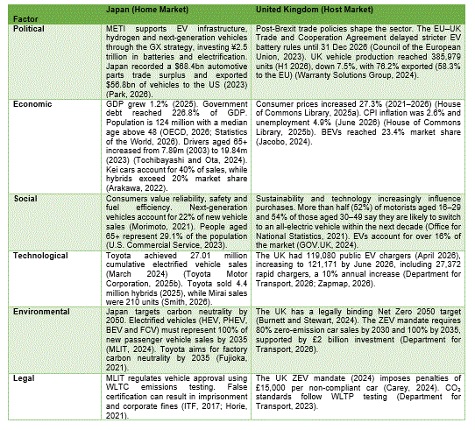

PESTLE Analysis of Japan (Home Market)
Political Factors
Toyota has a supportive political climate in Japan because the government is involved in developing the automotive industry. The Ministry of Economy, Trade and Industry (METI) is promoting the next generation vehicle technologies under policies for EVs, fuel-cell vehicles, charging infrastructure, and automotive supply chains. The government has provided ¥2.5 trillion to support Japan's battery and electrification value chains as part of its Green Transformation (GX) initiative, bolstering local innovation in the automotive sector. Japan holds a solid international automotive trade surplus of $68.4 billion in 2023, and exported $56.8 billion worth of automobiles to the US in 2023 (Park, 2026).
Economic Factors
Japan continues as advanced economies globally, with GDP growth of 1.2% in 2025, primarily driven by domestic demand (OECD, 2026). Toyota is, however, facing a difficult economic climate as population decline, an ageing society and the high public debt, which in the end stood at about 226.8% of GDP. Japan has approximately 124 million people, and a median age of over 48 (Statistics of the World, 2026). As the population of elderly drivers has grown, so has the demand for vehicles, rising from 7.89 million in 2003 to 19.84 million in 2023 (Tochibayashi and Ota, 2024). Toyota enjoys high sales of compact fuel-efficient cars because kei cars make up approximately 40% of Japan's new car market and hybrid cars have achieved over 20% market share because of their fuel efficiency and government incentives (Arakawa, 2022).
Social Factors
Japanese consumers have a high expectation of vehicle reliability, safety, fuel economy and cost, which are similar to Toyota's well-known reputation for quality, durability and technological innovation (Morimoto, 2021). In addition, Japan’s ageing population, with 29.1% aged 65 and above, has increased demand for vehicles offering enhanced safety, accessibility and driver-assistance technologies. Toyota's foresight and reliable hybrid cars and advanced safety features allow the company to effectively meet the trends and expectations of the population and its culture (U.S. Commercial Service, 2023).

Technological Factors
In Japan, technology is one of Toyota's competitive advantages. In hybrid technology, the company has helped lead the world with a total sale of 27.01 million electrified vehicles through Toyota and Lexus, as of March 2024 (Toyota Motor Corporation, 2025b).
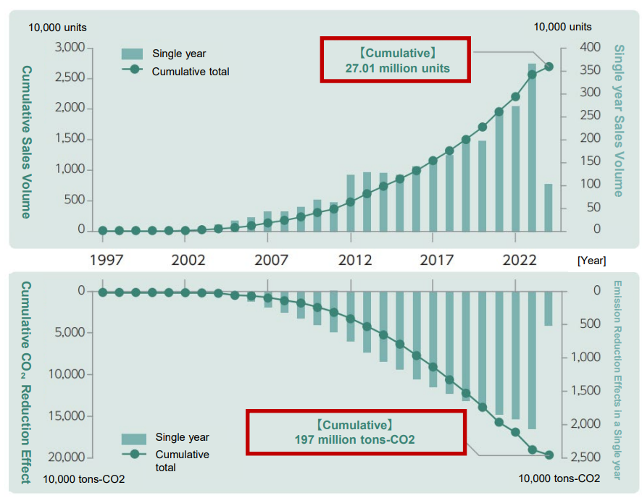
Figure 1: Toyota’s Cumulative Sales of Electrified Vehicles (Toyota Motor Corporation, 2025b).
The hybrid technology play a significant role in Toyota's strategy, with the company selling 4.4 million hybrid vehicles in 2025. While Toyota investing in hydrogen fuel-cell technology, commercialization is not widespread, with only 210 hydrogen vehicles (Toyota Mirai) sold in 2025; Smith, 2026).
Environmental Factors
The METI has identified 14 priority areas for sustainable economic development in the Green Growth Strategy, which sets the goal of reaching carbon neutrality in Japan by 2050. The government wants HEVs, PHEVs, BEVs and fuel-cell vehicles to account for 100% of new passenger vehicle sales by 2035 (MLIT, 2024). In response, Toyota has announced that it speeds its own factory carbon neutrality initiative from 2050 to 2035. Through these environmental policies, Toyota is promoted to development of low carbon technologies and to retain its hybrid leadership (Fujioka, 2021).
Legal Factors
Toyota is required to comply with strict Japanese automotive regulations under the control of the Ministry of Land, Infrastructure, Transport and Tourism (MLIT). Manufacturers have to meet safety approval and environmental testing protocols, such as WLTC emissions standard that was introduced in 2018 (ITF, 2017). There are penalties for companies that fail to certify information, such as imprisonment and corporate fines (Horie, 2021).

PESTEL Analysis of United Kingdom (Host Market)
Political Factors
Trade policies and evolving automotive regulations following Brexit have influenced the UK automotive market heavily. The EU–UK Trade and Cooperation Agreement gave a grace period for EV battery local-content requirement until the end of 2026, which allowed potential 10% tariffs on EV related trade (Global Banking & Finance Review, 2026).
The UK's vehicle production in H1 2026 was 385,979, down 7.5% year-on-year. Vehicles exported from the UK accounted for approximately 76.2% of all vehicles built, with the EU absorbing 58.3% of exports. With political uncertainty and changing trade policies, Toyota become more adept at the supply chain (Warranty Solutions Group, 2024).
Economic Factors
The UK automotive industry is affected by economic pressures resulting from inflation and affordability issues. Consumer prices rose by 27.3% from May 2021 to March 2026, impacting consumer purchasing power (House of Commons Library, 2025a). The CPI inflation rate was 2.6% and unemployment 4.9% in June 2026 (House of Commons Library, 2025b).
Consumers consider vehicle costs is major influence on their purchase decision, with affordability and quality. Battery electric vehicles, on the other hand, accounted for 23.4% of the market, reflecting the increasing demand for sustainable mobility solutions (Jacobo, 2024).
Social Factors
UK consumers consider environmental awareness and sustainable products as important factors when choosing a vehicle. Over half (52%) of motorists aged 16-29 and 54% of those aged 30-49 believe they are likely to purchase an all-electric vehicle within the next 10 years (Office for National Statistics, 2021).
Over 16% of new car sales in the UK are now for EVs, which indicates a change of mind about low-emission modes of transport. Toyota's brand and reputation for hybrid technology is a good asset, but it needs to improve its marketing messaging to emphasis innovation (GOV.UK, 2024).
Technological Factors
The UK has significantly accelerated the growth of its charging infrastructure, contributing to the shift towards cleaner transportation. As of April 2026, there are 119,080 public EV charging stations in the country, with 27,372 of them at 50kW or higher (Department for Transport).
As of June 2026, the charging network reached 121,171 charging stations, which saw a growth rate of 10% compared to 2025. To integrate into digital customer experiences, the development of connected vehicle technologies, such as vehicle connectivity solutions and 5G-enabled systems, also presents opportunities for Toyota (Zapmap, 2026).

Environmental Factors
Toyota's UK strategy is affected by environmental regulations. The UK is legally required to become a net zero greenhouse gas emitter by 2050 as per the Climate Change Act 2008 (Burnett and Stewart, 2024). The Zero Emission Vehicle (ZEV) mandate will mandate 80% of all new cars and 70% of all new vans to be zero emission by 2030, and 100% by 2035. Over £2 billion is being invested in the roll-out of charging infrastructure. Such policies impose pressure on Toyota to expand its BEV product lineup (Department for Transport, 2026).
Legal Factors
The UK motor industry has had to comply with strict emissions regulations and vehicle standards (compliance). The ZEV mandate, which went into effect in 2024, sets annual targets for manufacturers for ZEV sales. Companies who do not meet the targets are fined up to £15,000 per non-compliant car (Carey, 2024).
Toyota will need to achieve emissions compliance and simultaneously make investments in hybrid and electric vehicle technology (Department for Transport, 2023).
Differences between UK and Japan
The key difference between the two markets as per PESTLE analysis is presented below
Table 2: Similarities and differences of Japan and UK Markets
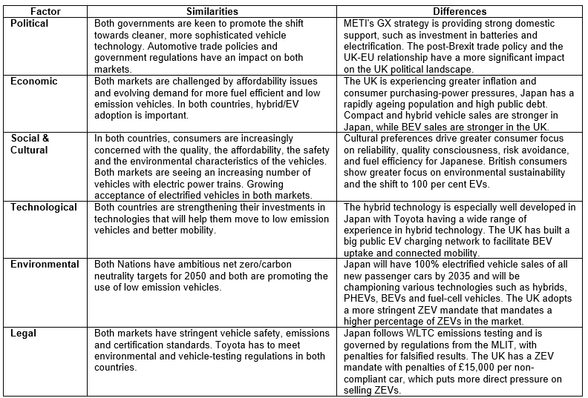

2.2 Hofstede Culture Dimension
Hofstede's cultural dimensions’ framework explains why there are differences in consumer behaviour between Japan and the UK and how these differences would affect Toyota's international marketing strategies (Hofstede, 2011). The key advantages and disadvantages of Hofstede's cultural dimensions’ model are shown in Table 2, while Hofstede's Cultural Dimensions scores for both countries is shown in Fig 3.

Advantages and Disadvantages of Hofstede's Cultural Dimensions Model
Table 3: Advantages and Disadvantages of Japan and UK Markets
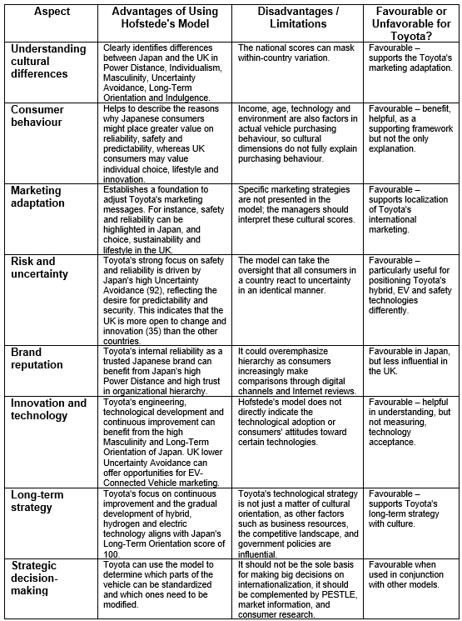

Figure 2: Hofstade Culture Dimension (The Culture Factor Group, 2025)
Hofstede's cultural dimensions Japan
The score for Power Distance in Japan is moderate at 54, which means that there is moderate acceptance of hierarchy and respect for established organisations in the country. This promote Toyota's status as a trusted Japanese brand. Consumers appreciate corporate reliability, responsibility and history of quality (Luo, 2024). The Individualism score in Japan is 62, indicating a balance between individual preferences and collective values. Personal needs are the consumer's consideration, but purchasing decisions are affected by trust, reputation and social expectations (Mishra, 2026).
The country scores very high on the Masculinity scale (95), reflecting a strong focus on achievement, performance, and technological accomplishments. This promotes respect for engineering talent and ingenuity in the automotive industry. In Japan, consumers are very security-oriented and prefer predictability, as reflected by the Uncertainty Avoidance score with a value of 92. With Toyota's reputation of safety, and durability, the perception of risk is lessened in the vehicle purchasing process. In Japan, this cultural trait gives Toyota a solid footing in the market (Frank et al., 2013).
The Long-Term Orientation score of 100 reflects a focus on future orientation and continuous improvement in Japan. The long-term plan is evident in the gradual development of hybrid, hydrogen and electric vehicle (HEV) technology at Toyota. This lower score of Indulgence (42) indicates that consumers are more focused on practicality and moderation, reflecting the efficiency and value offering of Toyota (Fadhlia et al., 2023).
Hofstede's cultural dimensions United Kingdom
The UK has a lower score for Power Distance (35), suggesting a more equal society, with a stronger emphasis on transparency, and more choice in consumer choices. Toyota should pay more attention to what customers want and focus on product comparison and value (Rashedkhan, 2021).
Consumers in the UK are high Individualism (76), they value personal identity and independent decision making. It's also a lifestyle choice, and Toyotaoffer a range of options to satisfy different customer needs.UK consumers are moderately interested in achievement, competition and performance with a Masculinity score of 66. The innovation, reliability and technological features of Toyota contribute to their competitive positioning (Toyota, 2020).
The UK has a lower Uncertainty Avoidance score (35) which represents a willingness to embrace change and innovation. This provides an opportunity for Toyota to market EVs, connected technologies and sustainable mobility solutions (Jeong et al., 2024). The long-term orientation score (60) suggests that UK consumers consider future benefits such as fuel savings and environmental effects (Abdelrahim, 2021).

2.3 Segmentation: Japan and the UK
The appropriate consumer segmentation has been determined using the VALS (Values, Attitudes, and Lifestyles) model and the STP (Segmentation, Targeting, and Positioning) framework. The key variables for STP segmentation with their examples are shown in Table 4.
Table 4: Variables and Examples
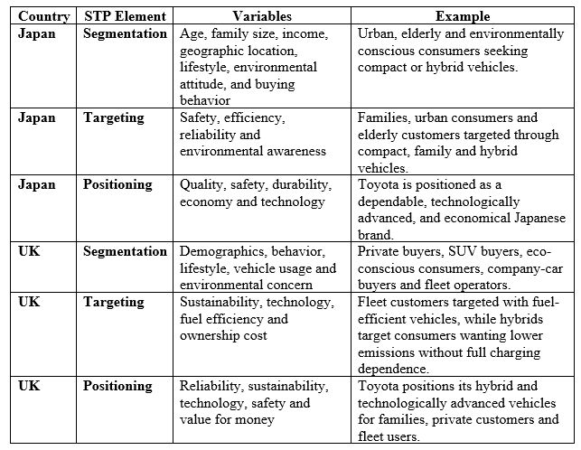

2.3.1 STP Analysis

Japan: STP Strategy
Segmentation
Toyota divides the Japanese market based on demographic, behavioural, lifestyle and attitudes towards the environment, such as age, family size, income, geographical location, and attitudes toward the environment. In total, hybrids accounted for 33.8% of all Japanese vehicle sales in H1 2025 (JATO Dynamics, 2026) and some 40% of all new vehicle sales were kei vehicles in 2024 (Tribdino, 2025).
Targeting
Toyota has a wide targeting strategy, targeting mass market customers who focus on safety, efficiency and reliability. It is designed to meet the needs of environmentally aware and urban, family and elderly consumers in its various range of compact, family and hybrid vehicles (Burnett, 2026). Electrified vehicles and Toyota's reputation can give them an edge, as consumers are becoming more aware of the technology (Ajila et al., 2023).
Positioning
Toyota markets itself as a dependable Japanese company, with technologically sophisticated, long-lasting and economical cars. It focuses on quality, safety and reliable mobility which are in line with the Japanese consumer's preference for function and minimising risk (Toyota UK, 2026).
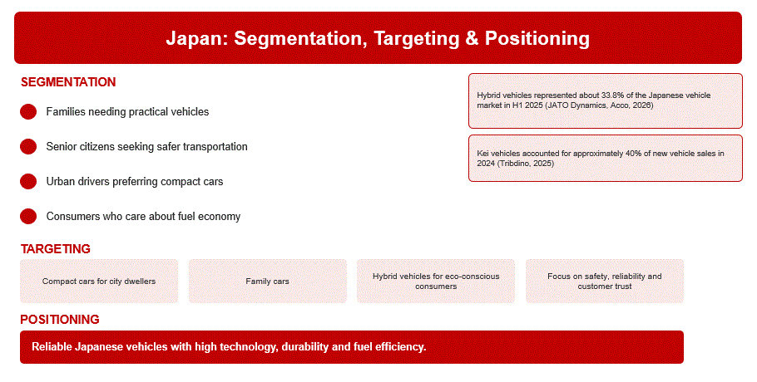
Figure 3: STP Strategy for Japan (Self-Created)

UK: STP Strategy
Segmentation
Toyota segments its market by demographics, behaviour and lifestyle to appeal to the private buyer, the SUV buyer, the eco-minded consumer, the company-car buyer and fleet operators. Of all the new cars sold in the UK in 2025, 23.8% were BEVs and 48.4% were BEVs, PHEVs or HEVs (Drift Bridge Group, 2025; Society of Motor Manufacturers and Traders, 2026).
Targeting
Toyota's focus is on customers who want environmentally friendly and technologically advanced cars at reasonable ownership costs. Fuel-efficient vehicles draw business and fleet customers, and hybrids are attractive to those who want to reduce emissions but don't want to become fully reliant on the charging infrastructure.

Positioning
Toyota is a reputable brand of reliable, sustainable and technologically advanced cars with good value for money. Its range of hybrid skills, economy and safety features and advanced technology sets it apart from families, individual customers and fleet users. There is intense competition with the likes of Volkswagen, BMW, Kia and Mercedes. Volkswagen held an 8.52% market share in 2024, while Toyota held 5.19% (Munnangi, 2025).

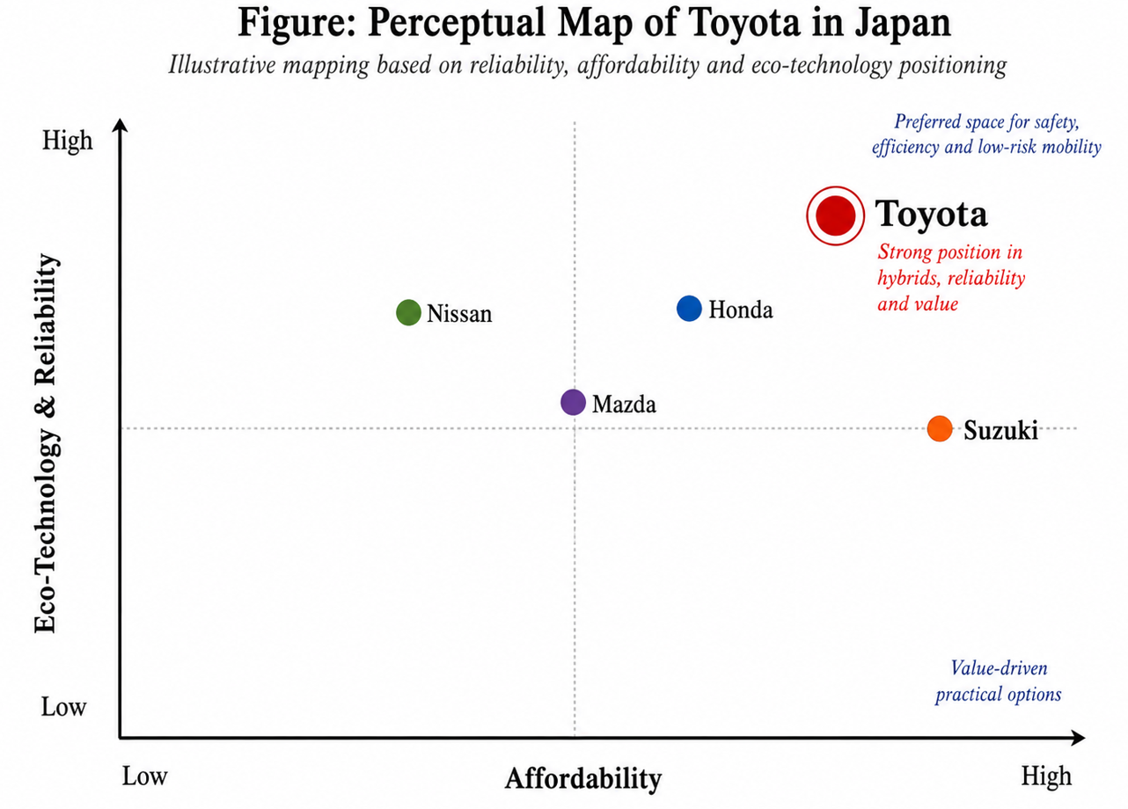
Figure 4: Perceptual Map (Self-Created)
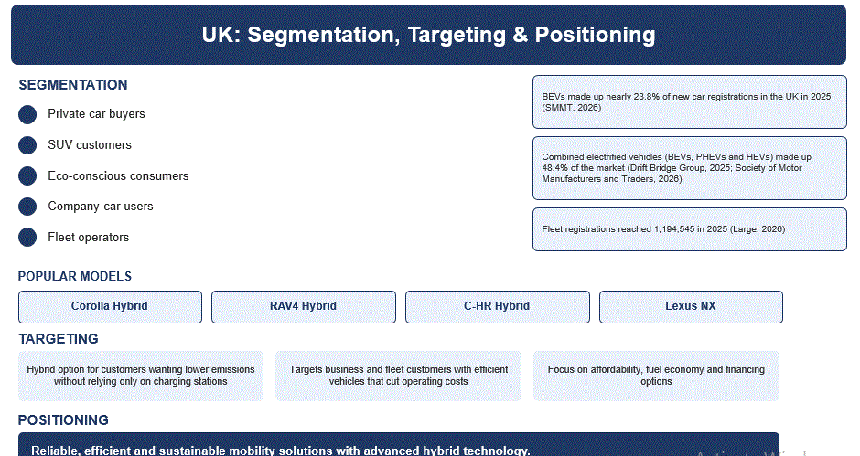
Figure 5: STP Strategy for UK (Self-Created)

2.3.2 VALS Analysis

VALS in Japan
The VALS is a psychographic segmentation that Toyota can complement by using demographic segmentation. There is a preference for reliable and cost-effective vehicles among Thinkers, performance, quality and technology elements among Achievers and stylish and technologically advanced products among Experiencers. Budget and practicality and functionality are important for makers. This helps Toyota to identify the motives and lifestyles of consumers.
VALS in UK
In the United Kingdom, VALS can be used alongside demographic segmentation to determine the consumer based upon lifestyle and purchasing motives. Thinkers could prefer reliability and efficiency, Achievers technology and performance, and Experiencers stylish and innovative vehicles. Cost and usability are considerations for makers.
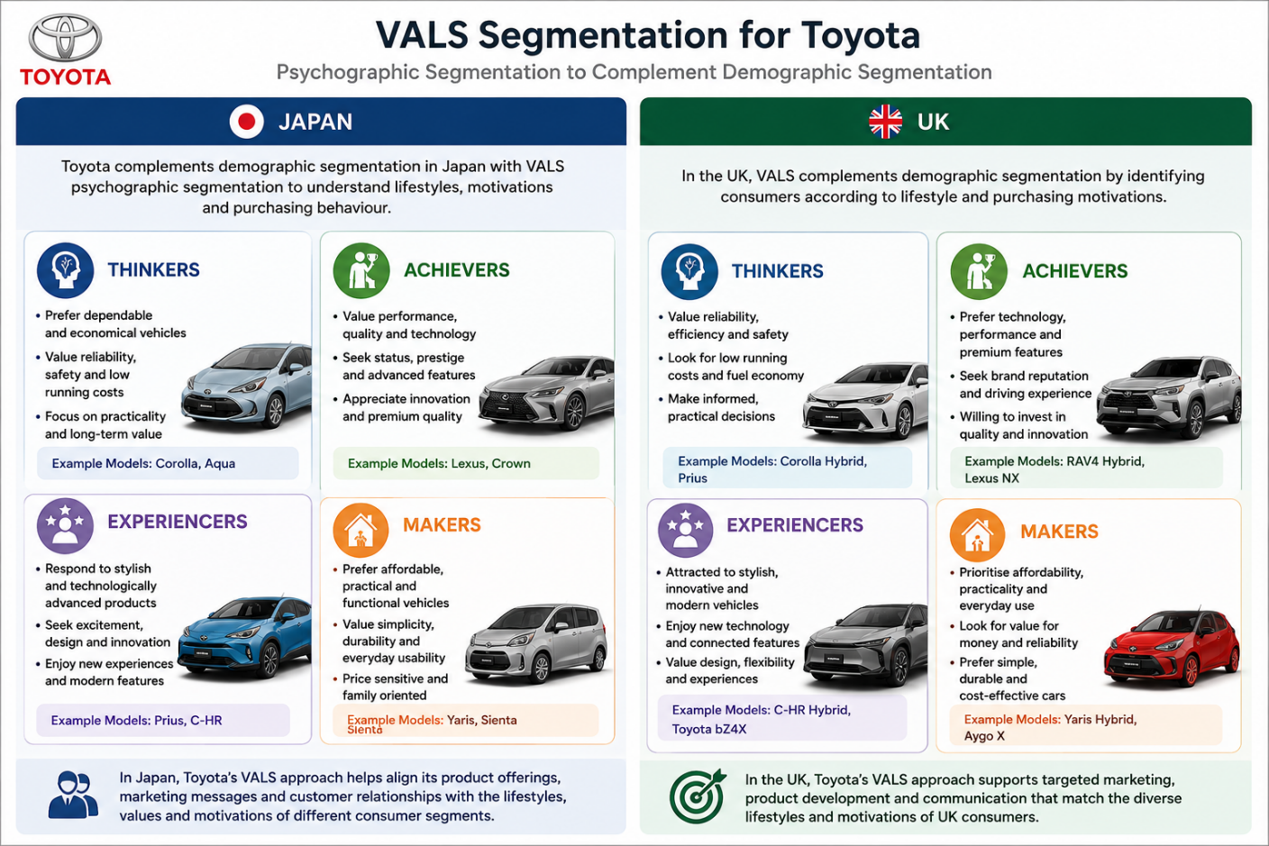
Figure 6: VALS in UK and Japan (Self-Created)

International Marketing Mix (7Ps): Toyota Japan and United Kingdom
The marketing mix is the 7P's that an organisation use in creating and executing effective marketing strategies which include Product, Price, Place, People, Process and Physical evidence. These components allow a business to meet customer requirements, to add value, establish competitive advantage and to accomplish marketing objectives through the efficient provisioning of products and services in a target market. The international marketing mix (7Ps) for Toyota in Japan and UK is presented below in Table 5
Table 5: International marketing mix (7Ps) for Toyota in Japan and UK
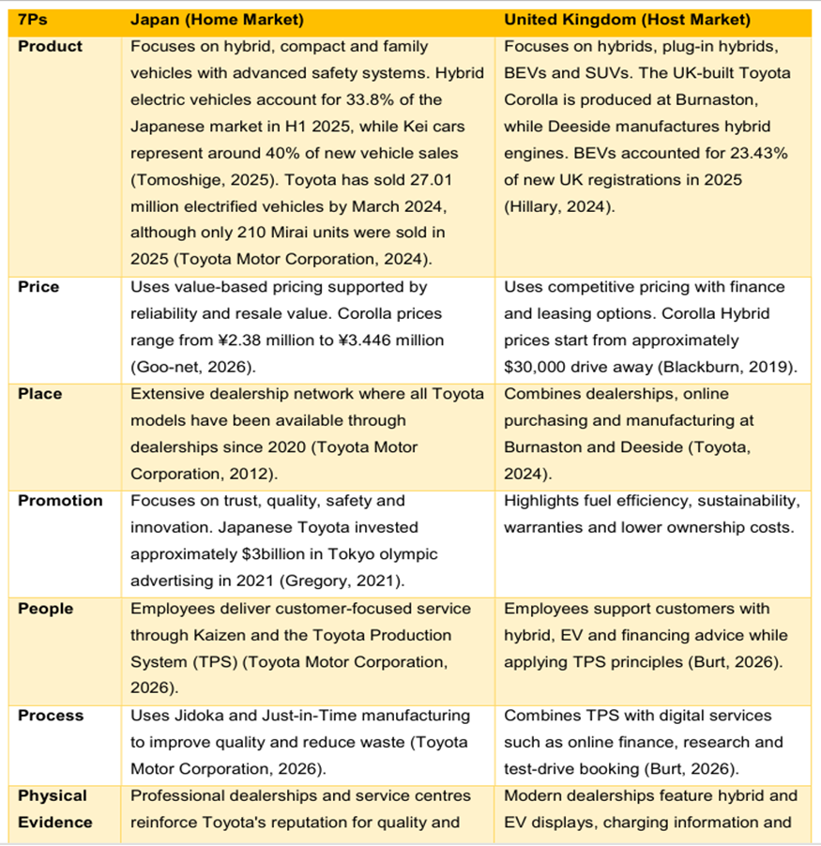

International Marketing Mix (7Ps) for Japan (Home Market)
Toyota's marketing mix in Japan is indicative of its status as a local leader in the automotive industry and its reputation for reliability, quality, and technological innovation.
Product:
Japan’s product mix comprises hybrid cars, compact cars, family cars, and safety features. Cost-saving and urbanization account for the high demand for fuel-efficient and functional vehicles amongst consumers in Japan (Burnett, 2026). HEVs constituted 33.8% of vehicles sold in H1 2025 in Japan, while the kei cars represented 40% of new car sales in Japan (Tomoshige, 2025). The reason behind Toyota’s electrification is the success of Toyota in selling 27.01 million electrified vehicles across the globe up to March 2024 (Toyota Motor Corporation, 2024).
Price:
In Japan, Toyota is a value-based brand, where higher prices are associated with greater reliability, durability and long-term ownership benefits. Toyota have a very good reputation and the quality and high resale value in Toyota products means they have value based pricing. It also uses competitive pricing to be competitive with other manufacturers, and product-line pricing to different models to cater to different customer groups. For instance, the price of Toyota Corolla in Japan is from around ¥2.38 million to ¥3.446 million (Goo-net, 2026).
Place:
Toyota has a long distribution system in Japan via their service centres. Toyota has been providing customers with greater convenience and access to all Toyota models since 2020 via its dealership network (Toyota Motor Corporation, 2012). Dealerships also offer maintenance and after-sales services and relationship-building, which further enhances customer loyalty.

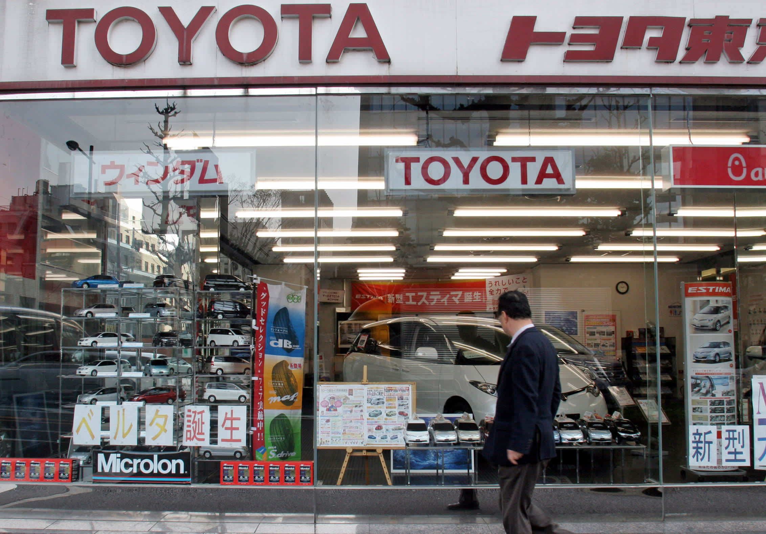

Figure 7: Toyota store in Japan (Toyota Motor Corporation, 2025).
Promotion:
In order to set itself apart from rivals, Toyota's Japanese promotional strategy places a strong emphasis on trust, safety, engineering excellence, and innovation. It also makes extensive use of Toyota's Japanese heritage, superior manufacturing, and technical advancements. Instead of competing mainly on price or style trends, this messaging continually upholds Toyota's reputation for dependability and precision engineering, promoting the business as a symbol of Japanese workmanship and long-term durability. (Gregory, 2021).
People:
Toyota employees 73,133 staff in Japan adapt the principles of the Toyota Production System (TPS) and Kaizen (continuous improvement) to help maintain the company's customer-centric service culture.
Process:
TPS is the basis of Toyota's operations in Japan, specifically their Jidoka and Just-in-Time manufacturing. These processes contribute to maintain the quality of the product, decrease wastes and increase production efficiency (Toyota Motor Corporation 2026). It's the same way Toyota builds its reputation for reliability.
Physical Evidence:
Toyota's dealerships and service centres in Japan uphold the brand's reputation with their polished infrastructure, strict quality controls, and customer-centric layout. These physical features help support consumer confidence and show the quality and reliability of Toyota as a supplier of service excellence (Toyota (GB) PLC, 2023).
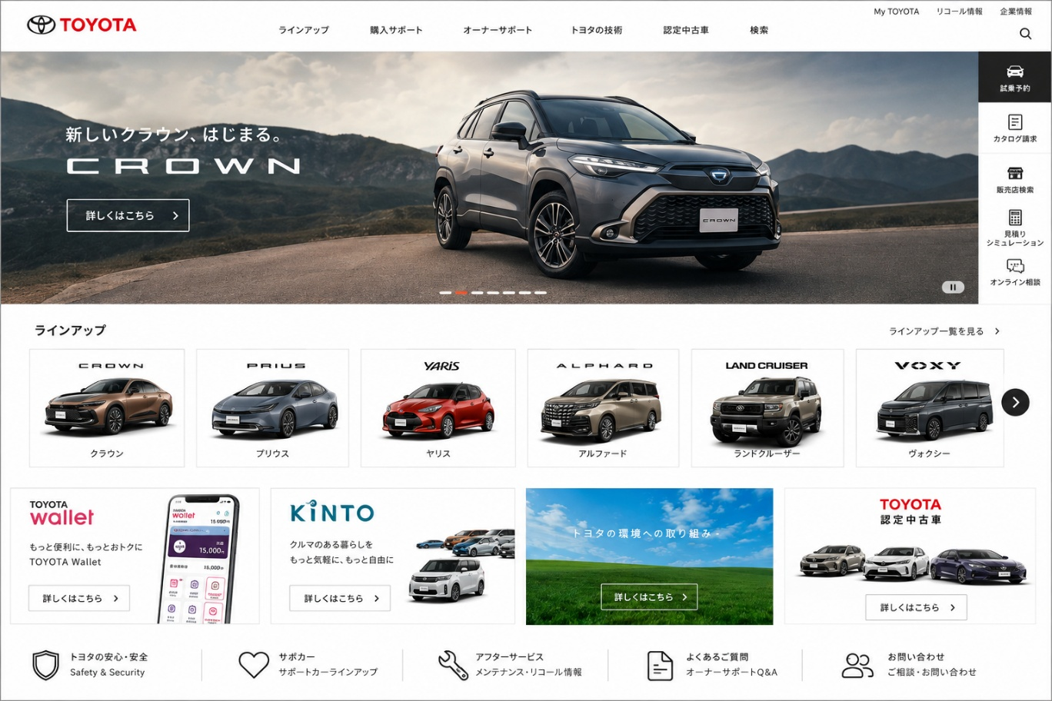
Figure 8: Website of Toyota (Toyota Motor Corporation, 2025).

International Marketing Mix (7Ps) for United Kingdom (Host Market)
Toyota's UK marketing mix illustrates the adaptation to the market, defined by the new criteria of sustainability, electrification and changing consumer expectations.
Product:
Toyota’s UK product strategy focuses on hybrid vehicles, plug-in hybrids, battery electric vehicles (BEVs) and SUVs. The company caters to rising demand for low emission vehicles through product strategy. It is complemented by Toyota's UK manufacturing that includes the Corolla made at Burnaston and hybrid engines made at Deeside (Toyota, 2024). With 23.43% of new car registrations in the UK in 2025, battery electric vehicles are a significant part of the market (Hillary, 2024).
Price:
Competitive pricing in the UK, along with financing, leasing and fleet solutions to make it more affordable, is how Toyota does this. It prioritizes fuel efficiency and lower running/ownership costs, reflecting economic pressure and understanding of total cost of ownership. Toyota also uses value-based pricing, especially with hybrid and technologically advanced cars, and product-line pricing enables distinct product lines to appeal to different customer segments (Blackburn, 2019).
Place:
Toyota's mix of dealerships, online eCommerce sites and UK manufacturing plants. Burnaston and Deeside production plants enhance supply chain efficiency, bolster job opportunities, and bolster Toyota's foothold in the UK automotive sector (Toyota, 2024). Toyota's retail network provides customers with opportunities to research vehicles online, organise test drives and enjoy after sales services.
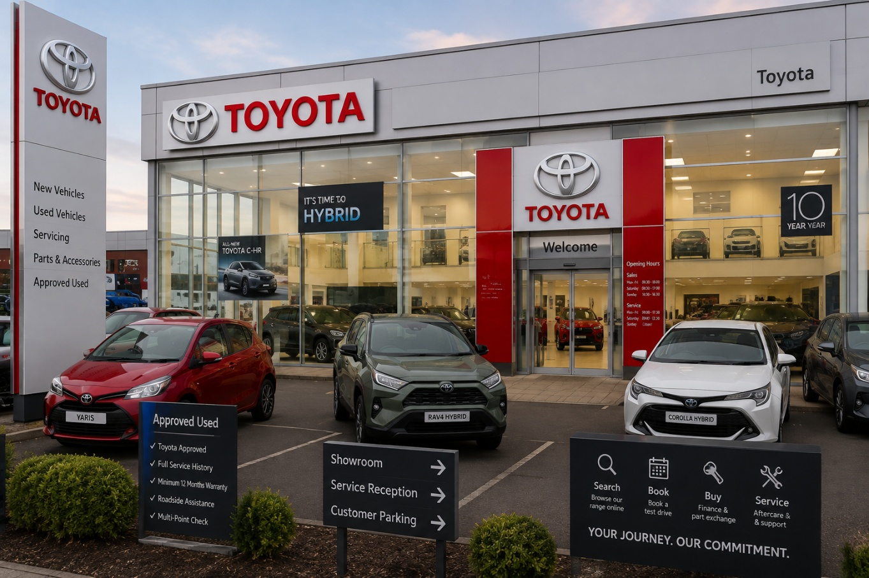
Figure 9: Toyota store in UK (Toyota, 2024).
Promotion:
The UK marketing focus on Toyota is on fuel efficiency, sustainability, warranties and reduced ownership costs. UK promotion focuses on cleaner mobility, with communication that is more reliable than in the UK, and sustainability claims must be truthful, transparent, and credible, compared with the communication in Japan that is based on reliability. Toyota's UK marketing is focused on fuel efficiency, sustainability, warranties and lower ownership costs. In the UK promotion, the emphasis is on cleaner transportation.
People:
Toyota UK employs approximately 3,000 staff, including agency workers, across its Burnaston and Deeside manufacturing plants. Toyota UK staff assist customers by advising on hybrid tech, EV choices, finance and comparing vehicles. Employees also embrace the TPS principles to maintain the quality and satisfaction of the service given
Process:
In the UK, Toyota combines its classic TPS with the use of digital customer service. Customers can do their research about cars, financing, test drive scheduling and post-sales services through the internet. These services bring convenience and reduce uncertainty in decision-making (Burt, 2026).
Physical Evidence:
This is evident at Toyota UK dealerships from the advanced showrooms, hybrid and electric car demonstrations, charging information and customer service services. Toys are also known for their reliability and innovation, as evidenced by their digital platforms, warranties and service documentation (Toyota (GB) PLC, 2023).
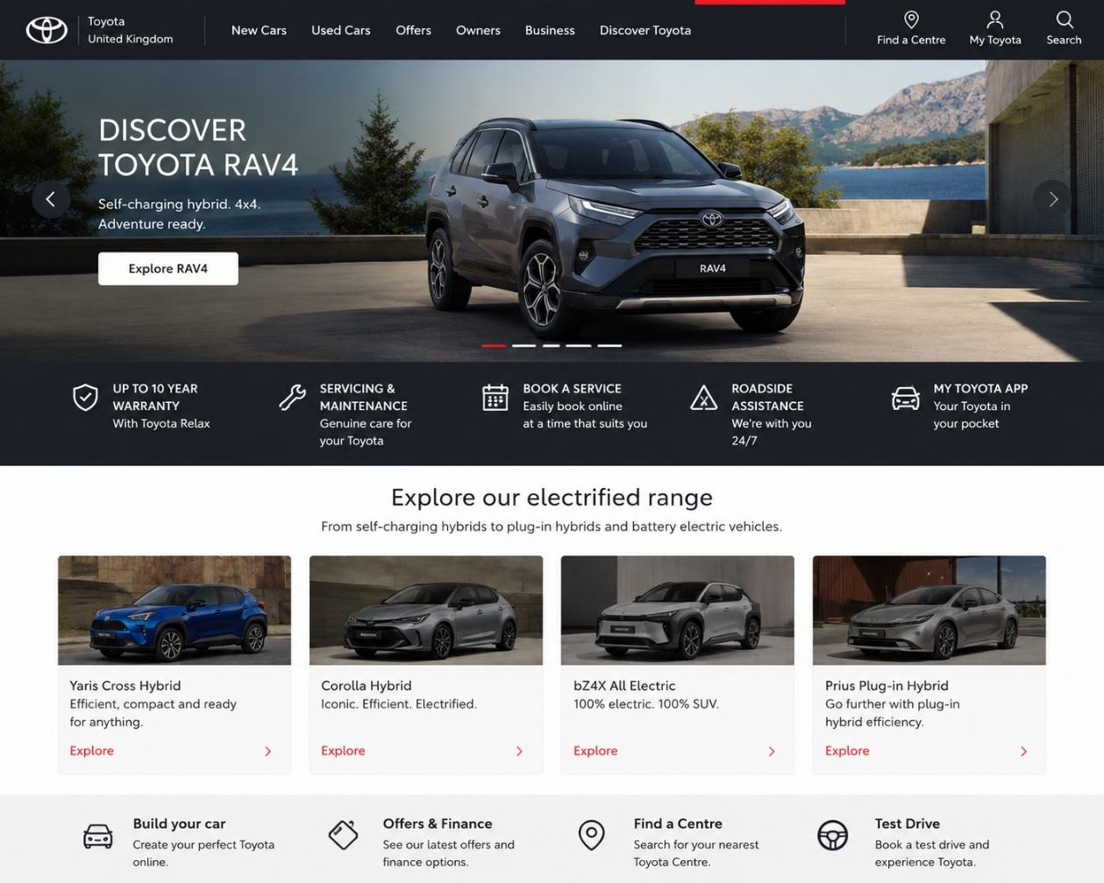
Figure 10: Website of Toyota (Toyota, 2024).
In general, Toyota focuses on quality and reliability, whilst adjusting its 7Ps as per market conditions. The Japanese approach is more about trust, hybrid leadership and long-term relationships, while the UK approach is more focused on sustainability, electrification and customer convenience.
Similarities and Differences
Similarities: Toyota’s marketing mix in Japan and the United Kingdom shows several clear similarities. In their product strategy, the company seeks quality, reliability, cost-efficient fuel consumption, and technological development in the two markets. Toyota has provided electrified vehicles in the two countries and is employing value-based and competitive pricing and product lines to penetrate different types of customers. It supports distribution by providing dealership networks, after-sales services, and customer support. Presentation in both markets brings out the quality, technology, and solid performance of the brand. The credibility is further enhanced by material representations like service centres, dealerships, and online.
Differences: However, Toyota adapts the 7Ps to local market conditions. The product strategy in Japan is more focused on hybrids, compact cars, safety, durability, and long-term ownership value, and promotion has been more focused on Japanese heritage, engineering excellence, and trust. The Japanese processes are based on Jidoka, Just-in-Time, and Kaizen. Conversely, UK strategy places more focus on BEVs, PHEVs, SUVs, financing, leasing, and fleet solutions. UK promotions have focused on sustainability and cleaner mobility, warranties, and lower cost of ownership.

Toyota Market Entry Strategy in the UK
Toyota approached the UK market primarily by foreign direct investment (FDI) with a wholly owned subsidiary (WOS) or greenfield investment (GFI) approach, as opposed to a joint venture or a franchising approach. Toyota Manufacturing UK (TMUK) opened vehicle and engine manufacturing at Burnaston, Derbyshire and Deeside, North Wales. This entry mode gives Toyota a better control of manufacturing, quality, technology and operations in the supply chain (Supply Chain, 2025. While exporting – as Toyota does – is a means for selling vehicles and parts to international markets, its UK manufacturing is a long-term investment in the local market and in its overall competitive position.
Table 7: Advantages, Disadvantages and Rationale of Toyota’s UK Market Entry Strategy
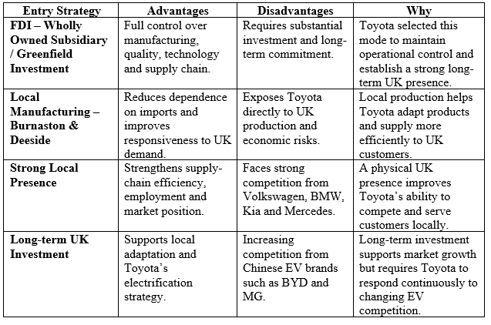

Ethical Issues in Toyota’s Marketing Mix
There are ethical problems with Toyota's marketing when it does not properly depict the environmental and social footprint of its products. A scandal took place in the UK in 2023 when the Advertising Standards Authority (ASA) confirmed that complaints against Toyota's Born to Roam advertising of its Hilux was upheld. The advertisement depicted a number of Hilux vehicles traversing natural environments and the ASA felt that the ad had presented and condoned vehicle use in a manner which ignored the negative impacts. An advertisement was thus deemed socially irresponsible and banned in this format (ASA, 2023).
Another unethical example from Japan is the irregularity in Toyota's 2024 certification testing. Toyota admits there were "a number of instances in which certification tests were not conducted according to the procedures required by the government," and stated that it would temporarily suspend shipping of several models (Keyser,2025). This was mainly a compliance and company governance issue, but it made for an ethical dilemma as Toyota's safety, quality and reliability reputation is tied to its market positioning
A Japanese example of ethical communication is Toyota's information on the ecological impact of hybrid cars. Toyota has been encouraging the use of hybrid cars as a way to make its operations more environmentally friendly and has disclosed what it says are its estimates of the reduction in CO₂ emissions and fuel consumption in comparison to non-hybrid petrol cars (Keyser,2025). When such communication is based on evidence and is adequately communicated to consumers, it is deemed ethical.

Recommendations for Toyota’s Future International Marketing Strategy
The analysis of Toyota's marketing strategy in Japan and the UK suggests three recommendations in regard to their future international strategy.
Japan

Keep the multi-pathway electrification approach: The threat of new entrants from Chinese EV manufacturers such as MG, BYD, Omoda and Jaecoo has also increased competition as these brands capture approximately 15% of the UK's new car registrations (Hargreaves, 2026). Toyota should keep building its hybrid leadership in Japan as consumers are receptive to fuel efficient and reliable hybrid cars. Meanwhile, gradually expand the BEV and PHEV models, and hydrogen-related technologies in order to meet future environmental needs and consumer demands.

Enhance trust marketing through digital channels: Toyota should continue to leverage its long-standing reputation for reliability, safety, quality and value but should also increase its digital platforms and online vehicle information and the personalised communication it delivers. Fuel efficiency and technological innovation and total ownership benefits should be emphasized in marketing to reflect the expectations of Japanese consumers.

Enhance sustainability transparency: Toyota has a responsibility to offer evidence-based and transparent data on emissions, fuel economy and environmental benefits. Sustainability communication that is transparent can further build customer confidence and help ensure consistency between customer messages and Toyota's environmental commitments.
United Kingdom

Increase investment in BEV: Toyota should ramp up investments in BEV, charging infrastructure and battery supply chain, as EV adoption is picking up in the UK. Hybrids need to continue in the product mix, but more needs to be done to focus attention on BEVs to meet evolving customer demand and environmental regulations.
Strengthen digital and personalised marketing: Toyota should enhance online shopping, online research tools and personalised marketing communicative.

Improve supply-chain resilience: Toyota should diversify its battery suppliers and create strategic partnerships to mitigate their dependency on any one supplier, thereby enhancing its EV supply chain. Reliable product availability and operation risks can be managed with local and flexible supply arrangements.

Improve ethical sustainability promotion: Toyota needs to make sure that all sustainability claims are accurate, transparent, and backed up by evidence, after the ASA (2023) raised concerns about Toyota's environmental advertising. This can help to maintain customer confidence, minimise reputational risk and enhance Toyota's sustainable brand reputation in the UK.

Section 2: Reflective Account Using Gibbs’ Reflective Cycle
This reflective account critically reflects on the process used during the research, analysis and preparation of the international marketing report on Toyota, using Gibbs’ Reflective Cycle (1988).
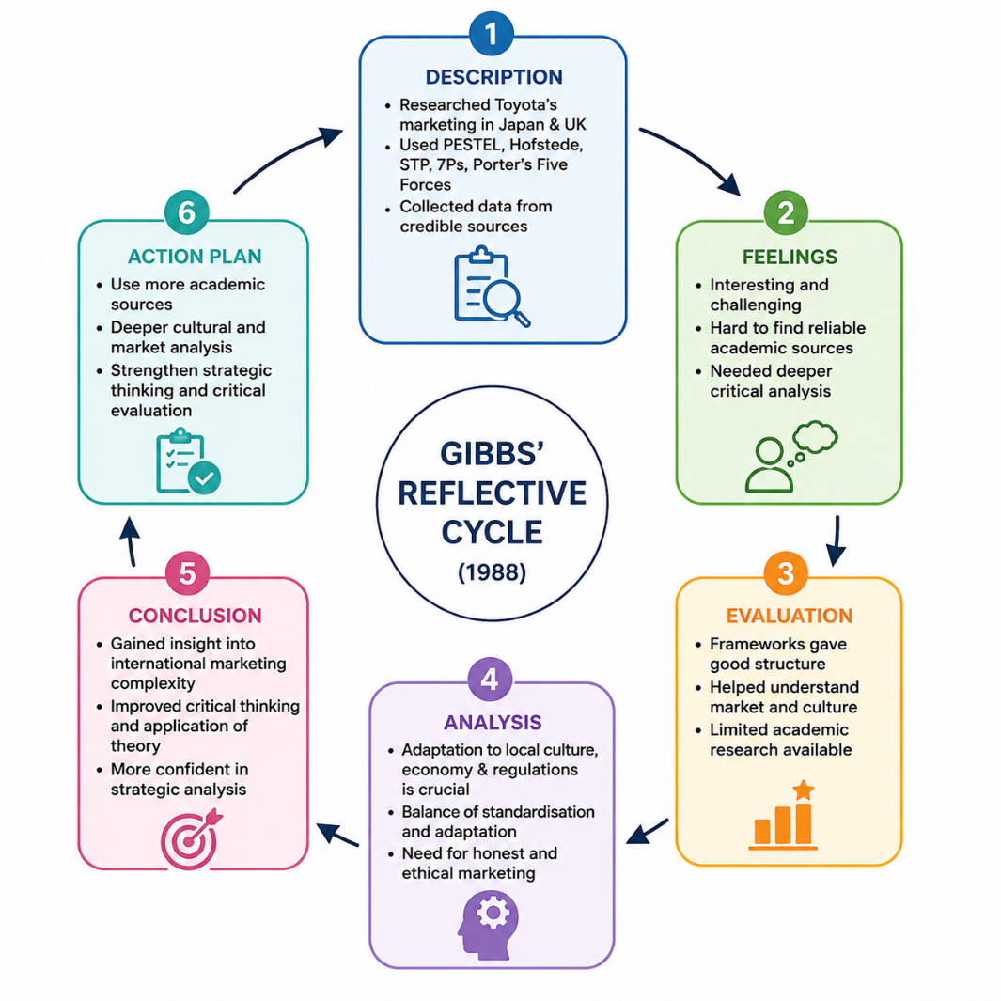
Figure 11: Gibbs’ Reflective Cycle
1. Description
For this assessment, I have applied a systematic research and analytical approach to analyse Toyota's international marketing strategies in Japan and the United Kingdom. I chose Toyota because Japan is the company's home market and the UK is an important international host market to understand how a global brand adapts its strategies in different markets. The purpose was to gain insight into how Toyota makes decisions on international marketing and maintains its global identity.
The research process included information gathered from academic literature, industry reports, government documents and companies and their sources. Examined the market position of Toyota in both countries and contrasted automotive industry differences in Japan and in the UK. I used PESTEL analysis to assess the external environment, identifying political, economic, social, technological, environmental and legal factors that impact Toyota's operations. I also applied Hofstede's cultural dimensions’ framework to understand the differences between the UK and Japan and how this affects the consumer behaviour and marketing decisions.
In addition, I explored Toyota's Segmentation, Targeting and Positioning (STP) and VALS strategies to assess the company's approach in identifying and addressing different customer segments across these markets. The 7Ps Marketing Mix Model was used to compare the marketing mix of Toyota with respect to the product, price, place, promotion, people, process and physical evidence.
2. Feelings
Comparing the UK with Japan has been interesting and challenging for me as I've been researching and preparing. Toyota is an international company but the company does not apply the same strategy all the time in all markets. Careful analysis was required to understand how differences in culture, economy and regulation affect marketing decisions.
The selection of the sources was one of the most difficult challenges. The automotive industry contains a large amount of online information, but not all sources provided accurate or academically suitable evidence. I therefore had to use credible sources, which for me included Toyota's official statements, government documents and industry sources like the Society of Motor Manufacturers and Traders (SMMT) and academic publications.
Another difficulty was the avoidance of a descriptive approach. At first it was easier to gather facts on Toyota's sales, technologies and market position, but the assessment involved a critical analysis of why Toyota uses different strategies in their respective countries of Japan and UK. In-depth analysis was needed to establish relationships between frameworks and real business decisions.
3. Evaluation
There were a couple of things that went well in the research process. Strategic frameworks gave a good structure for analysing Toyota's approach to international marketing. The PESTEL analysis enabled external factors to be identified, including Japan's backing of car innovation and the UK's growing emphasis on electric cars, which impact Toyota's choices.
The Hofstede cultural analysis proved to be very useful as it had shown consumer behaviours vary across countries. For instance, Japanese consumers are more interested in reliability, safety, and long-term trust while UK consumers are more interested in sustainability, personal choice, and technological innovation. This provides an understanding of why Toyota customizes its communication and product strategies for every market.
The STP and 7Ps analyses also helped me gain a better understanding of how Toyota both maintains consistency and adapts to local needs around the world. The company maintains its core values of reliability and quality but varies its products, pricing, promotion and customer engagement based on local market expectations.
4. Analysis
The research process has enhanced the knowledge of international marketing and has shown me that companies that are successful in the international market are not just companies that can take their domestic strategies overseas. Rather they will have to tailor their business operations to local cultural, economic, technical and regulatory conditions.
Toyota's case demonstrated that there is a need for balancing standardisation and adaptation when marketing internationally. Toyota has a high level of national identity in Japan, with customer trust and acceptance of hybrid technology. Consumers look for reliability, efficiency and long-term relationship.
The UK market is not the same, however. Given the growing competition, the rising demand for EVs and changing environmental laws, Toyota should prioritize sustainability, affordability, and innovation. Porter's Five Forces analysis resulted in the identification of the automotive industry in the UK as a highly competitive sector with supplier pressures and changing customer expectations noted.
Furthermore, the research enabled me to be a critical assessor of the business decisions rather than a mere description of the business activities. Toyota, for example, has the advantage of a hybrid program, but as tougher regulations take effect and new EV companies emerge, Toyota will have to invest even more in EV technology. Similarly, ethical concerns in marketing brought up a need for marketing messages to be truthful in terms of sustainability responsibilities.
5. Conclusion
This assessment was helpful to gain insight into the complexity of international marketing strategy. The research found that Toyota's success is not solely the result of its technological ability but also its ability to understand and adjust to different market contexts.
I applied Gibbs' reflective cycle to evaluate my research process and to find problems and ways of enhancing my approach. This evaluation helped me develop critical arguments, utilize analysis frameworks, and collect evidence. I learnt how to be good in the marketing analysis, it showed me a theory and a business case.
In general, my confidence in analysing multinational companies and how global brands find competitive advantage in different countries was enhanced.

6. Action Plan
For future academic and professional projects, I will improve the research process in collecting and evaluating sources to be more systematic. During the next few months, I will spend more time determining academic peer-reviewed research and industry reports in order to strengthen the theoretical support.
In addition, I will also make more critical analysis of my quantitative data, as well as comparing market trends from different sources. Future studies will be conducted at a deeper level of cultural analysis, to better comprehend consumer behaviour and its implications for international marketing decisions.
Furthermore, I will continue to develop my strategic thinking skills, and analysis will not only be used to describe information about the business, but will also be used to explain why business decisions are made, and what implications this will have. These changes will help in my studies and help me be a better market analyst.

References
Abdelrahim, Y. (2021). The influence of indulgence and long-term orientation on a country’s risk aversion. Journal of Organizational Management Studies, 2021(2021), pp.1–9. doi:10.5171/2021.909336.
Ajila, F., Cruz, A., Foutty, K., Love, C. and Ba, V.N. (2023). Toyota - Strategic Analysis. [online] Researchgate. doi:10.13140/RG.2.2.34720.15365.
Arakawa, K. (2022). Assessing consumer valuations of future costs versus purchase prices in Japan’s auto market. Economics of Transportation, 30, p.100260. doi:10.1016/j.ecotra.2022.100260.
ASA (2023) Toyota (GB) plc advertising ruling. Advertising Standards Authority.
Bekker, H. (2026). Japan Best-Selling Carmakers and Brands – Full Year 2025. [online] Best-selling-cars.com. Best-Selling-Cars.com. Available at: https://www.best-selling-cars.com/japan/2025-full-year-japan-best-selling-carmakers-brands-and-market-analysis/ [ Accessed: 27 July, 2026]
Blackburn, R. (2019). Car that will change the way you drive. [online] news.com.au. Available at: https://www.news.com.au/technology/motoring/new-cars/toyota-corolla-hybrid-review-fuel-consumption-is-the-name-of-the-game/news-story/505ac6be52adf6770e310fe9f093092a [ Accessed: 29 July, 2026]
Burnett, N. and Stewart, I. (2024). The UK’s plans and progress to reach net zero by 2050. [online] House of Commons Library. UK Parliament. Available at: https://commonslibrary.parliament.uk/research-briefings/cbp-9888/
Burnett, S. (2026). Chinese brands squeeze UK automakers on price, SMMT warns. [online] Automotive World. Available at: https://www.automotiveworld.com/news/chinese-brands-squeeze-uk-automakers-on-price-smmt-warns/ [ Accessed: 27 July, 2026]
Burt, M. (2026) What is kaizen and how does Toyota use it? Toyota UK Magazine, 14 May. Available at: https://mag.toyota.co.uk/kaizen-toyota-production-system/ [ Accessed: 29 July, 2026]
Carey, N. (2024). Carmakers say British EV sales mandate to cost them $7.5 bln in 2024. Reuters. [online] 26 Nov. Available at: https://www.reuters.com/business/autos-transportation/carmakers-say-british-ev-sales-mandate-cost-them-75-bln-2024-2024-11-26/ [ Accessed: 28 July, 2026]
Council of the European Union (2023) EU-UK relations: Council greenlights extension of current rules of origin for electric vehicles until the end of 2026. 21 December. Available at: https://www.consilium.europa.eu/en/press/press-releases/2023/12/21/eu-uk-relations-council-greenlights-extension-of-current-rules-of-origin-for-electric-vehicles-until-the-end-of-2026/ [ Accessed: 30 July, 2026]
Department for Transport (2023) A Zero Emission Vehicle (ZEV) Mandate and CO₂ Emissions Regulation for New Cars and Vans in the UK: Consultation Document. GOV.UK. Published 30 March. Available at: https://assets.publishing.service.gov.uk/media/64537b0ffaf4aa0012e132a8/zev-mandate-co2-emissions-regulation-consultation-document.pdf [ Accessed: 29 July, 2026]
Department for Transport (2026) Public electric vehicle charging infrastructure statistics: 1 April 2026. GOV.UK. Published 21 May. Available at: https://www.gov.uk/government/statistics/electric-vehicle-charging-infrastructure-statistics-1-april-2026/public-electric-vehicle-charging-infrastructure-statistics-1-april-2026 [ Accessed: 29 July, 2026]
Drift Bridge Group (2025) Why BEVs made up nearly 24% of UK new car sales in 2025. Available at: https://www.driftbridge.co.uk/news/why-bevs-made-up-nearly-24-percent-of-uk-new-car-sales-in-2025/ [ Accessed: 1 August, 2026]

Fadhlia, M.N., Jaumil, K., Abelechristo, R.V. and Ilham, A. (2023). Competitive advantage and policies of Japan’s electric vehicles in Southeast Asia. Journal of World Trade Studies, [online] 8(2), pp.1–18. doi:10.22146/jwts.v8i2.7780.
Focus2Move. (2026) Japan 2026. Sales Turn Positive As H1 Closes, Mitsubishi Leads in Growth (+15.4%). Available at: https://www.focus2move.com/japan-vehicle-market/ [ Accessed: 2 August, 2026]
Frank, B., Torrico, B.H. and Enkawa, T. (2013) ‘Elucidation of the mechanism behind the influences of uncertainty avoidance on customer attitudes towards Japanese products and services’, Journal of Japan Industrial Management Association, 63(4), pp. 201–209. https://doi.org/10.11221/jima.63.201
Fujioka, K. (2021). Toyota speeds up carbon-zero target for factories to 2035. [online] Nikkei Asia. Available at: https://asia.nikkei.com/Spotlight/Environment/Climate-Change/Toyota-speeds-up-carbon-zero-target-for-factories-to-2035 [ Accessed: 2 August, 2026]
Gibbs, G. (1988) Learning by Doing: A guide to teaching and learning methods. Further Education Unit, Oxford Brookes University, Oxford
Global Banking & Finance Review (2026). British car lobby group warns of £1.4 billion potential hit from post-Brexit rules. [online] Global Banking & Finance Review. Available at: https://www.globalbankingandfinance.com/british-car-lobby-group-warns-1-4-billion-potential-hit/ [ Accessed: 3 August, 2026]
Goo-net (2026) Toyota Corolla (カローラ): New car information. Available at: https://www.goo-net.com/newcar/TOYOTA__COROLLA [ Accessed: 3 August, 2026]
GOV.UK (2024). Pathway for zero emission vehicle transition by 2035 becomes law. [online] GOV.UK. Available at: https://www.gov.uk/government/news/pathway-for-zero-emission-vehicle-transition-by-2035-becomes-law [ Accessed: 4 August, 2026]
Gregory, S. (2021) Tokyo Olympics sponsor Toyota skips opening ceremony and cancels ads. Fortune, 23 July. Available at: https://fortune.com/2021/07/23/tokyo-olympics-sponsor-toyota-skips-opening-ceremony-cancels-ads/ [ Accessed: 2 August, 2026]
Hargreaves, L. (2026). IEA: Battery Prices Drop, but Supply Chain Risks Grow. [online] Supplychaindigital.com. Bizclik Media Ltd. Available at: https://supplychaindigital.com/news/iea-battery-prices-drop-supply-chain-risks-grow [ Accessed: 3 August, 2026]
Hillary, A. (2024). Corolla makes history as Toyota’s five millionth UK-built car - Toyota Media Site. [online] Toyota Media Site. Available at: https://media.toyota.co.uk/corolla-makes-history-as-toyotas-five-millionth-uk-built-car/ [ Accessed: 7 August, 2026]
Hofstede, G. (2011). Dimensionalizing cultures: The Hofstede model in context. [online] ScholarWorks@GVSU. Available at: https://scholarworks.gvsu.edu/orpc/vol2/iss1/8/ [ Accessed: 2 August, 2026]
Horie, N. (2021) Overview of Road Vehicle Compliance in Japan. National Traffic Safety and Environment Laboratory (NTSEL). International Council on Clean Transportation (ICCT). Available at: https://theicct.org/wp-content/uploads/2021/10/Overview-of-road-vehicle-compliance-in-Japan.pdf [ Accessed: 1 August, 2026]
House of Commons Library (2025a) Zero Emission Vehicle (ZEV) Mandate. Research Briefing CBP-10100. UK Parliament. Available at: https://researchbriefings.files.parliament.uk/documents/CBP-10100/CBP-10100.pdf [ Accessed: 1 August, 2026]
House of Commons Library (2025b) Economic indicators: Key statistics for the UK economy. Research Briefing CBP-9040. UK Parliament. Available at: https://commonslibrary.parliament.uk/research-briefings/cbp-9040/ [ Accessed: 5 August, 2026]
IMARC Group (2026) UK ride-sharing market: Size, share, trends and forecast 2026–2034. Available at: https://www.imarcgroup.com/uk-ride-sharing-market [ Accessed: 7 August, 2026]
International Transport Forum (ITF) (2017) Vehicle Inspection and Maintenance Program in Japan. Paris: OECD Publishing. Available at: https://www.itf-oecd.org/sites/default/files/docs/vehicle-inspection-maintenance-programme-japan.pdf [ Accessed: 5 August, 2026]
Jacobo, J.T. (2024). Nearly one in four cars sold in the UK were BEVs in 2025. [online] EV Infrastructure News. Available at: https://www.evinfrastructurenews.com/ev-fleet/nearly-one-in-four-cars-sold-in-the-uk-were-bevs-in-2025 [ Accessed: 4 August, 2026]
Jeong, J.H., Kim, C. and Jo, H.J. (2024). Three major challenges in the shift to electric vehicles: industrial organization, industrial policy, and a just transition. Sociology compass, 18(5). doi:10.1111/soc4.13218.
Large, P. (2026). UK new car market breaches two million as almost one in four buyers go electric - SMMT. [online] SMMT. Available at: https://www.smmt.co.uk/uk-new-car-market-breaches-two-million-as-almost-one-in-four-buyers-go-electric/ [ Accessed: 23 July, 2026]
Keyser, S. (2025). Detecting Greenwashing in the Automotive Sector: Unpacking Greenwashing in Tesla, Volkswagen, and Toyota Through AI-Assisted ESG Evaluation.
Luo, L. (2024). Analysis of Japanese Cultural Patterns —Based on Hofstede’s Value Dimensions and Minkov’s Cultural Dimensions. [online] ResearchGate. Darcy & Roy Press Co. Ltd. Available at: https://www.researchgate.net/publication/381541985_Analysis_of_Japanese_Cultural_Patterns_-Based_on_Hofstede [ Accessed: 27 July, 2026]
MarkLines Co (2026). UK - New car sales in 2025 by OEM, vehicle type. [online] MarkLines Automotive Industry Portal. MarkLines Co., Ltd. Available at: https://www.marklines.com/en/statistics/flash_sales/automotive-sales-in-uk-by-month-2025 [ Accessed: 25 July, 2026]
Ministry of Land, Infrastructure, Transport and Tourism (MLIT) (2024) Japanese Government's Efforts to Achieve Carbon Neutrality in the Automotive Sector. Japan Automobile Standards Internationalization Center (JASIC). Available at: https://www.jasic.org/meeting_docs_admin/contents/uploads/doc/meeting3/Japanese%20Government's%20Efforts%20to%20Achieve%20Carbon%20Neutrality%20in%20the%20Automotive%20Sector.pdf
Mishra, N. (2026). How Japanese consumer behaviour differs from western markets. SSRN Electronic Journal. doi:10.2139/ssrn.6217358.
Morimoto, H. (2021) Overview of MLIT's Vehicle Environmental Policy. Presentation for the International Transport Forum Expert Workshop, Ministry of Land, Infrastructure, Transport and Tourism (MLIT), Japan, 25 January. International Council on Clean Transportation (ICCT). Available at: ICCT PDF
Munnangi, V.E. (2025). SMMT publishes UK new car pre-registration figures for November 2025. [online] Yahoo Autos. Available at: https://autos.yahoo.com/policy-and-environment/articles/smmt-publishes-uk-car-pre-143056324.html?guccounter= [ Accessed: 1 August, 2026]
OECD (2026). OECD economic surveys: Japan 2026. [online] OECD Economic Surveys: Japan. OECD Publishing. doi:10.1787/54cc833d-en.
Office for National Statistics (2021) Over half of younger drivers likely to switch to electric in next decade. 25 October. Available at: https://www.ons.gov.uk/economy/environmentalaccounts/articles/overhalfofyoungerdriverslikelytoswitchtoelectricinnextdecade/latest [ Accessed: 3 August, 2026]
Park, M. (2026). Japan auto industry statistics. [online] Gitnux. Available at: https://gitnux.org/japan-auto-industry-statistics/ [ Accessed: 1 August, 2026]
Profiroiu, M., Kaneko, H., Vlad, C., Dutescu, A. and Ishida, H. (2020). Toyota Motor Corporation’s Culture Strategy. Review of International Comparative Management, [online] 21(4). doi:10.24818/RMCI.2020.4.458.
Rashedkhan, M. (2021). Individual’s Leadership Style Changes Due to Different Culture in the UK. International Journal of Trend in Scientific Research and Development (ijtsrd), [online] 5(3), pp.1136–1143. doi:10.5281/zenodo.4730640
Smith, G. (2026). Toyota sold 4.4 million hybrids in 2025, and nobody else is even close. [online] CarBuzz. Available at: https://carbuzz.com/toyota-streets-ahead-in-hybrid-sales-in-2025-and-nobody-else-is-close/ [ Accessed: 1 August, 2026]
Society of Motor Manufacturers and Traders (2026) SMMT Motor Industry Facts 2026. London: Society of Motor Manufacturers and Traders. Available at: https://smmtweb.lon1.cdn.digitaloceanspaces.com/wp-content/uploads/2026/02/SMMT-FACTS-2026-FINAL.pdf [ Accessed: 2 August, 2026]
Society of Motor Manufacturers and Traders (2026) UK new car market breaches two million as almost one in four buyers go electric. 6 January. Available at: https://www.smmt.co.uk/uk-new-car-market-breaches-two-million-as-almost-one-in-four-buyers-go-electric/ [ Accessed: 3 August, 2026]
Statistics of the World (2026) Japan Economy 2026 — Deflation Ends, BOJ Rates Rise. Available at: https://www.statisticsoftheworld.com/japan [ Accessed: 1 August, 2026]
Supply Chain (2025). Beyond NMC batteries: Supply chain issues for emerging battery technologies . [online] IEA. Available at: https://www.iea.org/reports/global-critical-minerals-outlook-2025/beyond-nmc-batteries-supply-chain-issues-for-emerging-battery-technologies [ Accessed: 2 August, 2026]
The Culture Factor Group (2025). Country comparison tool. [online] Theculturefactor.com. Available at: https://www.theculturefactor.com/country-comparison-tool?countries=japan%2Cunited+kingdom [ Accessed: 1 August, 2026]
Tochibayashi, N. and Ota, M. (2024). What an ageing world can learn from Japan’s campaign to get seniors driving safely. [online] World Economic Forum. Available at: https://www.weforum.org/stories/2024/12/japan-senior-driver-safety/ [ Accessed: 3 August, 2026]
Tomoshige, Y. (2025). Japan’s Automotive Electrification Trends (2025 H1). [online] Jato.com. JATO Dynamics Limited. Available at: https://www.jato.com/resources/news-and-insights/japans-automotive-electrification-trends-2025-h1 [ Accessed: 4 August, 2026]
Toyota (2020). Toyota Leads UK Auto Industry in Customer Satisfaction. [online] Toyota Media Site. Available at: https://media.toyota.co.uk/toyota-leads-uk-auto-industry-in-customer-satisfaction/ [ Accessed: 1 August, 2026]
Toyota (2024). Toyota motor manufacturing uk. [online] Toyotauk.com. Available at: https://www.toyotauk.com/ [ Accessed: 7 August, 2026]
Toyota (GB) PLC (2023) Toyota Professional advances with increased product power and leading customer service. Toyota Media Site, 4 December. Available at: https://media.toyota.co.uk/toyota-professional-advances-with-increased-product-power-and-leading-customer-service/ [ Accessed: 3 August, 2026]

Toyota Motor Corporation (2012) List of dealerships in Japan. In: 75 Years of Toyota: Automotive Business – Sales – Dealerships in Japan, Overseas Distributors. Available at: https://www.toyota-global.com/company/history_of_toyota/75years/data/automotive_business/sales/dealerships/japan/index.html [ Accessed: 2 August, 2026]
Toyota Motor Corporation (2021). Toyota’s Discerning Approach to Car-making and Challenges for the Future | Corporate | Global Newsroom. [online] Toyota Motor Corporation Official Global Website. Available at: https://global.toyota/en/newsroom/corporate/35891478.html [ Accessed: 1 August, 2026]
Toyota Motor Corporation (2024) Sustainability Data Book 2024. Toyota Motor Corporation. Available at: https://global.toyota/pages/global_toyota/sustainability/report/sdb/sdb24_en.pdf [ Accessed: 29 July 2026]
Toyota Motor Corporation (2025a). Integrated Report 2025. [online] Available at: https://global.toyota/pages/global_toyota/ir/library/annual/2025_001_integrated_en.pdf [ Accessed: 1 August, 2026]
Toyota Motor Corporation (2025b) Fact Data. Toyota Motor Corporation. Available at: https://global.toyota/pages/fact-data/fact-data_002_03_en.pdf [ Accessed: 5 August, 2026]
Toyota Motor Corporation (2026) Toyota Production System. Available at: https://global.toyota/en/company/vision-and-philosophy/production-system/index.html [ Accessed: 2 August, 2026]
Toyota UK (2026). company background. [online] Available at: https://media.toyota.co.uk/wp-content/uploads/sites/5/pdf/210720M-Toyota-Company-Background.pdf [ Accessed: 4 August, 2026]
Tribdino, R. (2025). China’s Direct Assault On Japan’s Most “Domestic” Automotive Segment - CleanTechnica. [online] CleanTechnica. Available at: https://cleantechnica.com/2025/11/04/chinas-direct-assault-on-japans-most-domestic-automotive-segment/ [ Accessed: 3 August, 2026]
U.S. Commercial Service (2023) Japan Autonomous Driving. International Trade Administration, U.S. Department of Commerce. Available at: https://www.trade.gov/market-intelligence/japan-autonomous-driving [Accessed: 2 August, 2026]
UK Car Discount (2023). Toyota UK A Journey of Success. [online] Uk-car-discount.com. UK Car Discount. Available at: https://www.uk-car-discount.com/news/toyota-uk-a-journey-of-success [ Accessed: 1 August, 2026]
Warranty Solutions Group (2024) ZEV mandate review is urgent, industry warns new PM. Available at: https://consumer.warrantysolutionsgroup.co.uk/zev-mandate-review-is-urgent-industry-warns-new-pm [ Accessed: 28 July, 2026]
Wright, C. (2022). Is the car ownership model ready for a shake-up? [online] Business Motoring. Available at: https://businessmotoring.co.uk/is-the-car-ownership-model-ready-for-a-shake-up/ [ Accessed: 27 July, 2026]
Zapmap (2026) How many charging points are there in the UK? Available at: https://www.zapmap.com/ev-stats/how-many-charging-points [ Accessed: 25 July, 2026]

