

Undergraduate Dissertation coversheet & feedback form

PLEASE COMPLETE THE TOP SECTION OF THIS FORM AND SUBMIT ONE COPY WITH YOUR DISSERTATION
For completion by student:
Student Name: Broyan Evans Dymond

Student University Email: 1303350@student.uwtsd.ac.uk
Module code: HPHE6010 Heritage Studies Dissertation | Student ID number:  1303350 |  |  |  | Educational support needs:  Yes/No
Dissertation title: The Sustainable Preservation of Scapa Flow as a Heritage Site
Supervisor: |  |  | Word count: with abstract 10447
I confirm that this is my original work and that I have adhered to the University policy on plagiarism.
Signed B. J Evans Dymond ……………………………………………………
For completion by the first marker:
Comments:

First Marker’s Mark:  Signature: |  |  |  | Date:
For completion by the second marker (if appropriate):

Comments:

Second Marker’s Mark:  Signature: |  | Date:
NB. All marks are provisional until confirmed by the final examination board.

For completion by the External Examiner:

Comments:

Proposed Mark:

Signature of External Examiner:

Final Agreed Mark:

B. Dymond (2019) Ship wreck by Churchill Barriers  The Sustainable Preservation of Scapa Flow as a Heritage Site | Abstract  Heritage plays an important role in tourism and vice versa. The sustainable exploitation of their Underwater Cultural Heritage is vital to the economy of the Orkney Islands. This research aims to discuss the importance of the World War I Underwater Cultural Heritage at Scapa Flow in the Orkneys. It is imperative to recognise that the disintegration of the wrecks is likely to impact the marine environment, therefore this and other hazards have been considered. As the ships decay, the emphasis of the divers who come here has changed from an historical to an environmental approach. Marine wildlife has colonised the wrecks and they have become living reefs. The development of a scheme which uses the 3D and virtual reality technology available today to map the Scapa Flow wrecks in their current state and use these to develop the tourist industry is suggested. As tourism and the Heritage of the place are crucial to the economic stability of the Islands maintaining a link with the past will help to sustain the future. Therefore although the perspective has changed the story continues.  Broyan Dymond 1303350  HPHE6010 Heritage Dissertation

Contents
- Introduction |  | 5
- Methodology |  | 6
 | - Fieldwork | 6
 | - Desk based assessment | 6
- Background |  | 8
 | - Background | 8
 | - Recovery | 11
 | - WWII Developments | 11
 | - The Barrier Block Ships | 12
 | - Salvaging rights | 12
- Hazards |  | 13
 | - Environmental | 13
 | - Conservation | 16
 | - Erosion of steel from the effects of sea water | 17
 | - Failed salvage attempts | 18
- Heritage, Preservation and Tourism |  | 19
 | - Heritage | 19
 | - Preservation | 25
 | - Tourism | 27
 | - Preserving Sustainability | 30
6. Findings |  | 31
7. Conclusion |  | 37
8. Bibliography |  | 41
9. Appendix |  | 45

The Sustainable Preservation of Scapa Flow as a Heritage Site: How to manage the preservation of the historic World War I wrecks in Scapa Flow in order to maintain the heritage and tourism industries of the Orkneys

Chapter 1 Introduction
Heritage encompasses a broad and overarching term: “it” is something that someone or a collective considers to be worthy of being valued, preserved, catalogued, exhibited, restored, admired. (Kersel & Luke 2015: 71)
This research project report is focused on Scapa Flow, which is a body of water located in Orkney at the top of Scotland. In this harbour there are situated wrecks from World War I and World War II (WWI and WWII). The research trip was planned as it is the centennial of the scuttling of the WWI German fleet.
This dissertation aims to consider the importance of heritage and the preservation of marine archaeology, its impact on marine and land environments and the significance of the tourist sector.
I have used different methodologies in gathering information about this site. There will be an account of my personal experiences and explorations of the site and my experience of carrying out research in the field, as well as my interactions with other visitors, the crew members of the chartered boat and the local community. I will be summarising my experiences and my findings in the conclusion. In addition to this, I have used a desk based assessment of several books, websites and research papers.

In the course of my research, several issues appeared which need to be resolved in order to preserve this area as a heritage site for the future. There is a definite link between the economy of the Islands, tourism, heritage and the environment. How will this story be told to generations in the future?

Chapter 2 Methodology
In order to get a clearer idea and cover all aspects of this research project, I used several methods to gather information.
- Fieldwork; visit local areas; first hand inspection (on site photos); dive briefs.
- Anthropological approach. As my fieldwork involved travelling with twelve members of the diving group, as well as interaction with the crew of the charter boat and the local people, I had to find the best way of gathering information about the site and the experiences of my companions. I experimented with the use of questionnaires and informal conversations.
- Questionnaires: I developed three questionnaires, one for my team members, one for the crew and one for the museums (see appendix 4). The trip organiser suggested to complete the questionnaire as a group. This approach was not well received. The questionnaire aimed at the crew was not able to be completed due to time restraints. The museum was not open therefore this questionnaire was redundant.
- Informal interviews proved to be the best way of gathering information. For this purpose, I based my discussion around the questions I devised for the questionnaires.
- Desk based assessment: books; maps; research papers; websites

Literature:
Books about Scapa Flow were of course integral to this research. Hewison (This Great Harbour) was one of the most fascinating books discussing the history of the harbour. It was accessible and informative. A more challenging read, but still insightful was Van Der Vat (The Grand Scuttle) which describes events in WWI. Stories and eyewitness accounts came from Meara’s useful book of archive material, The Great Scuttle.
Historic Scotland reports were vital to this piece of research as they discussed visitor numbers and sources of funding as well as the question of raising the artefacts and the points of view of the stakeholders.
Useful but difficult to process, due to it being a scientific analysis, was Subir Paul’s research paper discussing the corrosion rate of mild steel in seawater.
The ideas in the heritage research papers vary from east to west and whether land based or water based. Some call for a pluralisation of international policy and others discuss whether the broad frameworks can possibly cover the issues faced by maritime heritage. Often the ideas presented are conflicting and add to the confusion.

Chapter 3 Background
This chapter will be exploring the history and heritage of the Orkney lslands and its association with Scapa Flow. It will also be exploring the development of Scapa Flow during the two World Wars and the consequences of the ships which were sunk, or scuttled, in the harbour and their recovery and the relevance it has in the present day in relation to the tourism and heritage of the region. The Orkney Islands are located at the top of Scotland, including the body of water connecting the islands together. The history of the islands and the Orkney cultural heritage is important in relation to the evolution of local tourist industry.
Scapa Flow is a body of water in the Orkney Islands in the north of Scotland and was discovered by the Vikings (c.800AD). Archaeological evidence exists of the Viking’s occupation dating from c.100-200AD (Hewison, 2000, p. 8). The islands and surrounding body of water form a natural harbour, which overtime gave birth to the name ‘Scapa Flow’. This natural harbour has been in use for many centuries, up to and including the present day. Therefore, it is important to recognise that the history of the area pre-dates the scuttling which led to it becoming well known. The first time this area became officially recognised is evidenced on a seventeenth century English map, referring to the area as Scapa Bay. Scapa Flow gained notoriety following the Napoleonic Wars and World War I. It is now known as a world famous diving site. In this harbour, there are situated wrecks from World War I and World War II (WWI and WWII). Further reference to Scapa Flow can be found in Sir Walter Scott’s nineteenth century diaries for the commission of a lighthouse, whereby Scapa Flow is described as a deep bay with indents in it (Hewison, 2000, p. 2). The research trip was planned as it is the centennial of the scuttling of the WWI German fleet.

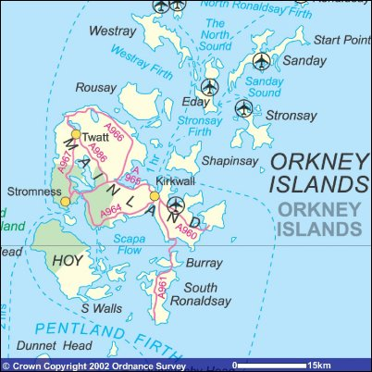

Map Orkney Islands https://www.scotland-inverness.co.uk/orkney.htm
A military defence base was started around the Scapa Flow area in response to the threat posed by the attacking forces during the Napoleonic Wars. In 1812, cannon sites were built to aid the defence of the region (Hewison, 2000, pp. 18-24). The development of the military base at Scapa Flow continued during the following peace time, (Hewison, 2000, pp. 26-38). During this quiet period, the Germans and the Allies researched ship building and development of their fleets. The Germans were jealous of the British regarding their fleet, and the Germans began to build their own fleet of the Dreadnought class of ships.
From 1904-1910, the British admiralty continued to develop their naval base around Scapa Flow. By 1909, it was considered a first class naval base. New technology, oil instead of coal, was used to power the ships (Hewison, 2000, pp. 26-38). Therefore it was a recognised Naval Base within the United Kingdom (UK) before the outbreak of WWI in 1914 (Hewison, 2000, pp. 26-38). By the end of WWI in 1919, Scapa Flow was well known throughout Europe. Today it is known globally because of the scuttling of the German Fleet here in June 1919.
The preparations for and during WWI had a major impact for the people who lived on the Orkney Islands, with families being separated as the islands became a hostile environment, and this was before the German fleet arrived. It was difficult trying to produce food by farming and accessing resources was a problem due to the lack of manpower. Many local men had been enlisted in the forces at this time (Hewison, 2000, pp. 83-92).
On the 11th November 1918, armistice started but it did not become fully active until the 21st June 1919 (Muir, 2019, pp. 2-5). By the end of November 1918, the first of the German fleet entered Scapa Flow. At the beginning of December 1918, German officers and men began to be expatriated, this continued up to Armistice Day (Muir, 2019, pp. 2-5).
The German fleet sank in June 1919. On the 21st June 1919 Rear Admiral von Reuter give the orders to the German fleet to scuttle themselves (Muir, 2019, pp. 2-5). Out of the 74 interned ships, 52 ships in total sank (Vat, 2007, pp. 3,4). Several people were killed in this instance, but their bodies were recovered and buried in Lyness Naval Cemetery. Therefore, these wrecks are not classified as war graves (Mearn, 2019, p. 91). In 2001, the seven remaining ships were scheduled, under the Ancient Monuments and Archaeological Areas Act 1979, by Historic Scotland (Wilson, 2019, p. 4).
Recovery
The first attempt to salvage these ships was made by the Royal Navy between 1919 and 1920. One battleship, three light cruisers and nineteen torpedo boats were re-floated (Muir, 2019, pp. 2-5). Another attempt was made by East Coast Wrecking Co in 1922, this time two Destroyers were salvaged (Muir, 2019).
The biggest contributor to the recovery of the wrecks was Ernest Cox. He was an electrical and mechanical engineer who used his skills in marine salvage. He set up Cox and Danks Shipbreaking Co Ltd with his cousin as a silent partner and financer. In 1924, Cox & Danks purchased twenty six Destroyers and Battle Cruisers from the Royal Navy for £24,000. Over the next few years they managed to successfully raise 35 ships (Mearn, 2019, p. 81).
Cox’s theory was that the way to raise these ships was to pump in compressed air, to force the water out after sealing all the openings in the hull. In this way, the ships should rise to the surface (Mearn, 2019, p. 81). He tested this theory by getting divers to fix the airlocks, using air lines and a number of compressors to pump air into the sealed hull to force the water level down. In practice, it was discovered that there was more to it than just pumping air into a hull to raise it off the seabed, as there were thousands of small holes, each of which had to be patched, at considerable risk to the divers involved. (Mearn, 2019, pp. 81-84).
WWII Developments
In a similar way to defence tactics used in WWI, a number of sunken merchant ships were used to blockade the Scapa Flow’s harbour entrance. These ‘block ships’ were to defend against submarine attack in WWII. These and other ships became a permanent feature in the harbour and are known as the Churchill barriers (Hewison, 2000, p. 3). In addition to these, many other defences around the Orkney Islands were up-graded at this time.
Events in WWII led to the site being recognised as a war grave due to the sinking of three ships here. The Royal Oak; The Hampshire and The Vanguard were the casualties of war. This catastrophe had major consequences for the British fleet during WWII. War graves are protected under the ‘Protection of Military Remains Act 1986’, which means they cannot be disturbed and divers are prohibited from getting too close to them (Bowd, 2019).
There remain seven ships from the WWI German fleet (see Appendix 1). Other wrecks in the harbour, including the ‘block ships’ can all be dived on at present. However, corrosion makes this hazardous on some ships (these are also listed in Appendix 1). Apart from the war graves, there are a number of WWII which can be dived on (see Appendix 1).

The Barrier Block Ships
As previously mentioned, the barrier block ships are ships that were purposely sunk along the sea floor at the entrances to Scapa Flow in WWI and WWII, as a temporary solution to prevent the German Ships or submarines from entering Scapa Flow (Wood, 2018, pp. 107-149). The numerous ships on the Churchill Barriers range in depth from 8m on the seaward side and 12-20m on the Scapa Flow side (Wood, 2018, pp. 107-149). Due to their location, many are damaged or submerged because of the currents and tidal effects. Therefore these are too hazardous to dive on. However, they serve to slow the currents and help to preserve the ships deeper within the harbour.
Salvaging rights
Due to the degradation of the ships and unmanaged salvaging, from 1981 the Orkney Islands Council decided it wanted to see salvaging controlled and promote tourism. Scottish Heritage became involved in May 2001. From this point in time, the seven remaining German ships were recognised as scheduled monuments due to their historical and cultural significance (Muir, 2019, p. 5).
During this author’s fieldwork a number of small museums were open but the main museum was being redeveloped. However, an enterprising local hotelier has opened a small display in its absence. The islanders are continuing to open distilleries and work at their farming and fishing to sustain their community. Tourism is high on their agenda, with the diving community being a valuable resource. Overall, the Orkney Islanders have a strong heritage stretching from The Iron and Bronze ages, and the Vikings through to their part in the World wars of the 20th century

Chapter 4 Hazards
This section will explore the conditions and hazards which are present in the harbour which may impact the future of the heritage site. These hazards vary from environmental factors such as weather conditions on sea and land, tidal factors and currents, physical concerns form shipping and what impact the associated pollutants may have on the local marine life. These are all key factors relating to this location and their effects on the preservation of the heritage of Scapa Flow.
This research will be examining the effects of the erosion of the ships and discovering the relevance in the differences in steel manufacture between WWI and WWII. The construction of the ships varied, mainly due to the thickness of the pattern plates used in the manufacture of the ships from both wars, during WWII, thinner steel was used.
The erosion of the steel used for the manufacture of the sunken ships, by the air and sea water has a subsequent effect on the local environment. For example, because of the degradation of the ships there is a possibility of pollutants and what the impact to the environment would be if the wrecks were removed. This chapter will be reviewing the condition of the wrecks at present and considering the problems for divers and underwater archaeologists.
Environmental
Wind and water
The Orkney Islands are located in the North Sea to the north-east of Scotland. Here the weather and climate are very unpredictable, the Gulf Stream is a major influence, resulting in a slightly higher temperature than that of the mainland (Towrie, 1996-2019). It is the humid air carried on the Gulf Stream which means that the overall temperature is warmer than expected for such a northerly latitude (Towrie, 1996-2019).
Other factors influencing The Orkney Islands are the dark winter period and the extreme wind forces, with over 52 gales recorded annually. The land is affected as well as the sea, as the gales carry salt from the sea onto the mainland, therefore the plant life has to be able to survive in these extreme circumstances (Towrie, 1996-2019). Snow is rare on the islands but humidity and rainfall result in a wet environment and there are often sea mists and fog (Towrie, 1996-2019).
The wind and the currents influence the shape of the shoreline. Severe erosion of the coast is caused when the longshore drift of natural material (shingle and sand) is disturbed. In some places, however, the sediment is small in volume and which moves in one direction around the headland (Brampton, 2000, pp. 2,3).
A major factor in defining our coastline are the tidal conditions. These are affected by both the weather and influenced heavily by astronomical forces, such as the movements of the earth, the moon and the sun. Another consideration is the diurnal rhythm, the length of time between tides (Brampton, 2000, p. 7). All the tides on the Scottish coastline of the North Sea result from the connections to the Atlantic Ocean. As there is an underwater European continental shelf, waters here tend to be shallow. This meeting of the wave energy and the shallow water results in a complex mixture of tidal conditions, including areas of little or no tidal range and vortexes (called Astronomical tide points) (Brampton, 2000, p. 8).
A major problem the wind can cause, which alters the water levels dramatically is known as a ‘storm surge’. This is a result of high winds on shallow seas. The effect of sudden high winds on the sea in narrow estuaries or harbours can amplify the wave patterns and cause devastating results (Brampton, 2000, p. 8).
A crucial feature of today’s environment is the predicted rise in sea levels as the climate changes. Coastal habitats may have to be monitored in order to be able to minimise flood risks and erosion (French, 2001, pp. 305-307).
Animals and plants
Some animals and plants have found an ecological niche in which they have managed to thrive. The various habitats found on land include coastal cliffs, moorland and saltmarshes (Orkney Islands Council , 2014-2019). The diverse sea life found there includes plankton, shellfish and fish with fins, various types of seals, cetaceans, otters and turtles (The European Marine Energy Centre, 2019, pp. 8-19).
The effects of fishing
Fishermen are one of the major stakeholders involved with Scapa Flow. Fishing is one of the major industries in the area and it has been a source of income and livelihood for many hundreds of years. As technology develops, fishing has become more of an industrial activity. Smaller ships within the harbour are fishing for lobster, crabs and scallops. Dredging for scallops takes place in the centre of Scapa Flow and these catches are landed in three harbours around Scapa Flow. Crucially, none of these activities take place close to the Scapa Flow site (The European Marine Energy Centre, 2019, p. 27). Fishermen have a vested interest in the wrecks as it is here that large numbers of fish are found and wrecks are a potential breeding ground (UNESCO, 2012). However, wrecks may also be a hazard for fishermen as their equipment may be lost or damaged by them.
Fish farming known as ‘aquaculture’ is carried out locally; salmon farming is a major industry in Scapa Flow and the Northern Isles. A commercial shellfish site is found quite close to the Scapa Flow site, this venture is monitored by Orkney Sustainable Fisheries (The European Marine Energy Centre, 2019, p. 27).
Commercial Sea Traffic and other shipping activity
As a designated harbour area, controlled by the Orkney County Council Act 1974, many local harbours are used for commercial purposes. Many of the vessels which travel through the harbour are small fishing boats and charter boats for divers and tourists and these journeys happen mostly in the summer season (The European Marine Energy Centre, 2019, pp. 27,28). A bigger hazard to the area are the large oil and gas tankers which travel to the nearby Flotta Oil Terminal. Of major concern for the environment are the ship to ship transfers (The European Marine Energy Centre, 2019, pp. 27,28).

Conservation
Many different designations of scientific interest have been assigned to the Scapa Flow area and there are detailed maps of fisheries provided, to enable developers to assess the environmental impact of any proposal they may have (The European Marine Energy Centre, 2019, pp. 38-42).
Scapa Flow has many different interacting conservation aspects, from heritage on the land, the fishing industries and the oil industry. This means that the environment is in a delicate balance as one small mistake could cause an environmental disaster.
The wrecks beneath the surface of the water also present an environmental challenge. In preparation for WWI, many British Merchant ships and boats were sunk in order to block the harbour, known as Block Ships. Because these ships were deliberately sunk, they were cleaned and emptied of any fuel and pollutants (Bowd, 2019). However, the German Fleet Ships, which were sunk in haste during WWI, caused Scapa Flow to be awash with oil and large amounts of debris from these sunken ships (Wood, 2018, p. 18). Three British Battleships, which sunk in WWII in the harbour, still contained all their pollutants. These ships are now classified as War-Graves. In this case, as the author discovered whilst researching, the locals still believe they can smell the oil (Personal, 2019).
WWI Block Ships (see appendix 1) remain in various conditions, due to erosion from the strong currents and tidal conditions as mentioned earlier (Bowd, 2019). These ships still serve to protect the harbour from the rate of flow tidal currents and a couple of these ships are presently used by divers who can explore them (Wood, 2018). Seven WWI wrecks are used as dive sites. Today, the condition of each varies according to the depth at which they lie, and the way they sank. As some of the ships were top heavy, some lie on their side and some lie with the bottom up and their heavy guns buried in the seabed (Mearn, 2019, pp. 78-86).
An important factor in considering the rate of erosion of the wrecks is the steel used in constructing the ships. For an insight into steel manufacture see appendix 2.
Erosion of steel from the effects of sea water
Subir Paul (2009) wrote a paper discussing the life expectation of steel structures in the marine environment. His paper focused on the rate of corrosion of mild steel in sea water and the parameters that influence the rate of decay. This paper, however, did not include the effects of the tides and sea conditions. He states that five factors affect the corrosion of steel in water; chloride, sulphate, pH, dissolved oxygen and temperature all contribute to the rate of corrosion (Paul, 2009, pp. 1-9).
He carried out several experiments in laboratory conditions. By adjusting each one of these elements and recording the relationship between them and the rate of steel corrosion during the changing conditions. His experiments showed that steel, at depth, in seawater had a longer lifespan (Paul, 2009, pp. 1-9). This is due to the water being colder and containing less chloride and sulphate, and in deeper water there is less dissolved oxygen. This means that steel at depth takes longer to corrode than that at shallower depths (Paul, 2009, pp. 1-9).
How does Subir Paul’s theory effect the erosion and preservation of the heritage of the German Fleet? As mentioned previously, Subir Paul states there are five elements which affect the rate of corrosion. All the German Fleet are at a depth from 20 meters and down to beyond 40 meters. The water temperature in Scapa Flow varies from 8 -14 degrees centigrade at the shallower depth and beyond 20 meters it becomes colder. (Personal, 2019) Where ships are located on the seabed at varying depths, there is less dissolved oxygen in the sea water. The ships of the German Fleet are eroding at different rates as the shallower parts of the ships are corroding quicker than those in deeper waters. The WWII war ships, the three war graves, lay on the sea bed at a depth of 34 to 60 meters (Wood, 2018, pp. 101-104). Therefore these ships are protected by the temperature, depth and the lack of oxygen in the water.
So, it is difficult to compare the rates of decay between the German Fleet of WWI and the British Fleet of WWII due to the dissimilar depths of water where the ships lay. Additionally, the steel used in the manufacture of WWI ships contains more lead and is of a thicker gauge than that used for the British Fleet in WWII.
It is vital to consider these factors when planning for the preservation or removal of the wrecks and the impact on the heritage of Scapa Flow in the future.
Failed salvage attempts
There have possibly been many attempts to recover the remaining seven WWI German ships, however there are no records before WWII. The failed attempts may be due to the way the ships lay and their condition. There is no record of whether pollutants such as oil and fuel were removed. During WWII, three British ships were sunk in the harbour and these were available for salvage until 1958 (Muir, 2019, p. 3). Due to public outrage, the British warships became designated as war graves and were protected by the government and the Royal Navy. Today, only the Navy can dive on the three ships (Muir, 2019, p. 3). As diving became more accessible, there have been more attempts to salvage parts from the ships, but there is no official record of this. In 1986, the Orkney Islands Council wanted to stop salvaging and began to encourage diving and tourism. In May 2001, the WWI ships became protected under the Scheduled Monuments Act (Muir, 2019, p. 4).
Health and Safety issues for divers are included in appendix 3.
Considering the hazards, it seems the biggest factor is the delicate balancing act between heritage, the environment, the fisheries and the oil industry. All these will need to be considered in order to preserve Scapa Flow for the future.

Chapter 5 Heritage, Preservation and Tourism
This chapter will be looking at the heritage of Scapa Flow; how it has been preserved so far and looking forward into ideas for sustaining the narrative of Scapa Flow for the future. Considering the importance of the heritage sector for tourism and the local economy, the environmental impact of the wrecks and the impact on the local ecology, is a vital concern. Several issues need to be addressed in order to preserve this area as a heritage site. For example how to maintain the delicate balance between the local stakeholders and the heritage site in order to sustain the economy. It is essential to consider how this story will be told to generations in the future?
Heritage
At this time, curiosity about the past and our local and national heritage, as well as interest in maritime culture are higher than in previous eras. I agree with Flatman’s statement that ‘protection of cultural heritage [is] a moral, social, imperative but also… an economic one.’ (Flatman, 2009, p. 7).
Of all the visitors to the Orkneys and Scapa Flow, each has their own preconceived ideas about the narrative of the area and their individual understanding of the meaning of heritage. For first time visitors, it is advisable to research the area beforehand. However, if the name ‘Scapa Flow’ is entered into a search engine, many pages are listed showing the wartime history of the harbour, and this is focused around diving activities. If you are a dedicated diver and member of a club, Scapa Flow is one of the most important diving sites in the world. BSACS diving magazine published a large dedicated centenary year article and there are often reports or columns discussing the excellent diving on the site. From this, it can be understood that the heritage of Scapa Flow is recognised all over the world (Bsac Diving, 2019, pp. 48-83).
As a heritage studies student, I have considered the question of who ‘the heritage’ actually belongs to. Does it belong to the owners of the land, the owners of the material or the country where it is discovered? In some cases, there is some debate about ownership, whether it belongs to the flag nation or the nation where it sank (Stratigea, 2019, p. 1596).
According to Jesse Ransley, heritage is portrayed as something to be protected.
A sense of ‘rights’ is involved, along with ownership—my heritage, our heritage—and these are linked to community identity and associated, more ephemeral, notions of posterity, future generations and preservation as an expression of communal resilience (Skeates, 2002; Edson, 2004; Carman, 2005). (Ransley, 2007, p. 226)
Within every narrative, there are several stories, for example public, social cultural and collective (Benton, 2010, p. 7) that develop into the full picture (Ransley, 2007), the artefacts stay the same but the stories may vary over time.
In respect of this, my knowledge of the site did not cover the ancient stories of the Vikings use of the natural harbours of Scapa Flow as they expanded westwards (Hewison, 2000, p. 8). Scapa Flow has a rich and diverse heritage but the ancient narrative is not as well-known as the historic scuttling of the WWI German Fleet. It is this heritage which currently brings tourists and divers from all over the world to the area. The income generated is therefore essential to the local community and to Scotland as a whole.
My personal point of view of Scapa Flow was related to the WWI scuttled ships from 1919. This is because the area is one of the highlighted sites for divers, advertised and discussed in magazines for divers and the diving community.
Whilst on my fieldtrip, talking to the community of Scapa Flow, I came across stories about the development of Scapa Flow during the preparations for WWI. Later I read an interesting book The Great Harbour which verified these stories, including the way the community was divided by the men going off to work as it was a priority to develop the base and protect the harbour from invasion (Hewison, 2000).
Something else to consider, is the Royal Navy’s perspective and the relevance of this heritage immediately after WWI, compared to its relevance in the present day. An example of the different opinions is shown in the narrative about the block ships. At the time of WWI the local inhabitants were not very happy with the blockade of the harbour, as it affected their use of their own ships. However the government and the Royal Navy imposed a decision on them for the sake of national security (Personal, 2019). The block ships remain one of the main features and are still used as protectors of the harbour today. They contribute to the control of the currents and help to stabilise the flow of water. A later development was made in 1939 to provide security for the bay in preparation for WWII, it was named the Churchill Barriers (Hewison, 2000, pp. 4-6).
It is important to realise that during times of war the spoils go to the victors, therefore as the Allies won WWI, the German ships in British water belonged to Great Britain and some were interned in the harbour at Scapa Flow (Stratigea, 2019, p. 1596). In order to save honour and prevent the British from gaining access to these vessels, they were gradually sabotaged by opening hatches and setting charges and prepared for a time when the order would come from the German Admiral to scuttle the fleet (Vat, 2007, p. preface). On 21st June 1919 the order was given and the self-destruction of the fleet took place. Of the seventy four ships in the harbour, fifty two were actually sunk to the bottom (Vat, 2007, p. preface).
The Royal Navy successfully salvaged some of the sunken vessels in 1919 and 1920 (Muir, 2019, pp. 2-5). The salvage rights were contracted out by the Royal Navy and in 1922 East Coast Wrecking Co salvaged two Destroyers. Ernest Cox was an innovator in terms of salvage methods and recovered the largest amount of vessels, numbering thirty five (Meara, 2019, p. 81).
It can be seen that the narrative of the area has changed and developed over time. From the perspective of a wartime Naval base, through to the story of the post war salvage attempts, up to the present day where enterprising individuals have developed the local economy to reflect the interests of those on the heritage trail and the diving community (Muir, 2019, pp. 2-5).
Scapa Flow became a heritage site on 23rd May 2001: Historic Scotland awarded the seven remaining German wrecks ‘scheduled monument’ status (Muir, 2019, p. 4).
At present a number of bodies contribute to the maintenance of the site. Orkney Islands Council are supported by Historic Environment Scotland (Historic Environment Scotland, 2019) and United Nations Educational, Scientific and Cultural Organisation (UNESCO). The local council and the local community as well as the tour guides are all involved in the upkeep and consultations regarding the safekeeping of the historic artefacts within the area. They are helping to shape the modern narrative of Scapa Flow (historicenvironment.scot, 2020).
The Royal Navy is responsible for the three WWII ships which are designated war graves. In 1958, after a public outrage, the Admiralty were prevented from selling salvage rights to the three British battleships (Muir, 2019, p. 3). As late as February 2002 these vessels were designated under the Protection of Military Remains Act (PMRA), 1986. Before this although designated war graves, they had no real legal protection. Therefore no diving is permitted on them at present (Muir, 2019, p. 4). However some of the diving community (who play an important role in bringing in income from tourism) consider that they ‘should be able to dive the Royal Oak and Vanguard, no reason why people should be able to walk over battlefields in France where thousands of soldiers lie buried underneath but not dive a wreck with remains in there.’ (Historic Environment Scotland, 2019, p. 16).
As previously discussed, Scapa Flow is a heritage site at local, national and international levels. Both the land and the sea contain national treasures which need to be preserved and presented in the best possible way according to each individual case. There are several museums on the Islands telling different aspects of local history. One of the oldest examples of this is the Orkney Museum, which opened in 1968 and shows the narrative of the Picts and the Vikings (orkney.gov.uk, 2019).
In terms of the underwater heritage and how best to manage a site that is disappearing, this raises a couple of questions (Ransley, 2007). What needs saving/protecting and what can be left to disintegrate? For example, are the remaining ships to be left in situ or should/could they be raised? Important heritage may be lost as structures collapse. According to a regular diver at this site ‘the last 5 years have seen a very noticeable collapse of the big wrecks, clearly they are starting to weaken to the point where the corroded supports can no longer hold the weight.’ (Historic Environment Scotland, 2019, p. 11). The National Heritage Act (2002) affected the English approach to Maritime Heritage introducing a formalised system for managing underwater heritage, often Scotland adopts these ideas (Ransley, 2007).
As mentioned above, many ships were salvaged when it was a legal operation. To this end, in 1974, the Stromness Museum held an exhibition of the process called ‘The salvaging of the German Fleet’. This is now one of the permanent displays there (Muir, 2019, p. 4). The Scapa Flow museum is managed and owned by the Orkney Islands Council, it is in the Hoy wartime naval buildings. However at the time of my visit it was undergoing a major renovation, planning to reopen 2021. These renovations were funded by a number of bodies such as the Heritage Lottery Fund, Orkney Islands Council, Historic Environment Scotland, Highlands and Islands Enterprise, Museums Galleries Scotland and LEADER (Scottish Rural Network) (orkney.gov.uk, 2020). As can be seen these are both local and national bodies. It seemed disappointing that the centennial was advertised and promoted throughout the diving community but the museum was not available for the many visitors at this time. An enterprising initiative by the local community was successful in opening a temporary museum in the Hoy Hotel, Lyness, for the many visitors coming during the centennial (Personal, 2019).
The big question seems to be ‘how can we add to the heritage of Scapa Flow?’ How to sustain the narrative of Scapa Flow into the future. What is the best way to keep the tourist interest in the area as the condition of the underwater heritage changes? It is crucial to consider the interests of divers in this instance as they are the biggest sector of the tourist industry and they were a major contributor to the consultation carried out by Historic Environment Scotland (Historic Environment Scotland, 2019, p. 8).

(Historic Environment Scotland, 2019, p. 8)
HISTORIC ENVIRONMENT SCOTLAND: Analysis report: Scapa Flow Wartime Underwater Heritage
Q1 – In what capacity are you completing this survey? Please choose one from the following list - (answered 450, skipped 0)
It is interesting to see that from the 450 people who completed this survey, 273 (almost two thirds of the participants) were divers.
In conversation with the local people, tour guides and charter operators, it seems that their life is planned around working from season to season. The tour guides are extremely knowledgeable about the sunken ships and the local sites. They have observed changes to the wrecks over the time they have been operating. According to them, the last five years have seen the biggest changes and the degradation to the wrecks (Personal, 2019). The result is that the stability of the underwater heritage is now in question. For divers this means conditions have changed and they are no longer advised to swim through the wrecks but stay on the outside. According to the tour guide, it is possible to dive on the wrecks many times as the ships are so big it is impossible for the average diver to get the full picture, due to having a limited amount of air (Personal, 2019).
This being the case, it remains to discover other methods to give visitors a clear picture of the scale of the underwater heritage at Scapa Flow.
Preservation

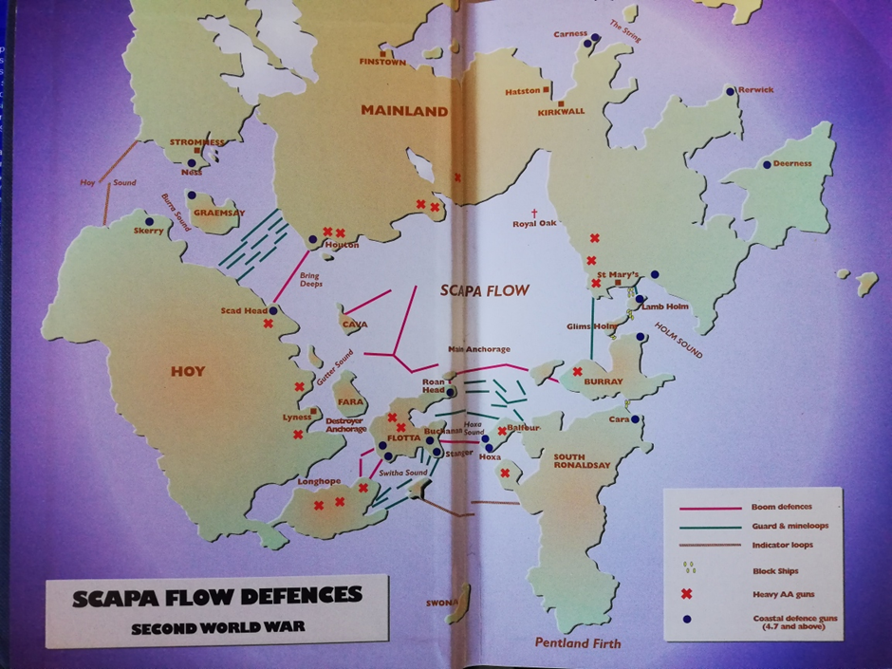
(Hewison, 2000, p. inner cover)
There are local, national and international bodies which are accountable for protecting the wrecks. Each organisation has its own legal responsibilities towards the heritage site. According to international organisation UNESCO’s ideology, to preserve the heritage, it is important to consider all the stakeholders involved (UNESCO, 2012, p. 6). According to Firth, the issues around shipwrecks are complicated, because many interests are involved (Firth, 2018, p. 1). His report includes not only the archaeological and historical interest (heritage) but another nine sectors with equal interests in wrecks, these are commemoration; fishing; international interests; nature conservation; navigation safety; ownership; public and environmental risk; recreation; sea-use (Firth, 2018, p. 1). Other bodies classify these sectors as stakeholders with interests in the Underwater Cultural Heritage too, for example UNESCO (UNESCO, 2012, pp. 3,6). It is interesting that Flatman considers the UNESCO 2001 Convention on the Protection of Underwater Cultural Heritage to be unsustainable as many countries have not signed it (Flatman, 2009, p. 6).
Nationally, Historic Environment Scotland, as well as the local Orkney Island Council and the local Harbour Authority are all dedicated stakeholders looking after the management of the harbor. Each stakeholder has its own responsibilities towards this site, however it is crucial to realise that the recreational diving industry contributes by surveying and reporting on the condition of the sites on a regular basis. This is done by informal reporting to the skipper of the chartered boats who report back on a regular basis to the Harbour Authority (Personal, 2019).
Orkney Islands Council has ownership of these sunken WWI vessels, and one was recently auctioned on an on-line website (Orkney Islands Council , 2014-2019). One thing to consider here is the morality of heritage in private ownership.
In the early 1980’s, the salvage rights belonged to the Orkney Islands Council and recovered artefacts were given to them to add to the collection in Stromness Museum (Wilson, 2019, pp. 18-21). Another museum was developed in Lyness in the Naval Buildings there to tell the story of the harbour during WWI and WWII. Here are many examples of artefacts from both the wars (Wilson, 2019, pp. 22,23). With the passage of time, the importance of preserving the remaining artefacts is a major concern as now the degradation of the wrecks means that internal diving is more hazardous. Recognition that designation is not enough to preserve the narrative in this instance, but that some recovery is required has been discussed in the report from Historic Environment Scotland (Historic Environment Scotland, 2019, p. 9).
Divers who visit the site follow the instructions given in the booklet published by Historic England. Here the directive follows guidelines set out in the annex of the 2001 UNESCO Convention on the Protection of the Underwater Cultural Heritage (Historic England, 2015, p. 1). This approach consists of a ‘look but do not touch’ strategy, and it is important to recognise that heavy fines apply if these guidelines are found to have been broken both for the individual concerned and for the charter boat involved. This law is enforced by the Harbours Authority.
The Orkney Isles and Scapa Flow rely on the tourism industry for their seasonal income, however the local population is small. Nevertheless, there is a strong sense of local identity and whilst researching on my fieldtrip, I discovered that the history and local cultural stories are passed from generation to generation (Personal, 2019). According to Drury and McPherson (2008), social value is derived from a sense of identity associated with a place. This social value is added to by the re-creation of stories of the past (Benton, 2010, p. 9). This is reinforced by the local community who are actively involved in activities which continue to embrace narrative of the past with their present activities.
As can be seen on the map of the harbour at the beginning of this section, the block ships themselves are still present and continue to preserve the site. Today they help to keep the inner harbour protected from the strong currents of the North Sea. Some of these are too hazardous to dive on, but some are still used by the recreational divers who visit the site (Bowd, 2019).
What effect would any salvage attempts of the whole ships have on the artefacts themselves and the environment? In what way can the value of this site be preserved and the story of this place be continued?

Tourism
Stories of the World Wars as well as tales of shipwrecks and their salvage are one of the main ways that the public finds a connection to their past (Firth, 2018, p. 5). The general tourist is either interested in the historical value of the Islands or visits as a diver interested both in the history of the ships and their value for recreation (Pearce, 1990, p. 133). In addition, some divers are focused on the environmental aspects of these ships, which have been colorised by marine creature and have become living reefs over the hundred years they have been submerged (Wood, 2018, pp. 153-162).
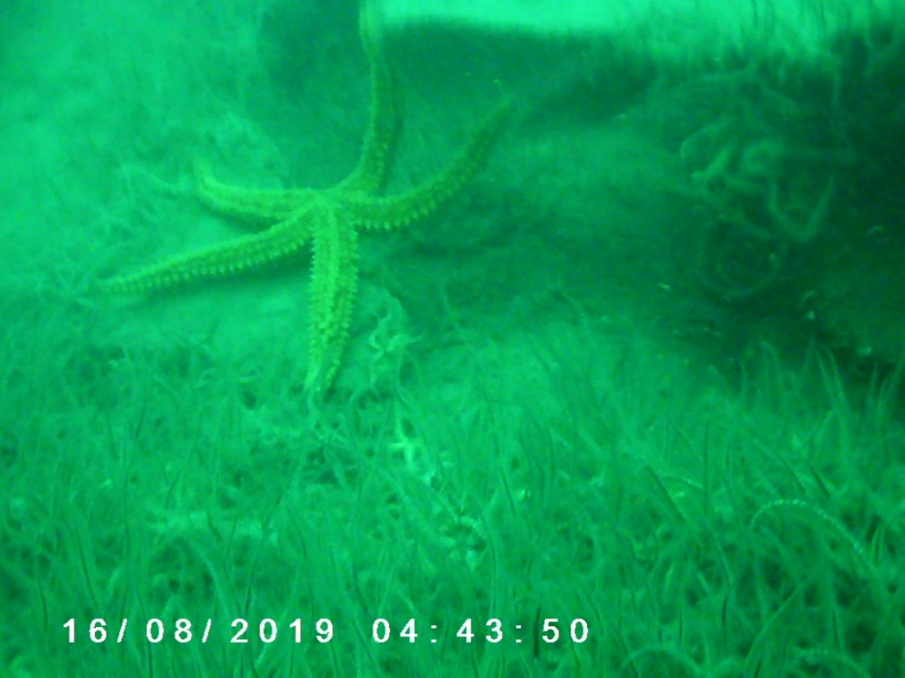
Broyan Dymond fieldwork 2019
As previously mentioned, heritage is a driving force for the local community, with many businesses based around the seasonal visitors. In this way, the local residents and businessmen are focused on a year to year plan and often close down or reduce hours in the winter. To allow for them to plan further ahead would require some incentives and guidance.The stakeholders who do operate in the winter time are the fishermen, farmers and the oil companies.
I was told that the story of the WWI ships is still a major element in the local community and it brings visitors from across the world (Personal, 2019). To this end new businesses have developed and there is a local diving community, actively training new divers and a shop which caters for the needs of both local and visiting divers (Personal, 2019), (Wood, 2018, p. 153). Other enterprises which benefit from tourism include shops and distilleries, hotels and cafes (Personal, 2019).
The most frequent local divers are the tour guides and those who run the diving shops and schools. The tour guides have been diving on these wrecks for many years. They have photographed and mapped the wrecks (Bernier, 2006). In addition to this they have dropped shot lines as entry points for divers. Each trip they give a dive brief explaining safety, the lay of the wreck and what type of ship it is, as well as any hazards to be aware of. The recommendation is that divers can visit these sites on a ‘look but don’t touch basis’ (Development and Infrastructure Committee, 2019).
This site was promoted as a world class diving site as early as 1986 (Wilson, 2019, p. 4). In 2019, one charter boat is predicting 5,000 dives during the season. It has been estimated recently that diving expenditure in Scotland is £38M annually (Firth, 2018, p. 28). The growth of this business demonstrates the importance of preserving this site, the tourist industry connected with it and the narrative of Scapa Flow.

Case study
In comparison with Scapa Flow, which is a WWI and WWII site, managed by local and national bodies, is Truk Lagoon, located in the Pacific, Papua New Guinea, which is a privately owned WWII site. Here the water is much warmer and calmer, however similar to Scapa Flow it is a natural harbour surrounded by islands. It was the Japanese nation’s forward naval base during the Second World War, with an infrastructure to support it. Although forewarned, the Japanese only had time to move their larger ships. The base was destroyed by air attack in 1944, when planes from American aircraft carriers sank the remaining warships and merchant ships as well as many aircraft on land. This makes Truk Lagoon possibly the largest ship graveyard in the world (Trumbull, 1972, April 30th). This site is also protected by UNESCO and the ships are classified as Japanese war graves. This gives them responsibility for the clean-up of the site. As this site is privately owned diving is permitted although no disturbance of remains or artefacts is allowed (UNESCO, 2012) (Stratigea, 2019, p. 1590).
Diving guide and wreck finder, Kimiuo Aisek bought the site and the nearby hotel in 1998. A large museum (Kimiuo Aisek Memorial Museum) was dedicated to his memory in 2014. It is situated near the dive shop in the Blue Lagoon Resort in Truk. This site clearly has its focus on attracting tourists and the diving community. Here the income benefits the business rather than the general community.
The wrecks here are at a much shallower depth, and the water has very few currents but the wrecks have developed into reefs as in Scapa Flow. As Subir discusses, the shallow, warmer water may possibly corrode the metal faster than those at Scapa Flow (Paul, 2009). One consequence of corrosion is the environmental damage caused by the leakage of fuel and other pollutants. There is a concern that the rusting ships may release tons of oil onto the coral reefs. In the same way as in Scapa Flow there is no way of knowing how much fuel and therefore damage may be caused to the environment (Brahic, 2nd Sept 2008).
These two sites are very similar but one is community based and the other is a private investment and a business model. Scapa Flow is more accessible to the average diver but the expense of visiting Truk means that it is restricted to the wealthy (Stratigea, 2019, p. 1590).

Preserving Sustainability at Scapa Flow
The potential of the site could be developed by carrying out more research into the rate of decay of the wrecks. Grants were awarded towards archaeological research of the site by Historic Environment Scotland, for example: UHI Archaeology Institute, Scapa Flow - Ship Time Archaeology, £1,120, 05.07.2018 and Orkney Research Centre for Archaeology, Scapa Flow Underwater Scrap Sites Survey Phase 2, £31,080, 17.07.2018 (Historic Environment Scotland, 2018-2019). New sources of potential funding would help to maintain a steady flow of income and ensure that research is continued and the narrative of Scapa Flow continues into the future.
Ideas for expanding tourism include designing heritage trails involving local interests, as well as the possibility of virtual dive tours of the WWI and WWII wrecks and the experience of using a Virtual Reality (VR) headset to get a clear idea of the wrecks without the hazards associated with diving. VR can enhance the diving experience and give a clearer idea of the whole ship, before entering the water on a chosen site.
Another, more expensive proposal might include converting a submarine, with viewing ports to do tour guides around the wrecks for non-divers.
Chapter 6 Findings
This chapter will be exploring interactions with the crew of the charter boat, the other visitors and local people and interpreting their views. For the replies to my questions, see Appendix 4.
It will also describe my first hand experiences of exploring the wrecks.

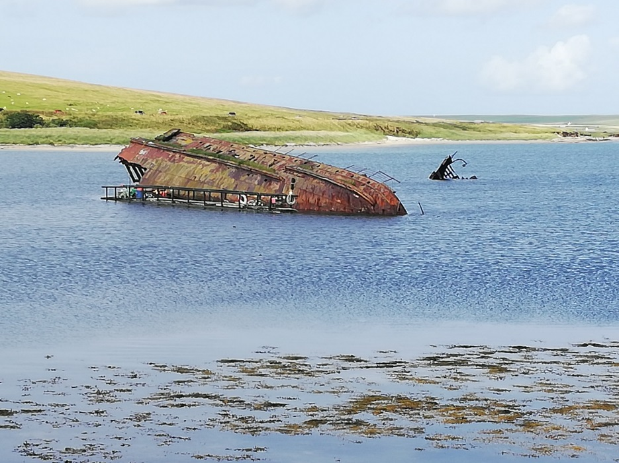
B. Dymond (2019) Ship wreck by Churchill Barriers

By observing this picture of a wreck by the Churchill Barriers, it can be seen that it is unsafe to examine it more closely. This is due to the amount of oxidation of the steel structure and the way it has degraded due to the action of the environment, sea water and air. This is a good example of Subir Paul’s theory describing the way steel corrodes in sea water, as discussed in the section describing hazards at Scapa Flow (page14) (Paul, 2009). As this boat is on the surface it is affected by all the five elements which contribute to corrosion of the steel.
The dive brief given by the tour guide describes the conditions on the charter boat we will be staying on for the next week. This includes health and safety on board and the regulations set by the boat’s owner. He emphasised the regulations and that all diving is on a ‘look but don’t touch’ basis as well as the possibility of a spot check carried out by the Harbour Master.
He gave us a brief outline of the wrecks included on the tour and explained that the schedule was two dives a day for six days. These dives included four German Light Cruisers and three battleships. The first dive concentrated on Dresden II in order to familiarise the divers with the safety routines. The guide informed the group that this was one of the easiest wrecks to dive on, due to the shallow water ranging from 16m to 38m (Personal, 2019). The trip organiser decided on the diving buddies according to their equipment differences as some had single cylinders, others had twin sets and two had rebreathers (Personal, 2019). This first dive was to make sure everyone was familiar with their equipment and the diving environment. It was followed by a debrief and each diver logged their dive in a reflective way, considering how to improve their experience next time.
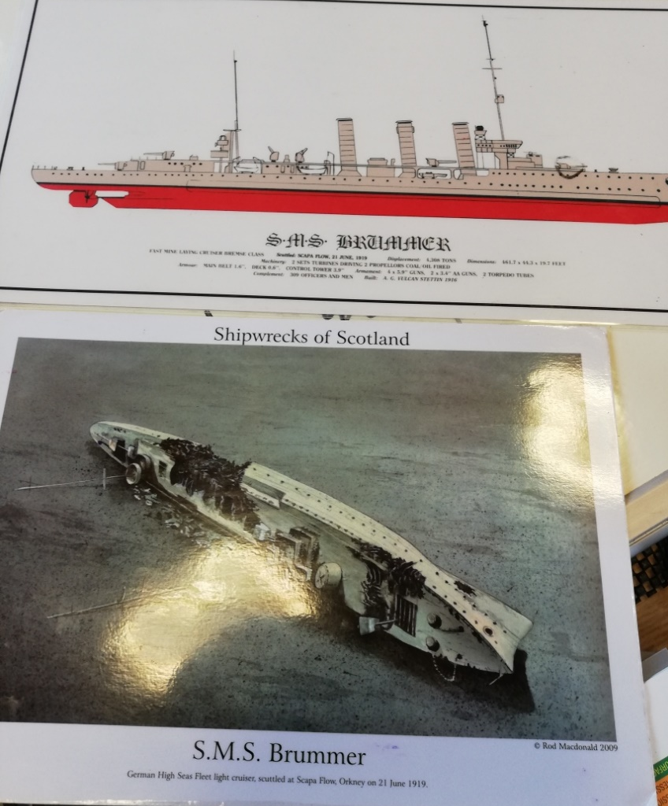
B. Dymond 2019 Dive Briefs Brummer light cruiser

The tour guide went into much more detail about this wreck. He described how the ship is laid on its side on the sea bed and the depth (24-36m) it is found in. Above can be seen a photograph of the ship back in 2009 and an artist’s impression of how it looked originally. The tour guide said that although it is possible to swim inside the wreck, he did not recommend it due to the amount of deterioration (Personal, 2019). In this case, I dived with an extra cylinder (still a limited 45 minute dive) and spent a lot of time on visual inspection of the wreck. This helped me to understand the amount of corrosion and the difference in the shallower water to deeper. It corresponds to the varying levels of oxidation at different depths and corresponds to the research by Subir Paul (Paul, 2009). Previous damage caused by salvage attempts has increased corrosion in several areas. Whilst on this dive it was possible to see the steel plates coming away from the hull. These pieces crumbled to the touch. These failed attempts mean that there is no longer a chance to recover this ship, although an expert diver may be able to recover some of the artefacts contained within.
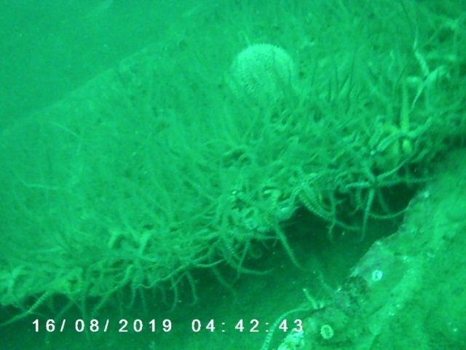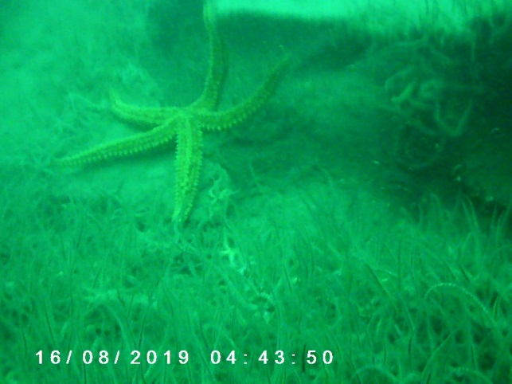
B. Dymond (2019) Life on Ship
The wreck was swarming with marine life and it was apparent that it had become a living reef habitat as seen in the pictures above.

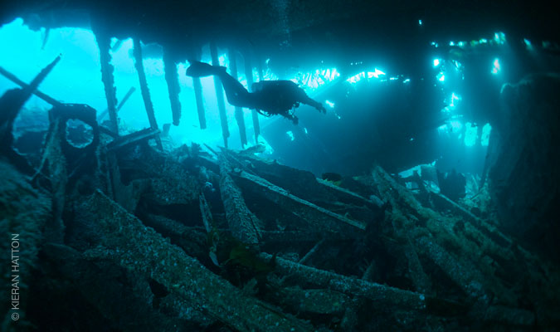
The Tabarka http://www.scapaflowwrecks.com/img/wrecks/tabarka/udw/boilers-forward.jpg

This picture shows one of the block ships, considered by the tour guide to be a challenging dive due to the strong currents because of its position protecting the harbour, although it is found at a shallow depth (14-18m). My experience of diving there was that the currents gave a gentle drift. This was due to the skill of the skipper and his knowledge of the sea conditions. We were able to swim inside the wreck and the deterioration was clearly visible. There were some panels which had completely disappeared and huge holes which it was possible to swim through. This wreck had developed into a place where many fish and crustaceans had found a habitat, but it was not as covered in marine reef life.
The dive briefs and the shared experiences of diving at this location enabled me to answer all the questions I had developed as a questionnaire (see Appendix 4). A significant comment by the tour guide was that he had seen the deterioration of the wrecks increase over the last five years (Personal, 2019). This is possibly due to the influences of climate change for example, the increase in sea temperatures (Stratigea, 2019, p. 1596). One of the group who had dived there about 30 years ago informed me that the amount of silt in the harbour had increased more than she had expected and commented that the block ship she had dived on before was no longer safe to dive (Personal, 2019) and Appendix 4).These discussions with those people who had been visiting and diving here on previous occasions helped me to understand the rate of decomposition of the wrecks and the importance of finding a way to preserve this unique site for future generations (Personal, 2019).
Exploring the environment and interacting with local people, asking their opinions, knowledge and stories about this area, helped me to understand that the local economy is very dependent on the tourism generated by the Underwater Cultural Heritage of the area. In turn this generated an answer to the question of whether to raise the ships or keep them in situ. In my opinion, these wrecks should be left where they lay on the seabed where they are better protected, moving them would cause a huge environmental impact. I agree with the removal and protection of some of the artefacts, as suggested in the analysis report from Historic Environment Scotland (Historic Environment Scotland, 2019, p. 9) and with their statement that there is a need for continued survey work (Historic Environment Scotland, 2019, p. 15).
With these factors in mind, when I visited the Annual Diving Exhibition, I was looking for ways to promote and enhance the experience of Underwater Cultural Heritage at Scapa Flow in order to sustain the vital tourist economy of the Orkneys Islands.
Experience at Go Diving Exhibition (22nd and 23rd February 2020)
One of the largest events at this exhibition was a presentation and photo stage displaying pictures and videos about diving in the UK. The main exhibition showed Scapa Flow and its rich heritage. The WWI wrecks have been recognised as one of the great marine heritage sites in the world, in particular the rich and diverse wildlife and reefs which have developed there. The recommendation is that these wrecks should be considered as conservation sites for marine life, living reefs (Morgan, 2020).
In addition, at this exhibition there was an opportunity to experience Virtual Reality (VR) headsets which have been used to show what it feels like to dive on wrecks which may be too deep for the inexperienced diver. John Kendall is working on a project to develop photographic models for a ship at a depth of 75 meters. He has converted these pictures into 3D models and used them in a VR simulation. In this way the wrecks at Scapa Flow may be photographed and in a similar way VR can be used for those who are not able to access the underwater heritage personally, providing an opportunity for them to access the interior of the wrecks without any hazards to their health (Kendall, 2020).
Modern technology has developed in such a way that it is cheaper and easier for the regular diver to use, for example the availability of underwater photography. As well as this, research can be supported by the use of 3D underwater laser technology as well as remotely controlled robots and vehicles. In addition, here is sophisticated software which can support the mapping and documentation of underwater sites (Stratigea, 2019, p. 1596). The sharing of diving and research experience using the techniques which are available today can be applied at Scapa Flow, in order to provide a broader experience (such as VR as described above), available to a larger section of the public which in turn will ensure the vital tourist trade is sustained in the Orkney Islands. This will improve the diving experience for many regular divers as well as those who cannot dive. It will be in line with proposals from the locals and researcher who would like to develop the site as a conservation site for marine wildlife (Morgan, 2020).

Chapter 7 Conclusion
In order to maintain the heritage and tourism industries of the Orkney Islands, in particular Scapa Flow, the preservation of the narrative of the historic WWI wrecks in Scapa Flow is vital.
The local people have been embracing their heritage through stories passed down from generation to generation including the development of the harbour and the recovery of the German fleet.
Unlicensed salvaging was taking place before the Orkney Islands council got involved in 1986. From this time tourism has been high on their agenda and the diving community has embraced this.
The local community have developed their businesses around the tourist industry by becoming tour guides with boats to charter and opening cafes, gift shops and hotels all supported by tourists interested in the local heritage.
The Orkney Islands are a harsh environment. The weather and climate is very unpredictable with many gales each season. This affects the tidal currents and the erosion of the coastline. It is however a unique environment for many animals and plants, enjoyed by many of the visitors who travel here.
There are other stakeholders involved with the area, including fishermen commercial sea traffic, the oil industry and research and scientific interests. All these accept the tourist industry and are involved in protecting the heritage and the environment. It would be effective to consider some financial stability to give some incentive to the Islanders who usually focus on seasonal planning rather than a long term outlook.
There is concern about the pollutants contained in both the WWI and WWII ships. This is due to the rate of erosion of the wrecks, in turn affected by their age and location. An example of this is the wreck on page 29 which is situated by the Churchill Barriers and demonstrates Subir Paul’s theory about the erosion of steel. However, many wrecks are still well preserved due to the depth at which they lay. This is shown to be due to variation in the five factors which Subir Paul considers to contribute to the erosion of steel.
Previous failed salvage attempts and progressive erosion means that these wrecks are no longer feasible to be salvaged or raised. It would be far too costly financially and to the environment. Museums display the artefacts which had already been recovered before May 2001 when the wrecks were designated as ‘scheduled monuments’.
From my first-hand experience of diving on the wrecks, I can say that they are covered in marine life and in my opinion it would be wrong to carry out any large scale salvaging on them. I do agree with the comments made in the survey by Historic Environment Scotland ( see 18 & 25) which stated that some artefacts from the interior of the structures should be recovered before their eventual collapse. According to the tour guide and the Historic Environment Scotland survey deterioration of the wrecks has increased visibly over the last five years. Therefore it is important to decide whether or what to recover before it is too late.
The average diver with a limited air supply, rarely get to much more than a small section of the ship. Today it is no longer safe to swim inside many of the ships and therefore many of the dives just cover small sections of the exterior.
As scuba divers constitute the majority of the visiting tourists their interests can cover both historical and environmental aspects of the area.
In order to develop the further potential of the site, new sources of funding need to be found. It is possible that divers could be used as researchers or help with 3D photography of the wrecks. In this way, virtual tours using virtual reality (VR) headsets could become a feature of a trip to Scapa Flow. This would enable divers to get a clear picture of the ships without entering the water. It would enhance the diving experience and make it available to others. It could be made available through the charter boats and the museums to protect their interests and help to sustain their income.
Promotion of the area as an environmental habitat is already taking place as I discovered at the Go Diving Exhibition. I agree with their recommendation that before diving it is beneficial to visit the museums in order to gain an understanding of the heritage and the local environment.
My experience with VR headsets at the Exhibition confirmed to me that the technology is available and can be used to sustain the heritage and tourism at Scapa Flow. This will enhance the diving experience and may possibly increase tourism to the area.
This is another chapter in the ever changing narrative of Scapa Flow. The same story but from a different perspective.

Bibliography

Bell, T., 2019. The History Steel From Iron Age to Electric Arc Furnaces. [Online]
Available at: https://www.thebalance.com/steel-history-2340172
[Accessed 16 11 2019].
Benton, T., 2010. Understanding heritage and memory. Manchester: Manchester University Press.
Bernier, M. A., 2006. To dig or not to dig: underwater cultural heritage at risk. [Online]
Available at: https://www.icomos.org/risk/2006/22bernier2006an.pdf
[Accessed 25 Feb 2020].
Bowd, C., 2019. A Complete Guide to the Wrecks of Scapa Flow. [Online]
Available at: https://www.northlinkferries.co.uk/orkney-blog/wrecks-of-scapa-flow/
[Accessed 30 10 2019].
Brahic, C., 2nd Sept 2008. Paradise island threatened by wrecked WWII oil tanker. [Online]
Available at: https://www.newscientist.com/article/dn14645-paradise-island-threatened-by-wrecked-wwii-oil-tanker/
[Accessed 27 Jan 2020].
Brampton, D. L. R. &. A. H., 2000. Scottish Natural Heritage: Cell 10 Orkney. [Online]
Available at: dynamiccoast.com/files/Ramsay_Brampton_Cell_10.pdf
[Accessed 6th November 2019].
BSAC DIVE WITH US, 2019. SCAPA. Offical Magazine of Britain Biggest Diving club, April, pp. 48-83.
Bsac Diving, 2019. Scapa. Offical Magazine of Britain Diving Bsac Dive with us, Issue 89, p. 43 81.
Development and Infrastructure Committee, 2019. Proposed Scapa Flow Historic Marine Protected Area, s.l.: Historic Environment Scotland.
edited by Fred Hocker, 2006. Vasa 1: The Archaeology of a Swedish Warship of 1628. Stockholm: Oxbow Books.
Ellerby, D., 2013. The Diving Manual . In: R. Scarsbrook, ed. An introduction to Scuba Diving. Cheshire: AquaPress Ltd, p. 34.
Firth, A., 2018. Managing-Shipwrecks. [Online]
Available at: file:///F:/Managing-Shipwrecks-April-2018-web.pdf
[Accessed 20 july 2019].
Flatman, J., 2009. Conserving Marine Cultural Heritage: Threats, Risks and Future Priorities. conservation and Management of archaeological Sites , 11(1), pp. 5-8.
French, A. &. J., 2001. Habitat Conservation. In: Managing the Physical Environment. Chichester : John Wiley & Sons.
Hewison, W., 2000. This Great Harbour Scapa Flow. Third Edition ed. KirKwall: The Orcadian Limited.
Historic Environment Scotland, 2018-2019. Scapa Flow Grants Awarded. [Online]
Available at: file:///F:/diss%20scapa%20flow/grants-awarded-2018-19.pdf
[Accessed 10 08 2019].
Historic Environment Soctland, 2005. A Practical Guide to the Strategic Environmental Assessment Directive. [Online]
Available at: file:///F:/diss%20scapa%20flow/practicalguidesea.pdf
[Accessed 10 09 2019].
Historic England, 2015. Accessing England's Protected Wreck sites/ Guidance Notes for Divers and Archaeologists. [Online]
Available at: file:///F:/diss%20scapa%20flow/HEAG075%20Guidance%20notes%20for%20divers%20and%20archaeologists.pdf
[Accessed 02 08 2019].
Historic Environment Scotland, 2019. ANALYSIS REPORT: SCAPA FLOW WARTIME UNDERWATER HERITAGE. [Online]
Available at: file:///F:/diss%20scapa%20flow/scapa-flow-analysis-report.pdf
[Accessed 15 06 2019].
Historic Scotland, 2007. (SHEA) Scotland’s Historic Environment Audit. [Online]
Available at: file:///F:/diss%20scapa%20flow/scapa%20flow%20shea%20report.pdf
[Accessed 10 06 2019].
Historicenvironment.scot, 2020. www.historicenvironment.scot/. [Online]
Available at: https://www.historicenvironment.scot/
[Accessed 6 Jan 2020].
Ian.R.Calder, 1999. The Blue Revolution. In: and Use and Integratted Water Resources Management. London: Earthscan Publications.
Kendall, J., 2020. Global Underwater Explorers. [Online]
Available at: www.johnkendall.com
[Accessed 22 February 2020].
Meara, D., 2019. The Great Scuttle. In: First, ed. The End of the German High seas Fleet Witnessing History. s.l.:Amberley Publishing.
Morgan, J., 2020. Focus on UK Marine Life. Coverntry, https://www.godvingshow.com/dive-show-speakers.
Morgan, J., 2020. Focus on UK Marine Life. Coventry, https://www.godivingshow.com/dive-show-speakers.
Muir, T., 2019. Time Line. Salvaging the German Fleet , 1(1), pp. 2-4.
Orkney Islands Council , 2014-2019. Orkney.com. [Online]
Available at: https://www.orkney.com/things/nature
[Accessed 6th November 2019].
orkney.gov.uk, 2019. www.orkney.gov.uk/Service-Directory/S/orkney-museum.htm. [Online]
Available at: https://www.orkney.gov.uk/Service-Directory/S/orkney-museum.htm
[Accessed 6 Jan 2020].
orkney.gov.uk, 2020. scapa-flow-visitor-centre-and-museum. [Online]
Available at: https://www.orkney.gov.uk/Service-Directory/S/scapa-flow-visitor-centre-and-museum_2.htm
[Accessed 3rd Feb 2020].
Paul, S., 2009. Estmatation of Corrosion Rate of Mild Steel in Sea Water and Applicationof Genetic Algorithms to find Miniumum Corrosion Rate. Canadian Metallurgical Quarterly, 49(1), pp. 1-8.
Pearce, S. M., 1990. Archaeological Curatorship. London: Leicester University Press.
Personal, C., 2019. Locals from Scapa Flow [Interview] (Aug 2019).
Ransley, J., 2007. Rigourous Reasoning, Reflexive Research and the Space for 'Alternative Archaeologies'. Questions for Maritime Archaeological Heritage Management. The International Journal of Nautical Archaeology, 36(2), pp. 221-237.
Scottish Government, 2013. Scapa flow strategic environmential assessment. [Online]
Available at: file:///F:/diss%20scapa%20flow/strategic%20environmential%20assessment.pdf
[Accessed 30 06 2019].
Sottish Government, 2006. ANCIENT MONUMENTS AND ARCHAEOLOGICAL AREAS ACT 1979. [Online]
Available at: file:///F:/diss%20scapa%20flow/rowallan-public-enquiry-2009-report-2.pdf
[Accessed 10 09 2019].
Stratigea, V. A. a. A., 2019. Sustainable Management of Underwater Cultural Heritage: The Route from Discovery to Engagement - Open Issues in the Mediterranean. Heritage, Volume 2, pp. 1588-1613.
The European Marine Energy Centre, 2019. Scapa Flow scale Test Site - Environmental description, s.l.: EMEC.
Towrie, S., 1996-2019. The Climate of Orkney. [Online]
Available at: http://www.orkneyjar.com/orkney/climate.htm
[Accessed 6th November 2019].
Trumbull, R., 1972, April 30th. The 'Graveyard' Lure of Truk Lagoon. New York Times.
UNESCO, 2012. www.unesco.org. [Online]
Available at: http://www.unesco.org/new/en/culture/themes/underwater-cultural-heritage/protection/protection/protection-and-management/ 05.01.2020
[Accessed 5 January 2020].
UNESCO, 2012. www.unesco.org. [Online]
Available at: http://www.unesco.org/new/fileadmin/MULTIMEDIA/HQ/CLT/pdf/UNIT3.pdf
[Accessed 5th January 2020].
Vat, D. V. D., 2007. The Grand Scuttle: the sinking of the German fleet at scapa Flow in 1919. 3rd ed. Edinburgh: Birlinn.
Wilson, B., 2019. Salvaging the German Fleet: our enduring legacy 1919-2019. 1st ed. Orkney: Stromness Museum.
Wood, L., 2018. Scapa Flow. In: Third, ed. The Definitive Guide to Scapa Flow. Essex: AquaPress book.

Appendices

Appendix 1 Shipwrecks
- Ww 1König (salvage abandoned, still at Scapa Flow)
- Kronprinz Wilhelm (salvage abandoned, still at Scapa Flow)
- Markgraf (salvage abandoned, still at Scapa Flow)
- Brummer (sunk to the seabed and belongs to Orkney Islands Council)
- Cöln II (sunk to the seabed and belongs to Orkney Islands Council; the bell is on display at the Scapa Flow Visitor Centre and Museum in Lyness on the island of Hoy)
- Dresden II (pictured below – sunk to the seabed and belongs to Orkney Islands Council)
- Karlsruhe II (sunk to the seabed and privately owned by a salvage company)
World War II Wrecks
- The YC21 was a salvage barge which was used to salvage parts from the F2. The 20mm Gun from the F2 can still be found on the wreckage of the YC21, because it sank whilst salvaging parts from the F2.
Other wrecks
- The Aorangi sunk as a block ship in 1915. It was raised again in August 1920 in an attempt to clear the channel for navigable shipping after 3 men had died because their ship hit one of the sunken block ships in the water.
- Coal Barge sunk during World War 1. It was used during the war to fuel the home fleet.
- Concrete Barge, little is known but it is potentially French. It sunk after being abandoned.
- The HMS Roedean was launched in 1897 as the TSS Roebuck, it ferried between Weymouth and the Channel Islands for years. It was commandeered by the British admiralty in 1914, renamed the Roedean, and converted into a minesweeper where it then sunk after being hit with a mine.
- The MV James Barrie started sinking on 27th March 1969, it was abandoned on the 29th March 1969 but floated off the rocks and went adrift in the Pentland Firth. It sunk after the ice that stopped the water from seeping in melted and water filled up the hold. It is still intact under the water.
- MV Mara used to be a fishery research vessel; it then became a live-aboard dive boat where it was ignored and abandoned because of a lack of business. Severe deterioration occurred after several winter storms and it began to sink. It eventually sank in central gutter in 1995 after being moved.
- The Prudentia was a fleet auxiliary tanker to supply the British naval fleet during World War 1. It was built in 1889 and it sunk when it struck the SS Hermioine. It lies on port side and is still relatively intact. The wreckage leaks oil, so the hull has been covered by sand and cement bags in order to prevent any further leaks.
- Rose Valley was originally called the Sylt when it was built in 1918. It was used as a fishing boat until it was requisitioned by the admiralty to be used as a supply boat for transporting torpedoes during World War 2. It was involved in a collision and quickly sank on the 16th December 1943.
- The Strathgarry was built in 1906. It was originally owned by the Aberdeen trawling and fishing company until being requisitioned by the British admiralty during World War 1. There was controversy over the sinking of the ship because it was possibly struck by the HMS Herald.
- UB116 was a German type UB III submarine which sunk on 28th October 1918 as it approached Scapa Flow through Hoxa sound under the command of Kapitänleutant Hans-Joachim Ensmann. UB116 was destroyed after mines were detonated electronically from the shore after it got close to the surface before submerging below the water again. The wreckage of the submarine was found in the next morning by two trawlers. A destroyer in the area bombed the submarine again with depth charges. When divers entered the vessel, they found only bodies in officer uniforms and several suitcases full of civilian clothing; it is speculated that the crew would have surrendered at the end of the war. In 1975, the navy removed the crew’s remains and attached charges to the torpedoes inside the submarine. UB116 was then blown up for the third and final time.

Appendix 2 Steel Manufacture
This section is looking at the steel manufacture used in the building of WWI and WWII ships. It will look consider how steel erodes and the different impacts on the surrounding environment, which in turn influences the future preservation or removal of the wrecks and the heritage site.
Steel is an alloy composed of carbon and iron, whereby there is a 0.2 - 2.0 percent mixture of carbon with the iron. Certain types of steel were produced in England as early as the 17th century. Known as Blister Steel, it is molten pig iron blended with powdered charcoal (Bell, 2019). By the 1860s, German engineer Karl Wilhelm Siemens, developed processes of enhanced steel production called the Open Hearth Process. By the 1900s, Henry Bessemer introduced oxygen into the molten iron which reduced the carbon content. This method is more controlled than the previous method and became known as the Bessemer Process (Bell, 2019).
In the 1920s, a new development in steel production called Electric Arc Furnace (EAF) was developed by Paul Heroults. This process, by passing a current through the material, can cause a rise in temperature of the steel to increase production (Bell, 2019). These methods grew by World War II and lowered the cost of steel manufacturing. More Steel Mills were developed in Europe and America and the steel manufacturing techniques used in this period helped to advance the steel alloys to become stronger and lighter (Bell, 2019).
The method of making steel alloys used for ship building prior and during WWI produced a thick steel with a heavier iron content. The WWI ships in relation to Scapa Flow, comprised of thick steel pattern plates. This was suitable at the time of WWI, when warships were fighting ship to ship and attacks from land defences and may have been subject to submarine attack.
The manufacturing of specialty steels using EAF would have been current at the time when WWII ships were manufactured. EAF steel would have been and is stronger and thinner than the steel used during the WWI manufacture of war ships but offered the same protection. EAF steel can be and was produced from scrap or cold ferrous ore and meant that this particular steel could be and was recycled and reused for new projects (Bell, 2019).
In theory, the WWI ships sunk and recovered in Scapa Flow may have been dismantled and the steel redeveloped for ship building. As the steel was stronger and more flexible, it was suitable to use for building WWII ships which were to be bigger and stronger. They did however use thinner plating, which helped to make the ships faster and more manoeuvrable. As technology developed in the design of war ships, a new threat appeared in WWII, which was the air attacks from the newly developed war planes.

Appendix 3 Health and Safety issues for divers
Underwater health and safety: problems for divers are from decomposing of the wrecks. Divers must overcome several hazards even before getting into the water. One of these is communication underwater and on the surface by using hand signals (Ellerby, 2013, p. 34). Divers have to be aware of their own diving kit and capabilities as well as their ‘buddy’s’. Divers must not dive alone for safety reasons and all checks must be done before getting into the water (Ellerby, 2013, pp. 34-51). Diving from a boat has more hazards as just by moving round the boat, the dive kit could fall and get damaged. This kit is the lifeline for underwater (Ellerby, 2013, p. 104). If diving from a boat, the water is deeper, so each diver has to take more air for the dive as there is more risk (Ellerby, 2013, pp. 104-109). When venturing deeper, each diver will have to be aware of their air consumption and the build-up of nitrogen in their bodies. On returning to the surface, they will have to do decompression stops to avoid decompression illness (Ellerby, 2013, p. 70). Diving can be a dangerous sport but through a lot of training and practice it can be a very safe sport.
Appendix 4 Questionnaires

Questionnaire for museum manager
- How long have you been working in this museum?
- What inspired you to work here?
- What training have you had?
- Are you a diver/have you dived on the site?
- How do you preserve the artefacts and the stories they tell?
- Have you got any ideas for the sustainability of the site for the future?
At the time I visited Scapa Flow the main museum was undergoing major renovations and closed until 2021funded by the Heritage Lottery Fund, Orkney Islands Council, Historic Environment Scotland, Highlands and Islands Enterprise, Museums Galleries Scotland and LEADER.
During this period, there was a comprehensive Scapa Flow exhibition in the Hoy Hotel, Lyness, half a mile from the ferry terminal and adjacent to the Lyness Royal Naval Cemetery. The exhibition is a great first stop for visitors to the island and has lots of information on all the other activities and attractions available on Hoy. https://www.orkney.gov.uk/Service-Directory/S/scapa-flow-visitor-centre-and-museum_2.htm

Questionnaire for tour guide
- How long have you been working as a tour guide on this site?
The skipper has been a tour guide for about 24 years.
The crew has been working on the charter boat 3 years. The crew is doing a study on the marine life which has developed on and around the wreckage as well as the impact of tourism on the marine life in Scapa Flow.

- What inspired you to become a tour guide here?
The skipper started off being a diver at young age and has been diving in Scapa flow for many years. Then an opportunity came up to buy a fishing boat. He converted it into a diving boat (liveaboard), this is a boat where visitors can stay on board. He continued to dive on the shipwrecks and started to research them. This experience changed his perspective from a diver to a teacher. In addition to this he has been able to monitor the condition of the wrecks for safety reasons.

- What training have you had?
The training I have had is health and safety; how to mix gas for divers; how to look after the divers if thing go wrong; understanding how the boat runs.

- How many times have you dived on this site?
The crew and skipper could not give me a number, as they have dived so many times. The newest crew member has dived on site 200 times this season, so far. When there are three people working, one of the crew members take a turn to dive. They describe it is a daily routine.

- How many tours do you do each season?
The season is from February to November. This charter boat runs with a full capacity of 12 divers per group for 40 weeks of the year.
There were 11 charter companies in the past, but now there are 7. From chatting to crew, I have understood that this charter boat seem to be busier than the others and runs longer into the season.

- How are the artefacts in-situ secure?
The Orkney Island Council wanted to stop salvaging and encouraged the tourist diving industry. Historic Scotland developed this idea and applied a scheduled monument status to the wrecks in May 2001. This means that the removal of any artefact is illegal and incurs heavy penalties for the perpetrator and the charter boat owner. The harbour master is responsible for applying this law and performs spot checks.

- Have you got any ideas for the sustainability of the site for the future?
It is interesting to note that the charter boat owners only plan for the forthcoming season and do not seem to have developed a long term perspective.

Questionnaire for other visitors

- How experienced a diver are you?
The trip organiser is a first class diver and instructor, there are 12 people in this group. The minimum level of experience for these dives is sports diver, as they have qualified to dive to 35 metres. On this trip there are 3 first class divers, 1 navy diver, 1 advanced diver, 5 dive leaders and 2 sports divers. The range of experience is from 3 years to 30 years.

- Are you interested in the environment as well as the wrecks?
All the divers are interested in the wrecks as well the marine life taking over wrecks such as marine organisms, fish, eels, starfish, lobsters and crabs which have developed the wrecks into artificial reefs.

- What made you decide to visit this site?
It was 100th anniversary of the site.

- Why are you here at this time of year?
It was this charters only free time (18-24 Aug) and the trip organiser had been with this company before and considered them to be one of the best. He had to book over one year in advance.

- Have you dived at this site before?
The trip organiser had been 6 times before. The first time was in 1995.
Someone else had been 3 times before, the first time was in 1995. Another person had visited once before about 30 years ago. Yet another of the divers had been there once before about 10 years ago. Two divers had already been to visit the site earlier in the year and the rest of the party were new to the site.

- What did you think of the experience?
Overall this group enjoyed the experience of diving at Scapa Flow. In the main it was due to the weather; it was warm and overcast with a gentle wind in the day time; this meant we could dive on the wreck without any problems. In fact, there was a thunder storm one evening and the boat had to dock into another harbour, this was over by morning and diving was not affected.

- Would you return here?
All said yes.

Questionnaire for experienced divers to Scapa Flow
Diver A
1. Have you dived this site before and if so when?
Yes in 2012.
2. What were the conditions of the site, when you first dived there?
Very good considering they were almost 100 years old.
3. What were your opinions of the site?
One of the best wreck sites in the world.
4. How much change have you seen on the site?
None.
5. How has diving at the site changed since you first visited?
Having extended my skills and experience since 2012, diving was easier and more enjoyable.

Diver B
1. Have you dived this site before and if so when?
Yes, 1993, 2013 and 2019.
2. What were the conditions of the site, when you first dived there?
It is very difficult to be specific because;
- the wrecks are so big you do not dive the exact same site twice
- my diving experiences have broadened
- the technology of diving has changed over the time
I was overawed by the size of the wrecks. The majority of the big wrecks seem to be in a similar condition today.
3. What were your opinions of the site?
Scapa Flow has got everything a wreck diver could hope for. It has a variety of dive sites from small, shallow wrecks, to massive, deep wrecks. Some of these wrecks were the cutting edge of naval technology when they were sunk in 1919. The history of the wrecks and their unique scuttling is something special. The opportunity to dive on such historic wrecks is a divers dream.
The first time I dived in Scapa Flow I was struck by the sheer size of the wrecks!
4. How much change have you seen on the site?
The main change that I have noticed is that the smaller block ship wrecks are deteriorating. Back in 1993 we dived a block ship ‘The Inverdale’. We climbed onto the deck then dived inside it and out of a gap at the bottom. The wreck had deteriorated so much that diving on it was banned by 2013.
5. How has diving the site changed since you first visited?
The first time I dived we used 12 litre cylinders, decompression tables and a dry suit for the first time. Dive computers were rare in 1993. This meant that the dives were much shorter due to decompression planning and limited air. This meant that we rushed around underwater trying to take it all in.
Today diving with twinsets, using decompression computers and stage decompression gases, or rebreathers, means that dive times are at least twice that of 1993. This allows more time to relax and take in the features and conditions of the wrecks.
- When I wrote to thank him for his response to the questionnaire, this was his reply:
Yes as you know from the Tabarka there are big currents when the tides run through the entrance channels.
It was a unique dive, putting your kit on, on the deck of the wreck then going inside and starting the dive. There was so much water running through the channel around the wreck that the height of the water was about 1.5m higher on the one side of the wreck compared to the other, but inside the wreck you were protected! You could see some of the plates of the wreck which was exposed to the tide moving from the pressure of the water running past them. I guess they became too loose and dangerous.
Diver C
1. Have you dived this site before and if so when?
Yes I have dived Scapa Flow before, in May 1984.
2. What were the conditions of the site, when you first dived there?
There were very few dive boats in those days – you certainly did not see another boat on site when you were diving. Orkney was a much quieter place, with far less tourism than there is in 2019. I remember the wrecks being cleaner in terms of less silt – I do not know whether sea conditions in the Flow have changed, for example the water circulation or whether fish farms have made a difference.
3. What were your opinions of the site?
I very much enjoyed both my visits to Scapa Flow – although change has occurred, nothing stays the same, and the change has been generally positive.
4. How much change have you seen on the site?
A lot of change in Orkney itself. The wrecks are slowly deteriorating, which is to be expected.
5. How has diving at the site changed since you first visited?
There are far more dive boats on sites. Additionally diving has changed with the use of mixed gases, twinsuits, stages, etc – when I dived before, it was old-fashioned diving with air, single cylinders and ABLJs. However, I have to say I cannot see a great deal of advantage in the new equipment versus the old equipment in terms of dive times or necessarily safety – but I suspect I am an old dinosaur.

