Brave Dave (Crib Goch Incident)

Introduction/overview: In this review of the “Brave Dave” incident, which took place on the Crib Goch ridge in Snowdonia, I will give an overview of the incident, which we get to see from his YouTube video, also his reflective follow up video. Then give praise and critique where I feel it justified.
I feel there is no right or wrong to this incident in how it was handled, it’s just fortunate that nobody died that day (luckily!!), so we can all give a reflective view and try and learn from it, to improve knowledge and actions for future incidents, because there certainly will be future incidents, it’s the nature of adventurous, risky, life in the outdoors.
Who is “Brave Dave”?
Brave Dave is a mountain guide who has a YouTube channel where his intro is: “I am Brave Dave and I do things outside and make videos about it”. I also lead people on mountain adventures in Snowdonia, North Wales”. He has many videos posted on his channel and has over 100k subscribers, so he is very popular and seems very experienced in outdoor activities. He states, “I have my Mountain Leader qualification; (www.mountain-training.org). I have my insurance and I have a lot of energy and enthusiasm for showing people how cool the mountains really are”. Dave states on his intro video on his website (www.iambravedave.com) that “he leads groups or does 1-2-1 courses for fun and adventure in the mountains, especially in Snowdonia”. He also states “What you need to understand is that when I am by myself I sometimes do more dangerous things, because I am not responsible for anyone else and should anything go wrong then it is only me who is at risk. But when I am leading a client, I take their safety very seriously”. He also does skills specific courses at £60 per day (see website).

So, do you need any qualifications to be a mountain leader?
There are thirteen national qualifications in the UK and Ireland and two international qualifications for those who coach and instruct climbing, hill walking, and mountaineering. Holders of the qualifications have proven they are capable of working in specific environments and performing tasks. For leaders, displaying their competence can often be accomplished most easily by holding a relevant qualification. Those without a qualification, however, they might decide to show their competence in another manner. (www.hillwalking.thebmc.co.uk).

According to the Health and Safety Executive there are four ways for leaders to demonstrate their competence, which are:
- to hold the relevant qualification
- to hold an equivalent qualification
- to have received appropriate in-house training
- to be competent through experience
The British Mountaineering Council (BMC), Mountaineering Scotland, and Mountaineering Ireland (MI), in addition to Mountain Training, endorse the National Guidelines. However, they acknowledge that the guidelines may not apply to recreational climbers, hill walkers, or mountaineers who are enjoying their activity on the same level (www.mountain-training.org).

The Crib Goch incident
On March 7th, 2020, there was a very serious accident on the side of Crib Goch. Dave was leading one other person when they came across two other walkers on the ridge, after speaking with the other two, they decided to join the two groups together as the weather was deteriorating badly and they needed to get back down. Dave suggested an “escape route” (short cut) which was down a steep slope, that went back to the Pyg track, Dave said he had used many times previous, but this could have been an Holistic trap!!(Barton, B., 2006). The conditions under foot were extremely slippery (wet, from rain and snow on the ground) According to the Met Office, Crib Goch gets more rainfall than anywhere else in the UK. Over four metres a year on average, in fact (www.metoffice.gov.uk/2014/10/20) and wind blowing up to 70mph. Dave was leading the group of four down the slope, when one of the group fell and slid off the edge of the ridge. As everything was filmed on the GoPro Dave was wearing, we get to see how the following events unfolded. The group went into instant panic mode, with Adrenaline kicking in, which is a natural response in times of danger (Paterson, J.L., Aisbett, B. and Ferguson, S.A., 2016). Stress responses in the body to hazardous circumstances are very adaptable. They enable the human body to adapt for the best possible reaction to outside threats, promoting intense concentration on the stressor and the necessary energy for a defensive reaction. Stress hormones mediate stress reactions. These include the sympathoadrenal medullary system's rapid release of catecholamines, including adrenaline, which causes the "fight, flight, or freeze" response, and the hypothalamic-pituitary-adrenal axis' more delayed release of cortisol, which promotes the body's resources being prioritised to deal with the stressful situation. (Chrousos, G, 2009). Dave took an autocratic style of leadership (transactional) The Conditional Outdoor Leadership Theory (COLT) (Priest & Chase, 1989; Priest & Gass, 1997; 2005) and just went straight down the mountain after the fallen person, with the others close behind him. After watching this on the video, I feel, this is one of the main areas he could have managed better and was lucky not to have any more casualties. He should have stopped and assessed the situation before they all headed down the slope in pursuit of the fallen person.
Some kit the group should have had could have made the response a lot safer:
- A rope (which I feel should have been carried, especially over Crib Goch). Knowing the conditions were going to be bad.
- Also, they should have been wearing helmets.
- A whistle
- GPS
- Other kit that is recommended by mountain rescue is: walking poles, spare hat, gloves, waterproof jacket, foil blanket, first aid kit, head torch, hot drink, food, heat packs, foil blanket. Other bits could be a blow-up sleep pad, a lightweight sleeping bag, micro spikes and essentially a group shelter (6-8 person). www.buxtonmountainrescue.org.uk

With this kit available, Dave could have used the whistle to try and get a response from the casualty or any other walkers in the vicinity. If no response, then he could have put on the micro spikes, attached the rope to himself to allow the other two of the group to belay him down, also using the walking poles as spikes to give more stability. Then he can assess the situation further down the slope, after arriving in a more controlled manner (Tyson, A. and Loomis, M., 2006). Once he had arrived at the casualty, another member of the group could have used the rope to get down. The fourth member would stay in phone signal reception range to call for mountain rescue and relay the location of the casualty (Bwlch Goch), the condition of the casualty and the terrain approaching the casualty and general back and forth communication, which they did.

First Aid Primary Survey:
- Danger (check the location for any hazards)
- Response (Talk to casualty to check responsiveness)
- Airways (Check inside the mouth, also C spine control)
- Breathing (Listen for breathing, rise, and fall of chest)
- Circulation (Check colour of skin, check wrist for pulse, 60-80 BPM is normal)
- Disability (Check eyes and head)
- Exposure (Insulate and keep the casualty warm)
- Fractures (Apply splints to fractures, Leg, arm, pelvis etc)
www.buxtonmountainrescue.org.uk www.youtube.com/watch?v=T31GbMZrkdY

Dave arrived at the casualty, and I feel he missed the first part of the Primary Survey (Danger), due to him being in a panic state. In future, if he is involved in any more incidents, this should be something to be mindful of, take a few breaths and calm himself and approach in a more measured way, which was the complete opposite in how professional the Mountain Rescue Team were in their approach to the casualty. Whereas in Dave’s follow up video, where he revisited the scene, he descended the slope in a much slower and more controlled manner, just because there was no casualty.
The casualty was responsive, so no need for basic ABC first aid checks. Overall body checks for injuries and assessment. As there were no immediate life-threatening injuries, the next priority was to insulate the casualty from the wet floor and cold wind, which will quickly reduce body temperature, which could turn into a fatality in a short space of time (see Fig 1 appendices). Hypothermia is a reversible cause of cardiac arrest and increases morbidity and death in trauma patients. (Ireland, Endacott, Cameron, et al, 2011).
Two million square miles of diverse terrain, including mountains, lowland areas, underground caves and mines, inland bodies of water, coastal territory, and offshore, are covered by search and rescue (SAR) providers operating throughout the United Kingdom. (United Kingdom Search and Rescue, accessed 28 Jul 2017). Any of these conditions puts an injured or stranded victim at danger of hypothermia. Particularly vulnerable to heat loss through evaporation are wet casualties. Recent studies have provided support for consensus guidelines have claimed that the need to remove wet clothing might be eliminated by using vapour-tight layers to minimise evaporative heat loss (Henriksson, Lundgren, Kuklane, et al,2015).
Ideally if they had been carrying a sleep pad and a sleeping bag, into which heat packs and a foil blanket could be placed, these could have been used to insulate and keep the casualty warm, whilst using the group shelter to provide shelter from the wind and rain, with the walking poles being utilized to make a tent structure over the casualty, allowing the other members of the group to get in and provide extra body heat (see Fig 2). Overall, they managed pretty well with what they had, Dave recognised the importance straight away of keeping the casualty warm and “off” the ground, without moving him too much. They also knew to keep talking to the casualty and not let him drift off, so they could constantly assess his condition and tend to his needs.
The other important factor to discuss is knowing your location, to be able to relay it to the rescue team, so giving them the best chance to get to the casualty as quick as possible, as time can mean the difference between life and death. So, map skills and being able to give an accurate reading of a grid reference, especially in a highly stressful situation also, if available using apps on a phone e.g. What 3 words and OS maps etc.
The mountain rescue team eventually arrived and as I have been fortunate enough to experience their professionalism and expertise first hand, by observing a training rescue drill, the group could allow them to take over (see Fig 3). The rescue team have specialists that can administer drugs on the scene to make the casualty more comfortable and dress and splint any bleeds or fractures (see Fig 4). They have stretchers that can be carried to a suitable point, where a wheel can be attached and then the casualty can be moved easier to a vehicle for extraction (see Fig 5).
The injured person was stretchered down to a waiting Land Rover with assistance from volunteers from the Aberglaslyn and Aberdovey mountain rescue teams as well as Llanberis. The Coast Guard Rescue Helicopter could not land due to the unfavourable weather. After being examined by Air Ambulance medical professionals, he was flown to a Liverpool hospital via a coast guard helicopter for search and rescue.
"He wasn't taken to Stoke as he didn't have a massive head injury, but he had sustained severe lacerations to his face”. He’d gotten away with a broken femur, shoulder, and wrist. Notwithstanding his "severe lacerations" and fractures to his wrist, shoulder, and femur, rescuers did not think he would live” (www.dailypost.co.uk).
The local newspaper stated:
“The Llanberis Mountain Rescue Team volunteers hurried to assist the man who was critically hurt. The team's spokesperson stated: "We received a call yesterday afternoon at approximately 1:30 p.m. Given the terrible weather and 20-meter visibility, it made sense for the two groups of two people on the mountain to form a partnership.” There were torrential rain showers and wind gusts between 60 and 70 mph," he continued. It was a very long way to fall, and I was pretty sure the man wouldn't be with us when we got there” (www.dailypost.co.uk).

Conclusion:
Holistic skills are required and not just practical skills after gaining NGB awards, there should be more ongoing training, to prevent (skill fade), looking at incidents in various scenarios and critically examining them, to prepare the mind to familiarize with as many situations as possible. Many leaders may go for long periods of time without any issues arising (which is good). But not good for when something bad does happen. They are then not prepared emotionally and physically. Its very difficult to replicate a “real-life” tragic incident in a mock set up, but it’s a lot better than to have never been exposed to a situation and trying to deal with it “on the fly”. This is something Dave talks about in his reflective, revisit video. He states that he had been on 2x2 day first aid courses and that it’s a totally different scenario dealing with a casualty on a training course on a sunny day as compared to this real-life incident.
A leader could be doing the job for 20 years have all the needed technical skills but can catastrophically fall apart if they must deal with a critical incident. If they had ongoing training to expose their mind and reaction pathways by observing incidents, then critically analysing them, they would be better prepared to manage any potential future incidents, as the “seed has already been planted”. Its like virtually building experience for situations through simulations. With modern technology, this could be done using VR headsets (Jensen, and Konradsen, 2018).
Dave could have handled his situation more proficiently if he had previously been exposed to some prior simulations of similar incidents. It would help blunt the shock and panic he experienced as he’d never been in that situation in the past. Building knowledge with experiential learning.

I’m finding it hard to be too critical of Daves actions on the day, and it is very easy sitting in an armchair, nice and comfortable, being a “keyboard warrior” to nitpick and appear all high and mighty. But it’s essential to reflect (Kolb, 1984) in life and especially when doing adventurous outdoor activities, because that’s where the growth and perpetual improvements come from. My initial thoughts after watching the video were that he did well in such difficult conditions and stressful circumstances and will hopefully become a better mountain leader with improved knowledge and experience.

References

Barton, B., 2006. Safety, risk and adventure in outdoor activities. Safety, Risk and Adventure in Outdoor Activities, pp.1-200.

Chrousos, G. Stress and disorders of the stress system. Nat Rev Endocrinol 5, 374–381 (2009). https://doi.org/10.1038/nrendo.2009.106

Henriksson O, Lundgren PJ, Kuklane K, et al. Protection against cold in prehospital care: wet clothing removal or addition of a vapor barrier. Wilderness Environ Med 2015;26:11–20

https://blog.metoffice.gov.uk/2014/10/20/what-is-the-wettest-city-in-the-uk/?utm_content=link1&utm_campaign=articles_id_9344&utm_medium=articles_post&utm_source=ukhillwalkig

https://hillwalking.thebmc.co.uk/

https://www.dailypost.co.uk/news/north-wales-news/climber-lucky-alive-after-plunging-17886459?utm_source=linkCopy&amp%3Butm_medium=social&amp%3Butm_campaign=sharebar

https://www.iambravedave.com/index.php?page=about-brave-dave#mb

https://www.mountain-training.org/help/resources/national-guidelines

https://www.mountain-training.org/membership/mountain-training-association

Ireland S, Endacott R, Cameron P, et al. The incidence and significance of accidental hypothermia in major trauma—a prospective observational study. Resuscitation 2011;82:300–6.

Jensen, L. and Konradsen, F., 2018. A review of the use of virtual reality head-mounted displays in education and training. Education and Information Technologies, 23, pp.1515-1529.

Paterson, J.L., Aisbett, B. and Ferguson, S.A., 2016. Sound the alarm: Health and safety risks associated with alarm response for salaried and retained metropolitan firefighters. Safety science, 82, pp.174-181.

Priest, S., & Chase, R. (1989). The Conditional Theory of Outdoor Leadership: An exercise in flexibility. Journal of Adventure Education and Outdoor Leadership, 6(2), 10-17.

Tyson, A. and Loomis, M., 2006. Climbing Self-rescue: Improvising Solutions for Serious Situations. The Mountaineers Books.

United Kingdom Search and Rescue. Strategic overview of Search and Rescue in the United Kingdom and Northern Ireland. 2017 https://www.gov.uk/government/ publications/search-and-rescue-framework-uksar (accessed 28 Jul 2017)

www.buxtonmountainrescue.org.uk
www.youtube.com/watch?v=T31GbMZrkdY

Appendices

Fig 1 (Insulate casualty) Fig 2 (Group Shelter)

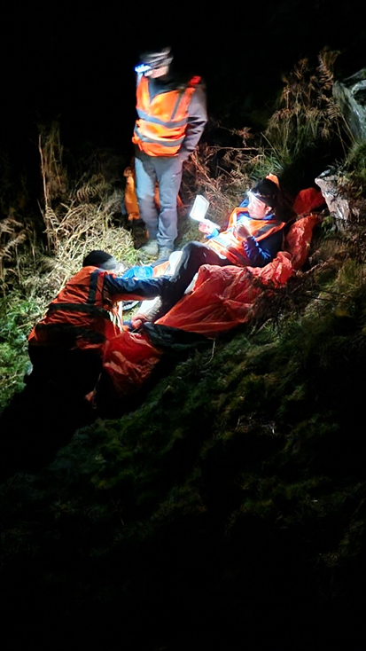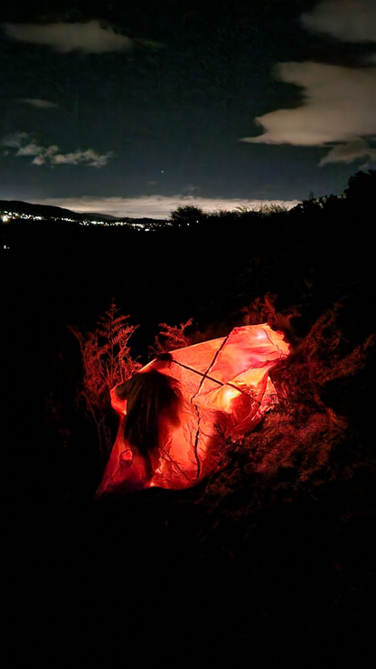

Fig 3 (Mountain Rescue arrival)

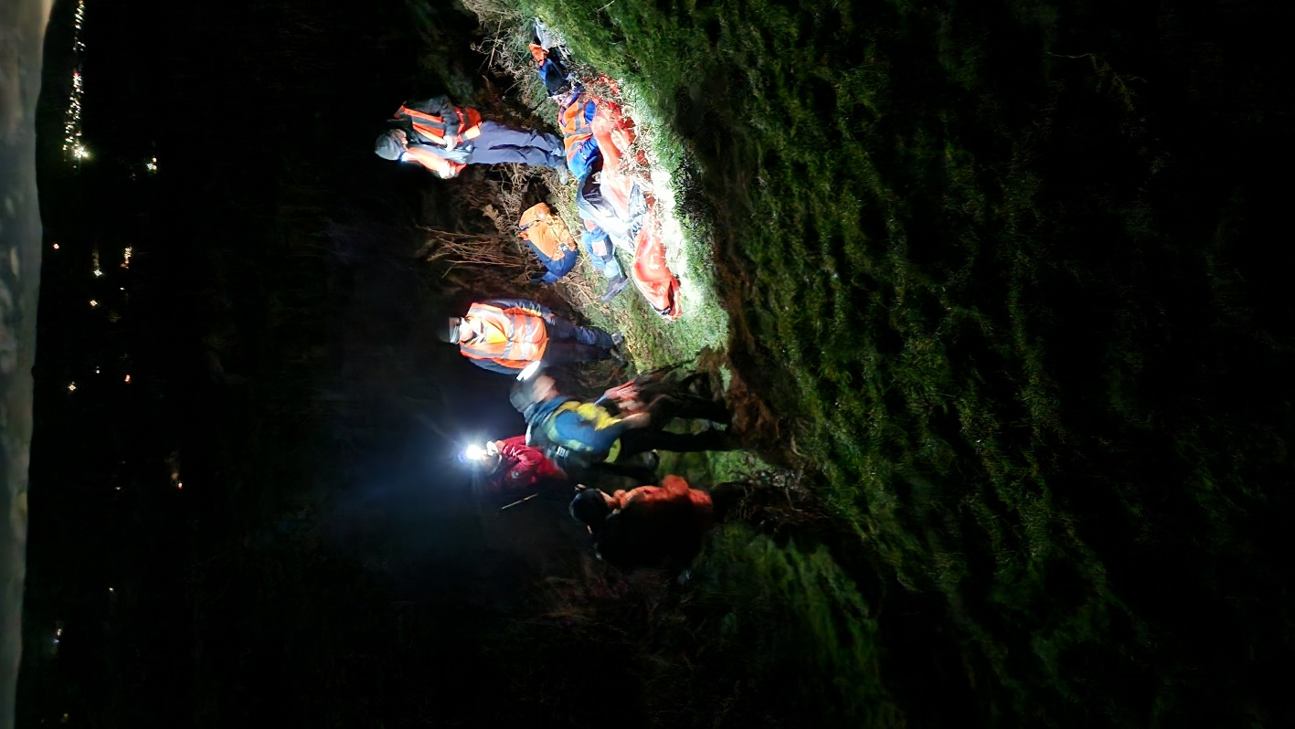

Fig 4 ( Tending to the casualty) Fig 5 (assembling the stretcher)

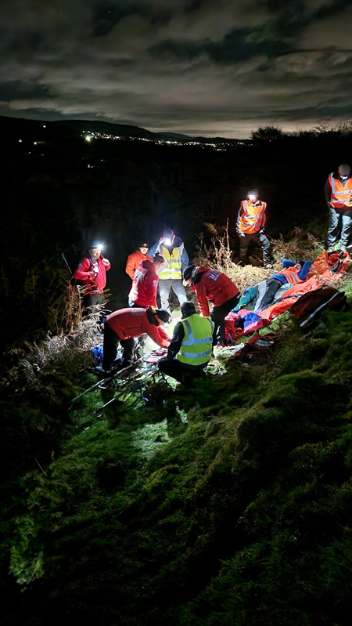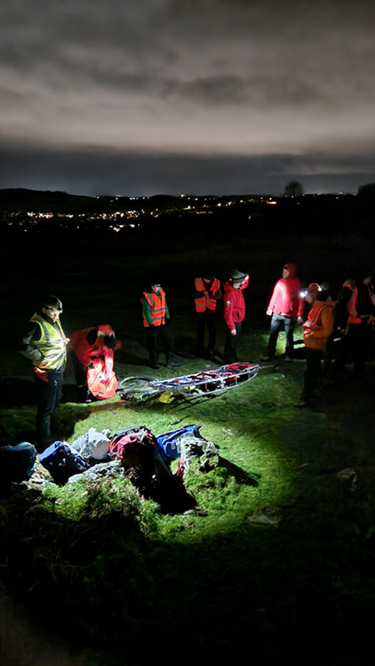

Fig 6 (Casualty on stretcher and wheel attached)



