University Of Wales Trinity Saint David’s
School of Engineering


Electronic Ignition & Fuel Injection Systems
Electrical Control Systems ACHA4010

James Evans
2104143
12/13/2021

Contents
1 Introduction 3
2 system review 4
3 Methodology 5
3.1 Equipment 5
3.2 Checks and tests 7
3.2.1 LE3 1.6l GTE 7
3.2.2 Motronic 2.0L 8
4 Results 9
4.1 Le3 Results 9
4.2 Motronic Results 11
5 Analysis 13
5.1 Bosch L.3 Jetronic system analysis 13
5.2 Bosch Motronic System analysis 14
6 Discussion 17
6.1 the Le3 engine 17
6.2 Motronic engine 17
7 Conclusions 18
8 Reference List 19

Figure 1 - Engine Rig 5
Figure 2 - Exhaust Extraction System 5
Figure 3 - Bosch BEA950 Emission Analyser (Hickleys n.d.) 6
Figure 4 - Multimeter 6
Figure 5 - Expected throttle data (Autodata 1990) 7
Figure 6 - Aux Air valve spec resistance 7
Figure 7 - L3 Injector valve spec resistance 7

Table 1 - L3 Throttle Resistance 9
Table 2 - Water temperature sensor L3 9
Table 3 - Aux Air Valve L3 9
Table 4 - Fuel Injector Resistance L3 9
Table 5 - Voltage and ground tests L3 10
Table 6 - L3 Warm up phase results (V Watkins 2022, personal communication, 22 February) 11
Table 7 - Motronic Results 1 (L Chess 2022, personal communication, 12 March) 11
Table 8 - Motronic results 2 (L Chess 2022, personal communication, 12 March) 12
Table 9 - Motronic results 3 (L Chess 2022, personal communication, 12 March) 12

Introduction
The aims of this task were to
- Test the electrical systems of two engines with different fuel injection systems
- Identify Problems with engine sensors and suggest improvements

The first engine that was tested was a naturally aspirated straight 4-cylinder engine from a Vauxhall-Opel nova 1.6l GTE 1988-92. The engine used a single overhead camshaft with two valves per cylinder. The engine made use of the BOSCH L3.1 Jetronic fuel injection system. The L- Jetronic system by BOSCH is an electronic fuel injection system that calculates fuel delivery based on input from air intake sensors, it is a timed injection system meaning the length of time each injection solenoid is open is based on signal output from the ECU based upon input by engine sensors. (BOSCH 1982)

The second engine tested used the Bosch Motronic 1.5 ignition system and was from a Vauxhall Frontera sport 2,0L 1991 the main difference between the two systems is that the Jetronic is analogue and the motronic is digital.

system review

The Bosch L3.1 Jetronic fuel injection as shown bellow is an electronic fuel injection system that injects fuel intermittently into the intake manifold. The system eliminates the need for a carburettor by spraying fuel directly in front of the inlet valves this allows the intake manifolds to be designed with only optimising air input flow in mind because of the optimised air fuel mixture a higher torque and better torque curve are achieved. Having individual injectors also ensures even and precise distribution of fuel, each cylinder receiving the same amount of fuel as the others under all operating conditions helps improve fuel efficiency.

The Bosch Motronic 1.5 is a fully integrated system that controls idle control fuelling and primary ignition from the same ECU. The motronic system is a refined and improved version of the L – Jetronic system.

Methodology

Equipment

PPE
Safety goggles, rubberised boots and lab coat were required PPE. A fire extinguisher was readily available
Engine Rig
First the engine was set up on a metal frame with protective caging around dangerous fast-moving parts.
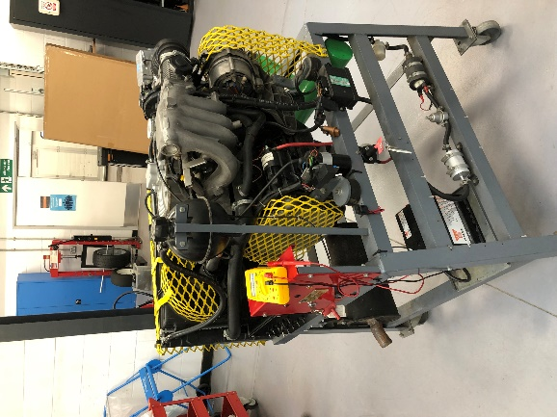
Figure 1 - Engine Rig
Exhaust removal
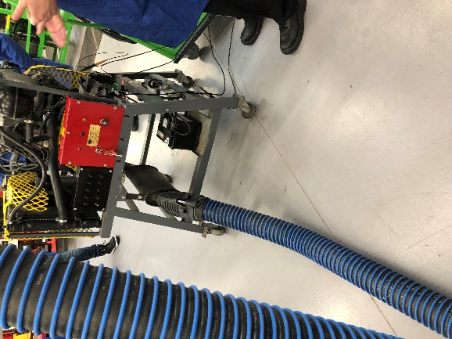
Figure 2 - Exhaust Extraction System
An extraction pipe was used to manage and dispose of harmful gasses
Bosch Emission centre
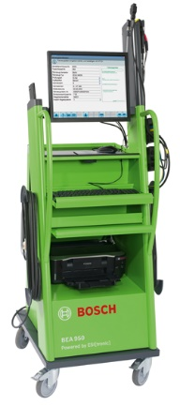
Figure 3 - Bosch BEA950 Emission Analyser (Hickleys n.d.)
gives recorded live data for emission and ecu diagnostics
Multimeter
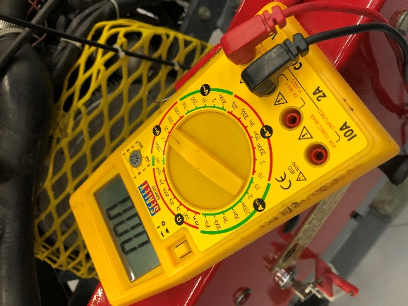
Figure 4 - Multimeter
a device capable of measuring multiple values such as voltage and resistance. In order to take accurate resistance measurements, the leads were touched together, and lead resistance was recorded as 0.2 ohms.

Checks and tests

LE3 1.6l GTE
Throttle switch resistance
First the multi switch plug was disconnected then with the throttle closed the multimeter was set to read ohms and connected between terminals 2 and 18. A reading was recorded. Probe on pin 2 was moved to pin 3 and reading was recorded.
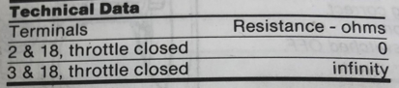
Figure 5 - Expected throttle data (Autodata 1990)
Auxiliary Air valve resistance
With the engine cold the valve multi plug was disconnected. The multimeter set to ohms was connected to both valve terminals and a reading for resistance was taken.
In order to check the valves operation, the engine was idled at cold temperature, the hose between the auxiliary air valve and inlet manifold was squeezed in order to observe an expected significant drop in engine speed. The engine was then run at idle until reaching hot operating temperature. The hose between auxiliary air valve and inlet manifold was again squeezed to observe an expected tiny drop in engine speed.
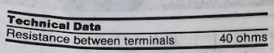
Figure 6 - Aux Air valve spec resistance
Injector Valves resistance
The multiplugs of each injector was disconnected and a multimeter set to ohms was connected between each injector’s terminals reading were recorded.
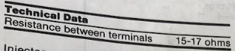
Figure 7 - L3 Injector valve spec resistance
CAN bus network test
A CAN bus network () is
The multimeter was set to read voltage and negative lead was earthed. A probe connected to the positive lead was used to test each of the Engine Control Unit (ECU) pins with the ignition off and then the ignition on.
Warm up phase
A dedicated engine system testing centre was used to perform a warmup phase analysis on the car results for the resistance of the coolant temperature sensor, the injection on time and the NTC2 voltage were recorded at temperatures from 20 to 60 degrees Celsius at intervals of 10◦.

Motronic 2.0L

Throttle potentiometer
First the potentiometer multiplug was disconnected. The multimeter set to ohms was then used to record resistance measurements between throttle open and closed circuits. The ohmmeter was then set to voltage and the ignition turned on. With ignition switched on the voltage between plug terminals was observed and recorded. Ignition was switched off, the potentiometer was then reattached to its multiplug socket and the multiplug cover was pulled back to reveal terminals. The voltmeter was setup between a multiplug terminal and earth. The ignition was switched on and a recording for voltage was taken at throttle idle position. The throttle was slowly opened until at full and a recording for full throttle position voltage was recorded.

Airflow sensor
First the air flow sensor was disconnected from its multiplug. The air intake pipe was also removed from the airflow sensor. A multimeter set to ohms was set between air flow sensor terminals. The sensor flap was operated by hand smooth change in the parts resistance was expected to be observed. The resistance of the other two terminals was also recorded.
Coolant temp sensor
First a temperature probe was immersed in the coolant. The engine was left to idle until reaching close to the desired temperature. At the desired temperature, the resistance of the coolant temperature sensor was checked with a multimeter.
Air Temperature Sensor
A multimeter set to ohms was used across air temp terminals and a resistance value was recorded to be compared with spec.
Idle Speed control valve
the control valves multiplug was disconnected. First a voltmeter was connected across terminals
Injector valves
Each injector plug was disconnected from its terminal. The multimeter set to ohms was used to measure resistance each injector expected to be within 10% of operating spec.

Results

Le3 Results

Table 1 - L3 Throttle Resistance

Table 2 - Water temperature sensor L3

Table 3 - Aux Air Valve L3

Table 4 - Fuel Injector Resistance L3
Table 5 - Voltage and ground tests L3
Table 6 - L3 Warm up phase results (V Watkins 2022, personal communication, 22 February)
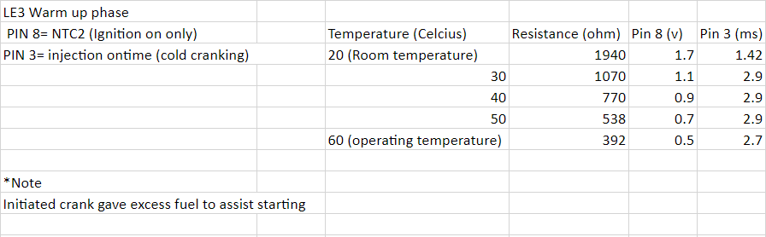

Motronic Results

Table 7 - Motronic Results 1 (L Chess 2022, personal communication, 12 March)
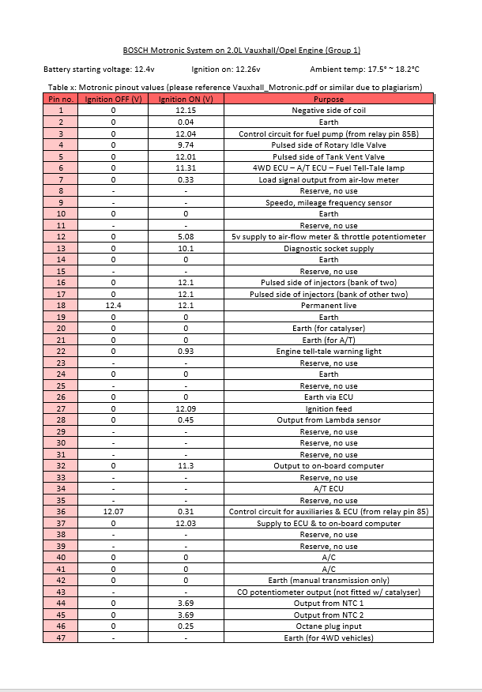
Table 8 - Motronic results 2 (L Chess 2022, personal communication, 12 March)
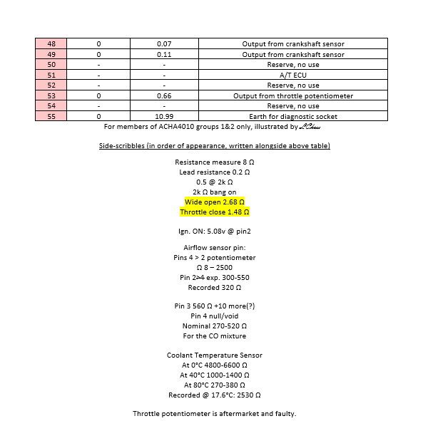
Table 9 - Motronic results 3 (L Chess 2022, personal communication, 12 March)
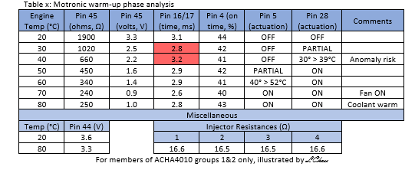

Analysis

Bosch L.3 Jetronic system analysis
Fuel Injector resistance
Checking the resistance of fuel injectors is important as it indicates whether they are all supplying the same volume of fuel to the combustion chambers. The fuel injectors for the L.3 engine were all within spec meaning their operation is considered normal.
Throttle switch resistance
the throttle switch connects to a potentiometer and sends signals to the ECU that are used in the control of the amount fuel the engine requires (Ferrell 2020). testing its resistance between the two loops ensures the system is operating normally. The resistances were both on spec no alteration was required.
Water temperature
The coolant temperature sensor detects the engines operating temperature this information is used by the ECU to determine Injection timing (Hella n.d.) a faulty coolant sensor could cause higher fuel consumption and a higher idle RPM. As the engine temperature was within operating spec when under operating conditions it was determined to be working properly

Auxiliary Air valve checks
By squeezing the pipe between inlet manifold and the auxiliary air valve (AAV) the action performed by the AAV when told to by the ECU was emulated. This simulated closing of the AAV indicates whether it operates correctly in conjunction with the rest of the engine. When the engine is cold the AAV should be fully open to allow extra air around the throttle plate in order to keep idle speed up to spec when the oil is thicker. The AAV allows extra air into the inlet manifold when engine is cold to allow for higher air pressure at the intake ports. Auxiliary air valves resistance was checked to ensure the part was working properly it was not within spec this could negatively affect engine performance. When starting and at lower temperature the injector valves should open for a longer time the first result collected for injection on time did not show that the Injectors were following the correct behaviour in conjunction with temperature however voltage signal followed a correct pattern.

Bosch Motronic System analysis
Due to poor formatting of secondary results analysis required some results corresponding tests to be guessed.
Throttle potentiometer
The first check done was on the throttle potentiometer it was pre- mentioned that the potentiometer was aftermarket and potentially faulty. While results for its resistance were on spec results for potentiometer voltage were 2.68 with the throttle open and 1.48 with it closed. This means the voltage signal coming from the part is too low for the 3.9 – 4.95 at full throttle and too low for the 0.12 – 1.22 with throttle closed.
Air Flow Sensor
the recorded 320Ω value follows spec for this part however recordings of the first two values were not made.
Coolant temperature sensor
Resistance values for the coolant temperature sensor throughout the warmup phase are all well under spec this indicates a problem with the sensor itself. before warmup phase resistance was checked at an engine temperature of 17.6 degrees, the resistance value was 2530Ω furthering analysis of malfunctioning sensor.

Air temperature sensor
The air temperature sensor followed spec with a resistance of 8Ω
Idle speed control valve
Resistance measurement for this pat was not recorded making analysis impossible
Injector valves
all injector valves were within 10% resistance of each other and within spec this means they are firing properly and with close accuracy in relation to each other.
warm up phase
“Cold cranking @20°C, injection on time is 21.3ms. Followed by next rotation 18.2ms; in the region of 300ms the engine is running, and injector pulse returns to standard.
Idle speed is wildly between 710 and 780rpm, potentiometer partially to blame” (L Chess 2022, personal communication, 12 March)
From the above information it was concluded that the general injection timing of the engine followed the correct pattern of supplying increased fuel for cold cranking and more fuel at lower engine temperature than at higher.
Earthed voltage checks
Taking readings from each pin the ECU connects to the ignition system with gives a detailed map of the functionality of the engines circuits as shown bellow
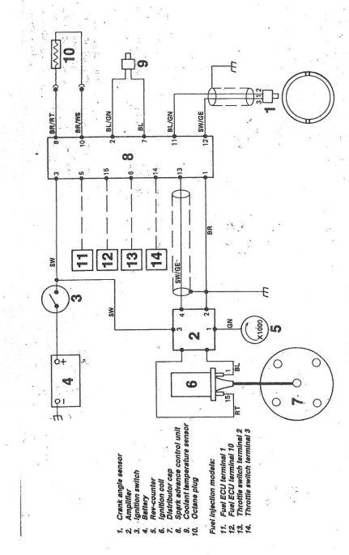
As expected, all systems gave no reading with ignition off and values were recorded for all expected connections indicating the ignition system was operational and all signals were able to be received and sent to and from the ECU.
Warm up phase analysis
Regrettably RPM values for the warmup phase of the L.3 engines warmup phase were lost. The resistance of the coolant temperature sensor was not within spec. At 20◦ Celsius the temp sensor reached the maximum resistance expected at a temperature of 80 ◦C while still 60 ◦C this indicates a faulty sensor which could affect the performance of the engine as injection on times will not be accurately consistent with engine needs as well as the fuel mixture which in the l3 system is ordered to be enhanced by 30 to 60%(Bosch technical instruction).

Discussion

the Le3 engine
the le3 engine increases fuel efficiency through optimising the air fuel mixture in the combustion chamber. It does this by making use of various sensors throughout the engine to determine the on time of fuel injectors. problems with the l3 engines injection timing arose at cold temperatures likely due to a faulty coolant temperature sensor. As resistance was normal at each fuel injector the injectors themselves are unlikely to be to blame. Readings from the temperature sensor could affect ECUs ability to control injection timing and auxiliary airflow (BOSCH 1982). The auxiliary air valve had a resistance of 45.9Ω instead of the expected 40Ω this indicates the flap was in the wrong position.

Motronic engine
Although injection and airflow functions of the engine appear to be operating under correct patterns from a distance the engine likely has problems with fuel consumption, smoothness of the engine acceleration and starting behaviour all as a result of a faulty aftermarket throttle potentiometer problems with coolant temperature sensor may add to negative performance effects on the engine

Conclusions
L3.1
Changing the Le3s Temperature sensor would provide for more accurate injection timing and auxiliary airflow this should significantly help performance and fuel consumption. However, with a less rushed testing environment and more complete results such as RPM in the warmup phase a different conclusion may be reached.

Motronic
A stock potentiometer and new coolant temperature sensor should be fitted to the engine before tests are repeated. diagnosing more refined problems with system is difficult due to two major issues which could be affecting other systems.

Reference List
Autodata, 1990, Fuel Injection 2,
BOSCH, 1982, Technical instruction L – Jetronic, BOSCH, Germany.

Ferrell, D 2020, How Do You Know If a Throttle Position Sensor Is Bad?, Axel Addicts, viewed 23 April 2022,< https://axleaddict.com/auto-repair/How-Do-You-Know-if-a-Throttle-Position-Sensor-is-Bad#:~:text=The%20TPS%20connects%20to%20the,position%20of%20the%20throttle%20plate.>.

Hickleys, n.d., Bosch BEA950 Emission Analyser, hickleys.com, viewed 24 April 2022, <https://www.hickleys.com/diagnostics/bea950.php>.

Hella, n.d., COOLANT TEMPERATURE SENSOR TESTING - SYMPTOMS, CAUSE OF FAILURE & TROUBLESHOOTING, viewed 23 April 2022 <https://www.hella.com/techworld/uk/Technical/Sensors-and-actuators/Test-coolant-temperature-sensor-4277/#:~:text=Coolant%20temperature%20sensors%20are%20used,with%20a%20negative%20temperature%20coefficient>

