University of Wales Trinity Saint David
Wales Institute of Science and Art


Structural & Fluid Analysis – Application of CAE Processes

ACHA6010
Owen Roberts
2203329
15/12/2024
Word Count: 2992
Contents
1 Introduction 4
2 Validation Testing 5
2.1 Bi-Metallic Strip 5
2.2 Cantilever Beam – Uniformly Distributed Load 7
3 Methodology 9
3.1 Engineering Data 9
3.2 Rigid Dynamics 9
3.3 Static Structural 11
3.4 Steady State Thermal Study 11
3.5 Fully Linked System 12
3.6 Post-Processing Analysis 12
4 Piston Testing 13
4.1 Baseline Piston 14
4.2 Iteration 2 Piston 19
4.3 Iteration 3 Piston 24
5 Comparison 29
6 Limitations of FEA analysis 31
7 Conclusion 32
8 References 33

Table of Figures
Figure 1 Cantilever Beam – Uniformly Distributed Load.……………………………...………………………………………………………………………………….7
Figure 2 Engineering Data………………………………………………………………………………………………………………..………………………………………..9
Figure 3 Young’s Modulus Temperature coefficient……………………………………………………………………………………..………………………………..9
Figure 4 Piston Assembly Model…………………………………………………………………………………………..…………………………………………………..10
Figure 5 Material Assignment Tab…………………………………………………………………………………..…………………………………………………………10
Figure 6 Connections for component interactions………………………………………………………...……………………………………………………………..10
Figure 7 Analysis Step controls…………………………………………………………………………………………………………………………………………………11
Figure 8 Applying a rotational velocity………………………………………………………………………………………………………………………………………..11
Figure 9 Thermal Study Boundary Conditions…………………………………………………………………………………………………………………….………..11
Figure 10 Temperature Map of Piston………………………………………………………………………………………………………………………………………..12
Figure 11 Fully linked System…………………………………………………………………………………………………………………………………………………..12
Figure 12 ANSYS material data of aluminium 6061-T6……………………………………………………………………………………………………..…………..13
Figure 13 Baseline Piston Design…………………………………………………………………………………………………………………………………...…………14
Figure 14 Front View of Baseline Equivalent Stress (MPa)…………………………………………………………………………………………………..…………17
Figure 15 Section View of Baseline Equivalent Stress (MPa)……………………………………………………………………………..………………..…………17
Figure 16 Highest Equivalent Stress at the Pin bore Support………………………………………………………………………….…………...…………………18
Figure 17 Iteration 2 Piston Design……………………………………………………………………………………………………………………………………………19
Figure 18 Iteration 2 Equivalent Stress Front View……………………………………………………………………………………………………….………………22
Figure 19 Iteration 2 Equivalent Stress Section View……………………………………………………………………………………………………………………22
Figure 20 Iteration 2 Equivalent Stresses in pin bore support……………………………………………………………………………………………..…………23
Figure 21 Side View of Iteration 2 equivalent stress to demonstrate areas of low stress……………………………………………………………………23
Figure 22 Iteration 3 Piston Design………………………………………………………………………………………………………………………………..…………24
Figure 23 Iteration 3 Equivalent Stress Front View………………………………………………………………………………………………………………………27
Figure 24 Iteration 3 Equivalent Stress Section View………………………………………………………………………………………………..…………………27
Figure 25 Iteration 3 Equivalent Stresses at the Piston Pin Bore Supports……………………………………………………………………….………………28
Figure 26 Iteration 3 Equivalent Stress Side View…………………………………………………………………………………………………………..……………28

Table of Tables
Table 1 Bimetallic Strip Properties.…………………………………………………………………………………………………………………………………….……….5
Table 2 Bimetallic Strip Mesh Study……………………………………………………………………………………………………………………………………………6
Table 3 Cantilever Beam – Uniformly Distributed Load Properties…………………………………………………………………………………………………….7
Table 4 Cantilever Beam – Uniformly Distributed Load – Mesh Study………………………………………………………………………………………………..8
Table 5 Aluminium 6061-T6 Composition…………………………………………………………………………………………………………………………………..13
Table 6 Baseline Piston Mesh Size Study……………………………………………………………………………………………………………………………………14
Table 7 Baseline Total Deformation (mm)………………………………………………………………………………………………………………………………..…15
Table 8 Baseline Equivalent Stress (MPa)…………………………………………………………………………………………………………………………………..16
Table 9 Iteration 2 Mesh Study……………………………………………………………………………………………………………….………………………………..19
Table 10 Iteration 2 Total Deformation (mm)………………………………………………………………………………………………………………………………20
Table 11 Iteration 2 Equivalent Stress (MPa)……………………………………………………………………………………………………………………………….21
Table 12 Iteration 3 Mesh Size Study…………………………………………………………………………………………………………………………………………24
Table 13 Iteration 3 Total Deformation (mm)………………………………………………………………………………………………………………………………25
Table 14 Iteration 3 Equivalent Stress (MPa) ………………………………………………………………………………………………………………………………26
Table 15 Total Deformation (mm) Comparison……………………………………………………………………………………………………………………………29
Table 16 Equivalent Stress (MPa) Comparison……………………………………………………………………………………………………………………………30

1 Introduction

This report focuses on the analysis and optimization of a piston assembly, investigating its performance under various operational parameters. The main focal points of this research are the inertial forces, due to the rotating mass, thermal effects, and the mechanical forces acting on the piston during engine operation. Through the use of Finite Element Analysis (FEA) in ANSYS, this study aims to optimise the design of the piston without increasing the stresses on the piston.
In order to optimise the piston design, the main objective is to look at the piston geometry and reducing the mass of the piston to improve performance. Thermal considerations are integrated into the analysis to accurately simulate property changes in materials due to temperature variations, to ensure the results can mimic real world scenarios as accurately as possible. By analysing total deformation and evaluating equivalent stresses, the study utilises an iterative design process, influenced by data obtained from the kinematic and structural simulations, in order to refine the piston geometry for reduced mass.

2 Validation Testing
By comparing simulation results with analytical solutions, Finite Element Analysis (FEA) validation ensures that the computational models accurately represent real world physical systems. This is a critical step as there can be discrepancies between real world data and FEA results due to assumptions and simplifications that are inherent in in FEA modelling. Brinkgreve and Engin (2013) emphasize that finite element analysis validation ensures a model includes essential features of the real system and produces representative results, while WEN (2007) highlights its necessity for confirming a model’s accuracy despite the simplifications made. Through finite element analysis validation, the results can be trusted, therefore designs can be optimised informed by the results.
To validate results for this investigation, Standard cases with analytical solutions will be utilized, along with a mesh study in order to assess the effects of mesh sizes on results.

2.1 Bi-Metallic Strip
The first validation study will be conducted on a bimetallic strip comprised of Invar and Copper, one end is fixed, and the other end is free, a thermal loading of 100°C is applied and the maximum deflection is determined. The deflection is caused by the different coefficients of thermal expansion for each material.
Material | Invar | Modulus of Elasticity | E_{i} | 137000 | MPa
Material | Invar | Poisson’s Ratio | ν_{i} | 0.280 | -
Material | Invar | Coefficient of Thermal Expansion | 𝛼_{i} | 1.2*10⁻⁶ | °C⁻¹
Material | Copper | Modulus of Elasticity | E_{c} | 130000 | MPa
Material | Copper | Poisson’s Ratio | V_{c} | 0.354 | -
Material | Copper | Coefficient of Thermal Expansion | 𝛼_{c} | 2*10⁻⁵ | °C⁻¹
Geometry |  | Cross-Section Width | w | 5 | mm
 |  | Layer Thickness | t_{i} = t_{c} = t | 1 | mm
 |  | Length | L | 100 | mm
Load |  | Thermal Loading | T_{c} | 100 | °C
Table 1 Bimetallic Strip Properties

Analytical Solution
$$Stiffness (K1)=4+6\frac{tc}{ti}+4{\left(\frac{tc}{ti}\right)}^{2}+ \frac{Ec}{Ei}{\left(\frac{tc}{ti}\right)}^{3}+\frac{Ei ti}{Ec tc}$$

$$Maximum Deflection=\frac{L^2}{2} \frac{6\left(αi-αc\right)\left(ti+tc\right)Tc}{t^{2} K1}= -7.049 mm$$

The accuracy of a solution in finite element modelling generally improves with a finer mesh size. However this generally comes at the expense of increased computational time. In order to find the middle ground between accuracy and computational efficiency, a mesh convergence study is often carried out. According to Autodesk, this involves systematically refining the mesh and analysing the model until the results converge to a stable value. The process begins by creating a coarse mesh with an appropriate number of elements, analysing the model, and recording the results. The mesh is then refined, and the analysis is repeated, comparing the new results to the previous ones. This cycle is continued until the solution stabilizes, indicating that further mesh refinement will not significantly change the results. The benefit of conducting a mesh convergence study is that computational demands can be minimised whilst still achieving accurate results
Mesh Study – 7.049mm Max Deflection
Mesh Size | Max Deflection | %Deviation from Analytical
1mm | 7.1233 mm | 1.054 %
0.5 mm | 7.123 mm | 1.0389 %
0.25 mm | 7.1213 mm | 1.026 %
0.1 mm | 7.1203 mm | 1.011 %
Table 2 Bimetallic Strip Mesh Study
From the results of this mesh study, it can be seen that through the range of mesh sizing the total deviance is 0.043% from the analytical solution. Furthermore, the total deviation is only just over one percent for each of the mesh sizes, validating that the finite element analysis is accurate, and could be used to inform design and geometry changes.

2.2 Cantilever Beam – Uniformly Distributed Load
In this cantilever beam standard case, a uniformly distributed pressure is applied across the whole beam which is fixed at one end. The maximum deflection of the beam is then calculated.
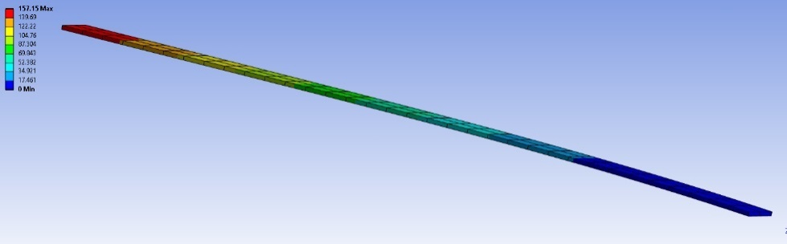
Figure 1 Cantilever Beam - Uniformly Distributed Load
Material | Elastic-Plastic | Modulus of Elasticity | E | 210000 | MPa
Material | Elastic-Plastic | Poisson’s Ratio | V | 0
Material | Elastic-Plastic | Shear Modulus | G | 105000 | MPa
Geometry | Plate | Length | L | 1 | m
Geometry | Plate | Width | w | 0 | m
Geometry | Plate | Thickness | t | 0.005 | m
Load | Plate | Pressure | P | 2750 | Pa
Table 3 Cantilever Beam – Uniformly Distributed Load Properties
Analytical Solution

$$M=\frac{q{\left(L-x\right)}^{2}}{2}$$
EI_{y}$\frac{{uz d}^{2 }}{dx^{2}}$ = M
I_{y =} $\frac{wt^{3}}{12}$
u_{z}(x) = $\frac{qx^{2}\left(6l^{2}-4Lx+x^{2}\right)}{24EIy}$
u_{z,max} = $\frac{qL^{4}}{8EIy}=\frac{3pL^{4}}{2Ew^{2}t}=157.143mm$

Mesh Study – 157.143mm Max Deflection
Mesh Size | Max Deflection | %Deviation from Analytical
30 mm | 157.15 mm | 0.0045 %
25 mm | 157.15 mm | 0.0045 %
20 mm | 157.15 mm | 0.0045 %
15 mm | 157.15 mm | 0.0045 %
10 mm | 157.15 mm | 0.0045 %
5 mm | 157.15 mm | 0.0045 %
Table 4 Cantilever Beam – Uniformly Distributed Load – Mesh Study

3 Methodology

3.1 Engineering Data
The first step is to configure the engineering data section, this allows the definition of different materials and their properties. In this case the engineering data is imported from Granta, and the Young’s Modulus for each temperature is defined- this helps ensure that the simulation accounts for thermal effects accurately.
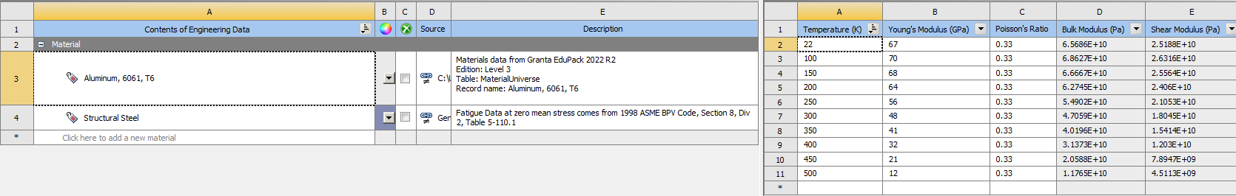
Figure 2 Engineering Data
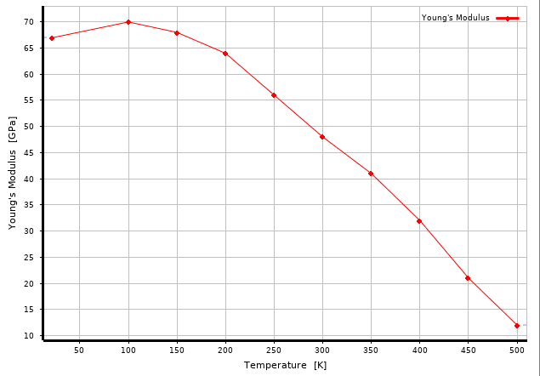
Figure 3 Youngs's Modulus Temperature coefficient

3.2 Rigid Dynamics
The Rigid Dynamics Module can then be brought in and linked to the Engineering Data Module to ensure material properties are carried over. The assembly geometry should then be imported as a .STEP format for compatibility. The material assignments can then be configured as the material density will affect mass of the components and therefore inertia.
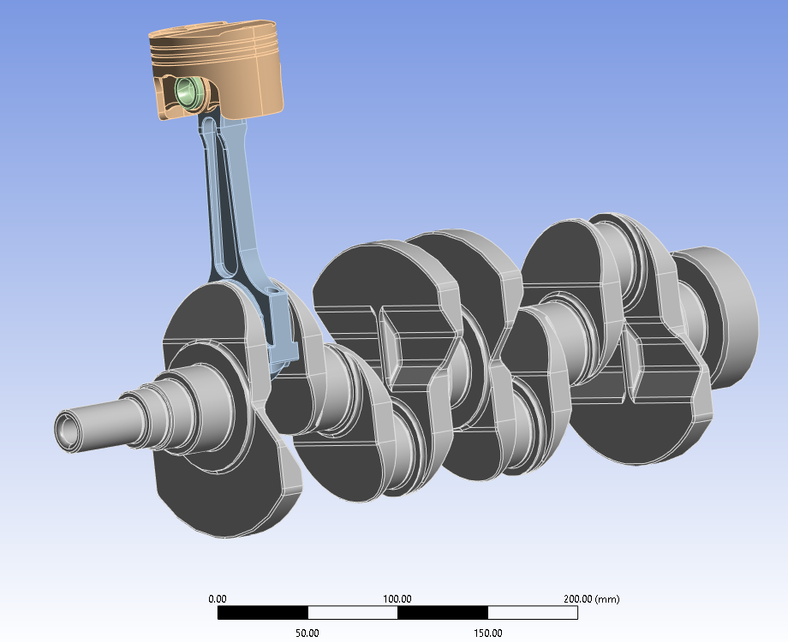
Figure 4 Piston Assembly Model
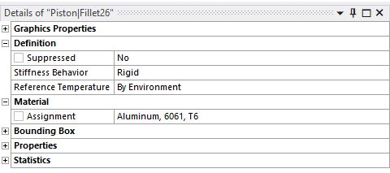
Figure 5 Material Assignment Tab
The component interactions then have to be configured, firstly the autogenerated contacts then have to be deleted and new joints can be set up.
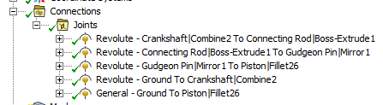
Figure 6 Connections for component interactions
Once this is done, the transient solver settings can be set up, and a rotational velocity of 4000rpm can be applied to the crankshaft to simulate the inertia.
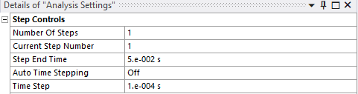
Figure 7 Analysis Step controls
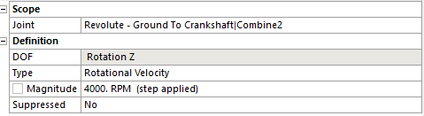
Figure 8 Applying a rotational velocity
Once the forces measured on the piston are solved, the maximum force loading scenario can be exported as ‘Motion Loads’ which will later be applied in the static structural stage.

3.3 Static Structural
A Static Structural solver can then be brought over, and the data can be shared over from the rigid dynamics module where the components other than the Piston can be suppressed and the Piston can be set to flexible in order to measure the deflection and stresses later on. The Motion Load calculated from the rigid dynamics stage can be imported and applied to the piston. The Static structural is not complete yet but will be completed later on.

3.4 Steady State Thermal Study
A Steady State Thermal study can then be brought in and linked to the engineering data and model tabs from Rigid Dynamics to ensure consistency in material properties and geometry. The Heat Transfer Coefficients and Ambient Temperatures are then assigned to each part of the piston.
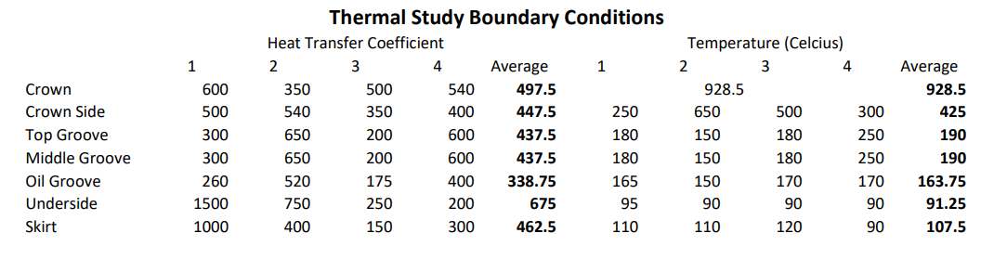
Figure 9 Thermal Study Boundary Conditions
A mesh is then generated for the piston, in this case a 4mm mesh is used, and the thermal study is solved to produce a temperature profile for the piston.
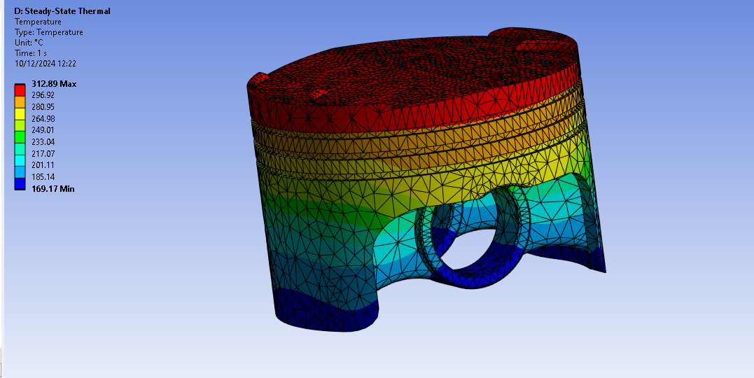
Figure 10 Temperature Map of piston

3.5 Fully Linked System
The thermal study solution can then be linked into the setup stage to integrate the temperature effects into the static structural solution. The mesh can then be generated using a size facing mesh for the crown of the piston for improved accuracy.
A pressure load can then be added to simulate combustion gas pressure of 6.7715 MPa taken from cylinder pressure data. To solve the fully linked system, weak springs and inertia relief have to be turned off and instead a fixed support on the inside faces of the pin bore has to be applied.
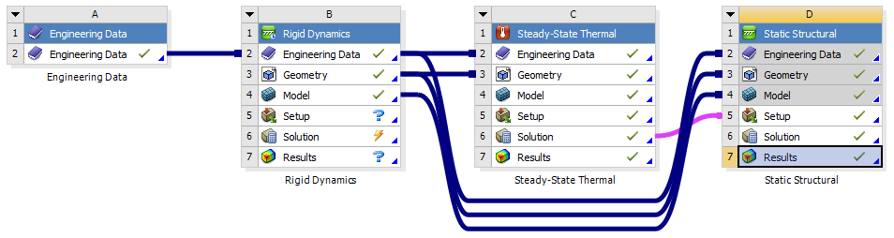
Figure 11 Fully linked System

3.6 Post-Processing Analysis
After solving the fully linked system, the results for total deformation and principal stresses can be analysed to evaluate the performance of the piston designs under operational loads. This step involves interpreting the finite element analysis (FEA) results to assess the structural integrity and identify areas for further optimization.

4 Piston Testing
The material used for the piston test is Aluminium 6061-T6. It is a lightweight aluminium alloy with high corrosion resistance and high strength properties. Aluminium 6061-T6 is precipitation hardened; precipitation hardening is a process that uses high temperatures to increase the materials yield strength. Precipitation hardening not only increases the yield strength, but it lowers the plasticity. (Aerocom). 6061-T6 has a density of between 2.69 g/cm³ to 2.73 g/cm³ and the composition is listed below.
Aluminium 6061-T6 Composition
Element | %
Al (Aluminium) | 95.8 – 98.6
Cr (Chromium) | 0.04 – 0.35
Cu (Copper) | 0.15 – 0.4
Fe (iron) | 0 – 0.7
Mg (magnesium) | 0.8 – 1.2
Mn (Manganese) | 0 – 0.15
Si (Silicon) | 0.4 – 0.8
Ti (Titanium) | 0 – 0.15
Zn (Zinc) | 0 – 0.25
Other | 0 – 0.15
Table 5 Aluminium 6061-T6 Composition
The information for material properties used in this report is sourced from Ansys Granta. Granta is a materials database where the material information can be easily imported into the Ansys Software.

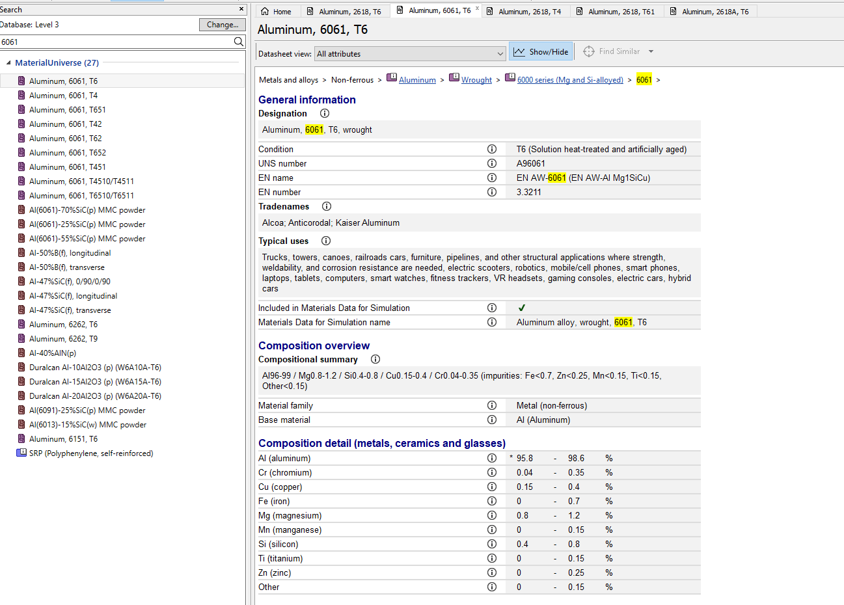
Figure 12 ANSYS material data of aluminium 6061-T6

4.1 Baseline Piston

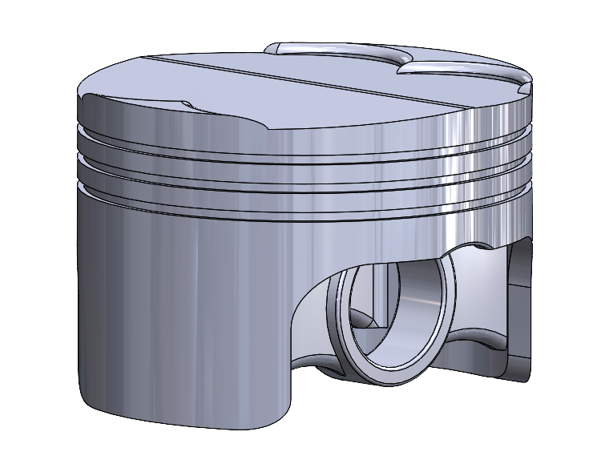
Figure 13 Baseline Piston Design
Material = Aluminium 6061 T6
Mass = 255.77 grams
Baseline Piston Mesh Size Study @ 6.7715MPa, 4000rpm
Mesh Size (mm) | Max Deformation (mm) | Max Stress (MPa) | Min Stress (MPa)
10mm, 5mm Crown | 0.34194 | 364.5 | 0.54
8mm, 4mm Crown | 0.34128 | 399.71 | 0.41197
6mm, 3mm Crown | 0.34187 | 355.57 | 0.34035
4mm, 2mm Crown | 0.34657 | 352.47 | 0.171491
2mm, 1mm Crown | 0.35434 | 316.57 | 0.28814
1mm, 0.5mm Crown | 0.36886 | 325.98 | 0.067492
Table 6 Baseline Piston Mesh Size Study
The mesh size selected for this study was 4mm for the piston skirt, side and underside, and 2mm mesh sizing for the crown. This was chosen in order to balance the accuracy of the results alongside the time taken to compute. The mesh study showed that the 4mm/2mm configuration produced deformation results closest to the average, helping to ensure convergence whilst minimizing computational demands.
The refinement in mesh sizing on the crown was employed due to the fact that the piston crown experiences the highest thermal loads and the highest pressures. The finer mesh can help capture stress and deformation gradients with precision, without wasting computational time on less critical locations. Comparisons with finer meshes confirmed that the chosen mesh sizing provided negligible results in results. This approach aligns with FEA best practices to deliver accurate and reliable results for the pistons analysis and optimisation by balancing precision and efficiency.
 | Baseline Deformation (mm)
 | Isometric View | 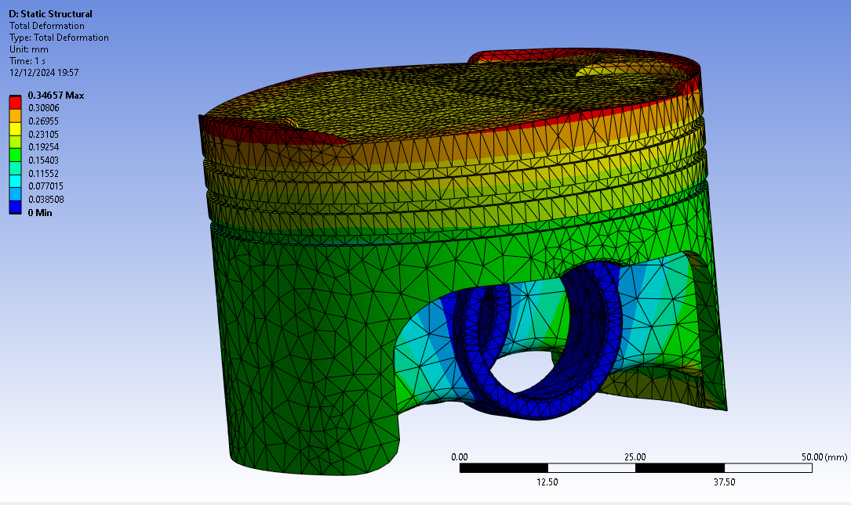
 | Bottom View | 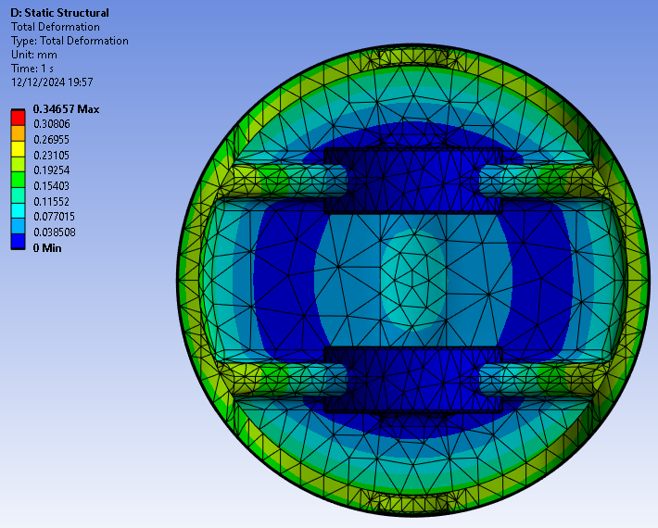
 | Top View | 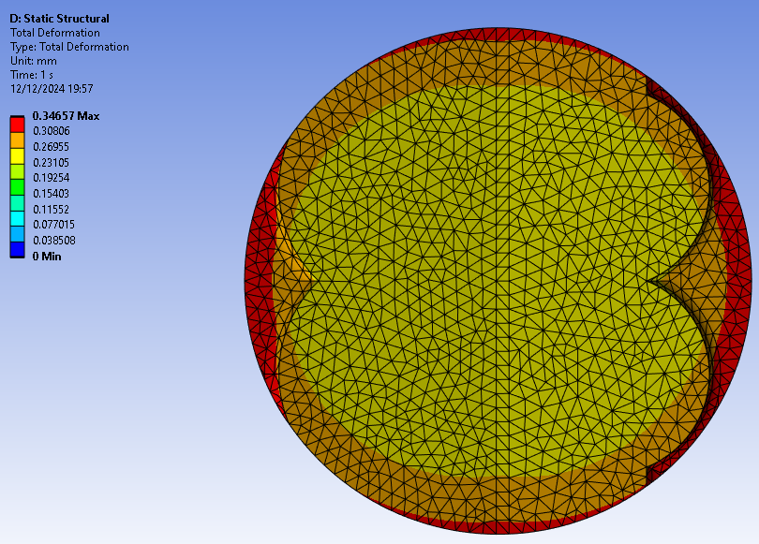
 | Side View | 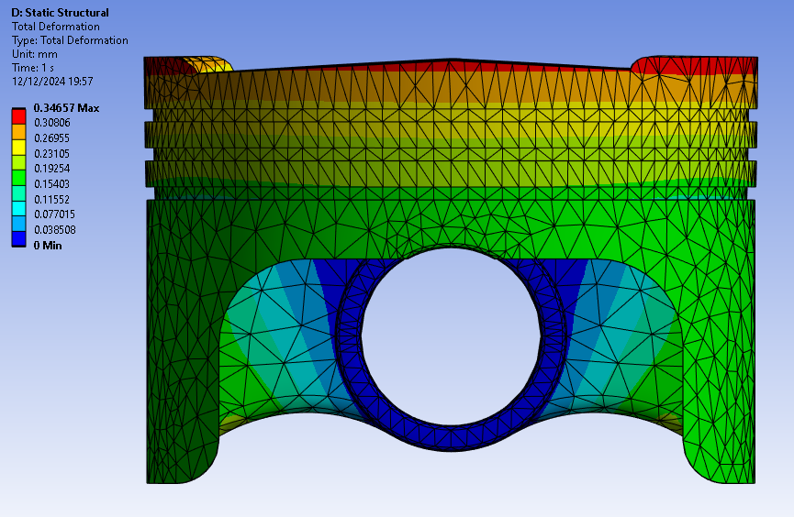
 | Section View | 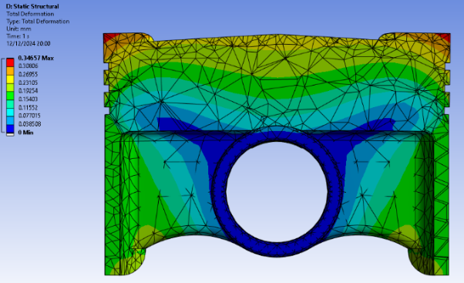
Table 7 Baseline Total Deformation (mm)
 |  | Baseline Equivalent Stress (MPa)
Isometric View |  | 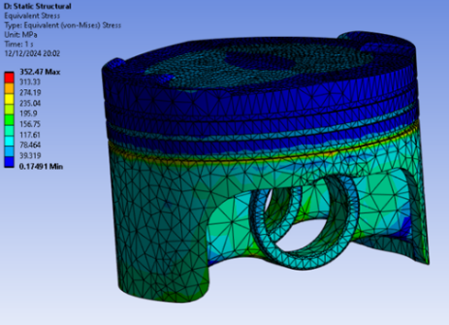
Bottom View |  | 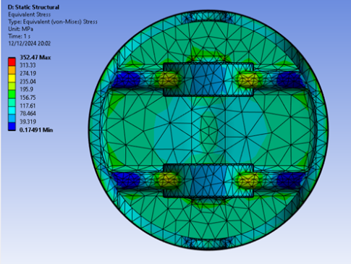
Top View |  | 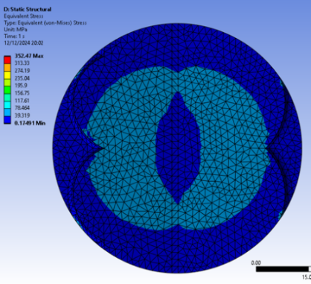
Front View |  | 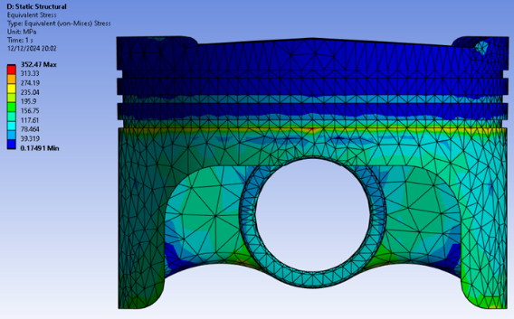
Section View |  | 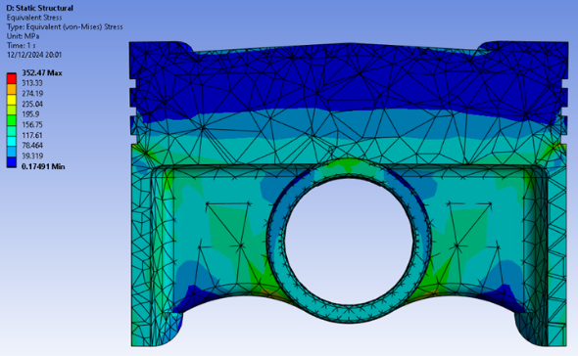
Table 8 Baseline Equivalent Stress (MPa)
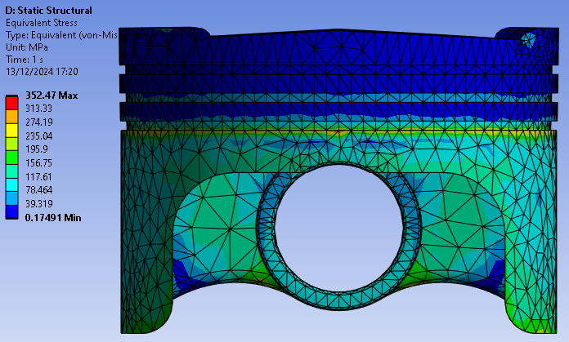
Figure 14 Front View of Baseline Equivalent Stress (MPa)
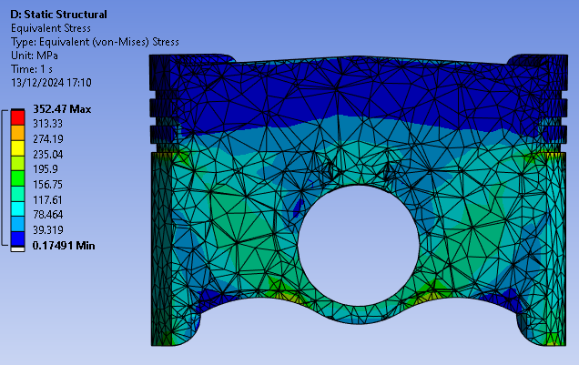
Figure 15 Section View of Baseline Equivalent Stress (MPa)
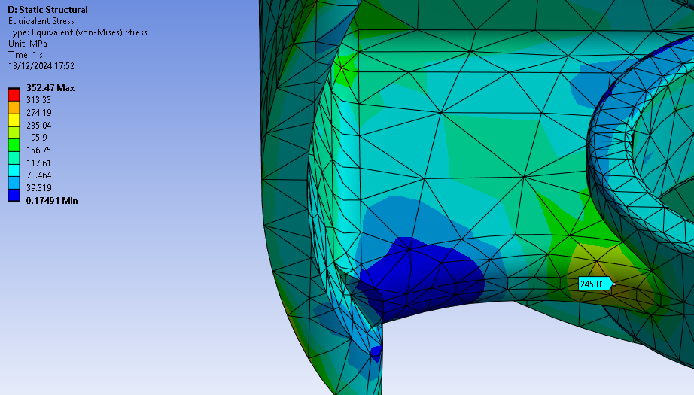
Figure 16 Highest Equivalent Stress at the Pin bore Support

The baseline piston geometry shows high stress concentrations at the oil ring and pin bore supports. As making alterations to the geometry of the oil ring could lead to issues such as blow by in the engine, the more effective approach would be to take material away from the areas of low stress such as the pin bore supports, this would help to improve performance and reduce inertia. Figure16 shows that the pin bore support exhibits relatively low stresses away from the lowest section closest to the pin bore. This would also be an effective way of lowering the mass of the piston.

4.2 Iteration 2 Piston
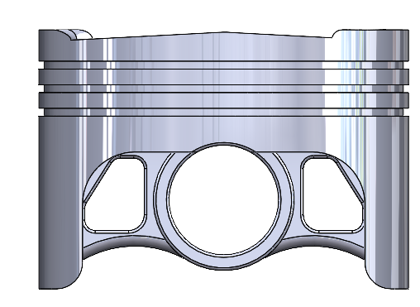
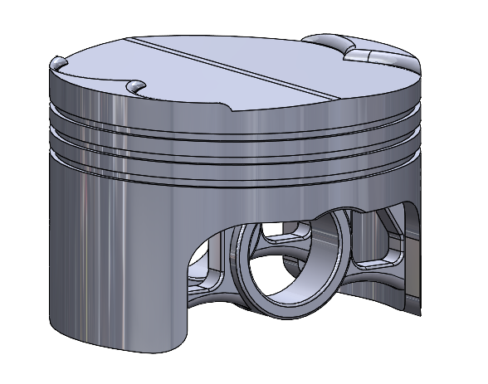
Figure 17 Iteration 2 Piston Design
Material = Aluminium 6061 T6
Mass = 248.81 grams
In order to optimise the piston design, material was removed from the piston pin bore supports, which are areas of low stress. The original mass of the piston was 255.77 grams. The removed material resulted in a total mass reduction of 6.96 grams or 2.72%. This should help to improve the design by lowering the inertia of the piston, whilst minimising the effects of deformation and Equivalent stresses.

Iteration 2 Piston Mesh Size Study @ 6.7715MPa, 4000rpm
Mesh Size (mm) | Max Deformation (mm) | Max Stress (MPa) | Min Stress (MPa)
10mm, 5mm Crown | 0.36591 | 367.68 | 0.39787
8mm, 4mm Crown | 0.36577 | 363.4 | 0.40818
6mm, 3mm Crown | 0.3665 | 363.02 | 0.66299
4mm, 2mm Crown | 0.37116 | 340.46 | 0.76995
2mm, 1mm Crown | 0.37852 | 317.35 | 0.69506
1mm, 0.5mm Crown | 0.39294 | 312.46 | 0.94146
Table 9 Iteration 2 Mesh Study

Baseline Deformation (mm)
Isometric View | 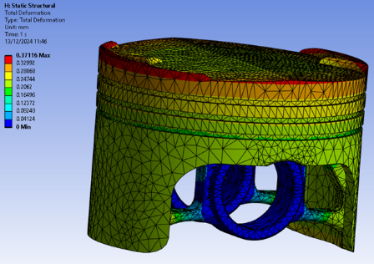
Bottom View | 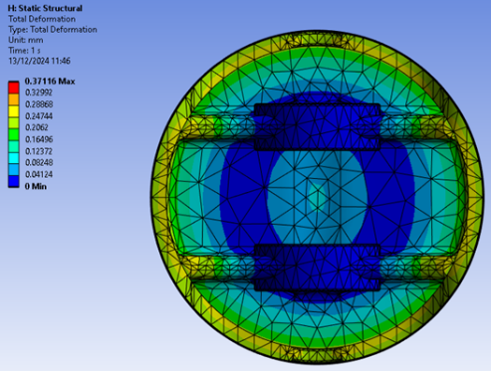
Top View | 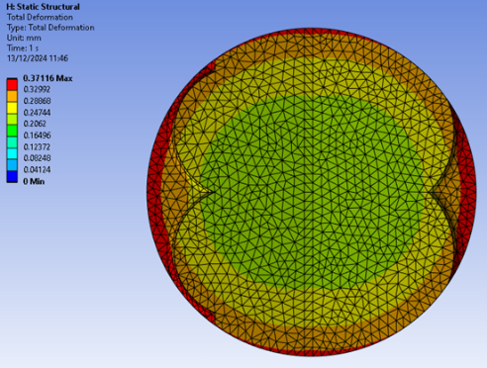
Front View | 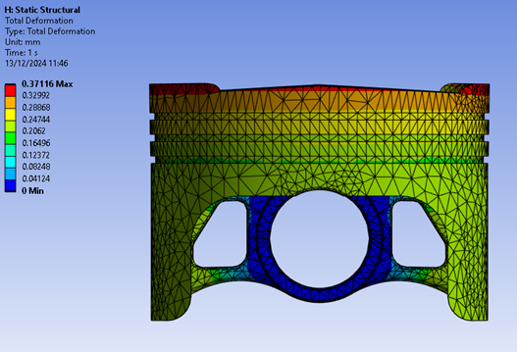
Section View | 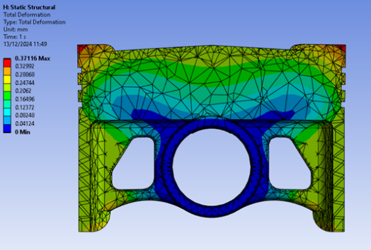
Table 10 Iteration 2 Deformation (mm)

Equivalent Stress (MPa)
Isometric View | 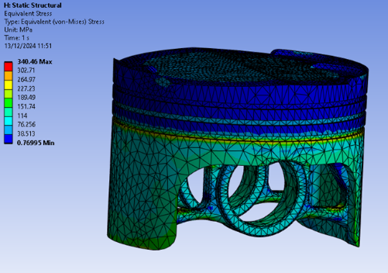
Bottom View | 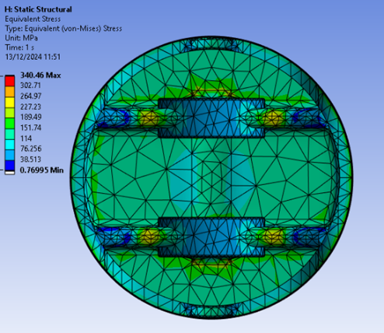
Top View | 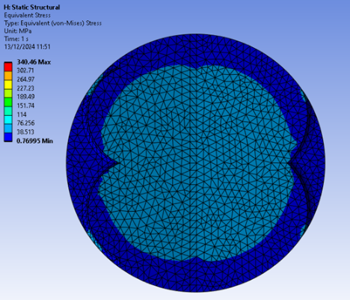
Front View | 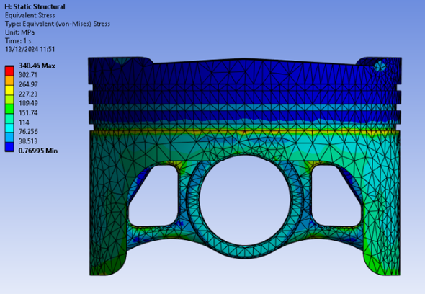
Section View | 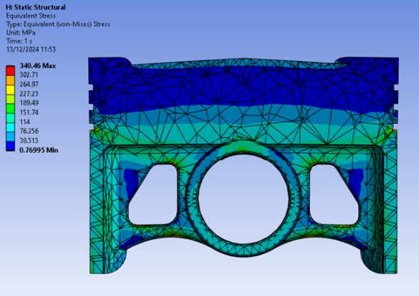
Table 11 Iteration 2 Equivalent Stress (MPa)

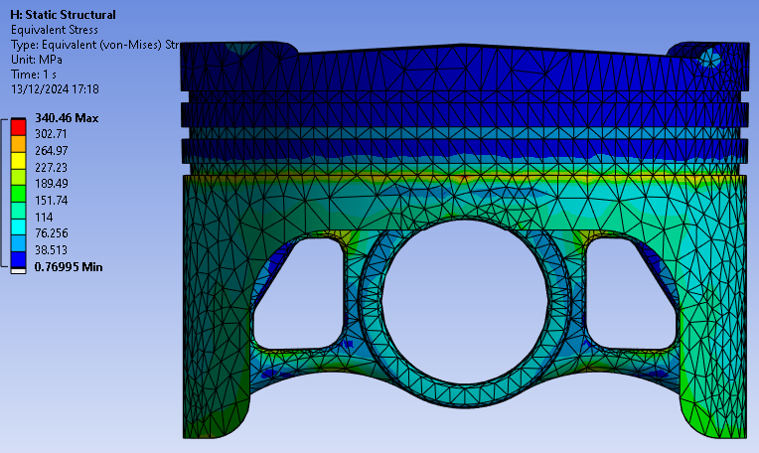
Figure 18 Iteration 2 Equivalent Stress Front View
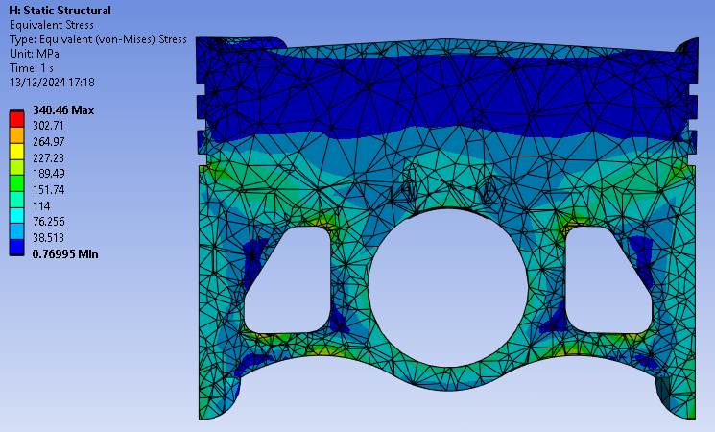
Figure 19 Iteration 2 Equivalent Stress Section View
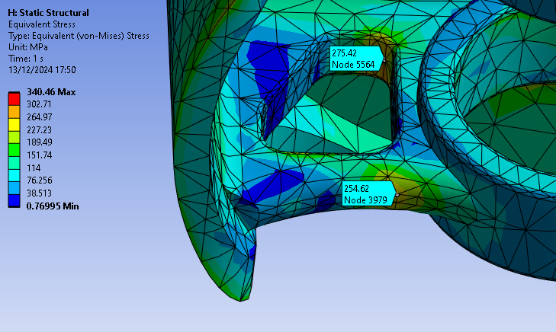
Figure 20 Iteration 2 Equivalent stresses in the Pin Bore Support
The results from the finite element analysis shows a 3.4% reduction in maximum equivalent stress going from 352.47 MPa in the baseline to 340.46 MPa in the second iteration. This could be put down to the reduced mass leading to lower inertia forces. There is a 7.095% increase in deformation, but this can be justified due to the reduction in equivalent stress and the lower mass.
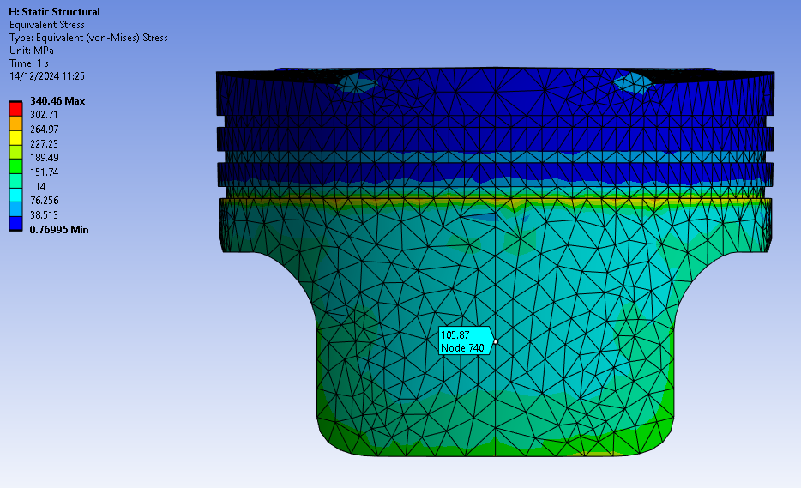
Figure 21 Side view of Iteration 2 Equivalent Stress to Demonstrate are of low Stress
To further improve the design of the piston, the equivalent stress can be analysed to evaluate where more mass reduction can take place in order to further improve the design of the piston. Looking at figure 21 it can be seen that there is an area of redundant mass in an area of low stress concentration.

4.3 Iteration 3 Piston
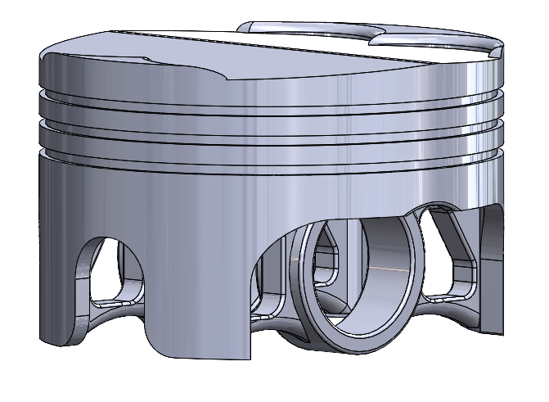
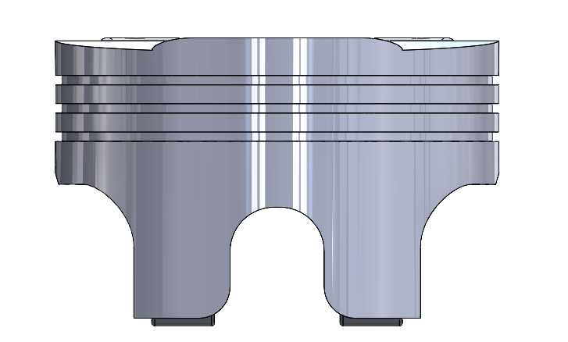
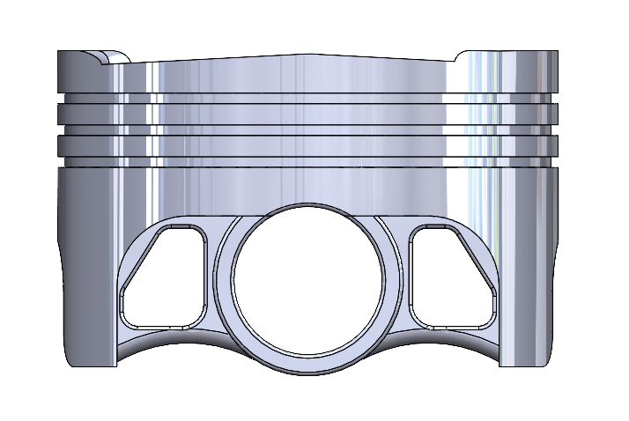
Figure 22 Iteration 3 Piston Design
Material = Aluminium 6061 T6
Mass = 241.55 grams
In order to further optimise the piston design, material was removed from the piston skirt, the length of the skirt was shortened, and cut-outs were made. The mass of the Iteration 2 was 248.81 grams. The removed material resulted in a mass reduction of 7.26 grams or 2.92%. From the Baseline design, there was a total mass reduction of 14.22 grams or 5.6% overall. This will further improve the design by lowering the inertia of the piston.
The design changes were influenced by Mahle (2016) Pistons and engine testing where they state that the total height of the piston should be kept as low as possible to obtain low piston mass.
 | Iteration 3 Piston Mesh Size Study @ 6.7715MPa, 4000rpm
 | Mesh Size (mm) |  | Max Deformation (mm) | Max Stress (MPa) |  |  | Min Stress (MPa)
 | 10mm, 5mm Crown |  | 0.37163 | 367.64 |  |  | 0.75845
 | 8mm, 4mm Crown |  | 0.3714 | 376.75 |  |  | 0.51265
 | 6mm, 3mm Crown |  | 0.37365 | 370.37 |  |  | 0.72865
 | 4mm, 2mm Crown |  | 0.37414 | 318.09 |  |  | 0.77219
 | 2mm, 1mm Crown |  | 0.38366 | 335.69 |  |  | 0.9196
 | 1mm, 0.5mm Crown |  | 0.39927 | 312.47 |  |  | 0.90071
 | Table 12 Iteration 3 Mesh Size Study
Iteration 3 Deformation (mm)
Isometric View |  | 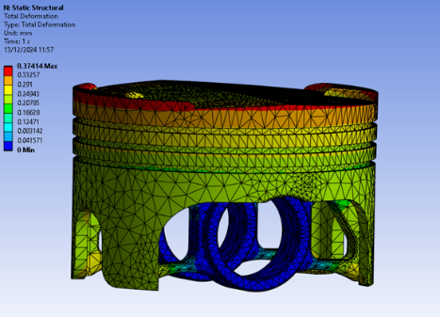
Bottom View |  | 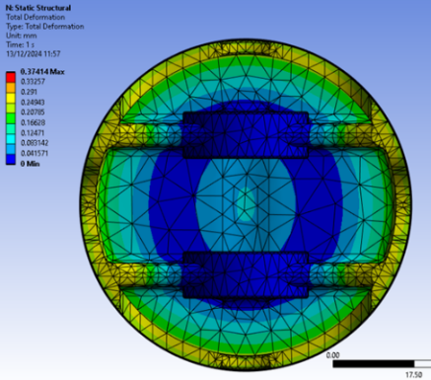
Top View |  | 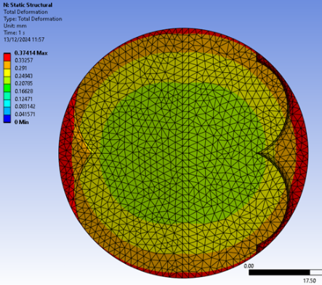
Front View |  | 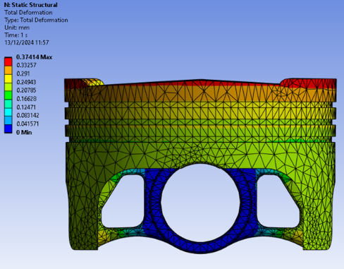
Section View |  | 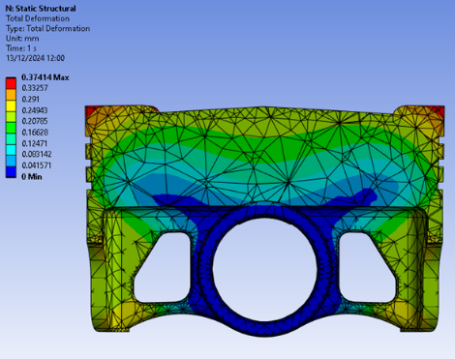
Table 13 Iteration 3 Deformation (mm)
Iteration 3 Equivalent Stress (MPa)
Isometric View |  | 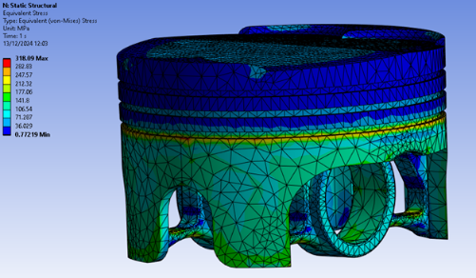
Bottom View |  | 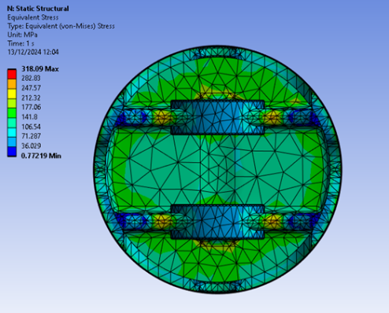
Top View |  | 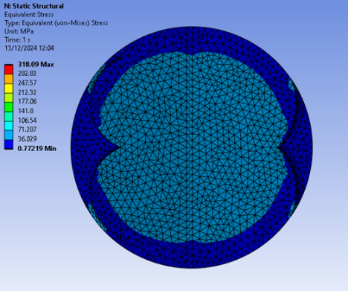
Front View |  | 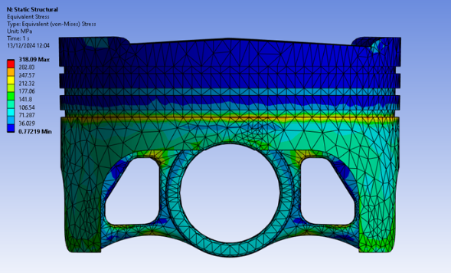
Section View |  | 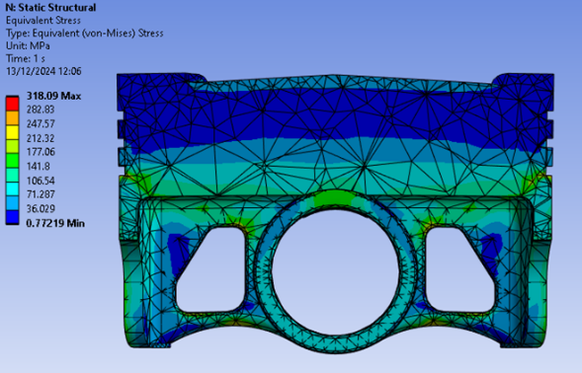
Table 14 Iteration 3 Equivalent Stress (MPa)

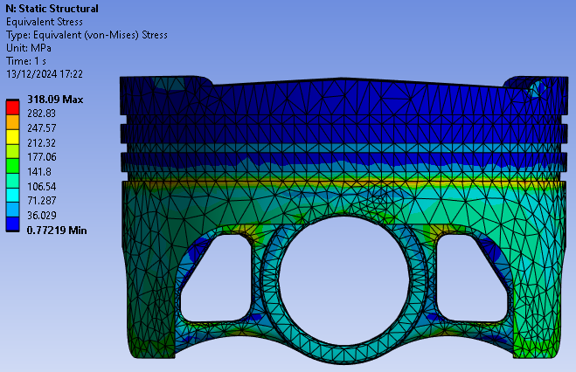
Figure 23 Iteration 3 Equivalent Stress Front View
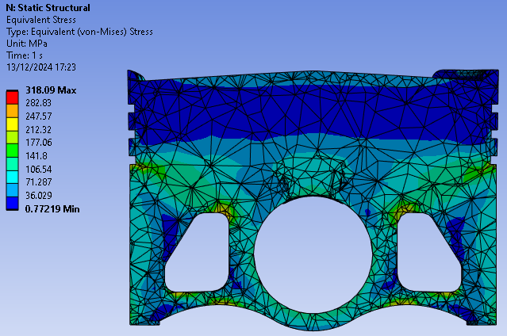
Figure 24 Iteration 3 Equivalent Stress Section View
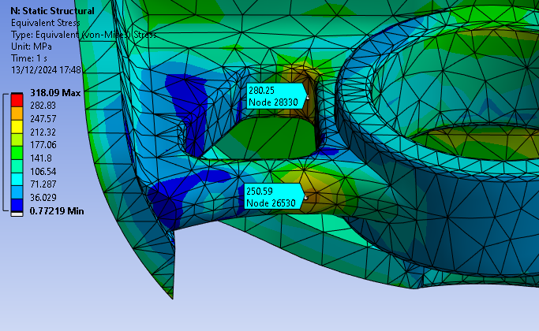
Figure 25 Iteration 3 Equivalent Stresses at the Piston Pin Bore Supports
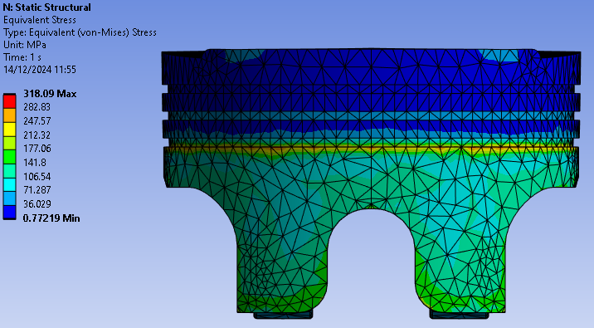
Figure 26 Iteration 3 Equivalent Stress Side View
In the third iteration of the piston design the additional mass reduction gives a 2.92% from a mass of 248.81 grams in the second iteration to 241.55 grams in the third iteration. The maximum stress shows a significant decrease of 6.57% with a maximum equivalent stress of 340.46 MPa in the second iteration to 318.09 MPa in the second iteration.

5 Comparison
Total Deformation (mm) Comparison
Base |  | Iteration 2 |  | Iteration 3
Isometric View |  | 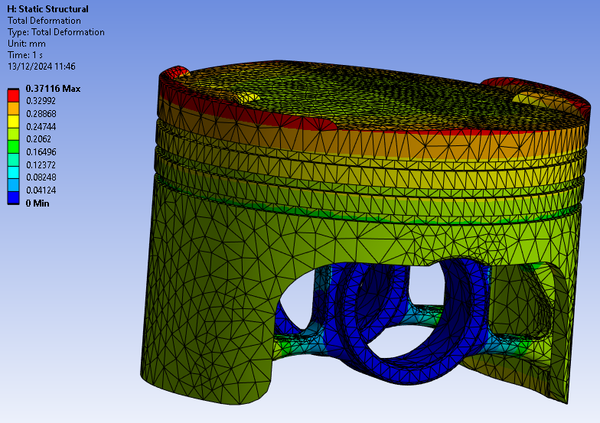 |  | 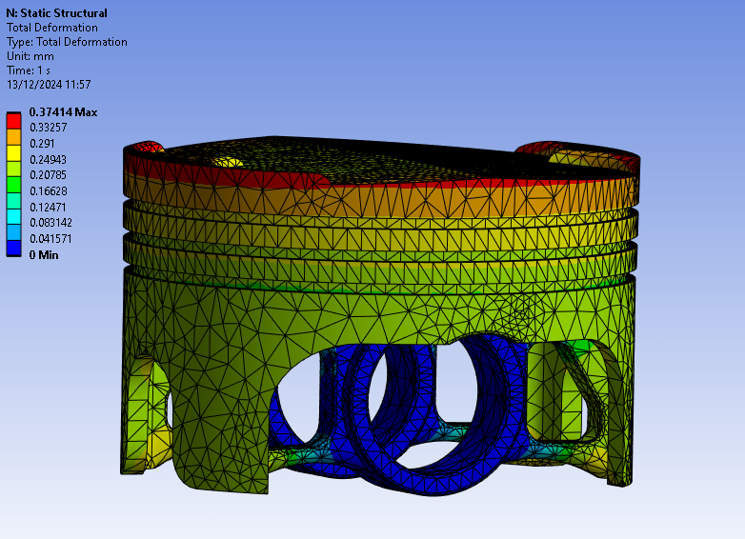
Bottom View |  |  | 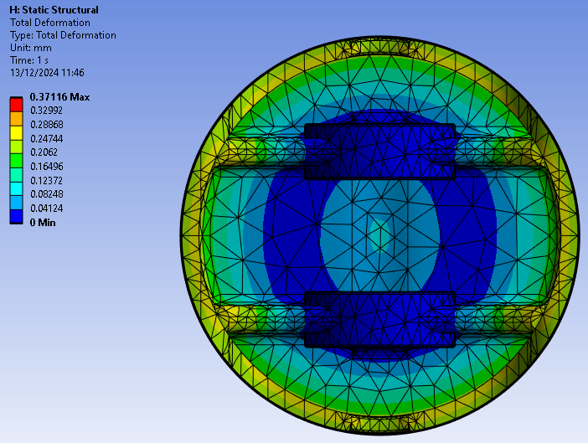 |  | 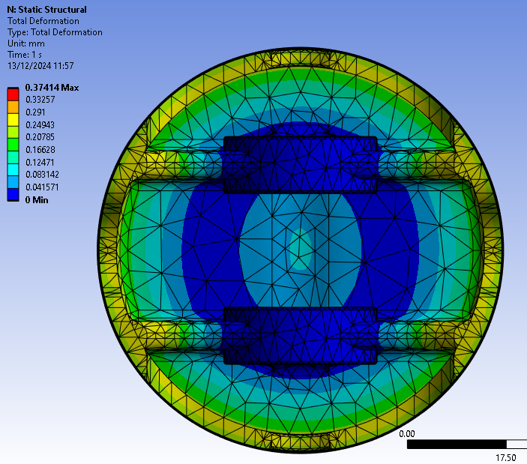
Top View |  | 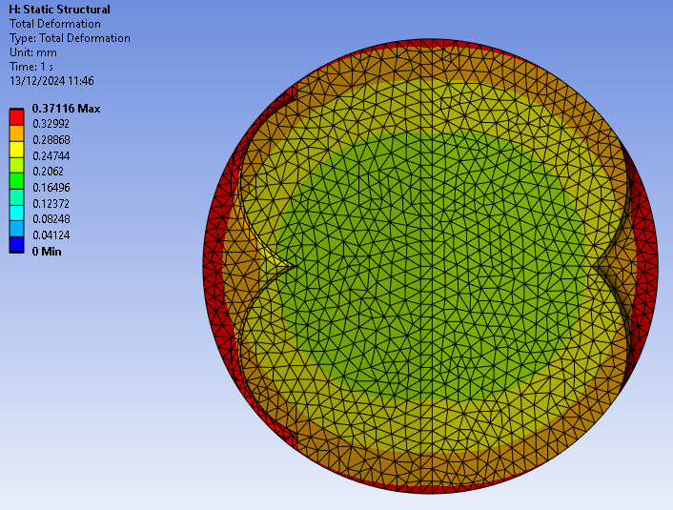 |  | 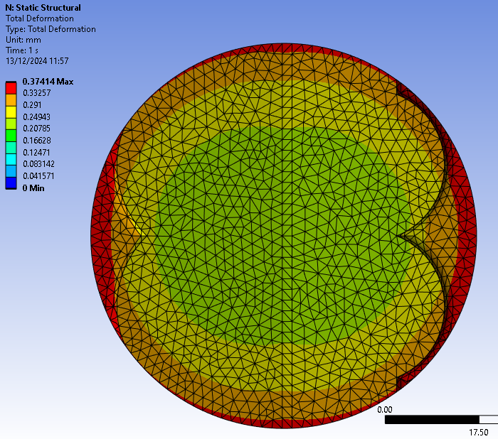
Side View |  | 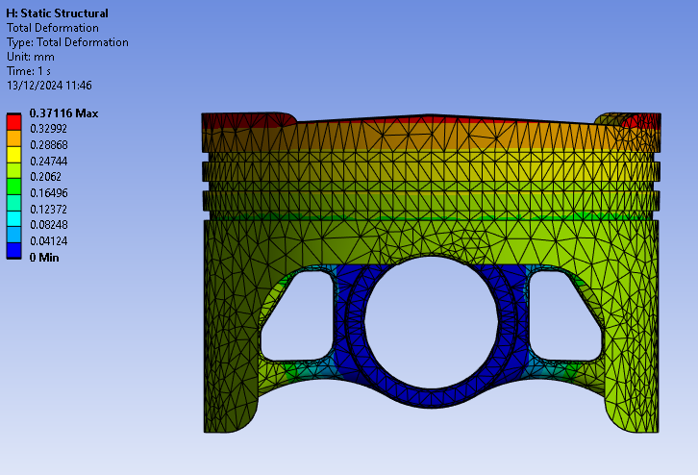 |  | 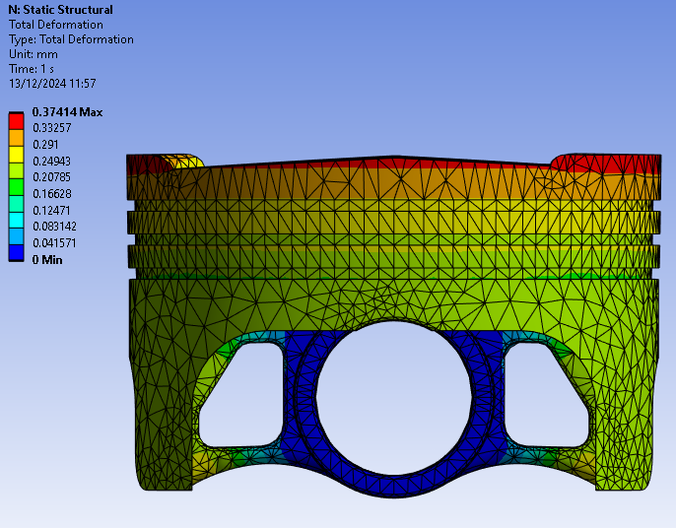
Section View | 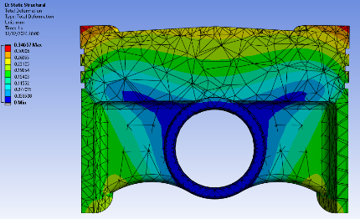 | 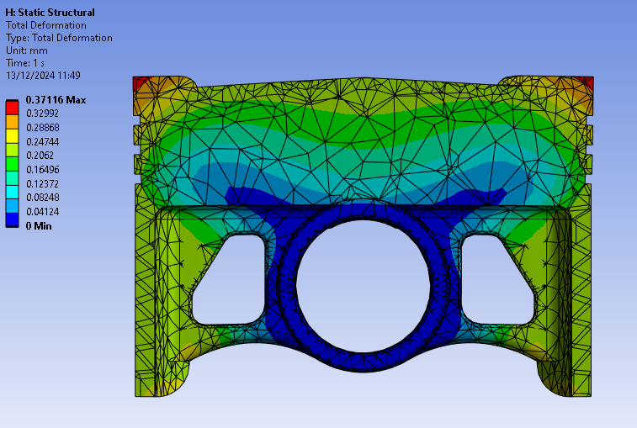 |  | 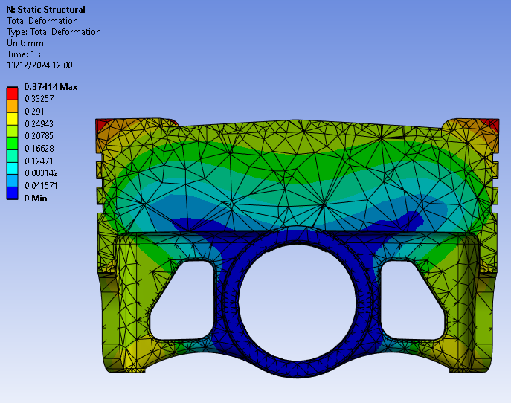
Table 15 Total Deformation (mm) Comparison

Equivalent Stress (MPa) Comparison
Base |  | Iteration 2 |  | Iteration 3
Isometric View | 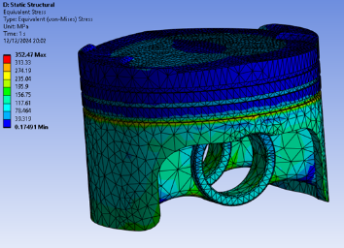 | 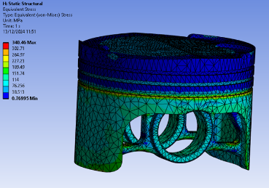 |  | 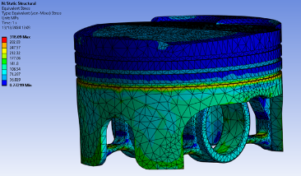
Bottom View | 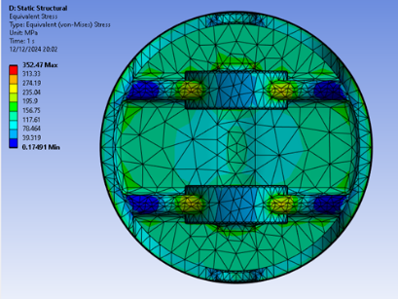 |  | 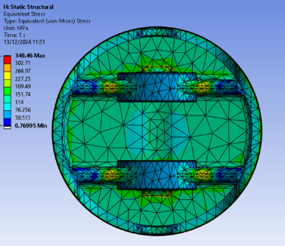 |  | 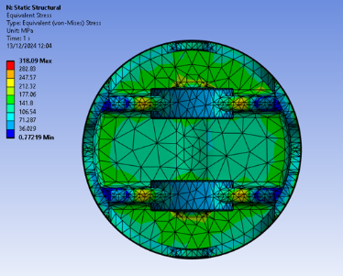
Top View | 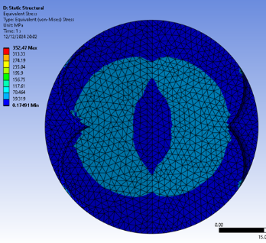 | 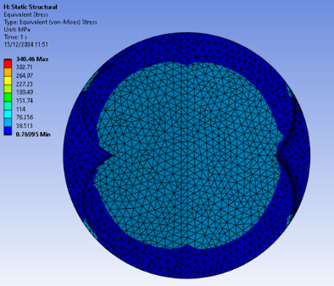 |  | 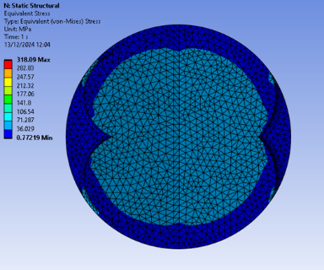
Side View | 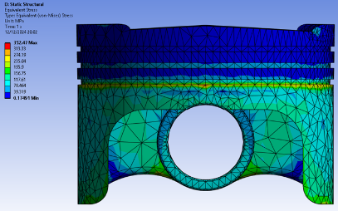 | 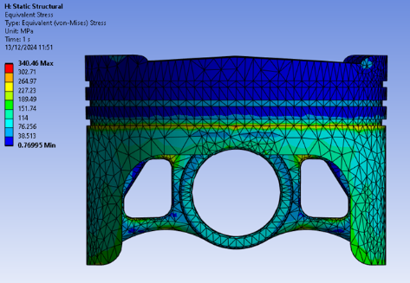 |  | 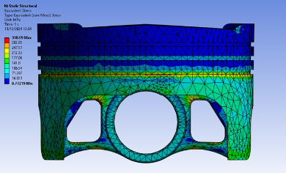
Section View | 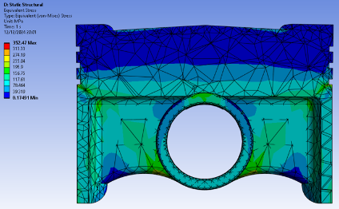 | 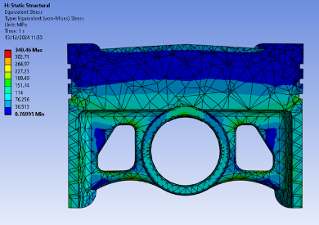 |  | 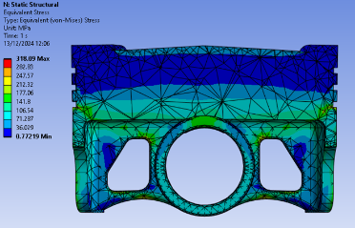
Table 16 Equivalent Stress (MPa) Comparison

6 Limitations of FEA analysis
Whilst FEA is a useful tool for predicting the behaviour of materials under various loads, it has inherent limitations that can impact the reliability and accuracy of the results. FEA often relies on assumptions, such as material properties, geometry and boundary conditions, which may not be true to real life simulations, particularly for non-linear situations such as plastic deformation (Autodesk). Moreover, simplified boundary conditions and loading scenarios can lead to discrepancies in stress and deformation as supported by Lulay. In addition to this, many studies ignore the effects of environmental factors such as wear or corrosion, as well as vibration, thermal cycling and fatigue.

7 Conclusion
Iteration 3 achieves a 9.8% overall reduction in maximum equivalent stress compared to the baseline. Going from 352.47 MPa (baseline) to 340.46 MPa (Iteration 2) to 318.49 MPa maximum equivalent stress, this shows a consistent and clear reduction in maximum stress across the designs. The material being removed from the low stress regions, for example, the pin bore supports and the piston skirt, leads to mass reductions from 255.77 grams (baseline) to 248.81 grams (Iteration 2) to 241.55 grams (Iteration 3) which overall is a 5.6% improvement. The reduction in mass effectively brings the reciprocating mass down, reducing inertial forces acting on the piston. On the other hand, the maximum deflection does rise slightly with each iteration- 0.34657mm (Baseline) to 0.37116mm (Iteration 2) to 0.37414m (Iteration 3), the effects of the increased maximum deflection can be justified by the benefits of improved equivalent stress figures, reduced weight and improved overall vehicle performance.

8 References
Aalco (n.d.) 6061 – T6 Extrusions . Available at: https://www.aalco.co.uk/datasheets/Aluminium-Alloy-6061-T6-Extrusions_145.ashx

Aerocom (n.d.). Aluminium alloy 6061-T6. Available at https://aerocommetals.co.uk/featured-inventory/aluminium-alloy-6061/

Autodesk (n.d.) How to Perform a Mesh Convergence Study. Available at: https://www.autodesk.com/support/technical/article/caas/sfdcarticles/sfdcarticles/How-to-Perform-a-Mesh-Convergence-Study.html

DigitalXplore (n.d.) Finite Element Analysis and Optimization of Piston Using CAE Tools. Available at: https://digitalxplore.org/up_proc/pdf/123-142244499145-48.pdf

Dlubal (2017) Bimetallic Strip Verification Example. Available at: https://www.dlubal.com/en/downloads-and-information/examples-and-tutorials/verification-examples/000078

Dlubal (2022) Elastic Bending – Continuous Load Verification Example. Available at: https://www.dlubal.com/en/downloads-and-information/examples-and-tutorials/models-to-download/000104

IJERT (n.d.) Design and Analysis of Piston by Using Finite Element Analysis. Available at: https://www.ijert.org/research/design-and-analysis-of-piston-by-using-finite-element-analysis-IJERTV4IS090411.pdf

International Journal of Scientific and Management Research (2023) A Review of Piston Analysis by Using Finite Element Analysis. Available at: https://ijsmrt.com/wp-content/uploads/2023/02/IJSMRT-22090304.pdf

Lulay, K. (n.d.) Convergence and Mesh Independence in FEA. Available at: https://faculty.up.edu/lulay/ME304/ConvergenceStudy.pdf

MAHLE International GmbH, editor, & MAHLE International GmbH, editor. (2016). Pistons and engine testing (Second edition.). Springer Fachmedien Wiesbaden. https://doi.org/10.1007/978-3-658-09941-1

